3GPP TSG RAN WG1 #103-e R1-2008140
e-Meeting, October 26th – November 13th, 2020

Agenda item: 7.2.6
Source: Moderator (Samsung)
Title: Summary for Rel.16 NR eMIMO maintenance
Document for: Discussion and Decision

- Introduction
The moderator summary of the maintenance-related issues raised in the submitted contributions for Rel.16 NR_eMIMO maintenance is given below. The listed maintenance issues are under the usual designations:
- LP: low-PAPR RS
- MB: Multi-beam operation
- MT: Multi-TRP
- MU: Type-II enhancement for MU-CSI
- UL: UL full power transmission
An initial assessment on each of the issues is given (but can be revised based on the outcome of the discussion during the preparation week). The assessment will be used as a basis to select four issues (per chairman instruction) for further discussion in the upcoming weeks.
- High priority (H): this includes high-priority item (essential, pending issues, broken spec components) and proposed editorial changes that either enhance the clarity of the specs or correct mistakes
  - H2: The proposal can be endorsed without discussion in the upcoming weeks (i.e. unless pointed out otherwise, the moderator will propose to the chair that the proposal be endorsed by Oct 23rd thereby not counted toward the four-thread quota). It can be merged with any of the assigned threads without any further discussion
- Non-essential (N): this includes all other purposes such as spec optimization and low priority issues

- Maintenance issues
The issues are summarized in the following table:

Table 1 Summary of issues
# | Issue (summary) | Companies | Initial assessment | Company inputs (if any)
LP.x
MB.1 | Specifying TCI state codepoint mapping for DCI format 1_2  FL note: Remaining work from the Reply LS (R1-2007197) | Samsung (  R1-2008139  ), Qualcomm  R1-2008611  , Ericsson  R1-2008638 | H | Apple: Okay  LG: OK to discuss  Nokia: as it was agreed in the RAN1 LS answer to have the TCI codepoints clarification, it is a priority to get this done int he spec, agree with the current classification as H. Discuss further the CR proposals from Samsung and Ericsson.  Huawei, HiSilicon: Fine to discuss.  Docomo: Support  OPPO: Ok  FUTUREWEI: agree to discuss.  Ericsson: Agree to discuss with high priority.  MediaTek: Support  NEC: Support.
MB.2 | Clarifying that multi-CC simultaneous TCI update can be applied to CORESET#0  FL note: Good clarification for aligning TS38.321 and TS38.213 | Vivo  R1-2008674 | H2 | Apple: we do not see the necessity of this CR, since the corresponding behavior is clearly defined in 38.321. In addition, this CR seems ambiguous since the range of p is defined to be 0<p<12 or 0<p<16, which is configured by controlResourceSetId, and this CR proposed a condition like p>=0.  From the product implementation perspective, we do not see ambiguity in terms of the expected UE behavior. We are fine to make 38.213 clearer. But we think more time should be given to clarify the issues that has product implementation impact such as MT.13 and MT.17.  Qualcomm: Strictly speaking, not needed. Because the main bullet “a CORESET index p, by controlResourceSetId, where” does not have any restriction on the index p. So it can be equal to 0.  Vivo: Support.  To address Apple’s concern, this is not to change the following part, configuration of CORESETResourceSetID is still limited to p>0, the same as in the current spec:  a CORESET index $p$, by controlResourceSetId, where  - $0<p<12$ if CORESETPoolIndex is not provided, or if a value of CORESETPoolIndex is same for all CORESETs if CORESETPoolIndex is provided;  - $0<p<16$ if CORESETPoolIndex is not provided for a first CORESET, or is provided and has a value 0 for a first CORESET, and is provided and has a value 1 for a second CORESET;  To address QC’s concern, this is related to the following paragraph where p is explicitly mentioned but only limited to p>0 in previous paragraph:  if the UE is provided by simultaneousTCI-UpdateList-r16 or simultaneousTCI-UpdateListSecond-r16 up to two lists of cells for simultaneous TCI state activation, the UE applies the antenna port quasi co-location provided by TCI-States with same activated tci-StateID value to CORESETs with index $p$ in all configured DL BWPs of all configured cells in a list determined from a serving cell index provided by a MAC CE command  Nokia: agree with th FL proposal that this issue is not critical.  Docomo: Support as H2  OPPO: Not needed. Agree with Apple and QC.  The paragraph cited by vivo is only for the CORESET configured by ControlResourceSet, thus p>0. However, for CORESET#0, index p = 0. Thus, the current spec has no issue. Some information is copied & pasted from TS 38.331 for reference  -- ASN1START  -- TAG-CONTROLRESOURCESETID-START  ControlResourceSetId ::= INTEGER (0..maxNrofControlResourceSets-1)  ControlResourceSetId-r16 ::= INTEGER (0..maxNrofControlResourceSets-1-r16)  ControlResourceSetId-v1610 ::= INTEGER (maxNrofControlResourceSets..maxNrofControlResourceSets-1-r16)  -- TAG-CONTROLRESOURCESETID-STOP  -- ASN1STOP  FUTUREWEI: not needed.
  controlResourceSetId
  Identifies the instance of the ControlResourceSet IE. Value 0 identifies the common CORESET configured in MIB and in ServingCellConfigCommon (controlResourceSetZero) and is hence not used here in the ControlResourceSet IE. Other values identify CORESETs configured by dedicated signalling or in SIB1. The controlResourceSetId is unique among the BWPs of a serving cell.
  If the field controlResourceSetId-v1610 is present, the UE shall ignore the controlResourceSetId field (without suffix).
MB.3 | Aligning RRC parameter names with TS38.331 (MediaTek’s TP handles the names of the CC lists and Nokia’s TP handles the names of QCL types)  FL note: Editorial corrections | MediaTek  R1-2008514  , Nokia/NSB | H2 | Apple: Okay  LG: Support  Nokia: disagree with the FL proposals, these type of changes should be taken into account during RAN1#103-e. Propose to include a new categorization in the as Editorial ‘'and these should be pushed to the spec editors!  Docomo: Support as H2  FUTUREWEI: Chairman will have dedicated editors’ alignment CR email thread to also handle such issues.  MediaTek: Support FL’s proposal.  NEC: Support.
MB.4 | Text change made in #102-e for default PL RS for DCI format 0_2 was not same as the agreed TP, and it is proposed to adopt the agreed TP due to potential misunderstanding of the current text.  FL note: Current text seems to have the same meaning with the agreed TP. | ZTE  R1-2007748 | N | LG: Agree with FL’s assessment  ZTE: This issue should be marked as H2.  - According to our knowledge, “the PUSCH transmission is scheduled by a DCI format 0_1 or format 0_2 that does not include an SRI field” in the endorsed TP corresponds to the case that a PUSCH is scheduled by DCI format 0_1 or format 0_2 and meanwhile there is a single SRS resource configured for CB/nonCB transmission, i.e., an SRI field in DCI is saved. It is NOT equivalent to the “the PUSCH transmission is not scheduled by DCI format 0_0 that does not include SRI field” in current spec.  BTW, are there any companies/proponents who can nicely clarify the meaning of the above highlighted sentence in current spec? In our views, it is confusing.  Nokia: agree that the CR should be implemented as endorsed by RAN, consider this topic as H.  Docomo: We prefer to mark it as H2. The current specification is also confusing to us. We think this should be H2, rather than H, because this is how to capture the previous agreement.  FUTUREWEI: H2 is better  NEC: Support to be H2.
MB.5 | Further refinement on the QCL definition  FL note: Proposal is not related to Rel-16 features and seems not critical | Samsung  R1-2008139 | N | LG: Agree with FL’s assessment  Nokia: agree with FL! The QCL is clear also in Rel15 and follows the LTE definition also.  FUTUREWEI: agree that it is not needed
MB.6 | Supporting default spatial relation/PL RS for Rel-16 MTRP features  FL note: Extension of feature, considered as not essential issue | Apple  R1-2008437 | N | Qualcomm: Support for it as “H”. The extension is beneficial, since mTRP default beam is only defined for DL but not for UL. So the reliability gain cannot be truly achieved if not considering UL enhancement  Nokia: this is not an essential correction under multi-beam. Even within multi-TRP discussion, it is not essential to define default spatial relation for multi-DCI based multi-TRP.  LG: Agree with FL’s assessment  FUTUREWEI: not essential  Samsung: Suggest changing to ‘H’. This proposal effectively reduces beam indication overhead for M-DCI M-TRP in FR2, where PUCCH/PUSCHs to different TRP need to be applied different beam/PL RSs.
MB.7 | Supporting default PL RS in FR1  FL note: Discussed in the last meeting but not agreed | Qualcomm R1-2008611  Huawei, HiSilicon R1-2008796 | N | Qualcomm: Support for it as “H”. This topic is not selected for formal discussion in last meeting due to the limited topic #.  LG: Agree with FL’s assessment  Nokia: agree with QC’s proposal, this can be H item.  FUTUREWEI: agree with QC and Nokia to mark it as H
MB.8 | Support SSB for SCell BFD (TP2 in R1-2007748)  Delete SSB in PCell/PSCell for BFD (TP2 in R1-2008213)  FL note: TP from ZTE reverts previous agreement, and TP from OPPO is related to PCell BFR. | ZTE  R1-2007748  , OPPO | N | LG: Agree with FL’s assessment  Nokia: agree with FL  OPPO: SSB cannot be used as BFD RS in both SCell BFR and PCell BFR. But current text description in 38.213 does not align with each other. That shall be corrected.  FUTUREWEI: agree with FL  Ericsson: The ZTE TP is correct, and should be discussed. Note that ZTE only proposes to delete “on the PCell or PSCell”, since the text should apply to SCell as well. Editorial, could be H2
MB.9 | After SCell BFR, define CORESET pool index = 0 for all CORESETs (TP3 in R1-2007748)  FL note: This is a new issue, but it seems this is related to Rel-17 TRP specific BFR. | ZTE  R1-2007748 | N | LG: Agree with FL’s assessment  Nokia: agree with FL  FUTUREWEI: agree with FL  NEC: agree with FL.
MB.10 | Correction on L1-SINR Resource Setting (R1-2007909)  - Editorial correction (add SSB in CMR)  - Support both ZP and NZP IMR  Do not support both ZP and NZP IMR (R1-2008571)  FL note: Whether to support both ZP and NZP IMR has been discussed multiple times. | FutureWei  R1-2007909  , LGE, Huawei, HiSilicon (R1-2008796) | N for 2  H2 for editorial correction | Apple: Okay.  For the second bullet, we prefer to either not discuss it, or to remove the specification in bracket for CMR + ZP-IMR + NZP-IMR (not support this feature)  Qualcomm: Support for “H2” of LG’s proposal. This has been discussed multiple times and not agreed in the formal discussion among selected topics in last meeting.  LG: Although this issue has been controversial, it is unfortunate if there still exist some text in square brackets until v16.4.0 of Rel-16 spec.  Nokia: we propose to reject the FW CR on removing the square brackets, this issues dates back with a pending WA which we do not agree to confirm!  Huawei/HiSilicon: Support the 2nd bullet as proposed in R1-2008796.  FUTUREWEI: the issue need to be resolve so essential for a stable spec. Suggest to discuss as H.  Ericsson: N for 1. With a single resource setting, CSI-RS is the only option.  Samsung: If the square brackets are removed, it will be good to clarify the supported combination(s) of time-domain behavior of the NZP CSI-RS for interference and CSI-IM. For example, the supported combination would only hold for aperiodic NZP CSI-RS for interference and aperiodic CSI-IM. Would this be an acceptable compromise to the opposing companies?  MediaTek: Support LG’s revision
MB.11 | Specify that the UE shall apply same QCL-TypeD assumption on channel measurement and interference measurement when QCL-TypeD RS is not configured to the NZP CSI-RS resource for channel measurement. (TP1 in R1-2008213)  Specify UE assumption and expectation when periodic CSI-RS configured as CMR for L1-SINR measurement is not provided with QCL indication (R1-2008796)  FL note: This seems to be a resubmission, and according to the feedback in previous meetings, not to configure QCL for CSI-RS looks to be a general issue. | OPPO  R1-2008213  Huawei, HiSilicon (R1-2008796) | H | Apple: Okay  Good to discuss. However, we prefer the QCL-TypeD always be configured for NZP-CSI-RS or the default QCI behavior is well defined for NZP-CSI-RS  Qualcomm: Not essential. There is no valid use case for this scenario. If CMR has no QCL-D configured, UE does not even know it will be transmitted by same gNB beam over different occasions for UE to determine its Rx beam.  Nokia: this is an error case which does not need spec support! Propose to reject the CR.  LG: Seems not critical issue. It would be more typical to use L1-RSRP based BM for CSI-RS without QCL-D for initial P-1 or P-2 operation  Huawei, HiSilicon: We support discussing UE assumption and expectation when CSI-RS is not provided with QCL indication. Our proposal in R1-2008796 is if no QCL assumption is provided for a periodic NZP CSI-RS resource as CMR for L1-SINR measurement, the UE may assume all the instances of this CSI-RS are transmitted with the same downlink spatial domain transmission filter.  Docomo: We think not essential. We don’t understand the use case that CMR has no QCL-D configuration.  FUTUREWEI: not essential  Ericsson: No consensus in RAN1 if CSI-RS without QCL source is a valid use case. Suggest not to discuss.  Samsung: Not support. We do not expect the case when NZP CSI-RS has no QCL-TypeD.  MediaTek: We don’t think this is an essential issue. We prefer not to discuss this.
MB.12 | Update referenes to nrofReportedRSForSINR as to nrofReportedRS in 38.214. (R1-2008324, R1-2008641)  FL note: Editorial correction. | Huawei/HiSil, Nokia/NSB  R1-2008324 | H2 | Apple: Okay  LG: OK  Nokia: this is a slightly editorial issue, agree with HW, rating should be H  FUTUREWEI: can use the editors’ alignment CR email thread  MediaTek: Support
MB.13 | PUCCH spatial relation assumption after CBRA-BFR (R1-2008536)  FL note: This was discussed in last meeting, and the proposal seems to be updated based on some discussion in last meeting. | Docomo  R1-2008536  , Nokia/NSB, IDC | H | Apple: Okay, Supportive as high priority  LG: OK  Nokia: agree with FL.  Huawei, HiSilicon: Fine to be discussed.  Docomo: Support. This is important for operators.  OPPO: Do not support to discuss this issue again:  - One email thread was allocated for it in RAN1#102-e. But we could not reach consensus. We should not repeat the discussion again.  - The issue here is out of the scope of rel16 eMIMO.  - The function proposed in MB.13 can be supported by the feature of default spatial relation for PUCCH. Why do we need specify redundant functions?  FUTUREWEI: Ok to discuss  Ericsson: discussed many times. Little chance of consensus. Suggest not to discuss.  MediaTek: We have a doubt that we can have unified conclusion this time, but we are fine with the discussion.  NEC: Support.
MB.14 | Define measurement restriction related UE behavior for L1-SINR measurement (R1-2008674)  FL note: This seems to be related to previous conclusion and aligned with agreed CR for L1-RSRP. | v vivo  R1-2008674 | H | Apple: Okay, Supportive as high priority  Qualcomm: Not essential. Without additional clarification, UE will follow the same rule for L1-RSRP. No ambiguity.  Vivo: Don’t understand Qualcomm’s concern on this issue. L1-RSRP is already captured. L1-SINR related behavior should also be captured.  Nokia: Agree with Vivo’s proposal that it is good to clarify whether timeRestrictionForChannelMeasurements and timeRestrictionForInterfereceMeasurements can be simultanously configured for all resource settings. The clarification is especially needed for the case of “one resource setting” where same resource is used for both channel and interference measurement.  FUTUREWEI: Ok to discuss.  MediaTek: Support
MT.1 | TP to capture the agreement on default TCI state of AP CSI-RS in mTRP  - ZTE (R1-2007750) proposed TP to capture the agreement  - OPPO (R1-2008212) provided TP to capture the agreement of default TCI state of AP CSI RS in mTRP  - Apple (R1-2008436) provided TP to capture that  - Ericsson (R1-2008635) also provided TP for that agreement  - vivo (R1-2008675) proposed TP too  FL note: it is the agreement made in last meeting but no time to discuss the TP in last meeting. | ZTE,OPPO, Apple, Ericsson, vivo, Samsung | H | Apple: Okay, Supportive as high priority  Qualcomm: Our understanding is that this item should be separately handled in terms of the budget, based on the following note:  - “Note: for the agreements from previous meetings without the corresponding TPs, draft CRs are to be prepared and endorsed in email threads separately, from the budget above”.  LG: OK  Nokia: This should not consume a separate email tread. No new agreement is needed. It is just capturing the TP.  vivo: OK  Huawei, HiSilicon: can be considered as H2, for the sake of discussing spec updates.  Docomo: Support it as high priority  FUTUREWEI: agree with FL.  Ericsson: Agree with Qualcomm and Nokia that this is a TP for the agreement made last meeting, and this should not consume one email thread from the budget. This should be treated with high priority.  Samsung: Support  MediaTek: Support  CATT: Support  NEC: Support.
MT.2 | Issue 1: The issue of PDCCH and PDSCH collide with different QCL-TypeD  - ZTE (R1-2007750) proposed to clarify UE behavior for the case when PDCCH and PDSCH with different QCL-TypeD collide.  - Apple (R1-2008436) propose that priority rule of PDSCH colliding with PDCCH is applied to per CORESETPoolIndex  - vivo (R1-2008675) proposed to conclude that PDSCH and PDCCH for different TRP shall not overlap  Issue 2: Clarify PDCCH monitoring with respect to a QCL-TypeD in M-DCI mTRP:  - ZTE(R1-2007750)proposed to support two QCL-TypeD for PDCCH reception at a given time in M-DCI.  - Intel [R1-2007938] proposed to extend the PDCCH prioritization based on QCL-TypeD to M-DCI multi-TRP operation.  - Spreadtrum (R1-2008093) proposed to specify the priority rules of monitoring PDCCHs is applied within the CORESETs with the same value of CORESETPoolIndex  - Qaulcomm (R1-2008610) proposed to specify that Rel. 15 procedures on PDCCH for QCL prioritization is done per CORESETPoolIndex  - Nokia (R1-2008723) proposed to specify that For a UE capable of simultaneous reception with different QCL-TypeD, the PDCCH monitoring priority rule based on QCL-TypeD is applied within CORESETs of the same coresetPoolIndex. | ZTE, Intel, Spreadtrum, Apple, vivo, Nokia, Qualcomm,  Ericsson | H | Apple: Okay, Supportive as high priority  Qualcomm: Supportive as high priority.  LG: Both issues are not essential; it can discussed in Rel-17 if needed. Issue 2 was discussed in the last UE feature session but no consensus was reached.  Nokia: This is an essential correction as specification otherwise not allowing simultaneous reception in FR2.  vivo: OK  Huawei, HiSilicon: For issue 1, it is unclear/unspecified how to handle PDCCH/PDSCH collision with different QCL-Type D for intra-TRP in Rel-15. Therefore, it can be risky whether/how changes are applied to inter-TRP cases, including both S-DCI and M-DCI based M-TRP transmission and a certain Rel-15 UE behavior, e.g. i.e. CORESETPoolindex is transparent to TRP from UE perspective.  For issue 2, supporting two different type-D PDCCH reception simultaneously is more or less contradict to the latest 38.331.  “simultaneousReceptionDiffTypeD-r16  Indicates whether the UE supports simultaneous reception with different Type D as specified in TS38.213 [11]. This applies to PDSCHs.”  Also both issues 1 and 2 are inter-wined. If we can support PDSCH+PDSCH and PDCCH+PDCCH with different type in issue 2, excluding PDCCH+PDSCH in issue 1 seems to be odd.  FUTUREWEI: Ok to discuss  Ericsson: fine to discuss both issues with high priority.  Samsung: Not support. Especially on issue 2, Rel-16 UE does not support reception of PDCCH+PDCCH with different QCL-TypeD since no consensus was made on the support of such capability in UE feature discussion.  MediaTek: Agree with LG and Samsung  NEC: Support.

MT.3 | The issue of default TCI state for PDSCH in S-DCI mTRP  - ZTE (R1-2007750) propose to Clarify the default TCI state for single-DCI mTRP: scheme 1a/2a/2b for the following cases: When one TCI state is indicated and When two TCI states are indicated  - vivo (R1-2008675) proposed to specify the default TCI state for:  - Indicating one TCI state  - TCI field is not present  - Scheme 2a/2b  FL note: this issue has been discussed in previous meeting | ZTE, vivo | N | LG: Agree with FL’s assessment  ZTE: It is better to solve this issue to make spec correct. Otherwise, the default TCI states is only specified for TDMed schemes, but not for SDM, FDM and single-TRP.  Based on the current spec, if TDM is configured by RRC but the actual transmission is SDM, the default TCI states are still for TDM. This is not correct.  Nokia: Agree with FL. not an essential correction.  vivo: current spec is unclear and incomplete if we don’t treat the cases for default TCIs. Should be treated  OPPO: We have Agreed not to discuss this issue any more.  FUTUREWEI: agree with FL  CATT: Agree with FL. Current spec is clear.  NEC: Support. We think it’s better to define default TCI states for all schemes.
MT.4 | ZTE ((R1-2007750) proposed to specify the UE behavior in single-DCI mTRP transmission when sequenceOffsetforRV-r16 is not configured.  FL note: This issue can be avoided by implementation. | ZTE | N | LG: Agree with FL’s assessment  ZTE: This issue can be solved very quickly, e.g. adopt the following change  Table 5.1.2.1-3: Applied redundancy version for the second TCI state when sequenceOffsetforRV-r16 is present  Nokia: There is no issue with the current specification. sequenceOffsetforRV-r16 should always present when SlotBased-R16 is used.  FUTUREWEI: agree with FL.  CATT: agree with FL.  NEC: Support ZTE’s proposal.
MT.5 | The issue of 3 CDMs groups in S-DCI mTRP:  - Apple (R1-2008436) proposed to clarify that 3 CDMs groups should not be used in mTRP  FL note: Current specification suggests that when 2 TCI states are indicated, 3 CDM groups cannot be indicated | Apple | N | Apple: Just to clarify whether what FL’s note is common understanding, if that is the case, we suggest marking it as ‘H2’ and to make what FL said as a quick conclusion.  LG: Agree with FL’s assessment  Nokia: for SDM operation, spec already mention that 2 CDM groups are indicated. There is no case where 3 CDM groups are used with single DCI based multi-TRP. No specification changes are needed here.  FUTUREWEI: No need to discuss  CATT: agree with FL.
MT.6 | The issue of radio link monitoring in mTRP:  - Apple (R1-2008436) proposed to specify the method of UE determining RLM RS in M-DCI mTRP system  FL note: Optimization | Apple | N | Apple: This CR includes two changes: one is an editorial change to include Lmax = 8 since for mDCI, there can be 5 CORESETs. We suggest at least handling the following editorial change as ‘H2’.  “- For and L_{max} = 8, the UE selects the RS provided for active TCI states for PDCCH receptions in CORESETs associated with the search space sets in an order from the shortest monitoring periodicity. If more than one CORESETs are associated with search space sets having same monitoring periodicity, the UE determines the order of the CORESET from the highest CORESET index as described in Clause 10.1.”  LG: Agree with FL’s assessment  Nokia: Just an additional restriction for multi-TRP. Not supported.  Docomo: Support it as high priority  FUTUREWEI: no need to discuss  CATT: agree with FL.
MT.7 | The issue of RV value for PDSCH scheme 4:  - CATT (R1-2007818) proposed that table 5.1.2.1-2 in 38.214 is used to specify the RV for PDSCH with aggregation factor or scheme 4. So, R1-2007818 proposed to use a separate table to specify the RV for PDSCH of scheme 4.  FL note: It seems there is no confusion in current spec. | CATT | N | LG: Agree with FL’s assessment  Nokia: agree with FL  FUTUREWEI: No need  CATT: according to current spec, for scheme 4, the redundancy version applied to multiple transmission occasions associated with the first TCI state is derived from the table which was defined for slot aggregation transmission in Rel-15 when using the higher layer parameter pdsch_AggregationFatcor to indicate the repetition number of PDSCH. However the description of the table is not appropriate for URLLC scheme 4 highlighted as below and may lead to a misunderstanding on repetition number indication. Therefore, we suggest to use a separate table for the illustration for scheme 4 to avoid the confusion.  Table 5.1.2.1-2: Applied redundancy version when pdsch-AggregationFactor is present
  rv_{id} indicated by the DCI scheduling the PDSCH | rv_{id} to be applied to n^{th} transmission occasion
  rv_{id} indicated by the DCI scheduling the PDSCH | n mod 4 = 0 | n mod 4 = 1 | n mod 4 = 2 | n mod 4 = 3
  0 | 0 | 2 | 3 | 1
  2 | 2 | 3 | 1 | 0
  3 | 3 | 1 | 0 | 2
  1 | 1 | 0 | 2 | 3
MT.8 | The issue of out-of-order of PDSCH in mTRP:  - CATT (R1-2007818) proposed to update 38.214 to support out-of-order of PDSCH from different TRPs within a slot: description in current 38.214 only supports out-of-order PDSCH across slot  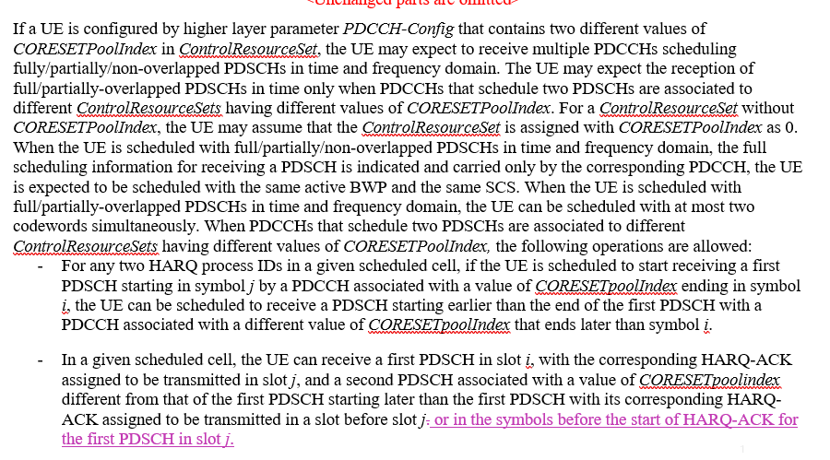  FL note: It seems to be optimization | CATT | N | LG: Agree with FL’s assessment  Nokia: Open to discuss more.  FUTUREWEI: not essential  CATT: In current specification, out-of-order operation for PDSCH to HARQ-ACK can be supported only in slot-level granularity. According to the agreement on TDMed PUCCHs within a slot, it is natural to support out-of-order operation for PDSCH to TDMed HARQ-ACK within a slot.
MT.9 | Spreadtrum (R1-2008093) proposed  - to add the constraint at N_"cells" ^"Cap" in text description when UE does not report pdcch-BlindDetectionCA:  FL note: It captures what is included in one previous agreement. | Spreadtrum, Qualcomm | H2 | Apple: We have concern on this issue. Yes, we do have a previous agreement. However, in Rel-15, when UE does not report pdcch-BlindDetectionCA, UE supports PDCCH monitoring BD and CCE linear scaling for any number of CCs. This is clearly captured in the Rel-15 specification. Rel-16 specification follows the same principle.  There are two options, which we prefer the first option  - We do not discuss this issue, i.e., “N”  - If we ever need to discuss this issue, we need to discuss the previous quoted agreement. It is “H”  Qualcomm: In our understanding, this is editorial, and a good clarification to avoid any confusion. This issue can be combined with issue MT. 19.  Nokia: not essential.  Huawei, HiSilicon: It is not needed. Following spec is clear enough to address :  “the UE determines, for the purpose of reporting pdcch-BlindDetectionCA, a number of serving cells as $N_{\text{cells,0}}^{\text{DL}}+R⋅N_{\text{cells,1}}^{\text{DL}}$ where R is a value reported by the UE.” Therefore “for the purpose of reporting pdcch-BlindDetectionCA” means that if $N_{\text{cells,0}}^{\text{DL}}+R⋅N_{\text{cells,1}}^{\text{DL}}$ is more than 4, the UE would report pdcch-BlindDetectionCA according to 38.306 otherwise $N_{\text{cells,0}}^{\text{DL}}+R⋅N_{\text{cells,1}}^{\text{DL}}$ " is always equal to or smaller than 4, similar with Rel-15 design principle.  OPPO: Good clarification based on previous agreement. Support to approve it  FUTUREWEI: not essential  Spreadtrum: Agree with FL as H2. It’s good clarification based on the agreement.  Response to Apple, the clarification is about the constraint on the value of N_"cells" ^"Cap" based on the previous agreement, not PDCCH monitoring BD and CCE scaling issue. In Rel-15, when UE does not report pdcch-BlindDetectionCA, UE supports PDCCH monitoring BD and CCE linear scaling for any number of CCs. Rel-16 specification still follows the same principle.  Response to Huawei, the clarification will make the spec much clear.
MT.10 | Spreadtrum (R1-2008093) proposed to delete redundant description in Section 9.1.2 of 38.213  FL note: Not essential | Spreadtrum | N | LG: Agree with FL’s assessment  Nokia: not essential.  FUTUREWEI: not essential  Spreadtrum: We agree that the issue is not essential. But from the perspective of specification readability, the issue could be considered as H2.
MT.11 | Clarify in 38.214 the default TCI state for PDSCH of cross-carrier scheduling in single-DCI based mTRP  - Samsung (R1-2008141) propose to specify the default TCI state of PDSCH of cross-carrier in single-DCI based mTRP.  - vivo (R1-2008675) also proposed to specify the default TCI state for cross-carrier scheduling case.  FL note: It is a further optimization. | Samsung, vivo | N | LG: Agree with FL’s assessment  Nokia: Agree with FL. We have not foreseen cross carrier scheduling optimizations with multi-TRP in Rel-16.  vivo: ok not to discuss CA related enhancement in Rel-16  FUTUREWEI: agree with FL  CATT: agree with FL.
MT.12 | Issue of SPS transmission in mTRP:  - Samsung (R1-2008141) proposed to include the SPS of scheme 4 in the description of Type-1 HARQ-ACK codebook determination.  - Samsung (R1-2008141) propose to specify how to receive two overlapped SPS PDSCHs associated with different TRPs in M-DCI mTRP  - LGE proposed the following TP to support SPS of mTRP transmission.  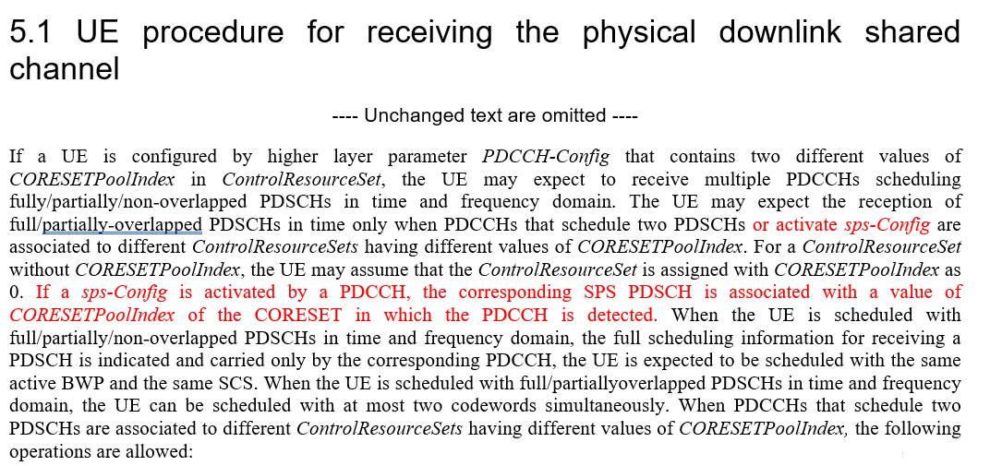  - Qualcomm (R1-2008610) proposed Clarification that the RV sequence used across multiple repetitions in schemes 2b, 3, and 4 is based on setting rvid=0. And Qualcomm also proposed TP to specify that Each SPS PDSCH is associated with a CORESETPoolIndex value, and resolving overlap procedures are done within the same CORESETPoolIndex value  - Ericsson (R1-2008637) provided TP for the change: specifies the RV values to be assumed for DL SPS scheduled with single DCI based multi-TRP PDSCH repetition schemes. To indicate RV values for DL SPS based multi-TRP PDSCH repetition schemes, a similar approach to what is adopted for Rel-15 based DL SPS PDSCH repetition is reused.  FL note: supporting mTRP SPS seems to be optimization | Samsung, LGE, Qualcomm, Ericsson | N | Qualcomm: We suggest to remove the FL note as the issue is not an optimization. SPS is a basic feature, and excluding it for mTRP does not make sense to us. If there is no time in this meeting, the issue should be discussed in the next meeting.  LG: SPS transmission in M-DCI based M-TRP should be high priority as SPS PDSCHs overlapped in time cannot be supported even though a UE has capability receiving different PDSCHs at a given time.  Nokia: supporting SPS with multi-TRP was not discussed in Rel-16. May be something to add in a later release.  FUTUREWEI: this is additional feature considering Rel-16 is finished so not essential.  Ericsson: Similar view as Qualcomm. Note that the current spec allows the single DCI based multi-TRP PDSCH repetition schemes to be scheduled with CRC scrambled by C-RNTI, MCS-C-RNTI, CS-RNTI, or PDSCH scheduled without corresponding PDCCH transmission using sps-Config and activated by DCI format 1_1 or 1_2. The remaining part for single DCI based multi-TRP is to clarify which RV sequence to use. Without clarifying this further, the current spec is incompleted (i.e., SPS can be triggered via single DCI based multi-TRP but the spec is unclear on which RV sequence to use). If we don’t have time to discuss this in this meeting, we can discuss in future meeting. Note from FL should be removed.  Samsung: Suggest changing to ‘H’. SPS is supported already in S-DCI based M-TRP. There’s no reason to exclude SPS for M-DCI based M-TRP only.  MediaTek: OK to discuss  CATT: agree with FL.  NEC: Support to discuss.  Spreadtrum: Ok to discuss
MT.13 | The issue of PUCCH/PUSCH overlapping with two HARQ-ACKs associated with different TRPs  - OPPO (R1-2008211) and vivo (R1-2008675) proposed to specify in 38.213 that this case is not expected by the UE  FL note: it can be resolved by system implementation. | OPPO, vivo | N | This is high priority for us. There are commercial interest of deploying MDCI MTRP. For device to support MDCI MTRP, it is very likely that the UE needs to support separate HARQ-ACK PUCCH, to accommodate the non-ideal backhaul of NW. We need to have UE UL multiplexing rule clearly defined.  We propose this to be “H”, replacing UL.2  LG: Agree with FL’s assessment  Nokia: agree with FL.  OPPO: We think this issue is critical to avoid a hole in the spec otherwise the UE behavior is unclear when the case occurs. Agree with Apple to place this to H.  FUTUREWEI: not essential  CATT: agree with FL.
MT.14 | The issue of closed-loop power control in mTRP  - OPPO (R1-2008211) proposed to specify a default closed loop index for CORESETPoolIndex = 1 related with out-of-order operation.  - OPPO (R1-2008211) proposed to specify the default pathloss for mTRP case.  FL note: The issue of closed-loop power control related with out-of-order was discussed in last meeting and some companies commented there is no spec impact | OPPO，Huawei, HiSilicon (R1-2008796) | N | LG: Agree with FL’s assessment  Nokia: agree with FL.  Huawei, HiSilicon: please find Huawei’s TP in R1-2007896 for the issue as well.  OPPO: If this TP is not agreed, some modification is needed on the note in FG 16-2a-3, otherwise M-DCI based M-TRP can hardly work when UE reports support of UL out-of-order.  FUTUREWEI: agree with FL  CATT: agree with FL.
MT.15 | The issue of active BWP in M-DCI mTRP system:  - Lenovo/MOT (R1-2008293) proposed that If a UE detects two DCIs indicating a same active DL BWP change in a same slot, the UE is not required to receive or transmit in the cell during a time duration from the end of the third symbol of a slot where the UE receives the DCI until the beginning of a slot indicated by the smaller slot offset value of the time domain resource assignment fields in the two DCI  FL note: It seems to be further optimization. Comment from companies in previous meeting is this is not an issue. | Lenovo/MOT | N | LG: Agree with FL’s assessment  Nokia: agree with FL.  FUTUREWEI: agree with FL  Ericsson: agree with FL  CATT: agree with FL.  NEC: Support to discuss.
MT.16 | CR on maximum number and index value of CORESET in M-DCI mTRP:  - Huawei (R1-2008325) proposed the TP on maximum number of CORESETs:  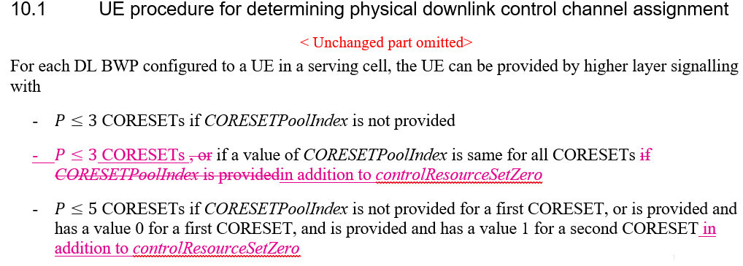  - Huawei (R1-2008326) proposed the TP on index value of CORESETs:  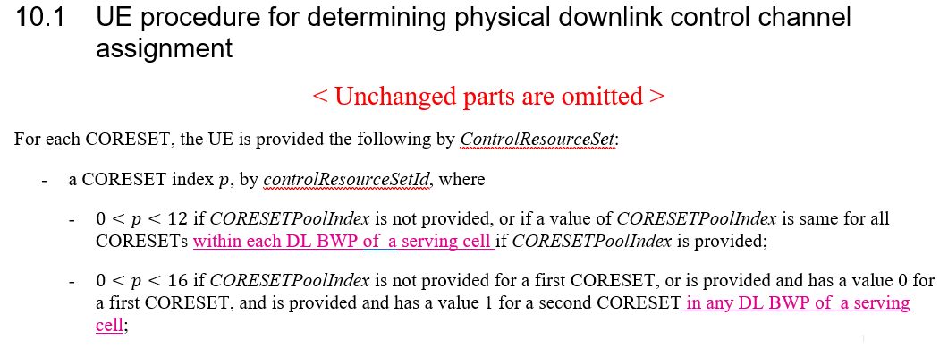  Note: the current spec looks clear | Huawei.HiSilicon | N | LG: Agree with FL’s assessment  Nokia: not an essential correction to the specs. Open to discuss only for clarification purpose.  Huawei, HiSilicon: Prefer to discuss this TP due to following UE capability note:  “Note: RAN1 will continue discussing how the network will interpret the signaled maximum number of CORESETs in components (1) and (2) (i.e., candidate value 5 for component (1) and candidate value 3 for component (2)) of FG 16-2a, e.g., when CORESET #0 is not configured”.  FUTUREWEI: Ok to discuss.
MT.17 | The issue of sub-slot based HARQ-ACK feedback vs M-DCI mTRP:  - Apple (R1-2008436) propose to clarify whether sub-slot based HARQ-ACK feedback can be used in M-DCI mTRP | Apple | N | Apple: We also proposed to clarify whether two HARQ-ACK codebooks with different priorities can be used with MDCI MTRP.  This is high priority for us.  There are commercial interest of deploying MDCI MTRP, so the UE may support MDCI MTRP.  On the other side, the UE may also choose to support some Rel-16 eURLLC HARQ-ACK PUCCH enhancement including (1) sub-slot based HARQ-ACK PUCCH (2) two HARQ-ACK codebook with different priorities  There has not been any discussion in terms of the interaction between eURLLC enhancement and MDCI MTRP. It has UE implementation impact.  We propose this to be “H”, replacing UL.2 together with MT.13  LG: Agree with FL’s assessment  Nokia: sub-slot based HARQ-ACK already supported with multi-TRP. No additional specification or UE capability discussions are essential at this stage.  vivo: we also find the conflicts in 38.213 for sub-slot support and separate HARQ-ACK feedback. We agree to resolve this issue.  FUTUREWEI: Ok to discuss.  Ericsson: Similar view as Nokia. No need to discuss additional specification or UE capability.  NEC: discuss in Rel-17.
MT.18 | The issue of BFR in mTRP:  - Qualcomm (R1-2008610) proposed to specify that for S-DCI mTRP, after BFR, the UE reset all the TCI state point to the qnew.  Note: rel17 is discussing BFR in mTRP now. | Qualcomm | N | Qualcomm: What is being discussed in Rel. 17 is per-TRP BFR. The issue mentioned in MT. 18 is not related to Rel. 17. Our understanding is that this issue is critical and should be assigned high priority. The issue is that in current spec, there is no way for UE and gNB to communicate after BFR in certain cases for single-DCI based mTRP.  LG: Agree with FL’s assessment  Nokia: This should be considered in rel17 that considers the mTRP BFR.  FUTUREWEI: This is part of R17 discussion already.
MT.19 | The issue of NR-DC and M-DCI based mTRP  - Qualcomm (R1-2008610) proposed to clarify BD/CC limit in the presence of NR-DC in M-DCI based mTRP system  Note: optimization | Qualcomm | N | Qualcomm: We suggest to remove the FL note as the issue is not an optimization. NR-DC is a basic feature, and excluding it for mTRP does not make sense to us. If there is no time in this meeting, the issue should be discussed in the next meeting. If we decide to address issue MT. 9, it can be bundled with this issue.  LG: Agree with FL’s assessment  Nokia: not an essential correction.  FUTUREWEI: not essential
MT.20 | Quectel (R1-2008569) proposed a TP to delete redundant text:  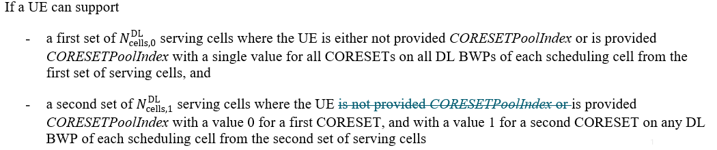  Note: It looks like that the text does not have redundancy. | Quectel | N | LG: Agree with FL’s assessment  Nokia: agree with FL.  FUTUREWEI: agree with FL
UL.1 | Port coherence assumption in UL full power Mode1  FL note: This has been discussed for several meetings | ZTE | N | Qualcomm: this is non-essential issue.  LG: Agree with FL’s assessment  ZTE: We believe this issue should be High priority (H), and which is essential to enhance the clarity of the current specifications.  - When the UE implements codebook based PUSCH transmission with full power Mode 1, the NW will assume that the relative phase indicated by additional allowed TPMIs can be ensured and the Tx power should be 23dBm. Correspondingly, the NW will configure the parameters of (the number of RBs) and (related to MCS level) based on the Tx power with 23dBm. However, in practice, the non-coherent and partial-coherent UEs cannot ensure the relative phase indicated by the additional allowed TPMIs of Mode 1, that means the actual Tx power is not equal to the full power in Mode 1. From the perspective of specifications, in order to keep the alignment of UE and NW that the relative phase among non-coherent Tx ports is random/uncontrolled, this issue should be addressed.  vivo: this has been discussed in several meetings, agree with FL’s assessment  FUTUREWEI: no need to discuss  Ericsson: Think this can be H3 in principle, but following the feature lead guidance regarding adding ‘H’s, we are OK to discuss in a later meeting. We agree with ZTE that port coherence should be clarified for Mode 1, but this issue does not seem as important to tackle at this meeting as UL.2 and UL.4.
UL.2 | PTRS port assumption in the case of rank-1 full coherent TPMI and 2 PTRS ports  FL note: This has been discussed in last meeting. | CATT, Huawei, HiSilicon (R1-2008796) | H(?) | Apple: We do not need to discuss this. It has been discussed in the last meeting and the UE behavior is clear. Or we can clarify it with “H2”  Qualcomm: this issue should be non-essential. Actually, based on our study which was already shared in last meeting, this is even not an issue. There is no problem in current spec for PTRS port association in this case. There is no need to discuss this not-existing “issue”.  LG: Fine to further discuss this  ZTE: We think this issue should be Non-essential (N).  - As we have discussed of this issue in last meeting, from the perspectives of specifications and implementation, the number of configured PT-RS ports of non-coherent and partial-coherent UE in Mode 1 is correct and clear.  vivo: this has been discussed in last meeting, and looking at comments above there is no consensus,  Huawei, HiSilicon: The mapping between 2 port TRS and coherent TPMIs are not defined for Mode-1. Please note that in Rel-15, only one port PTRS port can be used for full coherent TPMIs. (see the detailed discussion in R1-2008796) So, we need to clarify whether support 2 port PTRS for Mode-1 and how to support, otherwise the spec is ambiguity for Mode-1.  FUTUREWEI: Ok to discuss.  Ericsson: Ok to discuss at this meeting, and think it is ‘H2’.  MediaTek: okay to discuss  CATT: Our understanding is that 38.211 does not support the case of a single layer transmission with two PTRS ports, so the UE behavior is missing for mode 1 when coherent TPMI of rnak-1 is scheduled.
UL.3 | UL full power and single port SRS configuration  FL note: This has been discussed for several meetings. | Spreadtrum | N | Qualcomm: this issue is not essential.  LG: Agree with FL’s assessment  vivo: Agree with FL’s assessment  FUTUREWEI: No need to discuss  Ericsson: As discussed in last meeting, while we think that proponents have a point, there does not seem to be a need to define single port operation for Mode 1. Therefore, we do not think this is an essential correction.  MediaTek: Agree with FL’s assessment  Spreadtrum: Indeed, it seems to be common understanding that there is no need to support higher layer parameter ul-FullPowerTransmission-r16 set to ‘fullpowerMode1’ and SRS-ResourceSet with usage set to ‘codebook’ with single port SRS resource for one UE are configured simultaneously. But if we check the current specification, we will find that Current TS38.214 g30 still allows UE to be configured with single port SRS resource with usage as codebook and fullpowerMode1 simultaneously. But current TS38.213 g30 has not provided solution to power scaling for fullpowerMode1 for the case where single port SRS resource with usage as codebook is configured. Thus, the UE behavior is not clear when single port SRS resource with usage as codebook and fullpowerMode1 are configured simultaneously.  Thus, we think at least one clarification is needed. That the issue treated as H2 is ok for us.
UL.4 | To capture TPMI groups in spec. (Samsung proposes to capture in 38.214, LG proposes to capture in 38.306) | Samsung, LG | H | Apple: Okay  Qualcomm: This issue is not essential. This is just about where to capture existing agreement. RAN1 should spend time on more important issues in Rel-16 MIMO maintenance. Regarding where to capture the agreement, we think it should be captured in 38.306 because this is about UE capability reporting.  LG: Support  vivo: maybe 38.306 is better place to capture  Huawei, HiSilicon: Need to be discussed.  OPPO: Agree with Qualcomm. No needed to discussion in RAN1. The TPMI groups are related to UE capability. Therefore, it should be captured in TS 38.306  FUTUREWEI: Agree to discuss  Ericsson: Agree with ‘H’ designation; this is a hole in the specs. Would like to further discuss which specs it should be captured in.  Samsung: Support  MediaTek: 38.306 will be better.

- Discussion and proposal
From the inputs shared by participating companies during the preparation phase, the following observation can be made:
- The following four issues can be designated as H2 (editorial TPs that can be agreed without further email discussion): ...
- The following five issues can be designated as essentially uncontested H: ...
- The following issues can potentially be designated as H (although contested): ...
  - XYZ

In light of the above observations, the moderator makes the following proposals:
- XYZ

Appendix A: ...

References
1 | R1-2007748 | Maintenance of multi-beam operation | ZTE
2 | R1-2007749 | Draft CR on UL full power transmission Mode 1 | ZTE
3 | R1-2007750 | Maintenance of Multi-TRP enhancements | ZTE
4 | R1-2007818 | Discussion on remaining issues of multi-TRP/panel transmission | CATT
5 | R1-2007819 | Correction on PTRS for UL full power transmission | CATT
6 | R1-2007820 | Remaining Issues on multi-beam operation enhancement | CATT
7 | R1-2007909 | Correction on L1-SINR Resource Setting | FUTUREWEI
8 | R1-2007938 | Corrections to multi TRP | Intel Corporation
9 | R1-2008093 | Discussion on remaining issues for multi-TRP operation | Spreadtrum Communications
10 | R1-2008094 | Discussion on remaining issues on full TX power for UL transmission | Spreadtrum Communications
11 | R1-2008139 | On maintenance of Rel.16 multi-beam operation | Samsung
12 | R1-2008140 | Summary for Rel.16 NR eMIMO maintenance | Moderator (Samsung)
13 | R1-2008141 | On Rel.16 multi-TRP/panel transmission | Samsung
14 | R1-2008142 | On UL full power transmission | Samsung
15 | R1-2008211 | Text proposals for enhancements on multi-TRP and panel Transmission | OPPO
16 | R1-2008212 | Correction for default TCI state of AP CSI-RS for M-TRP | OPPO
17 | R1-2008213 | Text Proposals for Multi-beam Operation Enhancement | OPPO
18 | R1-2008293 | Maintenance on multi-TRP operation | Lenovo, Motorola Mobility
19 | R1-2008324 | Correction on L1-SINR reporting | Huawei, HiSilicon
20 | R1-2008325 | Correction on the maximum number of CORESETs for Multi-DCI Transmission | Huawei, HiSilicon
21 | R1-2008326 | Correction on the index value range of CORESET for Multi-DCI Transmission | Huawei, HiSilicon
22 | R1-2008345 | Remaining issues on multi-beam operation | Sony
23 | R1-2008436 | Remaining issues on Rel-16 Multi-TRP enhancement | Apple
24 | R1-2008437 | Remaining issues on Rel-16 Beam Management | Apple
25 | R1-2008514 | Remaining issues on multi-beam operation | MediaTek Inc.
26 | R1-2008536 | Updated proposal of PUCCH spatial relation after CBRA-BFR in Rel.16 | NTT DOCOMO, INC, Nokia, Nokia Shanghai Bell, InterDigital
27 | R1-2008569 | Corrections on Multi-TRP PDCCH | Quectel
28 | R1-2008570 | Draft CR on multi-TRP/panel transmission | LG Electronics
29 | R1-2008571 | Draft CR on beam management | LG Electronics
30 | R1-2008572 | Text proposals on full Tx power UL transmission | LG Electronics
31 | R1-2008610 | Remaining Issues on Multi-TRP Enhancements | Qualcomm Incorporated
32 | R1-2008611 | Remaining issue on multi-beam operation | Qualcomm Incorporated
33 | R1-2008635 | Draft CR on TCI states for Aperiodic CSI-RS | Ericsson
34 | R1-2008637 | Draft CR on DL SPS based PDSCH repetitions | Ericsson
35 | R1-2008638 | Draft CR on TCI state codepoint mapping for DCI format 1_2 | Ericsson
36 | R1-2008640 | Draft CR on QCL terminology alignment | Nokia, Nokia Shanghai Bell
37 | R1-2008641 | draft CR on higher layer parameter enabling L1-SINR operation procedures | Nokia, Nokia Shanghai Bell
38 | R1-2008674 | Remaining issues and corrections on multi beam related issues | vivo
39 | R1-2008675 | Corrections on multi TRP related issues | vivo
40 | R1-2008676 | Miscellaneous corrections on power control | vivo
41 | R1-2008723 | Maintenance of Rel-16 Multi-TRP operation | Nokia, Nokia Shanghai Bell

