3GPP TSG-RAN WG4 Meeting #117 R4-2522269

Dallas, USA, Nov. 17-21, 2025

Agenda item: 8.1
Source: Feature lead (China Telecom)
Title: WF on [117][104] 6G spectrum
Document for: Information

Introduction
At RAN4#116 a plan R4-2511652 for the 6G study in RAN4 was presented by the RAN4 chair. One of the topics was “Spectrum” with a scope listed as Band/band combination definition and simplification, Definition of frequency ranges and Spectrum related regulatory survey.
In RAN4#116bis the spectrum was firstly discussed and reach some agreements as captured in the WF of R4-2514626, which further clarifies the scopes of the 6G spectrum discussion.
According to agenda of RAN4#117 meeting and WF above mentioned, the topics/sub-topics for 6G spectrum are listed as follows:
- Topic#1: Band/band combination definition and simplification
- Topic#2: Definition of frequency ranges
- Topic#3: 6G spectrum related other aspects, including the regulatory status survey

Topic #1: Band/band combination definition and simplification

Open issues summary

Sub-topic 1-1: Bands naming and Bands Number range
Issue 1-1-1: 6G Bands Naming Convention
- Proposals
  - Proposal 1: It is proposed to adopt “s” as 6G band prefix.
  - Proposal 2: All of the 6GR band numbers should be written with a new prefix, such as ‘r’, ‘s’, ‘z’.
  - Proposal 3: The prefix of the 6G bands could be “r”.
  - Proposal 4: For 6GR operating band naming re-use prefix concept from NR but replace “n” with “s”.
  - Proposal 5: Decide if “s”, “t”, or “g” is used as prefix
  - Proposal 6: Use the “s” prefix to differentiate 6G bands from LTE/NR bands (keeping the same band numbering between RATs).
Agreement: use letter “s” as the prefix for 6G bands

Issue 1-1-2: 6G Bands Number Range
- Proposals
  - Option 1: RAN4 shall define a new number range for 6G bands for new frequency range.
  - Option 2: RAN4 shall re-use the NR number range for 6G bands.
    - a) All numbers from 1-512 can be reused for 6G bands.
    - b) RAN4 can request to RAN2 extend the band number bit with 10 bits from 9 bits if needed.
    - c) The band numbers of refarming bands in 6GR should be same with the band numbers of 5G NR

Agreement:
  - It is agreed to re-use the NR number range for 6G bands including both 5G refarming bands and new 6G bands. Both TN and NTN bands are covered by this agreement.
    - The band numbers of refarming bands in 6GR should be reused as much as possible.
      - It is not precluded to enhance the band numbers of 6G over 5G NR.
      - FFS on how to define the band numbers for the bands which are partially or fully overlapped, including both TN and NTN bands.
        - Potential regulatory requirement difference should be taken into consideration.

Sub-topic 1-2: Band and Band combination introduction/simplification
Issue 1-2-1: Band introduction
- Proposals
  - Option 1: RAN4 to further evaluate NR refarming bands into 6GR as case-by-case manner instead of inheriting all the bands from 5G to 6G.
    - The consideration factors include commercial deployment status, operator’s request.
                - New 6GR bands should be introduced on “first come first served” basis
  - Option 2: RAN4 to consider a new frequency band definition, which is a continuous spectrum segment that can be configured to support uplink, downlink, or both, without UL operating band and DL operating band pairing.

Agreement in Ad Hoc:
- Introduce the 6G bands by considering the following option.
  - RAN4 to further evaluate NR refarming bands into 6GR as case-by-case manner instead of inheriting all the bands from 5G to 6G.
    - The consideration factors include commercial deployment status, operator’s request.
                - New 6GR bands should be introduced on “first come first served” basis
  - For 6G band definition
    - FFS on how to harmonize bands which are partly overlapping and subset.

Issue 1-2-2: Band combination introduction
- Proposals
  - Option 1: RAN4 to consider transferring existing NR band combinations to be applicable also for 6G.
    - a) Applicable requirements are FFS
    - b) Applicable requirements are also transferred from NR
  - Option 2: RAN4 to define 6G band combinations only based on request, meaning no band combinations will be automatically supported.
    - Focus on the band configurations for real deployment
  - Option 3: Besides database BC simplification approach, RAN4 to study the Band Group Concept to structure the RF requirement improvement and corresponding UE behavior under CA structure
    - Note that the Band Group Concept is not a replacement to normal CA.
    - No restriction on operators’ request on band combination
Agreement in Ad Hoc:
- For band combination introduction in 6G: RAN4 will study and define 6G band combinations per the request, meaning no 5G band combinations will be automatically transferred to 6G. .
  - FFS how to handle operator request to transfer 5G combination to 6G
  - FFS on how to port 5G combinations to 6G
- RAN4 to study the Band Group Concept to structure the RF requirement improvement
  - Concept of band group includes RF requirements simplifications and FFS on whether include RF architecture assumptions.
  - Note that the Band Group Concept is not a replacement to normal CA.
  - No restriction on operators’ request on band combination

Issue 1-2-3: Meanings/benefits for band combination simplification
- Proposals
  - Option 1: Simplification of specification means how the specification can be made leaner and simpler to understand
  - Option 2: Simplification of the UE complexity means reducing the RF front end complexity
  - Option 3: Simplification of UE capability signalling and reporting
  - Option 4: Simplification of UE conformance test
  - Option 5: Reduce Insert Loss from RF front-end and increase UE MOP and REFSENS
  - Option 6: Can achieve higher possible antenna gain at given antenna size with supported relative frequency width compared between inter-band CA and single band
  - Option 7: Can improve coverage and throughput with more suitable RF resource allocation for the bands falling in different band groups especially for mid and high frequency bands with larger channel bandwidth at given number of RF paths
  - Option 8: Greatly reduce RAN4 workload and meeting cycle when introduction a new band combination
Tentative Agreement:
The BC simplification will primarily focus on how to
- Improve the procedure, if feasible, to introduce BC compared to 5G
- Make the spec leaner and simpler to understand
- Simplify UE conformance test
It is noted the market needs and the related proposals by the operators should not be sacrificed. RAN4 will further study how to maintain the reasonable workload and meeting cycle when new BC is introduced.

Sub-topic 1-3: Band Group Concept for band combination simplification
Many companies propose to assign fixed frequency ranges for band group categories, however some point out there may be some disadvantages such as restriction of UE implementation, difficult to define the boundary of the group categories. Some propose to define the range based on operators/vendors’ request which intends to address the above concerns.
Issue 1-3-1: Frequency ranges for band group
- Proposals
  - Option 1: Define frequency range of band group based on division of the specific frequency range.
  - Option 2: Defined frequency range of band group based on operators/vendors’ request.
- Recommended WF
  - TBA

Some have concern that band group combination concept will restrict the band combination numbers within one band group, as only one band is allowed in one group. Some propose to adopt ‘switching’ function within one band group. Some propose to still allow CA within one band group.
Issue 1-3-2: Restriction for band group
  - Option 1: Within one band group, restrict only one band can be scheduled for UL/DL transmission at a time with exceptional cases of commercialized band combinations and operators’ request
    - Study how to support switching UL/DL transmissions between bands
  - Option 2: Not restrict which band combinations can be specified i.e. bands also within band group can be aggregated like in 5G
- Recommended WF
  - TBA

Issue 1-3-3: UE behaviour and RF requirements impact under band group concept
- Proposals
  - Proposal 1: (if band group concept is adopted) Study band group concept aiming to minimize the performance degradation from normal carrier aggregation so that both coverage and throughput performance can be improved at least for the bands within the same group. Following aspect can be taken into consideration as starting point.
    - If carrier aggregation is configured for bands within a band group, study how to support switching UL/DL transmissions between each two of the bands and how to improve the UL/DL performance by e.g. delta Tib/Rib, MSD etc.
    - Otherwise, study based on normal CA operation UE behavior and RF requirements

- Recommended WF
Chair: Band group discussion will be handled in the 6G spectrum thread.
Following aspects are taken into consideration for band group concept study
  - Frequency ranges for band group
  - Restriction for band group including how to support switching UL/DL transmission between each two of the bands within one band group
  - Impacted requirements such as delte Tib/Rib, MSD etc.

Sub-topic 1-4: Bandwidth Combinations Sets (BCS) in 6G
In 5G, the BCS 4&5 method is introduced to indicate UE support all channel bandwiths for the CA which is inherited from the comprised single bands. Therefore, some are proposing to abandon the BCs concept in 6G.
Issue 1-4-1: Bandwidth Combinations Sets (BCS) in 6G
- Proposals
  - Option 1: RAN4 shall not use Bandwidth Combinations Sets (BCS) in 6G
  - Option 2: RAN4 shall further investigate the need for Bandwidth Combinations Sets (BCS) in 6G
  - Option 3: RAN4 shall introduce Bandwidth Combinations Sets (BCS) in 6G
- Recommended WF
  - TBA

Sub-topic 1-5: ∆TIB and ∆RIB in 6G
In last meeting, RAN4 have agreement that RAN4 shall discuss ∆TIB requirements under the 6G general RF and UE RF agenda. It is not precluded to discuss band combination related structure/use of the ∆TIB requirements under this agenda, i.e. simplification of its use. However, there are still companies proposing their views on ∆TIB and ∆RIB. Thus, we just open the floor to decide if continue the discussion.
Issue 1-5-1: ∆TIB and ∆RIB in 6G
- Proposals
  - Option 1: It must be firstly determined, in the UE RF thread, whether the ∆TIB and ∆RIB requirements will be removed from CA requirements or kept, before discussing any kind of simplification in this thread.
  - Option 2: Continue discuss in this thread on improve/simplify the ΔTIB/ΔRIB.
- Recommended WF
  - TBA

Issue 1-5-2: Improvement on ∆TIB and ∆RIB in 6G
- Proposals
  - Option 1: Check the relevance of continuing to define the ΔTIB and ΔRIB insertion loss values
  - Option 2: To improve/simplify the ΔTIB/ΔRIB requirements based on PRD guidance.
  - Option 3: Retain the concepts of TIB and RIB and discuss the simplification method based on ‘band group’ concept.
  - Option 4: Develop a unified and simplified framework for defining delta Tib/Rib values
- Recommended WF
  - TBA

Topic #2: Definition of frequency ranges

Companies’ contributions summary
T-doc number | Company | Proposals / Observations
R4-2520133 | CATT | Proposal 13: The definition of frequency ranges is shown in table 3.  The demarcation point can be set at 10 GHz. Frequencies below this point fall into the FR1 range, while those above it fall into the FR2-1 range.
R4-2520307 | KDDI Corporation | Proposal 3: Study the frequency ranges considering frequencies used first time in 6G and the progress/outcomes of the ongoing regulatory discussions.
R4-2520328 | Huawei, HiSilicon | Proposal 1-2: RAN4 to conduct studies pertaining to the TN frequency range from a UE and BS implementation perspective, particularly regarding the applicability of conducted requirements.  Observation 1-5: Definitions of FR1 and FR2 frequency ranges for TN and for NTN is already mis-aligned.  Observation 1-6: NTN specification (of FR1-NTN and FR2-NTN) does already cover 7 – 24 GHz range.  Observation 1-7: Range of 10700 – 14500 MHz is already specified to FR2-NTN.  Proposal 1-3: Refrain from introducing FR3 to cover any frequency range within 7 – 24 GHz.  Proposal 1-4: In 6G, keep separate discussion of frequency ranges of TN and NTN.
R4-2520359 | Samsung | Proposal 5: For frequency range definition/separation, following new options (i.e., Option 9a/b) are proposed, by considering single-SCS principle and UE RF front-end architecture.
R4-2520508 | Xiaomi | Observation 3-1: NR divided frequency range majorly based on applicable numerologies sets and UE RF front-end architecture (conductive vs radiated requirements)  Proposal 3-1: RAN4 consider UE RF front-end architecture (e.g., whether requirements can be verified conducted or not) as major principle for FR definition.  Observation 3-2: On 7-24 GHz, depending on frequency with initial survey on UE RF front-end architecture:  - For below10GHz, FR1 like is feasible with antenna connector  - For above 15GHz, FR2 like is most likely with integrated RF front end  - 10GHz ~ 15GHz, unclear mixed UE architectures probably exist for same frequency  Observation 3-3: on conductive and radiated requirement applicable rule, RAN4 can further discuss following different UE requirement types:  - UE type C: only digital BF with omnidirectional antenna performance and antenna connector  - UE type H: Hybrid, conductive requirements can be applied on RIB and OTA requirements plus  - UE type O: OTA requirements only with analog BF, FR2 like requirements  Proposal 3-2: two alternative approaches can be considered for frequency range definition and extension:  - Alt 1: Extend FR1 and FR2 to cover 7-24GHz with overlapping range  - Alt 2: Introduce dedicated FR3 frequency with hybrid requirements pending on device type  Proposal 3-3: At least FR1 can be further extended to 8.4GHz, dedicated sub-frequency range can be introduced for 7.125~8.4GHz i.e., “FR1-1”.  Proposal 3-4: Other frequency between 7-24GHz can be kept open until regulation on spectrum arrangement is clear.
R4-2520602 | Apple | Proposal 2a: As a starting point, existing FR1 and FR2 frequency ranges can be also considered for 6G.  Proposal 2b: FR1 frequency range can cover existing frequencies up to 7.1GHz and can be extended, if needed, to higher frequencies subject for further decisions in the regulatory domain.  Proposal 2c: FR2 frequency range can cover existing frequencies at 24.2-52.6GHz.  Proposal 3a: Introduction of a new frequency (sub-)range should be well justified by considering various factors including UE RF architecture, physical layer design and performance requirements verification.  Proposal 3b: UE RF architecture is one of the key factors to decide whether a new frequency range is needed or not.  Proposal 3c: Other factors, such as system parameters, can be taken into account to decide whether we need sub-ranges as 3GPP did in the past for FR2-1 and FR2-2.
R4-2520767 | Spreadtrum,UNISOC | Proposal 1: Proposed Frequency ranges in Fiugre1 in 6GR can be a starting point, the boundary (e.g., 15GHz) between FR3 and FR2-1 can be further studied.
R4-2520818 | MediaTek Korea Inc. | Proposal 2: Based on our preference of the criteria on the frequency range definition, we support option 3 as baseline in 6G study item phase. It will be decided the detail X frequency in WI phase.
R4-2520866 | China Telecom | Proposal 1: option 2 that define new name for 7125MHz- 24250MHz is our preference, unless technical analysis shows extension of FR1 or FR2 is beneficial to implementation.
R4-2520904 | Skyworks Solutions Inc. | Proposal: For 6G, do not introduce a new FR. Consider instead:  - Increasing the FR1 upper edge to a new limit “Y” greater than the current limit of 7125 MHz.  - Decreasing the FR2 lower edge to a new limit “X” smaller than the current limit of 24250 MHz.  FFS the following values of X and Y based on practical considerations for handheld UEs: 10 GHz for X and 15 GHz for Y. These limits may be further discussed to ensure that the new FR1/FR2 limits account for all types of 6G UEs (e.g., FWA, vehicles, etc.).
R4-2521282 | ZTE Corporation,Sanechips | Proposal 1: Postpone the discussion on FR extension and focus on the relevant technical discussions in 6G SI phase.  Proposal 2: RAN4 shall not use ‘FR3’ name before the detailed frequency range is concluded, instead of using “around 7GHz” or ‘around 15GHz’ for technical discussion.
R4-2521398 | LG Electronics Inc. | Proposal 1. It is reasonable to consider defining the frequency range between FR1 and FR2-1 as a range where one transmit chain can be connected to multiple radiating elements via a passive power divider in order to compensate for path loss.  Proposal 2. Lowering the FR2-1 frequency range is worth considering. While a reduced frequency increases antenna dimensions in AIP (Antenna in Package) modules, making practical PCB-edge integration more difficult yet still feasible, it becomes viable for commercial use in Semi-AIP (Semi-Antenna in Package) modules due to advantages such as integration with the phone structure and improved mechanical stability.  (ex). FR2-1: 24.125 15GHz  Proposal 3. At present, it is reasonable to consider extending the FR1 frequency range upward to around 10 GHz, and it can be used up to 15 GHz as well, since the mate height and cable dimensions of mobile connectors are within 1 mm, making them suitable for mounting in high-end mobile phones.  (ex). FR1 : 7.125 15GHz  Proposal 4. Assuming there is a path loss issue from around 7 GHz and above, FR1 can be divided into FR1-1 and FR1-2. FR1-1 would consider the basic structure with an antenna directivity of 0 dBi, while FR1-2 could consider antennas with directivity. The reason is that the path loss in the FR1-2 band is greater than that in the FR1-1 band.  (FR1 Devide region FR1-1 & FR1-2)  Proposal 5. The FR1‑2 region appears to be almost impractical to use for beamforming/beamsweeping with an array configuration, due to reliability issues arising from array size and mechanical structural constraints. Furthermore, when using the existing basic structure with an antenna directivity of 0 dBi, there seems to be no suitable method to compensate for the increased path loss.
R4-2521451 | OPPO | Frequency ranges  Observation 1: Adopting SAR or MPE limitation for the given frequency depends on the depth of penetration of the EMFs.  Observation 2: ICNIRP uses 6GHz as the boundary of SAR or MPE limitation, and account for focused beam exposure above 30GHz.  Proposal 1: Both of SAR and MPE are tested through OTA, SAR/MPE shouldn’t be the limit factors of frequency range definition.  Observation 3: BS type 1-H can adopt conducted requirements and OTA requirements separately based on different boundaries.  Proposal 2: For UE and BS, the key difference between adopting conducted requirements and radiated requirements lies in whether conducted connectors can be obtained.  Observation 4: For 4400-4800 MHz and 7125-8400 MHz, there is no concern that the UE can have a conducted isotropic radiation pattern antenna interface.  Observation 5: The size of single element for 15GHz is 10mm and the array length of 15GHz band is 40mm.  Proposal 3: It is possible for 15GHz to obtain conducted connector and adopt conducted test.  Proposal 4: Numerology will not impact the frequency range definition.  Proposal 5: The key criteria for frequency range definition are whether the conducted connector can be obtained.  Proposal 6: 15GHz to 24GHz shouldn’t be considered in TN frequency range definition in 6G day one.  Proposal 7: Extended FR1 up to 15300MHz and FR2-1 keeps 24250-52600 MHz as NR FR2-1, as shown in Figure 2.
R4-2521594 | Nokia | Observation 1: FR2 is separated into two sub-ranges FR2-1 and FR2-2, where FR2-2 currently is only for unlicensed deployment of NR.  Proposal 1: RAN4 shall excluded the FR2-2 range from the discussions in alignment with the SID.  Observation 2: NR currently has multiple frequency range definitions dependent on not only frequency range but also deployment type. The frequency ranges defined for TN deployments are not aligned to those defined for NTN deployments.  Observation 3: Other WGs are already using sub-ranges of the current frequency ranges for discussion.  Proposal 2: RAN4 shall conclude that a band around 7 GHz can be included into FR1  Proposal 3: RAN4 shall consider the proposal of extending FR1 upwards and FR2 downwards to cover the frequency range between FR1 and FR2 as the basis for a 6G frequency range framework. This does not preclude the option of defining sub-ranges under FR1 and FR2.  Proposal 4: RAN4 shall consider pairing frequency sub-ranges to specified assumptions and requirements in 6GR.  Proposal 5: RAN4 shall discuss a split into multiple frequency sub-ranges spanning from around 400MHz to around 52GHz in 6GR.  Observation 4: NR concept for band numbering has proven successful and very usable. This concept means that 3G, 4G, and 5G had used same band number if frequency arrangement is same. LTE uses Arabic numeral, WCDMA uses Roman numeral and NR has prefix on “n” in front of Roman numeral.
R4-2521846 | Ericsson | Observation 1: It would be premature to investigate further regulations in the 7-24 GHz frequency range in the scope of the 6G study.  Observation 2: Discuss further how to align HPUE and PC3 work items and the meeting procedurals for them.  Proposal 1: Consider extending the FR1 frequency range upper limit at least up to 10.5 GHz.  Proposal 2: In case of RAN4 identifies the need for an overlapping of FR1 and FR2 frequency ranges, RAN4 should instead consider introducing a new frequency range FR3 corresponding to that overlapping range.  Proposal 3: Further study if FR1 should further extend up to 15.35 GHz, if FR2 should be extended down to 10.5 GHz or if a new frequency range FR3 shall be specified.

Sub-topic 2-1: Frequency Range framework
Some make the point that since we are now starting a new generation, there may not be a need to adopt the frequency ranges used by NR for 6GR. Others point out that due to co-existence would need to be alignment. An important point is that the unresolved regulatory framework for the 7-24 GHz frequency range, with critical decisions from WRC-27 scheduled post-6G study conclusion, should not hinder the progress of the design and standardization of 6G radio access technology.

Issue 2-1-1: Basis of frequency range definitions
- Proposals
  - Option 1: Extend FR1 and FR2 to “close the gap” from 7.125 – 24.25 GHz
    - Option 1a: Extended existing NR FR1 and FR2 without overlapping frequency
    - No new frequency range designation between extended FR1 and FR2
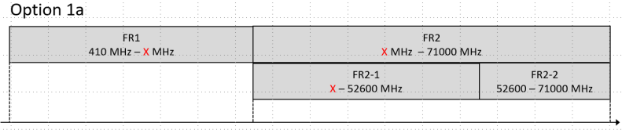
    - Option 1b: Extended existing NR FR1 and FR2 with overlapping frequency
      - No new frequency range designation for 7.125-24.25GHz
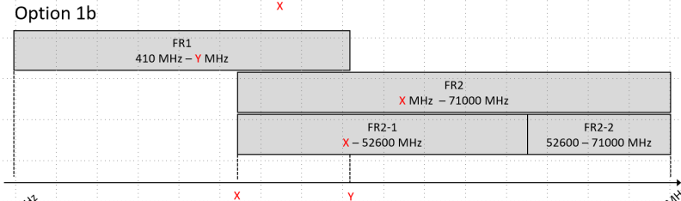
  - Option 2: Define a new frequency range for the 7.125 – 24.25 GHz and keep the current FR1 and FR2-1 definitions
  - Option 3: Extend FR1, define a new frequency range and keep FR2-1 definitions.
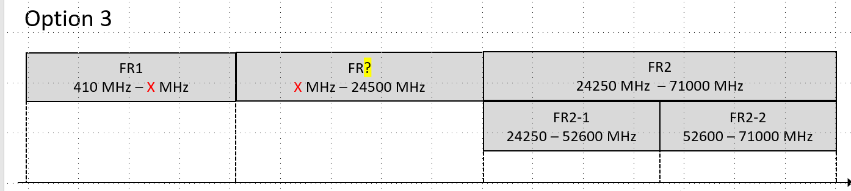
  - Option 4: Sub-divide FR1, define new frequency ranges and keep FR2-1 definitions.
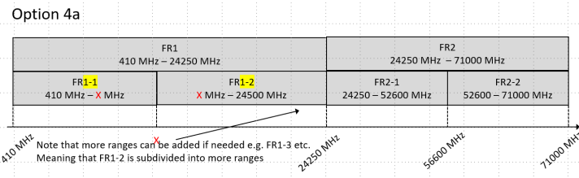
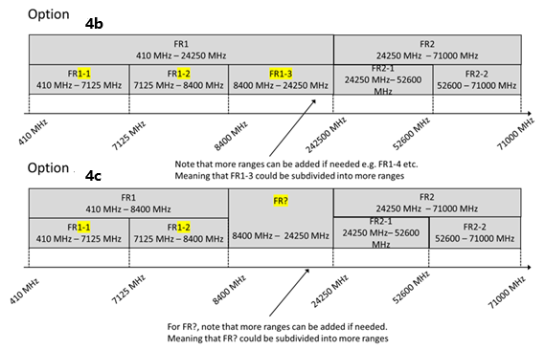
  - Option 5: Clean slate and define new frequency ranges from around 400MHz to 52.6GHz
  - Option 6: Postpone the discussion on FR1 extension
  - Option 7: Extend existing NR FR1 and FR2 to cover partial part of 7.124-24GHz
    - New frequency range designation for remaining part between extended FR1 and FR2
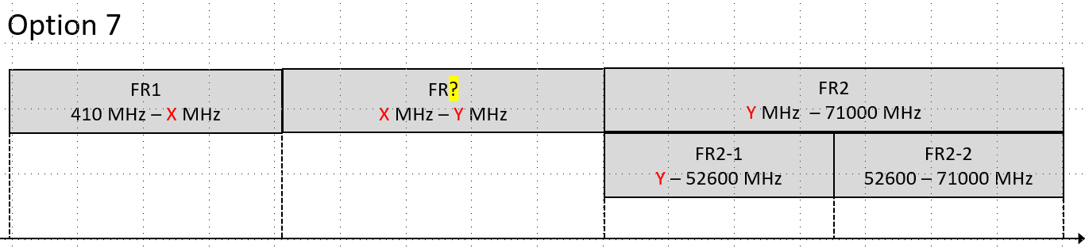
  - Option 8: Extend existing NR FR1 and FR2 to cover partial part of 7.124-24GHz
    - Sub-divide FR1, define new frequency ranges
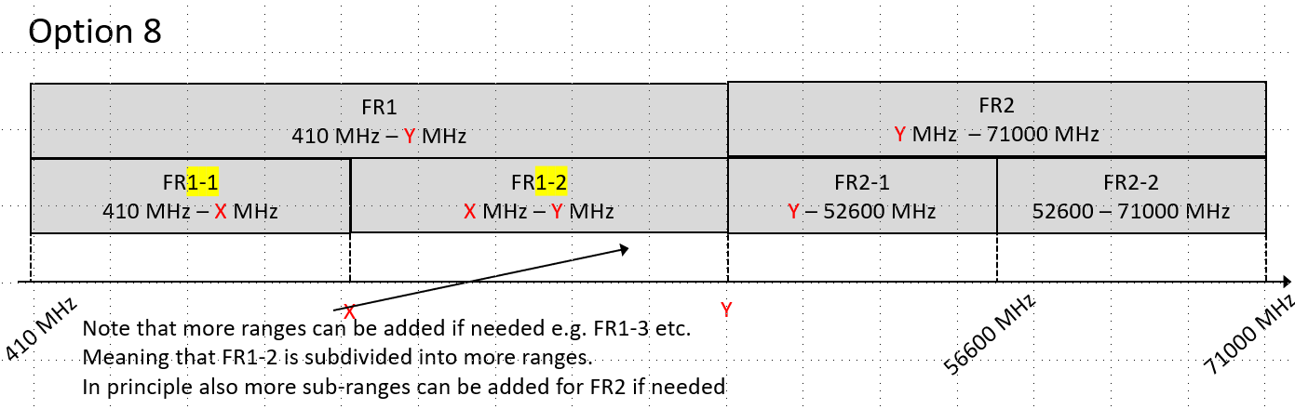
- Recommended WF

    - Option 1: Extend FR1 and FR2 to “close the gap” from 7.125 – 24.25 GHz
    - Option 3: Extend FR1, define a new frequency range and keep FR2-1 definitions.
    - Option 4: Sub-divide FR1, define new frequency ranges and keep FR2-1 definitions.
    - Option 7: Extend existing NR FR1 and FR2 to cover partial part of 7.124-24GHz
    - Option 8: Extend existing NR FR1 and FR2 to cover partial part of 7.124-24GHz
    - Option 9: Extend FR1, keep FR2-1 definitions, no to define a new frequency range
  - Observation: All the options as down select above share same extension to extend 5G FR1 frequency range to x MHz, in which x is proposed to be more or equal to 8400MHz.

Sub-topic 2-2: Frequency Range naming convention
Some have already proposed to adopt “FR3” within the 6G timeframe, while others are against using that name. In relation to this, some suggest that something else than “frequency range” should be used for 6GR.
Issue 2-2-1: Early adaptation of the name “FR3”
- Proposals
  - Option 1: RAN4 shall adapt the name FR3 and use it for the “gap” between FR1 and FR2-1 now
  - Option 2: RAN4 shall not use any names for a frequency range before it is agreed. This does not preclude adapting the name FR3 at a later stage
  - Option 3: RAN4 shall not consider the name FR3 at any point
- Recommended WF
  - Option 2 – Different companies have even for this meeting been using FR3 for different frequency ranges, so to avoid ambiguity, it is recommended to refer to a specific range, e.g. 8.4–24.25 GHz, or only already defined NR ranges as FR1, FR2-1 or FR2-2

Issue 2-2-2: Name it “Frequency Range” (FR) or something else for 6G
- Proposals
  - Option 1: RAN4 shall continue to use “Frequency Range” (FR) in 6G
  - Option 2: RAN4 shall consider a different name as e.g. “Carrier Frequency Group” or “Frequency Group Numbering”.
- Recommended WF
  - TBA

Topic #3: Spectrum related regulatory survey

Companies’ contributions summary
T-doc number | Company | Proposals / Observations
R4-2520133 | CATT | Proposal 14: The conclusions of 6G spectrum related regulatory survey are shown in table 4.
R4-2520307 | KDDI Corporation | Proposal 1: Study several candidates as 6G bands for 6.425-7.125GHz identified in WRC-23 and 4.4-4.8, 7.125-8.4 and 14.8-15.35 GHz being discussed toward WRC-27 considering the regulatory discussions are still ongoing.
R4-2520328 | Huawei, HiSilicon | Proposal 1-1: Consider at least 4.4 – 4.8 GHz, 7.125 – 8.4 GHz, 14.8 – 15.35 GHz and 6.425 – 7.125 MHz for further study with co-existence evaluation.
R4-2520433 | CMCC | Observation 1: above list the regulatory status survey of 6425-7125MHz, 4400-4800MHz, 7125-8400MHz and 14.8-15.35GHz.
R4-2520508 | Xiaomi | Observation 1-1: The ITU-R is working on searching and identification new spectrum for IMT 6G, the potential frequency bands are 4 400–4 800 MHz, 7 125–8 400 MHz and 14.8–15.35 GHz.  Observation 1-2: The sharing and compatibility studies of WRC-27 agenda item 1.7 in under study, the identification methods, requirements, and regulations for the new bands for IMT are also under discussion in ITU-R.  Observation 1-3: 6425-7125 MHz is regarded by multiple nations as the primary frequency band for 6G.  Observation 1-4: The ITU-R is working on the in-band sharing and compatibility study for searching and identification new spectrum for DC-MSS-IMT service, the potential frequency bands including the IMT bands: 694-960 MHz, 1 710-1 880 MHz, 1 885-2 025 MHz, 2 110-2 200 MHz, 2 300-2 400 MHz, 2 496-2 690 MHz.  Observation 1-5: The sharing and compatibility studies for DC-MSS-IMT, including the in-band scenario study with the terrestrial IMT to identify new spectrum to the DC-MSS-IMT system in the scenario of cross-border.  Observation 1-6: For the DC-MSS-IMT system, the criterial and mechanism for protecting IMT systems operating is still on discussion.
R4-2520767 | Spreadtrum,UNISOC | Proposal 5: 6.425-7.125GHz, 4 400-4 800 MHz, 7 125-8 400 MHz and 14.8-15.35GHz as candidate spectrum to focus on studying in 6GR.  Observation1: Based on the IEEE Standard C951 and ICNIRP and FCC, SAR can be applied in below 6GHz, MPE (PD) can be applied in above 6GHz in 6GR.  Observation2: Based on the IEEE Standard C951 and ICNIRP, Epithelial power density is 20W/m2 for persons in unrestricted environments (General public) and 100W/m2 for persons in restricted environments (Occupational).  Observation3: Based on the FCC, for occupational in above 6GHz, MPE is 5mW/cm2; for occupational in above 6GHz MPE is 1mW/cm2.
R4-2520818 | MediaTek Korea Inc. | Observation 3: The following spectrum will be considered as a IMT (6G) Candidate spectrum in region 1.  - 3.3~3.4 GHz  - 4.4 ~4.8 GHz (Russia only)  - 6.425 ~7.125 GHz  - [7.125 ~7.25GHz] if feasibility study between military service and IMT service are proved, then these frequency range can be used for IMT service. (except with 7.25~8.4GHz as military service)  Observation 4: The following spectrum will be considered as a IMT (6G) Candidate spectrum in region 2.  - 2.7 ~ 2.9 GHz  - 3.98 ~ 4.2 GHz  - 4.4 ~ 4.9 GHz  - 6.425 ~ 7.125 GHz (only Brazil, Mexico, Still further identification between WiFi and IMT in US)  - 7.25 ~ 7.4 GHz  Observation 5: The following spectrum will be considered as a IMT (6G) Candidate spectrum in region 3.  - 4.8 ~ 4.99 GHz  - 6.425 ~ 7.125 GHz (China and a few South Asia countries)  - [7.125 ~ 8.4GHz] (Korea/Japan still not decide the spectrum usage as same US)  Proposal 11: For the Upper 6GHz and the around 7GHz (7.125 ~ 8.4GHz) will consider as 6G target spectrum in early stage. The around 15GHz (10~15.35GHz) can be consider in later stage.
R4-2521282 | ZTE Corporation,Sanechips | Observation 1: There are some proposals for the spectrum in WRC-23 conference, i.e. 4.4-4.8GHz, 7.125-8.4 GHz and 14.8-15.35 GHz. However the final decisions for the IMT-2030/6G spectrum will be made in the WRC-27 conference.
R4-2521451 | OPPO | Observation 6: 6425-7125 MHz is totally overlapping with NR band n104.  Observation 7: 10-10.5 GHz with very restrict limitation, no operator will support it in 6G clearly.  Observation 8: Candidate 6G Spectrum in WRC-27 includes 6 425-7 125 MHz, 4400-4800 MHz, 7125-8400 MHz, and 14.8-15.35 GHz which also need to be studied in RAN4.  Observation 9: New spectrum range of 4400-4800 MHz has been covered by NR band n79, furthermore, band n79 will also be considered for re-farming into 6G.  Proposal 8: RAN4 should first study whether the n79 can be re-employed for 6G to cover the new 6G spectrum 4400-4800MHz.  Observation 10: For the candidate spectrum 7125-8400 MHz, NS value could be used to solve specific requirements.  Proposal 9: RAN4 should strive to define global bands for 7125-8400 MHz and 14.8-15.35 GHz for 6G.
R4-2521594 | Nokia | Observation 13: Spectrum for 6GR is based on the availability provided by international designations for IMT and regional regulations.  Observation 14: Potential new 6GR TN spectrum around is focused around 7GHz, 12GHz and 15GHz  Observation 15: ITU-R is engaging in defining the studies to evaluate the potential of the bands 4.4-4.8, 7.1-8.4 GHz and 14.8-15.35 GHz  Observation 16: FCC is assessing the potential of the bands 3.1-3.45 GHz 12.7-13.25 GHz.  Observation 17: The currently most attractive band, in our view, for 6GR studies within RAN4 is the around 7GHz band.  Proposal 7: RAN4 shall initially focus on a new 6GR band around 7GHz.
R4-2521846 | Ericsson | Observation 1: It would be premature to investigate further regulations in the 7-24 GHz frequency range in the scope of the 6G study.  Proposal 5: Postpone further regulatory survey in the 7-24 GHz frequency range until Regulators published a new decision.

This topic addresses the impact of evolving regulatory requirements on the definition and management of frequency bands for 6G. The discussions include the implications of WRC outcomes and the need for ongoing studies to ensure compliance with regional regulations. The unresolved regulatory framework for the 7-24 GHz frequency range, with critical decisions from WRC-27 scheduled post-6G study conclusion, means there are some assumptions that need to be made to progress the standardization work.

Sub-topic 3-1: New spectrum for consideration during the 6G SI
As pointed out by multiple companies, the regulatory framework will not be completely clear before the end of WRC-27. However, there are still suggestions for new spectrum/bands to consider during the 6G SI.
Issue 3-1-1: New spectrum/bands for consideration during the 6G SI
- Proposals
  - Option 1: Study candidates as 6G bands for 6.425-7.125GHz identified in WRC-23.
  - Option 2: Study candidates as 6G bands for 4.4-4.8, 7.125-8.4 and 14.8-15.35 GHz being discussed toward WRC-27 considering the regulatory discussions are still ongoing.
  - Option 3: RAN4 shall initially focus on a new 6GR band around 7GHz.
  - Option 4: Postpone further regulatory survey in the 7-24 GHz frequency range until Regulators published a new decision.
  - Option 4: The ITU-R is working on the in-band sharing and compatibility study for searching and identification new spectrum for DC-MSS-IMT service, the potential frequency bands including the IMT bands: 694-960 MHz, 1 710-1 880 MHz, 1 885-2 025 MHz, 2 110-2 200 MHz, 2 300-2 400 MHz, 2 496-2 690 MHz
- Agreement:
  - For new 6G spectrum, RAN4 shall initially focus on a new 6GR band around 7GHz.

Sub-topic 3-2: Architecture for spectrum related regulatory survey
Companies provide their survey for the candidated 6G spectrum, this sub-topic intends firstly conclude the architecture/agenda for better summary of companies’ survey input.
Issue 3-2-1: Architecture/agenda for spectrum related regulatory survey
- Proposals
  - Clause 1: 6G candidate spectrum in region 1
  - Clause 2: 6G candidate spectrum in region 2
  - Clause 3: 6G candidate spectrum in region 3
- Recommended WF
  - Encourage companies input/suggestion on above proposals.

