3GPP SA WG2#171 S2-2508987
Wuhan, China, 13-18 October, 2025

Source: Tejas Networks Limited
Title: pCR: Service aspects for Ambient IoT KI#2
Spec: 3GPP TR 23.700-30
Agenda item: 20.5.1
Work Item / Release: FS_AmbientIoT_Ph2_ARC / Rel-20
Document for: Approval

Abstract of the contribution: This contribution proposes a new solution for KI#2 for the FS_AmbientIoT_Ph2_ARC work item to support DO-A as a service.

1. Introduction
During SA2#170, KI#2 for studying system architecture aspects for rel-20 Ambient IoT was formalized in S2-2507797.
This paper proposes solutions for the following subset of the topics mentioned as part of KI#2 :
- Support for How an autonomous AIoT Device originated procedure to send data to the AIOTF autonomously.
- Naiotf, Namf and Nnef interface enhancements to support DO-A capable AIoT Device operations .
- Whether and how to consider power consumption of DO-A Capable AIoT Devices.

2. Text Proposal
It is proposed to adopt the following text within TR 23.700-30.

* * * * First Change (All New Text) * * * *

6.X Solution #X: Service aspects for DO-A traffic in Ambient IoT networks

6.X.1 High-level solution principles
The solution proposed in this paper is based on the following principles:
- A new service type “DO-A support” for enabling DO-A traffic for a certain service within the network is introduced.
- Network can simultaneously support devices that are capable of DO-A and DT traffic at the same time.
- A-IoT readers present in the network can have varying capabilities. Some of them are able to support both DO-A and DT traffic, others can only support DT traffic.
- DO-A capable devices can be configured by the network to support both DO-A traffic and DT traffic or only DT traffic at a given time.

6.X.1 Description
For supporting DO-A traffic within an Ambient IoT network, an AF should first enable the service for supporting DO-A traffic within the network. This is essential as the AIoT Readers collocated with gNB (topology 1), or UE (topology 2) may need to broadcast certain specific signals for supporting DO-A traffic. These signals are used to typically allocate radio resource e.g., Random Access Channel (RACH) resources for enabling devices to access the network.
Enabling DO-A support as a service may help in energy saving in a twofold manner viz., 1). Energy Saving at the reader by reducing D2R signalling to support DO-A whenever DO-A capable devices are not present in the network or are disabled. 2) disabling a specific DO-A service for a device for supporting reduced energy consumption in the device.
Once DO-A service is enabled, a DO-A capable device(s) can register with the core network (AIOTF) with the service ID and is authenticated. It can then request for DO-A data transfer whenever it has some data to send.

6.X.2 Procedures

6.X.2.1 Configuring the network to support DO-A support as a service
Figure 1 illustrates the call flow for enabling DO-A service in a AIoT Network.
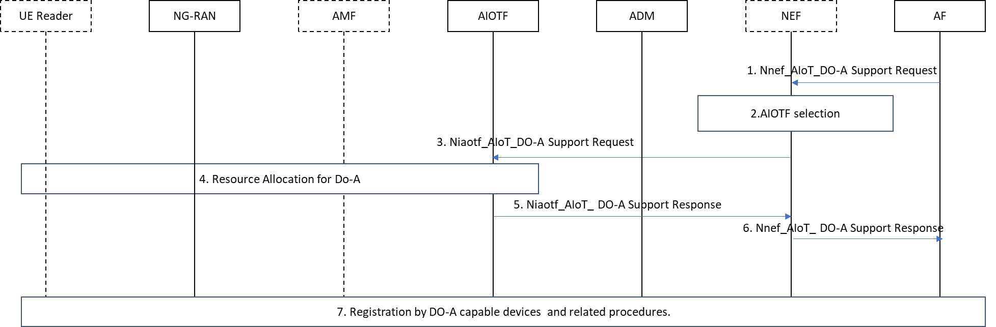
Figure 1:Procedure for supporting DO-A as a service.
The steps involved in the procedure are as follows:
- The Application Function (AF) invokes Nnef_AIoT_Do-A Support (Service Descriptor, AF ID, [service type], [target area], operation, [priority] [list of device IDs] [offset][duration]) service operation request to the NEF. Service Descriptor is an identifier for every service request that arrives at the AF. It shall be unique within particular AF. The service descriptor that is sent as part of this service operation request shall be the descriptor of the service that needs to be enabled, modified or cancelled. AF ID is the identifier for a given AF. Service type in this request would correspond to “DO-A support”. Operation in this request could either enable or disable. The Priority field indicates the priority of the service request. The list of device IDs is an optional parameter in which the set of devices for which this service can be enabled/disabled is indicated. When not provided, the specified service is enabled for all the devices in the network. Similarly, offset and duration are optional parameters used for enabling/disabling a service at “offset” time interval from the point of receiving the request and “duration” is used to specify the duration of time for which the service remains enabled/disabled. When the duration is not provided, the service continues to stay enabled/disabled until a follow-up service request is issued.
Note: In case the AF is considered as a trusted AF, the AF may directly reach the AIOTF using the Naiotf_AIoT_Do-A Support Request (Service Descriptor, AF ID, [service type], [target area], operation, [priority] [list of device IDs] [offset][duration]).
- The NEF may further authorize the AF request as specified in clause 5.6 of 3GPP TS 23.369. The NEF determines the Target Area information and selects suitable AIOTF(s) that can support DO-A related traffic. The NEF determines AIOTF instances(s) by providing the NRF Target Area information along with the request for DO-A traffic support, and the NRF returning AIOTF instance(s) that match the Target Area information and ability to support DO-A, or by using local configuration. Once the NEF authorizes the AF request, the NEF creates a Transaction Reference ID for transferring this request to the AIOTF and stores the AF Identifier along with the Transaction Reference ID.
- The NEF invokes Naiotf_AIoT_Do-A Support request (Transaction ID, AF ID, [service type], [target area], operation, [Approximate number of Do-A AIoT Devices], [Approximate number of AIoT Devices], [priority] [offset][duration]) towards to the selected AIOTF(s). The Approximate number of Do-A AIoT devices is an optional parameter and could be used for resource allocation.
- AIOTF receives the Naiotf_AIoT_Do-A Support request and checks the parameters included in the request. The AIOTF may perform checks as specified in clause 5.6 of 3GPP TS 23.369. Also, AIOTF may select a set of NG-RAN nodes and reader(s) within the target area for supporting DO-A traffic. The NG-RAN nodes and readers can be selected based on several criteria such as ability to support DO-A traffic, load on the NG-RAN nodes or readers, number of actively connected devices (both 5G NR UEs and A-IoT devices), available radio resources etc. The selected readers allocate radio resources for supporting DO-A traffic. For example, certain trigger time instants may be allocated to only support DO-A traffic from A-IoT devices. These resources may be broadcasted by the A-IoT readers or can be pre-configured by the network while the device is deployed. In case, the Naiotf_AIoT_Do-A Support request cannot be serviced due to any reason e.g., non-availability of readers supporting Rel-20, not enough resources etc., the AIOTF rejects the AIoT service operation request with an appropriate cause code in Step 5, and step 7 is skipped.
- Note: The Naiotf_AIoT_Do-A Support request is used to only provide assistance information to the AIOTF. It serves to provide an indication to the network that DO-A traffic may be expected within a certain time period. The actions following the reception of the request, especially the subsequent actions by the NG-RAN are to be coordinated with RAN2/RAN3 and are only mentioned as examples here.
5. AIOTF sends Naiotf_AIoT_Do-A Support Response to the NEF containing the accept or reject result for the Naiotf_AIoT_Do-A Support request based on step 4.
6. NEF sends Nnef_AIoT_Do-A Support Response to the AF, containing the accept or reject result for the AIoT service Cancel operation request as specified in clause 8.3 of 3GPP TS 23.369. If the response was an accept, then DO-A enabled A-IoT devices are able to attempt successful registration with the network.
7. Any device capable of DO-A traffic support can now register with the network. Once registered with the network, it can initiate transmission of DO-A traffic whenever it has some data to transmit.

6.X.3 Impacts on Services, Entities and Interfaces
The following impacts are envisioned on the existing network functions:
AIOTF:
- For supporting DO-A traffic, AIOTF must support the mechanism to indicate to the Readers to enable any DO-A specific signalling.
ADM:
- The AIOTF profile data in the ADM must be enhanced to also contain “AIoT Device Traffic Capability” which can identify whether device can support DT only or both DT and DO-A traffic type. When DO-A traffic can be supported by the device, then it also maintains whether DO-A is enabled/disabled for the device for a given service. Similarly, AF Authorization Profile should indicate the support for DO-A for a specific service.
AF:
- For supporting DO-A, the functionality of AF is enhanced to enable or disable DO-A support for a specific service.
* * * * End of Changes * * * *

