3GPP SA WG2#170 S2-250xxx

Goteborg, Sweden, 25-29 August, 2025 Revision of S2-2506708

**Source: Tejas Networks Limited, Samsung**

**Title:** **P-CR: New Solution for gNB based sensing**

**Spec: 3GPP TR 23.700-14**

**Agenda item: 20.2.1**

**Work Item / Release: FS_Sensing_ARC/ Rel-20**

**Document for:** **Approval**

*Abstract of the contribution: This contribution proposes a new solution to Key Issues#3,4,5 and 6 when gNB is chosen as a sensing entity.*

**1. Introduction**

The SA2 SID on architecture enhancement to support Integrated Sensing and Communication was approved in SP-250401 with the understanding that the scope of the sensing study in Rel-20 would be decided in alignment with RAN TSG. In RAN#108, RAN plenary decided to limit the scope of sensing related studies to gNB based monostatic sensing (reference:RP-251861).

Based on the decision of RAN#108, this paper proposes a new solution for the following KIs defined in SP-250401viz.,

* Discovery and selection of sensing entities based on service requirements triggered by the service request and capability of the sensing entities (KI#3).
* Sensing data and the associated information collection and transport mechanisms for result calculation (KI#4).
* Mechanisms for providing sensing associated information and result (including sensing result and contextual information) exposure, for one time, periodic or event-based reporting (KI#5).
* Configuration parameters for the support of ISAC services (KI#6).

**2. Text Proposal**

It is proposed to adopt the following text within TR 23.700-14.

**\* * * First Change * * * \***

# 6 Solutions

## 6.0 Mapping of Solutions to Key Issues

Table 6.0-1: Mapping of Solutions to Key Issues

|  |  |  |  |  |  |  |
| --- | --- | --- | --- | --- | --- | --- |
|  | Key Issues | | | | | |
| Solutions | <Key Issue #1> | <Key Issue #2> | <Key Issue #3> | <Key Issue #4> | <Key Issue #5> | <**Key Issue #6**> |
| X |  |  | X | X | X | X |

**\* * * * Next Change (All New Text) * * * \***

## 6.X Solution #X: Monostatic sensing operation with gNB as serving entity

### 6.X.1 High-level solution principles

The solution proposed in this paper is based on the following principles:

* The discovery of the gNB which serves as the sensing entity is carried out using two approaches viz, interacting with the SEs directly or indirectly via AMF
* In the indirect approach, the AMF collates information on the capabilities related to sensing from the associated gNBs and provides it to SF. In the direct approach, SF obtains the associated gNBs information (capability of gNBs providing sensing service, sensing service as Tx or Rx or both Tx and Rx, supported Area) via OAM.

SF is responsible for choosing and configuring the sensing entity for performing the monostatic sensing operation.

### 6.X.1 Description

Sensing service is initiated by an AF by sending a sensing service request. After the service request is successfully authorized, the SF chooses AMF(s) that serve a geographical area corresponding to the target sensing area. The sensing capability of these gNBs connected to these AMFs are then shared with the SF, which chooses a candidate Sensing Entity (SE) and configures the same.

Note: Although the SF has been shown as a single entity in the following section, it may comprise of other component NFs such as Sensing Control Function (SCF) responsible for handling the control plane functionality of sensing, Sensing Data Function (SDF) which handles the data plane aspect of sensing and Sensing Data Repository (SDR) which serves as database for sensing related data.

### 6.X.2 Procedures

### 6.X.2.1 End to End procedure for gNB-based monostatic sensing

Figure 1 illustrates the call flow for gNB-based monostatic sensing.

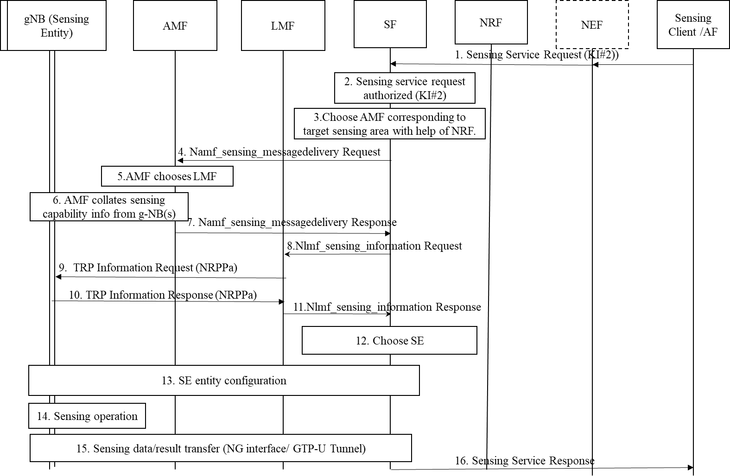

Figure 1:Procedure for gNB based monostatic sensing operation..

The steps involved in the procedure are as follows:

1. For initiating a sensing service, the AF creates a sensing service request (target sensing area, [required sensing accuracy], [vertical sensing resolution], [horizontal sensing resolution], [choice of sensing mode], [object characteristics], [type and frequency of reporting], [approximate mean velocity of target]).

Note1: The procedure for creating a sensing service request and transferring it to the SF are addressed by solutions to KI#2.

1. The service request is then authorized by the Sensing Function as detailed by solutions to KI#2.
2. The SF then queries the NRF for a suitable AMF. The choice of AMF depends on several factors such as support for sensing functionality, geographical serving area of the AMF having an overlap with the target sensing area etc.
3. The SF queries the AMF for the list of available sensing entities using the Namf_sensing_messagedelivery Request (Target sensing Area, AF ID, [sensing mode support], [periodicity of sensing supported], [Required horizontal, vertical resolution], [required Accuracy], [mean velocity of target]).
4. The AMF chooses an LMF serving the requested target sensing area. The LMF discovery and selection procedure (described in 3GPP TS 23.273) takes the 5G-AN currently serving that area into account. The selection may use a NRF query.
5. AMF collates the sensing capabilities i.e., supported sensing mode (e.g., monostatic, bi-static etc), operating modes supported (anchor/support) node etc. from the set of gNBs registered to it over the NG interface.

Note: Reporting of the sensing capabilities of the gNB can be done over NGAP. For example, the “NG Setup Request” message can be enhanced to provide the above details.

1. The AMF sends the collated information over the Namf_sensing_messagedelivery Response ([sensing mode supported] [operating mode support of the sensing entity] [LMF ID]) to the SF. The LMF is chosen by the AMF based on the NG-RAN nodes connected to it.
2. The SF sends the Nlmf_sensing_information Request ([NG-RAN id]) message to the LMF to obtain the radio capabilities of the Sensing Entities.
3. LMF uses NRPPa related messages to obtain the radio capability of the NG-RAN node. For example, the LMF can send “TRP information Request” message based on the NRPPa (TS 38.455) protocol to the NG-RAN node.
4. The NG-RAN node(s) respond with a suitable NRPPa message e.g., “TRP information Response” which provides the capability of the RAN in terms of beam forming, horizontal and vertical resolution etc.

Note: NRPPa messages are used here for obtaining information on TRP and not for positioning. In case the network implementation does not comprise of an LMF, a direct interface is necessary for obtaining these details. In that case, steps 8-11 of the callflow are skipped.

1. LMF transmits Nlmf_sensing_information Response ([SE beamforming capability] [vertical, horizontal resolution] [NG-RAN id]) to the SF(SCF) to provide the set of capabilities of each of the NG-RAN TRPs.
2. The SF then chooses the sensing entity based on the information received from LMF and the AMF together with the requirements received in the service request. For example, if the service request was to track a UAV’s altitude, then a sensing entity having good vertical resolution would be preferred.

For direct approach, the SE obtains the NG-RAN information (capability of providing sensing service, sensing service as Tx or Rx or both Tx and Rx, supported Area) via OAM. The SE receives sensing service request may include target area information from the NEF or trusted AF. Based on the received Target Area information and the NG-RAN information received from OAM, the SE selects the NG-RAN node(s). The Target Area information can span the supported Area of multiple SEs i.e., NG-RAN node(s) or can be a subset of the supported Area of a NG-RAN node. If multiple NG-RAN nodes are selected, the SF sends the sensing service request to each selected NG-RAN node along with its corresponding RAN Area information.

Note: If the chosen SEs capabilities are changed, then the SF is to be informed regarding the same with the help of the OAM (using subscribe and notify).

1. The SF then configures the sensing entity to perform the sensing operation using any of the methods defined in Section 6.X.2.4. In case, the target sensing area contain certain geographical locations that should not be sensed, the SF should take care of this while providing the configuration to the SEs (e.g., using radio related methods such as beamforming to restrict coverage). Additionally, the AF authorization profile (to be stored in the SF) should contain the details of the area that the AF is allowed to request sensing and this should be validated at the during service authorization stage (Step 2).
2. The configured sensing entity then performs the sensing operation. In case of gNB monostatic sensing, one sensing entity acts as both the transmitter and receiving entity.
3. Based on the configuration, the sensing entity chooses to report either the sensed measurements (NG-RAN assisted sensing)/ sensing result (NG-RAN based sensing) to the SF. This is performed as a one-time event or periodically based on configuration from the SF. The result/ data may be sent to SF using any of the methods described in Section 6.X.2.2. The SF may process the sensing data/result further to obtain the result.
4. The obtained sensing result is sent to the AF using the sensing service response, which is defined as part of KI#2.

### 6.X.2.2 Sensing data and the associated information collection and transport mechanisms

Once SF chooses a sensing entity, it provides the following configurations for collecting the sensing data/information form the sensing entity. The set of example configurations and the data collected are listed below:

1. Mode of operation for the entity: This configuration can be used to indicate the mode in which the sensing entity operates. For example, in multi-static sensing one of the sensing entities will serve as the main (Primary) entity and co-ordinate the sensing operation with other entities. Example values for this configuration can primary operation, supporting operation etc.
2. Configurations related to the radio such as beamforming related configurations, frequency of operations, configurations related to the measurements to be collected e.g, timing measurements, power, reflection related measurements
3. Frequency of collection of sensing measurements/sensing reports/data/parameters: This configuration indicates the time unit of collection of sensing measurements e.g., Periodic, Aperiodic, on-demand.
4. Mode of sensing result computation: This configuration is used to determine where the sensing result is computed. Example values can be SE based or SE aided computation. In SE based computations, the sensing measurements/parameters/data etc. obtained at the SE are used to compute the desired sensing result e.g., target co-ordinates, velocity etc., and the computed result is then shared to the SF. In SE aided sensing, the data/parameters/measurements obtained from the SE are transferred to the SF and the sensing result computation is performed by the SF. Note that in SE aided sensing, data may also be processed before sending it to the SF.

Note: The actual set of configurations provided to the sensing entity depends on the service requirements and the radio capability of the sensing entity.

Based on the choice of sensing result computation mode i.e., SE based or SE aided; the type, frequency, volume of data related to sensing exchanged between the gNB and the SF varies.

For example, for the UAV tracking use-case, if the result computation mode is configured by the SF as “SE-aided”, then the SE reports the collected data such reflection angles, power, measurement quality etc at the frequency of collection configured by the SF.

If result computation mode is “SE based”, then SE uses the sensing measurements to compute the result (in this case, the coordinates of UAV(s)) and provide estimated target(s) co-ordinates along with measure of confidence calculated based on the measurement quality.

These configurations can be transported to the SE via two mechanisms:

1. Direct Interface: A direct interface is set up between the SE and the SF using a new protocol e.g., Base Station Sensing Protocol (BSSP) for sensing. The configurations are then transferred using a set of messages based on this protocol.

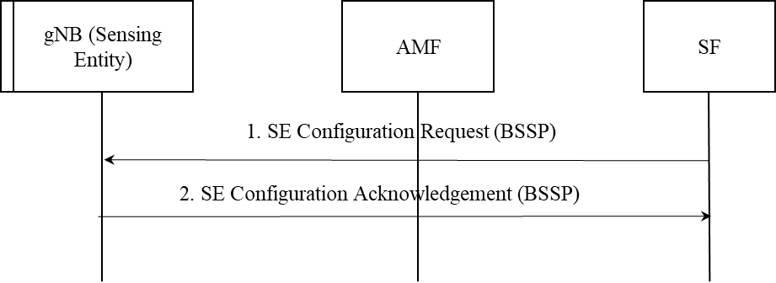

Figure 2: Configuring sensing entity over a direct interface.

1. Using NGAP and Namf services: In this method, the NGAP is extended to support the provision of sensing related configuration. For example, similar to “RAN configuration update” and “AMF configuration Update”, a “Sensing Configuration Update “message may be defined over NGAP to support this functionality. Additionally, extensions to AMF services to transport the configuration between AMF and SF is to be supported.

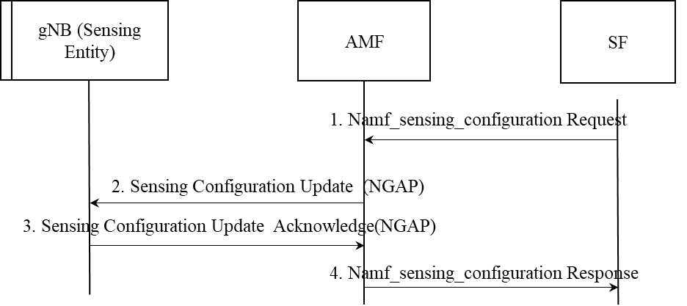

Figure 3: Configuring sensing entity via AMF.

### 6.X.2.3 Mechanisms for providing sensing associated information and result

The choice of the method for result exposure can be decided based on volume of sensing data volume, frequency, network data volume (e.g., communication data) and capacity of the network. Based on these factors, sensing associated information/result can be transferred within the 5G-A system using the following mechanisms:

1. Option1 – Data Plane transmission: The sensing information/data is sent from gNB to UPF as illustrated Figure 4 over a GTP tunnel created for the purpose. A distinct tunnel is created for each service request per sensing entity. For example, the tunnel ID at SF corresponding to the Service Descriptor provided by the AF, AF ID and at the gNB the tunnel ID is mapped to the Sensing Entity ID performing the sensing operation. The data from the UPF is then transferred to any consumer NF by configuring the notification endpoint in the SBI provided by the UPF. When the volume of the sensing data is large and it is frequently reported, it is preferable to route the data via the UPF as the UPF is generally provisioned to handle large volumes of data at a time.

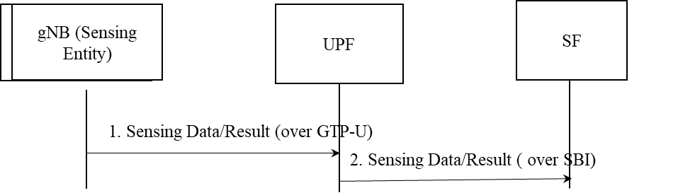

Figure 4:Sensing Data/Result exposure via data plane.

1. Option2 – Control Plane transmission: Another mechanism for transporting sensing information is to send the data from SE i.e., gNB to AMF via NGAP as illustrated in Figure 5. The AMF then sends it to SF using the Namf_sensing_messagedelivery notification service. In this method, the sensing information/result is not transparent to the AMF.

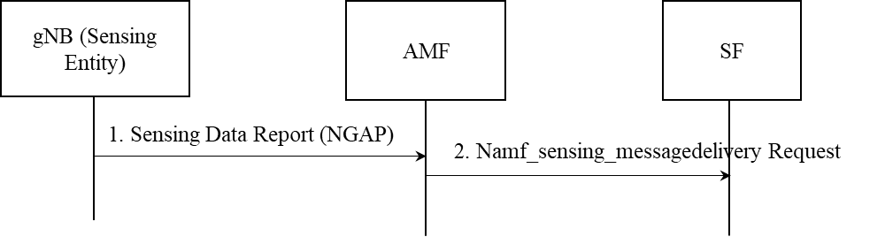

Figure 5 : Sensing Data/Result transport over control plane via AMF.

### 6.X.2.4 Configuration parameters for the support of ISAC services

For supporting gNB based monostatic sensing, the following configurations and services are required to supported at the AMF.

|  |  |  |  |
| --- | --- | --- | --- |
| Service Name | Service Operations | Operation  Semantics | Example Consumer(s) |
| Namf_Sensing | Message Delivery | Request/Response | SF |
|  | Notify | Subscribe/Notify | SF, UPF |
|  | Configuration | Request/Response | SF |

1. Namf_Sensing_MessageDelivery

**Service operation name:** Namf_Sensing_MessageDelivery

**Description:** This service operation enables the NF service consumer to request sensing entity related information and also receive reports related to the same.

**Inputs, Required:**

1. SF ID
2. At least one of the following parameters are included:

* Target area information for the sensing operation.
* Mode of sensing support requested (monostatic/bistatic etc)
* Mode of sensing entity operation (primary/secondary etc)
* Periodicity of sensing support requested
* Required horizontal and vertical resolution

1. Notification Endpoint.

**Inputs, Optional:** None

**Outputs, required:** Transaction ID, sensing entity ids with details of supported sensing mode, operating mode support of the sensing entity, LMF ID.

**Outputs, Optional:** None.

1. Namf_Sensing_Notify

**Service operation name:** Namf_Sensing_Notify

**Description:** This service operation enables the NF service consumer to receive sensing data reported by the sensing entities to the AMF.

**Inputs, Required:**

1. SF ID
2. At least one of the following parameters are included:

* Sensed Data parameters e.g., reflection angles, doppler, RSRP.
* Sensing result including estimated target co-ordinates, approximate velocity, confidence measure of the result.

1. Notification Endpoint.

**Inputs, Optional:** None

**Outputs, required:** None

**Outputs, Optional:** None.

1. Namf_Sensing_Configuration

**Service operation name:** Namf_Sensing_Configuration

**Description:** This service operation enables the NF service consumer to provide AMF with the set of parameters used to configure Sensing Entities.

**Inputs, Required:**

1. SF ID
2. At least one of the following parameters are included:
   1. Identifier of Sensing Entity e.g., gNB ID
   2. Mode of operation (primary/secondary)
   3. Radio related configuration such as operating frequency band to be used for sensing, beamforming configuration, Tx power
   4. Periodicity of sensing report requested
   5. Set of measurements requested (e.g., RSRP, RSRQ, doppler, reflection angles)
   6. Mode of sensing result computation (i.e., SE based; SE aided)
3. Notification Endpoint.

**Inputs, Optional:** None

**Outputs, required:** Transaction ID, Acknowledgment Result, Failure cause in case of failure.

**Outputs, Optional:** None.

### 6.X.3 Impacts on Services, Entities and Interfaces

The following impacts are envisioned on the existing network functions:

NEF:

* For supporting sensing services, NEF performs functions such as exposure of capabilities and events for other NFs.

NRF:

* NRF maintains the NF profile of available NF instances related to sensing e.g, SF, AMF and their supported services

AF:

* For supporting sensing service, the functionality of AF is enhanced to provide service parameters.

AMF:

* For supporting sensing, the AMF needs to support additional services and configurations related to sensing. It also needs to support the collation of sensing capabilities from SEs.

SF:

* Discovery and selection of SE via OAM in direct mode.
* Discovery and selection of SE via AMF in indirect mode.

**\* * * * End of Changes * * * \***