3GPP TSG-WG SA2 Meeting #170 *S2-2507473*

Göteborg, SE, 25th Aug – 29th Aug, 2025 (revision of S2-2507289)

**Source: Huawei, HiSilicon, China Telecom, CSCN**

**Title: [KI2, New Sol] SIP procedure optimization for IMS voice call via NB-IoT GEO**

**Document for: Approval**

**Agenda Item: 20.1.1**

**Work Item / Release: FS_5GSAT_Ph4_ARC / Rel-20**

*Abstract: Optimized call setup procedure for reducing call setup time in case one of the UEs is accessing network via NB-IoT GEO by using a simplified call set up time.*

# Introduction

This solution is proposed for Key Issue #2: IMS enhancement for GEO NB-IoT NTN access.

According to 3GPP TS 23.228 clause 5.6 and 5.7, the normal IMS call procedure consists of the following steps:

INVITE (SDP offer) -> 183 Progress (SDP answer) -> PRACK (Opt SDP) -> 200 OK for PRACK (Opt SDP) -> UPDATE (Opt SDP) -> 200 OK for UPDATE (Opt SDP) -> 180 Ringing -> PRACK -> 200 OK for PRACK -> 200 OK for INVITE -> ACK

This procedure requires 7 steps from the originating UE sending the INVITE request to the UE receiving 180 Ringing response: in the case where the UE is connected via NB-IoT to a GEO satellite, this results in a very long call setup time whereas SA1’s target is to complete the call setup in 30 seconds.

TS 23.228 clause 5.7a also defines a shortened IMS call procedure for when preconditions are not used. This procedure consists of the following steps:

INVITE (SDP offer) -> 180 Ringing -> 200 OK for INVITE (SDP answer) -> ACK

This short procedure only takes 2 steps from the originating UE sending INVITE request to receiving 180 Ringing response, however not using preconditions has some significant drawback especially when NB-IoT via GEO is used: the call might fail to be established due to SDP answer being sent too late while alerting user has already started. Under normal circumstances, the terminating UE starts alerting the user after sending180 Ringing and sends 200 OK response for INVITE when the terminating user “picks up the phone” (or whatever action to needed to answer the call). Over GEO access, the 200 OK response for INVITE may need a long time to reach the originating UE not only because of the propagation delay but also because the message could be quite large to contain the SDP answer and the low bit rate available. So, without preconditions, it is quite possible that the bearer establishment procedure is not completed while the terminating user has already begun to speak.

This solution proposes an optimized call setup procedure for reducing call setup time in case one of UEs is accessing network via NB-IoT GEO that limits the drawbacks of the short procedure described above.

# Proposal

It is proposed to agree the following changes to 3GPP TR 23.700-19.

* * * * First change * * * *

# 6 Solutions

## 6.0 Mapping of Solutions to Key Issues

Table 6.0-1: Mapping of Solutions to Key Issues

|  |  |  |  |  |
| --- | --- | --- | --- | --- |
|  | Key Issues | | | |
| Solutions | KI#1 | KI#2 | KI#3 | KI#4 |
| X |  | X |  |  |

* * * * Second change (all new) * * * *

## 6.X Solution #X: Call Setup Procedure optimization for NB-IoT via GEO

### 6.x.0 High-level solution Principles

This solution proposes to use as baseline the short call setup procedure without preconditions but introduce safeguards to ensure the media starts to flow only when bearer is set up by the UE connecting to the network using 3GPP-NB-IoT(GEO). The solution also takes into account whether one of the parties does not support the proposed simplified call setup procedure.

### 6.X.1 Description

This solution addresses Key Issue #2: IMS enhancement for GEO NB-IoT NTN access.

This solution aims to optimize call setup procedure for reducing call setup time in case one of the UEs is accessing network via NB-IoT GEO by proposing to use a simplified call set up time that uses as baseline the procedure in TS 23.228 [x] clause 5.7a:

INVITE (SDP offer) -> 180 Ringing (SDP answer) -> PRACK -> 200 OK for PRACK-> 200 OK for INVITE -> ACK

It is assumed that a UE capable of supporting IMS voice over GEO over NB-IoT GEO as IP-CAN (VoGoN) can support this simplified call setup procedure as default.

When the originating UE is accessing the network via GEO with NB-IoT RAT, the UE does not include Precondition in Supported header field in INVITE

The originating side P-CSCF inserts originating UE’s access network information and forwards the INVITE to the terminating side.

If the terminating UE also supports VoGoN, and at least one of UEs is accessing network via 3GPP-NB-IoT(GEO), it generates SIP 180 Ringing response with SDP answer and does not indicate precondition in Require header.

Based on the different combination of originating side and termination side, this solution examines three scenarios:

- Case1: Both UEs support VoGoN and at least one UE is accessing network via 3GPP-NB-IoT(GEO);

- Case2: UE A supports VoGoN and is accessing network via 3GPP-NB-IoT(GEO) while UE B does not support VoGoN;

- Case3: UE B supports VoGoN and is accessing network via 3GPP-NB-IoT(GEO) while UE A does not support VoGoN.

For case1 and case3, the simplified call setup procedure can be performed E2E between two UEs because UE B is capable of sending 180 Ringing with SDP answer due to it supports VoGoN, while for case2, considering that UE B does not support VoGoN, this solution proposes that the P-CSCF A acts as a B2B UA to perform simplified call setup procedure towards the UE A and normal call setup with the UE B.

### 6.X.2 Procedures

#### 6.X.2.1 Case1: Both UEs support VoGoN and at least one of UEs is accessing network via 3GPP-NB-IoT(GEO)

This procedure describes a simplified call setup procedure that can be applied since both originating and terminating parties support VoGoN.

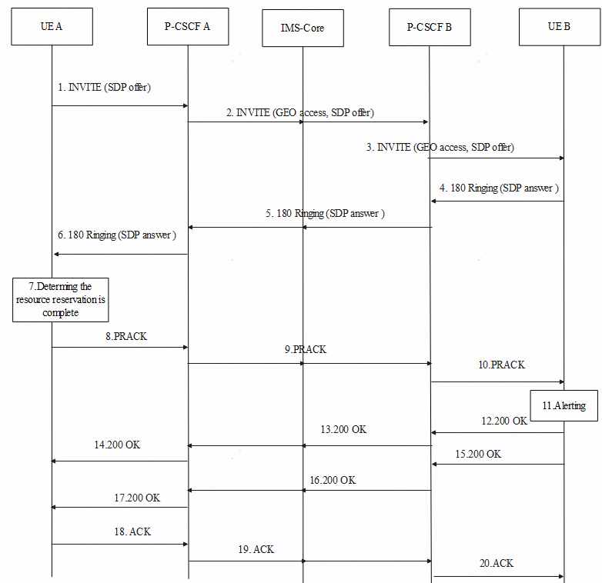

Figure 6.X.2.1-1: Call procedure for Case1: Both UE support VoGEO and at least one of UE is accessing network via GEO

1. UE A sends a SIP INVITE request containing an SDP offer to P-CSCF A.  
If UE A is accessing network via 3GPP-NB-IoT(GEO), it does not indicate precondition in Supported header or Required header.

2-3. P-CSCF A forwards SIP INVITE request to the terminating side via IMS core.  
P-CSCF A interacts with EPC to retrieve UE A’s access network information and inserts UE A’s access network in the INVITE.

4. If either of the UEs is accessing the network via 3GPP-NB-IoT(GEO), UE B generates SIP 180 Ringing response with SDP answer and UE B does not indicate precondition in Required header.

NOTE: In Case 1 both UEs support VoGoN and UE B can ascertain if UE A is accessing the network using NB-IoT GEO by inspecting the provided PANI header in the INVITE request from the originating network.

5-6. P-CSCF B forwards SIP 180 Ringing response to the originating side via IMS core.

7-8. After UE A determines resource reservation is complete, it sends PRACK as an acknowledgment of receiving SDP answer and resource reservation completion, and UE A starts playing the ring back tone.

9-10. P-CSCF A forwards the PRACK to the terminating side via IMS core.

11. UE B alerts User B when UE B receives PRACK and UE B resource reservation is complete.

12-14. UE B sends 200 OK response for PRACK to P-CSCF B, P-CSCF B forwards 200 OK response for PRACK to P-CSCF A via IMS core, P-CSCF A forwards 200 OK response for PRACK to UE A.

15-17. UE B sends 200 OK response for INVITE to P-CSCF B when User B picks up the phone, P-CSCF B forwards 200 OK response for INVITE to P-CSCF A via IMS core, P-CSCF A forwards 200 OK response for INVITE to UE A.

18-20. UE A sends ACK to P-CSCF A, P-CSCF A forwards ACK to P-CSCF B via IMS core, P-CSCF B forwards ACK to UE B.

#### 6.X.2.2 Case2: UE A supports VoGEO and is accessing network via 3GPP-NB-IoT(GEO) but UE B does not support VoGoN

In this procedure the P-CSCF of UE A acts as B2B UA so that UE B, can use the normal call setup procedure while UE A which connects via 3GPP-NB-IoT(GEO) can use the simplified call setup procedure reducing the number of round trips over the satellite service link.

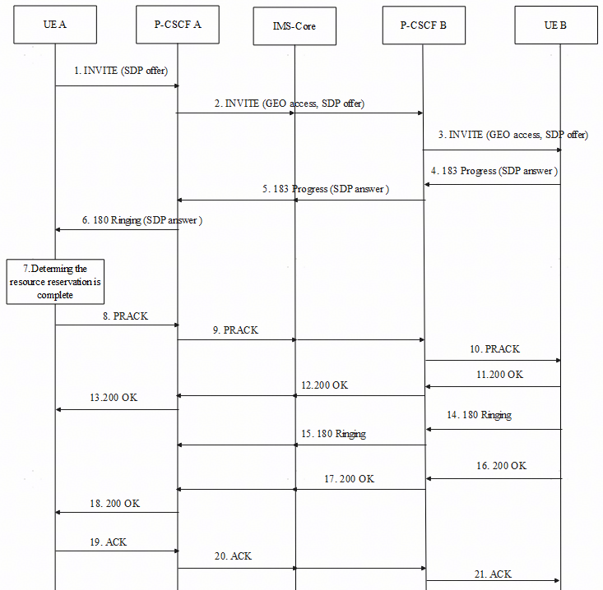

Figure 6.X.2.2-1: Call procedure for Case2: UE-A supports VoGoN and is accessing network via 3GPP-NB-IoT(GEO) but UE-B doesn’t support VoGoN

1-3. Same as step 1 to step 3 in clause 6.X.2.1.

4. UE B may generate and send 183 Progress response with SDP answer to P-CSCF B due to UE B not supporting VoGoN. In 183 Progress message, the UE B does not indicate precondition in Required header when UE A does not include precondition in Supported header in INVITE.

5. P-CSCF B forwards 183 Progress response with SDP answer to the originating side via IMS core. If P-CSCF B determines UE A is accessing network via 3GPP-NB-IoT(GEO) and UE B has subscribed to the CAT service the P-CSCF B should not trigger CAT AS modifying the SDP answer for CAT service.

6. P-CSCF A acts as a B2B UA and generates 180 Ringing with SDP answer based on the received 183 Progress response, then sends it to UE A.

7-8. When UE A determines resource reservation is complete, it sends PRACK as an acknowledgment of receiving SDP answer and resource reservation completion, and UE A starts playing the ring back tone.

9-10. P-CSCF A acts as a B2B UA and generates PRACK as the acknowledgement of 183 Progress response, then sends it to the terminating side.

11-12. UE B sends 200 OK response for PRACK acknowledgment.

13. P-CSCF A sends 200 OK response to UE A for PRACK acknowledgment.

14-15. UE B sends 180 Ringing response to P-CSCF B, P-CSCF B forwards 180 Ringing response to P-CSCF A via IMS core.

16-17. When User B answers the call, UE B sends 200 OK response for INVITE to P-CSCF B, P-CSCF B forwards 200 OK response for INVITE to P-CSCF A via IMS core.

18. P-CSCF A sends 200 OK response to UE A.

19. UE A sends ACK to P-CSCF A.

20-21. P-CSCF A sends ACK to P-CSCF B via IMS core, P-CSCF B forwards ACK to UE B.

#### 6.X.2.3 Case3: UE B supports VoGoN and is accessing network via 3GPP-NB-IoT(GEO), but UE A does not support VoGoN

Similar to Case1 the simplified call setup procedure can be performed end to end because UE B is capable of sending 180 Ringing with SDP answer.

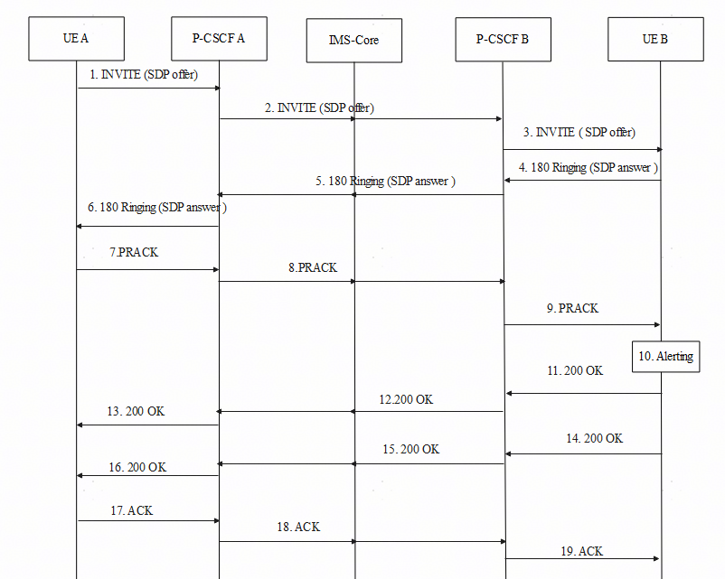

Figure 6.X.2.3-1: Call procedure for Case3: UE B supports VoGoN and is accessing network via NB-IoT over GEO but UE A doesn’t support VoGoN

1. UE A sends a SIP INVITE request containing an SDP offer to P-CSCF A.

2-3. P-CSCF A forwards SIP INVITE request to the terminating side via IMS core.

4. Based on the knowledge that UE B is accessing network via 3GPP-NB-IoT(GEO), UE B generates SIP 180 Ringing with SDP answer and UE B does not indicate precondition in Required header.

5-6. P-CSCF B forwards 180 Ringing to UE A via IMS core.

7-9. UE A sends PRACK to P-CSCF A, P-CSCF A forwards PRACK to P-CSCF B via IMS core. P-CSCF B forwards PRACK to UE B.

10. UE B alerts User B when UE B receives PRACK and UE B resource reservation is complete.

11-13. UE B sends 200 OK response for PRACK to P-CSCF B, P-CSCF B forwards 200 OK response for PRACK to P-CSCF A via IMS core, P-CSCF A forwards 200 OK response for PRACK to UE A.

14-16. UE B sends 200 OK response for INVITE to P-CSCF B, P-CSCF B forwards 200 OK response for INVITE to P-CSCF A via IMS core, P-CSCF A forwards 200 OK response for INVITE to UE A.

17-18. UE A sends ACK to P-CSCF A, P-CSCF forwards ACK to P-CSCF B.

19. P-CSCF B sends ACK to UE B.

### 6.X.3 Impacts on Services, Entities and Interfaces

The following entities are impacted based on the solution above:

**Originating UE:**

- Does not include Precondition in Supported header or Required header when it is accessing network via 3GPP-NB-IoT(GEO).

- Sends PRACK as an acknowledgment of receiving SDP answer and resource reservation completion.

**-Terminating UE:**

- Can decode the indication that the originating UE is accessing the network via 3GPP-NB-IoT(GEO) contained in the INVITE.

- Determines generating SIP 180 Ringing with SDP answer in case at least one of UEs is accessing network via 3GPP-NB-IoT(GEO).

- Does not include Precondition in Required header when it is accessing network via 3GPP-NB-IoT(GEO).

**Originating IMS:**

- Indicates originating UE is accessing network via 3GPP-NB-IoT(GEO) in INVITE to the terminating side.

- Acts as a B2B UA in case the originating UE is accessing network via 3GPP-NB-IoT(GEO), but terminating UE doesn’t support VoGoN.

- Performs simplified call setup procedure to originating UE and normal call procedure to terminating side.

**Terminating IMS:**

- Can determine that originating UE is accessing the network via 3GPP-NB-IoT(GEO).

* * * * End of changes * * * *