3GPP TSG-RAN WG4 Meeting #116bis R4-2514435
Prague, Czech Republic, 13 October – 17 October 2025

Agenda item: 5.10.3, 6.20.4, 6.21.3
Source: Moderator (Nokia)
Title: Topic summary for [116bis][312] Rel-19 Demodulation_Part2
Document for: Information

Introduction
This document summarises the contributions for Rel-19 Demodulation_Part2 (a combination of demodulation aspects from the following NTN Work Items NR_NTN_Ku_bands-Perf, IoT_NTN_Ph3-Perf, IoT_NTN_TDD-Perf) under AI’s 5.10.3, 6.20.4, and 6.21.3 at RAN4#116-bis.
The proposals from the contributions are grouped into the following topics:
- Topic #1: NR NTN Ku Band Demodulation
- Topic #2: IoT NTN Phase 3 Demodulation
- Topic #3: IoT NTN TDD Demodulation
- Topic #4: General Alignment and Integration

Topic #1: NR NTN Ku Band Demodulation

Companies’ contributions summary
T-doc number | Source | Proposals / Observations
R4-2513154 | CATT | Proposal 1: Define NTN-TDLC5-650 low for PUSCH for FR1-NTN Ku-band and FR2-NTN Ku-band as starting point.  Proposal 2: CBW and SCS for PUSCH for FR1-NTN can be reused for FR1-NTN Ku-band, and CBW and SCS for PUSCH for FR2-NTN can be reused for FR2-NTN Ku-band.  Proposal 3: The test parameters for PUSCH for FR1-NTN can be reused for FR1-NTN Ku-band, and the test parameters for PUSCH for FR2-NTN can be reused for FR2-NTN Ku-band.  Proposal 4: Define NTN-TDLC5-650 low for PUCCH for FR1-NTN Ku-band and FR2-NTN Ku-band as starting point.  Proposal 5: The PUCCH formats for FR1-NTN can be reused for FR1-NTN Ku-band, and the PUCCH formats for FR2-NTN can be reused for FR2-NTN Ku-band.  Proposal 6: The test parameters for PUCCH for FR1-NTN can be reused for FR1-NTN Ku-band, and the test parameters for PUCCH for FR2-NTN can be reused for FR2-NTN Ku-band.  Proposal 7: Define the following propagation conditions and correlation matrix, frequency offset for PRACH for FR1-NTN Ku-band as starting point.  And define the following propagation conditions and correlation matrix, frequency offset for PRACH for FR2-NTN Ku-band as starting point.  Proposal 8: The PRACH preamble Burst format for FR1-NTN can be reused for FR1-NTN Ku-band, and the PRACH preamble Burst format for FR2-NTN can be reused for FR2-NTN Ku-band.  Proposal 9: The test parameters for PRACH for FR1-NTN can be reused for FR1-NTN Ku-band, and the test parameters for PRACH for FR2-NTN can be reused for FR2-NTN Ku-band.
  Propagation conditions and correlation matrix (annex D) | Frequency offset
  AWGN | 0
  NTN-TDLC5-650 Low | 1500 Hz
  Propagation conditions and correlation matrix (annex D) | Frequency offset
  NTN-TDLC5-650 Low | 1500 Hz
R4-2513407 | Samsung | PDSCH requirement  Observation 1: RAN4 has already introduced the PDSCH requirement for 15KHz SCS and 10MHz CBW in FR1-NTN for FDD operation, and 120KHz SCS and 200MHz CBW in FR2-NTN.  Observation 2: For NTN demodulation requirement, only the requirement with LEO scenario was defined for UE side, and one set of requirements was defined for SAN requirement for both GSO and NGSO scenario.  Proposal 1: RAN4 could consider the introduction of NR NTN PDSCH requirement for 15KHz SCS with targeting for GSO scenario for Ku-band  Proposal 2: RAN4 could consider the introduction of NR NTN PDSCH requirement for 30KHz SCS with FDD operation for Ku-band  Proposal 3: No UE PDSCH demodulation requirement introduced for NTN with supporting Ku-band  PDCCH requirement  Proposal 4: RAN4 could consider the PDCCH requirement for both 15KHz and 30KH SCS for Ku-band. No new PDCCH requirements with 120 SCS for Ku-band.  CSI reporting requirement  Proposal 5: No CSI reporting requirement for NTN with Ku-band.  Observation 3: RAN4 has introduced the SAN demodulation requirement for FR2-NTN with 120KHz SCS  Proposal 6: No new SAN demodulation requirements introduced for Ku-band with 120 KHz SCS and 60KHz SCS.  Observation 4: From demodulation point of view, no different with 15KHz and 30KHz SCS in Ku-band compared with FR1-NTN scenario.  Proposal 7: No new SAN demodulation requirements introduced for Ku-band with 30KHz SCS  Proposal 8: FFS to define the SAN demodulation requirement for Ku-band with 15KHz SCS
R4-2513581 | SES S.A. | To progress forward with Ku Band Performance part the Test conditions, scenarios and output from simulations need to be clarified and agreed. If Ka Band results cannot be reused for Ku Band, we need to provide simulation results based on updated parameters for the following tables:  TS38.101-5: Table 11.2.2.1.1.1-3, Table 11.2.2.1.1.1-4, Table 11.2.3.1.1-1  TS38.108: Table 11.2.2.1.2-1, Table 11.2.2.2.2-1, Table 11.2.2.3.2-1, Table 11.3.2.3.1.2-1, Table 11.3.2.3.2.2-1, Table 11.3.2.4.1.2-1, Table 11.3.2.4.2.2-1, Table 11.3.2.5.2-2, Table 11.3.2.6.2-1,Table 11.4.2.2.2-1  Proposal 1: RAN4 to provide clarification to the following questions  - HARQ is likely to be disabled for GEO or MEO orbits. For Test 1-1, Test 1-2, Test 1-3, and Test 1-4 with HARQ disabled, what simulation can we configure?  - What Bandwidth and SCS should we assume for Ku Band? 50 MHz and 15kHz/30kHz?  - Are the modulation format and coding rate fixed and the same as Ka Band?  - Can the Ka Band results be re-used or do we need new set of results for Ku Band?  - What channel model to be used for Ku band FR1-NTN? What doppler to be used for Ku band FR1-NTN?  - What BLER is required for the simulations?  - Presentation format of the simulated results  Proposal 2: Rel-19 Ku-band will reuse (as much as possible, and where applicable) FR2-NTN demodulation configurations from the Ka-band (from Rel-18).  Proposal 3: Rel-19 Ku-band will add specific FR1-NTN demodulation configurations for above 10 GHz with similar TDL channels, Doppler and Delay spread values as for Ka-band.
R4-2514140 | Ericsson | Observation 1 NTN Ku band include both FR1 and FR2 configurations.  Observation 2 Channel models including Doppler shift in existing demodulation requirements can be reused for Ku band if new requirement is considered.  Observation 3 FR1-NTN Ku band UE would only support either 15kHz or 30kHz SCS.  Observation 4 Existing SAN and UE demodulation requirements could be reused for NTN Ku band.  Observation 5 FR2-NTN Ku band UE antenna implementation is the same as for Ka band.  Observation 6 Following potential new UE demodulation requirements are needed for FR1-NTN Ku band.  - PDSCH mapping type A and PDCCH  - 1Rx  - 15kHz SCS  - 30 kHz SCS  - 2Rx  - 30 kHz SCS  Proposal 1 Do not introduce new SAN demodulation requirements for both FR1-NTN and FR2-NTN Ku band.  Proposal 2 Do not introduce new UE demodulation requirements for FR2-NTN Ku band.  Proposal 4 Introduce 30kHz SCS UE demodulation requirement for FR1-NTN Ku band if it is confirmed as typical implementation.  Proposal 5 Introduce 1Rx UE demodulation requirement for FR1-NTN Ku band if 1Rx is confirmed as typical implementation.  •

Open issues summary

Sub-Topic 1-1: Ku Band SAN Demodulation

Issue 1-1-1: Whether to define requirements
Options:
- Option 1: Do not introduce new SAN demodulation requirements for both FR1-NTN and FR2-NTN Ku band. (Ericsson)
- Option 2: FFS whether to introduce new SAN demodulation requirements for FR1 NTN with 15 kHz SCS (Samsung)
- Option 3: Introduce new SAN demodulation requirements for both FR1-NTN and FR2-NTN Ku band. (CATT)
Recommended Way Forward:
- Discuss during the meeting, initially whether to define requirements of not.

Issue 1-1-2: Ku-band Channel Model and Frequency Offset
Options:
- For FR1:
  - For PRACH:
    - Option 1: NTN-TDLC5-650 Low with 1500 Hz FO (CATT)
    - Option 2: AWGN with 0 Hz FO (CATT)
  - For PUSCH:
    - Option 1: NTN-TDLC5-650 low (CATT)
  - For PUCCH:
    - Option 1: NTN-TDLC5-650 low (CATT)
- For FR2:
  - For PRACH:
    - Option 1: NTN-TDLC5-650 Low with 1500 Hz FO (CATT)
  - For PUSCH:
    - Option 1: NTN-TDLC5-650 low (CATT)
  - For PUCCH:
    - Option 1: NTN-TDLC5-650 low (CATT)
Recommended Way Forward:
- Depending on the outcome of Issue 1-1-1, channel models to be decided.

Issue 1-1-3: PUSCH Parameters
Options:
- Option 1: Reuse other NTN PUSCH Parameters (CATT, SES)
Recommended Way Forward:
- Depending on the outcome of Issue 1-1-1, PUSCH Parameters will be reused from FR1-NTN for FR1-NTN Ku-band and similarly from FR2-NTN for FR2-NTN Ku-band

Issue 1-1-4: PUCCH Parameters
Options:
- Option 1: Reuse other NTN PUCCH Parameters (CATT, SES)
Recommended Way Forward:
- Depending on the outcome of Issue 1-1-1, PUCCH Parameters will be reused from FR1-NTN for FR1-NTN Ku-band and similarly from FR2-NTN for FR2-NTN Ku-band

Issue 1-1-5: PRACH Parameters
Options:
- Option 1: Reuse other NTN PRACH Parameters (CATT, SES)
Recommended Way Forward:
- Depending on the outcome of Issue 1-1-1, PUCCH Parameters will be reused from FR1-NTN for FR1-NTN Ku-band and similarly from FR2-NTN for FR2-NTN Ku-band

Sub-Topic 1-2: Ku Band UE Demodulation

Issue 1-2-1: Whether to define requirements for FR1
Options:
- Option 1: Do not introduce new PDSCH demodulation requirements for FR1-NTN Ku band. (Samsung)
  - Option 1a: RAN4 could consider the PDCCH requirement for both 15KHz and 30KH SCS for Ku-band (Samsung)
- Option 2: Introduce new PDSCH demodulation requirements for 30kHz FR1-NTN Ku band if confirmed as typical implementation. (Ericsson)
  - Option 2a: Introduce 1Rx UE demodulation requirements if confirmed as typical implementation (Ericsson)
Recommended Way Forward:
- Discuss during the meeting, initially whether to define requirements of not.

Issue 1-2-2: Whether to define requirements for FR2
Options:
- Option 1: Do not introduce new UE demodulation requirements for FR2-NTN Ku band. (Ericsson, Samsung)
Recommended Way Forward:
- Confirm during the meeting that no new UE demodulation requirements will be introduced for FR2 NTN.

Sub-Topic 1-3: Ku Band CSI Requirements

Issue 1-3-1: Whether to define CSI Requirements
Options:
- Option 1: No CSI reporting requirement for NTN with Ku-band. (Samsung)
Recommended Way Forward:
- Confirm during the meeting that no CSI requirements will be introduced.

Topic #2: IoT NTN Phase 3 Demodulation

Companies’ contributions summary

T-doc number | Source | Proposals / Observations
R4-2513395 | Samsung | Proposal 1: RAN4 could configure the length of OCC operation, and add the note following when specifying the NPUSCH 1 requirement into specification  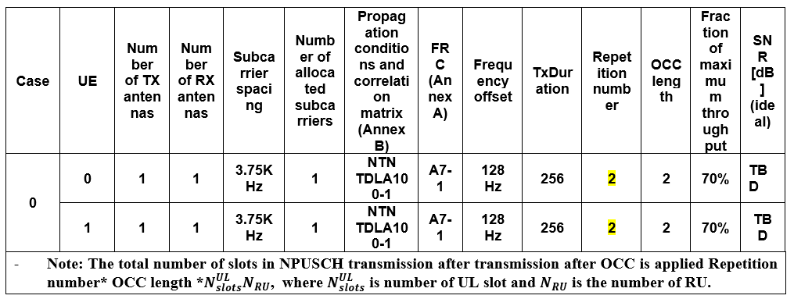  Observation 1: For 3.75KHz SCS, with OCC operation, around 1-2dB performance degradation compared with single UE without OCC operation.  Observation 2: For 15KHz SCS, with OCC operation, minor performance degradation compared with single UE without OCC operation  Observation 3: Compared with 2Rx configuration, around 3dB performance degradation was observed for 1Rx configuration
R4-2513441 | Huawei,HiSilicon | Simulation Results
R4-2513970 | Ericsson | Simulation Results and the following observations/proposals  Observations:  Observation 1: Difference of SNRs for NPUSCH format 1 to achieve 70% of the maximum throughput between two UEs is up to 0.1dB.  Proposals:  Proposal 1: Set the same SNR for NPUSCH format 1 with OCC2 from two UEs.  Proposal 2: RAN4 specify the SNR to achieve 70% of the maximum throughput of NPUSCH format 1 for OCC sequence indexes 0 and 1, which correspond to one UE and another UE, respectively.
R4-2514151 | ZTE Corporation, Sanechips | Simulation Results

Open issues summary

Sub-topic 2-1: OCC Aspects

Issue 2-1-1: OCC Length
Options:
- Option 1: RAN4 could configure the length of OCC operation, and add the note following when specifying the NPUSCH 1 requirement into specification: (Samsung)
  - Note: The total number of slots in NPUSCH transmission after transmission after OCC is applied Repetition number* OCC length *$N_{slots}^{UL}N_{RU}$, where $N_{slots}^{UL}$ is number of UL slot and $N_{RU}$ is the number of RU.
Recommended Way Forward:
- Check whether agreement can be reached to configure the length of the OCC operation and whether the note can be added.

Issue 2-1-2: SNR with two UEs
Options:
- Option 1: RAN4 to set the same SNR for NPUSCH format 1 with OCC2 from two UEs. (Ericsson)
Recommended Way Forward:
- Confirm during the meeting whether the approach to set the same SNR for both UEs is agreeable.

Issue 2-1-3: How to model two UEs
Options:
- Option 1: RAN4 specify the SNR to achieve 70% of the maximum throughput of NPUSCH format 1 for OCC sequence indexes 0 and 1, which correspond to one UE and another UE, respectively. (Ericsson)
Recommended Way Forward:
- Confirm during the meeting whether the approach to assign one format to one UE and another format to another UE is agreeable.

Topic #3: IoT NTN TDD Demodulation

Companies’ contributions summary
T-doc number | Source | Proposals / Observations
R4-2513406 | Samsung | Proposal 1: RAN4 could consider to define SAN and UE demodulation requirement to support NB-IoT TDD operation. FFS on the related test parameters to align with the TDD pattern (D/U=8ms)  - UE demodulation requirement: NPDSCH  - SAN demodulation requirement: NPUSCH 1 and NPUSCH 2 with 15KHz, NPRACH with format 0 and format 1  NPDSCH  Proposal 2: RAN4 could take the existing test configuration defining in current TN spec as starting point to define the UE demodulation requirement to support NTN TDD operation.  NPUSCH1 and NPUSCH 2  Proposal 3: RAN4 could take the following test cases to define the NPUSCH format1 and format 2 requirement for TDD operation  - NPUSCH format 1  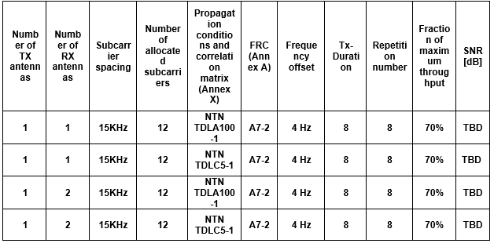  - NPUSCH format 2  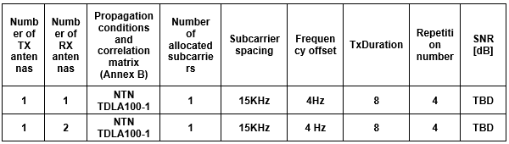  NPRACH  TDD configuration  Proposal 4: RAN4 can apply the TDD pattern with N, D/U=8 for related TDD configuration for NPRACH  Channel model  Proposal 5: RAN4 could apply the channel model with NTN-TDLA100-1 with 200Hz frequency offset for specifying NPRACH requirement with supporting TDD operation  Number of Repetition  Observation 2: The Tx duration of NPRACH format 0 is 2ms per each repetition. The Tx duration of NPRACH format 1 is 4ms per each repetition.  Proposal 6: RAN4 could consider the number of repetitions for NPRACH format 0 as 4, and number of repetitions for NPRACH format 1 as 2 when defining NPRACH requirement for TDD operation  Antenna configuration  Proposal 7: RAN4 could specify the requirement with both 1 Rx and 2Rx, and reuse the test applicability rule for different antenna configuration to test  Applicability rule  Proposal 8: The requirements for TDD are optional and only valid for SAN supporting TDD pattern.
R4-2513825 | Iridium, CCL | Proposal 1: RAN4 to consider updating the NPRACH demodulation performance requirements for IoT NTN TDD mode, by adding the Table 8.5.3.2.1-2 as follows:  Table 8.5.3.2.1-2: NPRACH missed detection requirements for IoT NTN TDD  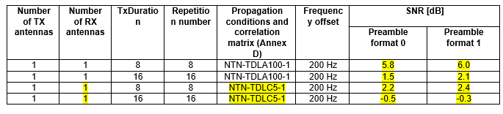  Proposal 2: RAN4 to consider updating the NPUSCH format-1 demodulation performance for IoT NTN TDD mode, to include Table 8.5.1.1.1-3, based on one of the following three options:  Option 1 (A7-2):  Table 8.5.1.1.1-3: Minimum requirements for NPUSCH format 1, 200KHz Channel Bandwidth, 15KHz subcarrier spacing, multiple subcarriers, 1Tx for IoT NTN TDD  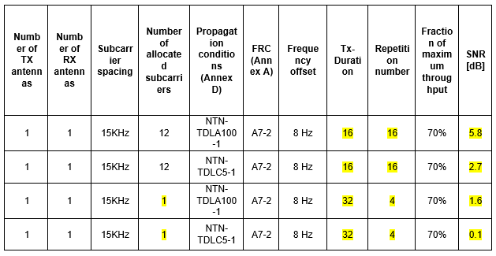  Option 2 (A14.3):  Table 8.5.1.1.1-3: Minimum requirements for NPUSCH format 1, 200KHz Channel Bandwidth, 15KHz subcarrier spacing, multiple subcarriers, 1Tx for IoT NTN TDD  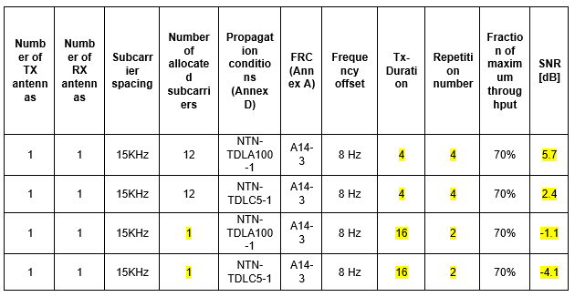  Option 3 (A7.2 for 12 SC and A14.3 for 1SC):  Table 8.5.1.1.1-3: Minimum requirements for NPUSCH format 1, 200KHz Channel Bandwidth, 15KHz subcarrier spacing, multiple subcarriers, 1Tx for IoT NTN TDD  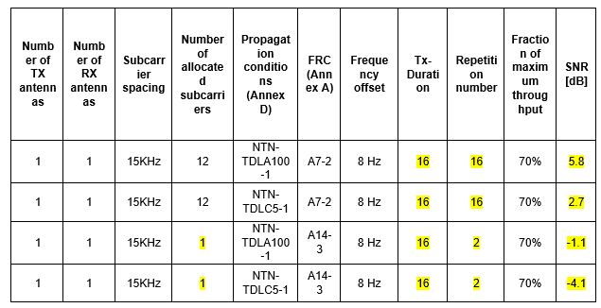  Proposal 3: The existing performance requirement for NPUSCH format-2 transmissions related to the probability of false ACK detection from DTX shall be equal to or less than 1% can also be applied to IoT NTN TDD mode.  Proposal 4: RAN4 to consider updating the NPUSCH format-2 missed ACK detection performance for IoT NTN TDD mode, by adding Table 8.5.2.2.1-3, as follows:  Table 8.5.2.2.1-3: Minimum requirements for NPUSCH format 2, 200KHz Channel Bandwidth, 15KHz subcarrier spacing, 1Tx for IoT NTN TDD  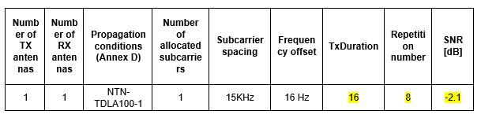  Proposal 5: RAN4 to consider updating the NPDSCH performance requirement for IoT NTN TDD mode by adding Table 8.3.1.1.1.1-3, as below:  Table 8.3.1.1.1.1-3: Minimum performance for NPDSCH under Standalone Operations and In-band Operations with 1 NRS port for IoT NTN TDD  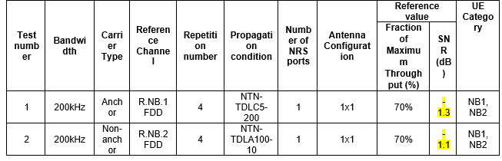
R4-2514422 | THALES | Proposal 1: RAN4 to consider the following simulation results for TDD NB-IoT NPRACH with NTN-TDLA channel model  Proposal 2: RAN4 to consider the following simulation results for TDD NB-IoT NPRACH with NTN-TDLC channel model  Proposal 3: Try to align as much as possible with RAN1 assumption and consider NTN-TDLC as well for NPRACH.  Proposal 4: RAN4 to consider the integration of the following specifications:  The probability of detection shall be equal to or exceed 99% for the SNR levels listed in table 8.5.3.2.1-1 and 8.5.3.2.1-2.  Table 8.5.3.2.1-1: NPRACH missed detection requirements for FDD  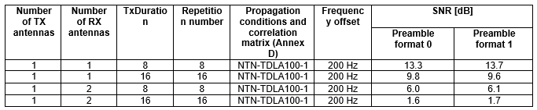  Table 8.5.3.2.1-2: NPRACH missed detection requirements for TDD  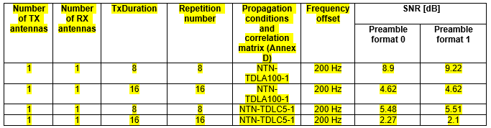  Proposal 5: RAN4 to consider the following simulation results for TDD NB-IoT NPUSCH format 1 with NTN-TDLA100 channel model with TBS 136 bits (12 subcarriers and QPSK, A7-2):  Proposal 6: RAN4 to consider the following simulation results for TDD NB-IoT NPUSCH format 1 with NTN-TDLC channel model with TBS 16 bits (1 subcarrier and π/2 BPSK, A14-3):  Proposal 7: RAN4 shall not consider 4 repetitions for NPUSCH demodulation performance with A14-3 – 1 tone with 16 bits payload (and if possible 2 repetitions should be excluded as well for 1 tone transmission).  Proposal 8: RAN4 to consider the following simulation results for TDD NB-IoT NPUSCH format 1 with NTN-TDLC channel model with TBS 136 bits (12 subcarriers and QPSK, A7-2):  Proposal 9: RAN4 to consider the integration of the following specifications:  Table 8.5.1.1.1-3: Minimum requirements for NPUSCH format 1, 200KHz Channel Bandwidth, 15KHz subcarrier spacing, multiple subcarriers, 1Tx, for TDD  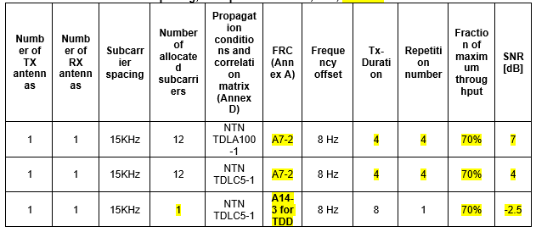  Proposal 10: RAN4 to assume 4 NPDSCH repetitions, with an SNR target around -1.3dB, R_{max}=4.  Proposal 11: RAN4 to consider the following simulation results for TDD NB-IoT NPDSCH with NTN-TDLC channel model  Proposal 12: RAN4 to consider the integration of the following specifications (with 1 single test number):  Table 8.3.2.1.1.1-2: Minimum performance for NPDSCH under Standalone with 1 NRS port  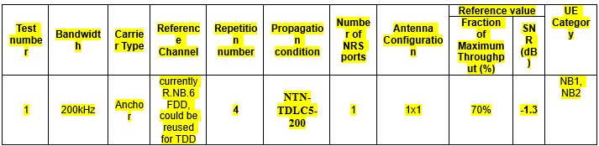
  SNR | BLER | Comment
  -10 | 1
  -9 | 1
  -8 | 1
  -7 | 1
  -6 | 1
  -5 | 1
  -4 | 1
  -3 | 0,990099
  -2 | 0,952381
  -1 | 0,925926
  0 | 0,884956
  1 | 0,826446
  2 | 0,746269
  3 | 0,662252
  4 | 0,502513
  5 | 0,414938
  6 | 0,355872
  7 | 0,294118 | Target SNR value selected: 7dB (at 70% throughput or 30% BLER)
  8 | 0,220264
  9 | 0,19084
  10 | 0,169205
  SNR | BLER | Comment
  -10 | 0,980392
  -9 | 0,970874
  -8 | 0,892857
  -7 | 0,806452
  -6 | 0,704225
  -5 | 0,636943
  -4 | 0,485437
  -3 | 0,357143 | Target SNR value selected: -2.5dB (at 70% throughput or 30% BLER)
  -2 | 0,242131 | Target SNR value selected: -2.5dB (at 70% throughput or 30% BLER)
  -1 | 0,190476
  0 | 0,13624
  1 | 0,0816327
  2 | 0,0515996
  3 | 0,03125
  4 | 0,0167308
  5 | 0,009
  SNR | BLER | Comment
  -10 | 1
  -9 | 1
  -8 | 1
  -7 | 1
  -6 | 1
  -5 | 1
  -4 | 1
  -3 | 1
  -2 | 0,990099
  -1 | 0,970874
  0 | 0,862069
  1 | 0,70922
  2 | 0,534759
  3 | 0,431034
  4 | 0,294118 | Target SNR value selected: 4dB (at 70% throughput or 30% BLER)
  5 | 0,203252
  6 | 0,158983
  7 | 0,0855432
  8 | 0,0522193
  9 | 0,0311333
  10 | 0,016518
R4-2514423 | THALES, Iridium Satellite LLC, Cambridge Consultants LTD | Aspects brought from previous meetings way forward
R4-2514247 | Nordic Semiconductor ASA | Observation-1: R17 NTN demodulation requirements for UE are not directly reusable to R19 NTN IoT TDD due to different target operation point.  Proposal-1: In RAN#116b agree on the set of perfomance test cases defined as depicted in the Tables 1 through 6. Define reference SNR value by RAN4#117.

Open issues summary

Sub-topic 3-1: SAN Demodulation – NPUSCH Format 1

Issue 3-1-1: Channel Model
Options:
- Option 1: NTN-TDLA100-1 (Samsung, Iridium, CCL, Thales)
- Option 2: NTN-TDLC5-1 (Thales)
Recommended Way Forward:
- Confirm during the meeting whether NTN-TDLA100-1 is agreeable, then discuss NTN-TDLC5-1.

Issue 3-1-2: Antenna Configuration
Options:
- Option 1: 1T1R (Samsung, Iridium, CCL, Thales)
- Option 2: 1T2R (Samsung)
Recommended Way Forward:
- Initially confirm that 1T1R is agreeable, then discuss 1T2R.

Issue 3-1-3: Repetition Number
Options:
- Option 1: 4 (Samsung, Iridium, CCL, Thales)
- Option 2: 16 (Iridium, CCL)
Recommended Way Forward:
- Initially confirm whether 4 is agreeable, then discuss 16.

Issue 3-1-4: Sub Carrier Spacing
Options:
- Option 1: 15 kHz (Samsung, Iridium, CCL, Thales)
Recommended Way Forward:
- Confirm during the meeting whether 15 kHz is agreeable.

Issue 3-1-5: Allocated Subcarriers
Options:
- Option 1: 12 (Samsung, Iridium, CCL, Thales)
  - Option 1a: with 4 Tx Duration and 4 repetitions (Thales)
  - Option 1b: with 16 Tx Duration and 16 repetitions (Iridium, CCL)
  - Option 1c: with 8 Tx Duration and 8 repetitions (Samsung)
- Option 2: 1 (Iridium, CCL, Thales)
  - Option 2a: with 32 Tx Duration and 4 repetitions (Iridium, CCL)
  - Option 2b: with 16 Tx Duration and 2 repetitions (Iridium, CCL)
  - Option 2b: with 8 Tx Duration and 1 repetition (Thales)
Recommended Way Forward:
- Discuss during the meeting, initially focused on number of subcarriers

Sub-topic 3-2: SAN Demodulation – NPUSCH Format 2

Issue 3-2-1: Channel Model
Options:
- Option 1: NTN-TDLA100-1 (Samsung, Iridium, CCL)
Recommended Way Forward:
- Confirm during the meeting whether NTN-TDLA100-1 is agreeable

Issue 3-2-2: Antenna Configuration
Options:
- Option 1: 1T1R (Samsung, Iridium, CCL, Thales)
- Option 2: 1T2R (Samsung)
Recommended Way Forward:
- Initially confirm that 1T1R is agreeable, then discuss 1T2R.

Issue 3-2-3: Repetition Number
Options:
- Option 1: 4 (Samsung)
  - Option 1a: With Tx Duration of 8 (Samsung)
- Option 2: 8 (Iridium, CCL)
  - Option 2a: With Tx Duration of 16 (Iridium, CCL)
Recommended Way Forward:
- Will require discussion at meeting, no obvious way forward from summary

Issue 3-2-4: Sub Carrier Spacing
Options:
- Option 1: 15 kHz (Samsung)
Recommended Way Forward:
- Confirm during the meeting whether 15 kHz is agreeable.

Sub-topic 3-3: SAN Demodulation – NPRACH

Issue 3-3-1: Channel Model
Options:
- Option 1: NTN-TDLA100-1 (Samsung)
- Option 2: NTN-TDLC5-1 (Iridium CCL)
Recommended Way Forward:
- Discuss during the meeting if NTN-TDLC5-1 should be introduced as well as NTN-TDLA100-1

Issue 3-3-2: Antenna Configuration
Options:
- Option 1: 1T1R (Samsung, Iridium CCL)
Recommended Way Forward:
- Confirm that 1T1R is agreeable.

Issue 3-3-3: Repetition Number and Tx Duration
Options:
- For Format 0:
  - Option 1a: 4 with 2ms per repetition (Samsung)
  - Option 1b: 8 with 8 Tx duration (Iridium CCL)
  - Option 1c: 16 with 16 Tx duration (Iridium CCL)
- For Format 1:
  - Option 2a: 2 with 4ms per repetition (Samsung)
  - Option 2b: 8 with 8 Tx duration (Iridium CCL)
  - Option 2c: 16 with 16 Tx duration (Iridium CCL)
Recommended Way Forward:
- Discussion required at meeting as no obvious way forward during summary

Issue 3-3-4: TDD Pattern
Options:
- Option 1: D/U = 8 (Samsung)
Recommended Way Forward:
- Confirm during the meeting whether D/U = 8 is agreeable

Issue 3-3-5: NPRACH Format
Options:
- Option 1: Both Format 0 and 1 (Samsung)
Recommended Way Forward:
- Confirm whether both formats 0 and 1 are agreeable

Sub-topic 3-4: UE Demodulation - PDSCH

Issue 3-4-1: Channel Model
Options:
- Option 1: NTN-TDLC5-200 (Iridium, CCL, Thales, Nordic semiconductor)
- Option 2: NTN-TDLA100-10 (Iridium, CCL, Nordic semiconductor)
Recommended Way Forward:
- Initially, confirm during the meeting whether NTN-TDLC5-200 is agreeable, then discuss NTN-TDLA100-10

Issue 3-4-2: Antenna Configuration
Options:
- Option 1: 1T1R (Iridium, CCL, Thales, Nordic semiconductor)
Recommended Way Forward:
- Confirm during the meeting whether 1T1R is agreeable

Issue 3-4-3: Repetition Number
Options:
- Option 1: 4 (Iridium, CCL, Thales, Nordic semiconductor)
- Option 2: 16 (Nordic semiconductor)
Recommended Way Forward:
- Confirm during the meeting that 4 repetitions is agreeable, then discuss 16.

Issue 3-4-4: TDD Pattern
Options:
- Option 1: D/U = 8 (Samsung)
Recommended Way Forward:
- Confirm during the meeting whether D/U = 8 is agreeable

Recommended Disposition of TDocs
T-doc number | Suggested Status | Comments (Optional)
R4-2513154 | Noted
R4-2513407 | Noted
R4-2513581 | Noted
R4-2514140 | Noted
R4-2513395 | Noted
R4-2513441 | Noted
R4-2513970 | Noted
R4-2514151 | Noted
R4-2514152 |  | Reserved Only
R4-2513406 | Noted
R4-2513825 | Noted
R4-2514422 | Noted
R4-2514423 | Noted
R4-2514247 | Noted | Initially Submitted to wrong Agenda Item (maintenance) – Treat under 6.21.3

