3GPP TSG-RAN WG2 Meeting #131-bis Draft R2-2507763

Prague, Czechia, October 13–17, 2025

Agenda Item: 8.8.2
Source: Ericsson
Title: Summary of the offline discussion [AT131bis][303][NR NTN] RRC open issues (Ericsson)
Document for: Discussion/Decision

Introduction
This document summarizes the following offline discussion:

* [AT131bis][303][NR NTN] RRC open issues (Ericsson)
Scope: Continue the discussion on applicability to inter-frequency [V204/H250] and on provision of a distance threshold [X250/V205]
Intended outcome: summary of the offline discussion (in R2-2507763)
F2F time: Wednesday, 9:30-10:30, BO3
Deadline for offline discussion summary: Wednesday 2025-10-15 17:00

Discussion
One open issue is the applicability of the Rel-19 SMTC enhancements to inter-frequency.
So far, there is no common understanding in RAN2 about which inter-frequency scenario is relevant (technically, commercially, etc.) for NTN deployments, if any. To understand whether the Rel-19 SMTC enhancements are 1) necessary and 2) sufficient to solve the inter-frequency case, RAN2 needs to first decide which inter-frequency scenario(s) is(are) considered.
Another open issue is whether the network provides a distance threshold for the UE to consider when selecting SMTCs in RRC_IDLE/INACTIVE mode and when reporting the N closest reference locations in RRC_CONNECTED mode, i.e., the UE potentially reports less than N closest reference locations if some of the N closest reference locations are still too far away according to the distance threshold.
As discussed by several companies in [1], a distance threshold is necessary for the inter-frequency case. Therefore, to efficiently discuss this open issue, we also need clarity on the inter-frequency scenario(s).
- Without clarity on the considered inter-frequency scenario(s), it is impossible to conclude on either the applicability of the Rel-19 SMTC enhancements to inter-frequency or the introduction of a distance threshold.
We therefore start by discussing what inter-frequency scenario(s) to consider before we continue discussion on the open issues as such.
Figure 1 show four potential inter-frequency scenarios for NTN deployments. Note that SMTC enhancements are relevant only in the case where neighbor cells on a different frequency are using different SMTC offset. For improved clarity, the inter-frequency neighbors are hence depicted in colors, each color representing a different SMTC offset, while the intra-frequency neighbors are outlined with dots.

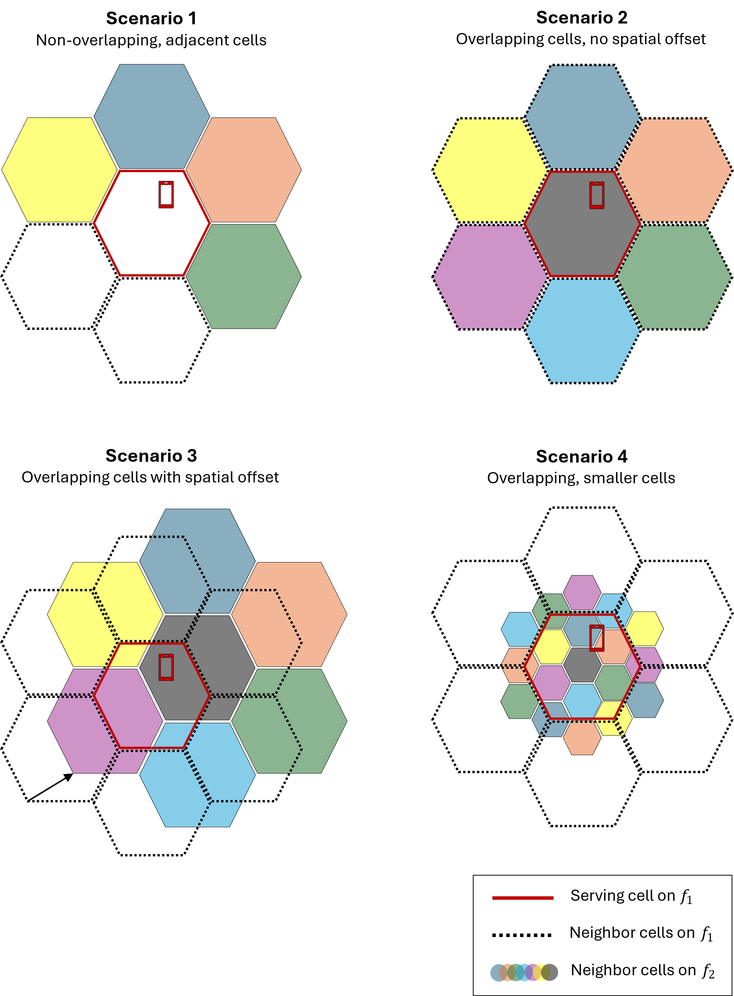

Figure 1: Potential inter-frequency scenarios for NTN deployments.

Potential inter-frequency scenarios
We elaborate on the potential inter-frequency scenarios for NTN deployments as shown in Figure 1.
In Scenario 1, the inter-frequency neighbor cells cover areas directly adjacent to the areas covered by the serving cell but do not (significantly) overlap the coverage of the serving cell or the intra-frequency neighbor cells.
In Scenario 2, the inter-frequency neighbor cells overlap the serving cell and intra-frequency neighbor cells in coverage and the cells on both frequencies (denoted as $f_{1}$ and $f_{2}$) are realized by pair-wise identical satellite beams, i.e., cell sizes and cell centers are identical. We refer to this as “overlapping cells without spatial offset”, or “perfect overlap”. For example, cells on both frequencies are realized by the same satellite.
Scenario 3 is somewhat similar to Scenario 2. However, the key difference is that the satellite beams realizing the cells on the frequencies $f_{1}$ and $f_{2}$ are spatially offset, i.e., the cell centers for cells on $f_{1}$ (the serving cell’s frequency) are different from those for cells on $f_{2}$. We refer to this as “overlapping cells with spatial offset”. For example, cells on the two frequencies are realized by different satellites of the same (or a similar) orbit. Scenario 3 can also be seen as a generalization of Scenario 2.
Lastly in Scenario 4, the inter-frequency neighbor cells overlap the serving cell (and intra-frequency neighbor cells) in coverage but are smaller in size (in this example, three times smaller). The scenario here may be, e.g., that the serving cell belongs to a MEO or GEO constellation while the inter-frequency neighbor cells belong to a LEO constellation. In other examples, all the cells are LEO cells but from different LEO orbits or realized by satellite beams of different widths.
- There are at least four different inter-frequency scenarios for NTN deployments that can be considered.
To simplify the discussion, we observe that there are two main types of inter-frequency scenarios, adjacent coverage (i.e., each area is covered by one frequency) as in Scenario 1 and overlapping/overlaid coverage (i.e., each area is covered by multiple frequencies) as in the Scenarios 2-4.
- There are two main types of inter-frequency scenarios, adjacent coverage and overlapping/overlaid coverage.

Revisiting Scenario 4 once again, we observe that there are many inter-frequency neighbor cells, too many considering the current maximum number of reference locations. In the given example, there are about 13 to 19 relevant inter-frequency neighbor cells. In other examples, there may be even more. Note that we assumed a cell size (radius/diameter) difference of factor 3. However, according to TR 38.821, there may be a cell size difference of factor of up to 10 for LEO cells (an extreme case). A similar situation exists when considering the scenario of a GEO serving cell and LEO inter-frequency neighbor cells. We therefore conclude that location-based SMTC selection based on a fixed and limited set of reference locations (as agreed for Rel-19) does not work for this inter-frequency scenario. Consequently, we propose to focus during the ASN.1 review phase on scenarios where cell sizes for cells on different frequencies are the same (or similar).
- Location-based SMTC selection based on a limited set of reference locations does not work for scenarios where the inter-frequency neighbor cells are much smaller than the serving cell.

In addition, one company has clarified in [2] that, in the LS to RAN4 [3], RAN2 has only and specifically referred to intra-frequency (and not inter-frequency).
- In the LS exchange with RAN4, RAN2 has so far not considered the inter-frequency scenario.

Question 1: Companies are asked to provide comments on which inter-frequency scenario(s) to consider in Rel-19.
Company | Preferred scenario | Comments

- ...

In what follows, we analyze how the Rel-19 SMTC enhancements can be applied to the above inter-frequency scenarios, starting from location-based/UE assisted SMTC selection and continuing with the additional SMTC periodicity.

Location-based/UE-assisted SMTC selection
We first analyze the necessity of location-based/UE-assisted SMTC selection/configuration for the inter-frequency case and then present potential solutions.
For Scenario 1, for RRC_IDLE/INACTIVE state, location-based SMTC selection is not necessary as the network can already configure up to four SMTCs per frequency, i.e., the network can configure the SMTCs of all inter-frequency neighbor cells. However, location-based SMTC selection may help to reduce the UE’s measurement effort and thus energy consumption, since the UE may decide to measure on only a subset of those up to four SMTCs. From the UE energy consumption perspective, ideally, the UE selects a subset of SMTCs across frequencies, potentially skipping measurement on a certain frequency, if not relevant considering the UE’s location and the reference locations associated with the SMTCs. For RRC_CONNECTED state, we observe that for UEs that support parallelSMTC-r17, the same is true, i.e., that UE-assisted SMTC selection is not needed but may be useful. Only for UEs that do not support parallelSMTC-r17, the network cannot configure the SMTCs of all four inter-frequency neighbors. In this case, UE-assisted SMTC selection can be used to understand which two SMTCs are most relevant.
For Scenario 3, there are four inter-frequency neighbor cells that the UE can reselect or be handed over to. This scenario is very similar to Scenario 1; the same rationale applies. Namely, UE-assisted SMTC selection may be necessary only for RRC_CONNECTED state and only for UEs that do not support parallelSMTC-r17, as explained above. However, location-based SMTC selection in RRC_IDLE/INACTIVE state as well as UE-assisted SMTC selection in RRC_CONNECTED state can in fact be useful for any UE that supports this feature.
We further observe that UE-assisted SMTC selection/configuration in RRC_CONNECTED state is independent of the scenario (intra- or inter-frequency). The network can simply configure a set of reference locations via dedicated RRC signaling, in response to which the UE reports the N closest reference locations. Since the reference locations are not connected to a certain frequency or scenario, the existing solution can already be applied to inter-frequency Scenarios 1 and 3 and can thus be used to identify the relevant SMTCs for UEs that do not support parallelSMTC-r17.
- For inter-frequency Scenarios 1 and 3, location-based SMTC selection in RRC_IDLE/INACTIVE state is not necessary and UE-assisted SMTC selection in RRC_CONNECTED state is not necessary, except for UEs that do not support parallelSMTC-r17.
- The existing solution for UE-assisted SMTC selection in RRC_CONNECTED state is independent of scenarios/frequencies and can already be used for the inter-frequency case.
- For inter-frequency Scenarios 1 and 3, location-based/UE-assisted SMTC selection for inter-frequency may be beneficial from the UE energy consumption perspective (across RRC states).
For Scenario 2, there is in principle only one inter-frequency neighbor that the UE can reselect, if in RRC_IDLE/INACTIVE state, or be handed over to, if in RRC_CONNECTED state. Considering RRC_CONNECTED state, inter-frequency handover is generally for load balancing, not due to UE movement. There is hence no need for the UE to measure on other inter-frequency neighbors (beside the one that is directly overlapping the serving cell). Upon UE movement, the UE is generally handed over to an intra-frequency neighbor, after which it may again measure on the corresponding inter-frequency neighbor, if configured to do so. The same rationale applies to RRC_IDLE/INACTIVE state, i.e., there is no need for location-based SMTC selection.
- For inter-frequency Scenario 2, location-based/UE-assisted SMTC selection is not necessary.

If, however, in Scenarios 2 and 3, reselection or handover to any of the surrounding inter-frequency neighbour cell needs to be possible, both location-based SMTC selection in RRC_IDLE/INACTIVE state and UE-assisted SMTC configuration in RRC_CONNECTED state needs to be extended to inter-frequency.

Question 2: Companies are asked to provide comments on whether 1.) location-based SMTC selection (RRC_IDLE/INACTIVE) or 2.) UE-assisted SMTC configuration (RRC_CONNECTED) or both needs to be extended to the selected inter-frequency scenario(s).
Company | Which (1,2,both,none)? | Comments

- ...

Additional SMTC periodicity
For Scenario 1 and 3, the additional SMTC periodicity is useful for inter-frequency provided that the different inter-frequency neighbor cells are applying different SSB periodicities. This is true independent of location-based SMTC selection.
For Scenario 2, the additional SMTC periodicity is in principle not necessary for inter-frequency since only one inter-frequency neighbor cell is relevant for the UE within the coverage of its serving cell.
For Scenario 4, the additional SMTC periodicity would be useful. However, the prevailing issue is how to configure/select SMTCs in the first place. Before this issue has been addressed, the question of the usefulness of the additional SMTC periodicity does not arise.
- For Scenario 1 and 3 (and in principle Scenario 4), the additional SMTC periodicity is useful for the inter-frequency case, whereas for Scenario 2, it is not necessary.

Question 3: Companies are asked to provide comments on whether the additional SMTC periodicity needs to be extended to the selected inter-frequency scenario(s) for RRC_IDLE/INACTIVE or RRC_CONNECTED or both.
Company | Which (1,2,both,none)? | Comments

- ...

Introduction of a distance threshold
Lastly, we discuss the open issue of the introduction of a distance threshold.
First of all, we observe that different companies promoting a distance threshold are addressing different issues/scenarios.

Some companies in [1] are addressing a case where neighbor cells are different in size.
In Figure 2, it is showcased the issue with the solution only considering the closeness between UE and neighbor cells. In the figure, neighbor cell 1 and neighbor cell 2 have different cell size. Although d1 < d2, UE is under coverage of neighbor cell 2 rather than neighbor cell 1 and should measure neighbor cell 2. If UE selects neighbor cell based on the closest distance, it will choose the wrong neighbor cell 1 (i.e. wrong SMTC):

Figure 2: Illustration of neighbor cells with different cell size (taken from [1]).
As clarified in [1], this problem can be addressed by network implementation if the network places the reference locations, e.g., on the edges (instead of centers) of the neighbor cells.
However, it is observed that the same strategy (for placing reference locations) does not work for the inter-frequency overlapping case, as illustrated in Figure 3. Here, two UEs are close to neighbor cell 2 at the same distance, but the measured distance to the yellow reference point is quite different:

Figure 3: Illustration of the inter-frequency overlapping case with reference location (yellow dot) at the cell edge of the overlaid neighbor cell (taken from [1]).

The companies in [1] conclude that, to solve this problem, the network needs to broadcast a distance threshold.

Other companies [4], [5] are seeing a certain benefit in a distance threshold to prevent the UE from selecting (in RRC_IDLE/INACTIVE mode) or being configured with (in RRC_CONNECTED mode) SMTCs that are not really relevant, because the associated reference locations is actually far away, even if among the N closest.
It was brought to the moderator’s attention that the Rel-17 distance threshold, which is associated with the serving cell’s reference location (that typically is the center of the serving cell), may already prevent the UE from having to perform unnecessary neighbor-cell measurements, if configured.
The remaining motivation for introducing a new distance threshold that is associated with the new/Rel-19 reference locations is thus to capture the case where the UE is very close to one of the (new) reference locations such that it is sufficient to measure only the SMTC associated with that one reference location. This is illustrated in Figure 4. The UE at the position shown in Figure 4 may only select or be configured with the SMTC of the blue cell.

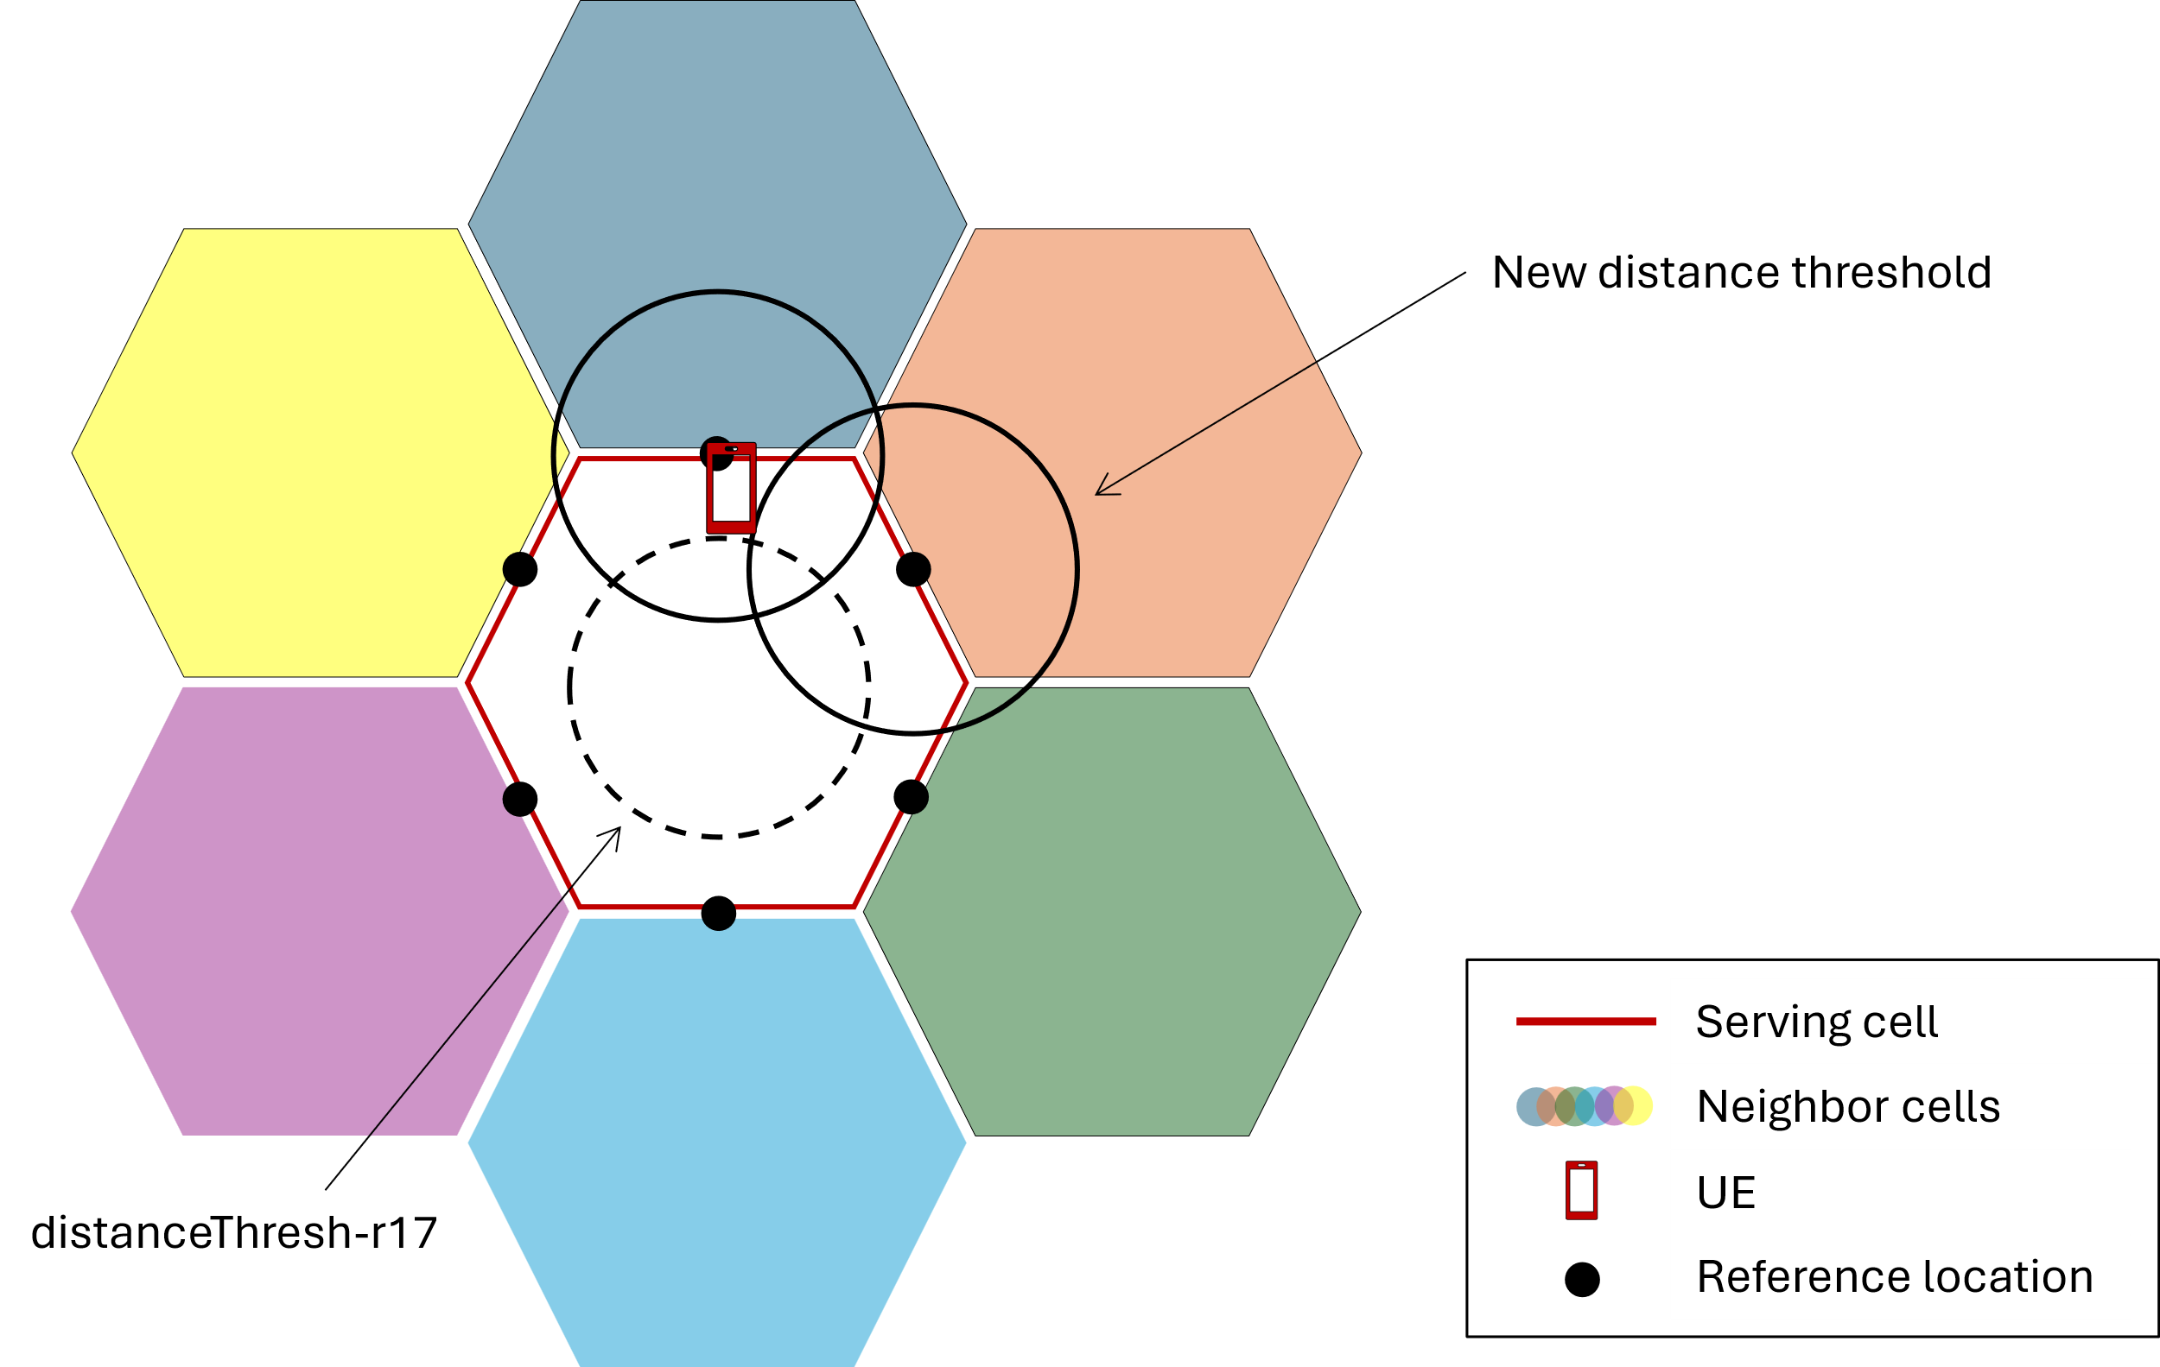
Figure 4: Illustration of a scenario where a new distance threshold is used to prevent the UE from having to perform unnecessary neighbour-cell measurements.

Additionally, we note that, if RAN2 decides to introduce a distance threshold regardless of the problem/scenario that is addressed, RAN2 needs to agree on the intended UE behavior and inform RAN4, especially for the behavior in RRC_IDLE/INACTIVE state.

Question 3: Companies are asked to comment on the motivation to introduce a new distance threshold in Rel-19, 1.) accommodate the scenario where cell sizes differ or 2.) prevent the UE from having to perform unnecessary neighbor-cell measurements, and on the intended UE behavior.
Company | Motivation (1 or 2) | Intended UE behavior

- ...

3 Conclusion
In the previous sections we made the following observations:
Observation 1 Without clarity on the considered inter-frequency scenario(s), it is impossible to conclude on either the applicability of the Rel-19 SMTC enhancements to inter-frequency or the introduction of a distance threshold.
Observation 2 There are at least four different inter-frequency scenarios for NTN deployments that can be considered.
Observation 3 There are two main types of inter-frequency scenarios, adjacent coverage and overlapping/overlaid coverage.
Observation 4 Location-based SMTC selection based on a limited set of reference locations does not work for scenarios where the inter-frequency neighbor cells are much smaller than the serving cell.
Observation 5 In the LS exchange with RAN4, RAN2 has so far not considered the inter-frequency scenario.
Observation 6 For inter-frequency Scenarios 1 and 3, location-based SMTC selection in RRC_IDLE/INACTIVE state is not necessary and UE-assisted SMTC selection in RRC_CONNECTED state is not necessary, except for UEs that do not support parallelSMTC-r17.
Observation 7 The existing solution for UE-assisted SMTC selection in RRC_CONNECTED state is independent of scenarios/frequencies and can already be used for the inter-frequency case.
Observation 8 For inter-frequency Scenarios 1 and 3, location-based/UE-assisted SMTC selection for inter-frequency may be beneficial from the UE energy consumption perspective (across RRC states).
Observation 9 For inter-frequency Scenario 2, location-based/UE-assisted SMTC selection is not necessary.
Observation 10 For Scenario 1 and 3 (and in principle Scenario 4), the additional SMTC periodicity is useful for the inter-frequency case, whereas for Scenario 2, it is not necessary.

Based on the discussion in the previous sections we propose the following:
Proposal 1 ...
Proposal 2 ...
Proposal 3 ...
Proposal 4 ...

References
- R2-2506807, “Discussion on RIL X250 X251 V205 for DL coverage enhancement ”, Xiaomi, ZTE, CSCN, Samsung, RAN2#131bis, October 13–17, 2025.
- R2-2507440, “Remaining issues on beam hopping with multiple SMTC offsets”, Qualcomm Incorporated, RAN2#131bis, October 13–17, 2025.
- R2-2503068, “LS on SMTC enhancements”, Source RAN2, To RAN4, RAN2#129bis, April 7–11, 2025.
- R2-2506834, “Discussion on RILs [V200][S024][S025][H250][V208][X250] regarding SMTC Enhancement”, vivo, RAN2#131bis, October 13–17, 2025.
- R2-2507690, “Discussion on various RILs for NR NTN”, Ericsson, RAN2#131bis, October 13–17, 2025.

