3GPP TSG-RAN WG1#122bis R1-25abcde
Prague, Czech Republic, Oct 13-17, 2025
Agenda Item: 8.5
Source: Moderator (Ericsson)
Title: Draft summary of R19 NES maintenance for adaptation of common signaling
Document for: Discussion

Introduction
This is the summary for AI 8.5 on the maintenance for adaptation of common signalling for NES based on the views expressed by companies in the contributions listed in the Appendix A and providing some topics and proposals for discussion/agreement.
Some companies provide TPs for aligning RRC parameter name in RAN1 specs with those in the RAN2 endorsed CRs. Moderator understanding is that RAN2 plans to send an LS with the updated RRC parameter names and the RAN1 specs can be updated based on RAN2 input.

Adaptation of PRACH

Proposed Corrections (TPs)

Discussion point 2.1.1 (new RRC parameters)
[4] proposes the following
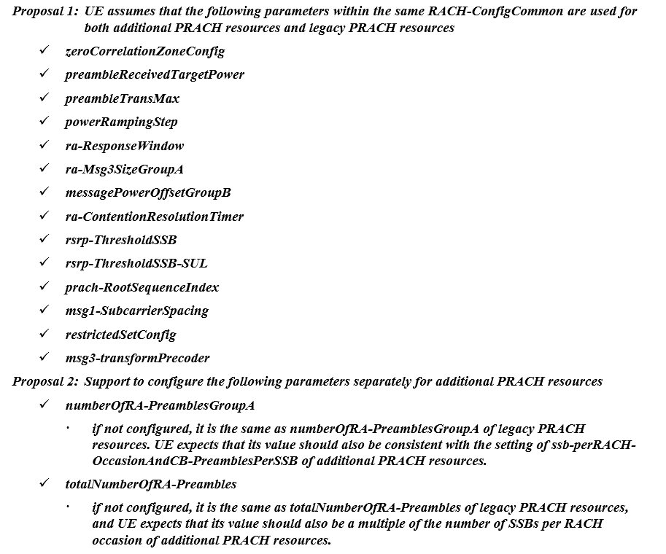
[5] proposes to configure totalNumberofRA-Preambles separately.
This issue and proposal was discussed in RAN1#122 (FL summary in R1-2506545, see topic 2.1.1).

Company | Comment (if any)
Moderator | This issue and proposal was discussed in RAN1#122 (FL summary in R1-2506545, see topic 2.1.1). The latest round discussion from last meeting is shown below.  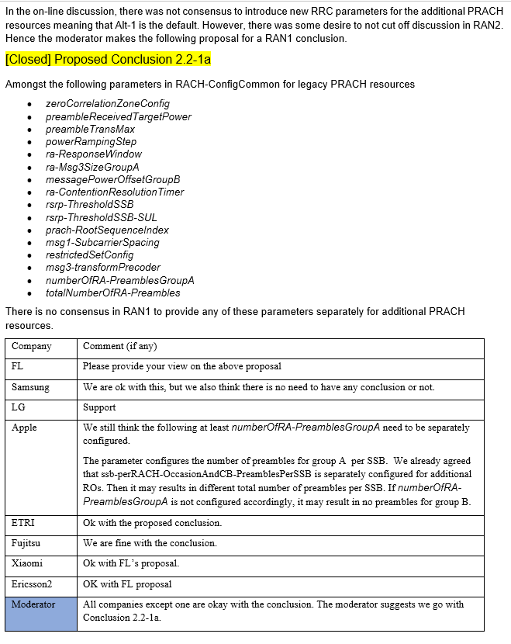
Moderator | Moderator suggests to pick up the discussion from last meeting, i.e. start from below proposed conclusion 2.2-1a which was OK for all companies (except one) that provided input.  Proposed Conclusion 2.2-1a  Amongst the following parameters in RACH-ConfigCommon for legacy PRACH resources  - zeroCorrelationZoneConfig  - preambleReceivedTargetPower  - preambleTransMax  - powerRampingStep  - ra-ResponseWindow  - ra-Msg3SizeGroupA  - messagePowerOffsetGroupB  - ra-ContentionResolutionTimer  - rsrp-ThresholdSSB  - rsrp-ThresholdSSB-SUL  - prach-RootSequenceIndex  - msg1-SubcarrierSpacing  - restrictedSetConfig  - msg3-transformPrecoder  - numberOfRA-PreamblesGroupA  - totalNumberOfRA-Preambles  There is no consensus in RAN1 to provide any of these parameters separately for additional PRACH resources.
ZTE, Sanechips | OK with the Proposed Conclusion 2.2-1a.
Huawei & HiSilicon1 | Thank you for the FL proposal.  If we are not mistaken, by the end of meeting after all the discussion happened, most companies seemed comfortable with having these two parameters configured separately:  • numberOfRA-PreamblesGroupA  • totalNumberOfRA-Preambles  Meanwhile, the rest of the parameters in the list are common between legacy and additional ROs.  We would like to reiterate our previous meeting comment for the sake of technical discussion, if needed.  =============== our last meeting comment ==========================  Parameters with General Consensus  For the following parameters, there is consensus that they should be jointly configured for both additional PRACH resources and legacy PRACH resources:  - zeroCorrelationZoneConfig  - preambleReceivedTargetPower  - preambleTransMax  - powerRampingStep  - ra-ResponseWindow  - ra-Msg3SizeGroupA  - messagePowerOffsetGroupB  - ra-ContentionResolutionTimer  - rsrp-ThresholdSSB  - rsrp-ThresholdSSB-SUL  - prach-RootSequenceIndex  - msg1-SubcarrierSpacing  - restrictedSetConfig  - msg3-transformPrecoder  We therefore suggest reaching agreement first on these non-controversial parameters and adding them to the RRC parameter list. It would then be up to RAN2 to capture how these parameters are applied for additional RO configurations. Otherwise, the UE cannot reliably perform RACH in additional ROs.  Parameters without Consensus  If there is no consensus in RAN1, then the issue centers around the following two parameters:  - numberOfRA-PreamblesGroupA  - totalNumberOfRA-Preambles  Our question to the goup is: What is the benefit of keeping these two parameters commonly configured, considering that ssb-perRACH-OccasionAndCB-PreamblesPerSSB is separately configured for additional ROs?  If the number of SSBs per RO is 1, what is the advantage of allowing flexible configuration of the size of Group B and the size of the contention-free group, while keeping the size of Group A fixed in additional ROs?  The situation becomes even more complex if we assume a different number of SSBs per RO between additional ROs and legacy ROs. In that case, it would be inconsistent to allow flexibility for only one parameter while keeping the others fixed. One example of this issue has already been presented by Apple.  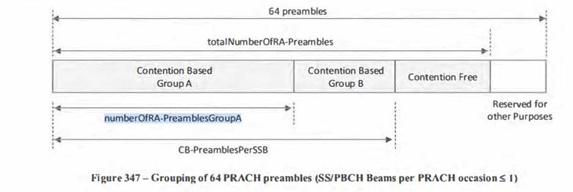
CATT | OK with the proposed conclusion 2.2-1a.
Nokia | Fine with the FL proposal
Xiaomi | OK with the Proposed Conclusion 2.2-1a.
DCM | Fine with the FL proposal
LG | We support the FL proposal.
vivo | Thanks for FL proposal and HW’s detailed comments  We agree with HW that it is very strange to configure ssb-perRACH-OccasionAndCB-PreamblesPerSSB searately but with common totalNumberOfRA-Preambles. Besides, RAN2 agrees that additional ROs can’t be used for OSI request. However, legacy RO can use them for OSI request. It is clear that legacy RO and additional RO should have separate configuration.
Ericsson | Regarding the proposal to add new RRC parameters for numberOfRA-PreamblesGroupA, totalNumberOfRA-Preambles, these were already discussed in RAN1#120bis. From our perspective, we do not see the need to optimize the spec further for the OSI request functionality.

Discussion point 2.1.2 (additional PRACH availability for PDCCH order)
Following was agreed in RAN1#120:
Agreement (from RAN1#120)
For adaption of PRACH in time-domain, for a connected mode UE, support a 1-bit field in DCI 1_0 with C-RNTI used to trigger PRACH (i.e. PDCCH order) to indicate whether the additional PRACH resource(s) is available for the triggered PRACH.
- FFS: UE behaviour (e.g. applicable resources for PRACH mask index) when it is indicated of additional PRACH resource(s)
- FFS: Details on how to reuse existing bit for the 1-bit indication
[5],[6],[8],[9],[11] propose corrections to 38.213 to clarify UE behaviour for availability of the PRACH resources indicated by PDCCH ordered PRACH. [4] provided a TP to 38.212 to clarify that the resource availability applies also to retransmissions for the PDCCH order.
This issue was discussed in RAN1#122 (FL summary in R1-2506545, see topic 2.1.2) with multiple alternatives.
For this week, moderator suggests to focus on the following TPs, i.e. P3 for 38.213 from [11] and P1 for 38.212 from [4].
TP for 38.213 in P3 from [11]

Proposal 3 from [11]: For adaptation of common signals/channels, adopt the following TP to 38.213, subclause 8.1 to clarify the UE behaviour for availability of the PRACH resources indicated by PDCCH ordered PRACH.
Reason for change: Agreement from RAN1#120 is not fully reflected in the specification i.e. for PDCCH ordered PRACH, the additional resource(s) is available for the triggered PRACH.
Summary of changes: Clarify that for indication by DCI format 1_0 with CRC scrambled by the C-RNTI, the PRACH occasions are available for the triggered PRACH associated with the PDCCH providing the DCI format 1_0 with CRC scrambled by the C-RNTI.
Consequences: Unclear UE behavior regarding availability of the PRACH resources indicated by PDCCH ordered PRACH.
--------------------------------------------Begin TP----------------------------------------------------------------------------------------

8.1 Random access preamble

<Omit unchanged text>
Valid PRACH occasions associated with addl-RACH-Config-Adaptation, and additionally in association periods indicated by prach-SubsetMask-Index-Adaptation, if provided, are indicated as available for PRACH transmission based on an indication in a DCI format 1_0 with CRC scrambled by a P-RNTI or a C-RNTI [5, TS 38.212]. For indication by DCI format 1_0 with CRC scrambled by the P-RNTI, the PRACH occasions are available for a duration provided by validity-DurationForAddlRACHAdaptation, starting from the first frame of the SI modification period [12, TS 38.331] that includes a PDCCH monitoring occasion where the UE receives a PDCCH providing the DCI format 1_0 with CRC scrambled by the P-RNTI. For indication by DCI format 1_0 with CRC scrambled by the C-RNTI, the PRACH occasions are available for the triggered PRACH associated with the PDCCH providing the DCI format 1_0 with CRC scrambled by the C-RNTI.
<Omit unchanged text>
--------------------------------------------End TP----------------------------------------------------------------------------------------

TP for 38.212 in P1 from [4]
Proposal 1: Adopt the following update to Clause 7.3.1.2.1 for TS 38.212
Reason for change | Now with current statement for the additional PRACH “initiated by the PDCCH order”, it is not clear on the applicability of the available additional PRACH resource for the initial PRACH transmission and/or PRACH re-transmission, if PRACH resource indicator is set to 1.
Summary of change | Clarify that when the PRACH resource indicator in PDCCH order DCI is set to 1, the additional PRACH resource(s) is available not only for the initial PRACH transmission but also for the PRACH re-transmission.
Consequences if not approved | The availability of additional PRACH resources for PRACH initiated by the PDCCH will not be clear.

7.3.1.2.1 Format 1_0
<omitted text>
Table 7.3.1.2.1-5: PRACH resource indicator
Bit field | PRACH resource indicator
0 | The PRACH resource configured by addl-RACH-Config-Adaptation is not available for the PRACH (re)transmission initiated by the PDCCH order
1 | The PRACH resource configured by addl-RACH-Config-Adaptation is available for the PRACH (re)transmission initiated by the PDCCH order

Company | Comment (if any)
Moderator | Companies are invited to provide their view on above two TPs, i.e. whether one or both of the TP for 38.213 in P3 from [11] and TP for 38.212 in P1from [4] can be adopted.  Please also provide any suggested updates.
Samsung | First, we also proposed the TP for this issue in our tdoc, i.e., TP#4; which is different from the ones list here.  Second, as we commented in last meeting and also discussed in our tdoc, the TP in [11] and [4] cannot solve the problem. Both TPs are actually functioning similarily to link the avaialiblity to the actual transmission of PRACH, which is not only a new way to determine the availability, but we also has doult on its feasibility. More specficially, the two TPs intend to make the additional RACH resource available for the whole-time duration when the UE transmits the PRACH. This implies that the PRACH resource is always available as long as the UE can transmit PRACH until the max allowed PRACH transmission time, which means the available duration for the PRACH resource is changeable. Moreover, the network has no idea how many times the UE has transmitted PRACH so that the network cannot know when to terminate the resource.  Consider above, we seriously suggest FL to discuss our TP as well.
  ======== TP #4 for TS 38.213 ===================================
  Reason for change: There is not clear understanding on the starting time and duration for the PDCCH ordered RACH with additional RACH indicated as available. Besides, there is difference between the cases when it’s CBRA and CFRA and also whether the paging DCI activates the additional RACH or not.
  Summary of changes: Add the relationship of SSB occasion before and after adaptation.
  Consequence if not approved: RAN1 agreement on relationship of SSB occasion before and after adaptation is not captured, and there is no limitation on the relationship of SSB occasion before and after adaptation.
  ===== Start of TP #4 =======================================
  8.1 Random access preamble
  ============= Unchanged Text Omitted ======================
  Valid PRACH occasions associated with addl-RACH-Config-Adaptation, and additionally in association periods indicated by prach-SubsetMask-Index-Adaptation, if provided, are indicated as available for PRACH transmission based on an indication in a DCI format 1_0 with CRC scrambled by a P-RNTI or a C-RNTI [5, TS 38.212]. For indication by DCI format 1_0 with CRC scrambled by the P-RNTI, or for indication by DCI format 1_0 with CRC scrambled by the C-RNTI and the value of the random access preamble index field is zero, the PRACH occasions are available for a duration provided by validity-DurationForAddlRACHAdaptation, starting from the first frame of the SI modification period [12, TS 38.331] that includes a PDCCH monitoring occasion where the UE receives a PDCCH providing the DCI format 1_0 with CRC scrambled by the P-RNTI. For indication by a DCI format 1_0 with CRC scrambled by the C-RNTI, when the value of the random access preamble index field is not zero, the PRACH occasions are available for a duration provided by validityDurationForAddlRACH-Adaptation, starting from the first frame of the SI modification period [12, TS 38.331] that includes a PDCCH monitoring occasion where the UE receives a PDCCH providing the DCI format 1_0 with CRC scrambled by the C-RNTI.
  ============ Unchanged Text Omitted ===================
  ========== End of TP #4 =======================================
Huawei & HiSilicon 1 | Once “initiated by the PDCCH order” meaning is clearified to include the PRACH and its re-tranmissions related to the PDCCH order, then we do not have strong on taking both TPs. But we are afried that we could be specifying the same thing in two places in the spec.
Nokia/NSB | Regarding P1 from [4], we think it is clear even without the new TP. Thus, we think it is not needed.  Regarding P3 from [11], we think the UE behavior for PRACH adaptation indicated by DCI format 1_0 with CRC scrambled by C-RNTI and P-RNTI are the same. Thus, for simplicity, we have the following TP proposal:  “Valid PRACH occasions associated with addl-RACH-Config-Adaptation, and additionally associated with prach-SubsetMask-Index-Adaptation, if provided, are activated for PRACH transmission based on an indication in a DCI format 1_0 with CRC scrambled by a P-RNTI or a C-RNTI [5, TS 38.212]. For activation by DCI format 1_0 with CRC scrambled by the P-RNTI, the The PRACH occasions are available for a duration provided by validity-DurationForAddlRACHAdaptation, starting from the first frame of the SI modification period [12, TS 38.331] that includes a PDCCH monitoring occasion where the UE receives a PDCCH providing the DCI format 1_0 with CRC scrambled by the P-RNTI or C-RNTI.”
Xiaomi | We prefer Samsung’s version as we think the validity time of additional RACH resources should also be applied to ROs related to contention-free random access.
LG | Firstly, we would like to clarify whether “triggered PRACH associated with the PDCCH” in P3 from [11] includes retransmission.  We prefer to use additional PRACH resources in the initial transmission when triggered by a PDCCH order, rather than waiting indefinitely for the UE to successfully transmit a PRACH. Nokia’s suggestion is also fine with us.
vivo | On P1 from [4], we agree with Nokia that it is clear that PRACH retranmission can use additional RO.  On P3 from [11], we agree with the intention that additional RO can only be used for the triggered PRACH procedure. However, there is a problem that gNB may not know when to stop monitoring additional RO if it can’t detect the PRACH from additional RO. Therefore, we propose to set a valid duration for the triggered PRACH as well. Therefore, we propose the following change based on P3:  For indication by DCI format 1_0 with CRC scrambled by the C-RNTI, the PRACH occasions are available for the triggered PRACH associated with the PDCCH providing the DCI format 1_0 with CRC scrambled by the C-RNTI, for at most a duration provided by validityDurationForAddlRACH-Adaptation, starting from the first frame of the SI modification period [12, TS 38.331] that includes a PDCCH monitoring occasion where the UE receives a PDCCH providing the DCI format 1_0 with CRC scrambled by the C-RNTI.
OPPO | We think maybe RAN1 can avoid any TP. The current TP seems complete. But RAN1 should align the understanding on the table 7.3.1.2.1-5. What does it mean by ‘the PRACH transmission initiated by the PDCCH order’ whether it is the first transmission or include re-attemped transmission. To our understanding, the table talks about the first transmission only.  Table 7.3.1.2.1-5: PRACH resource indicator
  Bit field | PRACH resource indicator
  0 | The PRACH resource configured by addl-RACH-Config-Adaptation is not available for the PRACH transmission initiated by the PDCCH order
  1 | The PRACH resource configured by addl-RACH-Config-Adaptation is available for the PRACH transmission initiated by the PDCCH order

Discussion point 2.1.3 (Short message indicator table in 38.212)
[7],[9][16] propose updates to Table 7.3.1.2.1-1: Short Message indicator in 38.212 and text related to it. The cited reason for change is that, without the proposed correction, below agreement is not correctly reflected in 38.212. [16] proposes update to Short message indicator fields description in 38.212 and Table 7.3.1.2.1-5: PRACH resource indicator of 38.212 to address same issue.
Agreement (from RAN1# 121)
Additional PRACH availability indication can be carried by a DCI 1_0 with P-RNTI with Short Messages Indicator set to 00, 01,10,11.
Note: Above is already reflected in the endorsed editor CR 38.212
Proposals covering this include P2 of [7] or P10 of [9] or P6 of [16].
This issue and proposal was discussed in RAN1#122 (FL summary in R1-2506545, see topic 2.2-3). There were divergent views on whether a spec change is needed or the issue can be handled by gNB implementation.
Company | Comment (if any)
Moderator | This issue and proposal was discussed in RAN1#122 (FL summary in R1-2506545, see topic 2.2-3). The latest round discussion from last meeting is shown below.  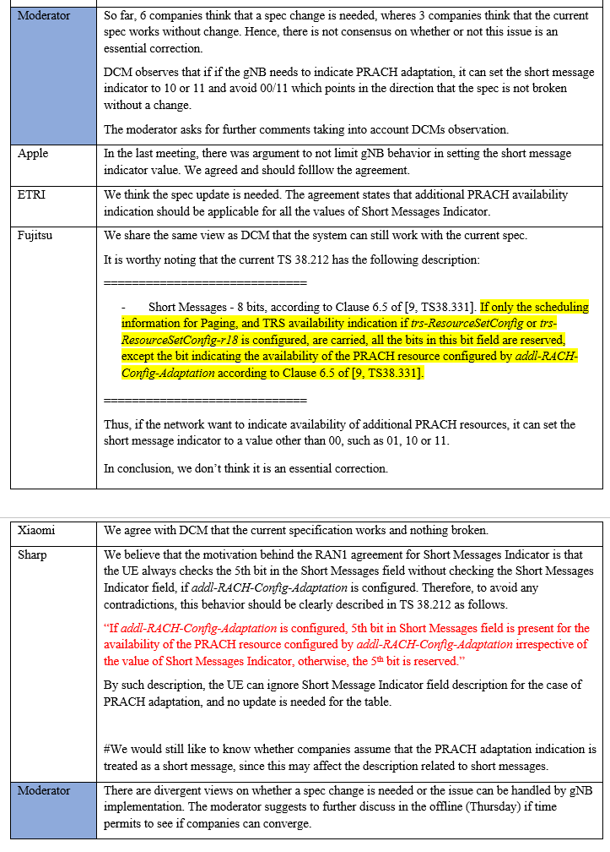
Moderator | Companies are invited to provide more views on whether a spec change is needed and if so which TP is preferred (P2 of [7] or P10 of [9] or P6 of [16]).
ZTE, Sanechips | A spec change is needed. We made a lot of efforts to reach a consensus that all values of Short Message Indicator can be used to indicate additional PRACH availability. We should capture it in the current spec. And only to made the spec change, gNB can flexibly choose which value to use without limitation.
Huawei & HiSilicon1 | We are fine with removing the note and 00 from the RAN1 agreement . Or no specification change is needed as the note states.
CATT | A spec change is needed to align with the agreement. While, we are also ok with the DCM’s observation, and it requires revising the previous agreement.
DCM | We are not meant to delay this discussion, so we are fine with changing the current spe, but if the controvertial point is only 00, we can remove 00 from the agreement and do not tough on the spec change. Either direction is fine.
LG | We also think the spec change is needed and P10 of [9] is preferred to clarify the UE behavior when addl-RACH-Config-Adaptation is configured.
Sharp | In our view, the motivation of the previous agreement on RAN1#121 above is to monitor PRACH adaptation indication without checking Short Messages Indicator field. As long as this motivation is valid, we feel necessity of spec change.  In addition, if companies assume the PRACH adaptation indication is one of the short message, current description for Short messages below doesn’t work well since it is for the case without short message, then anyway spec update (e.g. TP in our tdoc).  --------------------------------------------  If only the scheduling information for Paging, and TRS availability indication if trs-ResourceSetConfig or trs-ResourceSetConfig-r18 is configured, are carried, all the bits in this bit field are reserved, except the bit indicating the availability of the PRACH resource configured by addl-RACH-Config-Adaptation according to Clause 6.5 of [9, TS38.331].  --------------------------------------------
vivo | We are fine with spec change to align with the agreement.
OPPO | We are fine to live with the current spec. To our view, it is complete and no further change is needed.

Discussion point 2.1.4 (rounding for Mask index to AP mapping)
[9] discuss correction/clarification to Table 8.1-0: Mapping of mask index to association periods per Kmask association pattern periods in 38.213. The cited reason for change is that the current text is unclear for the case when the total number of Association Periods (APs) in the K_mask association pattern periods is not a integer multiple of 2/4/8/16.
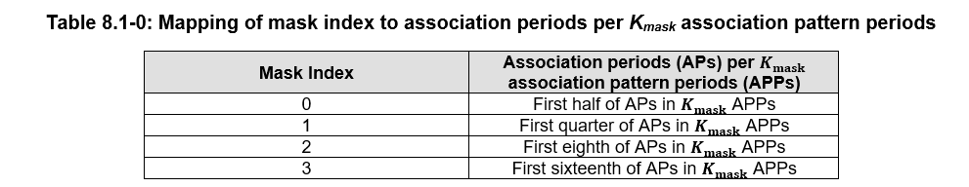
This issue and proposal was discussed in RAN1#122 (FL summary in R1-2506545, see topic 2.2-4). There were divergent views on whether a spec change is needed or the issue can be handled by gNB implementation.

Company | Comment (if any)
Moderator | This issue and proposal was discussed in RAN1#122 (FL summary in R1-2506545, see topic 2.2-4). The latest round discussion from last meeting is shown below.  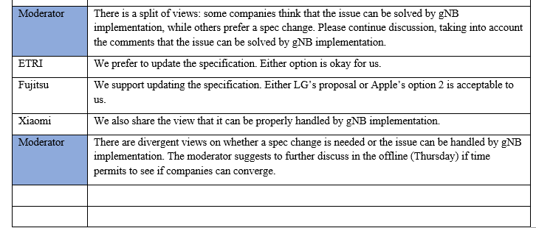
Moderator | Companies are invited to provide more views on whether a spec change is needed.
CATT | It can be handle by the gNB implementation.
LG | As FL commented, it is possible for an APP to contain 3 or 5 APs that is not a multiple of 2/4/8/16. Therefore, the TP in [9] for updating Table 8.1-0 in TS 38.213 can be supported to ensure an integer number of APs to apply the PRACH mask.

Discussion point 2.1.5 (‘0’ indication with P-RNTI)
[5] proposes below TP for indication ‘0’ by DCI format 1_0 with CRC scrambled by the P-RNTI, no change to a current assumption for the availability or unavailability of the PRACH occasions.
TP#3
Reason for change | It is not clear how to set the indication bit if no change to the validity duration of additional ROs after activated.
Summary of change | Add the description that if set the indication bit to ‘0’, the validity duration is not changed
consequences if not approved | It is not clear how to set the indication bit if no change to the validity duration of additional ROs after activated.
---------------------------- Start of Text Proposal for TS 38.213----------------------------
8.1 Random access preamble
*** Unchanged parts are omitted ***
Valid PRACH occasions associated with addl-RACH-Config-Adaptation, and additionally in association periods indicated by prach-SubsetMask-Index-Adaptation, if provided, are indicated as available for PRACH transmission based on an indication in a DCI format 1_0 with CRC scrambled by a P-RNTI or a C-RNTI [5, TS 38.212]. For indication ‘1’ by DCI format 1_0 with CRC scrambled by the P-RNTI, the PRACH occasions are available for a duration provided by validity-DurationForAddlRACHAdaptation, starting from the first frame of the SI modification period [12, TS 38.331] that includes a PDCCH monitoring occasion where the UE receives a PDCCH providing the DCI format 1_0 with CRC scrambled by the P-RNTI. For indication ‘0’ by DCI format 1_0 with CRC scrambled by the P-RNTI, no change to a current assumption for the availability or unavailability of the PRACH occasions.
*** Unchanged parts are omitted ***
---------------------------- End of Text Proposal for TS 38.213----------------------------

Company | Comment (if any)
Moderator | Please provide your view on TP#3 of [5].
CATT | We don’t think this TP is necessary since the description of PRACH indicator has been captured in TS 38.212.
Nokia/NSB | We don’t think the UE behavior shall be differentiated by the indication of “0” or “1”, Thus, it is not needed as to our view.
DCM | share the same view with Nokia
LG | We think this TP is not needed as other companies commented.
Sharp | We don’t think the TP is necessary. If the indication overlaps with the previous indication, the latest indication can overwrite the previous one (i.e. 0: deactivation, 1: the validity duration can be extended with the indication).
vivo | Without this clarification, it seems not clear on how to indicate whether additional RO is available or not. @CATT: could you please indicate which part of 212 capture this?  @Nokia: you mean indication of ‘0’ or ‘1’ has the same UE behavior? I can’t understand how it works.  @Sharp: Is there any agreement to say ‘0‘ means deactivation? Even if so, it needs clarification in spec.  Actually activation of additional RO is quite similar with that for idle state TRS. For idle state TRS, the following is existing in spec:  A value of '1' for a bit of the bitmap indicates presence of associated TRS resource sets for the multiple of the number of frames, starting from a SFN determined from $\left(SFN+PF_offset\right)modT=0$ [17, TS 38.304] that corresponds to the frame within the DRX cycle that includes the PDCCH providing the DCI format 2_7, or the DCI format 1_0 with CRC scrambled by P-RNTI, with the TRS availability indication field indicating the TRS resource sets, where $T$ is provided by defaultPagingCycle. A value of '0' for a bit of the bitmap indicates no change to a current assumption for the availability or unavailability of associated TRS resource sets.  Therefore, we propose a CR with similar text.
OPPO | We understand the intention of the TP, and agrees with vivo that this should be discussed. But we don’t think this TP is enough, RAN1 should make agreement on the UE behavior. Moreover, we wonder whether this behavoir suggested by the TP is reasonable. We think there are two options to discuss:  Option 1: UE reads the bit in short messge assigned for additional RO availability indication during validity duration and when reads ‘0’, UE assumes availability unchanged.  Optoin 2: UE does not read this bit during validity duration.  We are open to discuss.
CATT | Thanks for vivo’s explianation. Now, we understand the intention of the TP. After check with our RAN2 colloegus, from the logic of RAN2, ‘0’ is the default value which means no instruction, only ‘1’ has a specific meanting similar to other indications defined in 'short message'. Thus, the TP is not needed.

Discussion point 2.1.6 (‘separate RO mapping)
[3] proposes the following TP.
Proposal 2: Adopt TP #2 for the separate mapping of SS/PBCH block indexes to legacy RO configuration and additional RO configuration.
Reason for change: | In clause 8.1 of TS 38.213, it should be clarify that the legacy PRACH configuration is the valid PRACH occasions determined by RACH-ConfigCommon that are not associated with addl-RACH-Config-Adaptation.
Summary of change: | In clause 8.1 of TS 38.213, add the ‘that is not associated with addl-RACH-Config-Adaptation’ after the valid PRACH occasions determined by RACH-ConfigCommon.
Consequences if not approved: | The valid PRACH occasions determined by RACH-ConfigCommon includes both of legacy PRACH occasions and additional PRACH occasions. The agreement was not captured correctly.
-------------------------------------------- End of text proposal to TS 38.213 v19.1.0 ---------------------------------------
8.1 Random access preamble
< Unchanged parts are omitted >
SS/PBCH block indexes provided by ssb-PositionsInBurst in SIB1 or in ServingCellConfigCommon or in SSB-MTC-AdditionalPCI or in LTM-SSB-Config are mapped to valid PRACH occasions in the following order where the parameters are described in [4, TS 38.211]. The mapping of SS/PBCH block indexes to valid PRACH occasions is separate for valid PRACH occasions determined by RACH-ConfigCommon that are not associated with addl-RACH-Config-Adaptation and for valid PRACH occasions determined by addl-RACH-Config-Adaptation.
- First, in increasing order of preamble indexes within a single PRACH occasion
- Second, in increasing order of frequency resource indexes for frequency multiplexed PRACH occasions
- Third, in increasing order of time resource indexes for time multiplexed PRACH occasions within a PRACH slot
- Fourth, in increasing order of indexes for PRACH slots
-------------------------------------------- End of text proposal to TS 38.213 v19.1.0 ---------------------------------------
Company | Comment (if any)
Moderator | Please provide your view on TP#2 of [3].
CATT | This TP is needed to describe the the valid PRACH occasions for legacy UE. The valid PRACH occasions determined by RACH-ConfigCommon includes both the PRACH resources for legacy UEs and the additional PRACH resources for Rel-19 UEs.
Nokia/NSB | OK
LG | Okay
vivo | OK
CATT | To exclude additional PRACH occasions from the PRACH occasions determined by RACH-ConfigCommon to represent the legacy PRACH occasions, as per companny’s suggestion, the TP can be updated as follows:  -------------------------------------------- End of text proposal to TS 38.213 v19.1.0 ------------------  8.1 Random access preamble  < Unchanged parts are omitted >  SS/PBCH block indexes provided by ssb-PositionsInBurst in SIB1 or in ServingCellConfigCommon or in SSB-MTC-AdditionalPCI or in LTM-SSB-Config are mapped to valid PRACH occasions in the following order where the parameters are described in [4, TS 38.211]. The mapping of SS/PBCH block indexes to valid PRACH occasions is separate for valid PRACH occasions determined by RACH-ConfigCommon and not determined by addl-RACH-Config-Adaptation and for valid PRACH occasions determined by addl-RACH-Config-Adaptation.  - First, in increasing order of preamble indexes within a single PRACH occasion  - Second, in increasing order of frequency resource indexes for frequency multiplexed PRACH occasions  - Third, in increasing order of time resource indexes for time multiplexed PRACH occasions within a PRACH slot  - Fourth, in increasing order of indexes for PRACH slots  -------------------------------------------- End of text proposal to TS 38.213 v19.1.0 ------------------

Other

Adaptation of SSB in time domain

Proposed Corrections (TPs)

Discussion point 3.1.1 (clarifications to other UE procedures when using SSB periodicity adaptation)
Several contributions propose clarifications to other UE procedures in 38.213 and 38.214 for case when SSB periodicity adaptation is configured.
- [1],[9],[14],[15] propose clarifications to PDCCH monitoring (TP to Section 10, TS 38.213 given in [1],[14],[15]),
- [1],[9],[14],[15] propose clarifications to PDSCH resource mapping and rate matching (TPs for Section 5.1.4, TS 38.214 given in [1],[14],[15])
- [14] proposes clarifications to determination of SS/PBCH block transmission pattern for UL transmission (TP for section 11.1 of 38.213)
- [15] proposes clarifications to
  - PUSCH Resource Allocation in Time Domain (TPs to section 6.1.2.1, section 6.1.2.3 of 38.214)
  - Determination of HARQ-process ID for multiple PUSCH scheduled with DCI (TP to section 6.1. of 38.214)
  - UE procedure for deferring HARQ-ACK for SPS PDSCH (TP to section 9.2.5.4 of 38.213)
  - PUCCH repetition procedure (TP to section 9.2.6 of 38.213)
  - UE procedure for UTO-UCI reporting ((TP to section 9.3.1 of 38.213))
This issue and proposal was discussed in RAN1#122 (FL summary in R1-2506545, see topic 3.1-1). There were limited responses with some companies feeling clarifications as need and some others saying otherwise.
Company | Comment (if any)
Moderator | This issue and proposal was discussed in RAN1#122 (FL summary in R1-2506545, see topic 3.1-1). The latest round discussion from last meeting is shown below.  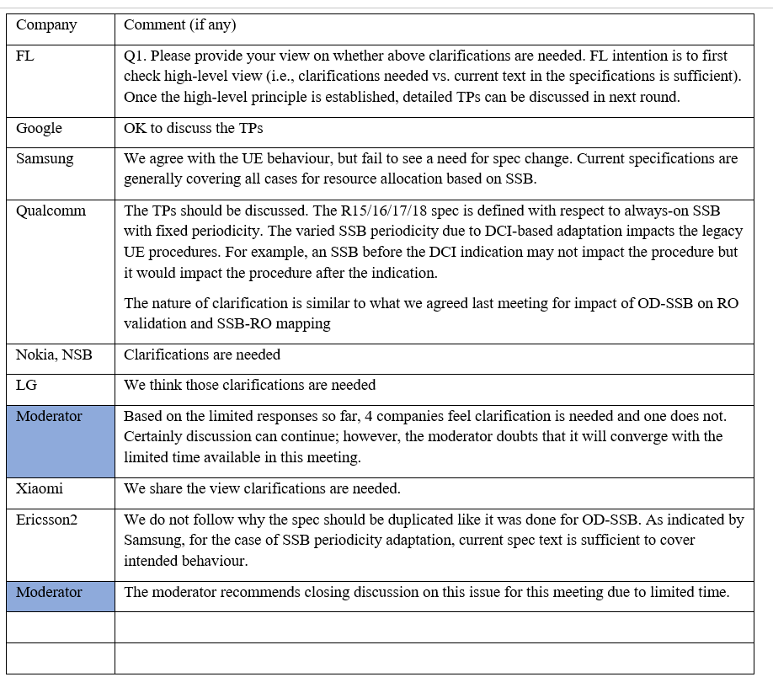
Moderator | Q1. Please provide your view on whether above clarifications are needed. FL intention is to first check high-level view (i.e., clarifications needed vs. current text in the specifications is sufficient). Once the high-level principle is established, detailed TPs can be discussed in next round.
Samsung | We don’t think any of the TPs is needed. Current specification uses a generic description using ssb-PositionsInBurst, which does not change before and after the periodicity adaptation. In this sense, the original wording of the specification can automatically apply after adaptation.
Nokia, NSB | Clarifications are needed.
LG | Clarifications are needed.
Ericsson | Similar comment as from last meeting, i.e. the current spec text is sufficient to cover intended behavior.

Discussion point 3.1.2 (clarifications to valid RO determination)
[1],[9],[14],[15] discuss clarifications to valid RO determination when SSB periodicity adaptation is configured together with PRACH adaptation using additional PRACH resources. [1] indicate preference for clarifying that the RO-SSB mapping and PRACH validity are based only periodicity provided via ‘legacy signaling’ while [14] proposes a TP (Proposal 4) that UE can determine the periodicity of SS/PBCH block for valid RO determination based on the indication for SSB adaptation in time domain
This issue and proposal was discussed in RAN1#122 (FL summary in R1-2506545, see topic 3.1-2). There were limited responses with some companies feeling clarifications as needed and one company saying otherwise.
Company | Comment (if any)
Moderator | This issue and proposal was discussed in RAN1#122 (FL summary in R1-2506545, see topic 3.1-2). The latest round discussion from last meeting is shown below.  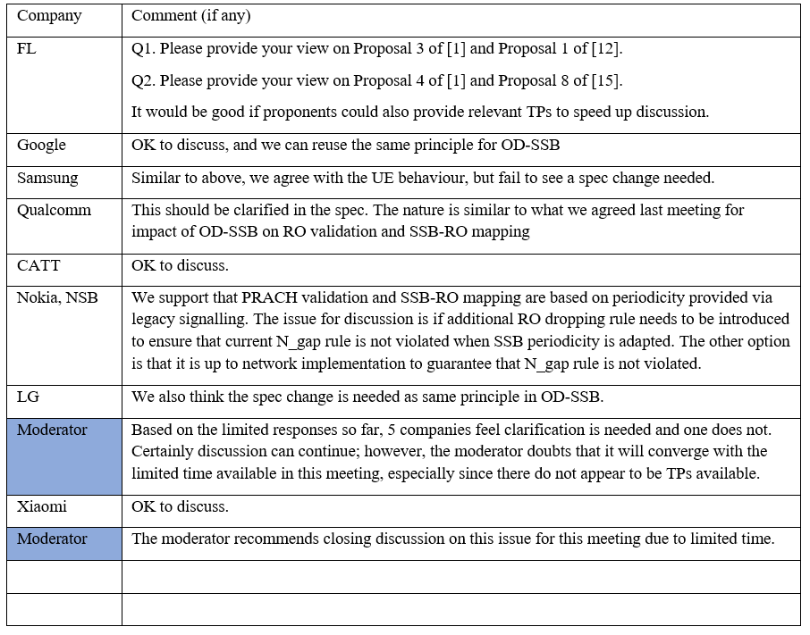
Moderator | Q1. Please provide your view on Proposal 12 of [1].  Q2. Please provide your view on Text Proposal 13a of [1], Text Proposal 4 of [14] and Proposal 8 of [15].  It would be good if the proponents that have not provided relevant TPs can provide TPs to speed up discussion.
Samsung | We don’t think any of the TPs is needed. Current specification uses a generic description using ssb-PositionsInBurst, which does not change before and after the periodicity adaptation. In this sense, the original wording of the specification can automatically apply after adaptation.
Nokia, NSB | Q1: Support  Q2: We support TP 13a in [1]. We think that RO determination should be based on legacy SSB periodicity. The issue that should be clarified in the specification is that N_gap rule should be taken into account after SSB periodicity is adapted.
LG | Q1: Ok  Q2: We support the following two alternatives for RO validation rule before SSB-to-RO mapping is performed 1) based on the default SSB burst periodicity, as in legacy, or 2) based on the shortest SSB burst periodicity among default SSB periodicity
Ericsson | Similar to Samsung comment, we do not think the TPs are needed.

Other

Conclusion
TBU

Appendix A (Contributions)
1 | R1-2507293 | Maintenance on Enhancements of network energy savings | Nokia, Nokia Shanghai Bell
2 | R1-2507516 | Maintenance for Network Energy Saving | Google
3 | R1-2507122 | Maintenance on enhancements of network energy savings for NR | CATT
4 | R1-2506950 | Maintenance on Rel-19 Network Energy Savings | Huawei, HiSilicon
5 | R1-2506875 | Maintenance on enhancements of network energy savings for NR | vivo
6 | R1-2507231 | Maintenance on Enhancements of network energy savings for NR | Samsung
7 | R1-2506824 | Discussion on remaining issues of Rel-19 NES | ZTE Corporation, Sanechips
8 | R1-2507134 | Maintenance on enhancements of network energy savings for NR | OPPO
9 | R1-2507353 | Remaining issues on enhancements of NES for NR | LG Electronics
10 | NULL
11 | R1-2507639 | Maintenance for R19 NES | Ericsson
12 | NULL
13 | R1-2507494 | A remaining issue on SSB time domain adaptation | ETRI
14 | R1-2507002 | Discussion on maintenance issue on Enhancements of network energy savings for NR | CMCC
15 | R1-2507698 | Maintenance on network energy savings for NR | Qualcomm Incorporated
16 | R1-2507566 | Maintenance on enhancements of network energy savings for NR | Sharp

List of RAN1 agreements

RAN1#116
Agreement
For adaptation of SSB in time-domain, consider the following adaptation mechanisms for further study
- Adaptation of SSB burst periodicity
- Adaptation based on two SSB configurations where up to two configurations can be active
- Adaptation based on skipping/transmitting some SSB bursts non-uniformly with single SSB configuration
- Adapting the transmitted number of SSBs within a SSB burst
- Cell DTX for SSB adaptation
- Whether to support new SSB burst periodicity value(s)
- Whether to support new SSB burst(s) (i.e. how SSB transmission is made within a burst)
  - New compact SSB burst(s)
  - Adapting the position of SSBs within a SSB burst
- Other mechanisms/combinations are not precluded

Agreement
For adaptation of PRACH in time-domain, consider the following adaptation mechanisms for further study
- Adaptation based on configuration of additional[/different] PRACH resources for NES-capable UEs in addition to PRACH resources for legacy UEs (if any)
  - Note: NES-capable UEs can use both additional PRACH resources and PRACH resources for legacy UEs
- For the additional PRACH resources,
  - Adaptation of PRACH resource periodicity/PRACH occasion
  - Adaptation at PRACH configuration/association period/association pattern period level and SSB to RO mapping cycle
  - Adaptation based on extending cell DRX operation for PRACH
  - Concentrating ROs in time domain
- Other options are not precluded

Agreement
For adaptation of paging,
- Study further from RAN1 perspective, techniques for adaptation of paging occasions in time-domain and achievable network energy savings
- Note: Specification details for PO/PF determination and paging-related configuration/procedures to be handled by RAN2

Agreement
For the adaptation mechanisms of SSB in time-domain, study further applicable scenarios and associated legacy UE impact/handling (if any) based on the following:
- Applicability to UE in idle/inactive and/or connected mode
- Applicability to PCell and/or SCell(s)

Agreement
For the adaptation mechanisms of SSB in time-domain, study further following mechanisms:
- Adaptation mechanism indicated or configured by gNB without UE trigger
- Adaptation triggered by UE (if any)
FFS: Details of associated signaling/indication/configuration

Agreement
For the adaptation mechanisms of PRACH in time-domain
- Support at least PRACH adaptation provided by gNB without UE trigger
  - FFS: PRACH adaptation with UE trigger
  - Note: UE trigger means UE requests adaptation of PRACH
- Study at least the following,
  - Dynamic signaling and/or semi-static signaling of PRACH adaptation
  - Adaptation of PRACH transmission according to certain condition
  - Applicability to idle/inactive and/or connected mode UEs
  - Which scenarios the adaptation mechanism is applicable to (e.g. cell with both legacy and Rel-19 UE, cell with only Rel-19 UEs)

RAN1#116bis

Agreement
For indication of adaptation of SSB in time-domain,
- Support at least SSB adaptation provided by gNB without UE trigger

Agreement
For adaptation of PRACH in time-domain, support at least the following:
- Adaptation based on additional PRACH resources for NES-capable UEs in addition to PRACH resources for legacy UEs (if any)
  - Note: NES-capable UEs can use both additional PRACH resources and PRACH resources for legacy UEs
  - Configuration of additional PRACH resources is provided by semi-static signalling
    - FFS: details including whether there is overlap of additional PRACH resources and PRACH resources for legacy UEs
  - FFS: adaptation mechanism for additional PRACH resources
  - Note: No change to the existing PRACH configuration tables in 38.211

Agreement
For adaptation of PRACH in time-domain, support the following:
- SSB-RO mapping for the additional PRACH resources is separate from the SSB-RO mapping of the PRACH resources for legacy UEs (if any)
  - FFS: whether/how to handle SSB-RO mapping if the additional PRACH resources overlap in both time and frequency with the PRACH resources for legacy UEs
  - Note: SSB-RO mapping of the PRACH resources for legacy UEs is not impacted if Rel-19 UE uses these PRACH resources
  - FFS: SSB-RO mapping for the additional PRACH resources

Agreement
Support adaptation mechanisms of PRACH in time-domain for following:
- UE in idle/inactive mode
- UE in connected mode

Agreement
Adaptation mechanism(s) of SSB in time-domain is supported at least for one of the following scenario(s):
- For cell with both legacy UEs and Rel-19 NES-capable UEs
  - Rel-19 NES-capable UE’s PCell (Connected mode)
    - Study from the following options:
      - Option A1: adaptation for CD-SSB
      - Option A2: adaptation for SSB that is not CD-SSB
      - Option A3: adaptation for SSB not on sync raster
  - Rel-19 NES-capable UE’s SCell
    - Study from the following options:
      - Option B1: adaptation for CD-SSB
      - Option B2: adaptation for SSB that is not CD-SSB
      - Option B3: adaptation for SSB not on sync raster
  - FFS: Rel-19 NES-capable UE in idle/inactive mode
- Note: Impact to idle/inactive UEs shall be minimized

Agreement
For adaptation of PRACH in spatial domain,
- Study possibility of scenarios with non-uniform distribution of UEs in different beams
    - Note 6: Companies are encouraged to provide details on how they map UEs to different beams
- Study network energy savings gain achieved by non-uniform PRACH resource allocation across SSBs for scenarios with non-uniform distribution of UEs in different beams (if any),
    - Assume the following framework for network energy evaluation in FR1 and companies to report at least the below settings used in the evaluation/simulation
      - 20ms SSB period
      - 30kHz SCS, DDDSU TDD pattern
      - Setting A: SIB1 period (20ms/40ms/160ms)
      - Setting B1: Cell load (Empty/low/medium)
      - Setting B2: Traffic model
      - Setting C: SIB1 PDSCH time domain resource index in 38.214 Table 5.1.2.1.1-2
      - Setting D: CORESET0/SSB multiplexing pattern including controlResourceSetZero (index) in 38.213 Table 13-6, and searchSpaceZero (index) in 38.213 Table 13-11
      - Setting E1: PRACH configurations
        - (legacy) PRACH resources according to the following PRACH configuration for all transmitted SSBs
      - Case A1-1: PRACH configuration #5 (20ms)
      - Case A1-2: PRACH configuration #17 (10ms)
      - Case A2-1: PRACH configuration #0 (160ms)
        - (time-domain PRACH adaptation) Additional and legacy PRACH resources yielding total PRACH resources that are according to one of the following PRACH configuration for all transmitted SSBs
      - Case B1: PRACH configuration #17 (10ms)
      - Case B2: PRACH configuration #0 (160ms)
      - Companies to report details of assumed time domain adaptation mechanism
        - (spatial-domain PRACH adaptation) Additional and legacy PRACH resources yielding total PRACH resources that are according to one of the following PRACH configuration
      - Case C1: PRACH configuration #17 (10ms)
      - Case C2: PRACH configuration #0 (160ms)
      - Companies to report details of assumed spatial domain adaptation mechanism, including details of non-uniform PRACH resource allocation across SSBs
      - Setting F: Cat 1/Cat 2 BS as defined in TR38.864
      - Setting G1: Number of SSB beams: 4,8 SSBs in a SSB burst with SSB pattern case C
      - Note 1: Baseline to compare is Case C1 vs Case B1/A1-1/A1-2, Case C2 vs Case B2/A2-1
      - Note 2: It is up to company to report the SSB-RO mapping ratio and FDMed RO number, etc
      - Note 3: Other PRACH configuration index with different PRACH format other than format 0 is not precluded
      - Note 4: Other SSB/SIB1/RACH periodicity/PRACH resource/configuration assumptions are not precluded (up to companies to report)
    - Other frameworks for network energy evaluation are not precluded, e.g. including for FR2

RAN1#117

Agreement
For the study of adaptation of PRACH in spatial domain, following network energy savings gains were reported by sources based on the evaluation framework agreed in RAN1#116bis:
- Two sources showed following NES gain for TDD, CAT1 BS power model, case C1 vs A1-1, zero load [R1-2404409, R1-2405107]
  - -4% ~ -45%
- Seven sources showed following NES gain for TDD, CAT1 BS power model, case C1 vs B1/A1-2, zero load [R1-2404225, R1-2404185, R1-2404334, R1-2404123, R1-2404562, R1-2405107, R1-2405163]
  - 0% ~ 31%
  - Note: Five sources assumed that case B1 has same PRACH resources as case A1-2. Remaining two sources evaluated only A1-2.
  - Note: Three sources showed NES gains 0% ~ 10% [R1-2404225, R1-2404185, R1-2404334]
- One source showed following NES gain for TDD, CAT1 BS power model, case C1 vs B1, zero load [R1-2404464]
  - 1.0%~8.8%
  - Note: The evaluation results provide the extra NES gain of spatial domain PRACH adaptation compared to time domain PRACH adaptation, where spatial domain and time domain PRACH adaptations are based on dynamic switching between PRACH resources according to two PRACH configuration indexes.
- One source showed following NES gain for TDD, CAT1 BS power model, case C1 vs B1, zero load [R1-2404626]
  - -48.41%~0%
  - Note: For B1, it was assumed that periodicity of PRACH resources can be adapted. For C1, it was assumed that periodicity of PRACH resources is not adapted and some ROs within a periodicity can be deactivated.
- One source showed following NES gain for TDD, CAT1 BS power model, for case C1 vs A1-2, zero load [R1-2404626]
  - 4.59%~38.04%
  - Note: For C1, it was assumed that periodicity of PRACH resources is not adapted and some ROs within a periodicity can be deactivated.
- Four sources showed following NES gain for TDD, CAT2 BS power model, case C1 vs B1/A1-2, zero load [R1-2404562, R1-2404225, R1-2403943, R1-2404626]
  - 0% ~ 3.5%
  - Note: Three sources assumed that case B1 has same PRACH resources as case A1-2. One source evaluated only A1-2.
- One source showed following NES gain for TDD, CAT2 BS power model, case C1 vs B1, zero load [R1-2404464]
  - 0%~0.2%
  - Note: The evaluation results provide the extra NES gain of spatial domain PRACH adaptation compared to time domain PRACH adaptation, where spatial domain and time domain PRACH adaptations are based on dynamic switching between PRACH resources according to two PRACH configuration indexes
- One source showed following NES gain for TDD, CAT2 BS power model, case C1 vs B1, zero load [R1-2404626]
  - -1.19%~0%
  - Note: For B1, it was assumed that periodicity of PRACH resources can be adapted. For C1, it was assumed that periodicity of PRACH resources is not adapted and some ROs within a periodicity can be deactivated.
- Two sources showed following NES gain for TDD, CAT1 or CAT2 BS power model, case C2 vs B2, zero load [R1-2403943, R1-2405107]
  - Less than 0.2%
- One source showed following NES gain for TDD, CAT1 BS power model, (C1 vs A1-2 with changed PRACH format), PRACH format A, 10ms PRACH periodicity, different loads [R1-2403980]
  - 13.7%/8.7%/4.9%/2.6% for zero/low/light/medium cell load
- One source showed following NES gain for TDD, CAT1 BS power model, (C1 vs B1 with changed PRACH format), PRACH format A, 10ms PRACH periodicity, different loads [R1-2403980]
  - 8.03%/5.1%/3.06%/1.74% for zero/low/light/medium cell load
- One source showed following NES gain for TDD, C1 vs B1/A1-2, different loads [R1-2404562]
  - 16%/4.78% for light/medium cell load for CAT1 BS power model
  - 0.65%/0.29% for light/medium cell load for CAT2 BS power model
- One source showed following NES gain for TDD, C1 vs B1, different loads [R1-2404626]
  - -18.57%~0%/-2.52%~0% for low /medium cell load for CAT1 BS power model
  - -0.81%~0%/-0.42%~0% for low /medium cell load for CAT2 BS power model
  - Note: For B1, it was assumed that periodicity of PRACH resources can be adapted. For C1, it was assumed that periodicity of PRACH resources is not adapted and some ROs within a periodicity can be deactivated.
- One source showed following NES gain for TDD, C1 vs A1-2, different loads [R1-2404626]
  - 3.67%~19.88%/2.29%~5.22% for low /medium cell load for CAT1 BS power model
  - 0.67%~1.75%/0.39%~0.91% for low /medium cell load for CAT2 BS power model
  - Note: For C1, it was assumed that periodicity of PRACH resources is not adapted and some ROs within a periodicity can be deactivated.
- One source showed NES gain for FDD, C1 vs B1, zero load [R1-2404464]
  - 1.4%~7% for CAT1 BS power model
  - 0%~0.3% for CAT2 BS power model
  - Note: The evaluation results provide the extra NES gain of spatial domain PRACH adaptation compared to time domain PRACH adaptation, where spatial domain and time domain PRACH adaptations are based on dynamic switching between PRACH resources according to two PRACH configuration indexes
- One source showed NES gain for FR2, CAT1 BS power model, spatial domain adaptation of PRACH configuration index 75 vs a time domain adaptation of PRACH configuration index 75, zero load [R1-2405163]
  - 4%~7%
- Note 1: About possibility of scenarios with non-uniform distribution of UEs in different beams
  - Several companies indicated (and three companies showed data/analysis) that there can be scenarios with non-uniform distribution of UEs in different beams.
  - Several companies mentioned that for non-uniform UE distribution, it can be addressed by gNB implementation e.g. by adjusting SSB beamwidth, etc. Several companies also mentioned that it is not clear how gNB can predict the distribution of UEs in different beams, especially for Idle/Inactive UEs.
- Note 2: Most sources that showed the NES gains (if any) for adaptation of PRACH in spatial domain compared to A1-2/B1 observed that the gain would be due to reduction in the number of overall ROs in time domain in their evaluations. Most of these companies only accounted for ROs in time domain.
- Note 3: The evaluation results assumed the non-uniform distribution of UE is static during the evaluation time period.

Conclusion
There is no consensus in RAN1 on the support of PRACH adaptation in spatial domain

Agreement
For adaptation of PRACH in time-domain, support at least the following case(s)
- Case 1: no time-domain overlap between the additional PRACH resources for NES-capable UEs and the PRACH resources for legacy UEs
- Case 2: time-domain overlap but no overlap in frequency domain between the additional PRACH resources for NES-capable UEs and the PRACH resources for legacy UEs
- Case 3: additional PRACH resources for NES-capable UEs and legacy PRACH resources overlap neither in time nor frequency domains
- FFS: whether additional conditions are needed to support the above cases
- FFS: Additional case whether full/partial overlap in both time and frequency is allowed
- Above does not preclude discussion for the case where the configuration for additional PRACH resources contains legacy PRACH resources

Agreement
At least for the case where legacy ROs and additional ROs overlap in neither time nor frequency domain, for adaptation of PRACH in time-domain, the SSB-RO mapping rule for additional PRACH resources follows the legacy SSB-RO mapping rule.
- Mapping SS/PBCH block indexes to valid additional PRACH occasions provided by semi-static signalling follows the legacy mapping order for preamble/time resource/frequency/PRACH slot indexes.
  - Note: This mapping is not impacted by time domain PRACH adaptation
- Validation rules for the additional PRACH resources follow the legacy validation rules for PRACH resources configured for legacy UEs.
Agreement
For adaptation of SSB in time-domain, Option 1 is supported
- Option 1: Adaptation of SSB burst periodicity using one or more SSB burst periodicity value(s)
- Note: Using Option 2 to realize Option 1 is not precluded
  - Option 2: Adaptation based on two SSB configurations [where up to two configurations can be active]
    - FFS: details of the differences between the two SSB configurations, e.g. two different periodicities
- FFS: Details including applicable scenarios
- FFS: Support of Cell DTX for connected mode UEs for SSB

Agreement
For adaptation of PRACH in time-domain, the additional PRACH resources are configured based on at least:
- a PRACH configuration index
- FFS: whether the PRACH configuration index is same and/or different from the PRACH configuration index for the legacy PRACH resources
Study further the following
- When the PRACH configuration index for the additional PRACH resources is same as the PRACH configuration index for the legacy resource,
  - Additional parameter(s) for determining the additional PRACH resources e.g.
    - Scaled/adjusted PRACH configuration period
    - Additional timing offset
    - Adjusting the parameters (e.g., (x, y) value and slot number) of the PRACH configuration
    - Muting/masking ROs
- When the PRACH configuration index for the additional PRACH resources is different from the PRACH configuration index for the legacy resource
  - Additional mechanisms (if any) for determining the additional PRACH resources e.g.
    - Muting/masking ROs (e.g. for the case when the PRACH configuration index for the additional PRACH resources contains legacy resources)
- Additional parameters to facilitate condensed/cluster RACH resources in time-domain (including whether needed)

Agreement
For the adaptation mechanism for additional PRACH resources, study further the following:
- Option 1: Higher layer signalling (with potential enhancements) based PRACH resource adaptation
- Option 2: L1-based adaptation to indicate whether the additional PRACH resources provided by semi-static signalling are available or not
  - FFS: details
  - Strive to re-use existing DCI format(s)
- Option 3: Adaptation of PRACH transmission according to predefined condition(s)
  - FFS: details
- Option 4-rev1: L1-based adaptation to indicate whether a subset of the additional PRACH resources provided by semi-static signalling are available or not
  - FFS: whether the subset of the additional PRACH resources is in RO level / SSB-to-RO mapping cycle level/PRACH association period level/PRACH association pattern period level for time-domain PRACH adaptation
  - Strive to re-use existing DCI format(s)
- Option 5: Enhanced cell DRX

RAN1#118
Agreement
For adaptation of PRACH in time-domain, select at least one from the following alternatives for configuration of the additional PRACH resources
- Alt 1: The PRACH configuration index for the additional PRACH resources is same as the PRACH configuration index for the legacy resources and
  - Discuss further additional mechanism(s) for determining the additional PRACH resources, e.g.
    - Opt 1-1: Scaled/adjusted PRACH configuration period
    - Opt 1-2: Adjusting the parameters (e.g., (x, y) value and slot number) of the PRACH configuration
    - Opt 1-3: Muting/masking ROs
    - Opt 1-4: additional timing offset(s)
- Alt 2: The PRACH configuration index for the additional PRACH resources is different from the PRACH configuration index for the legacy resources,
  - Discuss further additional mechanism(s) for determining the additional PRACH resources, e.g.
    - Opt 2-1: Muting/masking ROs (e.g. for the case when the PRACH configuration index for the additional PRACH resources contains legacy resources)
    - Opt 2-2: Additional timing offset(s)
- FFS: Additional parameters to facilitate condensed/cluster RACH resources in time-domain (including whether needed)
- FFS: Additional frequency domain parameter(s) (e.g., freq. starting offset)

Agreement
Extend the RAN1#117 agreement on SSB-RO mapping rule for additional PRACH resources to Case 1
- Case 1: no time-domain overlap between the additional PRACH resources for NES-capable UEs and the PRACH resources for legacy UEs

RAN1#117 Agreement
At least for the case where legacy ROs and additional ROs overlap in neither time nor frequency domain, for adaptation of PRACH in time-domain, the SSB-RO mapping rule for additional PRACH resources follows the legacy SSB-RO mapping rule.
- Mapping SS/PBCH block indexes to valid additional PRACH occasions provided by semi-static signalling follows the legacy mapping order for preamble/time resource/frequency/PRACH slot indexes.
  - Note: This mapping is not impacted by time domain PRACH adaptation
- Validation rules for the additional PRACH resources follow the legacy validation rules for PRACH resources configured for legacy UEs.

Agreement
For SSB-RO mapping rule for additional PRACH resources for Case 2.
- Extend the RAN1#117 and RAN1#118 agreements on SSB-RO mapping

Agreement
For the adaptation mechanism for additional PRACH resources (for CONNECTED mode UE and IDLE/INACTIVE mode UE),
- At least DCI based adaptation is supported. No introduction of new DCI format.

Agreement
For adaptation mechanism(s) of SSB in time-domain,
- For Rel-19 NES-capable UE’s PCell (Connected mode), adaptation of CD-SSB on sync raster is not supported
  - FFS: Adaptation for SSB that is not CD-SSB is supported (A2)
  - FFS: Adaptation for SSB not on sync raster is supported (A3)
- For Rel-19 NES-capable UE’s SCell
  - Adaptation of SSB configured for the SCell is supported for the following cases
    - FFS: Adaptation for CD-SSB (B1) including UE impact compared to legacy operation where the SSB is configured with periodicity>20msec for SCell
    - Adaptation for SSB that is not CD-SSB on sync raster (B2’)
    - Adaptation for SSB that is not CD-SSB not on sync raster (B3’)

Agreement
For DCI-based adaptation for additional PRACH resources,
- Select from the following DCI format(s) to carry the adaptation indication.
  - DCI format 1_0
  - DCI format 2_7
  - DCI format 2_9
- FFS: existing (P-RNTI, SI-RNTI, CellDTRX-RNTI, PEI-RNTI, C-RNTI) or new RNTI used for detecting the DCI format

Agreement
For Cell DTX extension to SSBs not on sync-raster for connected mode UEs, select from following options
- Option 1: One SSB burst periodicity is configured for the UE and UEs assumes SSB transmissions are not present during Cell DTX non-active period
- Option 2: UE assumes SSB transmission with different periodicities during Cell DTX non-active period and during Cell DTX active period
- Option 3: Cell DTX does not impact UE assumption on SSB transmissions (i.e. legacy behavior) – no spec impact

Agreement
For DCI-based adaptation for additional PRACH resources, select only from the following alternatives
- Alt 1: (PRACH resource configuration level) DCI-based adaptation to indicate whether the additional PRACH resources provided by semi-static signalling are available or not
  - FFS: details
- Alt 2: (subset of PRACH resource level) DCI-based adaptation to indicate whether a subset of the additional PRACH resources provided by semi-static signalling are available or not
  - FFS: whether the subset of the additional PRACH resources is in
    - Alt 2-1: RO level per SSB
    - Alt 2-2: SSB-to-RO mapping cycle level
    - Alt 2-3: PRACH association period level
    - Alt 2-4: PRACH association pattern period level
    - Alt 2-5: SFN level
- Alt 3: DCI-based Enhanced/new Cell DRX to indicate whether the enhanced/new Cell DRX is activated or deactivated.
  - If activated, the additional configured PRACH provided by semi-static signalling within non-active period are not available.
  - FFS: whether Alt 1 and/or Alt 2 can be applied to the active period
  - FFS: details

RAN1#118bis

Agreement
For adaptation of PRACH in time-domain, the same PRACH preamble format is used for the additional RACH resources and legacy PRACH resources.

Agreement
For adaptation of PRACH in time-domain, support both of the following
- Alt 1: The PRACH configuration index for the additional PRACH resources is same as the PRACH configuration index for the legacy resources
- Alt 2: The PRACH configuration index for the additional PRACH resources is different from the PRACH configuration index for the legacy resources
- FFS: Additional details

Working Assumption
For DCI-based adaptation for additional PRACH resources, at least DCI format 1_0 can carry the adaptation indication for UEs in idle/inactive and connected mode.
- P-RNTI is used

Agreement
For adaptation of PRACH in time-domain, the frequency domain resources for the additional PRACH resources and legacy PRACH resources can be same or different
- FFS: applicable case(s) (i.e. case(s) from the RAN1#117 agreement).
- Discuss further following options for signaling
- Option 1: at least the following parameter(s) can be configured separately for the additional PRACH resources.
  - msg1-FrequencyStart at least for 4-step RACH
  - FFS: other applicable legacy frequency domain parameter(s)
- Option 2: Offset to legacy frequency domain parameter(s) are configured for the additional PRACH resources
  - Note: Offset to legacy frequency domain parameter(s) is a new parameter
  - FFS: applicable legacy frequency domain parameter(s)

Conclusion
There is no consensus on the support of adaptation of SSB for idle mode UEs in Rel-19

Agreement
For Cell DTX extension to SSBs not on sync-raster for connected mode UEs, select Option 3, i.e. Cell DTX does not impact UE assumption on SSB transmissions (i.e. legacy behavior).
- No spec impact

Agreement
For adaptation of PRACH in time-domain, for determining the additional PRACH resources in time-domain,
- For Alt 1 (same PRACH configuration index for additional and legacy PRACH resources), select one or more of the following additional mechanism(s),
  - Opt 1-2a: up to N1 additional value(s) of (x, y)
    - FFS: value of N1(>=1)
  - Opt 1-2b: up to N2 additional value(s) of y
    - FFS: value of N2 (>=1)
  - Opt 1-3: Muting/masking ROs
  - Opt 1-4:
    - up to N4_1 additional timing offset(s) at frame-level
    - up to N4_2 additional timing offset(s) at slot-level
    - FFS: values of N4_1(>=1) and N4_2(>=1)
  - Opt 1-5: No additional mechanism is selected.
  - Note: x and y refer to the parameters from the random-access configuration tables (from 38.211)
- For Alt 2 (different PRACH configuration index for additional and legacy PRACH resources), select one or more of the following additional mechanism(s),
  - Opt 1-2a: up to N1 additional value(s) of (x, y)
    - FFS: value of N1(>=1)
  - Opt 1-2b: up to N2 additional value(s) of y
    - FFS: value of N2 (>=1)
  - Opt 1-3: Muting/masking ROs
  - Opt 1-4:
    - up to N4_1 additional timing offset(s) at frame-level
    - up to N4_2 additional timing offset(s) at slot-level
    - FFS: values of N4_1(>=1) and N4_2(>=1)
  - Opt 1-5: No additional mechanism is selected.
  - Note: x and y refer to the parameters from the random-access configuration tables (from 38.211)

RAN1#119

Agreement
Reply to Q1(What is the relation in terms of time location before and after SSB adaptation?):
- RAN1 agreed that at least SSB burst periodicity is adapted.
- There are no RAN1 agreements to adapt the time location of the SSB burst other than the periodicity but RAN1 is still discussing other options.

Agreement
Reply to Q2(What is the relation in terms of frequency location before and after SSB adaptation?):
- The frequency location is same before and after SSB adaptation.

Agreement
Reply to Q3(What is the spatial relation before and after SSB adaptation?):
- There is no change to spatial relation (in terms of QCL assumption) for the same SSB index before and after SSB adaptation.
- At least the case where there is no change to actually transmitted SSBs within a burst before and after SSB adaptation is supported.
Further update to be made based on RAN1#119 progress if any.

Agreement
At least msg1-FrequencyStart can be configured separately for the additional PRACH resources at least for 4-step RACH.

Agreement
For DCI-based adaptation for additional PRACH resources, select only from the following alternatives:
- Alt 1: (PRACH resource configuration level) DCI-based adaptation to indicate whether the additional PRACH resources provided by semi-static signalling are available or not
  - FFS: details
- Alt 2: (subset of PRACH resource level) DCI-based adaptation to indicate whether a subset of the additional PRACH resources provided by semi-static signalling are available or not
  - FFS: Maximum number of subsets of the additional PRACH resources= [2 or 3 or 4 or 16]
  - FFS: whether the subset of the additional PRACH resources is in
    - Alt 2-1: RO level per SSB
    - Alt 2-2: SSB-to-RO mapping cycle level
    - Alt 2-3: PRACH association period level
    - Alt 2-4: PRACH association pattern period level
    - Alt 2-5: SFN level
    - Alt 2-6: Network configured time period
Conclusion
There is no RAN1 consensus to support SSB adaptation in time domain for Rel-19 NES-capable UE’s PCell (connected mode)

Working Assumption
For DCI-based adaptation for additional PRACH resources,
- Select from the following options for carrying the adaptation indication in DCI format 1_0 with P-RNTI
- Option 1: Use reserved bits in the DCI format
  - FFS: relation (if any) to TRS availability bits / short message indicator in the DCI format
- Option 2: Use Bits 5-8 within the Short Message (from upper layers)
  - Note: Availability should be confirmed by checking with RAN2.
- Option 3: Use bits available for both Option 1 and Option 2
FFS: Payload size for adaptation for additional PRACH resources

Agreement
For DCI-based adaptation for additional PRACH resources, select only from the following alternatives:
- Alt 1: DCI-based adaptation to indicate whether the additional PRACH resources provided by semi-static signalling are available or not
  - [DCI payload size = 1 bit]
  - FFS: A single PRACH mask provided by semi-static signalling is used to identify the subset of the additional PRACH resources
  - FFS: details

Agreement
Confirm the following working assumption from RAN1#118bis.
Working Assumption
For DCI-based adaptation for additional PRACH resources, at least DCI format 1_0 can carry the adaptation indication for UEs in idle/inactive and connected mode.
- P-RNTI is used

RAN1#120
Agreement
For adaptation of PRACH in time-domain, for determining the additional PRACH resources in time-domain,
- When an additional RO is overlapped with legacy valid RO in both time and frequency domain, the additional RO is invalid before the SSB-RO mapping
  - Note: the overlapped RO for legacy resource is not impacted
  - FFS: Clarification on configuration of legacy ROs

Conclusion
There is no RAN1 consensus to support the following in Rel-19
- New SSB burst periodicity values other than the legacy values (i.e., 5 ms, 10 ms, 20 ms, 40 ms, 80 ms, or 160 ms).
- New UE trigger
- Adapting the transmitted number of SSBs within a SSB burst
- Adaptation of the time domain positions of SSBs within a burst

Conclusion
There is no RAN1 consensus to support time domain adaptation for CD-SSB in Rel-19 for SCell

Agreement
For adaptation of SSB in time-domain, support the following to adapt SSB burst periodicity for an SCell
- UE is configured with SSB burst periodicity using legacy signalling for the SCell
- UE is configured with X additional SSB burst periodicity for the SCell
  - FFS: Value of X
- SSB occasions with larger periodicity are subset of the SSB occasions with shorter periodicity
  - FFS: Whether there is specification impact
  - Note: This does not impact the discussion on OD-SSB
- For switching the periodicity, down-select between
  - (MAC-CE)
    - MAC-CE details for SSB burst periodicity adaptation is up to RAN2.
  - (DCI)
    - Alt 1-3: DCI based signalling is used

Agreement
For adaption of PRACH in time-domain, for a connected mode UE, support a 1-bit field in DCI 1_0 with C-RNTI used to trigger PRACH (i.e. PDCCH order) to indicate whether the additional PRACH resource(s) is available for the triggered PRACH.
- FFS: UE behaviour (e.g. applicable resources for PRACH mask index) when it is indicated of additional PRACH resource(s)
- FFS: Details on how to reuse existing bit for the 1-bit indication

Agreement
For DCI-based adaptation for additional PRACH resources, DCI 1_0 with P-RNTI indicates the availability information for additional PRACH resource from a reference point and for a validity time duration
- FFS: Validity time duration for availability is configured by higher layer signaling or predefined
- FFS: Location of the reference point defined in the specification
- FFS: Value/granularity of the validity time duration.
- FFS: Whether DCI can be used to explicitly deactivate the additional PRACH resources

Agreement
For DCI-based adaptation for additional PRACH resources, support optional semi-static signalling of a single PRACH mask to identify the subset of the additional PRACH resources
- The mask is applicable at unit of
  - Alt 1: PRACH association period
  - Alt 2: PRACH association pattern period
  - Alt 3: SFN level
- The PRACH association period is determined based on valid additional ROs only.
- The mask is applied after valid RO determination and SSB-RO mapping.
- Note: The existing behaviour in TS 38.213 "An association pattern period includes one or more association periods and is determined so that a pattern between PRACH occasions and SS/PBCH block indexes repeats at most every 160 msec." is not impacted due to application of the mask.
- This is applicable at least for adaptation for DCI 1_0 with P-RNTI
- The DCI does not indicate PRACH mask selection
- FFS: how the mask is identified
  - Option 1: The PRACH mask is from a PRACH mask table
    - Pre-defined table with N=[4 or 8 or 16] rows
    - The semi-static signalling indicates a PRACH mask index
  - Option 2: The PRACH mask is based on configuration parameters e.g. bitmap at SFN-level, periodic time domain window, …

Agreement
- Separate configuration of Msg1-FDM for the additional PRACH resources at least for 4-step RACH is supported
  - UE is not expected to be configured such that there are more than 8 FDM-ed valid ROs (legacy + additional ROs)
  - FFS: When there is no configuration of Msg1-FDM
- Separate configuration of number of SSB per RO is supported

Agreement
Study the following options for the reference point (for the availability information of additional PRACH resources indicated by DCI 1_0 with P-RNTI in a PF) for RRC idle/inactive mode UE and RRC connected mode UE,
- Option 1: SFN of the first PF from the next I-DRX cycle
- Option 2: SFN of the first PF from the current I-DRX cycle
- Option 3: From the first frame of the first PRACH association period after UE receives the DCI
- Option 4: From the first frame of the current SI modification period
- Option 5: From the first frame of the next SI modification period

Agreement
For adaptation of SSB in time-domain, for adapting SSB burst periodicity for an SCell
- Support group common DCI signalling for switching the SSB burst periodicity using DCI format 2_9 with [cellDTRX-RNTI]
- FFS: which scenario(s) is this applicable for (e.g. as defined in 9.5.1)
Note: Above does not prevent RAN2 from designing a MAC CE based on OD-SSB feature and also used for SSB burst adaptation

RAN1#120bis
Agreement
For adaptation of PRACH in time-domain, at least for 4-step RACH, at least for DCI 1_0 with P-RNTI,
- Support configuration of the additional PRACH resources within [the same] RACH-ConfigCommon in SIB1 used to configure the legacy PRACH resources
  - the legacy PRACH resources used for ‘additional RO validation before the SSB-RO mapping’ are configured in the RACH-ConfigCommon
Agreement
For DCI-based adaptation for additional PRACH resources, the following 1-bit field is used for adaptation indication in DCI format 1_0 with P-RNTI
- Use one bit from the Bits 5-8 within the Short Message field (from upper layers)
- Send LS to RAN2 to confirm the use of this bit.
Above applies for cell that transmits the DCI for connected UEs and IDLE/INACTIVE mode UEs

Agreement
For DCI-based adaptation for additional PRACH resources, for the availability information of additional PRACH resources indicated by DCI 1_0 with P-RNTI
- the validity duration is configured via higher layer signalling.

Agreement
For DCI-based adaptation for additional PRACH resources, PRACH mask that identifies the subset of the additional PRACH resources is applicable at unit of
- PRACH association period
- This PRACH mask applies to every [configured] K SSB RO association pattern period(s)

Agreement
For adaptation of SSB in time-domain, for DCI 2_9-based SSB burst periodicity adaptation for an SCell,
- The DCI is scrambled a new RNTI,
  - Same search space and DCI size as that of cell DTX/DRX DCI if gNB configures both

Agreement
For DCI 2_9-based SSB burst periodicity adaptation for an SCell
- the starting location of the information block for SSB burst periodicity indication for a SCell within the DCI format 2_9 is configured using a new RRC parameter
- the length of the information block is given by ceil(log2(1+X)), where UE is configured with X additional SSB burst periodicities for the SCell

Agreement
For adaptation of SSB in time-domain, UE can be configured with X (<=Xmax) additional SSB burst periodicities for an SCell.
- Xmax=2

Agreement
Separate configuration of the following parameters for the additional PRACH resources at least for 4-step RACH is supported
- CB-PreamblesPerSSB

Agreement
LS on DCI-based PRACH adaptation endorsed with the ACTION part modified compared to draft LS in R1-2503085 as follows:
- ACTION: RAN1 respectfully asks RAN2 to confirm whether the use of above bit is feasible.
Final LS in R1-2503086.

Agreement
For adaptation of PRACH in time-domain, for a connected mode UE,
- One of the reserved bits of PDCCH order (DCI 1_0 with C-RNTI) is used for the new DCI field that indicates the availability of additional PRACH resources.

Working Assumption
When a UE receives in slot $m$ on the active DL BWP of a first serving cell a PDCCH providing DCI format 2_9 that indicates a change in SSB burst periodicity of the SSB transmission on a second serving cell, the UE assumes SSB is transmitted on the second serving cell according to the indicated SSB burst periodicity from the beginning of the first slot containing the first [actually] transmitted SSB within the first [possible] SSB burst according to the indicated SSB burst periodicity that is no earlier than the slot $m+d$ of the first serving cell where $d$ is a number of slots for the SCS of the active DL BWP of the first serving cell [in Table 11.5-1 of TS 38.213].
- FFS: how to determine the first [possible] SSB burst

Agreement
For DCI-based adaptation for additional PRACH resources, the PRACH mask to identify the subset of the additional PRACH resources is given by:
- Option 1-2: Semi-static signalling of a PRACH mask index and a value of K (number of association pattern periods)
  - For K: one from up to four candidate values {2,4,8, [1 or 16]}
Mask index | Indication of association periods (AP) for subset of additional PRACH resources within every K association pattern periods (APP)
0 | 1st half of the APs in K APPs
1 | 1st quarter of the APs in K APPs
2 | 1st eighth of the APs in K APPs
3 | 1st sixteenth of the APs in K APPs

Agreement
- For DCI-based adaptation for additional PRACH resources, the reference point for the availability of additional PRACH resources indicated by DCI 1_0 with P-RNTI is the start of first frame of the current SI modification period where UE receives the DCI
- The validity duration configured by higher layer signalling for the availability information of additional PRACH resources indicated by DCI 1_0 with P-RNTI is
  - (Option 4) Multiple of SI modification period ({[1],2,[3],4,8,[],[],..})

RAN1#121
Agreement
For DCI 2_9-based SSB burst periodicity adaptation for an SCell for the case when cell DTX/DRX is not configured, reuse existing search space configuration parameter for DCI 2_9-based monitoring and existing DCI 2_9 size configuration parameter and update in specification that these are also applicable to SSB burst periodicity adaptation (when configured)

Agreement
Value d (in the WA from RAN1#120bis) is the number of slots for the SCS of the active DL BWP of the first serving cell in Table 11.5-1 of TS 38.213.

Agreement
Update the agreement from RAN1#120bis as shown below (i.e. updates in red).

Agreement (from RAN1#120bis)
For adaptation of PRACH in time-domain, at least for 4-step RACH, at least for DCI 1_0 with P-RNTI,
- Support configuration of the additional PRACH resources within [the same] RACH-ConfigCommon in SIB1 used to configure the legacy PRACH resources
  - the legacy PRACH resources used for ‘additional RO validation before the SSB-RO mapping’ are configured in the RACH-ConfigCommon
Note: Whether the additional PRACH configuration can be from RRC other than SIB1 is up to RAN2.

Agreement
The fourth candidate value for K (for PRACH subset mask) is 16. K=1 is default value (if parameter is not configured).

Agreement
Supported values for validity duration configured by higher layers are
- {2,4,8,16} x SI modification period.

Agreement
Value range for PRACH-Config Index parameter for additional RACH configuration is same as legacy, i.e. INTEGER (0...255).
- Note: Final decision on the value range is up to RAN2

Conclusion
Using DCI 1_0 with P-RNTI to explicitly deactivate the additional PRACH resources is NOT supported.

Conclusion
There is no consensus to support adaptation of RACH in time domain for 2-step RA in Rel-19.

Agreement
‘PRACH resource indicator’ field is present in DCI 1_0 with C-RNTI for PDCCH order when the configuration of the additional RACH resources is provided in SIB1(i.e. addl-RACH-Config-Adaptation).
- Above applies for PCell

Agreement
When the SSB burst periodicity is switched from periodicity value P1 to periodicity value P2 based on DCI format 2_9 indication,
- Alt 1: SFN offset (relative to SFN0) and half-frame index are configured per additional SSB periodicity value.
  - the first SSB burst according to the periodicity value P2 is determined as the first SSB burst according to the SSB burst periodicity value P2 and associated SFN offset and half-frame index that is no earlier than slot m+d.
SSB occasions with larger periodicity are subset of the SSB occasions with shorter periodicity.

Agreement
Both CBRA and CFRA based on additional PRACH resources is supported for PDCCH order via DCI 1_0 with C-RNTI.
- For CFRA,
  - The indicated SSB index and PRACH mask index are applied to both legacy PRACH resources and additional PRACH resources.
    - Note: The PRACH mask applies to either additional resources and/or legacy resources, depending on which one satisfies the conditions for the mask to be applicable.

Agreement
Adopt the below TP for Clause 8.1 of TS 38.213, as per Editor CR available in R1-2503167.

*** Unchanged text omitted ***
For valid PRACH occasions associated with addl-RACH-Config-Adaptation [in RACH-ConfigCommon], the UE can be additionally provided a PRACH mask index, by prach-SubsetMask-Index-Adaptation that, if provided, indicates one or more association periods per K_mask association pattern periods according to Table 8.1-0, where K_mask is provided by KforAPPForPRACHsubsetMask.

Table 8.1-0: Mapping of mask index to association periods per K_{mask} association pattern periods
Mask Index | Association periods (APs) perKmask association pattern periods (APPs)
0 | First half of APs in Kmask APPs
1 | First quarter of APs in Kmask APPs
2 | First eighth of APs in Kmask APPs
3 | First sixteenth of APs in Kmask APPs

Valid PRACH occasions associated with addl-RACH-Config-Adaptation, and additionally associated with in association periods indicated by prach-SubsetMask-Index-Adaptation, if provided, are activated indicated as available for PRACH transmission based on an indication in a DCI format 1_0 with CRC scrambled by a P-RNTI [or a C-RNTI] [5, TS 38.212]. For activation indication by DCI format 1_0 with CRC scrambled by the P-RNTI, the PRACH occasions are available for a duration provided by validity-DurationForAddlRACHAdaptation, starting from the first frame of the SI modification period [12, TS 38.331] that includes a PDCCH monitoring occasion where the UE receives a PDCCH providing the DCI format 1_0 with CRC scrambled by the P-RNTI.
*** Unchanged text omitted ***

Agreement
Additional PRACH availability indication can be carried by a DCI 1_0 with P-RNTI with Short Messages Indicator set to 00, 01,10,11.
- Note: Above is already reflected in the endorsed editor CR 38.212

RAN1#122
Agreement
The Draft LS in R1-2506586 in endorsed. The final LS in R1-2506587.

Conclusion
With respect to LS R1-2505118, there is no change in RAN1 specifications, e.g., no change to $n_{\text{RA}}$ calculation in 38.211.

