3GPP TSG RAN WG1 #122b R1-250xxxx
Prague, Czech Republic, October 13th – 17th, 2025

Agenda item: 5
Source: Moderator (Qualcomm Incorporated)
Title: Feature lead summary #1 for IMS voice over NB-IoT NTN
Document for: Discussion

Background
In R1-2506707, RAN1 received an LS from SA2 with the following question for RAN1:
During the voice call, if enough consecutive packets are lost or erroneously decompressed, the compressor can find itself leave Second Order (SO) state and enter First Order (FO) state, and then if another enough consecutive packets are lost or erroneously decompressed, the compressor can find itself leave First Order state (FO) and enter the Initialization and Refresh (IR) state, causing gaps in the transmission of the voice packets.Some companies indicated in SA2 that the number of consecutive lost packets that will trigger the compressor to fall back from SO state to FO state is around 16 (e.g., when UO-0 header with 4 bits SN is used in SO state), and the number of consecutive lost packets that will trigger the compressor to fall back from FO state to IR state is around 64 (e.g., when UOR-2 header with 6 bits SN is used in FO state).
[…]
Question 2 (To RAN1): Can RAN1 provide any data regarding the probability that such number of consecutive packets e.g. 16 or 64 can be lost or erroneously decompressed? How often such event can occur?

Discussion
The following input has been received regarding the above LS:
Tdoc number | Source | Quick summary
R1-2506863 | vivo, Spreadtrum | Negligible probability, based on LLS
R1-2506906 | ZTE | Negligible probability based on LLS, assumes independence of events
R1-2506957 | Xiaomi | Negligible probability assuming independence of events for 2% BLER
R1-2507085 | CATT | Negligible probability assuming independence of events for 1% BLER
R1-2507141 | OPPO | Negligible probability based on LLS.
 | Samsung | Negligible probability assuming independence of events for 2% BLER
  R1-2507218
R1-2507297 | Nokia | Highly unlikely to have consecutive losses, no simulations / calculations
R1-2507320 | NEC | Need modelling for NLOS/LOS transitions.  Need to model “packet collisions” when the PHY data rate is lower than the codec rate.
R1-2507919 | Huawei | Probability is negligible based on calculation and independence
R1-2507263 | Ericsson | Theoretical calculation based on to Shannon capacity, probability is negligible.
R1-2507687 | Qualcomm | For LLS with fixed receiver, probability is negligible.  For LOS/NLOS, probability is not negligible.  Take into account other issues (GNSS reading / SIB31 acquisition).

Feature lead observes the following:
- 3 inputs (vivo/SPDR, OPPO, Qualcomm) performed link level simulations with correlated fading channels. Under the typical link level assumptions used in RAN1, all of them observe that the probability of 16/64 packets being consecutively lost is negligible.
- The majority of inputs (ZTE, Xiaomi, CATT, Samsung, Nokia, Ericsson, Huawei) state that the probability of losing 16/64 packets is negligible, based on theoretical calculations / approximations / extrapolations of BLER curves assuming event independence.
- Two inputs (Qualcomm, NEC), state that LOS/NLOS transitions should be considered, and Qualcomm concludes based on simulations of LOS/NLOS transitions that the probability of losing 16/64 packets is not negligible.
- Two inputs (Qualcomm, NEC) propose to consider other factors than channel performance to reply to SA2:
  - Qualcomm observes that GNSS reacquisition and SIB31 reading will cause interruptions in the reception of packets, which can exceed 1s.
  - NEC proposes to study what would be the impact of packet collisions that may happen when the instantaneous transmission rate exceeds the one supported by the channel.

Feature lead proposes to discuss the input around the following 4 bullets for the reply to SA2:
- Assuming line-of-sight condition for the duration of the call, and no change in large scale parameters (e.g. shadowing), RAN1 concludes that the probability of having 16/64 packets consecutively lost is negligible under typical operating conditions (e.g. 2% packet error rate)
  - [TBD if we add more details in this bullet, to be discussed]
- Assuming a mobile UE that transitions between line-of-sight and non-line-of sight conditions (and vice-versa) during the call, RAN1 concludes that the probability of having 16/64 packets consecutively lost is non-negligible.
  - [TBD if we add more details in this bullet, to be discussed]
- If a voice packet needs to be transmitted for a duration longer than the inter-packet arrival rate (due to e.g. RoHC moving to a state that requires more bits to be transmitted), packet drops may be produced. RAN1 would need further input from RAN2/SA4 to further analyze this impact
  - [TBD if we add more details in this bullet, to be discussed]
- Some procedures needed for the operation of NB-IoT NTN, such as GNSS reacquisition and SIB19 reading, may result in interruption of reception / transmission of packets longer than 1 second.
  - [TBD if we add more details in this bullet, to be discussed]

Q4-1: Please provide your comments on the proposed bullets above:
Company | Comment
Ericsson | We think that the response to SA2 can focus on the first and second bullets, whereas the aspects mentioned in the last two bullets can be further studied.  The responses in the submitted T-docs span from very simple responses to overly detailed responses. On this matter, we think that the response should be something in between (i.e., not too simplistic, and not too detailed) and at the same time clear and concise.  Having said, we propose either of the following alternatives as response (which aim at accounting for Companies views):  Alt-1:  RAN1 concluded that under LOS conditions in an SNR range from -10dB to -2dB, the probability of 16 or 64 consecutive packet losses is very low (~ negligible) for voice codec rates spanning from fractions of Kbps to several Kbps. Error-correcting methods available in NB-IoT NTN including the use of repetitions contribute to meet the BLER target.  Assuming a mobile user for which the line-of-sight condition changes during the call (from line-of-sight LOS to non-line-of-sight NLOS and vice-versa) the probability of having consecutive packet losses exceeding 1 second is not negligible (from slightly above 1 second up to several seconds depending on the mobile speed).  Alt-2:  RAN1 concluded that under LOS conditions (which is the typical scenario for GEO IMS voice over NTN), in an SNR range from around minus ten dBs to around zero dBs, the probability of 16 or 64 consecutive packet losses is very low (~ negligible) for voice codec rates spanning from fractions of Kbps to several Kbps. Error-correcting methods available in NB-IoT NTN including the use of repetitions contribute to meet the BLER target.  The probability of having consecutive packet losses exceeding 1 second is not negligible in non-line-of-sight (NLOS) condition. However, the probability of NLOS in GEO is expected to be low, and NLOS is not typical scenario for GEO IMS voice over NTN from RAN1 perspective.

Discussion (2nd round)
In line with the online discussion on this topic, FL proposes the following reply to SA2:
Proposed reply:
Assuming line-of-sight condition for the duration of the call, and no change in large scale parameters (e.g. shadowing), RAN1 concludes that the probability of having 16/64 packets consecutively lost is negligible under typical operating conditions (e.g. 2% packet error rate)
RAN1 has not reached consensus on the probability of having 16/64 packets consecutively lost under the case that a mobile UE transitions between line-of-sight and non-line-of sight conditions (and vice-versa) during a call, since RAN1 has not previously evaluated this scenario. For this case:
- One company reported that the probability of having 16/64 packets consecutively lost is non-negligible.
- One company reported that being in non-line-of-sight conditions for a long period of time will result in the call being dropped.
- One company reported that, based on experimental results over a GSO scenario, it is typical to have interruptions between 1-2 seconds for the automotive use case in a suburban scenario.

Q3-1: Please provide your comments on the proposed reply above:
Company | Comment
Vivo2 | For the first bullet, we have evaluated both 2% and 10%, and have observed that for LOS case, the probability of having 16/64 packets consecutively lost is extremely low. Therefore, we suggest changing 2% to up to 10%.  For the second bullet, the situation is that RAN1 cannot reach consensus on whether to consider the case where LOS cannot be ensured because RAN1 has not evaluated this scenario in the previous releases. We also don’t think there is a need to provide every single detail of the companies’ views on the scenario since there is no consensus.  We suggest the following updates:  Assuming line-of-sight condition for the duration of the call, and no change in large scale parameters (e.g. shadowing), RAN1 concludes that the probability of having 16/64 packets consecutively lost is negligible under typical operating conditions (e.g. up to 102% packet error rate)  RAN1 has not reached consensus on the probability of having 16/64 packets consecutively lost to consider the scenario case that a mobile UE transitions between line-of-sight and non-line-of sight conditions cannot be ensured (and vice-versa) during a call, since RAN1 has not previously evaluated this scenario. For this case:  - One company reported that the probability of having 16/64 packets consecutively lost is non-negligible.  - One company reported that being in non-line-of-sight conditions for a long period of time will result in the call being dropped.  - One company reported that, based on experimental results over a GSO scenario, it is typical to have interruptions between 1-2 seconds for the automotive use case in a suburban scenario.
Huawei | We are fine with the first bullet point. I think it is sufficient to say:  Under typical operating conditions (e.g. 2% BLER) and Line of Sight, RAN1 concludes that the probability of having 16/64 packets consecutively lost is negligible  We don’t think we need to say anything about other operating assumptions that has not been agreed in RAN1. If we must say something about other conditions, we can add a note.  NOTE: There was no consensus in RAN1 in evaluating other non-typical conditions.
ZTE | Regarding first bullet, in previous RAN1 study, the change of large scale parameters is not considered. Hence, we think wording proposed by Huawei is enough.  Regarding second bullet, the details are not needed. RAN1 has not considered NLOS from Rel-17 and it is not suitable to provide information that RAN1 has not studied. Moreover, according to SA4 LS, the focused scenario is LOS considering the assumed channel is NTN-TDL-C. Reply for the unfocused case is not needed. Hence, it seems enough to just reply the first bullet which RAN1 can confirm.
Aalyria | Unfortunately we were not able to participate to the initial online discussion, but we think there is a fundamental misunderstanding in what LoS means in practice.  The assumption of a LoS scenario for the UE towards the satellite does not remove the existence of fading, including potentially deep fades, or intermittent shadowing or blockages.  Deep intermittent fades, shadowing or blockage events is very common, not only in the automotive/vehicular case (which includes both automotive UE, but also handheld UE inside a vehicle), but also in handheld scenarios with assumed LoS to the GEO satellite, simply due to normal usage behavior.  This has nothing to do with UE being in non-line-of-sight conditions for a persistent amount of time.  We also report that intermittent shadowing/blockage/fading events of 1-2 seconds are very common the GEO land mobile satellite scenario and channel model, which is one of the channel models studied by 3GPP in TR 38.811, the Land Mobile Satellite (LMS) channel model, which also explicitly includes shadowing (see figure below from TR 38.811), and which is particularly applicable for flat fading scenarios, such as GEO NB-IoT.  So in this respect we also disagree with the statement that 3GPP RAN1 has not considered this intermittent shadowing scenario.  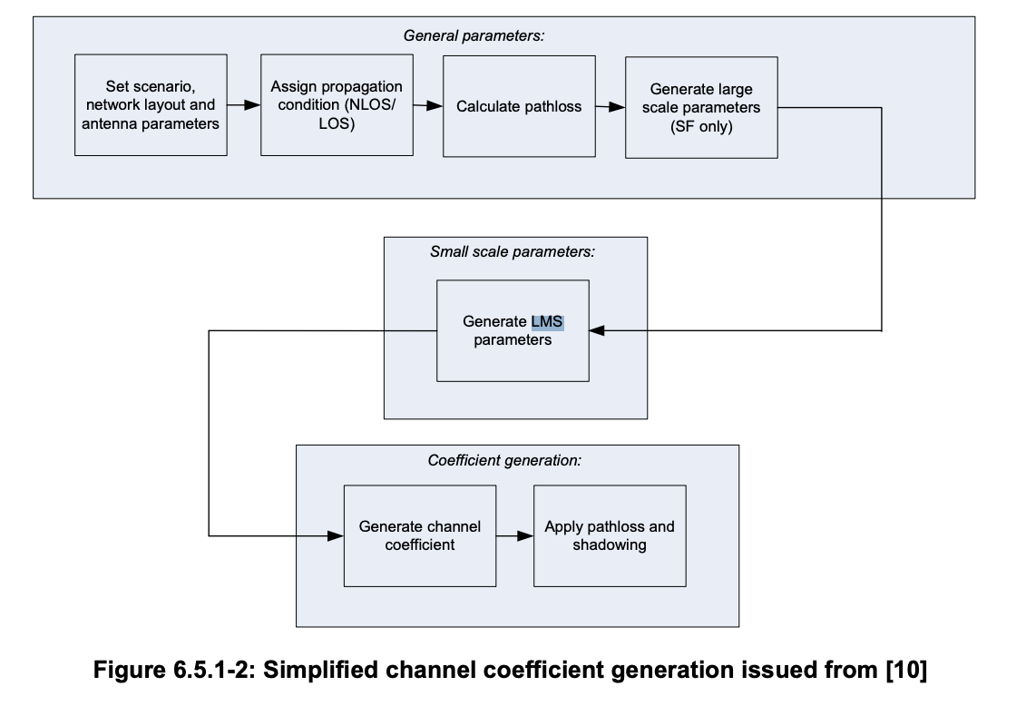  If companies are not familiar with this scenario, then we encourage them to study how land mobile satellite systems actually work, and the group will need further time to consider it, but we cannot agree with removing the intermittent shadowing, because it is a very high probability.
Viasat | Our strong preference is to give SA2 a full and clear answer to their question.  While there is no consensus on the exact probability of transient outage due to blockage, experimental results clearly show that these are not rare in the GSO case where the view to the satellite may be blocked by buildings, trees, other larger vehicles passing on the south etc.  We include a graph of our test data from an ACTUAL driving test in suburban San Diego, CA  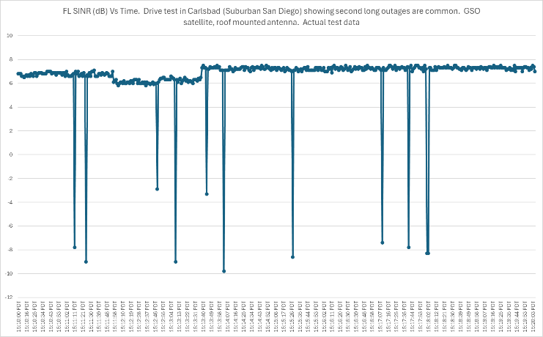  For the 2nd paragraph instead of the version proposed by the feature lead we would propose the following:  RAN1 has not reached consensus on the probability of having 16/64 packets consecutively lost under the case that a mobile UE transitions between line-of-sight and non-line-of sight conditions (and vice-versa) during a call, since RAN1 has not previously evaluated this scenario, however, this scenario is recognized to be relatively common in the suburban automotive use cases.
ESA | We are fine with the proposed moderator way forward. I understand that we cannot provide an agreeable probability of outage/blockage duration, however we are very concerned that there is clear direction to stick the head in the sand when ignoring these outage events in mobile channel conditions.
Nokia, NSB | We are fine for the first bullet. While for the second bullet, either Huawei’s version or Vivo’s version is fine to us.
Vivo3 | Regarding the comment from Aalyria  “The assumption of a LoS scenario for the UE towards the satellite does not remove the existence of fading, including potentially deep fades, or intermittent shadowing or blockages”  “So in this respect we also disagree with the statement that 3GPP RAN1 has not considered this intermittent shadowing scenario.”  I think no one has claimed that shadow fading is absent under LoS conditions. As defined in TR 38.811, shadow fading is modeled for both LoS and NLoS conditions, and the fading for LoS is smaller than that of NLOS. The referenced Figure 6.5.1-2 corresponds to the SLS case. In the LLS simulations, shadow fading is considered and indeed affects the required SNR.  In our LLS evaluations, we have accounted for shadow fading with 3dB (which is almost the worst case), along with other loss components such as scintillation loss and free space path loss, to determine the required SNR. And based on the SNR, it is observed that the probability of consecutive loss is extremely small.  The key point raised by the majority in the online discussion is that NLoS conditions were not a real focus during Rel 17–19, and therefore, should not be included for Rel 20
IITH, Wisig | Nbiot over GSO will have significant intermittent blockage, especially for the important auto use case, and so SA2 needs to be told about this in the LS from RAN1.
Qualcomm | We think the conclusion of the online discussion today was to mention the case of LOS / NLOS in the reply. If we only reply the LOS part of a fixed receiver, SA2 would not have the full information to proceed (as per Chairman’s guidance whether to be “conservative” or not).  We would be OK with Viasat’s wording as well, and we could even include the plot of the drive test as additional information.
NEC | We support replying with the “NLOS”. It is the SA2 decision on whether to consider the LOS-NLOS transaction in their ROHC design.
ST Engineering iDirect | Agree with NEC. Support the proposal to mention the LOS/NLOS scenario and showing the SINR from Viasat’s drive test.
Ericsson | In our view, providing a response fully focused on a line-of-sight condition is overly ideal. The NLOS condition can happen, and regardless of whether it is considered typical or not, as long as it exists then RAN1 should also cover it in the response to SA2 as to provide a complete and meaningful answer.  We are ok with the first paragraph proposed by the FL, whereas for the second on “NLOS” we the following suggestion to make it clear and not longer than the first paragraph:  Assuming line-of-sight condition for the duration of the call, and no change in large scale parameters (e.g. shadowing), RAN1 concludes that the probability of having 16/64 packets consecutively lost is negligible under typical operating conditions (e.g. 2% packet error rate)  Although RAN1 has not reached consensus on a non-line-of-sight assumption, a non-line-of-sight condition can still occur in practice (e.g., a mobile user changing LOS conditions to/from NLOS) in which case the probability of having consecutive packet losses exceeding 1 second is not negligible.
Spreadtrum | We share the same view with vivo.
CMCC | As discussed in the morning session, RAN1 chairman’s guidance is to provide 1st bullets in the last round discussion. And also provide the situation or the fact that RAN1 has not touch on any study on the enabling or dealing with NTN communication under NLOS situation. And even the transition between LOS and NLOS was not studied in the previous release in RAN1.  And it is not fair that in the reply in the 2nd round only mentioned that only some companies found issues in the nlos case (the last 3 bullets) and other companies do not think it is a typical use case for NTN communication.
CATT | Similar as vivo and Huawei, we agree with the first bullet, but for the second bullet, from RAN1 perspective, the NLOS channel is not typical case for GEO. LOS condition always acts as typical channel condition from Rel-17 to Rel-19. For LOS scenario, regardless the packet error rate(2% or 10%), 16/64 consecutive packets loss is negligible. For NLOS channel, the performance is not expected to guarantee.  For RAN1 perspective, we only inform SA2 the evaluation result of typical case, not touching the NLOS channel.
Xiaomi | Agree with the first bullet.  For the second bullet, support vivo or Huawei’s version.
Aalyria | In response to Vivo, perhaps our comment was not fully clear, but we should not conflate the link budget assumptions which were designed to capture the normal assumption of LoS link budget case, and thus the constant shadow fading margin, in this case (3 dB) due primarily to hand blockage, with the dynamic conditions of the channel model, which, even in the LoS case, include dynamic shadowing/blockage.  The actual dynamic shadow/blockage fading is a separate consideration that applies to an actual dynamic link level or system-level simulation, where transient fading is considered, depending on the actual channel model.  Which goes back to what I was referring to, i.e. the channel model referenced in the TR for FR1, which is the Land Mobile Satellite (LMS) “A. Jahn and E. Lutz “ model, which is captured (as mentioned in the TR) as an ITU-R Recommendation P.681 “Propagation data required for the design systems in the land mobile-satellite service”  https://www.itu.int/dms_pubrec/itu-r/rec/p/R-REC-P.681-11-201908-I!!PDF-E.pdf  The LMS model, as per the TR, applies to Flat Fading scenarios with bandwidth below 5 MHz (and thus to NB-IoT) or mmWave frequencies (e.g. Ka-band). Since at the time of the TR, FR1 did not include NB-IoT (NB-IoT was started later), in the table below you will see the Flat Fading model applied only to Fast Fading (where you will see that it’s a time-transient two-state model with GOOD and BAD state), and in Link-Level only for GEO/NGSO Ka-band.  But we should apply the Flat Fading model also for NB-IoT FR1. If we don’t do that, we’re making a mistake.  This is also used to approximate Fast Fading with a maximum fading margin of 5dB, meaning that Fast Fading in GOOD state is within the 5 dB margin, whereas in BAD state it is outside.  With the correct Flat Fading and dynamic Shadowing model (see the referenced LMS channel), you will find that the value of the fade (BAD state) and probability are much higher, but there is also a very high probability that the fade duration will be small (1-2 seconds), but still larger than the Fast Fading model.  In the TR, you can see this table:  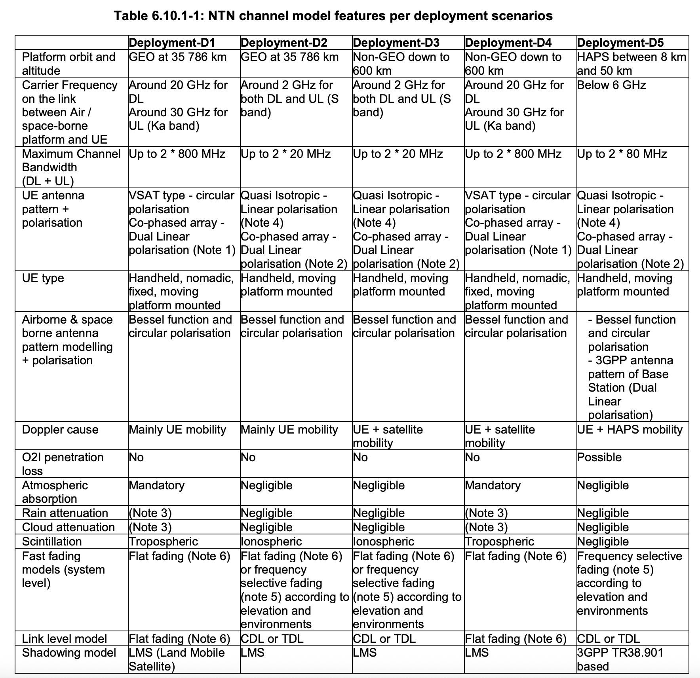  For context, Note 6 is as follows, which implies that the :  Note 6: Flat fading model refers to the 2 state model from ITU-R P681 (section 6). Since this model is based on time series, R1-1802975 proposes a method to adapt it to drop based simulations for system level evaluation.  To translate it to the SLS case, some UEs in the drop are characterized by deep fades, which simulate transient fades during normal operation, and that would most likely, in the absence of a sufficient NLoS component, result in link loss for that simulation quantum, which is what’s described in R1-1802975 referenced in the TR 38.811 for SLS.

Conclusion
TBD

Appendix: Summary of proposals
R1-2506863 | vivo, Spreadtrum | Proposal 1: Provide the following answer to SA2 in the LS reply.  - RAN1 evaluated the probability of 16 or 64 consecutive packet losses based on the typical NTN channel model and evaluation assumptions, and the example frame structure shown in Figure 5.2.2.3-1 and Figure 5.2.2.3-2 of excerpt_S4-251550_FS_ULBC_P-doc in LS R1-2505140 (S4-251584) from SA4.  - RAN1 concluded that the probability of 16 or 64 consecutive packet losses is negligible for voice codec rates of 0.8kbps, 1.2kbps, and 2.4kbps, and voice bundling periods of 80ms, 160ms, and 320ms, under target BLERs of up to 10%. Such an event is unlikely to occur in practice.
R1-2506906 | ZTE | Proposal 1: Reply SA2 that the probability that 16 or 64 consecutive packets loss or error is nearly zero and almost never not happen.
R1-2506957 | Xiaomi | Proposal 1: For a given voice data rate that could meet with the link budget of IoT-NTN GEO, the probability of M consecutive packets being in error satisfies the following formula: P=0.02^M
R1-2507085 | CATT | Proposal 1: For IMS voice over GEO, it can be considered that there is rare probability of 16 or 64 consecutive packets loss or erroneously decompressed.
R1-2507141 | OPPO | Proposal 1: Decompressing touches on higher layer operation and RAN1 cannot provides the probability or frequency that consecutive packets are erroneously decompressed.  Proposal 2: The probability that 16 and 64 consecutive packets are lost is very low, and the impact of consecutively lost packets on using RoHC for support of IMS voice over NB-IoT NTN can be negligible.
 | Samsung | Observation 1: Given that one NPDSCH or NPUSCH carries one packet, the probability of consecutive packet failures (with a 2% Target BLER) is 0.02^N, making the scenario SA2 is inquiring about extremely rare.
  R1-2507218
R1-2507297 | Nokia | Proposal 1: RAN1 to reply to SA2 that the scenario of losing 16-64 consecutive packets is highly unlikely and that SA2 does not need to consider this scenario any further.
R1-2507320 | NEC | Proposal 1: Replay to SA2 that  1) packet loss or erroneous decompression can be due to the wireless channel degradation and/or packet collisions;  2) the wireless channel degradation modelling requires further RAN1 discussion on the evaluation scenario assumption;  3) the packet collision modelling requires further inputs from RAN4 and SA2 to provide inputs on the UE power model, overall required PHY data rates for different IP-based solutions, and multi-party voice service modelling;  4) RAN1 will provide further feedback on the packet loss or erroneous decompression probability analysis based on the inputs from RAN4 and SA4.
R1-2507919 | Huawei | Proposal 1: The probability P_N that consecutive N packets are lost or erroneously decompressed is P_N=(P_bler)^N, which is negligible when the number of N is 16 or 64.
R1-2507263 | Ericsson | Response to “Question 2 (To RAN1)”: While providing numerical data on the probability of error requires link-level simulations, in principle it is theoretically possible to transmit data with an arbitrarily low error rate using suitable error-correcting methods (presumably the ones already available in NB-IoT):  • For SPS assuming a TBS of 328 bits with 15 kHz SCS NPUSCH Format 1 single-tone in an SNR range from -10 dB to -2 dB, it should be theoretically possible to transmit the following estimated data rates with an arbitrarily low error rate:  o Data rates: ~ 1.0250 kbps, ~ 1.0933 kbps, and ~ 2.05 kbps from the lowest SNR (i.e., ~ -10 dB) onwards.  o Data rate: ~ 8.2 kbps from ~ -3 dB onwards.  o Data rate: ~ 16.4 kbps is not achievable in the SNR from -10 dB up to -2 dB.  • For SPS assuming a TBS of 328 bits with 3.75 kHz SCS NPUSCH Format 1 single-tone in an SNR range from -10 dB to -2 dB, it should be theoretically possible to transmit the following estimated data rates with an arbitrarily low error rate:  o Data rates: ~ 0.3037 kbps, ~ 0.3094 kbps, ~ 0.5857 kbps and ~ 0.6074 kbps from the lowest SNR (i.e., ~ -10 dB) onwards.  o Data rate: ~ 4.1 kbps from ~ -6.5 dB onwards.  • For SPS assuming a TBS of 328 bits with 15 kHz SCS NPDSCH in an SNR range from -10 dB to -2 dB, it should be theoretically possible to transmit all the estimated data rates (from fractions of kbps up tens of kbps) at any SNR within the SNR range with an arbitrarily low error rate.
R1-2507687 | Qualcomm | Proposal 1: Assuming a static user in good channel conditions (i.e., ~2% BLER), the probability of having consecutive packet losses exceeding 1 second is negligible.  Proposal 2: Assuming a mobile user for which the line of sight condition changes during the call (from line-of-sight LOS to non-line-of-sight NLOS and vice-versa), there is a non-negligible probability of a large number of packets being consecutively lost. Assuming a rural scenario with 50 degree elevation angle:  - For a slow moving receiver (1m/s):  - 88% of the NLOS events will result in consecutive packet losses longer than 1.28s  - There are 0.25 events / minute exceeding 1.28s, with an average duration of 15.3s  - 65% of the NLOS events will result in consecutive packet losses longer than 5.12s  - There are 0.17 events / minute exceeding 5.12s, with an average duration of 20.4s.  - For a moderate speed receiver (10 m/s):  - 40% of the NLOS events will result in consecutive packet losses longer than 1.28s  - There is 1 event/minute exceeding 1.28s, with an average duration of 3.17s  - 7% of the NLOS events will result in consecutive packet losses longer than 5.12s  - There are 0.15 events/minute exceeding 5.12s, with an average duration of 7s  - For a high speed receiver (30m/s):  - 12% of the NLOS events will result in consecutive packet losses longer than 1.28s  - There are 0.83 events/minute exceeding 1.28s, with an average duration of 2s  - <0.1% of the NLOS events will result in consecutive packet losses longer than 5.12s  - There are 0.004 events/minute exceeding 5.12s, with an average duration of 5.88s  Proposal 3: Some procedures needed to operate NB-IoT NTN will result in consecutive packets being dropped:  - For GNSS reacquisition, the UE will drop all packets every GNSS-ValidityDuration for a duration of GNSS-PositionFixDuration  - GNSS-ValidityDuration is between 10s and infinity, GNSS-PositionFixDuration-r18 is between 1 and 31 seconds  - For SIB31 reading, the UE will drop all packets every ul-SyncValidityDuration for a duration of t318  - ul-SyncValidityDuration is between 5 and 900 seconds, t318 is between 0 and 4 seconds.  Proposal 4: Reply to the SA2 LS including proposals 1-3.

