3GPP TSG-SA5 Meeting #162 S5-254073
Goteborg, Sweden, 25 - 29 August 2025
CR-Form-v12.3
CHANGE REQUEST
 | 28.533 | CR | 0169 | rev | 1 | Current version: | 19.2.0
For HELP on using this form: comprehensive instructions can be found at
http://www.3gpp.org/Change-Requests.

Proposed change affects: | UICC apps |  | ME |  | Radio Access Network | X | Core Network | X

Title: | Rel-19 CR TS 28.533 Management services exposure
Source to WG: | Huawei, Nokia, AT&T, DTAG, China Mobile, China Unicom, Ericsson, Verizon, Telecom Italia, Orange, ZTE, China Telecom
Source to TSG: | SA5
Work item code: | SBMA_Ph3 |  |  |  |  |  | Date: |  |  | 2025-08-15
Category: | B |  |  |  |  |  | Release: |  |  | Rel-19
 | Use one of the following categories:  F (correction)  A (mirror corresponding to a change in an earlier release)  B (addition of feature),  C (functional modification of feature)  D (editorial modification)  Detailed explanations of the above categories can  be found in 3GPP TR 21.900. |  |  |  |  |  |  |  | Use one of the following releases:  Rel-8 (Release 8)  Rel-9 (Release 9)  Rel-10 (Release 10)  Rel-11 (Release 11)  …  Rel-17 (Release 17)  Rel-18 (Release 18)  Rel-19 (Release 19)  Rel-20 (Release 20)
Reason for change: |  | It is suggested to add management services exposure content captured in the endorsed contribution S5-251948.
Summary of change: |  | Add definitions of internal and external MnS consumers and different exposure scenarios depending on the type of the MnS consumer.
Consequences if not approved:
Clauses affected: |  | 2, 3.1, new clause 5.X
 |  | Y | N
Other specs |  |  | X | Other core specifications |  |  |  | TS/TR ... CR ...
affected: |  |  | X | Test specifications |  |  |  | TS/TR ... CR ...
(show related CRs) |  |  | X | O&M Specifications |  |  |  | TS/TR ... CR ...
Other comments:
This CR's revision history:

1st Change

2 References
The following documents contain provisions which, through reference in this text, constitute provisions of the present document.
- References are either specific (identified by date of publication, edition number, version number, etc.) or non-specific.
- For a specific reference, subsequent revisions do not apply.
- For a non-specific reference, the latest version applies. In the case of a reference to a 3GPP document (including a GSM document), a non-specific reference implicitly refers to the latest version of that document in the same Release as the present document.
[1] 3GPP TR 21.905: "Vocabulary for 3GPP Specifications".
[2] Void
[3] 3GPP TS 28.530: "Management and orchestration of networks and network slicing; Concepts, use cases and requirements".
[4] 3GPP TS 28.541: "Management and orchestration of 5G networks; Network Resource Model (NRM); Stage 2 and stage 3".
[5] 3GPP TS 28.552: "Management and orchestration of 5G networks; Performance measurements and assurance data".
[6] 3GPP TS 28.554: "Management and orchestration of 5G networks; 5G End to end Key Performance Indicators (KPI)".
[7] 3GPP TS 32.425: "Telecommunication management; Performance Management (PM); Performance measurements Evolved Universal Terrestrial Radio Access Network (E-UTRAN)".
[8] 3GPP TS 28.531: "Management and orchestration of 5G networks; Provisioning; Stage 1".
[9] 3GPP TS 28.532: "Management and orchestration; Management services".
[10] 3GPP TS 28.500: "Telecommunication management; Management concept, architecture and requirements for mobile networks that include virtualized network functions"
[11] 3GPP TS 28.510; "Telecommunication management; Configuration Management (CM) for mobile networks that include virtualized network functions; Requirements".
[12] 3GPP TS 28.511; "Telecommunication management; Configuration Management (CM) for mobile networks that include virtualized network functions; Procedures".
[13] 3GPP TS 28.512; "Telecommunication management; Configuration Management (CM) for mobile networks that include virtualized network functions; Stage 2".
[14] 3GPP TS 28.513: "Telecommunication management; Configuration Management (CM) for mobile networks that include virtualized network functions; Stage 3".
[15] 3GPP TS 28.515; "Telecommunication management; Fault Management (FM) for mobile networks that include virtualized network functions; Requirements".
[16] 3GPP TS 28.516: "Telecommunication management; Fault Management (FM) for mobile networks that include virtualized network functions; Procedures".
[17] 3GPP TS 28.517: "Telecommunication management; Fault Management (FM) for mobile networks that include virtualized network functions; Stage 2".
[18] 3GPP TS 28.518: "Telecommunication management; Fault Management (FM) for mobile networks that include virtualized network functions; Stage 3".
[19] 3GPP TS 28.520: "Telecommunication management; Performance Management (PM) for mobile networks that include virtualized network functions; Requirements".
[20] 3GPP TS 28.521: "Telecommunication management; Performance Management (PM) for mobile networks that include virtualized network functions; Procedures".
[21] 3GPP TS 28.522: "Telecommunication management; Performance Management (PM) for mobile networks that include virtualized network functions; Stage 2".
[22] 3GPP TS 28.523: "Telecommunication management; Performance Management (PM) for mobile networks that include virtualized network functions; Stage 3".
[23] 3GPP TS 28.525: "Telecommunication management; Life Cycle Management (LCM) for mobile networks that include virtualized network functions; Requirements".
[24] 3GPP TS 28.526: "Telecommunication management; Life Cycle Management (LCM) for mobile networks that include virtualized network functions; Procedures".
[25] 3GPP TS 28.527: "Telecommunication management; Life Cycle Management (LCM) for mobile networks that include virtualized network functions; Stage 2".
[26] 3GPP TS 28.528: "Telecommunication management; Life Cycle Management (LCM) for mobile networks that include virtualized network functions; Stage 3".
[27] ETSI GS NFV 003: "Network Functions Virtualisation (NFV); Terminology for Main Concepts in NFV V1.3.1 (2018-01)".
[28] Void
[29] ETSI GS ZSM 002: "Zero-touch Network and Service Management (ZSM); Reference Architecture V.1.1 (2019-08)".
[30] 3GPP TS 23.288: "Architecture enhancements for 5G System (5GS) to support network data analytics services".
[31] 3GPP TS 23.501: "System Architecture for the 5G system".
[32] 3GPP TS 28.622: "Telecommunication management; Generic Network Resource Model (NRM) Integration Reference Point (IRP); Information Service (IS)".
[33] IETF RFC 8446: "The Transport Layer Security (TLS) Protocol Version 1.3".
[34] IETF RFC 4253: "The Secure Shell (SSH) Transport Layer Protocol".
[35] 3GPP TS 28.100: "Management and orchestration; Levels of autonomous network".
[36] 3GPP TS 28.533: "Management and orchestration; Architecture framework".
[37] 3GPP TS 28.535: "Management services for communication service assurance; Requirements ".
[38] 3GPP TS 28.536: "Management services for communication service assurance; Stage 2 and stage 3".
[39] 3GPP TS 28.537: "Management and orchestration; Management capabilities".
[40] 3GPP TS 28.538: "Management and orchestration; Edge Computing Management".
[41] 3GPP TS 28.540: "Management and orchestration; 5G Network Resource Model (NRM); Stage 1".
[42] 3GPP TS 28.550: "Management and orchestration; Performance assurance".
[43] 3GPP TS 32.421: "Telecommunication management; Subscriber and equipment trace; Trace concepts and requirements".
[44] 3GPP TS 32.422: "Telecommunication management; Subscriber and equipment trace; Trace control and configuration management ".
[45] 3GPP TS 32.423: "Telecommunication management; Subscriber and equipment trace;Trace data definition and management".
[46] 3GPP TS 28.312: "Management and orchestration; Intent driven management services for mobile networks".
[47] 3GPP TS 28.557: "Management and orchestration; Management of Non-Public Networks (NPN); Stage 1 and stage 2".
[48] 3GPP TS 28.404: "Telecommunication management; Quality of Experience (QoE) measurement collection; Concepts, use cases and requirements".
[49] 3GPP TS 28.405: "Telecommunication management; Quality of Experience (QoE) measurement collection; Control and configuration".
[50] 3GPP TS 28.406: "Telecommunication management; Quality of Experience (QoE) measurement collection; Information definition and transport".
[51] 3GPP TS 28.631: "Telecommunication management; Inventory Management (IM) Network Resource Model (NRM) Integration Reference Point (IRP); Requirements".
[52] 3GPP TS 28.632: "Telecommunication management; Inventory Management (IM) Network Resource Model (NRM) Integration Reference Point (IRP); Information Service (IS)".
[53] 3GPP TS 28.633: "Telecommunication management; Inventory Management (IM) Network Resource Model (NRM) Integration Reference Point (IRP); Solution Set (SS) definitions".
[54] 3GPP TS 28.623: "Telecommunication management; Generic Network Resource Model (NRM) Integration Reference Point (IRP); Solution Set (SS) definitions".
[55] 3GPP TS 32.130: "Telecommunication management; Network sharing; Concepts and requirements".
[56] 3GPP TS 28.310: "Management and orchestration; Energy efficiency of 5G".
[57] 3GPP TS 28.104: "Management and orchestration; Management Data Analytics".
[58] 3GPP TS 28.313: "Self-Organizing Networks (SON) for 5G networks".
[59] 3GPP TS 28.314: "Management and orchestration; Plug and Connect; Concepts and requirements".
[60] 3GPP TS 28.315: "Management and orchestration; Plug and Connect; Procedure flows".
[61] 3GPP TS 28.316: "Management and orchestration; Plug and Connect; Data formats".
[62] 3GPP TS 28.555: "Management and orchestration; Network policy management for 5G mobile networks; Stage 1".
[63] 3GPP TS 28.556: "Management and orchestration; Network policy management for 5G mobile networks; Stage 2 and stage 3".
[64] ETSI GS NFV-IFA008 (V4.3.1): "Network Functions Virtualisation (NFV) Release 4; Management and Orchestration; Ve-Vnfm reference point - Interface and Information Model Specification".
[65] ETSI GS NFV-IFA013 (V4.3.1): "Network Function Virtualisation (NFV); Release 4; Management and Orchestration; Os-Ma-nfvo reference point - Interface and Information Model Specification".
[66] 3GPP TS 28.105: " Management and orchestration; Artificial Intelligence / Machine Learning (AI/ML) management "
[67] 3GPP TS 28.317: "Management and orchestration;Self-configuration of Radio Access Network Entities (RAN NEs) "
[68] 3GPP TS 28.111: "Management and orchestration;Fault management"
[69] 3GPP TS 28.318 "Management and Orchestration; Network and services operations for energy utilities"
[70] 3GPP TS 28.319 "Management and orchestration; Access Control for Management services"
[71] 3GPP TS 26.247 "Transparent end-to-end Packet-switched Streaming Service (PSS); Progressive Download and Dynamic Adaptive Streaming over HTTP (3GP-DASH)"
[XX] 3GPP TS 23.222 "Common API Framework for 3GPP Northbound APIs; Stage 2"
[YY] 3GPP TS 28.579 "Management and orchestration; Management services exposure to external consumers through CAPIF"

3 Definitions and abbreviations

3.1 Definitions
For the purposes of the present document, the terms and definitions given in 3GPP TR 21.905 [1] and the following apply. A term defined in the present document takes precedence over the definition of the same term, if any, in 3GPP TR 21.905 [1] or NFV-MANO [27].
Exposure governance management function: Management Function entity with the role of management service exposure governance.
Management Service (MnS): set of offered management capabilities.
External MnS consumer: MnS consumer outside the PLMN trust domain.
Internal MnS consumer: MnS consumer within the PLMN trust domain.
NOTE: the concept of PLMN trust domain is defined in TS 23.222 [XX].
Management Function (MnF): logical entity playing the roles of Management Service consumer and/or Management Service producer.
Network Function (NF): defined in TS 23.501[31].
NOTE: In 3GPP NRM, the Network Functions are modeled using ManagedFunction IOCs (e.g. AMFFunction) and its sub-classes.

Next change

5.X 3GPP management services exposure
In the context of 3GPP management services exposure, there are different exposure scenarios depending on the type of the MnS consumer as illustrated in Figure 5.X-1.
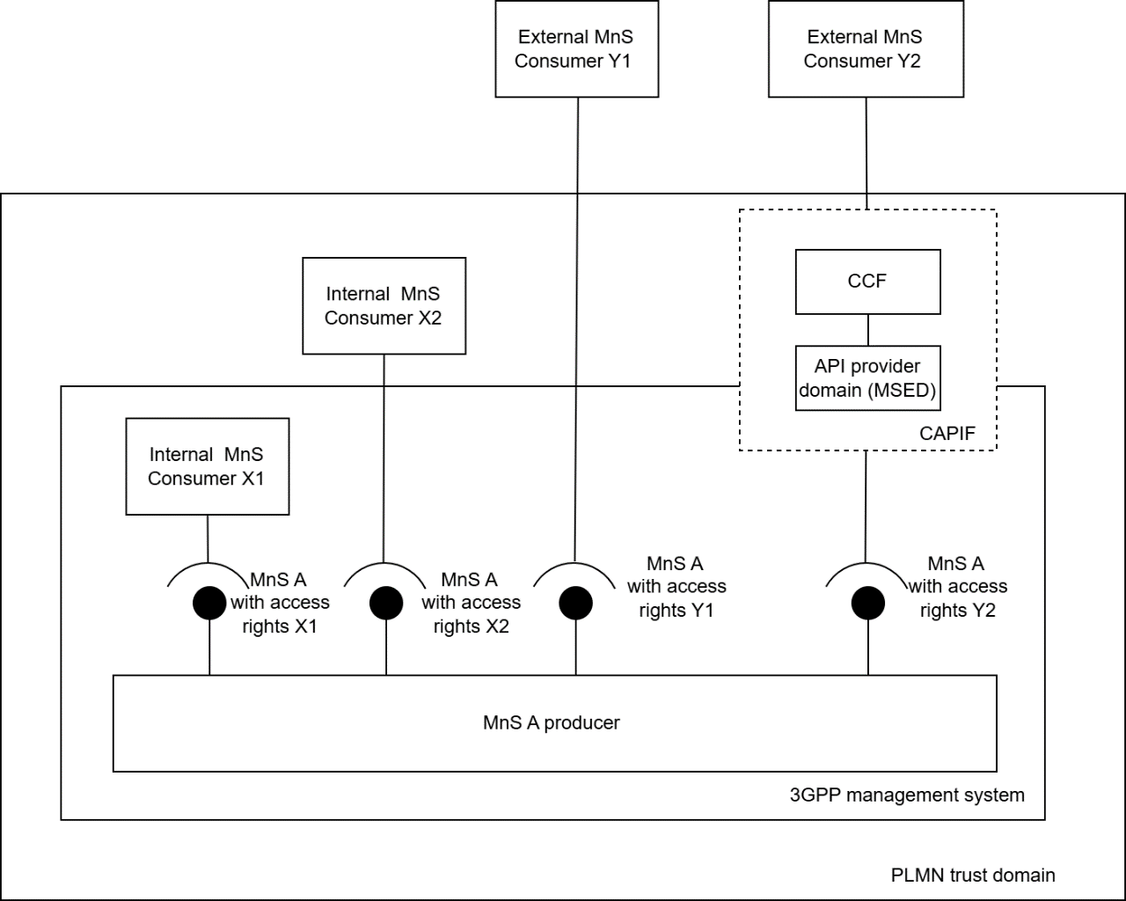
Figure 5.X-1: Management services exposure scenarios
- There are two categories of internal MnS consumers:
a) MnS consumer within the 3GPP management system, e.g. provisioning MnS consumer, fault management MnS consumer and streaming MnS consumer. This is equivalent to internal MnS consumer X1 in Figure 5.X-1.
b) MnS consumer outside the 3GPP management system but within the PLMN trust domain, e.g. NWDAF, operator’s AFs (e.g., EAS). This is equivalent to internal MnS consumer X2 in Figure 5.X-1.
- There are two categories of external MnS consumers:
a) MnS consumers outside the PLMN trust domain consuming management services directly from the 3GPP management system, e.g., participating operators in RAN sharing scenarios (see TS 32.130 [55]), energy utility verticals (see TS 28.318 [69]), and other verticals. This is equivalent to external MnS consumer Y1 in Figure 5.X-1.
b) MnS consumers outside the PLMN trust domain consuming management services indirectly through CAPIF (see TS 23.222 [XX]), e.g., Energy utility verticals (see TS 28.318 [69]), and other verticals. This is equivalent to external MnS consumer Y2 in Figure 5.X-1.
The exposure of management services to the different types of MnS consumers includes two aspects: discovery of the MnSs and access control. As a precondition, the discovery of management services assumes that the management services to be exposed have been registered.
MnS discovery mechanisms for the different types of MnS consumers:
- For MnS consumers consuming management services directly from the 3GPP management system (e.g., internal MnS consumer X1, internal MnS consumer X2 and external MnS consumer Y1), the mechanisms to discover the registered management services and the corresponding management capabilities have been specified in clause 5 of TS 28.537 [39].
- For MnS consumers consuming management services indirectly through CAPIF (e.g., external MnS consumer Y2), TS 28.579 [YY] specifies how to discover the registered MnSs to this category of external MnS consumers.
It is up to the network operator’s discretion to determine the appropriate discovery and access control rights for the different MnS consumers when consuming a given MnS.

End of change

