**3GPP TSG- Meeting #**

**, , -**

|  |  |  |  |  |  |  |  |  |
| --- | --- | --- | --- | --- | --- | --- | --- | --- |
| *CR-Form-v12.3* | | | | | | | | |
| **CHANGE REQUEST** | | | | | | | | |
|  | | | | | | | | |
|  |  | **CR** | - | **rev** |  | **Current version:** |  |  |
|  | | | | | | | | |
| *For* [***HE******LP***](http://www.3gpp.org/3G_Specs/CRs.htm#_blank)*on using this form: comprehensive instructions can be found at* [*http://www.3gpp.org/Change-Requests*](http://www.3gpp.org/Change-Requests)*.* | | | | | | | | |
|  | | | | | | | | |

|  |  |  |  |  |  |  |  |  |
| --- | --- | --- | --- | --- | --- | --- | --- | --- |
| ***Proposed change affects:*** | UICC apps |  | ME |  | Radio Access Network | **X** | Core Network | **X** |

|  |  |  |  |  |  |  |  |  |  |  |
| --- | --- | --- | --- | --- | --- | --- | --- | --- | --- | --- |
|  | | | | | | | | | | |
| ***Title:*** | Rel-19 Input to DraftCR TS 28.105 Correct Information model definition | | | | | | | | | |
|  |  | | | | | | | | | |
| ***Source to WG:*** |  | | | | | | | | | |
| ***Source to TSG:*** | SA5 | | | | | | | | | |
|  |  | | | | | | | | | |
| ***Work item code:*** |  | | | | |  | ***Date:*** | | |  |
|  |  | | | |  | |  | | |  |
| ***Category:*** | F |  | | | | | ***Release:*** | | |  |
|  | *Use one of the following categories:* ***F*** *(correction)* ***A*** *(mirror corresponding to a change in an earlier release)* ***B*** *(addition of feature),* ***C*** *(functional modification of feature)* ***D*** *(editorial modification)*  Detailed explanations of the above categories can be found in 3GPP [TR 21.900](http://www.3gpp.org/ftp/Specs/html-info/21900.htm). | | | | | | | | *Use one of the following releases: Rel-8 (Release 8) Rel-9 (Release 9) Rel-10 (Release 10) Rel-11 (Release 11) … Rel-17 (Release 17) Rel-18 (Release 18) Rel-19 (Release 19)  Rel-20 (Release 20)* | |
|  |  | | | | | | | | | |
| ***Reason for change:*** | | MLModel IOC is name-contained by MLModelRepository. However, clause 7.3a.3 shows that MLModel is also name-contained by AIMLInferenceFunction (figure 7.3a.1.1-1). The latter is incorrect. As specified in TS 32.156, clause 5.3.3, “a target instance cannot have multiple <<names>> with multiple source instances s, i.e. a target instance can not participate in or belong to multiple namespaces”. This means that an instance can only name-contained by one single parent instance.  The description of usedByFunctionRefList attribute (used in MLModel and AIMLInferenceFunction IOCs) in the big attribute table is misleading, because it points out to the AIMLInferenceFunction, while the reality is that it lists the DN of the functions represented by AIMLSupportedFunction (see figure 7.3a.4.1.1-2). | | | | | | | | |
|  | |  | | | | | | | | |
| ***Summary of change:*** | | Remove name containement of MLModel to the AIMLInferenceFuntion  Update PlantUML A.11  Correct description of usedByFunctionRefList | | | | | | | | |
|  | |  | | | | | | | | |
| ***Consequences if not approved:*** | | May lead to incorrect implementation | | | | | | | | |
|  | |  | | | | | | | | |
| ***Clauses affected:*** | | 7.3a.3.1.1, 7.5.1, A.11 | | | | | | | | |
|  | |  | | | | | | | | |
|  | | **Y** | **N** |  | | | |  | | |
| ***Other specs*** | |  | **X** | Other core specifications | | | | TS/TR ... CR ... | | |
| ***affected:*** | |  | **X** | Test specifications | | | | TS/TR ... CR ... | | |
| ***(show related CRs)*** | |  | **X** | O&M Specifications | | | | TS/TR ... CR ... | | |
|  | |  | | | | | | | | |
| ***Other comments:*** | |  | | | | | | | | |
|  | |  | | | | | | | | |
| ***This CR's revision history:*** | |  | | | | | | | | |

***1st change***

### 7.3a.3 Information model definitions for ML model deployment

#### 7.3a.3.1 Class diagram

##### 7.3a.3.1.1 Relationships

This clause depicts the set of classes (e.g. IOCs) that encapsulates the information relevant to ML model loading. For the UML semantics, see TS 32.156 [13].

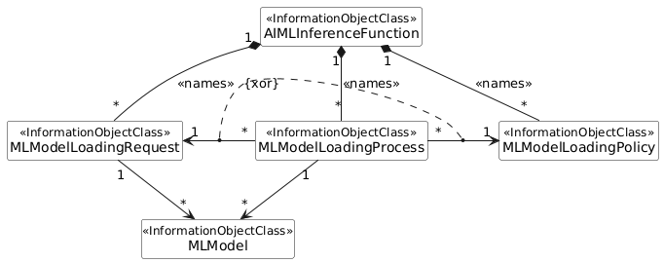

**Figure 7.3a.3.1.1-1: NRM fragment for ML model loading**

7.3a.3.1.2 Inheritance

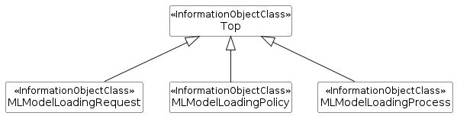

**Figure 7.3a.3.1.2-1: Inheritance Hierarchy for ML model loading related NRMs**

***change***

# A.10 PlantUML code for Figure 7.3a.3.1.1-1: NRM fragment for ML model loading

@startuml

skinparam ClassStereotypeFontStyle normal

skinparam ClassBackgroundColor White

skinparam shadowing false

skinparam monochrome true

hide members

hide circle

'skinparam maxMessageSize 250

class AIMLInferenceFunction <<InformationObjectClass>>

class MLModel <<InformationObjectClass>>

class MLModelLoadingRequest <<InformationObjectClass>>

class MLModelLoadingPolicy <<InformationObjectClass>>

class MLModelLoadingProcess <<InformationObjectClass>>

AIMLInferenceFunction"1" *-- "*" MLModelLoadingRequest : <<names>>

AIMLInferenceFunction "1" *-- "*" MLModelLoadingPolicy : <<names>>

AIMLInferenceFunction "1" *-- "*" MLModelLoadingProcess : <<names>>

MLModelLoadingRequest "1" <-r- "*" MLModelLoadingProcess

MLModelLoadingProcess "*" -r-> "1" MLModelLoadingPolicy

MLModelLoadingRequest "1" --> "*" MLModel

MLModelLoadingProcess "1" --> "*" MLModel

(MLModelLoadingProcess, MLModelLoadingRequest) ... (MLModelLoadingProcess, MLModelLoadingPolicy) : {xor}

@enduml

***change***