**3GPP TSG- Meeting #**

**, , -**

|  |  |  |  |  |  |  |  |  |
| --- | --- | --- | --- | --- | --- | --- | --- | --- |
| *CR-Form-v12.3* | | | | | | | | |
| **CHANGE REQUEST** | | | | | | | | |
|  | | | | | | | | |
|  |  | **CR** |  | **rev** | **1** | **Current version:** |  |  |
|  | | | | | | | | |
| *For* [***HE******LP***](http://www.3gpp.org/3G_Specs/CRs.htm#_blank)*on using this form: comprehensive instructions can be found at* [*http://www.3gpp.org/Change-Requests*](http://www.3gpp.org/Change-Requests)*.* | | | | | | | | |
|  | | | | | | | | |

|  |  |  |  |  |  |  |  |  |
| --- | --- | --- | --- | --- | --- | --- | --- | --- |
| ***Proposed change affects:*** | UICC apps |  | ME |  | Radio Access Network |  | Core Network | **x** |

|  |  |  |  |  |  |  |  |  |  |  |
| --- | --- | --- | --- | --- | --- | --- | --- | --- | --- | --- |
|  | | | | | | | | | | |
| ***Title:*** |  | | | | | | | | | |
|  |  | | | | | | | | | |
| ***Source to WG:*** |  | | | | | | | | | |
| ***Source to TSG:*** | S5 | | | | | | | | | |
|  |  | | | | | | | | | |
| ***Work item code:*** |  | | | | |  | ***Date:*** | | |  |
|  |  | | | |  | |  | | |  |
| ***Category:*** |  |  | | | | | ***Release:*** | | |  |
|  | *Use one of the following categories:* ***F*** *(correction)* ***A*** *(mirror corresponding to a change in an earlier release)* ***B*** *(addition of feature),* ***C*** *(functional modification of feature)* ***D*** *(editorial modification)*  Detailed explanations of the above categories can be found in 3GPP [TR 21.900](http://www.3gpp.org/ftp/Specs/html-info/21900.htm). | | | | | | | | *Use one of the following releases: Rel-8 (Release 8) Rel-9 (Release 9) Rel-10 (Release 10) Rel-11 (Release 11) … Rel-17 (Release 17) Rel-18 (Release 18) Rel-19 (Release 19)  Rel-20 (Release 20)* | |
|  |  | | | | | | | | | |
| ***Reason for change:*** | | |  | | --- | | Making available API Charging through CCF | |  | | | | | | | | | |
|  | |  | | | | | | | | |
| ***Summary of change:*** | | New flow for API Invoker/Provider Charging (ECUR mode) | | | | | | | | |
|  | |  | | | | | | | | |
| ***Consequences if not approved:*** | | API Invoker/Provider will not be able to be billed | | | | | | | | |
|  | |  | | | | | | | | |
| ***Clauses affected:*** | | 5.4.2.x, C.1.z | | | | | | | | |
|  | |  | | | | | | | | |
|  | | **Y** | **N** |  | | | |  | | |
| ***Other specs*** | |  | **x** | Other core specifications | | | | TS/TR ... CR ... | | |
| ***affected:*** | |  | **x** | Test specifications | | | | TS/TR ... CR ... | | |
| ***(show related CRs)*** | |  | **x** | O&M Specifications | | | | TS/TR ... CR ... | | |
|  | |  | | | | | | | | |
| ***Other comments:*** | |  | | | | | | | | |
|  | |  | | | | | | | | |
| ***This CR's revision history:*** | | Revision of S5-253362 | | | | | | | | |

|  |
| --- |
| **First change** |

#### 5.4.2.x CAPIF Invoker and Provider Request (ECUR)

Figure 5.4.2.x-1 describes the scenario where an API Invoker Management Request is delivered from the CCF for ECUR mode.

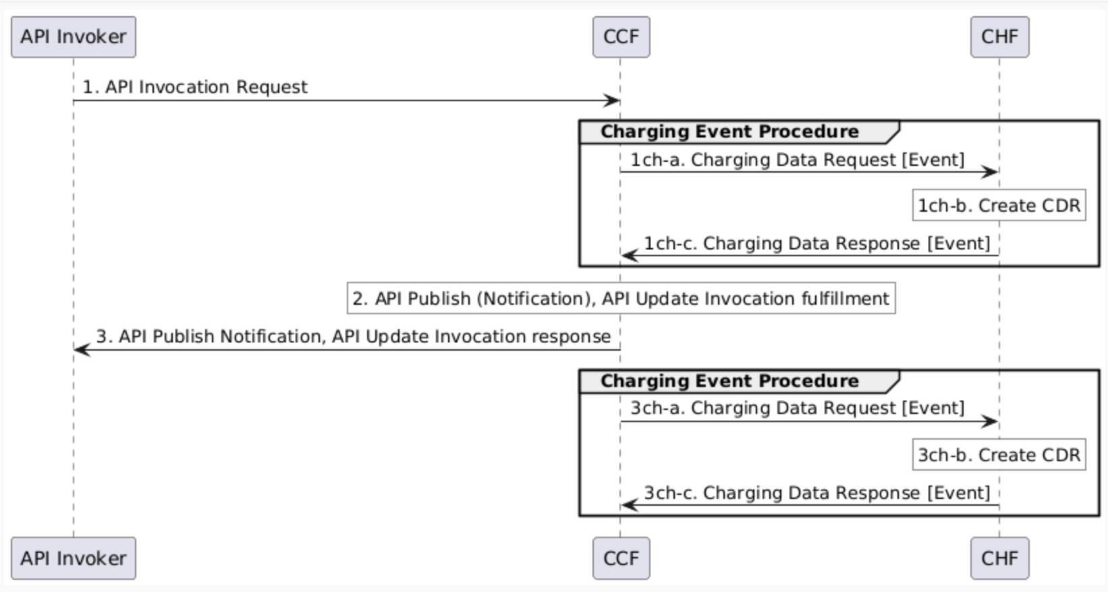

Figure 6.4.5.1-2: CAPIF Core Function Charging Scenario Example (ECUR)

1. CCF receives an API Invocation Request, from API Invoker.

1ch-a. The CCF sends Charging Data Request [Initial] to CHF for the received API Invocation.

1ch-b. The CHF creates a CDR for this API Invocation.

1ch-c. The CHF acknowledges and grants authorization by sending Charging Data Response [Event] to CCF.

2. CCF performs the actions needed to fulfil the API invoked (i.e. API Publish notification, API Update invocation).

3. The CCF continues the API invocation processing and sends the API Invocation Response (i.e. API Publish notification, API Update invocation) to API Invoker.

3ch-a. The CCF sends Charging Data Request [Termination] to the CHF for terminating the charging associated with the API Invocation.

3ch-b. The CHF closes the CDR for this API Invocation.

3ch-c. The CHF acknowledges by sending Charging Data Response [Termination] to the CCF.

|  |
| --- |
| **Second Change** |

## C.1.z CAPIF Invoker and Provider Request (ECUR)

@startuml

participant "API Invoker" as API

participant "CAPIF Core Function" as CAPIF

participant "CHF" as CHF

API -> CAPIF : 1. API Invocation Request

group Charging Event Procedure

CAPIF -> CHF : 1ch-a. Charging Data Request [Event]

rnote over CHF #white

1ch-b. Create CDR

endrnote

CHF -> CAPIF : 1ch-c. Charging Data Response [Event]

end

rnote over CAPIF #white

2. API Publish (Notification), API Update Invocation fulfillment

endrnote

CAPIF -> API : 3. API Publish Notification, API Update Invocation response

group Charging Event Procedure

CAPIF -> CHF : 3ch-a. Charging Data Request [Event]

rnote over CHF #white

3ch-b. Create CDR

endrnote

CHF -> CAPIF : 3ch-c. Charging Data Response [Event]

end

@enduml

|  |
| --- |
| **End of changes** |