3GPP TSG-SA5 Meeting #162 S5-253767

Stor-Göteborg, Sweden, 25th Aug 2025 - 29th Aug 2025
CR-Form-v12.3
CHANGE REQUEST
 | 32.254 | CR | 0075 | rev | 1 | Current version: | 19.1.0
For HELP on using this form: comprehensive instructions can be found at
http://www.3gpp.org/Change-Requests.

Proposed change affects: | UICC apps |  | ME |  | Radio Access Network |  | Core Network | x

Title: | Rel-19 CR 32.254 CAPIF API Invoker Charging Flow (ECUR)
Source to WG: | Nokia
Source to TSG: | S5
Work item code: | CH_CAPIF_EXT |  |  |  |  |  | Date: |  |  | 2025-08-12
Category: | B |  |  |  |  |  | Release: |  |  | Rel-19
 | Use one of the following categories:  F (correction)  A (mirror corresponding to a change in an earlier release)  B (addition of feature),  C (functional modification of feature)  D (editorial modification)  Detailed explanations of the above categories can  be found in 3GPP TR 21.900. |  |  |  |  |  |  |  | Use one of the following releases:  Rel-8 (Release 8)  Rel-9 (Release 9)  Rel-10 (Release 10)  Rel-11 (Release 11)  …  Rel-17 (Release 17)  Rel-18 (Release 18)  Rel-19 (Release 19)  Rel-20 (Release 20)
Reason for change: |  | Making available API Charging through CCF
Summary of change: |  | New flow for API Invoker/Provider Charging (ECUR mode)
Consequences if not approved: |  | API Invoker/Provider will not be able to be billed
Clauses affected: |  | 5.4.2.x
 |  | Y | N
Other specs |  |  | x | Other core specifications |  |  |  | TS/TR ... CR ...
affected: |  |  | x | Test specifications |  |  |  | TS/TR ... CR ...
(show related CRs) |  |  | x | O&M Specifications |  |  |  | TS/TR ... CR ...
Other comments:
This CR's revision history:

First change

5.4.2.x CAPIF Invoker and Provider Request (ECUR)
Figure 5.4.2.x-1 describes the scenario where an API Invoker Management Request is delivered from the CCF for ECUR mode.

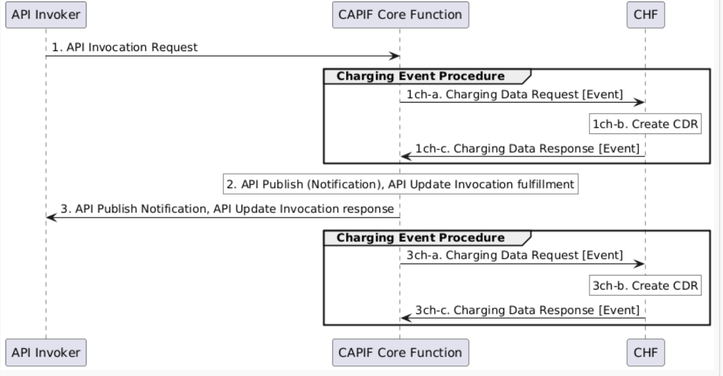
Figure 6.4.5.1-2: CAPIF Core Function Charging Scenario Example (ECUR)
1. CCF (CAPIF_Event API) receives an API Invocation Request, from API Invoker.
1ch-a. The CCF sends Charging Data Request [Initial] to CHF for the received API Invocation.
1ch-b. The CHF creates a CDR for this API Invocation.
1ch-c. The CHF acknowledges and grants authorization by sending Charging Data Response [Event] to CCF.
2. If authorized CCF performs the actions needed to fulfil the API invoked.
3. The CCF continues the API invocation processing and sends the API Invocation Response to CCF.
3ch-a. The CCF sends Charging Data Request [Termination] to the CHF for terminating the charging associated with the API Invocation.
3ch-b. The CHF closes the CDR for this API Invocation.
3ch-c. The CHF acknowledges by sending Charging Data Response [Termination] to the CCF.

Second Change

Annex C (informative):
PlantUML source code

C.1 Procedures for Northbound API converged online and offline charging scenarios

C.1.z CAPIF Invoker and Provider Request (ECUR)
@startuml
participant "API Invoker" as API
participant "CAPIF Core Function" as CAPIF
participant "CHF" as CHF

API -> CAPIF : 1. API Invocation Request

group Charging Event Procedure

CAPIF -> CHF : 1ch-a. Charging Data Request [Event]

rnote over CHF #white
1ch-b. Create CDR
endrnote
CHF -> CAPIF : 1ch-c. Charging Data Response [Event]
end
rnote over CAPIF #white
2. API Publish (Notification), API Update Invocation fulfillment
endrnote

CAPIF -> API : 3. API Publish Notification, API Update Invocation response

group Charging Event Procedure

CAPIF -> CHF : 3ch-a. Charging Data Request [Event]

rnote over CHF #white
3ch-b. Create CDR
endrnote
CHF -> CAPIF : 3ch-c. Charging Data Response [Event]
end

@enduml

End of changes

