3GPP TSG-SA WG4 Meeting #132 S4-250984r01

Fukuoka, Japan, 19th – 23rd May 2025

Source: InterDigital Canada
Title: [FS_ARSpatial] Pseudo-CR on XR Conference Use Case
Spec: 3GPP TR 26.819 v0.4.0
Agenda item: 9.8
Document for: Agreement

1. Introduction
The Study on Spatial Computing for AR Services (FS_ARSpatial) was approved during SA#104 meeting. The objectives of the study include identifying where spatial computing functions run and which media, metadata, and description formats are used for exchange between these elements based on the architecture defined in the TS 26.506, notably in split processing scenarios.
2. Reason for Change
In the scope of IMS, this change illustrates a new use case for the basic spatial computation functions in TR 26.819 and describes how it can leverage the functions of a spatial computation service.
3. Proposal
It is proposed to agree the following changes to 3GPP TR 26.819 v0.4.0.

* * * First Change * * * *

A.4 XR Conference

A.4.1 Description
The following use case is inspired from TR 26.928 [2] (clause 5.7 – XR conference).

Figure A.4.1-1, extracted from TR 22.856 (clause 5.3 – collaborative engineering), illustrates an example of an XR conference scenario.

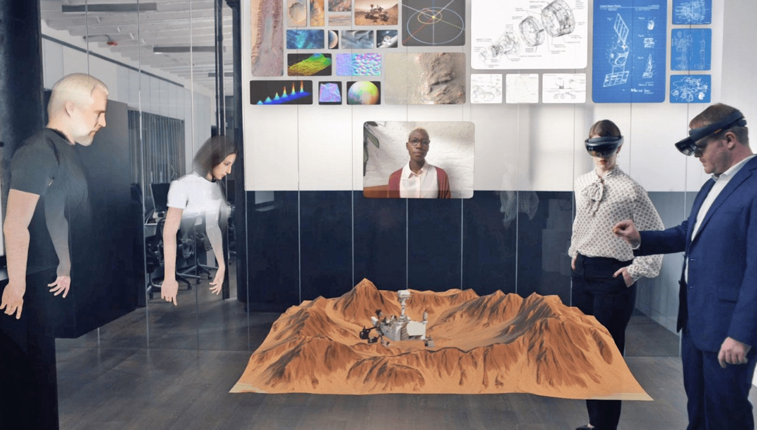
Figure A.4.1-1: XR enabled collaborative and concurrent engineering in product design
(Source: www.spatial.io)

This use case caters for an XR conference with multiple physically co-located and remote participants using XR to create a telepresence experience. The shared conference space is a virtual space that has the same layout as the physical space (digital twins) so that the physically present (local) and remote participants have a similar experience while moving in the space (e.g., constructed from sensor data).
Figure A.4.1-2 illustrates a system based on this use case. Virtual spaces and avatars are retrieved from the Application Server by the Conference Server. A Spatial Computing Server is used for constructing the 3D Model of the physical space. Remote participants would be seen as avatars within the XR experience located at their relative position in the shared space. During the conference, a local participant anchors a virtual screen on a wall to share a document to all participants.
The required video processing is located in the conference server (e.g., a media function) in Figure A.4.1-2. The spatial computing function may perform media and/or metadata processing that is required to place users consistently into a virtual environment.
The conversation/real-time XR stream shown in the figure is a mix of VR (remote user) or AR (local user) media, room layout, and mixed audio.

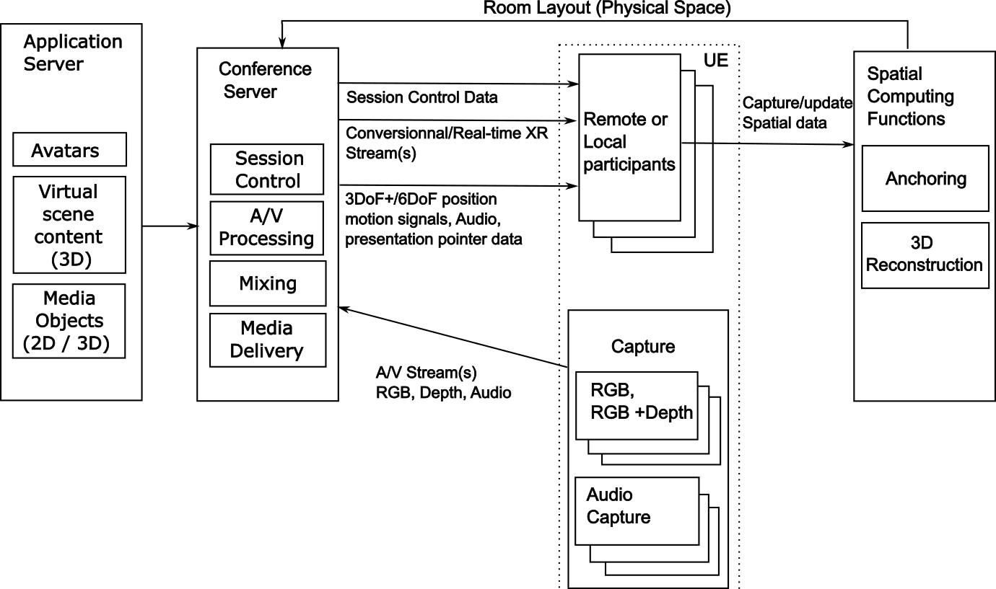
Figure A.4.1-2: XR Conference

A.4.2 Potential use of spatial computing functions
In this case, spatial computing functions are used to:
- Anchor the avatars and virtual assets in the AR scene for local participants at the beginning session.
- Anchor the virtual items (e.g., virtual screen) added during the session.
- Handle a 3D Model (layout of the physical space), including the creation of the 3D model in an offline process prior to the IMS session.
After anchoring, each user can be located and can interact with other participants (local and remote). As shown in Figure A.4.1-1, local and remote participants can interact with virtual assets in a shared experience.
* * * End of Changes * * * *

