3GPP TSG-SA WG4 #132 S4-250863
Fukuoka City, 19-23 May 2025

Source: Nokia
Title: [SR_IMS] pCR Foveated optimizations for Split Rendering
Spec: 3GPP TR 26.567 v1.1.0
Agenda item: 10.5
Document for: Discussion and agreement

- Introduction
XR devices are increasingly capable of gaze tracking, which can be used for interaction and visual optimizations. Foveated rendering and foveated video encoding, which leverage non uniform visual acuity (foveated vision) are two such optimizations which are relevant for split rendering scenarios. Foveated rendering techniques, when rendering a frame, assign rendering resources in a spatially varying manner such that the area where the user is looking, i.e. where the user gaze is tracked, is rendered with the highest quality. Foveated encoding techniques apply the same paradigm to video encoding, assigning highest bit budget in a frame to the gaze location. Typically, this is achieved by using so called importance maps which divide a frame into different zones with different importance to allocate different rendering or encoding resource budgets differentially. As an example, NVIDIA dynamic foveated rendering, used via the Variable Shading Rate API feature, by default divides the frame into three zones: High quality, medium quality and low quality. For easy usage, the size of these zones and the quality levels are saved as presets, levels, or profiles as shown in Figure 2. Meta Horizon for Meta Quest devices provides presets in a similar fashion as shown in Figure 3. These presets are recommended to be used with the consideration of content, for example, game genre and complexity and deployment devices. For standalone applications, for example, deployed on a “gaming” computer or HMD, the foveated optimization SDK can be configured to change the presets dynamically based on operating environment of the hardware. However, if foveated optimizations for rendering and encoding are used in split rendering, it is essential that the client has the ability to choose and/or change the optimization preset or profile that is used by the MF as the MF may not have visibility of operating conditions at the UE, user preference or link conditions.
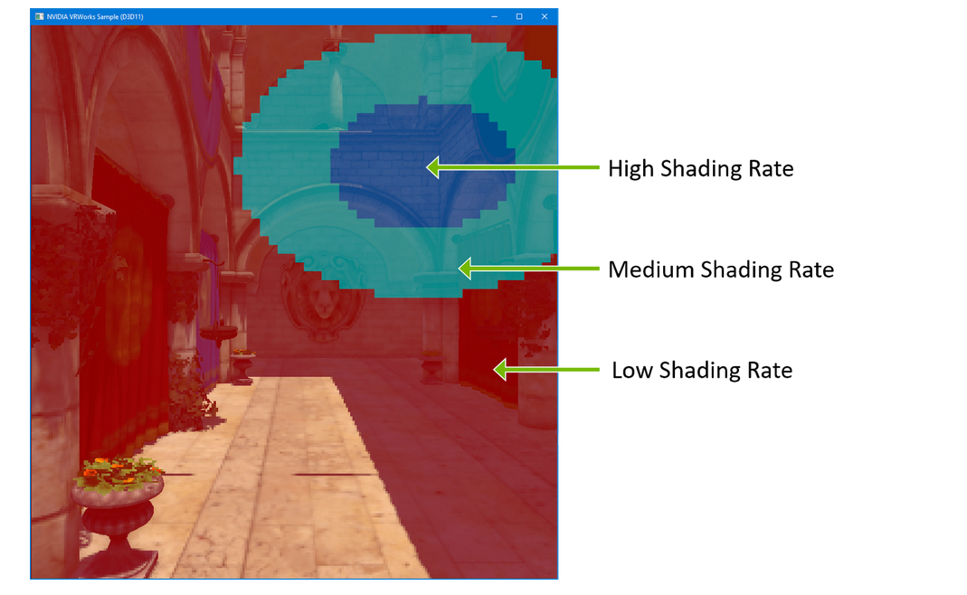
Figure 1 NVIDA VRS based foveated rendering illustration. Source: Easy VRS Integration with Eye Tracking

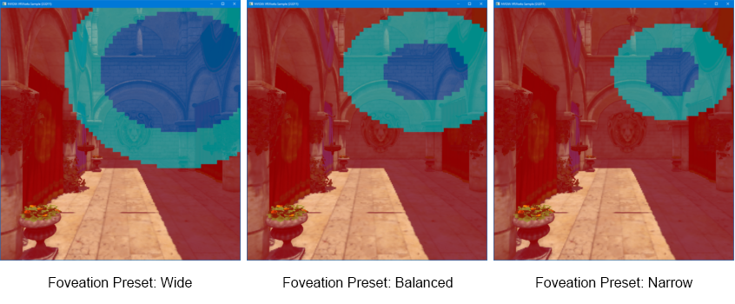
Figure 2 Foveated rendering presets in Nvidia VRS Source: Source: Easy VRS Integration with Eye Tracking
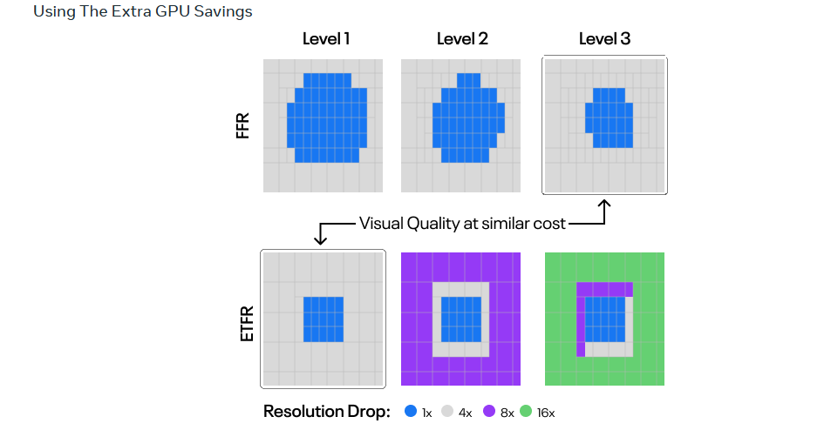
Figure 3 Meta Horizon Foveated rendering levels. Source: Save GPU with Eye Tracked Foveated Rendering
In split rendering use cases, when gaze data is available from a UE, it can be sent to the MF to be used for foveated rendering and foveated encoding. For a given perceptual quality, these optimizations may help in reducing server rendering resource usage and downstream channel capacity usage.
Devices with eye tracking functionality may provide gaze data via an API to an XR runtime which exposes it to the application. For example, OpenXR provides gaze data via the extension XR_EXT_eye_gaze_interaction. The gaze data is available as eye pose which includes orientation and position of the tracked eyes in an XR space. The available gaze data, if it is predicted for a future frame render time, may also contain information about the confidence in prediction of the (pose of) gaze sample.
- Reason for Change
To enable gaze-based optimizations in rendering and encoding processes in SR_IMS.
- Proposal
It is proposed to agree the following changes to TR 26.567 v.1.0.0.

* * * First Change All new text * * * *

A.2.X Foveated optimizations
Gaze based optimizations like foveated rendering and foveated encoding reduce resource usage and improve user experience for a given resource budget. If gaze data is available from the SR-DCMTSI client, for example, as gaze predictions , the SR-DCMTSI client and MF or DC AS may use gaze data for gaze-based optimizations in rendering and encoding. For gaze-based optimizations in rendering and encoding, the SR-DCMTSI client and the MF agree on an optimization profile during session negotiation from a list of profiles. An optimization profile provides importance maps based on the gaze position for foveated rendering and encoding. An importance map provides quality information for different regions of a frame, their size and location with reference to a gaze point.
During a split rendering session, the optimization profile being used might need to be adapted or a switch to a different profile might be desired based on, for example, user preference, network conditions, monitored QoE, etc.

A.2.X.1 Configuration format
To use gaze-based optimizations of rendering and encoding, the split rendering configuration shall indicate the gaze-based optimization profile used in the “extraConfigurations” field of the split rendering configuration format specified in Annex A.1.3. The configuration shall be JSON formatted and conform to the format in Table A.2.X.1-1. A gaze-based optimization profile contains importance maps for rendering and encoding a frame according to varying qualities based on the reported gaze location, which may be a gaze prediction. . During a split rendering session, for each frame, the MF calculates importance maps for rendering and encoding based on the gaze-based optimization profile and the gaze data received from the SR-DCMTSI client, centered around the gaze predicted for the current frame The gaze data received from the SR-DCMTSI client may contain confidence values of the predicted gaze, which may be used in the importance map calculations by the MF.
Table A.2.X.1-1 Configuration format for gaze-based optimization profile
Name | Type | Cardinality | Description
gazeOptProfile | Object | 1..N | An object corresponding to a gaze-based profile. It may be only an identifier such as a platform dependant name of a preset or level, a URI/N or it may comprise all information needed to use the profile, including quality regions, their relative sizes and their assigned quality.
renderingMap | Object | 0..1 | An object containing quality regions for rendering and their relative size around a gaze location. It may also contain an indication of actual rendering quality to be used for the different quality regions, for example, sampling rates.
name | String | 1..1 | A session wide unique identifier of the rendering map, for example, “Level 1”, “Level 2”, “Level 3” or “Wide”, “Balanced”, Narrow”. The name may identify a platform dependant preset which has fixed values for size of different regions of the frame and the desired rendering quality.
qualityRegion | Object | 0..N | A descriptor of the parameters of a region of a frame to be rendered with a particular importance or quality
name | String | 1..1 | An identifier of the region, for example, “high quality”, “medium quality”, “low quality”.
size | Float | 0..1 | A value of the size of the region as normalized radius of a circular region centred at the gaze point.
quality | Float | 0..1 | A value of the relative importance or quality of the region as a normalized  numeric value.
extras | Object | 0..N | Additional information about the renderingMap
encodingMap | Object | 0..1 | An object containing quality regions for encoding and their relative size around a gaze location. It may also contain information about desired relative encoding quality to be used for the different quality regions, for example, QP offsets or importance values to be used by the encoder for rate control.
name | String | 1..1 | A session wide unique identifier of the encoding map, for example, “Level 1”, “Level 2”, “Level 3” or “Wide”, “Balanced”, Narrow”. The name may identify a preset which has fixed values for size of different regions of the frame and their desired quality.
qualityRegion | Object | 0..N | A descriptor of the parameters of a region of a frame to be encoded with a particular relative importance.
name | String | 1..1 | An identifier of the region, for example, “high quality”, “medium quality”, “low quality”.
size | Float | 0..1 | A descriptor of the size of the region,as a normalized radius of a circular region centred at the gaze point.
quality | Float | 0..1 | A value of the relative quality of the region as a normalized numeric value.
extras | Object | 0..N | Additional information about the encodingMap

A.2.X.2 Metadata format
Adapting gaze-based optimization being in use in a split rendering session shall follow the general network procedures specified in clause 7.3.1. The metadata message to adapt the gaze-based optimization profile shall conform to the format specified in clause 5.4.3 and shall have the type indicated as “urn:3gpp:split-rendering:v1:asrp:gaze_opt_adapt”. Depending on the implementation and the adaptation needed, the payload may indicate a switch to a new gaze optimization profile or modification of parameters of the current profile. The message shall conform to the format in Table A.2.X.2-1
Table A.2.X.2-1 Metadata message format for gaze-based optimization adaptation
Name | Type | Cardinality | Description
id | string | 1..1 | A unique identifier of the message in the scope of the data channel session.
type | string | 1..1 | urn:3gpp:split-rendering:v1:asrp::asrp:gaze_opt_adapt
message | Object | 1..1 | Message content
subtype | string | 1..1 | An identifier of the subtype of the message, it may indicate a switch in optimization profile (SwitchOptProf) or a change in parameters of the optimization profile (ModOptProf)
gazeOptProfile | Object | 1..1 | An object corresponding to a gaze-based profile. It may be only an identifier such as a URI/N or it may comprise all information needed to use the profile. If the message subtype is to switch a profile, this contains or points to the gazeOptProf to switch to. If the message subtype is ModOptProfile, this contains or points to a modified version of the current optimization profile.

* * * End Changes * * * *

