**3GPP TSG-WG SA4 Meeting #132S4-250896**

**Fukuoka, Japan, 19th – 23rd May, 2025 (revision of S4-250xxx)**

|  |  |  |  |  |  |  |  |  |
| --- | --- | --- | --- | --- | --- | --- | --- | --- |
| *CR-Form-v12.3* | | | | | | | | |
| **CHANGE REQUEST** | | | | | | | | |
|  | | | | | | | | |
|  | **26.501** | **CR** | **0109** | **rev** |  | **Current version:** | **19.0.0** |  |
|  | | | | | | | | |
| *For* [***HE******LP***](http://www.3gpp.org/3G_Specs/CRs.htm#_blank)*on using this form: comprehensive instructions can be found at* [*http://www.3gpp.org/Change-Requests*](http://www.3gpp.org/Change-Requests)*.* | | | | | | | | |
|  | | | | | | | | |

|  |  |  |  |  |  |  |  |  |
| --- | --- | --- | --- | --- | --- | --- | --- | --- |
| ***Proposed change affects:*** | UICC apps |  | ME | **X** | Radio Access Network |  | Core Network |  |

|  |  |  |  |  |  |  |  |  |  |  |
| --- | --- | --- | --- | --- | --- | --- | --- | --- | --- | --- |
|  | | | | | | | | | | |
| ***Title:*** | Clarification on support of Improved QoS for media streaming services | | | | | | | | | |
|  |  | | | | | | | | | |
| ***Source to WG:*** | Huawei, HiSilicon | | | | | | | | | |
| ***Source to TSG:*** | S4 | | | | | | | | | |
|  |  | | | | | | | | | |
| ***Work item code:*** | AMD-ARCH-MED | | | | |  | ***Date:*** | | | 2025-05-13 |
|  |  | | | |  | |  | | |  |
| ***Category:*** | **F** |  | | | | | ***Release:*** | | | Rel-19 |
|  | *Use one of the following categories:* ***F*** *(correction)* ***A*** *(mirror corresponding to a change in an earlier release)* ***B*** *(addition of feature),* ***C*** *(functional modification of feature)* ***D*** *(editorial modification)*  Detailed explanations of the above categories can be found in 3GPP [TR 21.900](http://www.3gpp.org/ftp/Specs/html-info/21900.htm). | | | | | | | | *Use one of the following releases: Rel-8 (Release 8) Rel-9 (Release 9) Rel-10 (Release 10) Rel-11 (Release 11) … Rel-17 (Release 17) Rel-18 (Release 18) Rel-19 (Release 19)  Rel-20 (Release 20)* | |
|  |  | | | | | | | | | |
| ***Reason for change:*** | | For support of improved QoS, i.e. ECN marking for L4S, QoS monitoring, it is necessary to understand whether the Media Access Functino is capable of supporting the ECN marking. This paper intends to clarify how the Media Access Function and the Media Session Handler interacts for the capability negotiation. | | | | | | | | |
|  | |  | | | | | | | | |
| ***Summary of change:*** | | Clarification on support of Improved QoS for media streaming services | | | | | | | | |
|  | |  | | | | | | | | |
| ***Consequences if not approved:*** | | Error case where the dynamic policy for L4S marking is instantiated successfully while the Media Access Function doesn’t support L4S marking. | | | | | | | | |
|  | |  | | | | | | | | |
| ***Clauses affected:*** | | 4.0.6, 4.2.3, 4.3.3, 5.7.9, 5.7.10, 6.9.8, 6.9.9 | | | | | | | | |
|  | |  | | | | | | | | |
|  | | **Y** | **N** |  | | | |  | | |
| ***Other specs*** | |  | **X** | Other core specifications | | | | TS/TR ... CR ... | | |
| ***affected:*** | |  | **X** | Test specifications | | | | TS/TR ... CR ... | | |
| ***(show related CRs)*** | |  | **X** | O&M Specifications | | | | TS/TR ... CR ... | | |
|  | |  | | | | | | | | |
| ***Other comments:*** | |  | | | | | | | | |
|  | |  | | | | | | | | |
| ***This CR's revision history:*** | |  | | | | | | | | |

* * * * First change * * * *

### 4.0.6 Dynamic policies

The dynamic policies feature is applicable to both downlink media streaming and uplink media streaming. It enables the 5GMS Client in the UE to manipulate the network traffic handling policies for an ongoing media streaming session.



NOTE: The PCF is accessed via the NEF when the 5GMS network services are deployed outside the Trusted DN.

Figure 4.0.6‑1: High-level arrangement for dynamic policies



Figure 4.0.6‑2: Domain model for dynamic policies

With reference to figure 4.0.6‑2, dynamic policies work as follows:

1. A conceptual *Service Operation Point* is an abstract set of requirements that support a media streaming service (e.g., SD, HD, UHD). It is identified by an *External reference* that is used to tag *Policy Template* resources provisioned in the 5GMS System and *Service Descriptions* included in *Media Entry Point* documents.

2. The Service Operation Point is embodied in the 5G System by a *Policy Template* which is provisioned in the 5GMS network services by the 5GMS Application Provider within the scope of an umbrella *Provisioning Session*. A Policy Template may be defined as being applicable to one or more application session contexts, each identifying a particular Data Network and/or Network Slice. The Policy Template carries the *External reference* and Network QoS parameters corresponding to a single Service Operation Point. (Any number of Policy Templates provisioned for different Data Networks and/or Network Slices may reference the same Service Operation Point.) The 5GMS network services may reject attempts to provision a Policy Template that specifies Network QoS parameters outside acceptable bounds imposed by local system configuration.

In addition, the Policy Template may include a reference to an existing Background Data Transfer policy. If no previously defined Background Data Transfer policy exists, the Policy Template may instead include the parameters that are used by the 5GMS network services to provision a Background Data Transfer policy for the current Provisioning Session. These parameters may include desired time windows when Background Data Transfer may be advertised to 5GMS Clients, a quota representing the maximum number of 5GMS Clients that are permitted to take advantage of Background Data Transfers in each such time window and a quota representing a ceiling for the aggregate volume of data that all 5GMS Clients are permitted to transfer in each Background Data Transfer window. Hence, an advertised time window is not a guarantee that a request for Background Data Transfer will actually be granted by the 5GMS System.

The Policy Template may include an *L4S enablement* flag which indicates the availability to enable ECN marking for L4S in the 5G System (as described in clause 5.37.3 of TS 23.501 [2]). If set, this flag directs the 5GMS Client to select and activate ECN marking for L4S when it instantiates the Policy Template with an *L4S enablement* flag set in the Dynamic Policy request. The 5GMS network services accept the provisioning of such a Policy Template only if the underlying 5G System supports the detection of congestion and reaction to it.

NOTE: As described in RFC 9330 [38], RFC 9331 [39] and RFC 9332 [40], the purpose of ECN marking for L4S (Low Latency, Low Loss and Scalable Throughput) is to inform a recipient host at the earliest opportunity that an IP packet has experienced network congestion at some point in its routing path. It exposes congestion information by marking ECN bits in the IP header of the user IP packets between the UE and the Application Server.

The Policy Template may include a *QoS monitoring* *configuration* which indicates the availability to enable QoS monitoring in the 5G System (as described in clause 5.45 of TS 23.501 [2]) for measurement and reporting of QoS parameters when this Policy Template is instantiated with a *QoS monitoring enablement* flag set in the Dynamic Policy request. The QoS monitoring configurationindicates the trigger for reporting (event or periodic), the set of QoS parameters that are to be monitored when this Policy Template is instantiated and, optionally, an indication that notifications are to be sent via the UPF. The resulting Service Access Information for the Policy Template includes a *QoS monitoring availability* flag indicating that QoS monitoring may be enabled by the 5GMS Client when the Policy Template is instantiated. Based on its own knowledge of the intended media delivery session, or based on input from an application, the 5GMS Client decides whether to enable QoS monitoring when it instantiates the Policy Template. QoS monitoring is then activated by the 5GMS network services and the 5GMS network services notify the 5GMS Client about significant changes to these QoS parameters during the media delivery session.

3. The 5GMS Application Provider makes one or more *Media Entry Point* documents (e.g., DASH MPDs) available for use by the 5GMS Client. To take advantage of the dynamic policies feature, a Media Entry Point document includes one or more *Service Descriptions*, each identifying the streaming requirements of a presentation that correspond to a single Service Operation Point (e.g., SD, HD, UHD) and identified by means of an *External reference*. The same Service Description may be included in more than one Media Entry Point document in case a common Service Operation Point is applicable to multiple media presentations.

4. When a Media Entry Point is selected by the 5GMS Client at the start of a media streaming session, the 5GMS Client retrieves Service Access Information from a network-side component of the 5GMS System describing the set of available Policy Templates provisioned in step 2 and exposes this to a controlling application on the UE.

4a. If Background Data Transfer was provisioned as part of any Policy Templates in step 2 above, the Service Access Information includes details of the advertised time windows when Background Data Transfers are available and the data volume quota (if any). Maximum bit rates for the 5GMS Client in either or both the uplink and downlink direction may also be nominated by the 5G System and signalled to the 5GMS Client in the Service Access Information. Finally, an endpoint in the 5GMS network services may be provided allowing the 5GMS Client to subscribe to receive real-time notifications of Background Data Transfer warning notifications.

5. At the start of a media streaming session, the controlling application on the UE selects one of the Service Descriptions listed in the Media Entry Point document that realises its preferred Service Operation Point. Either the Media Player (when the Service Descriptions are within the Media Entry Point document) or the controlling application (when the Service Descriptions are not within the Media Entry Point document) informs the 5GMS Client of its choice by passing the corresponding External reference to it.

6. If there is a Policy Template available for the current media streaming session with the indicated External reference, the 5GMS Client instantiates this Policy Template by interacting with a network-side component of the 5GMS System in order to realise the Service Operation Point described by the Policy Template and the Service Description. The effect of this is that the corresponding network Quality of Service is applied to the media streaming session.

7. At any point during one of the advertised Background Data Transfer time windows the 5GMS Client may request a Background Data Transfer by instantiating a Policy Template with a Background Data Transfer specification in the 5GMS network services, including an estimate of the data volume it intends to transfer. The 5GMS network services may grant the request for the Background Data Transfer if the data volume estimate is acceptable and if the quota of requests for the time window in question has not already been exceeded. If the request is granted, the 5GMS network services apply the appropriate Background Data Transfer Quality of Service policy to the media streaming session from the Policy Template in question. The Background Data Transfer grant returned to the 5GMS Client includes an estimate of the time period for which Background Data Transfer is available for the 5GMS Client to use. After this period has expired, the 5GMS network services automatically revert the network Quality of Service back to its state before the grant.

8. The 5GMS media services also subscribe to receive Background Data Transfer warning notifications from the PCF related to the individual Background Data Transfer policy as defined in clause 4.16.7.3 of TS 23 502 [3]. The 5GMS media services shall notify the 5GMS Client when the network performance of that particular media streaming session degrades below the Background Data Transfer policy currently in force or when the aggregate data volume for all data transfers during the current Background Data Transfer time window has been reached.

In addition, the use of dynamic policies by 5GMS Clients is logged by the 5GMS System and, if suitably provisioned, is exposed by it to subscribing 5GMS Application Providers in the form of events (see also clause 4.0.12).

* * * * Next change * * * *

### 4.2.3 Service Access Information for downlink media streaming

The Service Access Information is the set of parameters and addresses which are needed by the 5GMSd Client to activate and control the reception of a downlink streaming session, and to report service/content consumption and/or QoE metrics.

The Service Access Information may be provided together with other service announcement information using M8d. Alternatively, the 5GMSd Client fetches the Service Access Information from the 5GMSd AF. The Service Access Information may be provided as, or may be accessed via, a 3GPP-defined Service URL that provides a unique resolvable identifier to the 5GMSd Provisioning Session and that may also include a reference to the Media Player Entry. Regardless of how it is provided, the Service Access Information contains different information, depending on the collaboration model between the 5GMS System and the 5GMSd Application Provider, and also depending on offered features. Baseline parameters are listed in table 4.2.3‑1 below:

Table 4.2.3-1: Parameters of baseline Service Access Information

|  |  |
| --- | --- |
| Parameters | Description |
| Provisioning Session identifier | Unique identification of the M1d Provisioning Session. |

When the content hosting feature is activated for a downlink streaming session, the parameters from table 4.2.3-1a below can additionally be present.

**Table 4.2.3-1a: Streaming Access parameters**

|  |  |
| --- | --- |
| Parameters | Description |
| Media Entry Points  (Media Player Entries) | A set of pointers to documents that provide additional details for different downlink streaming session configurations and/or define equivalent media presentations (see NOTE), e.g. MPD for DASH content or URL to a video clip file.  Each member of the set may specify additional details to aid selection by the 5GMS Client, including content type, profile indicators and precedence.  A Media Player Entry document may additionally include:  - Service Descriptions, each one identified by an *External reference* that enables it to be matched with a Policy Template, and each describing the set of media streaming parameters (e.g., bit rate, target latency) that realise a Service Operation Point.  - Service configuration information (e.g. location and configuration information for the purposes of accessing content from multiple service locations either internal or external to the 5GMS System).  A Media Player Entry URL may be embedded in a 3GPP Service URL. |
| NOTE: An equivalent media presentation is one which has the same content but may result in a different Quality of Experience. | |

When the consumption reporting feature is activated for a downlink streaming session, the parameters from table 4.2.3‑2 below are additionally present.

Table 4.2.3-2: Parameters for consumption reporting configuration

|  |  |
| --- | --- |
| Parameters | Description |
| Reporting interval | Identifies the interval between consumption reports being sent by the Media Session Handler. |
| Server address | A list of 5GMSd AF addresses where the consumption reports are sent by the Media Session Handler. |
| Sample percentage | The proportion of clients that shall report media consumption.  If not specified, all clients shall send reports. |
| Location reporting | Identify whether the Media Session Handler provides location data to the 5GMSd AF (in case of MNO or trusted third parties) |

When the dynamic policy invocation feature is activated for a downlink streaming session the parameters from table 4.2.3‑3 below are additionally present.

**Table 4.2.3-3: Parameters for dynamic policy invocation configuration**

|  |  |
| --- | --- |
| Parameters | Description |
| Server address | A list of 5GMSd AF addresses (in the form of opaque URLs) which offer the APIs for dynamic policy invocation sent by the 5GMS Media Session Handler. |
| Valid Policy Template Ids | A list of Policy Template identifiers which the 5GMSd Client is authorized to use. |
| Service Data Flow Methods | A list of recommended Service Data Flow description methods (descriptors), e.g. 5-Tuple, ToS, 2-Tuple, etc, which should be used by the Media Session Handler to describe the Service Data Flows for the traffic to be policed. |
| External reference | Additional identifier for this Policy Template that can be cross-referenced with external metadata about the streaming session.  The same external reference may appear on more than one dynamic policy invocation configuration within the scope of the same Provisioning Session provided the parameters below differ in the underlying Policy Template. |
| L4S enablement | A flag indicating that capability of ECN marking for L4S is available for this Policy Template.  The 5GMSd Client should not instantiate this Policy Template unless it supports L4S. |
| QoS monitoring availability | A flag indicating that QoS monitoring capability is available for this Policy Template which may be activated by the 5GMSd Client when this Policy Template is instantiated with QoS monitoring enablement flag set in the Dynamic Policy request. |

When the metrics collection and reporting feature is activated for a downlink streaming session, one or more parameter sets for metrics configuration, according to table 4.2.3‑4, are additionally present. Each metrics configuration set contains specific settings valid for that configuration, which is typically metric scheme dependent, and collection and reporting shall be done separately for each set.

Table 4.2.3-4: Parameters for each metrics configuration set

|  |  |
| --- | --- |
| Parameters | Description |
| Scheme | The scheme associated with this metrics configuration set. A scheme may be associated with 3GPP or with a non-3GPP entity. If not specified, a default 3GPP metrics scheme shall apply.  Metrics schemes shall be uniquely identified by URIs. |
| Server address | A list of 5GMSd AF addresses to which metric reports shall be sent for this metrics configuration set. |
| DNN | The Data Network Name (DNN) which shall be used when sending metrics report for this metrics configuration set.  If not specified, the default DNN shall be used. |
| Slice scope | A list of network slice(s) for which metrics collection and reporting shall be executed for this metrics configuration set.  If not specified, the metrics collection and reporting shall be done for all network slices. |
| Reporting interval | The sending interval between metrics reports for this metrics configuration set.  If not specified, a single final report shall be sent after the streaming session has ended. |
| Sample percentage | The proportion of streaming sessions that shall report metrics for this metrics configuration set.  If not specified, reports shall be sent for all sessions. |
| Streaming source filter | A list of content URL patterns for which metrics reporting shall be done for this metrics configuration set.  If not specified, reporting shall be done for all URLs. |
| Communication Service type | The type of Communication Service (Unicast and/or MBS broadcast and/or MBS multicast) for which metrics collection and reporting is requested.  If not specified, metrics collection and reporting shall be performed for all communication service types. |
| Metrics | A list of metrics which shall be collected and reported for this metrics configuration set.  For progressive download and DASH streaming services, the listed metrics are associated with the 3GPP metrics scheme and shall correspond to one or more of the metrics as specified in clauses 10.3 and 10.4, respectively, of TS 26.247 [7].  In addition, for the 3GPP metrics scheme as applied to DASH streaming, the quality reporting scheme and quality reporting protocol as defined in clauses 10.5 and 10.6, respectively, of [7] shall be used.  If not specified, a complete (or default if applicable) set of metrics will be collected and reported. |

When in-band client data reporting is activated for a downlink streaming session the parameters defined in clause K.3.7 of ISO/IEC 23009-1 [29] may be present as part of the relevant metrics configuration set. (These parameters are used to activate in-band client data reporting in case the Media Player Entry does not include in-band client data reporting configuration information.)

When 5GMSd AF-based Network Assistance is activated for a downlink streaming session the parameters from Table 4.2.3‑5 below shall be additionally present.

Table 4.2.3-5: Parameters for 5GMSd AF-based Network Assistance configuration

|  |  |
| --- | --- |
| Parameters | Description |
| Server address | 5GMSd AF address that offers the APIs for 5GMSd AF-based Network Assistance, accessed by the 5GMSd Media Session Handler. The server address shall be an opaque URL, following the 5GMS URL format. |

* * * * Next change * * * *

### 4.3.3 Service Access Information for uplink media streaming

The Service Access Information is the set of parameters and addresses which are needed by the 5GMSu Client to activate and control the uplink streaming session.

The Service Access Information may be provided by the 5GMSu Application Provider to the 5GMSu-Aware Application together with other service announcement information using M8u. Alternatively, the 5GMSu Client fetches the Service Access Information from the 5GMSu AF at reference point M5u. Regardless of how it is provided, the Service Access Information contains different information, depending on the collaboration model between the 5GMS System and the 5GMSu Application Provider (which are assumed to be independent entities), and also depending on offered features. The Service Access Information may be provided as, or may be accessed via, a 3GPP-defined Service URL that provides a unique resolvable identifier to the 5GMSu media session and that may also include a reference to the Media Entry Point.

Baseline parameters are listed in table 4.3.3‑1 below:

Table 4.3.3-1: Parameters of baseline Service Access Information

|  |  |
| --- | --- |
| Parameters | Description |
| Provisioning Session identifier | Unique identification of the M1u Provisioning Session. |

The parameters from table 4.3.3-2 below shall also be present.

Table 4.3.3-2: Streaming Access parameters

|  |  |
| --- | --- |
| Parameters | Description |
| Media Entry Points  (Media Streamer Entries) | A set of entry points. Each entry point consists of one of the following:  a. A URL endpoint on the 5GMSu AS to which media can be streamed directly at M4u and its associated data, or  b. The URL of a document that can be downloaded from the 5GMSu AS which contains the parameters for uplink media streaming at M4u.  A Media Streamer Entry document may additionally include Service Descriptions, each one identified by an *External reference* that enables it to be matched with a Policy Template, and each describing the set of media streaming parameters (e.g., bit rate, target latency) that realise a Service Operation Point.  A Media Streamer Entry URL may be embedded in a 3GPP Service URL. |

Each entry point is defined by its parameters and identifiers. The set shall have at least one member.

When the dynamic policy invocation feature is activated for an uplink streaming session the parameters from table 4.3.3‑3 below are additionally present.

**Table 4.3.3-3: Parameters for dynamic policy invocation configuration**

|  |  |
| --- | --- |
| Parameters | Description |
| Server address | A list of 5GMSu AF addresses (in the form of opaque URLs) which offer the APIs for dynamic policy invocation sent by the 5GMS Media Session Handler. |
| Valid Policy Template Ids | A list of Policy Template identifiers which the 5GMSu Client is authorized to use. |
| Service Data Flow Methods | A list of recommended Service Data Flow description methods (descriptors), e.g. 5-Tuple, ToS, 2-Tuple, etc, which should be used by the Media Session Handler to describe the Service Data Flows for the traffic to be policed. |
| External reference | Additional identifier for this Policy Template that can be cross-referenced with external metadata about the streaming session.  The same external reference may appear on more than one dynamic policy invocation configuration within the scope of the same Provisioning Session provided the parameters below differ in the underlying Policy Template. |
| L4S enablement | A flag indicating that capability of ECN marking for L4S is available for this Policy Template .  The 5GMSu Client should not instantiate this Policy Template unless it supports L4S. |
| QoS monitoring availability | A flag indicating that QoS monitoring capability is available for this Policy Template which may be activated by the 5GMSu Client when this Policy Template is instantiated with QoS monitoring enablement flag set in the Dynamic Policy request. |

When 5GMSu AF-based Network Assistance is activated for an uplink streaming session the parameters from table 4.3.3‑4 below shall be additionally present.

Table 4.3.3-4: Parameters for 5GMSu AF-based Network Assistance configuration

|  |  |
| --- | --- |
| Parameters | Description |
| Server address | 5GMSu AF address that offers the APIs for 5GMSu AF-based Network Assistance, accessed by the 5GMSu Media Session Handler. The server address shall be an opaque URL, following the 5GMS URL format. |

* * * * Next change * * * *

### 5.7.9 ECN marking for L4S for downlink media streaming based on Dynamic Policy

Figure 5.7.9-1 below shows a high-level call flow for downlink media streaming for configuration and usage of ECN marking for L4S. Differences from the procedure for downlink media streaming with dynamic policies defined in clause 5.7 are indicated in **boldface**.

The following is assumed:

- The service here is a unicast downlink media streaming service with dynamic policy support.

- As an example, the Layer 4 protocol used for application flows is TCP and the TCP stack used supports ECN marking for L4S.

- The network supports ECN marking for L4S packet marking.

- The application has specifically requested ECN marking for L4S for its media delivery session.

- NG-RAN manipulates the ECN bits (per clause 5.37.3.2 of TS 23.501 [2]). It is equally possible that the PDU Session Anchor UPF (PSA-UPF) manipulates the ECN bits (per clause 5.37.3.3 of [2]).

Msc-generator~|version=8.6.1~|lang=signalling~|size=1171x1304~|text=hscale=auto;~nnumbering=yes;~ndefcolor lgrey=224,224,224;~n~n~nUEBOX: 5GMSd Client {~n~4MSH[label=~qMedia\nSession\nHandler~q];~n~4Player[label=~qMedia\nPlayer~q];~n};~nUE[label=~qUE SDAP\n(Layer 2)~q];~nRAN;~nUPF;~nSMF[label=~qAMF/\nSMF~q];~nPCF[label=~qPCF/NEF~q];~nAF[label=~q5GMSd\nAF~q];~nAS[label=~q5GMSd\nAS~q];~n~n~nAF--AF [number=0]: Policy Template\nprovisioning \bwith L4S\b;~nvspace 10;~nbox -- [number=no, line.color=none, line.corner=round, fill.color=lgrey,0.4]: \iDynamic Policy instantiation (clause 5.7.2)\i {~n~4vspace 7;~n~4MSH~l-~gAF: Service Access Information acquisition and Dynamic Policy activation~n~9~5(\BL4S indicator\B);~n~4vspace 5;~n~4box --: ~qQoS Flow activation~q {~n~8AF~l-~gPCF [number=no]: QoS request\n\Bwith L4S;~n~8PCF~l-~gSMF [number=no]: PCC Rule provisioning\n\bwith L4S\b\n(5G System internal);~n~8SMF~l-~gUPF [number=no]: PDR + QER\n\B \[with L4S\];~n~8SMF-~gRAN [number=no]: QoS setup\n\Bwith L4S;~n~8SMF~l-~gUE [number=no]: QoS Indication;~n~4};~n~4MSH~gPlayer: \BInformatation that\nL4S is activated;~n};~n~n...:;~nbox RAN..RAN [number=no, fill.color=lgrey,0.4, line.color=none, line.corner=round]: \ITraffic monitoring {~n~4MSH--Player: \BSelect/enable L4S capability;~n~4Player-~gUE:; ~n~4UE--UE [number=no]: Detect\n QoS rule match\nand set QFI;~n~4UE-~gUPF-~gAS: Establish TCP Connection\n\B(ECT(1) codepoint);~n~4AS-~gUPF: SYN-ACK\n\B(ECT(1) codepoint);~n~4UPF--UPF: Set QFI\nfor packet;~n~4UPF-~gUE [number=no]: SYN-ACK\n\B(ECT(1) codepoint);~n~4UE-~gPlayer [number=no]: SYN/ACK\n\B(ECT(1) codepoint);~n~4Player-~gUE-~gUPF-~gAS [number=no]: ACK\n\B(ECT(1) codepoint);~n~4vspace 10;~n~4Player~l-~gAS [number=no, arrow.type=dot]: Use TCP Connection for HTTPS;~n~4...:;~n~4AS-~gUPF-~gRAN [number=no]: PDU carrying HTTP application data\n\B(ECT(1) codepoint);~n~4RAN--RAN: ~q\BCongestion\nmeasurement~q;~n~4RAN-~gUE-~gPlayer [number=no]: \n\B(CE codepoint);~4~n~4Player-~gUE-~gUPF-~gAS: \BECN-Echo;~n~4Player--Player: \BReact \naccordingly;~n};~n~|

Figure 5.7.9-1: Downlink media streaming call flow for ECN marking for L4S

The steps are as follows:

0: *Policy Template Provisioning.* A Policy Template is provisioned **with the availability for L4S capability, indicated by setting the *L4S enablement* flag**.

1: *Service Access Information acquisition and* *Dynamic Policy activation.* The Media Session Handler within the 5GMSd Client obtains Service Access Information and triggers a dynamic policy activation. A Policy Template Binding is present within the Service Access Information for each provisioned Policy Template. **Policy Template Bindings suitable for L4S are indicated by an L4S enablement flag being set. By default, the Media Session Handler detects that an L4S-capable media transport stack is present and in use, and selects this Policy Template.** If it is possible to access the statistics of ECN status, **the Media Session Handler checks whether the Media Player has an L4S-capable media transport stack and only instantiates the selected Policy Template with the L4S enablement flag set in the Dynamic Policy request when the Media Player supports L4S-capable media transport stack.**

2: *QoS request.* The 5GMSd AF requests QoS handling using e.g. the Nnef_AfSessionWithQoS service or the Npcf_PolicyAuthorization service. **If the L4S enablement flag is set in the Dynamic Policy request, this indicates that the new QoS flow is required to be L4S-enabled.** The new QoS flow with the ECN marking for L4S indication setting propagates through the 5G System.

**3: The Media Session Handler may inform the Media Player about the successful activation of the L4S-enabled Dynamic Policy via the client API at reference point M11d. Subject to availability of API access, the Media Player may use congestion notifications to perform early bit rate adaptation.**

4: **If the L4S enablement Dynamic Policy is successfully activated, the 5GMSd Client selects/enables the L4S capability of the used transport protocol.**

NOTE 1: This step may happen implicitly by selecting an L4S-supporting transport protocol stack in case of availability of API access.

5: The Media Player within the 5GMSd Client triggers the establishment of a TCP connection. The ECT(1) codepoint is set in the IP header, indicating an L4S-Capable Transport, and the SDAP entity ensures that the packet is forwarded via the matching QoS flow.

6: The 5GMSd AS responds to the TCP connection establishment request. The 5GMSd AS sets ECT(1) in the IP headers, indicating an L4S-Capable Transport.

7: The UPF finds the matching QoS Flow Identifier for the downlink packet and sends the packet via the corresponding QoS flow to the UE. TCP Connection setup continues, with one ECT bit set in all packets.

8: When the RAN detects an upcoming congestion event according to the congestion measurement (based on continuous congestion monitoring), the 5G System sets the CE (Congestion Experienced) codepoint in the IP header of the downlink packet.

9. The TCP protocol stack used by the Media Player in the 5GMSd Client reflects the Early Congestion Notification to the TCP sender by setting the ECN-Echo (ECE) flag in the TCP header of an uplink PDU of the same TCP connection. The TCP sender reacts to the ECN-Echo accordingly (i.e., by reducing its sending congestion window).

NOTE 2: The ECN-Echo flag is also acknowledged by the TCP sender setting the Congestion Window Reduced (CWR) flag in an outgoing TCP frame, but this acknowledgement is not illustrated in this call flow.

NOTE 3: Classic ECN as specified in RFC 3168 [41] requires an ECN signal to be treated as equivalent to a packet drop. L4S as specified in RFC 9330 [38] specifies a more fine-grained response and an early congestion signal triggers a less severe reaction. How a TCP sender behaves "accordingly" is beyond the scope of the present document.

10. Based on the CE indication received in step 8, or by detecting a reduced bit rate in the downlink application flow, the Media Player in the 5GMSd Client reacts by, for example, changing the requested representation.

* * * * Next changes * * * *

### 5.7.10 QoS monitoring of downlink media streaming based on Dynamic Policy

Figure 5.7.10-1 below shows a high-level call flow for the configuration and usage of QoS monitoring with downlink media streaming.

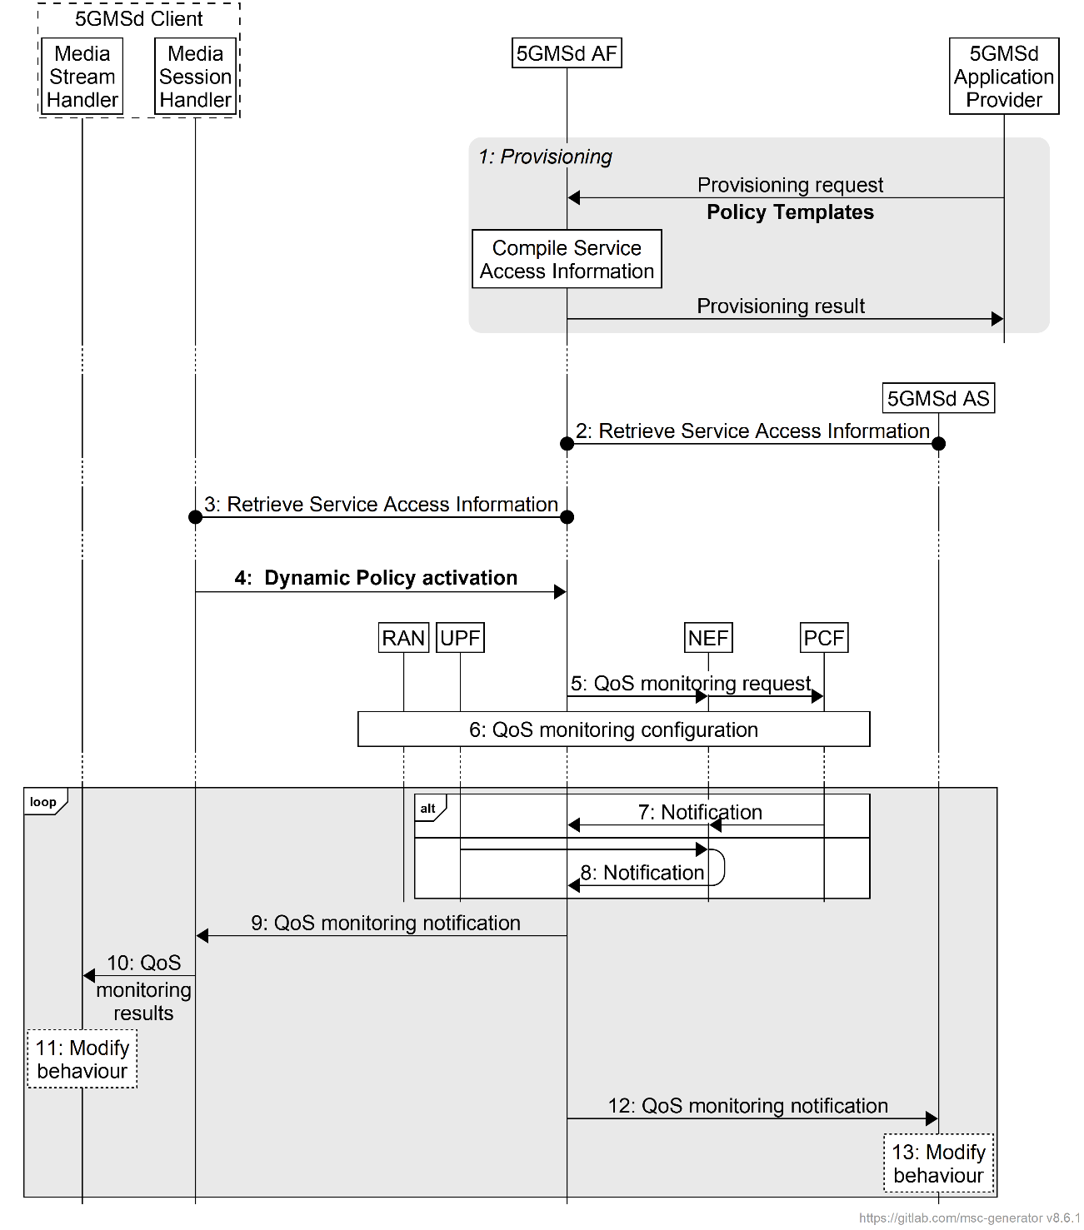

Figure 5.7.10-1: High-level call flow for QoS monitoring for downlink Media Streaming

The steps are as follows:

1. *Policy Template Provisioning.* A Policy Template is provisioned and shall **include the QoS monitoring configuration**. The QoS monitoring configuration includes the parameters to be monitored, the reporting frequency (event triggered, periodic), and optionally the notification via local UPF.

NOTE: In case the 5GMSd AS is deployed as an EAS instance in the Edge DN, a local UPF can also be inserted for local access to the 5GMSd EAS. In order to reduce the latency used for exposure of the QoS monitoring results, the local UPF is expected to provide the notifications of network status directly to the 5GMSd AF and 5GMSd AS, or via a locally deployed NEF as defined in clause 5.8.2.17 of TS 23.501 [2].

2. *Service Access Information retrieval by 5GMSd AS*. The 5GMSd AS retrieves Service Access Information from 5GMSd AF via reference point M3d. **The 5GMSd AS subscribes to receive notifications from the 5GMSd AF about changes to the monitored QoS parameters for all relevant Dynamic Policies.**

3. *Service Access Information retrieval by Media Session Handler*. The Media Session Handler retrieves Service Access Information from the 5GMSd AF via reference point M5d.

4. *Dynamic Policy activation.* The Media Session Handler within the 5GMSd Client obtains Service Access Information and triggers a dynamic policy activation. A Policy Template Binding is present within the Service Access Information for each provisioned Policy Template. **Policy Template Bindings** **include a QoS monitoring availability flag indicating whether QoS monitoring may be enabled when instantiating the corresponding Policy Template. If the Media Session Handler is aware that Media Access Function** **is capable of consuming QoS monitoring results based on interrogated capabilities of Media Access Function, it shall sets a *QoS monitoring enabled* flag accordingly in the Dynamic Policy activation****. If successful, the Media Session Handler subscribes to receive notifications from the 5GMSd AF about QoS monitoring results for this Dynamic Policy.**

5. *QoS monitoring request.* The 5GMSd AF invokes the Npcf_PolicyAuthorization service or the Nnef_AFsessionWithQoS service **with the requested QoS monitoring configurations if a *QoS monitoring enabled* flag is set to *true* in the Dynamic Policy request from the Media Session Handler**. In the case where the 5GMSd AS is deployed in the Edge DN, the 5GMSd AF may additionally enable the exposure of QoS monitoring results via the local UPF or local NEF in this step.

6. The PCF accepts the request and enables QoS monitoring within the 5G System, i.e., by configuring the RAN and/or the (local) UPF for monitoring and reporting of target QoS parameters for the downlink media streaming.

Following the QoS monitoring request(s):

7. The PCF may expose QoS monitoring results to the 5GMSd AF periodically or by event triggers using the Npcf_PolicyAuthorization_Notify service operation directly at reference point N5, or else using the Nnef_EventExposure_Notifyservice operation via the NEF at reference point N33.

8. Alternatively, the QoS monitoring results may be exposed to the 5GMSd AF by the UPF directly using the Nupf_EventExposure_Notify service or via a locally deployed NEF using the Nnef_EventExposure_Notifyservice at reference point N33.

9. If QoS monitoring was requested by the Media Session Handler, **the 5GMSd AF sends the notifications of the QoS monitoring results to the Media Session Handler** via reference point M5d.

**10. The Media Session Handler provides the QoS monitoring results to the Media Stream Handler at reference point M11d.**

**11. The Media Stream Handler may use the notified QoS monitoring results to modify its behaviour. For example, in the case of downlink media streaming, the Media Player may use the monitored packet latency to determine when to request the next media segment, and/or to change the bit rate of the next media segment based on the monitored congestion status.**

**12. The 5GMSd AF may provide the QoS monitoring results to the 5GMSd AS at reference point M3d.**

**13. The 5GMSd AS may use the notified QoS monitoring results to modify its behaviour.**

* * * * Next changes * * * *

### 6.9.8 Dynamic Policy of ECN marking for L4S for uplink media streaming

Figure 6.9.8-1 below shows a high-level call flow for uplink media streaming for configuration and usage of ECN marking for L4S. Differences from the procedure for uplink media streaming with dynamic policies defined in clause 6.9.3 are indicated in **boldface**.

The following is assumed:

- The service here is a unicast uplink media streaming service with dynamic policy support.

- As an example, the Layer 4 protocol used for application flows is TCP and the TCP stack used supports L4S.

- The 5GS network supports ECN marking for L4S.

- The application has specifically requested ECN marking for its media delivery session.

- NG-RAN manipulates the ECN bits (per clause 5.37.3.2 of TS 23.501 [2]). It is equally possible that the PDU Session Anchor UPF (PSA-UPF) manipulates the ECN bits (per clause 5.37.3.3 of [2]).

Figure 6.9.8-1: Uplink media streaming call flow for ECN marking for L4S

The steps are as follows:

0: *Policy Template Provisioning.* A Policy Template is provisioned **with the availability for L4S capability, indicated by setting the *L4S enablement* flag**.

1: *Service Access Information acquisition and* *Dynamic Policy activation.* The Media Session Handler within the 5GMSu Client obtains Service Access Information and triggers a dynamic policy activation. A Policy Template Binding is present within the Service Access Information for each provisioned Policy Template. **Policy Template Bindings suitable for L4S are indicated by an L4S enablement flag being set. By default, the Media Session Handler detects that** **an L4S-capable media transport stack is present and in use, and instantiates Policy Template with the L4S enablement flag set in the dynamic policy request. If it is possible to access the statistics of ECN status, the Media Session Handler checks whether the Media Player has an L4S-capable media transport stack and only instantiates the selected Policy Template with the L4S enablement flag set in the Dynamic Policy request when the Media Player supports L4S-capable media transport stack.**

2: *QoS request.* The 5GMSu AF requests QoS handling using e.g. the Nnef_AfSessionWithQoS service or the Npcf_PolicyAuthorization service. **If the L4S enablement flag is set in the Dynamic Policy request from the Media Session Handler, this indicates that the new QoS flow is required to be L4S-enabled.** The new QoS flow with the ECN marking for L4S indication setting propagates through the 5G System.

3: **The Media Session Handler may inform the Media Streamer about the successful activation of the L4S-enabled Dynamic Policy via the client API at reference point M11u. Subject to availability of API access, the Media Player may use congestion notifications to perform early adaptation.**

4: **If the L4S enablement Dynamic Policy is successfully activated, the 5GMSu Client selects/enables the L4S capability of the used transport protocol.**

NOTE 1: This step may happen implicitly by selecting an L4S-supporting transport protocol stack in case of availability of API access.

5: The Media Streamer within the 5GMSu Client triggers the establishment of a TCP connection. The ECT(1) codepoint is set in the IP header, indicating an L4S-Capable Transport, and the SDAP entity ensures that the packet is forwarded via the matching QoS flow.

6: The 5GMSu AS responds to the TCP connection establishment request. The 5GMSu AS sets ECT(1) in the IP headers, indicating an L4S-Capable Transport.

7: The UPF finds the matching QoS Flow Identifier for the downlink packet and sends the packet via the corresponding QoS flow to the UE. TCP Connection setup continues, with one ECT bit set in all packets.

8: When the RAN detects an upcoming congestion according to the congestion measurement (based on continuous congestion monitoring), the 5G System the CE (Congestion Experienced) codepoint in the IP header of the uplink packet.

9: The TCP protocol stack used by the 5GMSu AS reflects the Early Congestion Notification to the TCP sender by setting the ECN-Echo (ECE) flag in the TCP header of a downlink PDU of the same TCP connection. The TCP sender reacts to the ECN-Echo accordingly (i.e., by reducing its sending congestion window).

NOTE 2: The ECN-Echo flag is also acknowledged by the TCP sender setting the Congestion Window Reduced (CWR) flag in an outgoing TCP frame, but this acknowledgement is not illustrated in this call flow.

NOTE 3: Classic ECN as specified in RFC 3168 [41] requires an ECN signal to be treated as equivalent to a packet drop. L4S as specified in RFC 9330 [38] specifies a more fine-grained response and an early congestion signal triggers a less severe reaction. How a TCP sender behaves "accordingly" is beyond the scope of the present document.

10: Based on the CE indication received in step 8, or by detecting a reduced bit rate in the uplink application flow, the Media Streamer in the 5GMSu Client may react by, for example, changing the bit rate of the representation.

* * * * Next changes * * * *

### 6.9.9 QoS monitoring of uplink media streaming based on Dynamic Policy

Figure 6.9.9-1 below shows a high-level call flow for the configuration and usage of QoS monitoring with uplink media streaming.

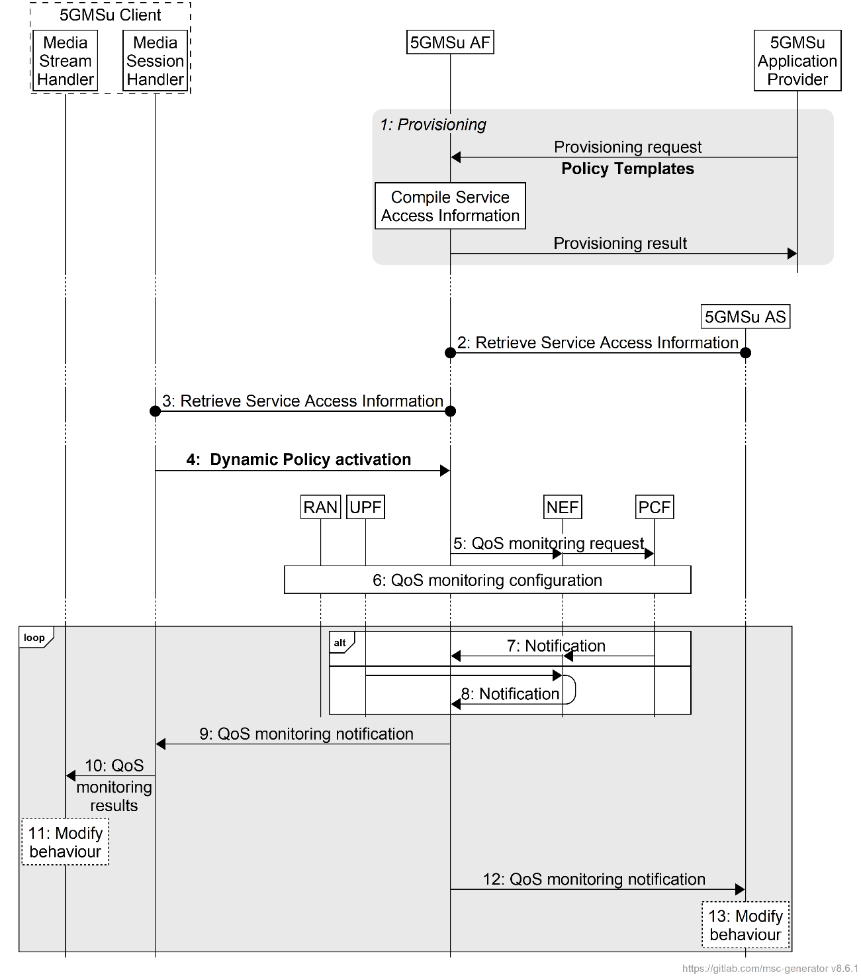

Figure 6.9.9-1: High-level call flow for QoS monitoring for uplink Media Streaming

The steps are as follows:

1. *Policy Template Provisioning.* A Policy Template is provisioned and shall include **the QoS monitoring configuration**. The QoS monitoring configuration includes the parameters to be monitored, the reporting frequency (event triggered, periodic), and optionally the notification via UPF.

NOTE 1: In case the 5GMSu AS is deployed as an EAS instance in the Edge DN, a local UPF can also be inserted for local access to the 5GMSu Edge AS. In order to reduce the latency used for exposure of the QoS monitoring results, the local UPF is expected to provide the notifications of network status directly to the 5GMSu AF and 5GMSu AS, or via a locally deployed NEF as defined in clause 5.8.2.17 of TS 23.501 [2].

2. *Service Access Information retrieval by 5GMSu AS*. The 5GMSu AS retrieves Service Access Information from 5GMSu AF via reference point M3u. **The 5GMSu AS subscribes to receive notifications from the 5GMSu AF about changes to the monitored QoS parameters for all relevant Dynamic Policies.**

3. *Service Access Information retrieval by Media Session Handler*. The Media Session Handler retrieves Service Access Information from the 5GMSu AF via reference point M5u.

4. *Dynamic Policy activation.* The Media Session Handler within the 5GMSu Client obtains Service Access Information and triggers a dynamic policy activation. A Policy Template Binding is present within the Service Access Information for each provisioned Policy Template. **Policy Template Bindings include a QoS monitoring availability flag indicating whether QoS monitoring may be enabled when instantiating the corresponding Policy Template. If the Media Session Handler is aware that Media Access Function is capable of consuming QoS monitoring results based on interrogated capabilities of Media Access Function, it shall instantiate this Policy Template with a *QoS monitoring enabled* flag set in the Dynamic Policy request. If successful, the Media Session Handler subscribes to receive notifications from the 5GMSu AF about QoS monitoring results for this Dynamic Policy.**

5. *QoS monitoring request.* The 5GMSu AF invokes the Npcf_PolicyAuthorization service or the Nnef_AFsessionWithQoS service **with the requested QoS monitoring configurations if a *QoS monitoring enabled* flag is set to *true* in the Dynamic Policy request from the Media Session Handler**. In the case where the 5GMSu AS is deployed in the Edge DN, the 5GMSu AF may additionally enable the exposure of QoS monitoring results via the local UPF or local NEF in this step.

6. The PCF accepts the request and enables QoS monitoring within the 5G System, i.e., by configuring the RAN and/or the (local) UPF for monitoring and reporting of target QoS parameters for the uplink media streaming.

Following the QoS monitoring request(s):

7. The PCF may expose the QoS monitoring results to the 5GMSu AF periodically or by event triggers using the Npcf_PolicyAuthorization_Notify service operation directly at reference point N5, or else using the Nnef_EventExposure_Notifyservice operation via the NEF at reference point N33.

8. Alternatively, the QoS monitoring results may be exposed to the 5GMSu AF by the UPF directly using the Nupf_EventExposure_Notify service or via a locally deployed NEF using the Nnef_EventExposure_Notifyservice at reference point N33.

9. If QoS monitoring was requested by the Media Session Handler, **the 5GMSu AF sends the notifications of the QoS monitoring results to the Media Session Handler** via reference point M5u.

**10. The Media Session Handler provides QoS monitoring results to the Media Stream Handler at reference point M11u.**

**11. The Media Stream Handler may use the notified QoS monitoring results to modify its behaviour.** For example, in the case of uplink media streaming, the Media Player may use the monitored packet latency, congestion status, etc. to determine the bit rate of the uplink streaming.

**12. The 5GMSu AF may provide the QoS monitoring results to the 5GMSu AS at reference point M3u.**

**13. The 5GMSu AS may use the notified QoS monitoring results to modify its behaviour.**