3GPP TSG-WG SA4 Meeting #132 S4-250896

Fukuoka, Japan, 19th – 23rd May, 2025 (revision of S4-250xxx)
CR-Form-v12.3
CHANGE REQUEST
 | 26.501 | CR | 0109 | rev |  | Current version: | 19.0.0
For HELP on using this form: comprehensive instructions can be found at
http://www.3gpp.org/Change-Requests.

Proposed change affects: | UICC apps |  | ME | X | Radio Access Network |  | Core Network

Title: | Clarification on support of Improved QoS for media streaming services
Source to WG: | Huawei, HiSilicon
Source to TSG: | S4
Work item code: | AMD-ARCH-MED |  |  |  |  |  | Date: |  |  | 2025-05-13
Category: | F |  |  |  |  |  | Release: |  |  | Rel-19
 | Use one of the following categories:  F (correction)  A (mirror corresponding to a change in an earlier release)  B (addition of feature),  C (functional modification of feature)  D (editorial modification)  Detailed explanations of the above categories can  be found in 3GPP TR 21.900. |  |  |  |  |  |  |  | Use one of the following releases:  Rel-8 (Release 8)  Rel-9 (Release 9)  Rel-10 (Release 10)  Rel-11 (Release 11)  …  Rel-17 (Release 17)  Rel-18 (Release 18)  Rel-19 (Release 19)  Rel-20 (Release 20)
Reason for change: |  | For support of improved QoS, i.e. ECN marking for L4S, QoS monitoring, it is necessary to understand whether the Media Access Functino is capable of supporting the ECN marking. This paper intends to clarify how the Media Access Function and the Media Session Handler interacts for the capability negotiation.
Summary of change: |  | Clarification on support of Improved QoS for media streaming services
Consequences if not approved: |  | Error case where the dynamic policy for L4S marking is instantiated successfully while the Media Access Function doesn’t support L4S marking.
Clauses affected: |  | 5.7.9, 6.9.8
 |  | Y | N
Other specs |  |  | X | Other core specifications |  |  |  | TS/TR ... CR ...
affected: |  |  | X | Test specifications |  |  |  | TS/TR ... CR ...
(show related CRs) |  |  | X | O&M Specifications |  |  |  | TS/TR ... CR ...
Other comments:
This CR's revision history:

* * * * First change * * * *

5.7.9 ECN marking for L4S for downlink media streaming based on Dynamic Policy
Figure 5.7.9-1 below shows a high-level call flow for downlink media streaming for configuration and usage of ECN marking for L4S. Differences from the procedure for downlink media streaming with dynamic policies defined in clause 5.7 are indicated in boldface.
The following is assumed:
- The service here is a unicast downlink media streaming service with dynamic policy support.
- As an example, the Layer 4 protocol used for application flows is TCP and the TCP stack used supports ECN marking for L4S.
- The network supports ECN marking for L4S packet marking.
- The application has specifically requested ECN marking for L4S for its media delivery session.
- NG-RAN manipulates the ECN bits (per clause 5.37.3.2 of TS 23.501 [2]). It is equally possible that the PDU Session Anchor UPF (PSA-UPF) manipulates the ECN bits (per clause 5.37.3.3 of [2]).
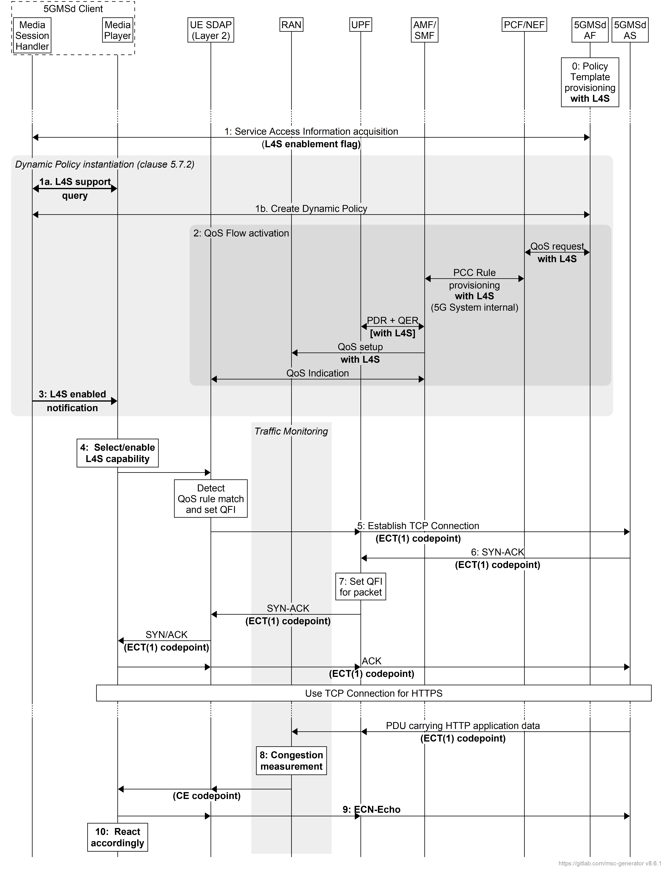
Figure 5.7.9-1: Downlink media streaming call flow for ECN marking for L4S
The steps are as follows:
0: Policy Template Provisioning. A Policy Template is provisioned with the requirement for L4S capability, indicated by setting the L4S enablement flag.
1: Service Access Information acquisition and Dynamic Policy activation. The Media Session Handler within the 5GMSd Client obtains Service Access Information. A Policy Template Binding is present within the Service Access Information for each provisioned Policy Template. Policy Template Bindings suitable for L4S are indicated by an L4S enablement flag being set.
At some later point, the Media Session Handler decides to activates a Dynamic Policy with ECN marking for L4S:
1a: Before instantiating the Policy Template, the Media Session Handler queries whether the Media Player has an L4S-capable media transport stack.
1b If the response from the Media Player is positive, the Media Session Handler instantiates the selected Policy Template with the L4S enablement flag set. Otherwise, an error notification shall be provided by the Media Session Handler.
2: QoS request. The 5GMSd AF requests QoS handling using e.g. the Nnef_AfSessionWithQoS service or the Npcf_PolicyAuthorization service. If the L4S enablement flag is set in the selected Policy Template, this indicates that the new QoS flow is required to be L4S-enabled. The new QoS flow with the ECN marking for L4S indication setting propagates through the 5G System.
3: The Media Session Handler informs the Media Player about the successful activation of the L4S-enabled Dynamic Policy via the client API at reference point M11d. Subject to availability of API access, the Media Player may use congestion notifications to perform early bit rate adaptation.
4: If the L4S enablement Dynamic Policy is successfully activated, the Media Player selects/enables the L4S capability of the used transport protocol.
NOTE 1: This step may happen implicitly by selecting an L4S-supporting transport protocol stack.
5: The Media Player within the 5GMSd Client triggers the establishment of a TCP connection. The ECT(1) codepoint is set in the IP header, indicating an L4S-Capable Transport, and the SDAP entity ensures that the packet is forwarded via the matching QoS flow.
6: The 5GMSd AS responds to the TCP connection establishment request. The 5GMSd AS sets ECT(1) in the IP headers, indicating an L4S-Capable Transport.
7: The UPF finds the matching QoS Flow Identifier for the downlink packet and sends the packet via the corresponding QoS flow to the UE. TCP Connection setup continues, with one ECT bit set in all packets.
8: When the RAN detects an upcoming congestion event according to the congestion measurement (based on continuous congestion monitoring), the 5G System sets the CE (Congestion Experienced) codepoint in the IP header of the downlink packet.
9. The TCP protocol stack used by the Media Player in the 5GMSd Client reflects the Early Congestion Notification to the TCP sender by setting the ECN-Echo (ECE) flag in the TCP header of an uplink PDU of the same TCP connection. The TCP sender reacts to the ECN-Echo accordingly (i.e., by reducing its sending congestion window).
NOTE 2: The ECN-Echo flag is also acknowledged by the TCP sender setting the Congestion Window Reduced (CWR) flag in an outgoing TCP frame, but this acknowledgement is not illustrated in this call flow.
NOTE 3: Classic ECN as specified in RFC 3168 [41] requires an ECN signal to be treated as equivalent to a packet drop. L4S as specified in RFC 9330 [38] specifies a more fine-grained response and an early congestion signal triggers a less severe reaction. How a TCP sender behaves "accordingly" is beyond the scope of the present document.
10. Based on the CE indication received in step 8, or by detecting a reduced bit rate in the downlink application flow, the Media Player in the 5GMSd Client reacts by, for example, changing the requested representation.

* * * * Next change * * * *

6.9.8 Dynamic Policy of ECN marking for L4S for uplink media streaming
Figure 6.9.8-1 below shows a high-level call flow for uplink media streaming for configuration and usage of ECN marking for L4S. Differences from the procedure for uplink media streaming with dynamic policies defined in clause 6.9.3 are indicated in boldface.
The following is assumed:
- The service here is a unicast uplink media streaming service with dynamic policy support.
- As an example, the Layer 4 protocol used for application flows is TCP and the TCP stack used supports L4S.
- The 5GS network supports ECN marking for L4S.
- The application has specifically requested ECN marking for its media delivery session.
- NG-RAN manipulates the ECN bits (per clause 5.37.3.2 of TS 23.501 [2]). It is equally possible that the PDU Session Anchor UPF (PSA-UPF) manipulates the ECN bits (per clause 5.37.3.3 of [2]).
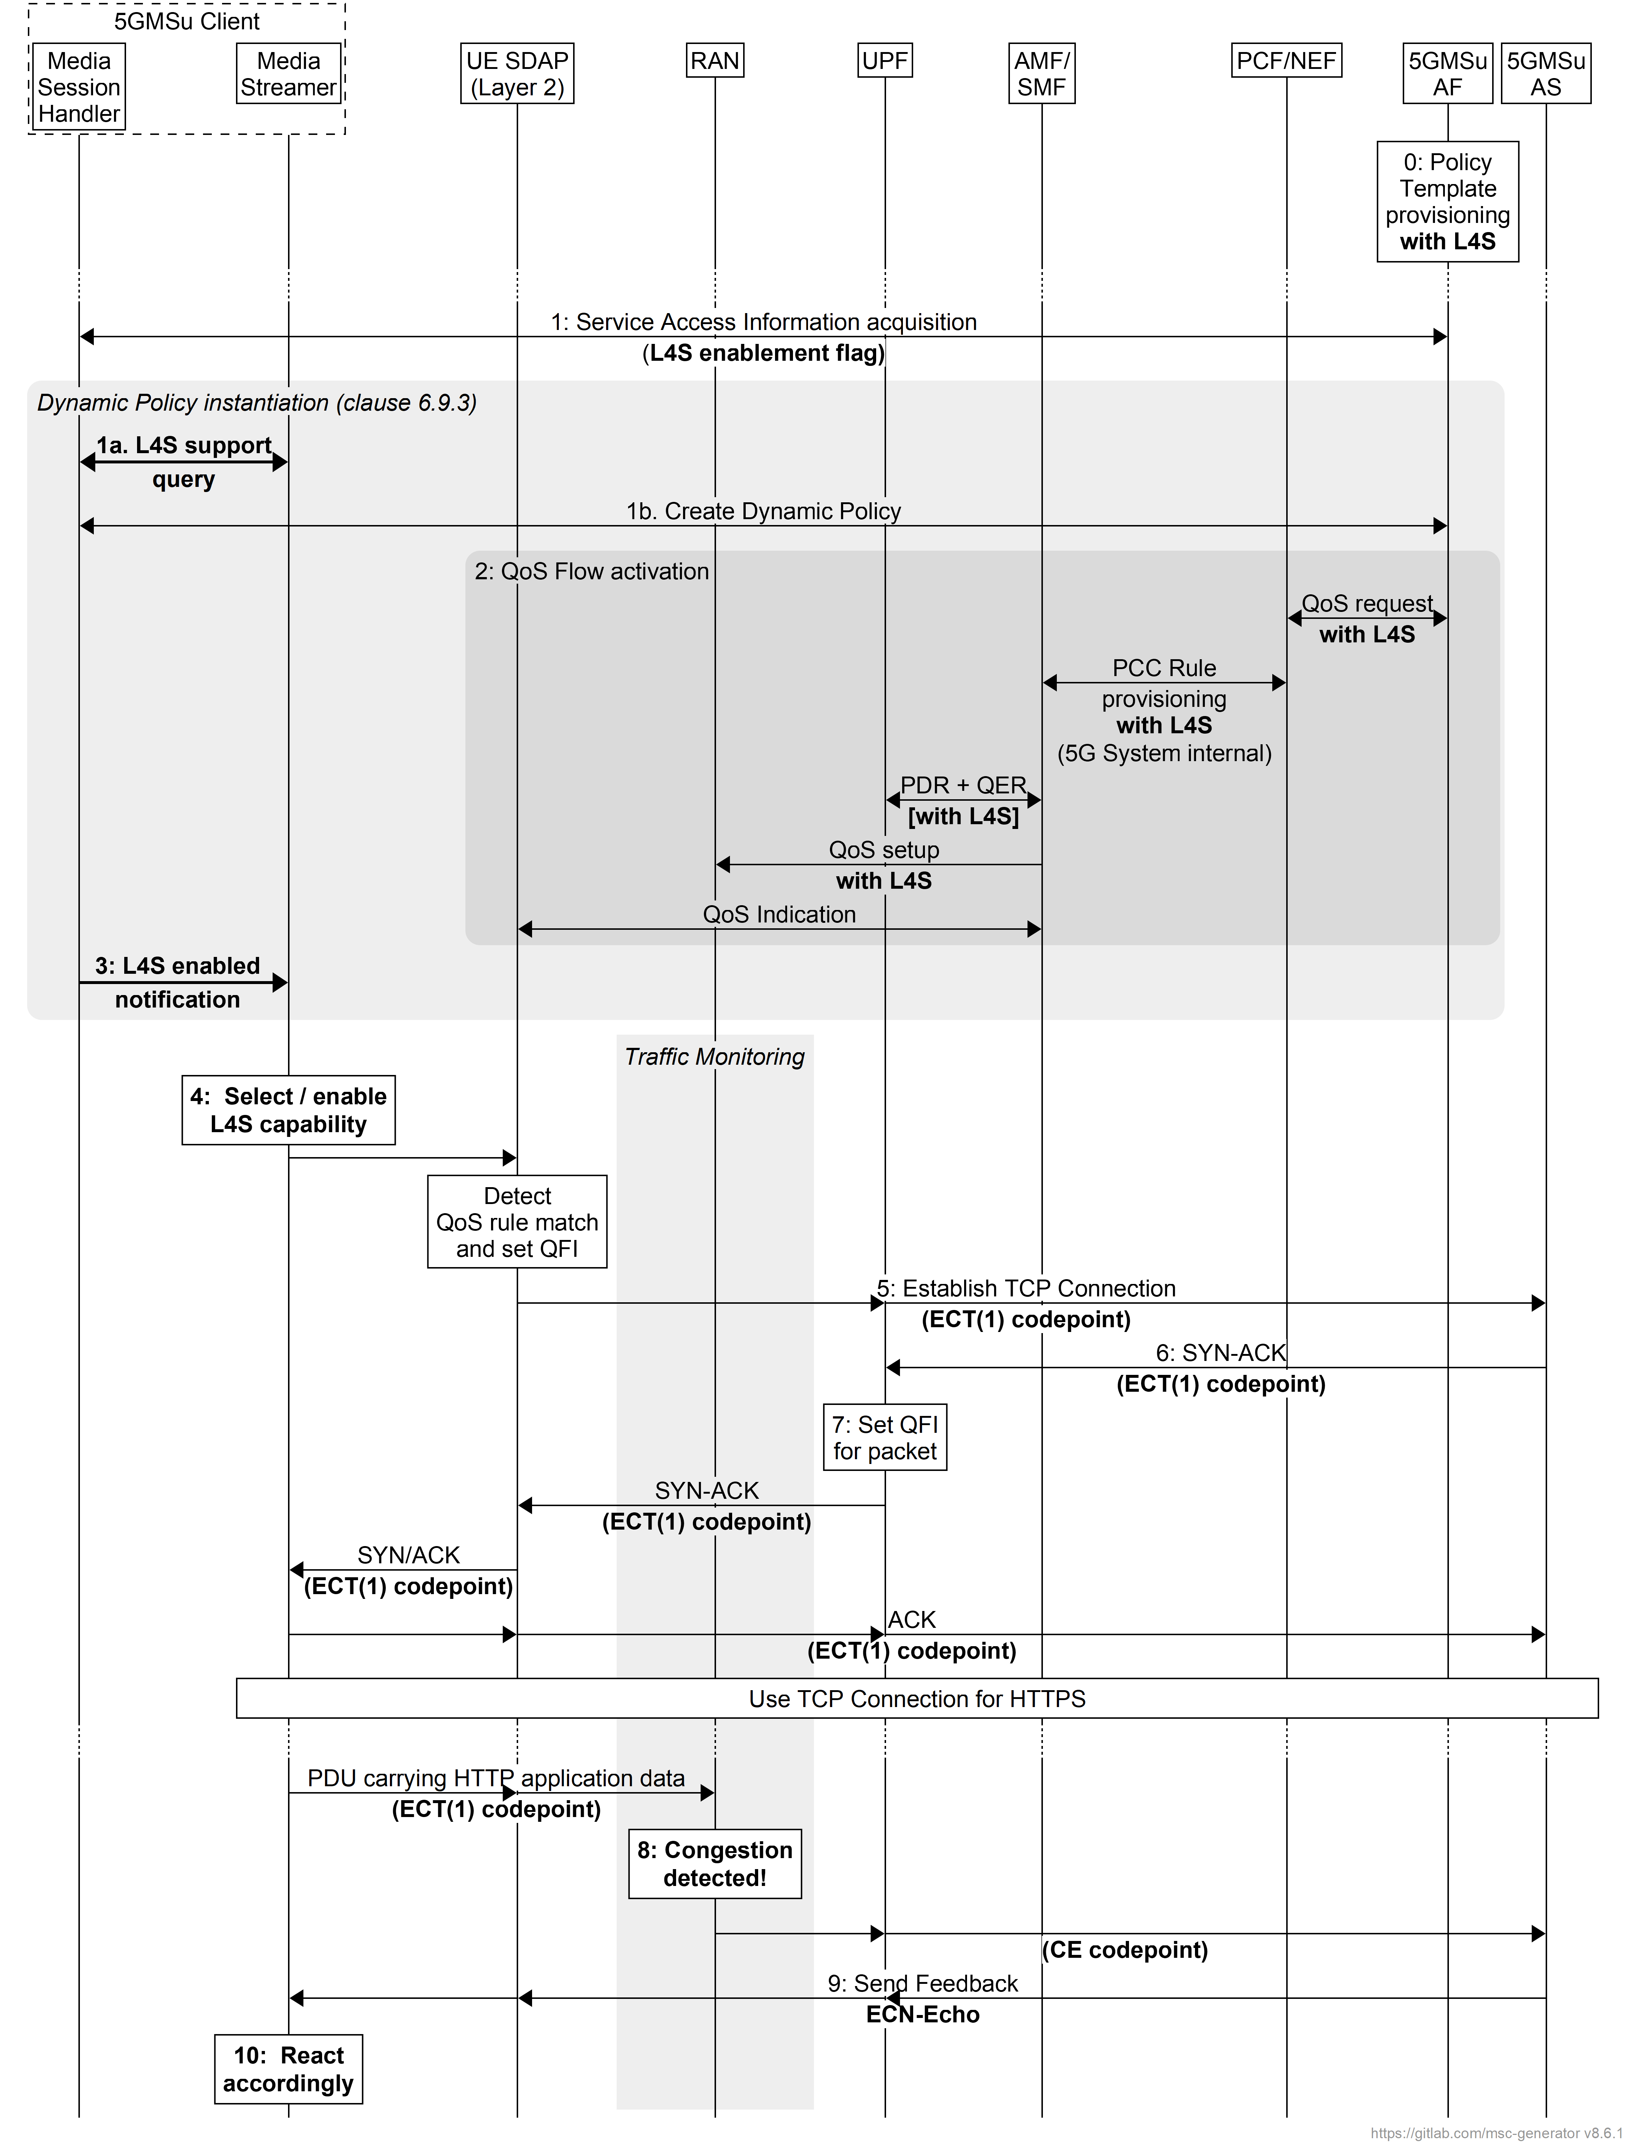
Figure 6.9.8-1: Uplink media streaming call flow for ECN marking for L4S
The steps are as follows:
0: Policy Template Provisioning. A Policy Template is provisioned with the requirement for L4S capability, indicated by setting the L4S enablement flag.
1: Service Access Information acquisition and Dynamic Policy activation. The Media Session Handler within the 5GMSu Client obtains Service Access Information. A Policy Template Binding is present within the Service Access Information for each provisioned Policy Template. Policy Template Bindings suitable for L4S are indicated by an L4S enablement flag being set..
At some later point, the Media Session Handler decides to activates a Dynamic Policy with ECN marking for L4S:
1a: Before instanitiating the Policy Template, the Media Session Handler queries whether the Media Streamer has an L4S-capable media transport stack.
1b. If the response from the Media Streamer is positive, the Media Session Handler instantiates the selected Policy Template with the L4S enablement flag set. Otherwise, an error notification shall be provided by the Media Session Handler.
2: QoS request. The 5GMSu AF requests QoS handling using e.g. the Nnef_AfSessionWithQoS service or the Npcf_PolicyAuthorization service. If the L4S enablement flag is set in the selected Policy Template, this indicates that the new QoS flow is required to be L4S-enabled. The new QoS flow with the ECN marking for L4S indication setting propagates through the 5G System.
3: The Media Session Handler informs the Media Streamer about the successful activation of the L4S-enabled Dynamic Policy via the client API at reference point M11u. Subject to availability of API access, the Media Streamer may use congestion notifications to perform early adaptation.
4: If the L4S enablement Dynamic Policy is successfully activated, the Media Streamer selects/enables the L4S capability of the used transport protocol.
NOTE 1: This step may happen implicitly by selecting an L4S-supporting transport protocol stack.
5: The Media Streamer within the 5GMSu Client triggers the establishment of a TCP connection. The ECT(1) codepoint is set in the IP header, indicating an L4S-Capable Transport, and the SDAP entity ensures that the packet is forwarded via the matching QoS flow.
6: The 5GMSu AS responds to the TCP connection establishment request. The 5GMSu AS sets ECT(1) in the IP headers, indicating an L4S-Capable Transport.
7: The UPF finds the matching QoS Flow Identifier for the downlink packet and sends the packet via the corresponding QoS flow to the UE. TCP Connection setup continues, with one ECT bit set in all packets.
8: When the RAN detects an upcoming congestion according to the congestion measurement (based on continuous congestion monitoring), the 5G System the CE (Congestion Experienced) codepoint in the IP header of the uplink packet.
9: The TCP protocol stack used by the 5GMSu AS reflects the Early Congestion Notification to the TCP sender by setting the ECN-Echo (ECE) flag in the TCP header of a downlink PDU of the same TCP connection. The TCP sender reacts to the ECN-Echo accordingly (i.e., by reducing its sending congestion window).
NOTE 2: The ECN-Echo flag is also acknowledged by the TCP sender setting the Congestion Window Reduced (CWR) flag in an outgoing TCP frame, but this acknowledgement is not illustrated in this call flow.
NOTE 3: Classic ECN as specified in RFC 3168 [41] requires an ECN signal to be treated as equivalent to a packet drop. L4S as specified in RFC 9330 [38] specifies a more fine-grained response and an early congestion signal triggers a less severe reaction. How a TCP sender behaves "accordingly" is beyond the scope of the present document.
10: Based on the CE indication received in step 8, or by detecting a reduced bit rate in the uplink application flow, the Media Streamer in the 5GMSu Client may react by, for example, changing the bit rate of the representation.

* * * * End of changes * * * *

