3GPP TSG-SA3 Meeting #125 S3-254584r1

Dallas, US, 17 – 21 November 2025

Source: Nokia
Title: Solution 1 update for key generation
Document for: Approval
Agenda item:
Spec: 3GPP TR 33.xx
Version: 0.2.0
Work Item: FS_AIML_CN_Ph2_SEC

Comments
This pCR proposes a security threat and requirement to the KI on intermediate UE authorization. The threat and requirement are unchanged compared to release 19, as the KI was discontinued by the plenary and is resumed in release 20.

* * * First Change * * * *

6.2 Solution #1: Security of UE connection setup with Data Collection NF

6.2.1 Introduction
This solution addresses requirements of key issue #1.
For authorization and user consent check between UE and data collection NF, it proposes that the entity who selects UE for data collection is deemed as enforcement point. Especially for user consent check, the existing mechanism can be reused.
For authentication and communication protection, it proposes that 3GPP network sends security parameters (e.g. PSK) to the UE in protected RRC/NAS message and the UE uses the security parameters to establish secure connection (e.g. TLS) with the DCF for UP data transferring.

6.2.2 Solution details
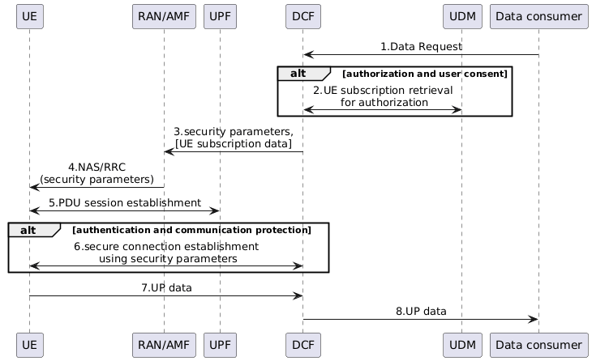
Figure 6.2.2-1: Security of UE connection setup with Data Collection NF
1. Data consumer (e.g. UE model training entity server) requests UE data collection to DCF.
2. DCF retrieves UE subscription data from UDM. The subscription data includes:
a) User consent data: existing user consent parameters can be reused.
b) Authorization profile: whether UE is allowed for exposing specific data to specific data consumer.
The DCF can be enforcement point for authorization and user consent check if it decides that DCF is used for UE selection for data collection.
3. The DCF sends security parameters (e.g. PSK) to the RAN/AMF. The DCF may also send UE subscription data to the RAN/AMF to enforce the authorization and user consent check if it decides that RAN/AMF is used for UE selection for data collection.
4. The RAN/AMF sends security parameters to the UE. The security parameters are protected by RRC/NAS mechanism.
5. The UE establishes a PDU session as depicted in clause 7.1.1 of TR 23.700-04 [2].
6. The UE establishes a secure connection using the security parameters to the DCF, e.g. the UE uses PSK to establish a secure TLS connection with the DCF.
7. The UE reports UP data in the secure connection to the DCF.
8. The DCF reports UP data to the Data consumer.
One alternative of PSK generation is that
- UE and Network (AUSF or AMF) derive the PSK independently via the root key (Kausf or Kamf). For this network sends the random value as a salt to UE; and UE and Network uses the same salt to drive the same PSK.
- Rest of the details of the key derivation is not defined in this solution.
Editor's note: Aspect related to user consent its application and enforcement in any form for UE data collection is FFS.
Editor's note: Applicability and distribution of related security parameter (i.e. PSK) for the purpose of secure channel establishment or applicability of UE subscription data and its distribution to AMF/RAN in any form is FFS.
- Editor's note: The need for UE authentication is FFS.
- Editor’s note: How the network sends the random value as salt to UE and how it is used for PSK generation is FFS

6.2.3 Evaluation
TBA
Editor's note: The evaluation is made based on SA2 conclusion.

* * * End of Changes * * * *

