3GPP TSG-SA3 Meeting #125 S3-254580-r1

Dallas, US, 17 – 21 November 2025

Source: Nokia
Title: Granular authorization for OTT/AF
Document for: Approval
Agenda item:
Spec: 3GPP TR 33.xx
Version: 0.2.0
Work Item: FS_AIML_CN_Ph2_SEC

Comments
KI2, requirement 2 talks about “The 5GS shall support authorization mechanisms for services related to exposure of UE-related data to the OTT server.” We are proposing a solution for the same.

* * * First Change * * * *

6.2 Solution #x: Granular authorization for OTT/AF

6.2.1 Introduction
This solution addresses requirements of key issue #2.

6.2.2 Solution details
When AF or OTT requests UE-side model training data from DCF via NEF, the exposure of such UE data outside the 3GPP domain introduces security risks requiring control at the exposure interface, particularly for authorization.

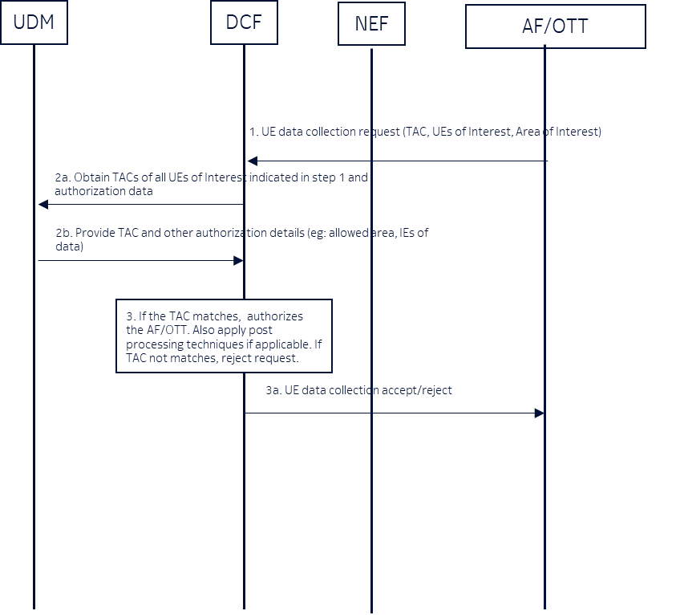

1: An AF/OTT server requests UE-side model training data from the DCF via the NEF, including the Type Allocation Code (TAC) . This request optionally includes UEs of interest, and/or areas of interest from which UE data needs to be collected.
NEF authenticate and authorize the AF/OTT via mTLS and authorization procedure defined in 33501, section 12. NEF and AF/OTT data exchange is integrity, confidentiality and replay protected via existing means.
Note: AF/OTT server can access data from UEs primarily when the UE's TAC matches the TAC specified by the AF/OTT, or from other TACs if permitted by operator policy/configuration in UDM.
Note: The Type Allocation Code (TAC) is the first 8 digits of the 15-digit International Mobile Equipment Identity (IMEI) number. It uniquely identifies the make and model of a mobile device
2: The DCF queries the UDM to obtain UE’s TAC and optionally retrieves authorization data from the UDM. This authorization data includes
  - allowed geographical area for data collection, (e.g. UE1 is allowed to collect data at certain location)
  - allowed IEs for UE-side model training data
  - applicable post processing on IEs before exposure
This authorization data can also be configured locally.

3: Based the information received from the UDM (or locally configured), the DCF authorizes the AF/OTT for data collection for selected UEs. E.g., If TAC does not match, then DCF rejects the request. If UE area does not fall into allowed geographical area, then reject the request. DCF also uses this information from the UDM to select the authorized list of UEs.
If there is a policy to apply post processing on the IE before the exposure, e.g. anonymization, the DCF shall apply the same.
Editor’s Note: Whether UDM is the right NF to store these granular information is FFS.
Editor’s Note: Aspect related to allowed IEs for UE-side model training data and applicable post processing on IEs before exposure is FFS

6.2.3 Evaluation

FFS.

* * * End of Changes * * * *

