3GPP TSG-SA3 Meeting #125 S3-254278-r1 merging 4341

Dallas, US, 17 – 21 November 2025

Source: Huawei, HiSilicon, ORANGE, Thales
Title: EN addressing and evaluation for solution#4
Document for: Approval
Agenda item: 5.2.1
Spec: 3GPP TR 33.703
Version: 0.2.0
Work Item: FS_CryptoPQC

Comments
This contribution proposes some update to solution #4 to address the Editor Notes:
“Editor’s Note: it is ffs that RAND without binding to any UE specific key or encryption or MAC value will result in the attacker is just sending and RAND number blocking the genuine UE.
Editor’s Note: it is ffs that just the RAND can’t be used for routing of the information.
Editor’s Note: How does pre-configured pseudonym prevent traceability is FFS.”
For the first EN, the solution is updated to use H (K, RAND) as the pseudonym. For the routing issue, routing indicator is added. For the traceability issue, a Note about adding COUNT to the calculation of pseudonym is listed.
* * * First Change * * * *

7.2.1.4 Solution #4 to SUCI calculation: SUPI Pseudonym

7.2.1.4.1 Introduction
This contribution proposes SUPI concealment using pseudonym instead of asymmetric encryption for SUPI.

7.2.1.4.2 Solution details
The Figure 7.2.1.4.2-1 illustrates the procedure:

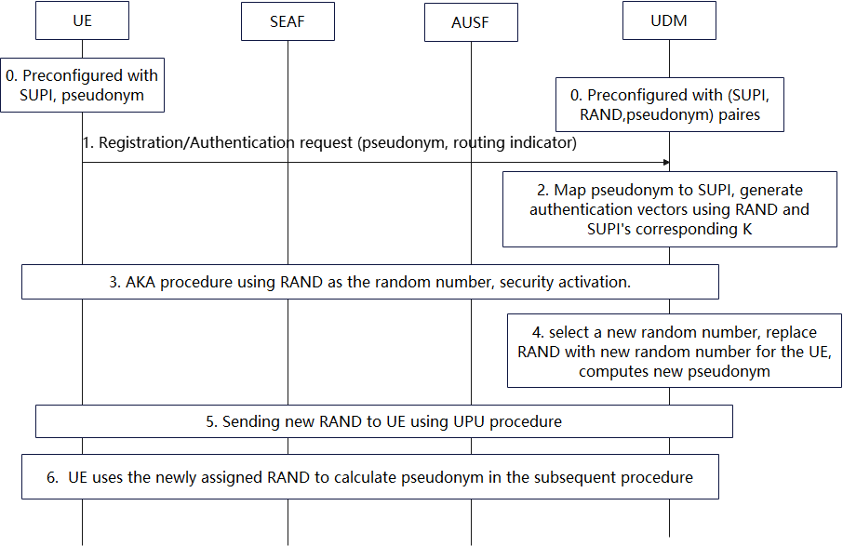
Figure 7.2.1.4.2-1 procedure of using random number to do SUPI concealment
0. The UE is pre-configured with the UE’s SUPI, a random value RAND generated by the network and a routing indicator binding to the UDM instance storing the UE’s subscription data. The UDM instance is pre-configured with the UE’s SUPI, the random value RAND and a pseudonym=H (K, RAND), K is UE’s long-term key and H is a quantum-resistant hash function.
1. During registration, the UE calculates pseudonym=H (K, RAND) using the pre-configured RAND, and sends pseudonym and the routing indicator as the UE's SUCI over the air interface.
2-3. The network routes the message to the corresponding UDM instance according to the routing indicator, UDM maps the pseudonym to SUPI and complete the authentication using the SUPI. The RAND can also be reused as the random value used in the primary authentication.
4-5. After authentication, the UDM instance assigns a new RAND for the UE, update thepseudonym with H (K, RAND) and sends the new RAND to the UE.
6. The UE uses the newly assigned RAND to calculate the pseudonym and the SUCI at UE in the subsequent procedure.
Note: In order to address the traceability issue, a COUNT with initial values setting to 0 can also be introduced in the computation of pseudonym. Specifically, the UE and network can compute H (K, RAND, COUNT) as the pseudonym, if the authentication is failed, the value of COUNT will increase from UE side. The UDM can pre-compute several pseudonyms using different COUNT values (e.g. 0,1,2, etc.) and compare the value to the receiving pseudonym in order to resolve SUPI.

7.2.1.4.3 Evaluation

This solution addresses the key issue about PQC migration for SUCI calculation.
This solution essentially relies on a one-time pseudonym RAND that will serve as the SUCI value. This pseudonym is known to the UDM which can then identify the corresponding UE. After each authentication, a new pseudonym RAND’ is generated by the UDM and transmitted to the UE. This requires to maintain synchronisation between the UE and the UDM, otherwise a desynchronized UE would lose access to the network.
Editor’s Note: resynchronization of desynchronized pseudonyms is FFS.
Editor’s Note: Further evaluation is FFS.

The UDM side needs to maintain the mapping between each UE's pseudonym and SUPI. After a pseudonym is used once, the network side must update the pseudonym in a timely manner to ensure that two consecutive requests from the same user are not linked.

Editor’s Note: Whether hash extension attacks need to be considered in this solution is FFS.
Editor’s Note: Whether use of a RAND value in a scheme for which it is not intended presents a security risk is FFS.

* * * End of Changes * * * *

