3GPP TSG-SA3 Meeting #125 S3-254251-r1
Dallas, US, 17 – 21 Nov. 2025

Source: Huawei, HiSilicon
Title: pCR on updating sol #3 for SUCI calculation to resolve EN
Document for: Approval
Agenda item: 5.2.1
Spec: 3GPP TR 33.703
Version: 0.2.0
Work Item: FS_CryptoPQC

Comments
This contribution proposes to resolve EN in SUCI calculation solution #3.
The Editor’s Notes are addressed as follows:
Editor’s Note: What is the advantage for presenting classical algorithm ECDH-KEM is ffs
Answer: Post-Quantum Traditional (PQT) hybrid scheme as defined in RFC 9794 [1], is a hybrid scheme where at least one component algorithm is a post-quantum algorithm and at least one is a traditional algorithm. The hybrid solution protects against quantum computer attacks but also ensure that the current levels of security (e.g., against traditional attacks) are maintained. Sentences have been added in the Introduction clause and the evaluation clause.
Editor’s Note: it is ffs whether there is no freshness aspect anymore as the stored key will be reused.
Answer: The keys are refreshed each time of usage. The KEM algorithms ensure freshness (e.g., reference session 5.1.1 in [4] and 6.2.2.2 in [5]) by using the randoms (i.e., ephemeral private key). For example, in ECDH-KEM, the ephemeral private key d_{e,U} is used to generate the ciphertext and is then required to be destroyed after usage. Sentences have been added for the UE side at step 1b.
Editor’s Note: it is ffs how will the HN identify which key is used if there is no identifier.
Answer: Before or after generating the scheme output, the terminal verifies the key and the corresponding key ID that are used, and send the key ID along with the SUCI to the network when sending the SUCI. The key ID can be part of the SUCI as in TS 33.501. A sentence has been added for the UE side at step 3-5
Editor’s Note: it is ffs, for the MAC creation, there is no key used, this is just a hashing, not a keyed-hash.
Answer: The MAC-1 is primarily used to allow the network to verify the correctness before performing hybrid de-KEM, considering the time consumption for executing de-KEM. Therefore, key hashing is not required for MAC-1. The integrity of the scheme output is protected by the MAC tag, as in TS 33.501. A sentence has been added for the UE side at step 2b
Editor’s Note: SUCI size is ffs since with the c1c2 cipher text, new MAC, still SUCI size will be more than existing SUCI in 5G apart from the PQC addition.
Answer: Assuming ML-KEM-768 (recommended in FIPS 203 [21]) is used for the PQC KEM, the hybrid scheme will increase the SUCI length by 1088 bytes. In addition, the MAC-1 will increase the length further by 32 bytes. Considering the existing scheme output, there is an additional increase of approximately 32+1088 =1120 bytes. Sentences have been added in the evaluation clause.
Editor’s note: Details on how the MAC computation is performed are FFS.
Answer: MAC-1 can be implementated with SHA-256, whereas MAC tag can be implementated re-using the existing profile in TS 33.501.
Editor’s note: it is ffs the security issue introduced by using a non-keyed hash over part of the message.
Answer: The integrity of the scheme output is protected by the MAC tag as in TS 33.501.
Editor’s note: Why MAC on c1 and c2 is required is FFS.
Answer: MAC-1 is used to verify correctness before performing hybrid de-KEM, considering the time consumption for executing de-KEM.

References
[1] IETF RFC 9794, Terminology for Post-Quantum Traditional Hybrid Schemes
[2] NIST.SP.800-227, “Recommendations for Key-Encapsulation Mechanisms”
[3] NIST.SP.800-56-r3, “Recommendation for Pair-Wise Key-Establishment Schemes Using Discrete Logarithm Cryptography”
* * * First Change * * * *

7.2.1.3 Solution #3 to SUCI calculation: SUCI calculation with hybrid KEMs

7.2.1.3.1 Introduction
This solution proposes a hybrid encryption approach with both PQC and traditional cryptography for SUCI calculation. The proposed solution uses two different KEM algorithms for key derivation. The hybrid solution can provide higher security protection as long as either the classical algorithm or the PQC algorithm succeeds.

7.2.1.3.2 Solution details

The proposed solution is illustrated below. Figure 7.2.1.Y-1 shows the SUCI calculation at the UE. Figure 7.2.1.Y-2 shows the scheme output that the UE sends to the HN. Figure 7.2.1.Y-3 is the HN decryption of the SUCI from the UE.

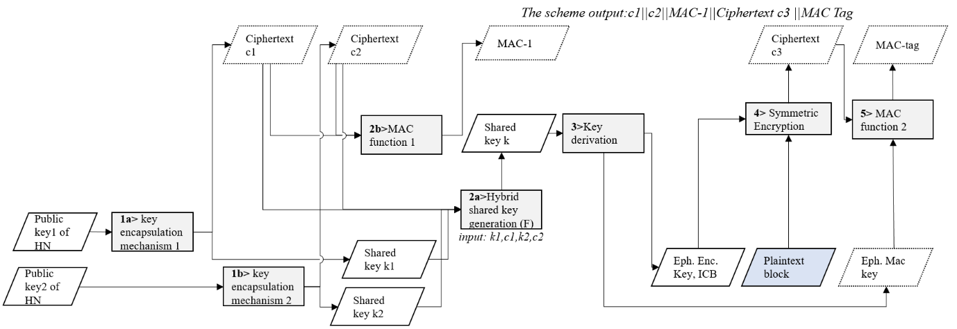
Figure 7.2.1.3-1 SUCI calculation using hybrid KEM schemes at UE

1a. UE generates a shared key k1 and the corresponding ciphertext c1 based on the key encapsulation algorithm 1 (KEM1). The KEM1 uses ECDH-KEM with traditional cryptography as specified in NIST.SP.800-227 [73].
1b. UE generates a shared key k2 and the corresponding ciphertext c2 based on the key encapsulation algorithm 2 (KEM2). The KEM2 is PQC secure, and uses the ML-KEM-768 as specified in NIST FIPS 203 [21].
NOTE: in Step 1a or 1b, freshness of generating k1, k2 is ensured by the randomnesss in the KEM algorithm.
2a. UE generates a hybrid shared key (k) using KDF as specified in TS 33.501 [4], where k1, c1, k2, and c2 are the inputs of the KDF (as recommended by NIST SP 800-227[73]).
2b. UE generates a MAC-1 by hashing c1 and c2, e.g., MAC-1 = SHA256 (c1||c2). The MAC-1 is primarily used to allow the network to verify the correctness before performing hybrid de-KEM, considering the time consumption for executing de-KEM.
The MAC-1 is used for the HN to verify correctness of c1 and c2 before performing the computation intensive cryptographic steps (e.g., steps 3-6 in Figure 7.2.1.Y-3).
3-5: UE continue with steps similar to the steps 3 -5 specified in clause C.3.2 in TS 33.501 [4].
The SUCI format generated by UE is as specified in TS 23.003 [74] and the Scheme Output as shown below includes the concatenation of the ciphertext c1||c2, MAC-1, ciphertext c3 and MAC tag. Before or after generating the scheme output, the terminal verifies the key and the corresponding key ID that are used, and sends the key ID along with the SUCI to the network when sending the SUCI. The key ID can be part of the SUCI.
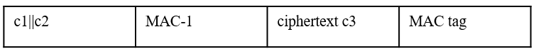
Figure 7.2.1.3-2 The Scheme Output generated at the UE side

The processing of the received packet at the HN is shown in Figure 7.2.1.Y-3 with details as follows:

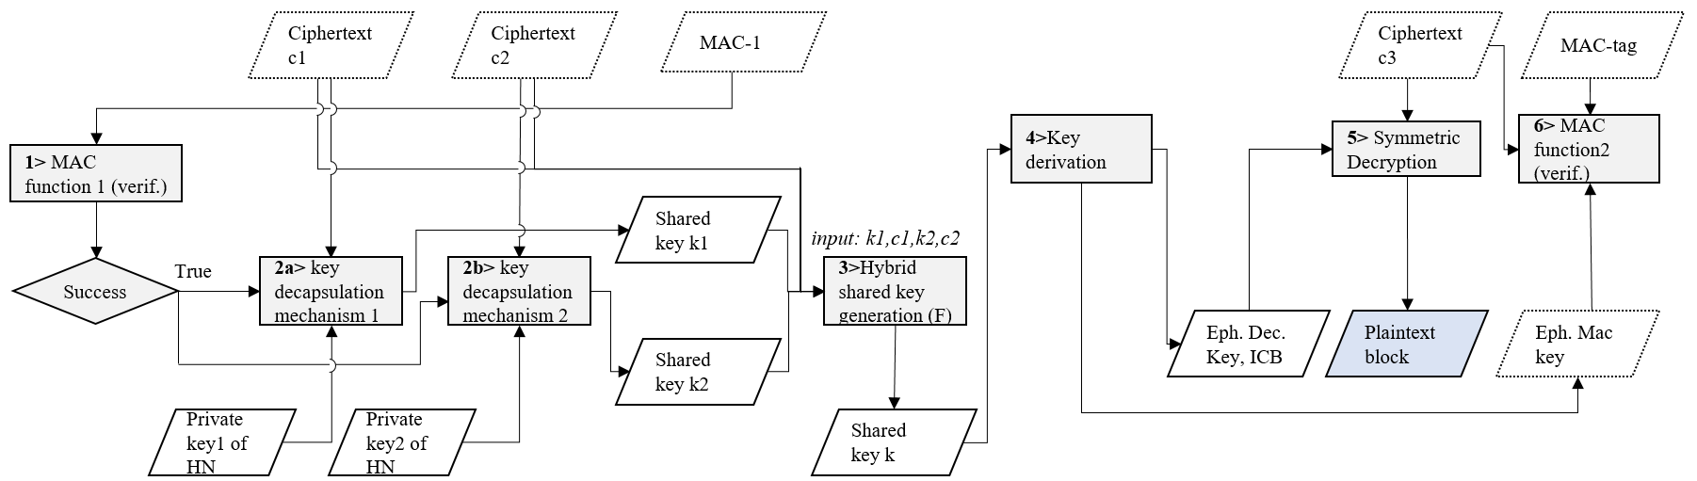
Figure 7.2.1.3-3 Decryption of SUCI at HN

1. HN verifies the received MAC-1 of UE. If it succeeds, HN continues to perform the decapsulation of the shared key.
2a. HN decapsulates the shared key k1 based on the key encapsulation algorithm 1 (KEM1), the private key 1 of HN, and the received ciphertext c1 from UE. In the case of KEM1 = ECDH-KEM, ciphertext c1 is used as the ephemeral public key of the UE [75].
2b. HN decapsulates the shared key k2 based on the key encapsulation algorithm 2 (KEM2), the private key 2 of HN, and the received ciphertext c2 from the UE.
3. HN generates the shared key k in the same way at the UE side.
4-6: HN follows the steps 2-4 specified in clause C.3.3 of TS 33.501 [4].

7.2.1.3.3 Evaluation

This solution addresses SUCI calculation.
This solution follows a hybrid approach and combines a traditional KEM and a PQC KEM to protect against both existing threats and future quantum computer threats.
The MAC-1 computed on c1 and c2 is a hash function evaluation. It is primarily used to allow the network to verify the correctness before performing hybrid de-KEM, considering the time consumption for executing de-KEM.
Assuming ML-KEM-768 (recommended in FIPS 203 [21]) is used for the PQC KEM, the hybrid scheme will increase the SUCI length by 1120 bytes, where the MAC-1 increases the length by 32 bytes.

* * * End of Changes * * * *

