3GPP TSG-SA3 Meeting #125 S3-254124

Dallas, USA, 17 – 21 November 2025

Source: Vodafone, China Mobile, AT&T, T-Mobile US, Verizon, Charter Communication, KDDI, Telecom Italia
Title: pCR to TS 33.502 - Example of trust domain
Document for: Approval
Agenda item: 5.1.1
Spec: 3GPP TS 33.502
Version: 0.2.0
Work Item: SECHAND

Comments
An editor’s note exist in clause 4 to review the architectural figure. This pCR attempts to remove the EN and revisit the figure according to discussions in SA3#124 meeting (S3-253789).

* * * First Change * * * *

4 Overview of Security related Events handling

The Service Based Architecture (SBA) is the dominant method for control plane as well as the Service Based Management Architecture (SBMA) is for management communications. In addition to the many benefits of using SBA, e.g. agility to increase and decrease the number of service instances in coordination with demand, potential attacks may still appear for network, service and/or APIs.
The 5G system includes heterogeneous and varied Network Functions (NF) deployments, where each and every Network Function has a specified behaviour according to 3GPP specifications. If any NF runs into errors, e.g. a violation of the normal behaviour, or abnormal access or unauthorised request, then the NF needs to be evaluated from a security perspective. Collection of data related to abnormal events needs to be performed for the evaluation of the NF behaviour, with related data being transmitted towards a security entity that will execute the evaluation.
The following figure shows an example of trust domains in the overall architecture for the collection and transmission of the Security related Events detected by NFs.

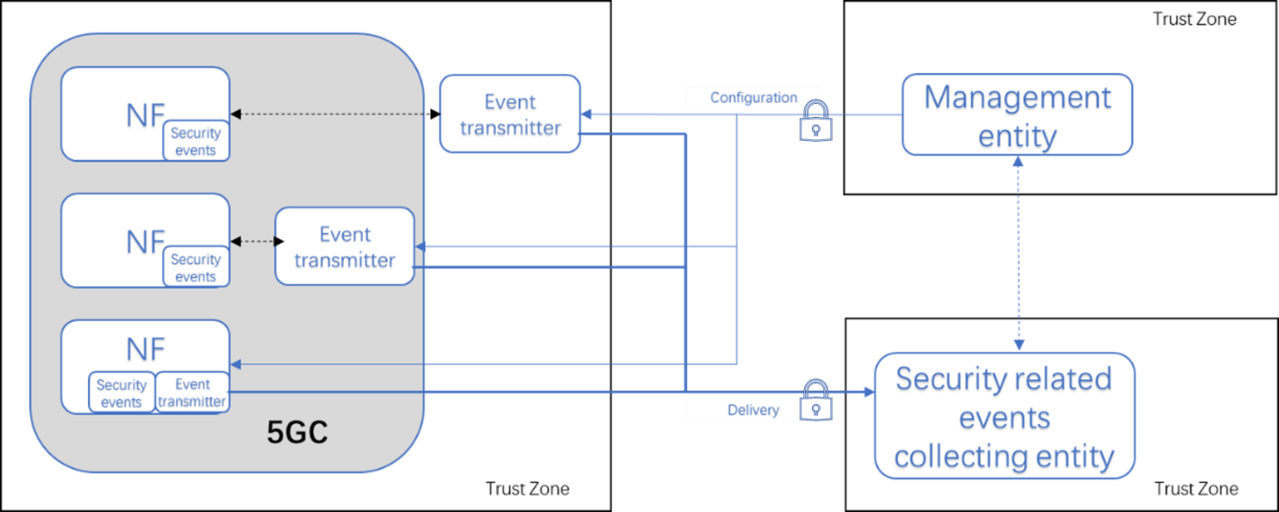

Figure 4-1 Example of trust zones in the Security related Events Handling architecture

The NF gets configuration of security related events from the Management entity and delivers security related events through the Event transmitter. The Event transmitter could be an independent function or part of the NF. The Event transmitter is recommended to be part of an NF. Whether the Event transmitter is inside the NF, outside the NF and inside the 5GC, or outside the 5GC, as depicted in Figure 4-1, is based on operator implementation.
The Event transmitter, Management Entity and Security related event collecting entity are the end points of the related configuration and collection interfaces. The interfaces for collection of security related events are in scope of the present document. Requirements on the configuration of security related events are in scope of the present document. The interfaces between the Event transmitter and the NFs are out of the scope of 3GPP.
NOTE 1: Operators will define the relationship between trust zones
NOTE 2: The Security related events collecting entity is under operator control (e.g. through business agreements, policy, managed service, directly managed, etc.) and it is out of the scope of 3GPP.
NOTE 3: Whether the security collecting entity is the same as the management entity is an operator decision.
NOTE 4: Whether the Event transmitter external to the 5GC is part of the Management entity is an operator decision.
* * * End of Changes * * * *

