3GPP TSG-SA3 Meeting #125 S3-254058-r1

Dallas, US, 17 – 21 November 2025

Source: Nokia
Title: Pseudo-CR on Solution proposal Hybrid SUCI calculation
Document for: Approval
Agenda item: 5.2.1
Spec: 3GPP TR 33.703
Version: 0.2.0
Work Item: FS_PQC

Comments

This pCR is introducing the Solution proposal Symmetric key SUCI procedures.
The proposed solution is to be added into the TR study on supporting the PQC [1].
The revision1 includes the description of the support requirement of two network identifiers, as well as the support requirement for combined symmetric cryptographic algorithm.

[1] TR 33.771, “Study on Transitioning to Post Quantum Cryptography (PQC)”

* * * First Change * * * *

2 References
The following documents contain provisions which, through reference in this text, constitute provisions of the present document.
- References are either specific (identified by date of publication, edition number, version number, etc.) or non-specific.
- For a specific reference, subsequent revisions do not apply.
- For a non-specific reference, the latest version applies. In the case of a reference to a 3GPP document (including a GSM document), a non-specific reference implicitly refers to the latest version of that document in the same Release as the present document.
[1] 3GPP TR 21.905: "Vocabulary for 3GPP Specifications".
[2] 3GPP TR 33.938: "3GPP Cryptographic Inventory".
[3] 3GPP TS 33.180: "Security of the Mission Critical (MC) service".
[4] 3GPP TS 33.501: "Security architecture and procedures for 5G System".
[5] PQUIP draft-ietf-pquip-pqc-engineers: "Post-Quantum Cryptography for Engineers".
[6] IETF RFC 6509: ''MIKEY-SAKKE: Sakai-Kasahara Key Encryption in Multimedia Internet KEYing (MIKEY)''.
[7] IETF RFC 9794: "Terminology for Post-Quantum Traditional Hybrid Schemes".
[8] NIST IR 8547: "Transition to Post-Quantum Cryptography Standards".
[9] SECG SEC 1: "Recommended Elliptic Curve Cryptography", Version 2.0, 2009. Available at http://www.secg.org/sec1-v2.pdf.
[10] SECG SEC 2: "Recommended Elliptic Curve Domain Parameters", Version 2.0, 2010. Available at http://www.secg.org/sec2-v2.pdf.
[11] EU, Roadmap for the Transition to Post-Quantum Cryptography
https://digital-strategy.ec.europa.eu/en/news/eu-reinforces-its-cybersecurity-post-quantum-cryptography
[12] UK NCSC, Timelines for migration to post-quantum cryptography
https://www.ncsc.gov.uk/guidance/pqc-migration-timelines
[13] NSA, The Commercial National Security Algorithm Suite 2.0 and Quantum Computing FAQ
https://media.defense.gov/2022/Sep/07/2003071836/-1/-1/0/CSI_CNSA_2.0_FAQ_.PDF
[14] ANSSI, Guide des Mécanismes cryptoraphiques
https://cyber.gouv.fr/sites/default/files/2021/03/anssi-guide-mecanismes_crypto-2.04.pdf
[15] ASD, Guidelines for cryptography
https://www.cyber.gov.au/business-government/asds-cyber-security-frameworks/ism/cybersecurity-guidelines/guidelines-for-cryptography
[16] Canadian Centre for Cyber Security, Roadmap for the migration to post-quantum cryptography
https://www.cyber.gc.ca/en/guidance/roadmap-migration-post-quantum-cryptography-government-canada-itsm40001
[17] Swedish NCSC, Kvantsäker kryptografi
https://www.ncsc.se/sv/aktuellt/kvantsaker-kryptografi/
[18] NSM Cryptographic Recommendations
https://nsm.no/getfile.php/1314334-1742808614/NSM/Filer/Dokumenter/Veiledere/NSM%20Cryptographic%20Recommendations%202025.pdf
[19] AIVD, The PQC Migration Handbook
https://english.aivd.nl/binaries/aivd-en/documenten/publications/2024/12/3/the-pqc-migration-handbook/The+PQC+Migration+Handbook+.pdf
[20] 3GPP, Release Timeline
https://www.3gpp.org/specifications-technologies/releases/release-20
[21] NIST FIPS 203: "Module-Lattice-Based Key-Encapsulation Mechanism Standard"
https://doi.org/10.6028/NIST.FIPS.203
[22] NIST FIPS 204: "Module-Lattice-Based Digital Signature Standard"
https://doi.org/10.6028/NIST.FIPS.204
[23] NIST FIPS 205: "Stateless Hash-Based Digital Signature Standard"
https://doi.org/10.6028/NIST.FIPS.205
[24] OpenSSH 10.0 Introduces Default Post-Quantum Key Exchange Algorithm https://quantumcomputingreport.com/openssh-10-0-introduces-default-post-quantum-key-exchange-algorithm
[25] Cloudflare Radar https://radar.cloudflare.com/adoption-and-usage#post-quantum-encryption-adoption
[26] A Coordinated Implementation Roadmap for the Transition to Post-Quantum Cryptography https://digital-strategy.ec.europa.eu/en/library/coordinated-implementation-roadmap-transition-post-quantum-cryptography
[27] Next steps in preparing for post-quantum cryptography https://www.ncsc.gov.uk/whitepaper/next-steps-preparing-for-post-quantum-cryptography
[28] PQC Transition in France ANSSI Views https://cyber.gouv.fr/sites/default/files/document/pqc-transition-in-france.pdf
[29] ANSSI plan for post-quantum transition https://pkic.org/events/2023/pqc-conference-amsterdam-nl/pkic-pqcc_jerome-plut_anssi_anssi-plan-for-post-quantum-transition.pdf
[30] ETSI TS 103 744: "Quantum-safe Hybrid Key Establishment". https://www.etsi.org/deliver/etsi_ts/103700_103799/103744/01.02.01_60/ts_103744v010201p.pdf
[31] FIPS 202: "SHA-3 Standard: Permutation-Based Hash and Extendable-Output Functions". https://nvlpubs.nist.gov/nistpubs/fips/nist.fips.202.pdf
[32] SP 800-185: "~SHA-3 Derived Functions: cSHAKE, KMAC, TupleHash, and ParallelHash". https://nvlpubs.nist.gov/nistpubs/fips/nist.fips.202.pdf
[33] GSMA: "Post Quantum Cryptography – Guidelines for Telecom Use Cases - v2.0"
[34] IETF RFC 5869 "HMAC-based Extract-and-Expand Key Derivation Function (HKDF)"
[35] IETF RFC 7748: "Elliptic Curves for Security".
[36] FN-DSA: Falcon is a cryptographic signature algorithm submitted to NIST, Refer to https://falcon-sign.info/falcon.pdf
[37] NIST: “Submission Requirements and Evaluation Criteria for the Post-Quantum Cryptography Standardization Process “,
https://csrc.nist.gov/CSRC/media/Projects/Post-Quantum-Cryptography/documents/call-for-proposals-final-dec-2016.pdf
[38] Bernstein, D.J. (2009): "Introduction to post-quantum cryptography ", 2009. Available at https://doi.org/10.1007/978-3-540-88702-7_1
[39] NIST IR 8545: “Status Report on the Fourth Round of the NIST Post-Quantum Cryptography Standardization Process”, 2025. Available at https://csrc.nist.gov/pubs/ir/8545/final
[40] NIST, "Considerations for Achieving Cryptographic Agility: Strategies and Practices," CSWP 39, Jul. 2025. [Online]. Available: https://csrc.nist.gov/pubs/cswp/39/considerations-for-achieving-cryptographic-agility/2pd
[41] IETF RFC 7696: “Guidelines for Cryptographic Algorithm Agility and Selecting Mandatory-to-Implement Algorithms”.
[42] IETF: “About RFCs”. Available at https://www.ietf.org/process/rfcs/.
[43] IETF RFC 9242: "Intermediate Exchange in the Internet Key Exchange Protocol Version 2 (IKEv2) "
[44] IETF RFC 9370: "Multiple Key Exchanges in the Internet Key Exchange Protocol Version 2 (IKEv2) "
[45] IETF Draft (Standards Track): "Post-quantum Hybrid Key Exchange with ML-KEM in the Internet Key Exchange Protocol Version 2 (IKEv2) ", https://datatracker.ietf.org/doc/draft-ietf-ipsecme-ikev2-mlkem/.
[46] IETF RFC 9593: "Announcing Supported Authentication Methods in the Internet Key Exchange Protocol Version 2 (IKEv2)"
[47] IETF RFC 8784: "Mixing Preshared Keys in the Internet Key Exchange Protocol Version 2 (IKEv2) for Post-quantum Security"
[48] IETF Draft (Standards Track): " Signature Authentication in the Internet Key Exchange Version 2 (IKEv2) using PQC ", https://datatracker.ietf.org/doc/draft-ietf-ipsecme-ikev2-pqc-auth/.
[49] IETF RFC 7383: "Internet Key Exchange Protocol Version 2 (IKEv2) Message Fragmentation". https://www.rfc-editor.org/rfc/rfc7383
[50] IETF RFC 9763: "Related Certificates for Use in Multiple Authentications within a Protocol "
[51] IETF RFC 9802: "Use of the HSS and XMSS Hash-Based Signature Algorithms in Internet X.509 Public Key Infrastructure"
[52] IETF Draft (Standards Track): "Internet X.509 Public Key Infrastructure - Algorithm Identifiers for the Module-Lattice-Based Key-Encapsulation Mechanism (ML-KEM) ", https://datatracker.ietf.org/doc/draft-ietf-lamps-kyber-certificates/.
[53] IETF Draft (Standards Track): "Internet X.509 Public Key Infrastructure: Algorithm Identifiers for SLH-DSA", https://datatracker.ietf.org/doc/draft-ietf-lamps-x509-slhdsa/.
[54] IETF Draft (Standards Track): "Internet X.509 Public Key Infrastructure - Algorithm Identifiers for the Module-Lattice-Based Digital Signature Algorithm (ML-DSA)", https://datatracker.ietf.org/doc/draft-ietf-lamps-dilithium-certificates/.
[55] IETF Draft (Standards Track): "Composite ML-KEM for use in X.509 Public Key Infrastructure", https://datatracker.ietf.org/doc/draft-ietf-lamps-pq-composite-kem/.
[56] IETF Draft (Standards Track): "A Mechanism for X.509 Certificate Discovery", https://datatracker.ietf.org/doc/draft-ietf-lamps-certdiscovery/.
[57] IETF RFC 5246: "The Transport Layer Security (TLS) Protocol Version 1.2"
[58] IETF RFC 8446: "The Transport Layer Security (TLS) Protocol Version 1.3"
[59] 3GPP TS 33.210: "Network Domain Security (NDS); IP network layer security"
[60] IETF Draft draft-ietf-tls-tls12-frozen-08: "TLS 1.2 is in Feature Freeze "
[61] https://datatracker.ietf.org/meeting/123/materials/slides-123-tls-wg-status-00
[62] https://datatracker.ietf.org/liaison/2058/
[63] IETF Draft draft-ietf-tls-hybrid-design-16: "Hybrid key exchange in TLS 1.3". https://datatracker.ietf.org/doc/draft-ietf-tls-hybrid-design/.
[64] IETF Draft draft-ietf-tls-mlkem-04: "ML-KEM Post-Quantum Key Agreement for TLS 1.3". https://datatracker.ietf.org/doc/draft-ietf-tls-mlkem/.
[65] IETF Draft draft-ietf-tls-ecdhe-mlkem-01: "Post-quantum hybrid ECDHE-MLKEM Key Agreement for TLSv1.3". https://datatracker.ietf.org/doc/draft-ietf-tls-ecdhe-mlkem/.
[66] IETF Draft draft-ietf-tls-mldsa-01: "Use of ML-DSA in TLS 1.3", https://datatracker.ietf.org/doc/draft-ietf-tls-mldsa/
[67] IETF Draft draft-ietf-jose-pqc-kem-03: "Post-Quantum Key Encapsulation Mechanisms (PQ KEMs) for JOSE and COSE"
[68] IETF Draft draft-ietf-cose-dilithium-08: "ML-DSA for JOSE and COSE"
[69] IETF Draft draft-ietf-cose-sphincs-plus-05: "SLH-DSA for JOSE and COSE"
[70] IETF Draft draft-ietf-cose-falcon-01: "JOSE and COSE Encoding for Falcon"
[71] IETF Draft (Standards Track): “Use of Hybrid Public Key Encryption (HPKE) with JSON Object Signing and Encryption (JOSE)”, https://datatracker.ietf.org/doc/draft-ietf-jose-hpke-encrypt/.
[72] IETF Draft (Standards Track): “Use of Hybrid Public-Key Encryption (HPKE) with CBOR Object Signing and Encryption (COSE)”, https://datatracker.ietf.org/doc/draft-ietf-cose-hpke/.
[73] NIST SP 800-227 Recommendations for Key-Encapsulation Mechanisms, url: https://csrc.nist.gov/pubs/sp/800/227/ipd
[74] 3GPP TS 23.003: "Numbering, addressing and identification".
[75] NIST.SP.800-56 Recommendation for Pair-Wise Key-Establishment Schemes Using Discrete Logarithm Cryptography. url: https://nvlpubs.nist.gov/nistpubs/SpecialPublications/NIST.SP.800-56Ar3.pdf
[76] Galois Counter Mode with Strong Secure Tags (GCM-SST). https://datatracker.ietf.org/doc/html/draft-mattsson-cfrg-aes-gcm-sst
[77] Ericssons comments on NIST SP 800-227 (Initial Public Draft). https://csrc.nist.gov/files/pubs/sp/800/227/ipd/docs/sp800-227-ipd-public-comments-received.pdf
[78] IETF Draft (Standards Track): " Mixing Preshared Keys in the IKE_INTERMEDIATE and in the CREATE_CHILD_SA Exchanges of IKEv2 for Post-quantum Security", https://datatracker.ietf.org/doc/draft-ietf-ipsecme-ikev2-qr-alt/.
[x1] 3GPP TS 23.501: “System architecture for the 5G System (5GS)”
[x2] …

* * * Next Change * * * *

3.3 Abbreviations
For the purposes of the present document, the abbreviations given in TR 21.905 [1] and the following apply. An abbreviation defined in the present document takes precedence over the definition of the same abbreviation, if any, in TR 21.905 [1].
AEAD Authenticated Encryption with Associated Data
ANSSI Agence Nationale de la Sécurité des Systèmes d'Information
CA Certification Authority
CBOR Concise Binary Object Representation
COSE CBOR Object Signing and Encryption
CRL Certificate Revocation Lists
CRQC Cryptographically Relevant Quantum Computer
DSA Digital Signature Algorithm
ECC Elliptic Curve Cryptography
ECDH Elliptic Curve Diffie–Hellman key Exchange
ECIES Elliptic Curve Integrated Encryption Scheme
FN-DSA Fast-Fourier Transform over NTRU-Lattice-Based DSA
GCI Global Cable Identifier
GLI Global Line Identifier
HBS Hash-Based Signature
HQC Hamming Quasi-Cyclic
HSS Hierarchical Signature System
IKEv2 Internet Key Exchange Protocol Version 2
IMSI International Mobile Subscriber Identifier
JSON JavaScript Object Notation
JWE JSON Web Encryption
JWS JSON Web Signature
KEM Key Encapsulation Mechanism
MAC Message Authentication Code
MCC Mobile Country Code
MIKEY-SAKKE Multimedia Internet KEYing – Sakai-Kasahara Key Encryption
ML-DSA Module-Lattice-Based DSA
ML-KEM Module Lattice-Based Key-Encapsulation Mechanism
NAI Network Access Identifier
NCSC National Cyber Security Centre
MNC Mobile Network Code
NSA National Security Agency
NSI Network Specific Identifier
NSM National Security Memorandum
NTRU Nth-degree Truncated Polynomial Ring Units
PKI Public Key Infrastructure
PKIX Public Key Infrastructure X.509
PLMN Public Land Mobile Network
PQC Post-Quantum Cryptography
SA Security Association
SDO Standards Development Organizations
SECG Security Engineering & Consulting Group
SLH-DSA Stateless Hash-Based DSA
SUCI Subscription Concealed Identifier
SUPI Subscription Permanent Identifier
TLS 1.2 Transport Layer Security Version 1.2
TLS 1.3 Transport Layer Security Version 1.3
XMSS eXtended Merkle Signature Scheme

* * * Next Change * * * *

7.2.1.Y Solution Y: Hybrid SUCI calculation

7.2.1.Y.1 Introduction
This solution addresses the key issue#1.

7.2.1.Y.2 Solution details
EN#1: The details of the Combiner Function (3>) is FFS.

SUPI and SUCI type
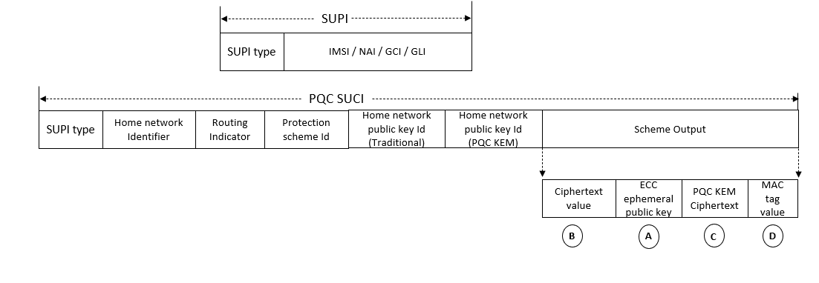
The SUPI is a globally unique 5G Subscription Permanent Identifier allocated to each subscriber in the 5G System. It is defined in clause 5.9.2 of 3GPP TS 23.501 [x1].
The SUPI is defined as:
- a SUPI type: in this release of the specification, it may indicate an IMSI, a Network Specific Identifier (NSI), a Global Line Identifier (GLI) or a Global Cable Identifier (GCI); and
- dependent on the value of the SUPI type:
- an IMSI as defined in clause 2.1 of TS 23.003 [74];
- a Network Specific Identifier (NSI), taking the form of a Network Access Identifier (NAI) as defined in clause 28.7.2 of TS 23.003 [74];
- a Global Cable Identifier (GCI) taking the form of a NAI as defined in clause 28.15.2 of TS 23.003 [74];
- a Global Line Identifier (GLI) taking the form of an NAI as defined in clause 28.16.2 of TS 23.003 [74].
NOTE: Depending on the protocol used to convey the SUPI, the SUPI type can take different formats.

The SUCI is a privacy preserving identifier containing the concealed SUPI. It is defined in clause 6.12.2 of 3GPP TS 33.501 [4].
The SUCI is composed of the following parts:
1) SUPI Type, consisting in a value in the range 0 to 7. It identifies the type of the SUPI concealed in the SUCI. The following values are defined:
- 0: IMSI
- 1: Network Specific Identifier (NSI)
- 2: Global Line Identifier (GLI)
- 3: Global Cable Identifier (GCI)
- 4 to 7: spare values for future use.
2) Home Network Identifier, identifying the home network of the subscriber.
When the SUPI Type is an IMSI, the Home Network Identifier is composed of two parts:
- Mobile Country Code (MCC), consisting of three decimal digits. The MCC identifies uniquely the country of domicile of the mobile subscription.
- Mobile Network Code (MNC), consisting of two or three decimal digits. The MNC identifies the home PLMN or SNPN of the mobile subscription.
When the SUPI type is a Network Specific Identifier (NSI), a GLI or a GCI, the Home Network Identifier consists of a string of characters with a variable length representing a domain name as specified in clause 2.2 of IETF RFC 7542. For a GLI or a GCI, the domain name shall correspond to the realm part specified in the NAI format for SUPI in clauses 28.15.2 and 28.16.2.
3) Routing Indicator, consisting of 1 to 4 decimal digits assigned by the home network operator and provisioned in the USIM, that allow together with the Home Network Identifier to route network signalling with SUCI to AUSF and UDM instances capable to serve the subscriber.
Each decimal digit present in the Routing Indicator shall be regarded as meaningful (e.g., value "012" is not the same as value "12"). If no Routing Indicator is configured on the USIM, this data field shall be set to the value 0 (i.e., only consist of one decimal digit of "0").
4) Protection Scheme Identifier, consisting in a value in the range of 0 to 15 (see Annex C.1 of 3GPP TS 33.501 [4]). It represents the null scheme, or a non-null scheme specified in Annex C of 3GPP TS 33.501 [4], or a protection scheme specified by the HPLMN; the null scheme shall be used if the SUPI type is a GLI or GCI.
5) Home Network Public Key Identifier (traditional), consisting in a value in the range 0 to 255. It represents a public key provisioned by the HPLMN or SNPN and it is used to identify the key used for SUPI protection. This data field shall be set to the value 0 if and only if null protection scheme is used.
6) Home Network Public Key Identifier (PQC KEM), consisting in a value in the range 0 to 255. It represents a public key provisioned by the HPLMN or SNPN and it is used to identify the key used for SUPI protection apart from traditional HN public key. Example of the PQC KEM Public key is ML-KEM [21] (selected by NIST standards).
Note: If the above 6 needs to be avoided, then it could be merged with 5 and sent as a bitmap, where the bits are set for those traditional and PQC identifiers (known at USIM and UDM). Example: 01 for traditional alone, 10 for PQC alone and 11 for both traditional and PQC.
So, the bitmap and public keys ID (traditional& PQC) needs to fit into 5).
Moreover this 6) is optional and present only when hybrid key exchange is available.
7) Scheme Output, consisting of a string of characters with a variable length or hexadecimal digits, dependent on the used protection scheme, as defined below. It represents the output of a public key protection scheme specified in Annex C of 3GPP TS 33.501 [4] or the output of a protection scheme specified by the HPLMN.
PQC KEM ciphertext: Post Quantum Cryptography Key encapsulation mechanism uses the PQC KEM public key of Home Network to generate the ciphertext.

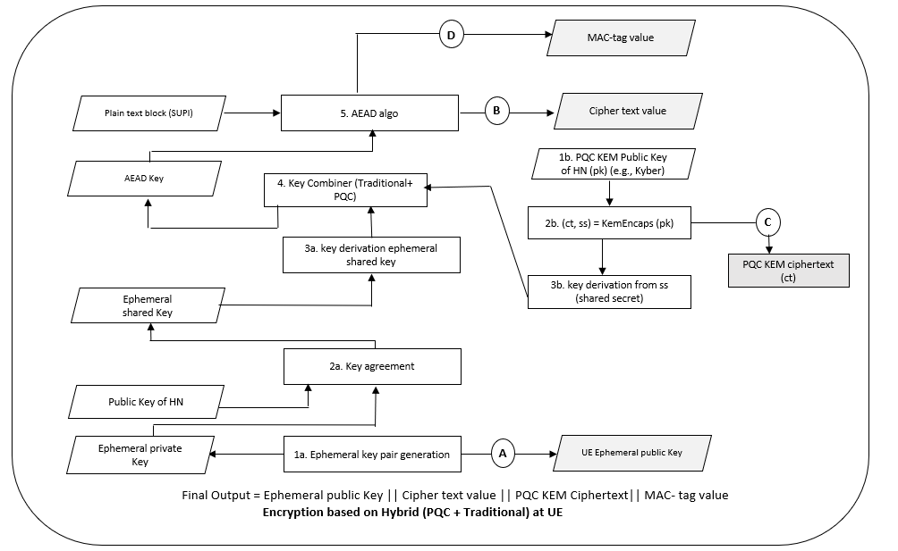
At UE, generate key pair (Ephemeral public key and private key) using key pair generation primitive. Based on the Diffie-Hellman primitive, a shared secret key element is derived (from public key of HN and generated ephemeral private key). PQC KEM ciphertext(ct) is generated using the Key encapsulation mechanism (asymmetric cryptographic scheme) where PK is PQC KEM public key of HN (PQC KEM public key is identified by PQC KEM public key ID and UDM/USIM has list of PQC KEM public keys). A PQC shared secret (ss) is also generated which is used as an input to a Key Derivation Function (KDF) to derive the final PQC shared secret.
Followed by that, key combiner function is used to combine the traditional shared key and newly generated final PQC shared secret (from the KDF function) to generate AEAD key K. With the derived key, symmetric encryption (AEAD) is performed to encrypt the plaintext block (SUPI) to generate the ciphered text and the MAC key.
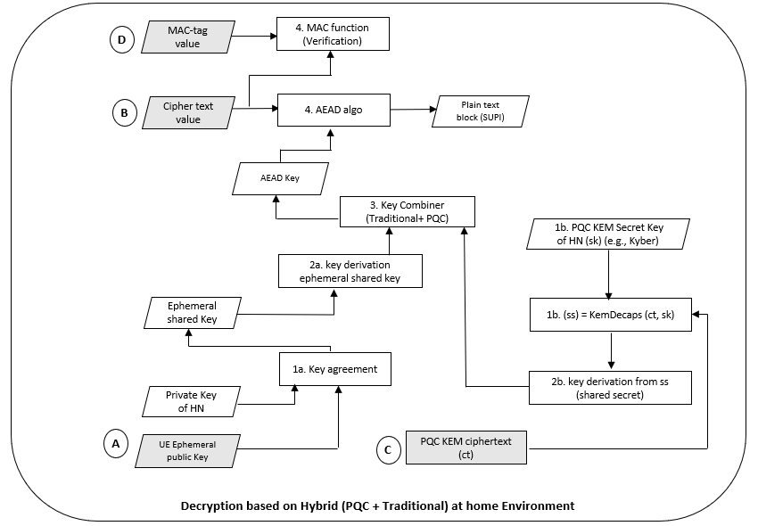
This hybrid PQC solution is making use of two separate HN identifiers, one for the classic (traditional) and yet another for the hybrid PQC. Consequently, at SIDF, the received UE ephemeral public key and stored private key of home network (Traditional HN public key ID is used to fetch the corresponding HN private key) is used to generate the ephemeral shared key. PQC KEM ciphertext(ct) is used along with the PQC KEM secret key of HN – SK (PQC Public key ID received from UE is used to fetch the Secret Key SK in HN), in Key decapsulation mechanism (asymmetric cryptographic scheme) to generate the shared secret. The newly generated shared secret is used along with the traditional ephemeral shared key as inputs to the key combiner function functions to generate AEAD Key. The generated AEAD Key is used to de-cipher the cipher text using symmetric decryption (AEAD). The expected MAC is compared against the received MAC, and with this comparison the integrity of the SUCI is verified.

7.2.1.Y.3 Evaluation
TBD
Editor’s Note: Further evaluation to be added.

* * * End of Changes * * * *

