**3GPP TSG-SA3 Meeting #124 draft_S3-253740-r2**

**Wuhan, China, 13 -17 October 2025 Revision of S3-253423**

**Source: China Telecom, ZTE**

**Title: Topology hiding in N9 interface**

**Document for: Approval**

**Agenda item: 5.2.4**

**Spec: 3GPP TR 33.758**

**Version: 0.0.0**

**Work Item: FS_PLMNNPN_Ph2**

**Comments**

This contribution proposes KI on topology hiding in N9 interface for SID on security for PLMN hosting a NPN phase 2.

**Proposed Changes**

* * * First Change * * * *

## 7.X Key Issue #X: Inter domain security on N9 interface

### 7.X.1 Key issue details

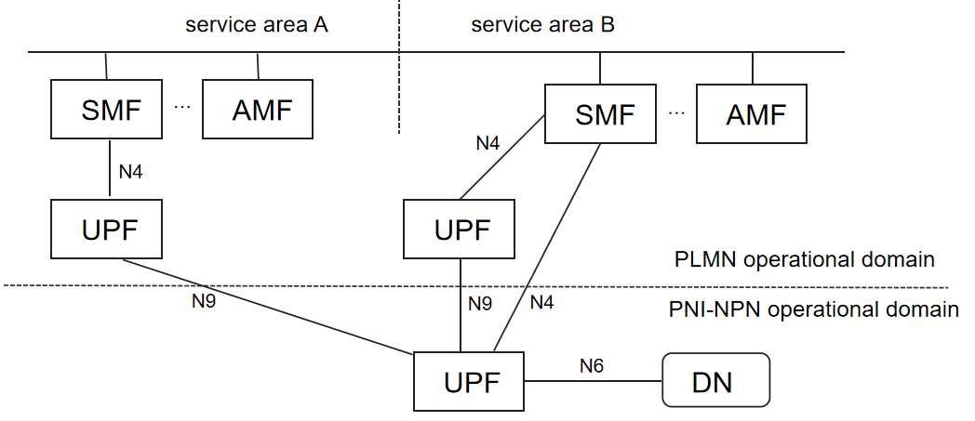

Figure 7.x-1 Scenario involving N9 interface

Considering the scenario depicted in Figure 7.x-1, attackers in PNI-NPN or PLMN operational domain (e.g., a misbehaving employee in PNI-NPN, PLMN or an external attacker gaining unauthorized access to the PNI-NPN or PLMN networks) can attack the opposing domain through the N9 interface.

TR 33.757 studied the intersection between the SMF and UPF and potential solution which could be used to improve resilience at the intersection. This KI proposes to improve the resilience of the N9 interface end points, when used to communicate over the intersection, without injecting new functions in the intersection nor change GTP protocol. As the N9 interface is key, in the home routed roaming architecture, improvements have already been standardized for the inter-PLNM which do not apply of the case of PLMN and NPN interconnection.

The KI aims to evaluate, whether existing security improvements for home routed roaming, can be reused for the case of PLNM interacting with an NPN and vice versa.

### 7.X.2 Security threats

When there is no security enabled on the N9 interface between PLMN operation domain and PNI-NPN operation domain, attackers in the PNI-NPN or PLMN operational domain can launch attacks to PLMN or NPN over the intersection.

### 7.X.3 Potential security requirements

The 5G system shall support a mechanism to protect the endpoints of the N9 interface between PLMN operation domain and PNI-NPN operation domain.

* * * End of Changes * * * *