**3GPP TSG-SA3 Meeting #124 draft_S3-253737-r1**

**Wuhan, China, 13 -17 October 2025 Revision of S3-253366**

**Source: China Telecom, ZTE**

**Title: Overview**

**Document for: Approval**

**Agenda item: 5.2.4**

**Spec: 3GPP TR 33.758**

**Version: 0.0.0**

**Work Item: FS_PLMNNPN_Ph2**

**Comments**

This contribution proposes overview for SID on security for PLMN hosting a NPN phase 2.

**Proposed Changes**

* * * First Change * * * *

# 2 References

The following documents contain provisions which, through reference in this text, constitute provisions of the present document.

- References are either specific (identified by date of publication, edition number, version number, etc.) or non‑specific.

- For a specific reference, subsequent revisions do not apply.

- For a non-specific reference, the latest version applies. In the case of a reference to a 3GPP document (including a GSM document), a non-specific reference implicitly refers to the latest version of that document *in the same Release as the present document*.

[1] 3GPP TR 21.905: "Vocabulary for 3GPP Specifications".

[2] 3GPP TS 33.501: "Security architecture and procedures for 5G system"

[3] 3GPP TR 33.757: "Study on security for a PLMN hosting a Non-Public Network (NPN)"

[y] 3GPP TS 23.501: " System architecture for the 5G System (5GS); Stage 2"

…

[x] <doctype> <#>[ ([up to and including]{yyyy[-mm]|V<a[.b[.c]]>}[onwards])]: "<Title>".

* * * Next Change * * * *

# 4 Overview

TR 33.757[3] has studied two scenarios of PLMN hosting a NPN, where the interface between PLMN operational domain and PNI-NPN domain is N4 or SBA interface.

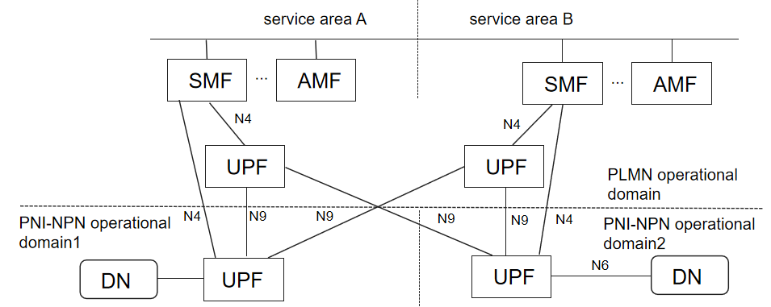

Figure 4-1 N9 interface across PLMN operational domain and PNI-NPN operational domain

In addition to the scenarios in TR 33.757[3], the interfaces between PLMN operational domain and PNI-NPN domain can include N9. Considering the scenario depicted in Figure 4-1, the dedicated UPF in PNI-NPN operational domain2 is controlled by SMF in service area B, and customers can access the DN through the UPF in service area A or the UPF in service area B depending on customers’ location. The situation is similar for the dedicated UPF in PNI-NPN operational domain1.

Editor’s Note: More clarification on the architecture is FFS.

In TR 33.757[3], the CP functions deployed in the PNI-NPN operational domain only consider AMF and SMF. However, more CP functions (except AMF, SMF, UDM) defined in TS 23.501 [y] are likely to be deployed in the PNI-NPN operational domain.

* * * End of Changes * * * *