**3GPP TSG-SA3 Meeting #124 S3-253710-r1**

**Wuhan, China, 13th – 17th October. 2025**

**Source: CATT**

**Title: New solution for Security of UE connection setup with Data collection NF**

**Document for: Approval**

**Agenda item: 5.2.6**

**Work Item: FS_AIML_CN_Ph2_SEC**

**Comments**

The contribution proposes to add a new solution for security of connection between UE and Data Collection NF.

**Proposed Changes**

* * * First Change * * * *

## 6.Y Soution #Y: New solution for Security of UE connection setup with Data collection NF

### 6.Y.1 Introduction

This solution addresses requirements of key issue on Security of UE connection setup with Data collection NF, particularly by hop-by-hop security. For authorization and user consent check between UE and data collection NF, it proposes detailed authorization checks against UE subscription data and operator policies at the data collection NF (DCF).

### 6.Y.2 Solution details

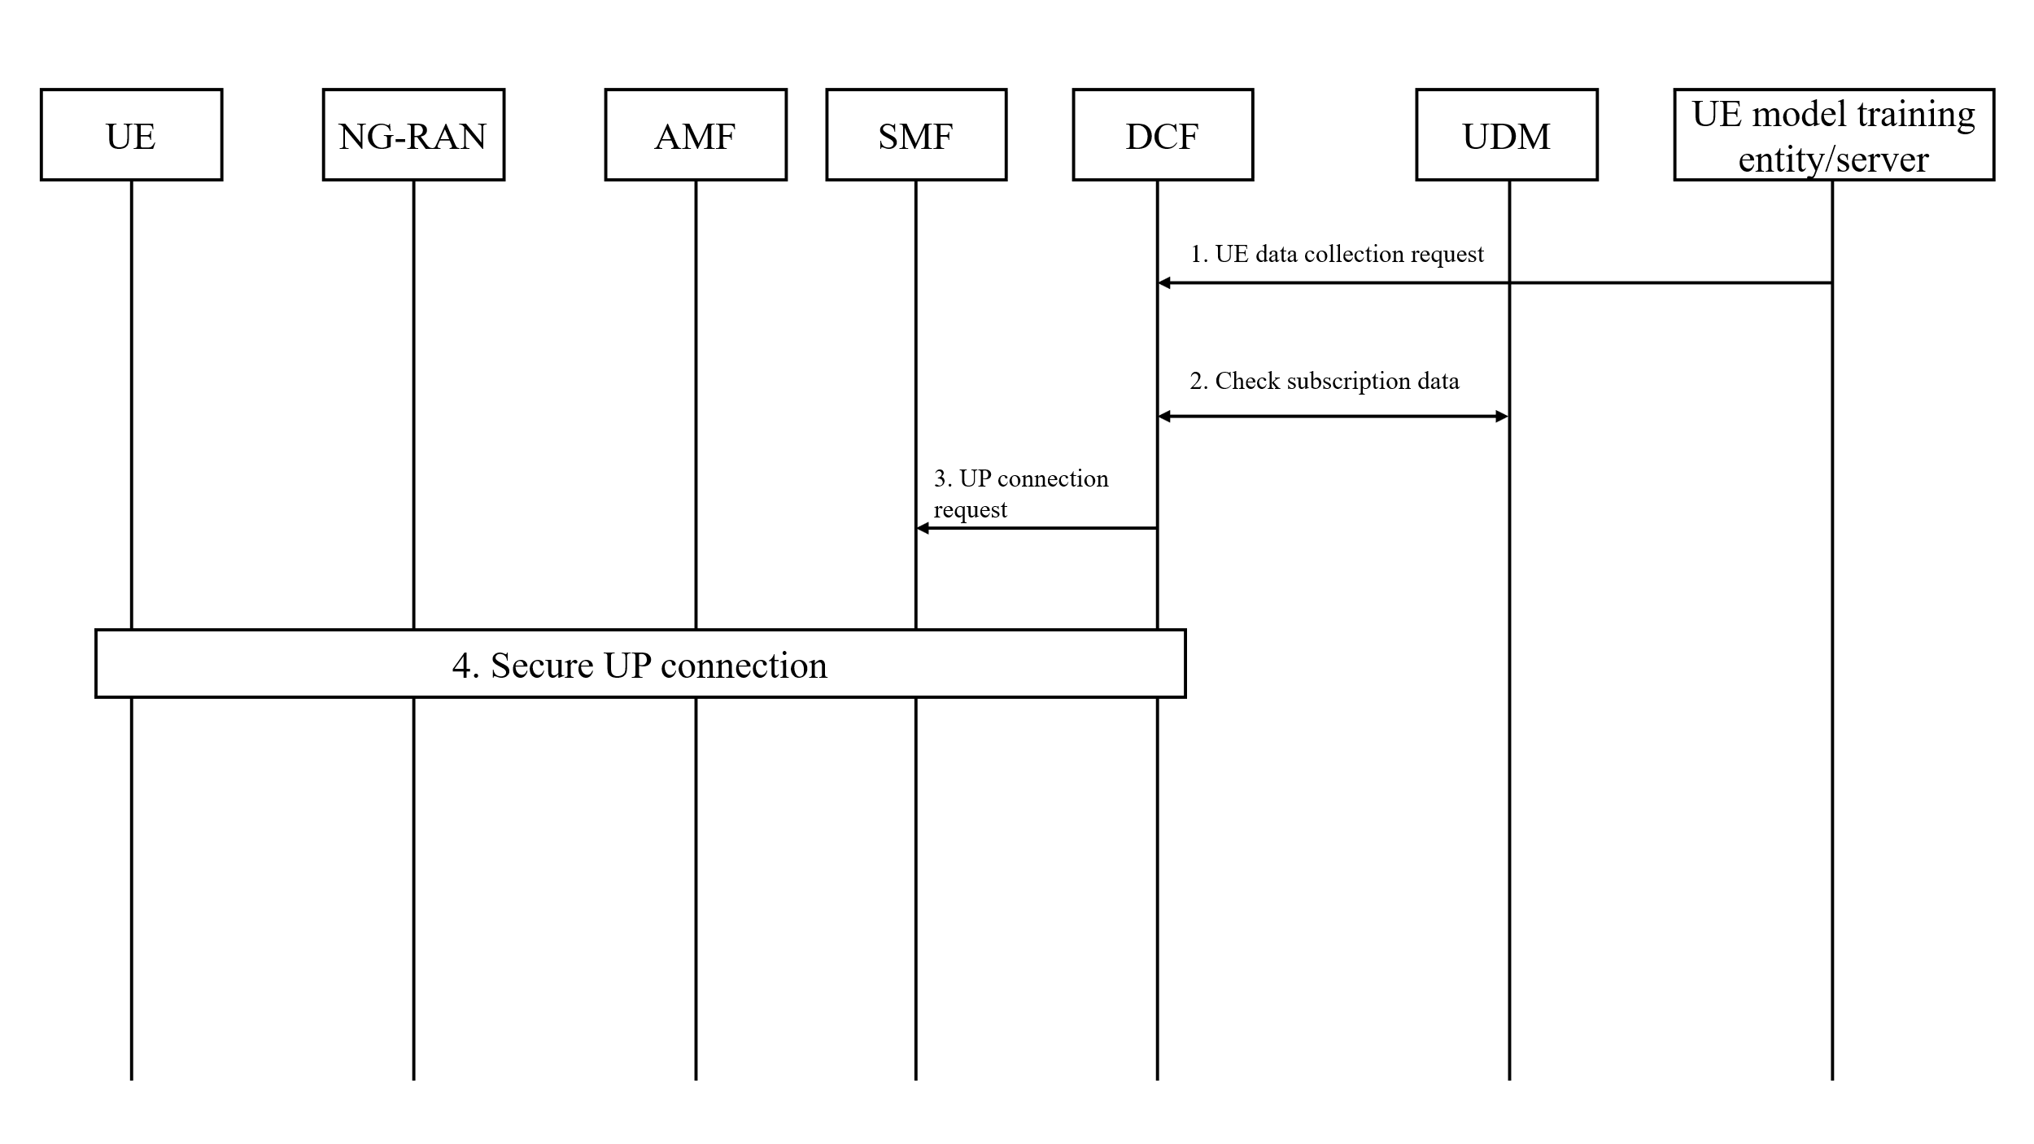

Figure 6.Y.2-1 Security of UE connection setup with Data Collection NF

1. The UE model training entity/server sends a request to the DCF to collect UE data for UE side model training.

2. The DCF checks subscription data for UE data collection and transfer from the UDM.

3. After successful authorization and user consent check, UE and UPF, DCF sends a request to SMF to establish a secure UP connection.

4. The procedure of secure UP connection shall reuse existing UP security mechanisms from TS 33.501 [x1] between UE and gNB, reuse exiting NDS/IP specified in TS 33.210 [x2] between gNB and DCF.

Editor’s Note: the authentication between UE and data collection NF is FFS.

Editor’s Note : Aspect related to user consent its application and enforcement in any form for UE data collection is FFS.

Editor’s Note: How the solution covers all the requirements of KI#1 is FFS.

Editor’s Note: How the UE perform data collection and its dependency on the solution is subject to SA2 progress

### 6.Y.3 Evaluation

TBD

* * * End of Change * * * *