3GPP TSG-SA3 Meeting #124 draft_S3-253266-r1

Wuhan, China, October 13 - 17, 2025 revision of S3-25yyyy

Source: vivo

Title: New Key Issue on Operational Sequence of AEAD
Document for: Approval
Agenda Item: 5.3.2

1 Decision/action requested
Approve the pCR on new key issue for TR 33.771.

2 References

3 Rationale
This contribution proposes a new key issue on operational sequence of AEAD.

4 Detailed proposals
Start of 1st Change

5.X Key issue #X: Operational Sequence of AEAD

5.X.1 Key issue details
The operational sequence for the AEAD algorithm follows a specific pattern: first, encryption is applied to the plaintext, transforming it into ciphertext. Subsequently, integrity protection is performed by generating a MAC from the already encrypted ciphertext, a method known as Encrypt-then-MAC (EtM).
In the realm of NAS protection, this sequence aligns with the process utilized by AEAD algorithms, adhering to the Encrypt-then-MAC approach to maintain the integrity of the data after encryption. Conversely, within PDCP protection, the process diverges from AEAD operation. Instead, PDCP employs a MAC-then-Encrypt (MtE) strategy, whereby integrity protection is performed first by generating a MAC from the plaintext, followed by the encryption of both the MAC and the plaintext (see figure below).
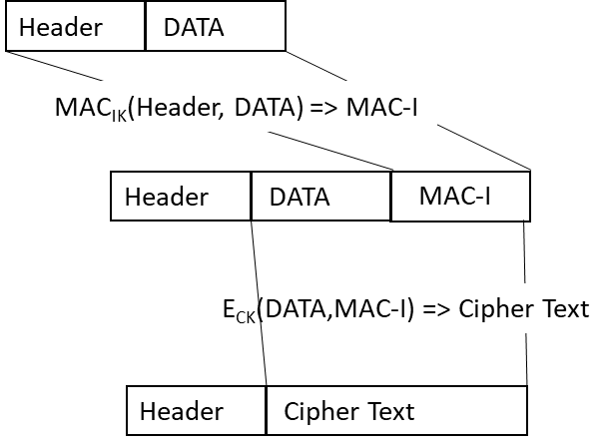
Figure 5.X.1-1. Legacy AS security protection with both ciphering and integrity protection
The differences in these operational sequences highlight the need for a careful evaluation when implementing these algorithms for AS Security.

5.X.2 Security threats
N/A.

5.X.3 Potential security requirements
N/A.
NOTE: Coordination with RAN is needed.
End of 1st Change

