3GPP TSG-SA3 Meeting #124 draft_S3-253260-r2

Wuhan, China, October 13 - 17, 2025 revision of S3-25yyyy

Source: vivo

Title: New Solution for Authorization for Sensing Service
Document for: Approval
Agenda Item: 5.2.7

1 Decision/action requested
Approve the pCR on new solution for 33.777.

2 References

3 Rationale
This contribution proposes a new solution for authorization for sensing service

4 Detailed proposals
Start of 1st Change

6.Y Solution #Y: Authorization for Sensing Service

6.Y.1 Introduction
This solution addresses requirements of key issue #1.
In this solution, existing SBA security framework is reused so that authentication and communication protection among sensing service consumer and NEF/SF can be protected using existing SBA mechanism, for authorization, NRF is deemed as authorization check point, and some specific criteria for sensing, e.g. sensing service, sensing location, is considered for sensing service authorization.

6.Y.2 Solution details
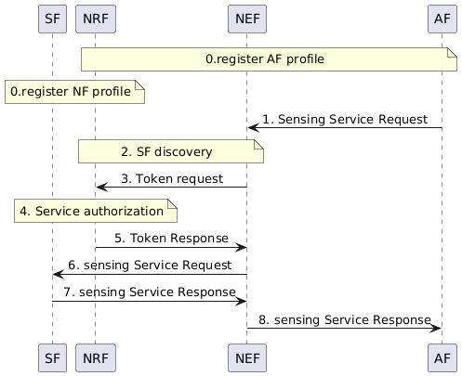
Figure 6.Y.2 - Authorization for Sensing Service
- SF, and AF registers on the NRF. The SF provides supported sensing services to the NRF. The SF may additionally provide allowed sensing location for the sensing service to the NRF.

External AF sends sensing service request to the NEF. The message includes the AF ID, the requested sensing services and optionally the requested sensing location for the sensing service.
- The NEF performs SF discovery procedure via NRF.
- The NRF performs service authorization, the NRF checks whether the Internal AF is authorized to access the SF, whether the requested sensing services are allowed for the AF, and optionally whether the requested sensing location for the sensing service is allowed.
- If it is authorized, NRF will issue access token and send it to the internal AF, and the access token claim includes AF ID, the allowed sensing services and optionally the allowed sensing location.
- The internal AF sends sensing service request to the SF. The message includes the access token, the AF ID, the requested sensing services and optionally the requested sensing location for the sensing service.
- After successfully verifying the access token, the SF performs sensing based on the allowed sensing services and optionally the allowed sensing location.
- The SF sends sensing service response including the sensing result to the internal AF.

- The NF sends sensing service response including the sensing result to the external AF.

6.Y.3 Evaluation
TBA

Editor’s Note: The evaluation will be made following SA2 conclusion.
End of 1st Change

