3GPP TSG-SA3 Meeting #124 draft_S3-254590-r3

Dallas, USA, 17 – 21 November 2025 (revision of S3-254117)

Source: Sateliot, Novamint
Title: EN removal for Solution #4 to Key Issue #1
Document for: Approval
Agenda item: 5.2.9
Spec: 3GPP TR 33.700-30
Version: 0.1.0
Work Item: FS_5GSAT_Ph4_SEC

1 Decision/action requested
Approve the pCR below

2 References

3 Rationale

This pCR is a revision of Solution #4 for Key Issue #1. The revision provides clarifications intended to address and remove the Editor Notes.
EN#1:
Editor’s Note: FFS whether the solution should also consider the use of the “SatelliteID” value as part of the NAS COUNT 32-bit value so that NAS count values are never reused.
The text has been revised to clarify that the proposed solution does consider the use of the SatelliteID as part of the NAS COUNT value. With these modifications, we propose to remove the EN.
EN#2:
Editor’s Note: How to address the wrap-around issue of independent COUNTs is FFS.
Before any of the pairs of NAS COUNT associated with each of the satellites wraps around, the MME is expected to trigger EPS AKA run to activate fresh NAS keys. This will result in an update of the EPS security context (with the fresh NAS key and reset of NAS COUNT values) that shall be propagated/synchronised across all MME-onboard(s) and associated MME-ground in the same way that this is done when the EPS security context is established for the first time.
The above explanation has been included in the text. With these modifications, we propose to remove the EN.
EN#3:
Editor’s Note: How to activate the security context between the SAT (e.g. SAT#2, SAT#n) and UE is FFS.
The activation of the EPS security context between the UE and the set of satellites of the S&F Monitoring List relies on (1) existing standardised procedures for EPS security context activation, which is conducted between the UE and one of the MME-onboard entities, and (2) propagation/synchronisation of the activated EPS security context to the set of MME-onboard(s) and associated MME-ground (note that procedures for the synchronization of UE context between the MME-ground and MME-onboard(s) is out of the scope of 3GPP). Accordingly, once the EPS security context is ready /synchronised in a MME-onboard, the UE and the MME-onboard can start interacting using a separate pair of NAS COUNTs. NAS COUNTs are assumed to be pre-set to zero in each MME-onboard(s).
The above explanation has been included in the text. With these modifications, we propose to remove the EN.
Indeed, we would like to stress that the above approach is already in line with the conditions captured in the description of the KI#1:
- The UE context of the UE registered in the network has been provided to the satellites included in the S&F Monitoring List;
- The UE can perform Mobile Originated (MO) or Mobile Terminated (MT) data transmission with the satellites that have the UE context;
- The UE context does not need to be synchronized across the multiple satellites for supporting the MO/MT data transmissions. However, UE context synchronization may still be required for other changes not being associated with the MO/MT data transmission.
EN#4:
Editor’s Note: FFS whether the capability to indicate the UE should use separate NAS counters per SatelliteID is optional or mandatory
The text has been revised to clarify that the support of separate NAS counters per SatelliteID is optional for both UE and NW. On this basis, a UE capable of using separate NAS counters per SatelliteID is expected to indicate this capability to the NW and the NW is expected to indicate the UE whether separate NAS counters are going to be used or not. In case the NW does not support or decides not to activate the use of separate NAS counters per SatelliteID, the UE shall assume that NAS counters are synchronised across the satellites of the S&F Monitoring List.
With these modifications, we propose to remove the EN.
EN#5:
Editor’s Note: Each solution should motivate how the potential security requirements of the key issues being addressed are fulfilled.
An explanation of how the security threats identified for KI#1 are accounted by the proposed solution has been added.
With these modifications, we propose to remove the EN.

4 Detailed proposal

* * * First Change * * * *

6 Solutions

6.4 Solution #4: Separate NAS COUNT pair per SatelliteID within an EPS Security Context

6.4.1 Introduction
This solution addresses Key Issue #1.
This solution is based on using separate pairs of NAS counters per Satellite ID in the EPS security context when the UE is served by multiple satellites operating in S&F mode and the UE registration remains valid even the serving satellite changes over time (i.e., the UE is not required to attach/detach in each satellite pass). The list of SatelliteID(s) in which the registration is valid is provided to the UE using the S&F Monitoring List.

6.4.2 Solution details
This solution applies to a satellite network operating in S&F mode and, it’s especially relevant for deployments based on the split MME architecture (see TS 23.402 Annex O.2) in which a UE registration remains valid across multiple satellites (unlike a full EPC deployment, where registration is only valid in one satellite).
The solution consists of enabling an option for the UE to use separate pairs of NAS counters (i.e. UL_NAS_Count and DL_NAS_Count) per SatelliteID within its EPS security context, where:
- SatelliteID is an identifier uniquely indicating an MME-onboard. The SatelliteID identifier of a given satellite is broadcast by the eNB within the SIB31 and the SatelliteID identifiers of the satellites that might be serving a given UE are included within the S&F Monitoring List, which is sent by the MME to indicate the satellite(s) that the UE may (re)-attempt NAS procedures (TS 23.401 clause 4.13.9.1)
- UL_NAS_Count is the uplink NAS counter related to the uplink NAS messages sent to the MME-onboard associated with SatelliteID.
- DL_NAS_Count is the downlink NAS counter related to the downlink NAS messages received from the MME-onboard associated with SatelliteID.
On the network side, this solution allows each MME-onboard to independently maintain its own pair of NAS counters, which shall no longer to be synchronised across the subset of the MME-onboard instances (identified each by a SatelliteID) that belong to the same logical MME in charge of the registered UE. This is depicted in Figure 6.Y.2-1, which is based on Figure O.2-1: "Split-MME" architecture for supporting Store and Forward Satellite operation for SMS and CP CIoT services” in Annex O.2 in TS 23.401.
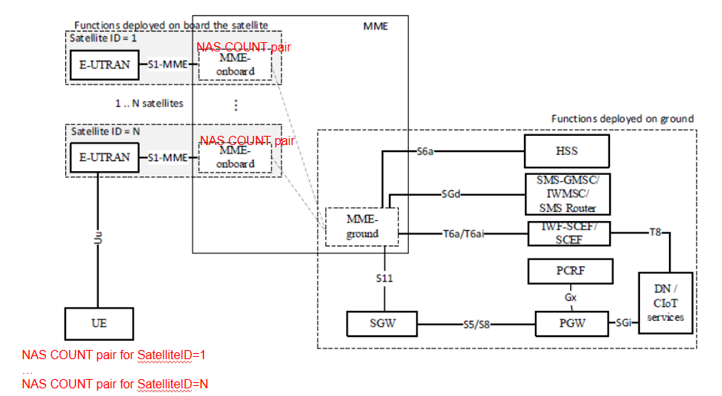
Figure 6.4.2-1: Illustration of the solution consisting on using separate NAS COUNT pairs per SatelliteID

To ensure backward compatibility with Rel-19 UEs, which will still assume that NAS counters are synchronised across the satellites of the S&F Monitoring List, the proposed solution can be introduced as an optional capability for both UE and network (NW). Therefore, a UE capable of handling separate NAS counters per SatelliteID is expected to indicate such capability to the NW and the network, if capable of handling separate NAS counters per SatelliteID, should be able to indicate the UE whether this option is activated (i.e. the UE should use separate NAS counters per SatelliteID) or deactivated (i.e. the UE shall assume NAS counters are kept synchronised). In case the NW does not support this capability, the UE shall assume that NAS counters are synchronised across the satellites of the S&F Monitoring List.
This solution also considers the use of the “SatelliteID” value as part of the NAS COUNT 32-bit value. In this respect, the padding bits of the NAS Count are filled with the SatelliteID, as illustrated in Figure 2, so that the NAS messages used between the UE and a given satellite cannot be replayed with another satellite given NAS COUNT values will not match.
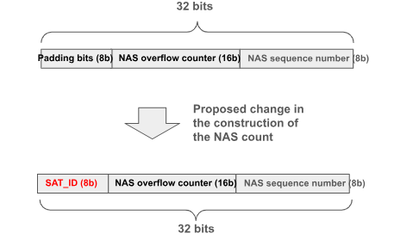
Figure 6.4.2-2: Filling NAS COUNT padding bits with SatelliteID

The activation of the EPS security context between the UE and the set of satellites of the S&F Monitoring List relies on:
(1) legacy LTE procedures for EPS security context activation as stated Annex N of TS 33.401, which is conducted between the UE and one of the MME-onboard entities, and,
(2) propagation/synchronisation of the activated EPS security context to the set of MME-onboard(s) and associated MME-ground, considering that how MME-onboard(s) interacts with MME-ground and how synchronization of the UE context between them is done is outside the scope of 3GPP, as stated in the principles of the split-MME architecture in 23.401 Annex O.2.
Accordingly, once the EPS security context is ready /synchronised in an MME-onboard, the UE and the MME-onboard can start interacting using a separate pair of NAS COUNTs. NAS COUNTs are assumed to be pre-set to zero in each MME-onboard(s).
Before any of the pairs of NAS COUNT associated with each of the satellites wraps around, the MME is expected to trigger EPS AKA run to activate fresh NAS keys. This will result in an update of the EPS security context (with the fresh NAS key and reset of NAS COUNT values) that shall be propagated/synchronised across all MME-onboard(s) and associated MME-ground in the same way that this is done when the EPS security context is established for the first time.

Editor’s Note: The establishment of AS security in this solution is FFS.

6.4.3 Evaluation

With this solution, the conditions listed in KI#1 can be met with no impact on the split-MME architecture principles. Also, existing EPS AKA and NAS SMC procedures can be reused with no impact.
The following impacts are needed:
- The EPS Security Context in the UE and MME needs to handle separate pairs of NAS COUNT per SatelliteID.
- A new NAS COUNT construction mechanism is needed to include the SatelliteID.
- To ensure backward compatibility, a new network capability and UE capability are needed to indicate support of satellite-specific NAS COUNTs.

The table below indicates how the security threats identified for KI#1 are accounted by the proposed solution.
Security threats (Section 5.2.2) | Mitigation
If the NAS COUNTs are not synchronized across multiple satellites, an attacker may intercept and replay previously transmitted NAS messages. Since different satellites may accept outdated NAS COUNT values, the replay protection mechanism could be bypassed, leading to unauthorized actions. | The NAS COUNT value includes the SatelliteID. This prevents reusing NAS COUNT values across the satellites.
Key stream may be reused if the security contexts are not well-managed across multiple satellites. | EPS security context across satellites are assumed to be always synchronized, excepting the NAS COUNT values which are independent for each satellite.  NAS COUNT values include the SatelliteID. This prevents reusing NAS COUNT values across the satellites and so reusing a key stream.

* * * End of Changes * * * *

