3GPP TSG-SA3 Meeting #125 Draft S3-254283-r2

Dallas, US, 17 – 21 November 2025

Source: Huawei, HiSilicon, Samsung
Title: Address ENs in Sol#6 of TR 33.700-30
Document for: Approval
Agenda item: 5.2.9
Spec: TR 33.700-30
Version: 0.1.0
Work Item: FS_5GSAT_Ph4_SEC

Comments
This proposal is to address ENs in Sol#6.

* * * First Change * * * *

6.6.2 Solution details
Based on the existing authentication procedures, this solution proposes to use different NAS keys when UE exchanges data with multiple satellites.

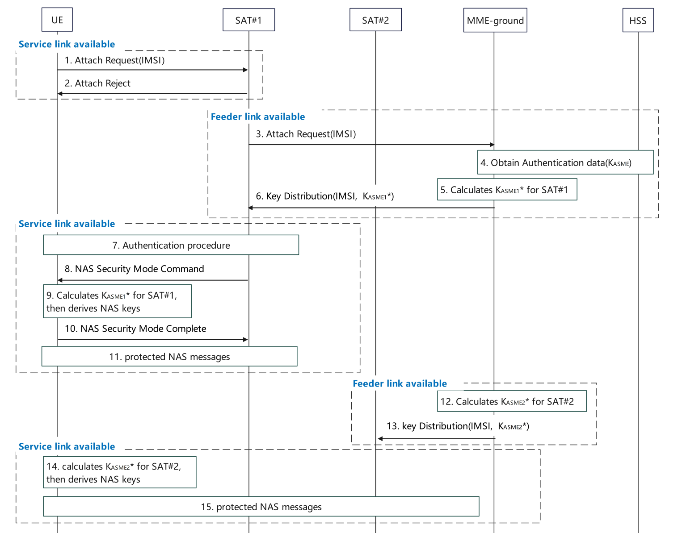
Figure 6.6.2-1 Enhanced NAS security for multiple satellites in S&F mode
SAT#1 has available Service Link.
- The UE sends the Attach Request to SAT#1.
- If SAT#1 does not have context to authenticate the UE, then sends the Attach Reject.

SAT#1 has available Feeder Link.
- SAT#1 sends the Attach Request to the MME-ground.
- The MME-ground obtains authentication data including K_{ASME}, as defined in TS 33.401 [3].
- The MME-ground determines to use SAT#1 to serve UE, then the MME-ground calculates K_{ASME1}* by using K_{ASME} and SAT Id of SAT#1.
- The MME-ground distributes K_{ASME1}* for SAT#1 during the transmission of AV.

SAT#1 has available Service Link.
- The authentication procedure is completed, as defined in TS 33.401 [3].
- SAT#1 derives NAS keys based on the K_{ASME1}* using existing mechanism as defined in TS 33.401[3] and sends the NAS security mode command integrity protected.
- The UE calculates K_{ASME1}* using the same method as the MME-ground in step5, and further derives the NAS keys using existing mechanism as defined in TS 33.401[3], then the UE verifies the NAS security mode command.
- If successfully verified, the UE sends the NAS security mode complete to SAT#1.
- After the NAS SMC procedure, the UE and SAT#1 send protected NAS messages.

SAT#2 has available Feeder Link.
- The MME-ground determines to use SAT#2 to serve the UE, the MME-ground calculates K_{ASME2}* by using K_{ASME} and SAT Id of SAT#2.
- The MME-ground distributes K_{ASME2}* for SAT#2. Then SAT#2 derives the NAS keys by using K_{ASME2}*.

SAT#2 has available Service Link.
- The UE establishes RRC connection with SAT#2 and calculates K_{ASME2}* using the method as the MME-ground in step12, and further derives the NAS keys by using K_{ASME2}*.
NOTE 1: The UE obtains the SAT Id of SAT#2 broadcast by the satellite SAT#2 to derive K_{ASME2}*.
- The UE sends a protected initial NAS message to SAT#2. The successful processing of the initial NAS message by the satellite SAT#2 activates the NAS key between the UE and the satellite SAT#2. The UE and SAT#2 exchange protected NAS messages.

NOTE 2: As described in TS 23.401[2], the MME-ground together with the associated MME-onboard(s) behave jointly as a single MME entity. For multiple satellites, assume MME-onboards have the same list of ordered NAS security algorithms. After NAS SMC, the selected NAS security algorithms could be synchronized for MME-onboards. Each satellite/UE pair maintains independent COUNTs.

NOTE 3: As Store-and-Forward satellite operations involve sparse, infrequent transmissions, spread across multiple satellites, COUNT wrap-around can only occur over a substantial amount of time. It is left to network policy to determine when the MME ground re-authenticates the UE to avoid COUNT wrap around.

NOTE 4: To secure NAS messages using different NAS keys during handover-like processes in Store-and-Forward satellite operations, the UE handles satellite changes as cell reselection events and performs a protected tracking area update procedure using NAS keys.
Editor’s note: The establishment of AS security in this solution is FFS.

* * * End of Changes * * * *

