3GPP TSG-SA WG1 Meeting #112 S1-254188r1
Dallas, USA, 17-21 November 2025 (revision of S1-253254)

Source: Nokia
pCR Title: New Use case on Energy-aware Network exposure considering UE preference
Draft TS/TR: 3GPP TR 22.870 v.0.4.1
Agenda item: 8.1.2
Document for: Approval
Contact: Laurent-Walter Goix

Abstract: This contribution proposes to introduce a new use case and requirements related to energy-aware Network exposure. Specifically, it introduces some evaluation of the amount of energy/carbon related to a specific API request, so it can be exposed by the provider and requested as criteria by the consumer. In addition, a UE preference is defined to temporarily avoid to impact the UE (e.g. collect data from it) when serving a service request via network exposure, which could drain the device battery.
Revision SA1#112 r1
- Fixed typos [TMO US]
- Added step 5 in service flows (to align with figure) [TMO US]
- Added ref to the figure in the text [TMO US]
- Added ref to TS 22.261 [TMO US]
- PR1: reverted to “temporarily exclude” vs “limit interactions” with the UE [Qualcomm, ZTE]. Clarified relationship with data collection at the UE [ZTE, Huawei] and that the requirement applies “during processing to satisfy requests” [Futurewei].
- PR2: replaced “system” with “network” [Qualcomm]
Revision SA1#112
- Reworded
  - “network API “ to “network exposure”
  - “involvment of the UE” with “interaction with the UE”
  - “fulfillment” with “serving”
- Clarified description and service flows
- Clarified that the UE preference has no impact on UE with regard to 3GPP services beyond network exposure
- Add examples beyond location (e.g. sensing, analytics, data collection in general)

---------- Use Case template ----------
FIRST CHANGE (new text)

5.8.x Use case on Energy-aware Network exposure considering UE preference

5.8.x.1 Description
5G provides several network services to third parties, like location services, quality on demand, network analytics such as connectivity insights through network exposure. Several new 6G services such as sensing, high precision positioning, data and AI-based services are envisioned in 6G, which could be also exposed by the 6G network to authorized third parties. These services may be energy intensive or trigger some interaction with the UE, e.g. to collect assistance data.
When Network exposure APIs are invoked by service consumers (e.g. AF, applications residing in the UE or enterprises/industrial applications), data from the UE (such as network performance measurements, MDT, sensing data, data for AI, etc) and different network domains (RAN, Core, OAM) may be required in order to serve the request. For example, a Location API request might be served using one of various methods such as DL-TDOA, which requires data from UE, while UL-AoA might not require data from UE. These have a direct impact on the energy consumption of the network and the UE, especially for repeated requests over long periods of time for e.g. tracking of IoT devices.

In addition, the network nowadays decides on its own whether to interact with the UE or not when serving a request based on the specific API (e.g. location API depending upon the positioning method used), on the consumer’s request parameters or on the producer’s internal logic. Network-UE interaction (e.g. collecting data from the UE by the network) can increase UE energy consumption, which may not be the user preference when e.g. the UE battery is low, due to privacy concerns, roaming situation or other scenarios.

5.8.x.2 Pre-conditions
John is managing the subscriptions and services related to the fleet of his company assets, including vehicles, smartphones, and various devices equipped with trackers displaced at various company locations, or rent to customers.
His operator provides him with a web portal to track the locations of the various assets and other information or statistics requiring some data collection at these UEs. The monthly fee he pays for this portal application service depends on the energy consumption induced in the network of the underlying network exposure services. In that sense, the portal provides him with some updated information about the energy consumption triggered by the monitoring of his assets, and various estimates so that John can decide on some configurations to optimize this energy consumption based on his own needs.
In that sense, John can set a preference to minimize the interaction with some of its UEs by network exposure services e.g. based on their battery level, battery saving mode, or roaming status. This preference has no impact on other services (e.g. communication service) provided by the network.

5.8.x.3 Service Flows
- John indicated to the network its UE preference settings for network exposure services. Such preference settings may be applicable for all or selected network exposure services.
- John’s asset monitoring web portal monitors the energy information (e.g. level of consumption, efficiency, CO2e etc) of the network exposure services requested from the web portal
- The network considers the UE preference to select the best method for serving the request and provides the estimated energy information (e.g. level of consumption, efficiency, etc) of the network and UE for serving this request. The level of energy consumption or carbon emission caused in the network can be abstracted (e.g. low, medium, high).
- If some energy related criteria are provided in the request from the web portal (e.g. John has asked the web portal not to use “high” energy consuming services in order to control his spending), the specified energy related criteria are considered by the network when selecting the method for serving the service request.
- (optional) Only if needed and if the UE preference allows, the network interacts with the UE (e.g. to collect data) in order to serve the external service request.
The service flows are illustrated in Figure 5.8.x.3-1.

Figure 5.8.x.3-1: Energy-aware Network exposure considering UE preference

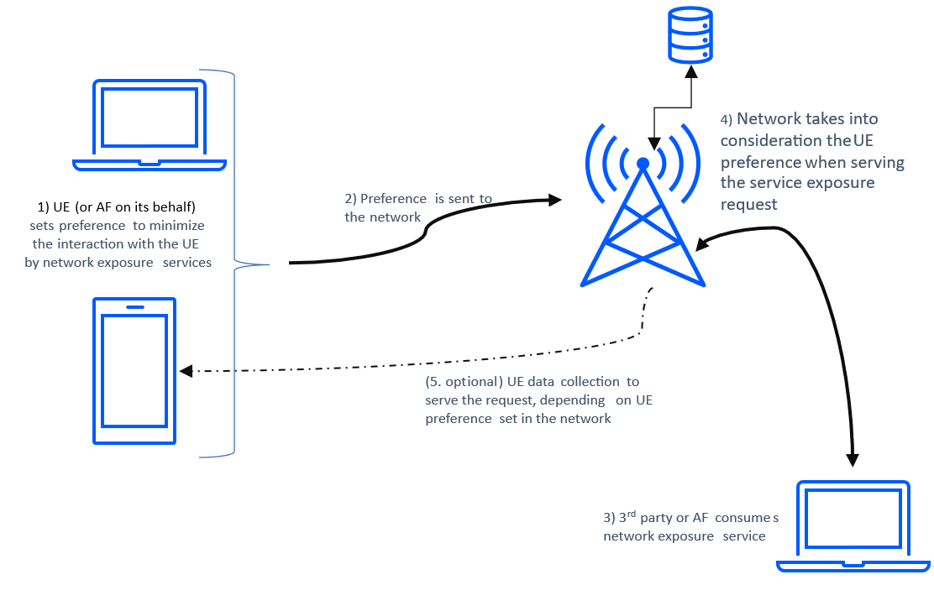

5.8.x.4 Post-conditions
John’s UE(s) preference settings can apply to all or selected network exposure services. The network takes into account John’s UE(s) preference settings for network exposure services as well as energy criteria to serve network services requests related to John’s UE(s).

5.8.x.5 Existing features partly or fully covering the use cases functionality
As specified in clause 6.10.2 of TS 22.261 [14], “Based on operator policy, the 5G network shall provide suitable APIs to expose various network capabilities to a trusted third-party”.
Network APIs offer the possibility to program the network and services to meet the needs of the end consumers. These APIs are being standardized by e.g. 3GPP via NEF/AEF, operational APIs by TMForum [r3] and service APIs by CAMARA [r1]. Such network services may be requested via Intents too.
CAMARA is an open-source project within Linux Foundation to define, develop and test simplified APIs that allow to access network capabilities. CAMARA works in close collaboration with the GSMA Operator Platform Group [r2] to align API requirements and publish API definitions. In addition, billable concepts/events in CAMARA API from GSMA Open Gateway Business Stream are defined.
SA6 is studying energy-related aspects in 5GA R20 although limited to the application enablement layer.

5.8.x.6 Potential New Requirements needed to support the use case

[PR 5.8.x.6-1] Subject to operator’s policy and regulatory requirements, the 6G system shall provide means (e.g. via a subscriber’s preference) to temporarily exclude data collection from the UE when processing requests to exposed network services from an authorized third party, without impacting other 3GPP services.
NOTE 1: A user can prefer that its UE(s) will not be involved (e.g. to collect data) when the network receives service exposure requests from authorized third parties due to e.g., low battery, privacy concerns, roaming status etc. Based on this preference, the network determines how to serve a request to an exposed network service, which can result degraded or not achievable if data from the UE cannot be collected.
[PR 5.8.x.6-2] Subject to operator’s policy and regulatory requirements, the 6G network shall provide means to provide an authorized third party with a prediction or estimation of the energy consumed and/or CO2e generated by a request to an exposed network service.
NOTE 2: The authorized third party can utilize such energy related information to adjust the service characteristics it requests from the network.
[PR 5.8.x.6-3] Subject to operator’s policy and regulatory requirements, the 6G network shall provide means to receive energy related preferences or criteria from an authorized third party as part of the request to an exposed network service (e.g. maximum energy or CO2e) and consider these preferences or criteria when serving this request.
SECOND CHANGE

2 References
The following documents contain provisions which, through reference in this text, constitute provisions of the present document.
- References are either specific (identified by date of publication, edition number, version number, etc.) or non-specific.
- For a specific reference, subsequent revisions do not apply.
- For a non-specific reference, the latest version applies. In the case of a reference to a 3GPP document (including a GSM document), a non-specific reference implicitly refers to the latest version of that document in the same Release as the present document.
Editor's Note: all References numbers to be corrected, missing references to be added
<< skip unchanged part >>

[r1] CAMARA, https://camaraproject.org/
[r2] GSMA Open gateway API, https://www.gsma.com/solutions-and-impact/gsma-open-gateway/gsma-open-gateway-api-descriptions/
[r3] TMForum API directory, https://www.tmforum.org/oda/open-apis/directory
END OF CHANGES

