3GPP TSG-SA WG1 Meeting #112 S1-254077r1
Dallas, USA, 17-21 November 2025 (revision of S1-25xxxx)

Source: Nokia, Orange, EDF
pCR Title: Update to sustainability overview
Draft Spec: 3GPP TR 22.870 v.0.4.1
Agenda item: 8.1.1
Document for: Approval
Contact: Laurent-Walter Goix

Abstract: This contribution proposes to add some introduction to the sustainability overview.
1. Introduction
Scope of this contribution is to provide an introduction to the various aspects related to sustainability which are already mentioned in various use cases of the TR, i.e. emissions, energy resources, material resources, TCO reduction, trustworthiness, inclusion & equality, health & well-being, education & culture, work & income, infrastructure, food.
2. Reason for Change
Several use cases mention various sustainability-related aspects/topics using the same terms. However these terms are not particularly introduced in the document, which may lead to misunderstandings to the reader. However there is no intention to provide a prescriptive formal definition of these terms.
This contribution aims at providing a breakdown of the overall “sustainability” into several underlying “aspects”; which are already referred to in the document. It also intends to better map with the UN SDGs as a target of 6G.

R1
- merged S1-254209, S1-254048, S1-254049 into this revision
- removed netzero timelines, updated “concrete levers” to “tangible actions”
- reworded reference to TS 22.261
- deleted some text from merged documents specific to the use case template (the rest of the text is copied as-is)
- proposed to rename clause 5.8 to “Energy-related aspects”
3. Conclusions
<Conclusion part (optional)>
4. Proposal
It is proposed to agree the following changes to 3GPP TR 22.870 v0.4.1
FIRST CHANGE

2 References
The following documents contain provisions which, through reference in this text, constitute provisions of the present document.
- References are either specific (identified by date of publication, edition number, version number, etc.) or non-specific.
- For a specific reference, subsequent revisions do not apply.
- For a non-specific reference, the latest version applies. In the case of a reference to a 3GPP document (including a GSM document), a non-specific reference implicitly refers to the latest version of that document in the same Release as the present document.
Editor's Note: all References numbers to be corrected, missing references to be added
[…]
[x1] Net-Zero Standard (https://sciencebasedtargets.org/net-zero) of Science Based Targets initiative (SBTi), a corporate climate action organization
[x2] Paris 2015 climate change agreement: unfccc.int/files/essential_background/convention/application/pdf/english_paris_agreement.pdf
[x3] Greening Digital Companies 2025 – monitoring emissions and climate commitments. ITU report. https://www.itu.int/en/ITU-D/Environment/Documents/Publications/2025/ITU-WBA-Greening-Digital-Companies-2025.pdf
[x4] The Impact of Networks in the Greenhouse Gas Emissions of a Major European CSP by Esteban Selva, Rony Bou Rouphael, Yuanyuan Huang, Nadia Mouawad, Guillaume Boudry, Xavier Parmantier, Azeddine Gati. https://hal.science/hal-04174678/file/final_The_impact_of_networks_in_the_greenhouse_gas_emissions_of_a_Major_European_CSP.pdf
[x5] NGMN alliance: Green Future Networks – Network Equipment Eco-Design and End-to-end Service Footprint : https://www.ngmn.org/wp-content/uploads/210719-NGMN_Green-future-Networks_Eco-design-v1.0.pdf
[x6] GHG protocol: https://ghgprotocol.org/sites/default/files/ghgp/standards_supporting/Diagram_of_scopes_and_emissions_across_the_value_chain.pdf
[x7] ISO 14006:2020 - Environmental management systems — Guidelines for incorporating ecodesign
[x8] C-MORE: Construction Material Opportunities to Reduce Emissions | US EPA

SECOND CHANGE

4.1 Sustainability
According to the United Nations, “Sustainable development is development that meets the needs of the present without compromising the ability of future generations to meet their own needs.” [29]
Many related target areas and actions are identified in the United Nations 17 Sustainable Development Goals (UN SDGs) [87], which are categorized into environmental, social and economic goals.
ITU-R has identified “the motivation for the development of IMT-2030 is to continue to build an inclusive information society towards contributing to support the United Nations Sustainable Development Goals (SDGs)." [27] "Sustainability is a foundational aspiration of future IMT systems. IMT-2030 is expected to help address the need for increased environmental, social, and economic sustainability”. [27]
More considerations on sustainability in 6G are provided in clause X.<Y>.
Editor's Note: this sub-clause on sustainability may be moved as another 4.x sub-clause or as normal text of the Overview clause.
THIRD CHANGE

5.8 Energy-related aspects

FOURTH CHANGE

X.<Y> Considerations on sustainability

X.<Y>.1 Sustainability aspects
6G as envisioned in this document considers sustainability aspects both in its own technological lifecycle (“Sustainable 6G”) and for its application across industries (“6G for sustainability”). In that sense, 6G can contribute to nearly all the 17 United Nations’ Sustainable Development Goals (UN SDGs), directly or indirectly, and benefit people, planet and the economy, as depicted in Figure X.<Y>-1.
Throughout this document, various use cases have been analysed in relation to their impact regarding sustainability. Potential impact can relate to benefits, or risks, introduced by the 6G features and services involved in the use case, which could be mitigated by 3GPP enablers. Some common terms have been used for these analyses in the various clauses of this document, which correspond to 11 sustainability aspects mentioned in Figure X.<Y>-1, further indicatively mapped to the related UN SDGs.
Figure X.<Y>-1: Sustainability aspects for 6G targeting UN SDGs
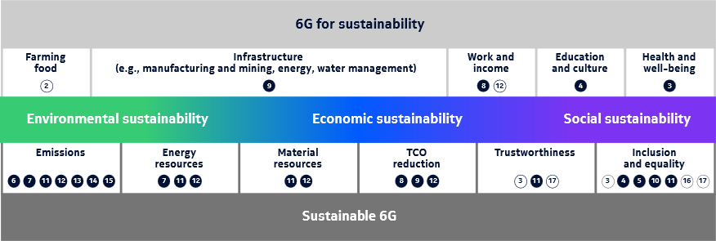
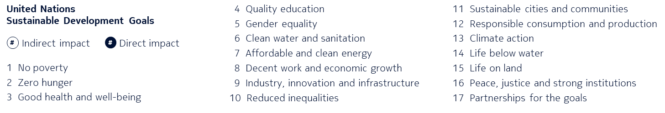

Each of the 11 sustainability aspects referenced in this document is described in Table X.<Y>-1.
Table X.<Y>-1: Description of sustainability aspects
 | Sustainability aspect | Description
Sustainable 6G | Emissions | to water, air, soil – including GHG/CO2e emissions, waste and other pollution
Sustainable 6G | Energy resources
Sustainable 6G | Material resources | including use of land, water
Sustainable 6G | TCO reduction
Sustainable 6G | Trustworthiness | including resilience, security, privacy, integrity
Sustainable 6G | Inclusion & equality | including affordability, accessibility
6G for sustainability | Health & well-being | including physical & mental well-being at individual and social/community level
6G for sustainability | Education & culture
6G for sustainability | Work & income
6G for sustainability | Infrastructure | including housing, transport, connectivity, energy, water, waste management
6G for sustainability | Food

X.<Y>.2 Network decarbonation
According to the Paris international treaty on climate change Paris agreement 2015 [x2], there is a target on holding "the increase in the global average temperature to well below 2 °C above pre-industrial levels" and pursue efforts "to limit the temperature increase to 1.5 °C above pre-industrial levels" to minimize the risk of far more severe climate change impacts, including more frequent and severe droughts, heatwaves and rainfall. To this end, the GHG emissions must peak before 2025 at the latest and decline 43% by 2030.
The ICT sector has its responsibility in achieving this target. According to International Telecommunication Union (ITU), estimates of the ICT sector's share of global carbon dioxide emissions vary across the literature ranging from 1.5% to 4% percent, with 1.4% increase in energy related emissions (scope 1 & 2), and 41% increase in value chain (also known as embodied) emissions (scope 3) since 2022 [x3]. Emissions related to telecommunication networks constitute 6% according to a study made by the French regulator [x4].
With this awareness, all sectors of industry in the supply-chain are concerned, such as transport, construction, telcos, … In the telco field, about around a hundred companies have committed to reaching net-zero emissions, with about half of them targeting the year 2040 and the other half targeting 2050 [x3]. Among them are the major telecom companies that have committed to net‑zero or carbon‑neutral targets, spanning both global operators and key regional players.
In response to the climate emergency and the Paris Agreement, the SBTi Net-Zero Standard [x1] aims to define a clear, robust and scientifically aligned approach for businesses to achieve net-zero by 2050. It is part of the need to limit global warming to 1.5 °C, ensuring that businesses contribute effectively to this objective.
In order to help these major telecom companies achieve their targets and contribute to the climate action, the GHG emissions related to the 6G network can for example follow the recommendations of the eco-design principles [x5] and in accordance with Net-Zero Standard. Embodied GHG emissions refer to the GHG emissions associated with the production (the extraction, transport and manufacturing) stages [x8].The eco-design principles span far beyond energy efficiency and energy consumption, and can be summarized as follows: life cycle consideration, minimize resource use, design for durability, design for disassembly, modularity and scalability, circularity, low environmental impact (less energy, less pollution, less water, less chemical use, …), resilience, design for energy saving, integration of renewable resources, plan for end-of-life, avoid hazardous/toxic substances in the supply chain, comply with the environmental standards [x7]. Increasing energy efficiency and savings in energy consumption are important and already exist in the eco-design principles but they are not sufficient for effectively reducing the embodied GHG emissions of the networks. Therefore, a holistic approach is needed in order to create an impact on the overall GHG emissions, comprising direct and indirect emissions (coming from the use of fuel and electricity respectively) and embodied emissions (coming from the manufacturing process) [x6]. Among the eco-design principles stated above, particularly those related to the life time extension can be impacted by 3GPP, such as modular design, effective obsolescence management (QoS management of the graceful degradation towards end-of-life), backward compatibility, preferred use of low embodied GHG and refurbished entities (through policies), definition of data models on lifecycle information and usage of these data for lifecycle extension without performance degradation, definition of new entities, interfaces and signaling on embodied GHG etc.
A possible operational strategy to meet the GHG emissions targets is to deploy RAN nodes powered by low-carbon energy sources. However, such deployments may need to be complemented by RAN nodes powered by carbon-intensive energy sources (e.g. diesel generators or grid) due to local constraints. Additionally, some RAN nodes whose main power source is decarbonized may require a backup energy supply that is carbon-intensive (e.g. diesel generator), and some RAN nodes may be powered by different energy sources over time, e.g. solar panels during the daytime and diesel generators at night.
Energy efficiency and energy saving features are in the already existing set of normative specifications. 5G specifications mainly focus on energy savings. These specifications also propose the exposure of information to allow awareness of CO2eq emissions induced by telcos services in TS 22.261 cl 6.15a and 7.13 [14]. If the intention is present, it remains very insufficient, offering no path towards emission reduction.
The scope of 6G works is larger than energy efficiency and energy savings, it spans the reduction of the embodied GHG emissions linked to 6G networks.
6G should address a focused set of sustainability and energy-efficiency use cases, aimed at reconciling environmental, social/societal and economic objectives across the full lifecycle of the 6G system. ICT’s GHG footprint is significant and growing. Networks and infrastructures are a major contributor. Against this backdrop, tangible actions—such as energy consumption reduction, AI-driven network optimization, circular economy principles (repair, reuse, refurbishment), hardware–software decoupling, equipment lifetime extension, infrastructure sharing, and integration with low-carbon energy—help operationalize this sustainability aim. The reconciliation between environmental, social/societal and economic objectives mentioned above explicitly addresses key trade-offs. These include performance and coverage versus emissions and TCO (Total Cost of Ownership), digital inclusion versus environmental impacts, and rapid deployment versus affordability and e-waste. It incorporates sustainability-based design (energy savings, privacy, safety, trust). It defines measurable outcomes (kWh/GB, site and subscriber kgCO2e across scopes 1–3, energy and spectrum efficiency, coverage quality, TCO, and inclusion indicators) to guide decision-making. This enables a credible path to Net Zero that preserves business viability and societal welfare.
END OF CHANGES

