3GPP TSG SA WG 1 Meeting #112 S1-254090r3
17-21 November 2025, Dallas, Texas, USA (revision of S1-254090r2r1, 4090, 3214)

Source: Xiaomi, ETRI
pCR Title: New use case on feasible intent achievement for AI agents
Draft Spec: 3GPP TR 22.870 V0.4.1
Agenda item: 8.1.3.2
Document for: Approval
Contact: Ruby Gong (gongyubing@xiaomi.com)

Abstract: This use case describes how a user uses his/her AI agent to send an intent to the network to request 3GPP services. Upon receipt, the network will evaluate the intent's feasibility. For the unfeasible intent, the network may provide alternative feasible intent(s) without a direct rejection. The user can also update the intent based on the alternatives. The network can also collect feedback from the user after task completion.

* * * All new text * * * *

6.X Use case on feasible intent achievement for AI agents

6.X.1 Description
With the rapid advancement and widespread adoption of AI technologies, AI service such as AI agents have become ubiquitously deployed across personal devices, evolving into indispensable intelligent companions in modern life. The AI agents now permeate various smart terminals including cell phones, wearable devices, vehicles, and home robots, fundamentally transforming human-device interaction paradigms.
The interoperability between AI agents across multiple personal devices creates a synergistic ecosystem capable of executing complex tasks beyond individual agent capabilities. For instance, heterogeneous devices belonging to the same user - despite variations in hardware specifications, operational contexts, and functional capacities - can form an intelligent collective through shared user subscription profiles and consent-based authorization frameworks.
The AI agents are able to provide the intent to request services on behalf of the user or subscriber. However, not all intents are feasible. By checking the feasibility of the received intent, the network can avoid wasting resources to achieve the task that is not supported by the network. This process can also help the AI agent of the user or subscriber to learn to provide feasible intent in the future.

6.X.2 Pre-conditions
Jack owns multiple smart devices, including a cell phone, a smart watch, and three smart speakers. Recently, Jack bought a car. All these devices have AI agents aboard. The AI agent can send intent to the network on behalf of the user.

6.X.3 Service Flows
As Figure 6.X.3-1 shows:
1. The network creates an AI agent group to store the information about all the AI agents belonging to Jack. Recently, Jack bought a car with an AI agent. Jack registered the AI agent on his car to the network, the network then added the car's AI agent to Jack's AI agent group. The information about the AI agent on his car is also stored in the network.
2. When Jack wakes up in the morning, his smart watch detects slight increases in body temperature, heart rate, and blood pressure. The AI agent on his smart watch infers that Jack is awake.
3. As part of his morning routine, Jack listens to the daily weather report. The AI agent on his smartwatch attempts to trigger the nearest smart speaker to play the weather update. The AI agent on his watch then sends an intent request to the network.
4. The network translates the received intent into service requirements checks the feasibility. Based on the stored information of Jack's AI agent, the network verifies that this AI agent belongs to Jack's AI agent group. The network retrieves the stored member information of Jack's AI agent group based on the provided group identifier. Based on the stored location of Jack's 3 smart speakers (speaker A, B, and C) and current location of Jack's watch, the network selects the smart speaker closest (e.g. speaker B). The network responds to the AI agent on watch with speaker B's information.
5. Upon receiving the response from the network, the AI agent on the watch delivers the weather announcement task to the selected speaker B's AI agent belonging to the same AI agent group via the network. The speaker B's AI agent then plays the weather report and provides outfit suggestions based on current trends and weather conditions.
6. Jack plans to drive from home to the shopping mall, and his phone's AI agent generates an intent and sends it to the network.
The network checks the feasibility of the intent. By comparing Jack's phone location with his car's positioning result, the network determines this task is currently unfeasible due to distance exceeds the service range. After the feasibility check of the received intent, the network can decide to negotiate the intent with the user if needed. Without rejecting Jack's request directly, the network provides an alternative solution: the network can first autonomously drive the car to Jack's home, and then drive Jack to the mall.
Jack then realizes his car is still parked 10km away at his company’s lot. He accepts the alternative solution provided by the network, and ask his AI agent to update his intent accordingly. The AI agent on his phone then sends an intent update request to the network.
7. After verification the feasibility of the update intent, the network delivers the feasible autonomous driving task to the AI agent on his car belonging to Jack's AI agent group.
8. Jack's car AI agent initiates the autonomous driving task. The AI agent on his car first requests positioning for Jack's cell phone, and sensing for Jack's car. As the car and cell phone belong to the same AI agent group, the network exposes the positioning results and sensing results to Jack's car AI agent. The AI agent integrates the information exposed from network and locally stored map information as input to the car's AI algorithm, enabling the car to autonomously drive to Jack's location and safely transport to the shopping mall.
9. Following the successful autonomous trip, the network queries his AI agent for feedback of the intent fulfilment. Satisfied with the alternative solution, Jack asks his AI agent to send positive feedback to the network.
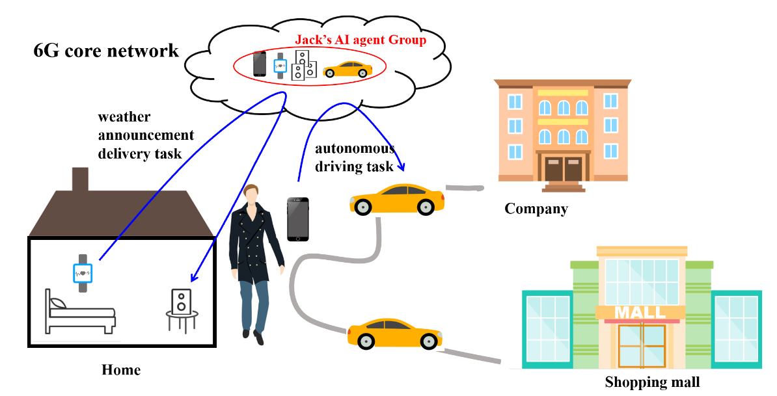
Figure 6.X.3-1 Feasible intent achievement for AI agents

6.X.4 Post-conditions
After shopping, Jack prepares to go back home. The AI agent on his cell phone understands his intention, and delivers another autonomous driving task to his car's AI agent through the network. The AI agent on his car transports him home successfully.

6.X.5 Existing features partly or fully covering the use case functionality
In clause 6.40 of TS 22.261 [14], the requirements related to AI/ML model training, inference, and data transfer are captured. However, for AI agents, the AI agents can send an intent on behalf of a user/subscriber. The handlings inside the network with the received intent are unclear.
For example, not all the intent received from the user/subscriber are feasible. The network needs to check the feasibility of the received intent, e.g. based on the capability of the network and historical results. This can avoid wasting resources to achieve the task that is not supported by the network. This process can also help the AI agent of the user or subscriber to provide feasible intent. After the feasibility check, the network can decide to perform other intent related handlings, e.g., intent negotiation, performance assurance, etc.

6.X.6 Potential New Requirements needed to support the use case

[PR 6.X.6-1] Based on the operator's policy, the 6G network shall support interactions between the 6G network and the user/subscriber (e.g. evaluating intent feasibility, negotiating the intent) to ensure the accurate understanding and efficient processing the intent received from the user/subscriber.

[PR 6.X.6-2] Based on the operator's policy, the 6G network shall support a mechanism to collect feedback from the user/subscriber about the 3GPP services provided by the 6G network based on the received intent, and perform adaptations if needed.

* * * End of new text * * * *

