**3GPP TSG-RAN5 Meeting #108 draft_R5-254907**

**Bengaluru, India, 25th- 29th Aug. 2025**

**Title:** Reply LS on requesting test Specification and procedures for NR-NR DC between FR1-FR2 devices in 3GPP 38.521-3

**Response to:** R5-253717 / S-25-096r3.zip

**Release:**

**Work Item:**

**Source:** TSG RAN WG5

**To:** GCF SG#103

**Cc:** GCF CAG

**Contact Person:**

#### Name: Jinwen Ma

**Tel. Number:**

E-mail Address: Jinwen.ma@verizonwireless.com

**Send any reply LS to: 3GPP Liaisons Coordinator,** [**mailto:3GPPLiaison@etsi.org**](mailto:3GPPLiaison@etsi.org)

**Attachments:** -

**1. Overall Description:**

In LS [1], GCF SG#103 requests test specifications and procedures for NR-NR DC between FR1-FR2 devices in 3GPP 38.521-3. Here is RAN5 feedbacks:

RAN5 follows RAN4 definitions regarding this aspect. It is stated in clauses 6.1 and 7.1 in [2] as follows. Same statements can be found in [3].

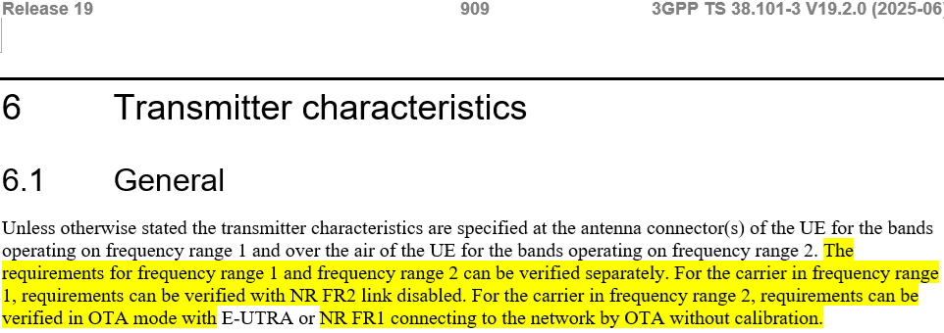

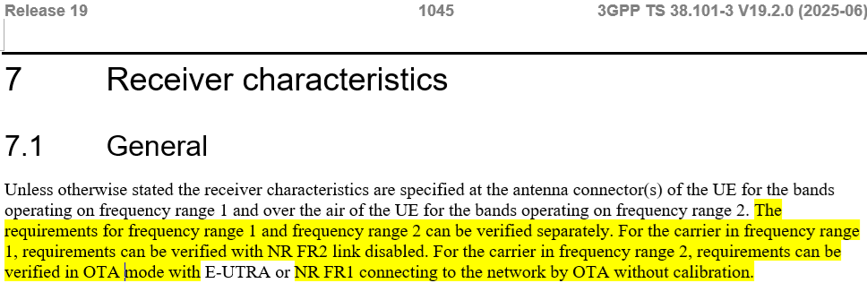

Highlighted statements indicate Testing between FR1 and FR2 for NRDC is not possible due to issues with combined testing of NR FR1 in conducted mode with NR FR2 in radiated mode.

RAN5 would like to also point out that the following test procedure descriptions in [3], which maps to the requirements of clause 6.2B.5.1.1 in [2] for NRDC between FR1 and FR2.

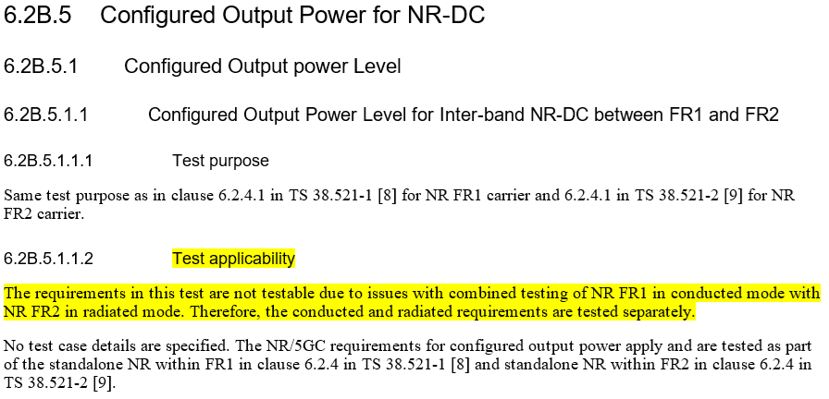

The test applicability for this test procedure states the same as of testing is not possible for NRDC between FR1 and FR2. There are no other test clauses covering NRDC between FR1 and FR2, if GCF requires similar descriptions for each test procedure in [3] for NRDC between FR1 and FR2, corresponding changes in specifications from RAN4 are necessary first before RAN5 can add test applicability updates for the same, which RAN5 doesn’t think is needed as combined testing of NR FR1 in conducted mode and NR FR2 in radiated mode is not possible for all tests.

**ACTION:**

No further action is required.

**2. References:**

1. R5-253717: LS on requesting test Specification and procedures for NR-NR DC between FR1-FR2 devices in 3GPP 38.521-3
2. 38.101-3: User Equipment (UE) radio transmission and reception; Part 3: Range 1 and Range 2 Interworking operation with other radios
3. 38.521-3: User Equipment (UE) conformance specification; Radio transmission and reception; Part 3: Range 1 and Range 2 Interworking operation