3GPP TSG-RAN WG4 Meeting # 119 R4-26XXXXX
Dalian, Liaoning Province, China, May 18th ‒ 22nd, 2026

Agenda item: 8.12
Source: Feature Lead (CATT)
Title: Ad Hoc for [119][111] 6G operation efficiency
Document for: Information

Introduction
The focus of the Ad Hoc will be:
- Issue 1-3: Documentation and TR skeleton (submitted to Joe in this meeting)
  - Issue 2-2-3: common drafting guidelines
  - Issue 3-3-2: Running CR approach
  - Issue 4-2-2: boundaries between spectrum and non-spectrum items.
  - Maybe also release independence
- Issue 4-1-1: spectrum/non-spectrum
- Issue 1-1-1: starting from the tentative agreement made online in the main session on Monday morning
- Issue 3-2-3: CR handling framework
- Issue 1-1-2: applicability to RF/RRM/Demod requirements
- Issue 2-3: Feature requirements structuring
- Issue 2-1: scoping
- Issue 2-7: RAN4/RAN5 interaction

Topic | Issues | Treated in this meeting (Y/N)? | Topic | Issues | Treated in this meeting (Y/N)? | Topic | Issues | Treated in this meeting (Y/N)? | Topic | Issues | Treated in this meeting (Y/N)?
#1 | 1-1-1 |  | #2 | 2-1 |  | #3 | 3-1-1 |  | #4 | 4-1-1
#1 | 1-1-2 |  | #2 | 2-2-1 |  | #3 | 3-1-2 |  | #4 | 4-1-2
#1 | 1-1-3 |  | #2 | 2-2-2 |  | #3 | 3-1-3 |  | #4 | 4-2-1
#1 | 1-1-4 |  | #2 | 2-2-3 |  | #3 | 3-2-1 |  | #4 | 4-2-2
#1 | 1-1-5 |  | #2 | 2-3 |  | #3 | 3-2-2 |  | #4 | 4-2-3
#1 | 1-1-6 |  | #2 | 2-4 |  | #3 | 3-2-3 |  | #4
#1 | 1-2-1 |  | #2 | 2-5 |  | #3 | 3-3-1 |  | #4
#1 | 1-2-2 |  | #2 | 2-6 |  | #3 | 3-3-2 |  | #4
#1 | 1-3 |  | #2 | 2-7 |  | #3 |  |  | #4
#1 | 1-4 |  | #2 | 2-8-1 |  | #3 |  |  | #4
#1 | 1-5 |  | #2 | 2-8-2 |  | #3 |  |  | #4
#1 |  |  | #2 | 2-8-3 |  | #3 |  |  | #4

Topic #1: General aspects
Main technical topic overview. The structure can be done based on sub-agenda basis.

Companies’ contributions summary
- 36 proposals in total on this topic.

Open issues summary
Before Meeting, moderators shall summarize list of open issues, candidate options and possible WF (if applicable) based on companies’ contributions.

Sub-topic 1-1
Sub-topic description: Handling of release independence
Open issues and candidate options before meeting:
Issue 1-1-1: Criteria on release independence for RRM, RF and Demod
- Proposals
  - Option 1: RAN4 should establish explicit criteria for determining whether a feature can be release-independent, namely that the feature has no signaling impact and no RAN1 impact. (Apple-P1, CATT-P2, vivo-P2, ZTE-P2, Huawei-P2@R4-2605763 under AI8.12.2)
    - Option 1a: FFS interpretation of no signaling/procedure impact, e.g., if early implementable of signaling/procedure is allowed. (vivo-P2)
    - Option 2a: A feature or configuration shall not be treated as release independent if its applicability in earlier frozen releases requires new or modified RAN1/RAN2 procedures, or new or modified interpretation rules for UE capabilities or configurations that the network must rely on in those earlier releases. (Huawei-P2@R4-2605763 under AI8.12.2)
  - Option 2: for the criteria of release independent in 6GR, it is proposed that urgent operator demand can be considered case by case. (CMCC-P3)
    - In NR, some important features with signaling impact, e.g. Rel-16 NR_HST, Rel-16 NR_perf_enh-Perf, Rel-17 NR_HST_FR1_enh, Rel-18 NR_demod_enh3-Perf, are release independent with RAN2 confirmation of early implementation without causing inter-operability issues.
  - Option 3: Release independence should be strictly restricted to spectrum-related topics. (Samsung-P1, Huawei-P1@R4-2605763 under AI8.12.2)
  - Option 4: Make it clear in RAN4 that one feature can be considered as release independent only when (OPPO-P1)
• it is spectrum related
• and only introduce band/BC-specific requirements
• and has no impact to generic core requirements or core spec in other WGs, e.g., shall has no signaling impact
  - Option 5: Following the MCC guidance on release independent handling in RAN4, only allow the band related feature in 3x.307. (Ericsson-P1)
- Recommended WF
  - Agree on the following explicit criteria for release independence:
    - No signaling impact
    - No RAN1 impact
    - Restricted to spectrum-related features
  - Alignment with outcome of Issue 1-2-1.
Tentative Agreement:
  - A feature X is defined as Rel-Y feature when the related requirements are specified within Rel-Y.
    - Feature X is defined as a release independent feature when it is supported from Rel-Z, where Z<Y.
  - The feature X which can be defined as the release independent is limited to
      - Spectrum related ones including
        - Band and band combinations
        - [Existing channel bandwidth to new band(s) and new BC]
        - [existing power class with the corresponding requirements specified (FFS VSAT types) to new bands and new BC]
        - FFS on others
      - Non-spectrum related ones: FFS
    - [NOTE: the request from operators other than the aforementioned features can be considered case by case if it is agreeable in RAN4. It is FFS on the procedure and RAN1 impact. ]
      - The feature referred in this agreement can include both spectrum and non-spectrum ones.
    - No RAN1 impact
    - It is FFS on the signaling related impact

Issue 1-1-2: Applicability to RRM, RF and Demod
- Proposals
  - Option 1: For 6G, RAN4 to adopt the same criteria as an eligibility filter for release independence consideration, applied uniformly to RF, RRM, and Demod. (Apple-P1)
  - Option 2: Only keep the RF specific feature, e.g. band, CA combo, power class etc in RAN4 release independent specification. (Ericsson-P2)
- Recommended WF
  - Option 1.

Issue 1-1-3: RAN4 release independence specification
- Proposals
  - Option 1: RAN4 to retain a dedicated Release Independence spec for 6G (TS 3x.307 equivalent), rather than distributing the release-independent content into the core specs. (Apple-P3, CATT-P1)
    - Option 1a: The 6G Release Independence spec to be maintained per-release, not as a single moving document covering only the latest release. (Apple-P4)
  - Option 2: If no dedicated release independent spec is considered, it is necessary to discuss where and how to capture the requirements to be fulfilled. (CMCC-P4)
- Recommended WF
  - Option 1.

Issue 1-1-4: If a dedicated release independence specification is used (i.e., similar to TS 38.307), how to maintain the spec in different releases?
- Proposals
  - Option 1: maintaining only the latest version of the specification. (CATT-P1)
  - Option 2: RAN4 to discuss release independent spec maintenance. (vivo-P3)
  - Option 2a: The release independent feature specs have different versions in different releases.
• Alt 1: The release independent feature is captured in each release from the starting release of the feature
• Alt 2: The release independent feature is captured only in the release the feature is introduced with clear information of introduced-release and early-implementable-release of each feature
  - Option 2b: Only one release independent spec with clear information of introduced-release and early-implementable-release of each feature.
• FFS version control method
• FFS whether differentiate requirements for spectrum, e.g., band/band combination, and requirements for non-spectrum early-implemented features."
  - Option 3: In 6GR stage, for release independent spec it is suggested to adopt a “latest release only” approach, while legacy band updates remain isolated within the legacy spec TS 38.307 in different releases. (ZTE-P1)
- Recommended WF
  - Check if Option 1 and Option 3 is agreeable.

Issue 1-1-5: Deciding a release independent feature
- Proposals
  - Option 1: The adoption of a feature as release-independent still remains a case-by-case RAN4 decision. (Apple-P1)
  - Option 2: RAN4 to discuss and decide that the release independent spec is for release independent band/band combination only, i.e., spectrum related, or for release independent features, i.e., non-spectrum features as well. (vivo-P1)
  - Option 3: Use of a backward-compatible capability-only indication, or reuse/clarification of an existing capability framework, does not by itself preclude release-independent treatment for RF/spectrum features or configurations within the primary scope, provided that the exclusion condition in Proposal #2 is not met. (Huawei-P3 @ R4-2605763 under AI8.12.2)
  - Option 4: Release-independent treatment is normally not needed for a feature whose earlier-release applicability is fully confined to RAN4 requirements. (Huawei-P4 @ R4-2605763 under AI8.12.2)
- Recommended WF
  - Agree on all above options.

Issue 1-1-6: Whether to present RAN4 conclusion to RAN Plenary on criteria on release independent features once concluded?
- Proposals
  - Option 1: After RAN4 conclusion is made on the criteria on whether one feature can be release independent, RAN4 shall present the conclusion in RAN-P for decision. (Samsung-P2)
- Recommended WF
  - Agree on Option 1.

Sub-topic 1-2
Sub-topic description: Handling of early implementation
Open issues and candidate options before meeting:

Issue 1-2-1: Considerations on features for early implementation and/or release independence
- Proposals
  - Option 1: In 6G, RAN4 consider defining the early implementation scheme for features that are not spectrum related. (OPPO-P3)
    - Option 1a: In 6G, the TSxx.307 spec should differentiate spectrum and non-spectrum features with release independent be applied only to spectrum features (band/band combination), and early implementation be applied to non-spectrum features. (OPPO-P5)
  - Option 2: When introducing new features with early implementation, RAN1/2 impacts need to be carefully checked and confirmed with them (OPPO-P7)
  - Option 3: For 6G, release-independence decisions follow feature ownership: RAN4 decides for RAN4-owned features (6G TS 3x.307 equivalent); RAN2 decides for RAN2-owned features (e.g. TS 38.331 Annex C). RAN2's mechanism does not transfer decision authority. (Apple-P2)
  - Option 4: It is suggested to handle features with RAN2 signalling impacts via the RAN2 “Early Implementation” concept, removing them from the RAN4 release independent scope in 6GR. (ZTE-P3)
  - Option 5: Use RAN2 release independent from Rel-N with early implementation concept for “release independent” feature instead of the 3x.307 if such feature has other working group impact, e.g signalling in RAN2 (Ericsson-P1)
- Recommended WF
  - Check if the following is agreeable
    - No overlapping between early implementation and release independence, i.e., a feature cannot be both early implementable and release independent (Aligned with Issue 1-1-1)
      - Early implementable features are only non-spectrum related.
      - Early implementable features have other working group impacts,

Issue 1-2-2: Interaction between RAN2 and RAN4 on early implementation
- Proposals
  - Option 1: RAN4 shall ensure that RAN2 is informed that if they agree upon early implementable signalling they shall inform RAN4 from which release the signalling is implementable (Nokia-P1)
  - Option 2: Whether a feature can be defined as early implementation need to cross check with RAN1/2. (OPPO-P4)
  - Option 3: For the early implementation features, consider split the work with RAN2:
• Captured in RAN2 TSxx.331 spec for the features that has signaling changes as is done today
• Captured in RAN4 TSxx.307 spec for the features that don’t have signaling impacts

- Recommended WF
  - Agree on Option 1
  - For Option 2/3, seek RAN plenary guidance.

Sub-topic 1-3
Sub-topic description: Documentation of RAN4 6G operation efficiency
Open issues and candidate options before meeting:
Issue 1-3: Documentation of the agreements reached in RAN4 6G operation efficiency discussions
- Proposals
  - Option 1: The dedicated document shall be produced to capture the corresponding the agreements for 6G specification efficiency related and the other specifical working procedures of 3GPP RAN4. (Xiaomi-P1)
  - Option 2: Capture the above agreements in RAN4 PRD to make it crystal clear and avoid debating in the future. (OPPO-P2)
- Recommended WF
  - Agree on a dedicated document to be created to capture agreements for 6G operation efficiency.
  - Discuss which of the following to be used together with Issue 2-2-3 (common drafting guidelines) , Issue 3-3-2 (Documentation for the running CR approach) and Issue 4-2-1 (boundaries between spectrum and non-spectrum items)
    - Option 1: 6G SID TR
    - Option 2: A dedicated PRD
    - Option 3: Some RAN4 specifications
    - Option 4: Any other?

Recommended AH Agreements:
- Capture all agreements for 6G operation efficiency in the 6G SID TR (Joe’s TR)
- The chapter skeleton:
X. Agreements on 6G RAN4 operation efficiency
X.1 General
X.2 Criteria on spectrum and non-spectrum items
X.3 Criteria on features claimed to be release independent
X.4 RAN4 running CR approach
X.5 Drafting guidelines for RAN4 specs
X.6 Other aspects

Sub-topic 1-4
Sub-topic description: Composite feature
Open issues and candidate options before meeting:
Issue 1-4: Applicability of agreed principles for composite features to RRM requirements
- Proposals
  - Option 1: For RRM requirement of the composite feature (Feature A+B), the proposed/agreed Principle 1 to 3 shall still be applicable (Samsung-P1)
- Recommended WF
  - Option 1.

Sub-topic 1-5
Sub-topic description: logistic issues for AI/ML
Open issues and candidate options before meeting:
Issue 1-5: Considerations on logistic issues for AI/ML
- Proposals
  - Option 1: For 6G AI/ML-enabled features, the following logistical aspects (which involves no technical discussion and not use-case specific) shall be discussed and treated in 6G operation efficiency topic: (Samsung-P3)
- AI/ML model format for sharing, e.g., ONNX
- AI/ML model and dataset naming rules
- Methods of sharing (including the current FTP-based method) by considering download/upload efficiency, the convenience for model/dataset update, and the availability of the location link for easy citation
  - Option 2: For 6G AI/ML-enabled features, RAN4 adopt an aligned approach to handle all logistical issues to name/share/store/update AI/ML model and dataset (Samsung-P4)
- Recommended WF
  - Agree to further discuss the following logistic aspects related to 6G AI/ML-enabled features in 6G operation efficiency thread under a dedicated sub-agenda item, which involves no technical discussion, and form an aligned approach to handle all logistical issues.
    - AI/ML model format for sharing, e.g., ONNX
    - AI/ML model and dataset naming rules
    - Methods of sharing (including the current FTP-based method) by considering download/upload efficiency, the convenience for model/dataset update, and the availability of the location link for easy citation

Topic #2: 6G specs enhancements
Main technical topic overview. The structure can be done based on sub-agenda basis.
FL: To focus the discussion in this meeting, those aspects/proposals common to RAN4 specifications are captured.

Companies’ contributions summary
- 124 proposals in total under this topic.

Open issues summary
Before Meeting, moderators shall summarize list of open issues, candidate options and possible WF (if applicable) based on companies’ contributions.

Sub-topic 2-1
Sub-topic description: Common scoping for all specs
Open issues and candidate options before meeting:
Issue 2-1: Functionalities, scenarios and use cases
- Proposals
  - Option 1: Define baseline RRM requirements for the most typical or practical use cases (some exceptions are allowed if there is strong demand from operators) (Apple-P2)
  - Option 2: For 6G specification enhancement, RAN4 should focus on basic functionalities and typical use cases and scenarios by avoiding corner cases. (CTC-P2).
  - Option 3: RAN4 can identify the basic functionalities and prioritize the 6G day1 typical cases’ requirements. (Xiaomi-P2)
  - Option 4: When defining RRM requirements, unrealistic cases/scenarios should not be considered which can be discussed case by case. (vivo-P3)
  - Option 5: For 6GR, RAN4 only define necessary RRM requirements for key features and procedures. (Samsung-P7)
- Recommended WF
  - Agree the common scoping for all RAN4 specs that RAN4 should prioritize basic functionalities and focus on typical, practical, and realistic use cases/scenarios.

Sub-topic 2-2
Sub-topic description: common drafting guidelines
Open issues and candidate options before meeting:
Issue 2-2-1: General drafting guidelines
- Proposals
  - Option 1: it is proposed that at least following aspects need to be avoided for RAN4 6GR specification (CMCC-P1@R4-2606061 under AI 8.12.1)
- Terminology/style inconsistency, incorrect notation/symbols/abbreviation, undefined abbreviations, redundant information/notes
- ‘TBD’, ‘FFS’, empty test cases
  - Option 2: The 6G Release Independence spec to apply the drafting principle: Rel-N requirements per Rel-N version, explicit identification of the requirements fulfilled by each release-independent statement. (Apple-P5@R4-2605595 under AI 8.12.1)
  - Option 3: In 6GR RAN4 spec, it is suggested to apply the following guidelines to table note drafting. (ZTE-P4@R4-2607028 under AI 8.12.1)
- Do not use NOTEs in tables for requirements that apply every cell/line or general requirements in the table. Use text above the table instead.
- If similar notes are to be introduced into a table, a more generic note description should be considered.
- If a note is intended for terminology, avoid having the note in the table if the terminology is defined in the clauses of symbols and abbreviations in the specification.
  - Option 4: It is proposed that the following guidelines be adopted for the use of abbreviations and symbols in the 6GR RAN4 spec. (ZTE-P5@R4-2607028 under AI 8.12.1)
- Abbreviations and symbols shall not be used arbitrarily in the main body without proper definition.
- The meaning of all abbreviations and symbols shall be consistent and unambiguous across the entire specification.
- Repeated definitions of abbreviations and symbols in the main body are unnecessary once they have been defined in Section 3.
  - Option 5: Organization of specification structure should be done jointly with UE RF/RRM/demod. (Nokia-P7)
  - Option 6: Study a methodology to align specifications created in parallel. (Apple-P8)
  - Option 7: Consistent and identical terminologies shall be used in RAN4 specifications. (Xiaomi-P4)
  - Option 8: Option 8: Avoid to introduce blank (sub-)clauses, or have some explanation at the beginning of the spec if the blank (sub-)clauses must be maintained. (CMCC-P2)
  - Option 9: Publish the rules of how to handle the ‘void’ in our spec, we have following suggestions about the rules: (CMCC-P7)
  - Option 10: The descriptions of test parameters should be aligned with RAN1/RAN2 descriptions as much as possible, in order to avoid ambiguous understanding. To this end, identifying negative examples from existing 5G specifications could help avoid repeating past mistakes. (CMCC-P10)
  - Option 11: The common test parameter can be introduced for text conciseness enhancement and document size management. (CMCC-P11)
  - Option 12: RAN4 should avoid to have any discriminating principle to a certain frequency range, such as “maximally re-use of NR 38.101-2 when creating FR2 requirements for 6GR”. (Samsung-P5)
- Recommended WF
  - Agree to apply common general drafting guidelines to all RAN4 specifications.
  - Further discuss details as general drafting guidelines which can be captured in a dedicated document.

Issue 2-2-2: Considerations redundancy free
- Proposals
  - Option 1: to avoid the duplication issue in the specification, it is proposed to consider following options: (CMCC-P2@R4-2606061 under AI 8.12.1, vivo-P9, vivo-P10)
- Option 1a: Add paragraph numbering to some paragraphs, and using these numbers to refer to identical paragraphs without any text changes.
- Option 1b: Block-based method, i.e. capture similar requirements just in one place and refer this part if needed.
- Option 1c: Introduce an applicability description in relevant sections and define different parameter values for each relevant parameter for the different scenarios, use cases etc.
- Option 1d: Uses block-based approach to define core requirements as much as possible (vivo-P9)
- Option 1e: Uses block-based approach to define test cases, especially for test setup (vivo-P10)
  - Option 2: In 6GR spec, RAN4 shall avoid duplication and repetition of UE requirements for different scenarios and use cases. (Xiaomi-P3)
  - Option 3: RAN4 to disucss guidance for requirements reference in RAN4 specifications, including applicability of newly introduced requirements in the referred clause. (vivo-P1)
- Recommended WF
  - Check if paragraph numbering is agreeable.
  - Check if block-based approach is agreeable.

Issue 2-2-3: Documentation of common drafting guidelines
- Proposals
  - Option 1: RAN4 to start documenting the drafting rules for writing the specification and CRs in an official document. (Nokia-P9)
  - Option 2: RAN4 should collect all drafting rules for writing the specification and CRs in a single document and publish it as a tdoc. (Qualcomm-P9)
  - Option 3: RAN4 should study whether further drafting principles should be defined to enhance the readability of the spec and should document the drafting principles (Qualcomm-P7)
- Recommended WF
  - Discuss together with Issue 1-3-1.

Sub-topic 2-3
Sub-topic description: Feature requirements structuring.
Open issues and candidate options before meeting:
Issue 2-3: Considerations on feature requirements structuring
- Proposals
  - Option 1: 6G MBB UE specification should include requirements for single carrier operation, CA, UL-MIMO and TxD anything else should go to another specification(s). (Nokia-P3)
  - Option 2: RAN4 should consider maximal re-use of NR 38.101-2 when creating FR2 requirements for 6GR. (Nokia-P4)
  - Option 3: Alternative way of writing a specification compared to suffix-method should be discussed for 6GR. (Nokia-P5)
  - Option 4: RAN4 to consider introducing compact tables to specify requirements corresponding to different complex applicable conditions. (CATT-P1)
  - Option 5: consider using the same heading level for all suffixes, including those representing composite features, so that all features specified using the suffix approach are visible directly from the top-level structure. (CATT-P2)
  - Option 6: RAN4 to consider introducing concatenated-letter suffixes at the top-level structure for a composite feature if the suffix approach is used to specify the requirements for the composite feature. (CATT-P3)
  - Option 7: The following alternatives can be considered in 6G to improve the specification readability in high level: (Xiaomi-P1)
• Option 7a: a single spec for all UE features
• Option 7b: the different sub-specs for common features and other vertical UE features, e.g. sidelink, NTN
• Option 7c: the different sub-specs for core, performance, TC separately.
  - Option 8: RAN4 should firstly discuss the specification style, and considers a template for requirements. (Xiaomi-P5)
  - Option 9: RAN4 should investigate a proper RF spec structure to specify the mandatory feature set and optional features, with clear applicability rules defined for each feature across different device types. (vivo-P12)
  - Option 10: The rules for combining of different features captured in R4-2602258 during RAN4#118 do not apply for RRM requirements. The feature combination impacts are discussed on the case-by-case basis (Ericsson-P8)
  - Option 11: The feature combination RRM impacts are discussed on the case-by-case basis also in 6G. (Ericsson-P9)
  - Option 12: Take TS 38.101-4 as a starting point, explore whether a more scalable architecture and straightforward applicability can be established from the beginning of 6G, if this proves unfeasible, consider alternative strategies to effectively incorporate new features and device types. (CMCC-P9)
  - Option 13: For UE RF specifications, RAN4 shall still maintain to use the suffix-approach for various features in one specification by default. (Samsung-P4)
  - Option 14: It is recommended to use the “Feature-sub-File approach” as the spec structure for RAN4 UE specifications in 6GR. (ZTE-P2)
  - Option 15: It is proposed to discuss how to capture common requirements (e.g. TRP measurement, EVM measurement, test mode/configuration, OTA test chamber) and test procedures across different network nodes specifications, where high similarity exists with only minor differences in items or notations. (ZTE-P6)
- Recommended WF
  - Discuss potential features supported in 6G Day 1, e.g., single carrier, CA, UL-MIMO, TxD etc.
  - Discuss the possible approaches for structuring requirements linked with a feature with a specific example, e.g., UL-MIMO)
    - Suffix approach
      - Heading level 1 or 2
      - Composite features
    - Sub-file approach
    - Other possible approaches
  - Discuss the structuring of specs considering
    - for mandatory and optional features
    - scalable architecture
    - applicability
    - common requirements and test procedures

Sub-topic 2-4
Sub-topic description: Tabular considerations
Open issues and candidate options before meeting:
Issue 2-4: Considerations on improving tables in specifications
- Proposals
  - Option 1: RAN4 to use JSON formatting in place of the legacy word tables for future tabular content included in future 6G RAN4 Demodulation Requirements TRs, at least covering the content test parameters (common or test specific), test number, minimum requirements, test applicability, and FRC. (Qualcomm-P10)
  - Option 2: RAN4 consider JSON format for the RF requirements, especially the ones which comprise large tables. (Apple-P1)
  - Option 3: It is proposed to maintain the 5G tabular format for A-MPR definitions and not to adopt JSON format as the primary maintenance format in 6GR stage. (ZTE-P1)
- Recommended WF
  - Further discuss the possible use of JSON for different requirements, e.g., A-MPR, Demod, etc.

Sub-topic 2-5
Sub-topic description: Auxiliary tools
Open issues and candidate options before meeting:
Issue 2-5: New auxiliary tools
- Proposals
  - Option 1: A new tool, if possible, is used to capture tabulated test setup in test cases. (vivo-P11)
  - Option 2: Explore the feasibility of developing an official calculation tool for FRC. (CMCC-P13, Samsung-P16)
- Recommended WF
  - Check with MCC to explore the feasibility of developing an official calculation tool for FRC.

Sub-topic 2-6
Sub-topic description: Specification modernization in RAN4
Open issues and candidate options before meeting:
Issue 2-6: Specification modernization in RAN4
- Proposals
  - Option 1: The general specification modernization works can be discussed and decided in RANP to identify the needs and feasibility first, before starting any trial/study in RAN WGs level. (Xiaomi-P2@R4-2605908 under AI8.12.1)
  - Option 2: RAN4 to use a database approach for the introduction and maintenance of performance requirements in 6G specifications. This would be natively supported if coupled with the previous proposal of JSON-based formatting approach of the performance requirements in the future 6G RAN4 Demodulation Requirements specifications. (Qualcomm-P11)
  - Option 3: RAN4 to scope usage of Markdown-based language for the drafting and maintenance of the performance specification. (Qualcomm-P12)
  - Option 4: RAN4 to collect drafting file format proposals from the companies for 6G Spec and then create drafts in the 3GPP Forge for delegates to comment and evaluate. (Qualcomm-P13)
  - Option 5: RAN4 to choose one clause or subclause in the existing specification (e.g. one or more subclauses in 5.2.2.2 in TS 38.101-4) and encourage companies to reformat the existing material in the proposed file format. (Qualcomm-P14)
  - Option 6: the band combination database should : (CMCC-P1)
• Include all band combination specific RF requirements
• Continuously update for every future release
• Support the integration of specific calculation formulas to enable the automated derivation of RF requirements, e.g. MSD, TIB, RIB based on UE RF requirements conclusion
• Support the integration of auto checking tool, e.g. for the check of fallback combination
  - Option 7: Based on the outcome form specification modernization study, RAN4 can consider to use markdown language for FRC and/or other part of RAN4 demodulation requirement (Samsung-P14)

- Recommended WF
  - Seek for RAN plenary guidance on whether / when to start any trial/study in RAN4 with regards to specification modernization.

Sub-topic 2-7
Sub-topic description: RAN4/RAN5 interaction and scoping.
Open issues and candidate options before meeting:
Issue 2-7: RAN4/RAN5 interaction and scoping
- Proposals
  - Option 1: We propose to discuss between RAN4 and RAN5 whether in 6GR RAN4 could focus on the scope and framework for defining RRM performance tests and RAN5 could specify the detailed parameter configurations of the RRM performance tests. (Qualcomm-P1)
  - Opiont 2: The exact test configurations and test cases should be determined by RAN5, in coordination with RAN4 as needed, considering field relevance and feature adoption considerations. (Qualcomm-P3)
- Recommended WF
  - From FL’s perspective, Option 1 is a plenary topic.

Sub-topic 2-8
Sub-topic description: Miscellaneous issues
Open issues and candidate options before meeting:
Issue 2-8-1: FRC table and case numbering
- Proposals
  - Option 1: Address the FRC table/FRC numbering issue as part of a broader CR handling improvement. (CMCC-P14)
- Recommended WF
  - Discuss FRC table and case numbering in CR handling.

Issue 2-8-2: Maintenance handling
- Proposals
  - Option 1: For both UE and RF specifications, RAN4 shall still maintain multiple releases, while only keeping one (latest) release will undermine the foundational principle of release-specific standardization. (Samsung-P2)

- Recommended WF
  - Agree on Option 1.

Issue 2-8-3: test mode application
- Proposals
  - Option 1: Assume in the study item that evaluations are applicable for all environmental conditions with no test mode applied (Qualcomm-P15)

- Recommended WF
  - Check if Option 1 is agreeable.

Topic #3: CR handling
Main technical topic overview. The structure can be done based on sub-agenda basis.

Companies’ contributions summary
- 38 proposals in total under this agenda item.

Open issues summary
Before Meeting, moderators shall summarize list of open issues, candidate options and possible WF (if applicable) based on companies’ contributions.

Sub-topic 3-1
Sub-topic description: Definition of RAN4 running CR approach including CR classes, roles
Class | Target | Essential nature
A. Running Big CR | New-feature WI | Specification impact differs feature by feature.  Affected clauses/tables become clear as technical agreements mature.  Default: feature-level editor-owned running document.
B. Basket Big CR | Basket WI / band combinations | Impacted sections, tables and database fields are largely predefined or recurring.  Main task is consolidation and validation of entries or values.  Detailed mechanics should follow database / JSON operational experience.
C. Residual maintenance handling | Existing-spec defects | Not aligned with a feature lifecycle.  Default artifact may remain individual CR or individual draftCR.  Focus on prevention, triage and periodic spec-wide consistency review.

Role | CR-handling responsibility
Big CR editor | Maintains the feature-level Running Big CR.  Prepares and updates the draftCR-formatted running document based on explicit RAN4 agreements and endorsed drafting inputs.  Maintains input traceability and feature-level consistency of terminology, notation, references, suffix usage, applicability conditions and wording.  May request section-level drafting support when needed, but remains responsible for feature-level CR consistency.
Section drafter, when needed | Provides section-level drafting support within the Running Big CR.  Checks that agreed technical content is correctly, clearly and unambiguously reflected in the assigned section.  Does not decide technical content and does not replace the Big CR editor’s feature-level consistency responsibility.
Companies | Submit technical contributions and review comments.  Provide proposed wording, diffs or alternative text against the editor-updated Running Big CR.  Do not normally submit separate standalone draftCRs for the same UE RF feature unless requested by the Big CR editor / Chair or needed for a clearly separable alternative.

(Courtesy of R4-2605764 Huawei)
Open issues and candidate options before meeting:
Issue 3-1-1: Definition of RAN4 running CR approach
- Proposals
  - Option 1: RAN4 to adopt the following definition for the RAN4 running CR approach: (CATT-P1)
    - A running CR is a RAN4 working document associated with an ongoing work item or study item, typically in the form of a draft CR linked to the RAN4 specification impacted by that work or study item. The running CR is continuously updated according to the agreements reached in each working group meeting for the corresponding work item or study item. Once all technical work has been completed at the conclusion of the work item or study item, the running CR is converted into a formal CR for the impacted specification.
  - Option 2: (ZTE-P2)
RAN4 Adaption:

7.2.6 Running CRs (Applicable to RRM domain only)
A running CR is a concept adopted in RAN4 specifically for RRM speifications. It is a draftCR (which can also be submitted as a CR) that collects all changes needed to introduce a feature or refine performance requirements. Typically, a running CR gathers the necessary changes over several RAN4 meeting periods and is submitted as a "real" for agreement just before a release freeze. This approach is not applicable to RF specifications, where the Draft BigCR mechanism is retained to ensure hardware stability.
A running CR in RAN4 is typically a cat B, cat F or cat A CR.
Since a running CR is a working document for RRM, the coversheet details do not need to be strictly enforced in intermediate versions. The following text provide some guidelines, but it is up to the running CR rapporteur to decide how to use these guidelines.
Comments by the editor (i.e. Editor's Notes) can exist in running CRs though it is up to the running CR editor to decide if they are used. Editor's Notes should be removed from the final CR. That is, frozen specifications should not have any Editor's Notes in them anymore. If the specification rapporteur believes there are still open issues requiring further discussion, it is possible to create a separate open issues list into which the existing Editor's Notes can be transferred.

To prevent specification version drift, the running CR editor should submit a new endorsed version of the running CR before each meeting. This endorsed version serves as a controlled, shared intermediate baseline for all contributors. It should contain only revision marks from a single user; or if the running CR editor had made further changes over the endorsed version such as fixing typos or adding some parameters, those should be shown with a different set of revision marks (i.e. a different user). Further changes during the meeting should be added with different revision marks (using company names). This can lead to changes-on-changes and it is up to the rapporteur to decide how the endorsed version shows these. However, changes on changes and multiple different revision marks should be removed by the rapporteur submission to the next meeting.
Running CRs can be either of type draftCR or CR. However, the running CR type should not be changed back and forth during its development path. The final submitted version should be of type CR though.

  - Option 3: Definition of RAN4 running CR approaches (Apple-P2)
• A running CR is a draftCR which contains [all] changes needed to introduce a feature to a specification. When all work is done for the feature, the running CR(s) are then submitted as a formal CR for agreement in RAN4.
• A running CR is typically a cat B or cat C CR.
• Since a running CR is a working document, the coversheet details do not need to be strictly enforced in intermediate versions. However, it is better to summarize the changes/agreements made after each RAN4 meeting.
• A running CR can be applied to either 5G WIs or 6G WIs.
- Recommended WF
  - Further discuss a formal definition of the RAN4 running CR approach by starting from the combination of all options.

Issue 3-1-2: Variation according to different CR classes
- Proposals
  - Option 1: RAN4 should distinguish the above three classes and should not force them into a single common CR handling procedure (Huawei-P1)
    - Running bigCR
    - Basket Big CR
    - Residual maintenance CR
- Recommended WF
  - Focus on running CR approach in this meeting, and postpone this issue to the next meeting.

Issue 3-1-3: Roles involved in RAN4 Running CR approach
- Proposals
  - Option 1: For UE RF new-feature Running Big CRs: (Huawei-P2)
➢ The Big-CR editor should maintain the feature-level Running Big CR and ensure consistency of terminology, notation, assumptions, references, suffix usage, applicability conditions, and wording within the final CR(s) for that feature.
➢ A section drafter, when needed, may support section-level drafting by checking that agreed technical content is correctly, clearly, and unambiguously reflected in the assigned section.
➢ The Spec editor role should be treated as a specification-wide consistency review function, independent of the Lane A operational workflow.
  - Option 2: Rapporteur(s), Co-Rapporteur(s) or other experts could be designated as responsible persions for running CRs. (CATT-P4)
  - Option 3: Feature rapporteur(s) can take the lead. If needed, more than one running draftCR can be created to share the work. (Apple-P2)
  - Option 4: For a work item, RAN4 leadership or the primary rapporteur could nominate responsible persons for all running CRs after some technical work has been carried out. (CATT-P3)
  - Option 5: for running CR approach. It is proposed to consider big CR editor, section editor. One example is that WI rapporteurs is responsible for the changes of each WI. For the sections which are updated by different WIs, section editor is responsible for merging the changes from different WI into the same section. Spec editor is responsible for merging the changes from different sections into the spec. (CMCC-P1)
  - Option 6: If the running CR approach is adopted for RAN4 works, running CR editor should maintain a list of all endorsed CR(s) in the running CR cover page. (Samsung-P2)
  - Option 7: RAN4 consider how to adapt the running CR approach for 6G SI/WIs, which should be well managed by a designated Big-CR editor. (Samsung-P3)
  - Option 8: Multiple big CRs (regardless of whether the running CR is adapted or not) shall be allowed for the first version of the 6G RRM/RF specification – the work split to be agreed and followed, based on the top and second section levels, depending on the amount of work. (Ericsson-P4)
    - Example of big CR work split (regardless of whether the running CR is adapted or not): (Ericsson-P5)
- Recommended WF
  - Further discuss the roles and corresponding responsibilities at different levels to be involved in RAN4 running CR approach:
    - Group level: RAN4 leadership
    - WI/SI level: primary rapporteur
    - Feature level: feature rapporteur or co-rapporteur
    - Specification level: spec editor, bigCR editor
      - Section level: section drafter to share the workload if needed.

Sub-topic 3-2
Sub-topic description: procedure / workflow (events, roles, outcomes), principles/guidelines and applicability of the RAN4 running CR approach.
Timing | Action / outcome
During Meeting N | Focus on essential technical agreements, e.g. impacted clauses/tables, requirement structure, applicability, assumptions, values or placeholders, and open issues.  Avoid detailed line-by-line wording discussions unless the WI is approaching final CR approval.
Within one week after Meeting N | Big CR editor publishes an editor-updated Running Big CR reflecting agreements reached up to Meeting N.  This early version is the primary company review baseline. No new technical content is introduced by the editor.
Inter-meeting review | Companies provide comments, proposed wording, diffs, or alternative text files against the editor-updated version, preferably in the same discussion folder/thread.  Separate standalone draftCRs for the same UE RF feature should not be the default input format.
During Meeting N+1 | RAN4 endorses whether the Running Big CR correctly captures agreements reached up to Meeting N.  Unresolved technical issues or disputed drafting points are discussed explicitly.
Penultimate meeting target | RAN4 targets consensus on the CR framework: clause/table framework, requirement structure, applicability, placeholders for unresolved values, and remaining open issue list.  Remaining value-only issues may still be finalized later if needed.
Final meeting | Used primarily for final CR review, final value or wording resolution, removal of Editor’s Notes / TBD / FFS / square brackets, and formal CR approval.
(Courtesy of R4-2605764 Huawei).

Open issues and candidate options before meeting:
Issue 3-2-1: Principles or guidelines for RAN4 running CR approach
- Proposals
  - Option 1: RAN4 running CR can be defined considering the following rules: (Xiaomi-P1)
    - It is a draftCR which contains all changes needed to introduce a feature to a specification. Typically, a running CR collects the necessary changes for a feature over several RAN4 meeting periods from the beginning to the finalization of RAN4 discussion on the corresponding WI, and it is then submitted as a formal CR for approval just before a release freeze.
    - After the individual draft CR endorsed to the ongoing running CR during the meeting, the running CR editors can further check and complied these draft CRs via the post-meeting review process. And submit the updated running CR for the next meeting CR drafting before [1] week of the Tdoc submission deadline of the next meeting
  - Option 2:
  - Option 3: For UE RF new-feature Running Big CRs, RAN4 should aim to reach consensus on the CR framework by the meeting immediately preceding the final WI meeting. The CR framework includes the affected clauses and tables, requirement structure, applicability conditions, placeholders for unresolved values, and the remaining open issue list. The final WI meeting should, as far as practical, be used mainly for final CR review, resolution of remaining numerical values or limited wording issues, and formal CR approval. (Huawei-P3)
  - Option 4: For UE RF new-feature WIs, RAN4 should use a feature-level Running Big CR as the default approach for each affected UE RF specification. Once the affected UE RF specifications, clauses, tables, or sections can be reasonably identified, a draftCR-formatted running document should be opened and maintained by a Big-CR editor over multiple RAN4 meetings. Excessive splitting of one UE RF feature into multiple section-based Running Big CRs should not be the default approach, since it may increase the burden of cross-CR consistency checking. Section-level drafting support may be used within a Running Big CR when needed. (Huawei-P4)
  - Option 5: For UE RF new-feature Running Big CRs, the Big-CR editor should maintain an editor-owned draftCR-formatted running document. During a meeting, RAN4 should prioritize essential technical agreements. After the meeting, the Big-CR editor should update the Running Big CR based on the agreements reached up to that meeting and should normally share the updated version within one week when relevant agreements were reached. Companies should normally provide comments, proposed wording, diffs, or alternative text against the editor-updated Running Big CR. Separate standalone draftCRs for the same UE RF feature should not be the default input format, unless requested by the Big-CR editor or Chair, or needed for a clearly separable alternative. At the next meeting, RAN4 should endorse whether the Running Big CR correctly captures the agreements reached up to the previous meeting and discuss only unresolved technical issues or disputed drafting points. (Huawei-P5)
  - Option 6: For Basket Big CR for basket WI / band-combination related work, since RAN4 is moving toward a database / JSON-based approach for band-combination related information, detailed Basket Big CR rules should be refined after gaining practical experience with the database operation. At this stage, RAN4 should capture the high-level principle that Basket Big CR may require a different optimized approach because its framework is largely predefined. (Huawei-P6)
  - Option 7: For UE RF maintenance handling, RAN4 should not require maintenance bigCRs as a mandatory artifact. Residual maintenance CRs may remain individual CRs or individual draftCRs by default. Before final approval of a feature-level Running Big CR, the Big-CR editor should complete and report an editorial and consistency checkpoint covering, where applicable, typo, formatting, cross-references, RAN2 IE / capability / configuration names, suffix usage, terminology, notation, table notes, and removal of Editor’s Notes / TBD / FFS / square brackets. (Huawei-P7)
  - Option 8: For residual technical maintenance, the CR author should remain responsible for maintaining and updating the individual draftCR. When additional review is needed, the draftCR may be updated after Meeting N, reviewed during the inter-meeting period, and approved as an individual CR in a later meeting cycle if mature. (Huawei-P8)
  - Option 9: For the purpose of ensuring overall UE RF specification quality, the Spec editor should perform periodic specification-wide consistency reviews, for example between selected normative meeting cycles. Such reviews may identify terminology issues, reference inconsistencies, RAN2 IE / capability / configuration naming issues, table-note issues, release-to-release inconsistencies, or similar problems across the specification. The Spec editor review should not introduce new technical changes by itself and should not replace RAN4 technical agreement. Any findings should be reported to the relevant CR author, Big-CR editor, or RAN4 discussion thread, as applicable. (Huawei-P9)
  - Option 10: In RAN4 big-CR approach, no changes are allowed (unless clear error is identified) after the meeting is closed, except editorial. I.e., the running big-CR approach should not extend to the week after the meeting. (Nokia-P3)
  - Option 11: Editor of the Running big-CR may make editorial changes to the CR in between the meeting but the changes should be provided to companies early (e.g. 1-2 week before tdoc submission deadline). To allow companies to have time to review. If no changes to endorsed documents, then meeting deadline is ok. FFS what is defined as editorial in guidelines. (Nokia-P4)
  - Option 12: RAN4 to maintain running CRs on a per-specification-per-objective basis during the technical works, and to merge all running CRs associated with the same specifications into a single formal CR at the conclusion of the work item. (CATT-P2)
  - Option 13: The purpose of the running CR is to capture the requirements based on the agreements made so far over several meeting cycles, and it is then submitted for agreement just before a release freeze. (vivo-P1)
  - Option 14: Adopt the running CR approach for RAN4 but whether to use running CR or draftCR/bigCR approach can be decided by rapporteur during the work plan discussion. (Ericsson-P1)
  - Option 15:Adopt the running CR approach for RAN4 and adapt to TR/new TS working flow. FFS: one or more CRs per TR/TS. (Ericsson-P2)
- Recommended WF
  - Focus on the definition and workflow of RAN4 CR approach in this meeting, and postpone principles/guidelines of the approach to the next meeting.

Issue 3-2-2: Application of RAN4 running CR approach
- Proposals
  - Option 1: For R21 6G specification drafting, RAN4 further discusses all three options in the above and other options before a conclusion is drawn. (FL: Spec rapporteur draft and update draftCRs as Option 1, Spec rapporteur splits works as Option 2, and combination of Option 1 and 2 as Option 3). (Apple-P1)
  - Option 2: Based on the similarity between RAN4 RRM and RAN2 works, at least the running CR approach should be seriously considered in RRM works. (Samsung-P4)
  - Option 3: For non-technical maintenance work, RAN4 consider to implement a draftCR-bigCR workflow to allow one additional quarter for maintenance CR review (Samsung-P5)
  - Option 4: For maintenance work CR approach improvement, It will be good to have one CR targeting to collect typos and minor errors instead of many CRs from different companies. (Ericsson-P3)
  - Option 5: It is proposed a dual-track CR mechanism in RAN4 where the Running CR approach is adopted for RRM to enhance agility, while the Draft BigCR mechanism is retained for RF to ensure hardware stability and prevent version drift. (ZTE-P1)
  - Option 6: A running CR can be applied to either 5G WIs or 6G WIs. (Apple-P2)
  - Option 7: If TEI CR on band combinations for Rel-19 or earlier releases has impacts on JSON content, in addition to update the MS Word table for those earlier releases, a companion CAT F CR targeting Rel-20 and later releases with the corresponding JSON file modifications shall also be submitted. (ZTE-P4)
- Recommended WF
  - For the first version of 6G specification drafting (Rel-21), apply draftCR-BigCR approach.
    - To be further clarified in the next meeting.
  - For Rel-22 onwards specifications, apply RAN4 running CR approach at least for
    - RRM specifications
  - For Maintenance CRs (both technical and non-technical), further discuss in the next meeting.
  - FFS application to 5G-A WIs as the first trial.
  - FFS MS word table updates which has impacts on JSON contents for Rel-19 or earlier releases.

Issue 3-2-3: Procedure or workflow of RAN4 running CR approach
- Proposals
  - Option 1: On RAN4 running CR approach, it is proposed to consider the following as a baseline: (Apple-P2)
Definition of RAN4 running CR approaches
• A running CR is a draftCR which contains [all] changes needed to introduce a feature to a specification. When all work is done for the feature, the running CR(s) are then submitted as a formal CR for agreement in RAN4.
• A running CR is typically a cat B or cat C CR.
• Since a running CR is a working document, the coversheet details do not need to be strictly enforced in intermediate versions. However, it is better to summarize the changes/agreements made after each RAN4 meeting.
• A running CR can be applied to either 5G WIs or 6G WIs.

Logistics of RAN4 running CR approaches
• When are running draftCRs created?
● The running CRs can be created at the 6th or 7th RAN4 meeting.
• Who is assigned to update and submit running draftCRs for each meeting?
● Feature rapporteur(s) can take the lead. If needed, more than one running draftCR can be created to share the work.
• When should running draftCRs be updated and submitted?
● As many agreements are reached towards the end of a meeting, post-meeting handling is preferred. To allow ample time to review the change, it is recommended that such updated versions be shared at least two weeks before the start of the next meeting.
• When should running draftCRs be endorsed for each update?
● As updated draftCRs are shared at least two weeks before the start of the next meeting, the drfatCRs should be endorsed at the beginning of the next meeting.
• When will running draftCRs be converted to formal CRs?
● Since running draftCRs are updated and endorsed meeting after meeting, it is natural to convert it to formal CRs at last meeting with the completion of the item. Depending on if there are more updates to be made at the last meeting, the agreement of the formal CRs can be made during the last meeting or by email approval post-meeting.

  - Option 2: Discuss and capture the key points of RAN4 running big-CR timeline, the following figure can be used as helper to progress the discussion. (Nokia-P1)
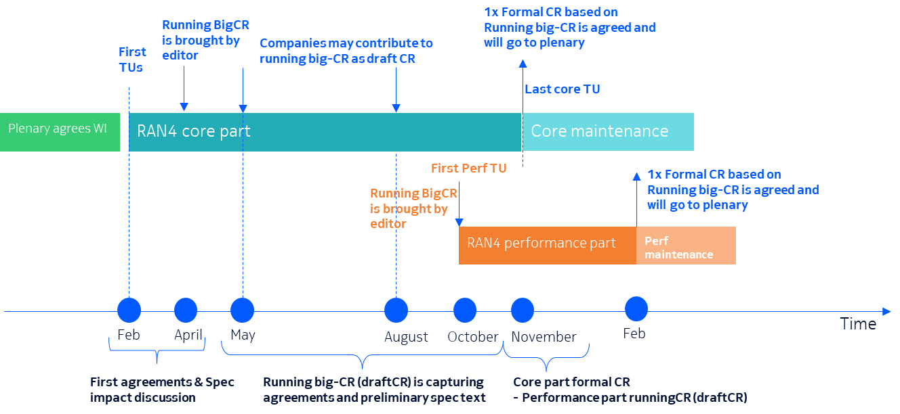
  - Option 3: Workflow for RAN4 CR running approach (CATT)
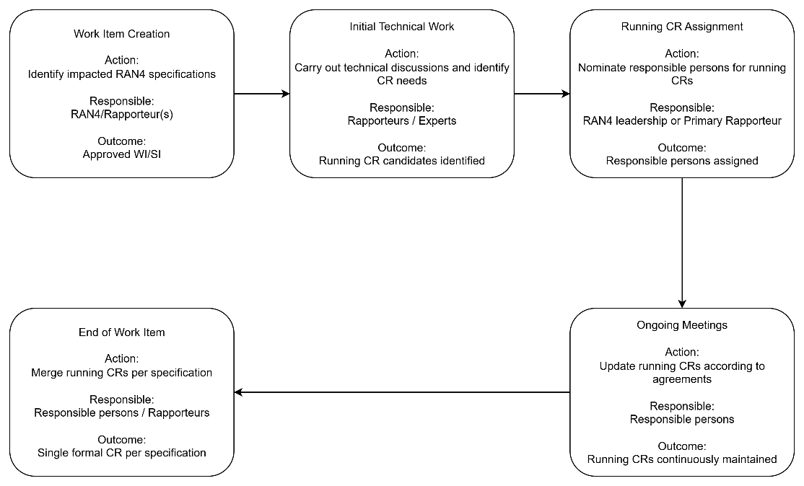
  - Option 4: RAN4 to discussed following procedure for running CR approach (vivo-P2)
- Step 0: Decide the structure for requirements of a RAN4 specification.
- Step 1: Decide necessary running CRs for the RAN4 spec, scope of a running CR and editor for the running CR.
- Step 2: When there are sufficient progress/agreements/conclusions, which could be based on judgement from RAN4 leadership or based on the timeline of the WI, e.g., half way of the WI, the running CR is to be prepared by the editor.
- Step 3: Editor of the running CR capture the agreements/conclusions made so far. The running CR is endorsed via email discussions after the meeting. Technical corrections may also be allowed in email discussions. It may or may not be accepted by the editor for endorsement, or
- Step 3a: Editor of the running CR capture the agreements/conclusions made so far. The running CR is endorsed during the meeting.
- Step 4: The running CR is resubmitted with or without additional changes made by editor in the next meeting. Comments for the running CR are collected during the meeting via e.g., online discussions or email discussions. Agreements during the meeting may or may not be captured into the running CRs. For example, if the agreement is made on Friday and it is not straightforward to be captured, then it can be captured after the meeting for post meeting email discussions, or
- Step 4a: The running CR is resubmitted with or without additional changes made by editor in the next meeting. Comments for the running CR are collected during the meeting via e.g., online discussions or email discussions. Agreements during the meeting may or may not be captured into the running CRs. For example, if the agreement is made on Friday and it is not straightforward to be captured, then it can be captured in the updated version for the meeting after next.
- Step 5: Repeat Step 3 and 4 for meeting cycles. In the last meeting of the release, a type CR of running CR is submitted by editor and it shall be agreed.

  - Option 5: The following key characteristic of RAN2 running CR approach can be further discussed in RAN4, to judge it is appliable to RAN4 and the necessity of adaption to RAN4 works: (Samsung-P1)
• Early initiation of CR drafting works.
• Additional flexibility provided to running CR editor
• Rules to track changes
• Iterative merging of endorsed CRs
• Accessibility to the latest progress of one certain feature
- Recommended WF
  - Use the following consolidated diagram to illustrate the workflow of RAN4 running CR approach with clarification on:
    - Interval between each node
    - Responsibles
    - Actions
    - Outcomes etc.
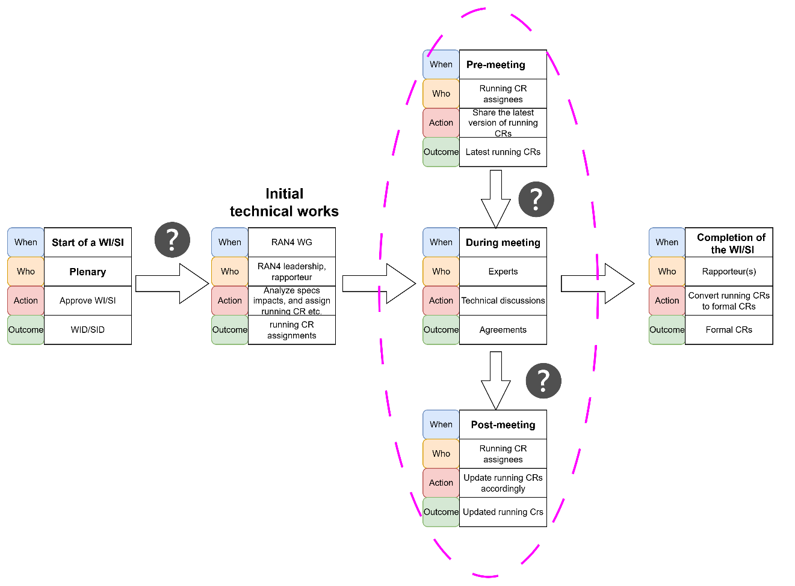

Recommended AH agreements:
- Agree on the following CR handling workflow framework:
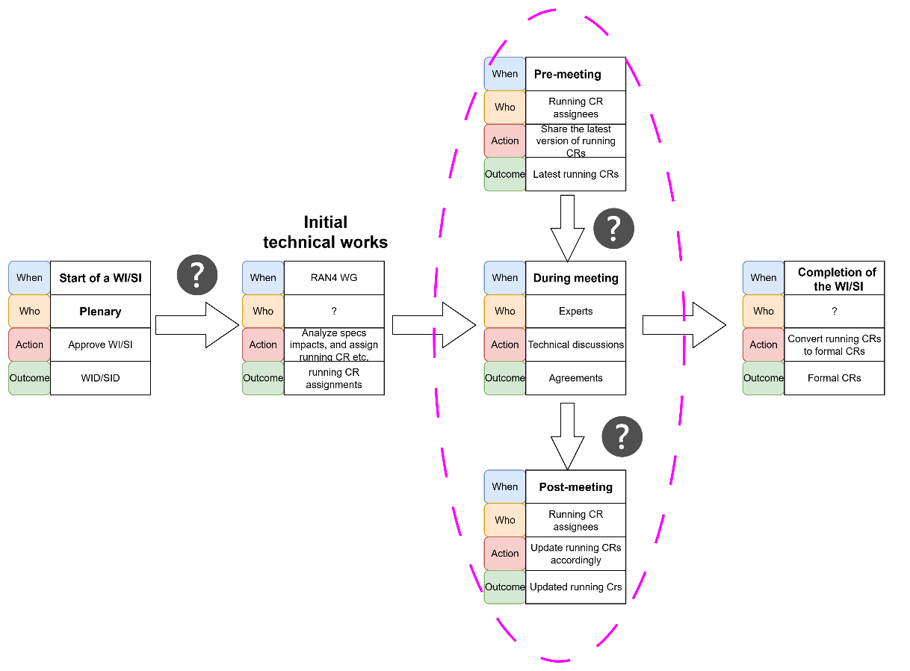
- Further discuss the elements (question marks) in the framework:
  - Intervals
  - Roles
  - Actions
  - Outcomes

Sub-topic 3-3
Sub-topic description: other aspects such as auxiliary tools and documentation
Open issues and candidate options before meeting:
Issue 3-3-1: Auxiliary tool for CR checking
- Proposals
  - Option 1: It is suggested to introduce a RAN5-like CR checking tool for early detection before meeting week to improve the CR handling efficiency in 6GR RAN4. (ZTE-P3)
  - Option 2:
- Recommended WF
  - Check with MCC if MCC can provide such a tool for CR checking.

Issue 3-3-2: Documentation on the running CR approach
- Proposals
  - Option 1: Capture RAN4 running big-CR process clearly in RAN4 maintained specification (Nokia-P2)
  - Option 2: RAN4 to specify running big-CR process clearly, for example in tdoc or other document in FTP. (Nokia-P5).
- Recommended WF
  - Consider capturing the definition of RAN4 running CR approach in RAN4 specs as well as the document in Issue 1-3-1.
  - Capture the workflow of RAN4 running CR approach in the document in Issue 1-3-1.

Topic #4: Criteria on spectrum and non-spectrum items
Main technical topic overview. The structure can be done based on sub-agenda basis.

Companies’ contributions summary
- 27 proposals in total on this Topic.

Open issues summary
Before Meeting, moderators shall summarize list of open issues, candidate options and possible WF (if applicable) based on companies’ contributions.
Several tdocs refer to a plenary summary RP‑212682 when discussing RAN4 Rel-18 packages, which describes the boundary between spectrum and non-spectrum items as:
- For RAN4 spectrum related and non-spectrum related topics
  - Boundary between RAN4 spectrum related items and non-spectrum related items,
    - Spectrum related items are items which aim to introduce band-specific and/or band combination specific requirements without impacting generic RF core requirements and/or core specifications of other WGs.
    - All the other items shall be defined as non-spectrum related.
  - Approach to specify RAN4 related features with both general requirements and band specific requirements
    - A non-spectrum related item with the chosen example band(s) and/or example band combination(s) is needed to study and/or specify the general RAN4 requirements as well as other necessary mechanism and the band or band combination specific requirements for the examples
      - The example band(s) and/or band combination(s) should be chosen to ensure that the finalized general requirements can be applied to other bands and/or band combinations.

However, in FL’s view, some clarifications may still be required, e.g., lists of generic RF core requirements which cannot be impacted by a spectrum item, moreover, considerations on RRM / Demod requirements. After common understanding is reached, the definitions should be formally documented and reported to RAN plenary.
With these in minds, FL recommends discussing the following aspects related to classification on RAN4 spectrum and non-spectrum items:
- Definition & clarification (under sub-topic 4-1)
- Principles (under sub-topic 4-1)
- Documentation & recommendations to Plenary (under sub-topic 4-2)
- Applicability (under sub-topic 4-2)

Sub-topic 4-1
Sub-topic description: Definitions and clarifications and principles
Open issues and candidate options before meeting:

Issue 4-1-1: Definition and clarifications on spectrum and non-spectrum items
- Proposals
  - Option 1: Using RP212682 (slide 2) rule as starting point to discuss any further clarifications needed or not (Xiaomi-P1, vivo-P1, ZTE-P1)
  - Option 2:
    - An item whose scope is limited to applying, or extending without a material change as defined below, already agreed RAN4 methodologies for RF core requirements and, where applicable, associated performance requirements, to specified bands, band combinations, or directly associated spectrum-related parameters. (Huawei-P1)
      - Such an item may include necessary ancillary changes to generic RAN4 specifications, such as adding or modifying tables, subclauses, matrices, applicability text, footnotes, or definitions, provided that such changes are limited to expressing requirements for the concerned bands, band combinations, or directly associated spectrum-related parameters using already agreed methodologies.
    - Notwithstanding the above, an item shall be considered non-spectrum-related if it has the objective to introduce a material change to, or materially modify, the band-independent RAN4 requirements framework, or to investigate such a material change, or if the work identifies the need for such a material change, or if it depends on substantive work by WGs other than RAN4. (Huawei-P2)
      - Material changes include, at least, changes to generic technical principles, core/performance requirement derivation rules or methodologies, capability categories, applicability frameworks, CA frameworks, or operation/deployment assumptions, where such changes affect the band-independent technical substance of the RAN4 framework.
  - Option 3: For the case where some SIs/WIs may only be studied for partial frequency bands at the initiation stage but are technically generic requirements that may be extended to all bands in the future, it is necessary to further clarify these items. (CMCC-P3)
  - Option 4: RAN4 to consider categorizing requirements into band-agnostic requirements, band-specific requirements and volatile requirements as the basis for distinguishing between spectrum-related or non-spectrum-related items (CATT-P1)
  - Option 5: RAN4 can consider the following ways to define spectrum item (either “blacklist” or “whitelist” way for the definition): (Samsung-P1)
    - - Option 1 (“blacklist” definition): Spectrum-related item shall involve no impact on any band-agnostic requirement (CMCC-P2, CATT-P6 @ RAN4#118bis)
    - - Option 2 (“whitelist” definition): Spectrum-related item shall only be applicable to new band(s)/band combination(s), or to introduce existing features in new band(s)/band combination(s).
  - Option 6: The following criteria apply for spectrum WI: (Ericsson proposal 1)
    - Only band specific requirements impacted
      - In the UE spec, NS values, band definitions, band combinations, A-MPR, MSD
      - In the BS spec, additional band specific or regional emissions and possibly band/region specific blocking requirements, and co-location/co-existence requirements
    - In the RRM and demod specs, only addition of band numbers, if at all needed.
    - Simulations and modelling: A-MPR and MSD (although now MSD has LUT for many cases) may be needed
    - “System analysis” meaning analysis of aspects such as in-device co-existence and MSD within the UE may be needed
    - Existing defined bandwidths only (a spectrum WI can add existing bandwidths to one or more bands)
    - Existing power classes only (a spectrum WI can add existing power classes to one or more bands)
  - The following things disqualify a WI to be a spectrum WI: (Ericsson proposal 2)
    - The need for adjacent network Co-existence analysis
    - Impact to any requirement that applies over multiple bands
    - Definition of new bandwidths
    - Definition of new power classes
    - Any RRM or demod requirements (apart from updating of tables listing bands within the RRM spec)
Work needed in other working groups
- Recommended WF
  - Starting points for defining spectrum and non-spectrum items (from RP-212682):
    - Spectrum related items are items which aim to introduce band-specific and/or band combination specific requirements without impacting generic RF core requirements and/or core specifications of other WGs.
    - All the other items shall be defined as non-spectrum related.
  - Further clarifying:
    - What requirements are deemed as generic RF core requirements?
      - Some requirements are always linked with a band, e.g., A-MPR
      - Some requirements might but not always be linked with a band, e.g., configured transmitted power
      - Some requirements are always not linked with any band, e.g., MPR.
      - Some aspects not linked with a band; e.g. new bandwidths or power classes, co-ex related studies

    - Should RRM and/or Demod requirements be also considered in addition to RF requirements?

Issue 4-1-2: Principles or guidelines
- Proposals
  - Option 1: An item shall not be considered non-spectrum-related solely because it investigates technical feasibility for specified bands, band combinations, or directly associated spectrum-related parameters, such as filter feasibility, coexistence, or implementation constraints, provided that the objective is to determine requirements for the concerned bands, band combinations, or directly associated spectrum-related parameters within already agreed RAN4 methodologies. (Huawei-P3)
    - Mere information exchange, liaison, or confirmation of no impact with WGs other than RAN4 shall not by itself make an item non-spectrum-related.
  - Option 2: Where it is not clear at the outset whether the item can remain within the already agreed RAN4 requirements framework and methodologies, the topic may be initiated as a RAN4-led spectrum feasibility SI. The classification of any subsequent WI as spectrum-related or non-spectrum-related shall be determined based on the SI conclusions. (Huawei-P4)
  - Option 3: RAN4 to consider some principles when determining whether a work item should be categorized as spectrum-related such as:
    - Principle 1: If a work item impacts band-agnostic requirements, the item should not be treated as spectrum-related.
    - Principle 2: If a work item introduces RAN2 signalling impacts, the item should not be treated as spectrum-related.
    - Principle 3: Work items impacting purely band-specific requirements may be considered spectrum-related.
    - Principle 4: Spectrum-related items may also impact certain volatile requirements, provided that the impacts are associated with band-specific conditions or spectrum-dependent considerations.
  - Option 4: It is proposed in 6GR, if for work items involving both band specific and band agnostic requirements, the classification shall be determined by the primary impact. (ZTE-P2)
- Recommended WF
  - Further discuss the following points aiming at agreeing some principles or guidelines for help to handle spectrum and non-spectrum items:
    - Technical feasibility investigation for a specific band or band combination, or directly associated spectrum-related parameters shall not be considered non-spectrum related.
    - RAN4-led spectrum feasibility SI can be considered to clarify an item remains within the already agreed RAN4 requirements framework and methodologies, then whether the follow-up WI is a spectrum or non-spectrum related shall be determined based on the SI conclusions.
    - If a work item introduces RAN2 signalling impacts, the item should not be treated as spectrum-related.

Sub-topic 4-2
Sub-topic description: Documentation & recommendations to Plenary, and also applicability (new items in 5G-A or 6G WIs)
Open issues and candidate options before meeting:
Issue 4-2-1: Documentation on the definition and guidelines for spectrum and non-spectrum items
- Proposals
  - Option 1: Clarifying a unified spectrum/non-spectrum classification principle will provide effective guidance for the discussions of 6G items and improve the efficiency of standardization work. (CMCC-P1)
  - Option 2: On top of the guidance, RAN4 should also further clarify a detailed interpretation on how to ensure the Boundary can be clearly implemented when submitting WI proposals by companies (vivo-P2)
  - Option 3: RAN4 shall discuss in which formal document the information about the separation between spectrum and non-spectrum WIs can be specified for reference.
- Recommended WF
  - Further discuss where to capture the definitions and guidelines
    - Option 1: 6G SID RAN4 TR
    - Option 2: A dedicated PRD
    - Option 3: any other?
  - Together with Issue 1-3 for other agreements reached in this thread and discuss whether or not a separate place for the definitions and guidelines for spectrum and non-spectrum items.

Issue 4-2-2: Recommendation to RAN plenary
- Proposals
  - Option 1: How to handle spectrum and non-spectrum project subject to RAN-P decision; and RAN4 can made some recommendation to RAN-P to facililate the decision in RAN-P. (Xiaomi-P1)
  - Option 2: After RAN4 conclusion is made on the criteria on Spectrum/Non-spectrum WI, RAN4 shall present the conclusion in RAN-P for decision, by recommending (Samsung-P3):
1) The detailed criteria (to be concluded form RAN4 discussion)
2) To recommend RAN-P to adopt the criteria as guidance during work item proposal approval
3) To recommend RAN4 and RAN-P to adopt the criteria as guidance to avoid any specification changes beyond the scope of a spectrum work item.

- Recommended WF
  - Recommend to RAN plenary to facilitate decision once RAN4 reaches a common understanding on definitions and guidelines on classifying spectrum and non-spectrum items.

Issue 4-2-3: Applicability (all new items in 5G-A or from 6G WIs?)
- Proposals
  - Option 1: RAN4 to clarify the earliest release in which spectrum WIs can be proposed and specified for 6G. (LGE)
  - Option 2: Take the following discussion points into the follow-up RAN4 discussion (Samsung-P2):
- 6G spectrum items can only be considered after the band-agnostic framework for one certain frequency range is finalized.
- The criteria should be guaranteed during work item proposal approval.
- How to use that criterion to avoid any specification changes beyond the scope of a spectrum work item
- The criteria shall be applicable to new 5G-Advanced proposals (for all new proposals afterward) and 6G Work Items proposals (for Rel-22) (Samsung-P3)
- Recommended WF
  - From all Rel-21 items?

…

