3GPP TSG-RAN WG4 Meeting #119 revR4-26050958

Dalian, China, 18th – 22rd May, 2026

Source: vivo, Smarter Micro, Sony
Title: TP for TR 38.760-4 Annex: 6G memory-based PA model and related study
Agenda Item: 8.2.1.2
Document for: Approval

Introduction
In the RAN4#118bis meeting, the TP for 38.760-4 about PA modelling has been endorsed. And this TP focuses on modelling study and tries to provide some observations regarding the PA’s applicable bandwidth and the impact of non-linearity and memory depth parameters.

TP for TR on 6G SI:
> Start of Change 1< ---

A.3.3 PA modelling study
This section is to record the experiences summarized during the research and modelling of 6G PA from different companies, including the influence of model coefficient selection on the modelling effect, applicable bandwidth of the PA model and so on. The following information is provided for reference.

A.3.3.1 Applicable bandwidth [2][10]
The recommended bandwidth of the input signal should be equal to or less than the given bandwidth of the PA model. Otherwise, the model may not accurately simulate the nonlinear distortion of the PA on the signal.
For reference:
Taking the models in A.3.1.5 and A.3.1.6 and one 20M memory-based PA model fitted from the same chip as examples, the performance comparison of the PA models for different bandwidth signals is as follows.
For the PSD curve:
When a 100M input signal is fed into a 200M PA model, the fitting 100M output signal 2 shows a high degree of overlap in its PSD curve when compared to the 100M output signal 1 obtained from actual PA measurements.
Conversely, when a 200M input signal is fed into a 100M PA model, the fitting 200M output signal 2 exhibits a slight decrease in PSD curve overlap compared to the 200M output signal 1 from actual PA measurements, particularly near the second adjacent channel.
Table A.3.3.1-1: PSD of 100M model w 200M signal and 200M model w 100M signal
100M input → 200M PA model | 200M input → 100M PA model
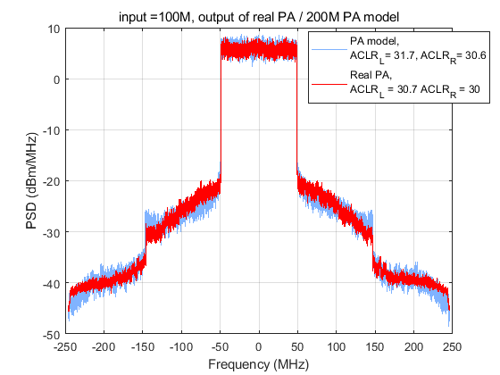 | 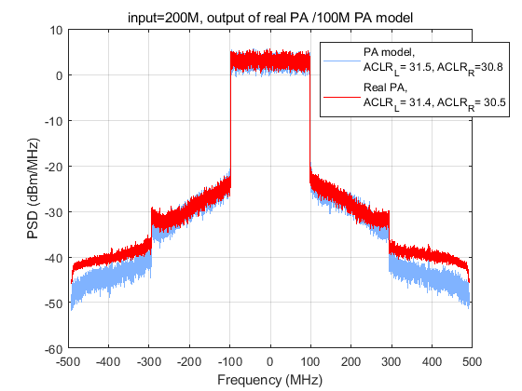
Similarly, when a 20M input signal is fed into a 100M PA model, the fitting 20M output signal 2 shows relatively good overlap in its PSD curve when compared to the 20M output signal 1 obtained from actual PA measurements, while the fitted curve is slightly mismatched with the measured one near the second adjacent channel.
This phenomenon is also verified with a separate PA model[10], obtained with 100 MHz at 9.85GHz, with 26 dBm power, 100 MHz CBW, CP-OFDM waveforms and sampling rate of the signal 491.5 MHz. It can be observed that this PA model obtained from measurement can accurately predict the performance of a 20 MHz and 5MHz signal, with Normalized Mean Squared Error (NMSE) < -33 dB.
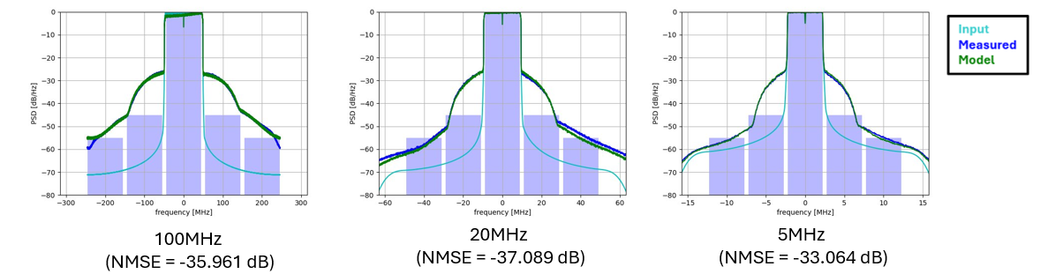
Figure A.3.3.1.1: Evaluation of a model obtained with 100 MHz signal against a 100MHz, 20 MHz and 5MHz signals.
In contrast, when a 100M input signal is fed into a 20M PA model (memory-based with the same fitting formula as the model in A.3.1.5 and A.3.1.6, with k=6 and m=4), the fitting 100M output signal 2 exhibits very low overlap in its PSD curve compared to the 100M output signal 1 from actual PA measurements. Moreover, significant fluctuations appear within the band of the fitted curve, and the out-of-band ACLR also deteriorates noticeably.
Table A.3.3.1-2: PSD of 100M model w 20M signal and 20M model w 100M signal
20M input → 100M PA model | 100M input → 20M PA model
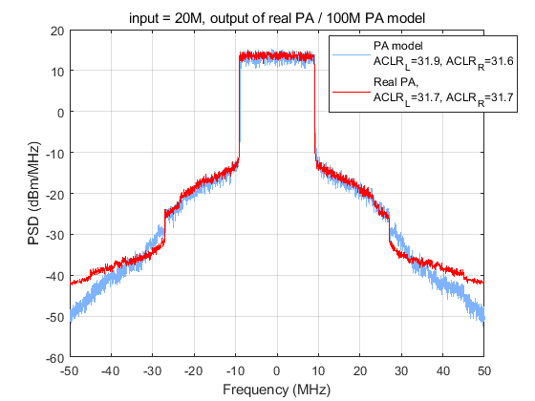 | 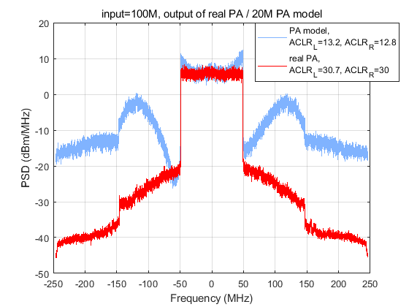

Similar observations also obtained with a separate model obtained with 5MHz signal (K = 7, M = 3, NMSE = -31.57) and used against 20 MHz and 100 MHz signal in simulation is shown in Fig. A.3.3.1.2. Especially when the input signal BW significantly beyond the original BW that the model was obtained, the NMSE of the model would be significantly degraded.[10]
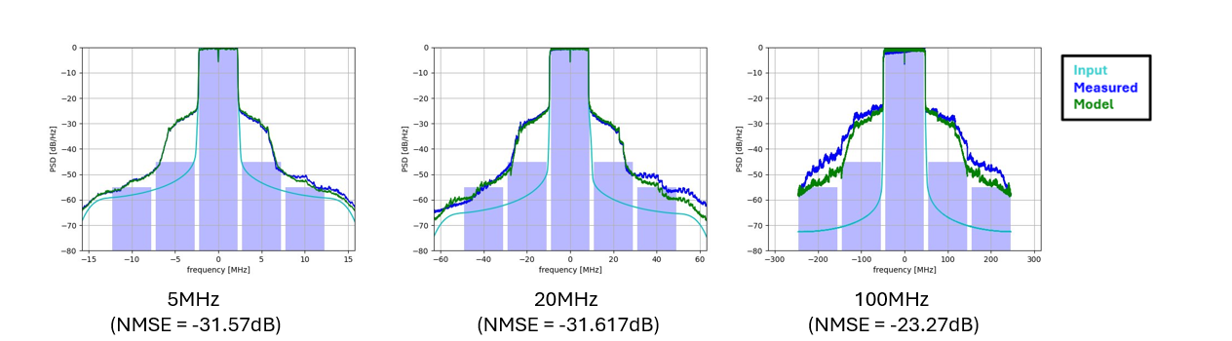
Figure A.3.3.1.2: Evaluation of a model obtained with 5 MHz signal against a 5MHz, 20 MHz and 100MHz signals.
From the results above, it could be seen that PA models with memory effects show dependence on the bandwidth of the training data used for fitting. Models trained with larger bandwidth data exhibit better downward compatibility, providing relatively higher accuracy in PSD when applied to narrowband signals. In contrast, models trained with narrowband data demonstrate poor upward compatibility, leading to relatively lower PSD accuracy when applied to wideband signals. Moreover, the greater the discrepancy between the PA model's bandwidth and the actual signal bandwidth, the poorer the fitting performance becomes.

> End of Change 1< ---
> Start of Change 2< ---

Reference
[1] “R4-2602304, system parameters for 6G —— Waveform, Huawei, Hisilicon.”
[2] R4-2600667, Discussion on 6G waveform and PA, vivo.
[3] M. Abdi Abyaneh and Y. Liu, “Evaluation of PA Memory Effects from 5G-NR to 6G Standards,” presented at the IEEE Conference on Standards for Communications and Networking (CSCN) 2025, Bologna, Italy, Sep. 2025.
[4] R4-2600785, Discussion on 6GR waveform, ZTE.
[5] R4-2602192, Views on 6G PA model, MediaTek Inc., RAN4#118
[6] R4-2603747, Views on 6G UE Tx RF requirements, MediaTek Inc., RAN4#118bis
[7] R4-2604705, View on 6G PA model, Xiaomi, RAN4#118bis
[8] R4-2601448, On 6GR waveform, OPPO, RAN4#118
[9] R4-2601122, Discussion on waveform evaluation for 6GR, Samsung, RAN4#118
[10] R4-2605606, Further analysis on PA modelling for waveform evaluation, Sony, RAN4#119
> End of Change 2< ---

