3GPP TSG-RAN WG4 Meeting #119 R4-2607250
Dalian, China, May 18th – 22nd, 2026

Agenda item: 8.1.1
Source: Feature lead (Huawei, HiSilicon)
Title: Topic Summary for [119][101-A] 6G system parameter (part I)
Document for: Information

Introduction
This document provides feature lead summary for 6GR system parameters. The scope includes:
- Waveform
  - Low PAPR
  - PA model
- Channel bandwidth
  - Max channel bandwidth
  - Min channel bandwidth
  - Numerology
  - Spectrum utilization
  - Asymmetric channel bandwidth
  - Irregular channel bandwidth
- Others
It is noted that the aspects related to the interim milestone should be prioritized according to the guidance of RAN4 chair.
According to the SI objectives set at both the RAN and working group levels, the primary objective of the RAN4 study on system parameters is to apply its unique expertise. This focuses on rigorous, implementation-aware evaluations that ensure the final defined parameters fulfil all target usage scenarios, requirements, deployment scenarios, and design principles, and to deliver a viable performance-complexity trade-off. It is important to note that this work is conducted through close coordination among RAN4, RAN and RAN1.
The interim milestones are listed below for reference (RP-251881).

4.1.1 Interim Milestone
Interim results shall be delivered as per the milestones below, in coordination with the RAN Plenary 6G Study [RP-250810].
TSG#112 (June/2026):
RAN1 to provide interim assessment on the following areas:
- Waveform, modulation, channel coding: scope of enhancements beyond NR baseline ((2) a, c)
- Channel bandwidth (min and max), frame structure, numerology ((2) b, d)
- Basic sync signal structure and associated periodicity(ies) ((2) h)
For objectives where RAN4 may be impacted, RAN1 shall coordinate with RAN4 early to enable the above assessment by June 2026.
The running summary reflects the status of each system parameter and the previous agreements reached in RAN4, RAN1 and RAN can be found at: R4-2605766
.

Topic #1: Waveform

Companies’ contributions summary
TDoc | Title | Source
R4-2605298 | On 6G system parameters - Waveform | Apple
R4-2605499 | MPR and Power boosting framework to enable optimal use of 6G low PAPR waveforms | Skyworks Solutions Inc.
R4-2605515 | 6GR - waveform - Low PAPR | Nokia
R4-2605606 | Further views on PA modelling for waveform evaluation | Sony
R4-2605666 | Discussion on low PAPR for 6GR | Samsung
R4-2605700 | (6G system parameters) Waveform-Low PAPR | LG Electronics
R4-2605711 | On 6GR low PAPR waveform | Huawei, HiSilicon
R4-2605801 | Further discussion on low PAPR for 6GR waveform | CATT
R4-2605802 | Further discussion on PA modeling for 6GR waveform | CATT
R4-2605956 | Discussion on 6G waveform | vivo
R4-2605957 | Discussion on 6G PA model | vivo
R4-2605958 | 6G PA model study TP for 6G SI TR | vivo, Smarter Micro
R4-2606003 | Discussion on 6GR low PAPR | CMCC
R4-2606004 | Discussion on 6GR PA model | CMCC
R4-2606081 | Discussion on low-PAPR of 6GR waveform | ZTE Corporation, Sanechips
R4-2606082 | Discussion on PA model calibration conditions | ZTE Corporation, Sanechips
R4-2606083 | Draft TP to TR38.760-4 to update the PA model calibration | ZTE Corporation, Sanechips
R4-2606701 | 6G PA model | OPPO
R4-2606863 | On Waveform Analysis for Low PAPR | Ericsson
R4-2606931 | Low PAPR waveform | MediaTek Inc.
R4-2606962 | View on 6GR: waveform | Beijing Xiaomi Mobile Software
R4-2606980 | on 6GR Low PAPR | OPPO
R4-2607053 | Low PAPR waveform evaluations | Qualcomm Incorporated

Open issues summary
Before Meeting, moderators shall summarize list of open issues, candidate options and possible WF (if applicable) based on companies’ contributions.

Observations and Proposals/Options

Sub-topic 1-1: Waveform
Relevant agreements in RAN1
Agreement:
Prioritize the following cases in the RAN1 study on UL coverage improvements through low UL PAPR enhancement for DFT-s-OFDM, based on Table in 5.3.1 of R1-2603312:
- FDSS [for π/2 BPSK, QPSK, 16QAM]
  - Opt1: Transparent filter
    - Filter defined through transmitter requirement such as spectrum flatness by RAN4
  - Opt2: non-transparent filter
    - Filter coefficients specified in RAN1
  - Note: This includes all the listed FDSS filtering variants
- FDSS for [π/2 BPSK, QPSK, 16QAM] with spectral extension
  - For FDSS part,
    - Opt1: Transparent filter
      - Filter defined through transmitter requirement such as spectrum flatness by RAN4
    - Opt2: non-transparent filter
      - Filter coefficients specified in RAN1
  - Note: This includes all the listed variants of the spectrum extension
- FDSS for π/2 BPSK with spectral truncation
  - For FDSS part,
    - Opt1: Transparent filter
      - Filter defined through transmitter requirement such as spectrum flatness by RAN4
    - Opt2: non-transparent filter
      - Filter coefficients specified in RAN1
  - Note: This includes all the listed variants of the spectrum truncation
  - Note: At least one variant of spectral extension, offset-QPSK with smaller DFT size can result in the same signal as the FDSS for π/2 BPSK-ST
- Note: companies are encouraged to report whether transparent CFR is used or not

Agreement
For single user evaluation assumption for MCS and subcarriers UL low-PAPR proposals with spectrum extension
No Spectrum Extension |  | With Spectrum Extension
MCS | #subcarriers | #SCs before extension $(A$) | Occupied BW:  #SCs after extension ($B$) | Spectrum extension  Extension: $α=\frac{B−A}{B}$
NR MCS | $$B$$ | $$(1−α)B$$ | $$B$$ | $$α∈\left\{\frac{1}{6}, \frac{1}{4},\frac{2}{7},\frac{1}{3},\frac{3}{8},\frac{2}{5},\frac{7}{16},\frac{1}{2}\right\}$$
For single user evaluation assumption for MCS and subcarriers UL low-PAPR proposals with spectrum truncation
No Spectrum Truncation |  | With Spectrum Truncation
MCS | #subcarriers | #SCs before truncation $(A$) | Occupied BW:  #SCs after truncation ($B$) | Spectrum truncation factor  Truncation: $α=\frac{A−B}{A}$
NR MCS | $$B$$ | $$A$$ | 𝐵 | $$α∈\left\{\frac{1}{10}, \frac{2}{10},\frac{3}{10},\frac{4}{10}\right\}$$

Sub-topic description
The main observations and proposals are based on the inputs for this meeting.
- Main observations
  - Waveform performance and Tx power gain:
    - Tx power gain is highly dependent on RB allocation (inner vs. outer), Spectrum Extension (SE) factors, PA models, and specific filter types.
    - PA output power gain is more visible for outer RB allocations where ACLR is the dominant limiting factor. For inner RB allocations, gains are often marginal (e.g., < 0.5 dB for QPSK).
    - Modulation Specifics:
      - pi/2-BPSK: Clear gains (up to 3.0 dB) are observed for edge/outer RB allocations. FDSS-SE provides approximately 1.2–2.5 dB gain over baseline DFT-s-OFDM.
      - QPSK/16QAM: I-modulation and Offset-QPSK show clear gains for QPSK (up to 2.9 dB) and 16QAM (up to 2.5 dB) in outer RB allocations.
      - GMSK: Shows clear power gain over pi/2-BPSK with FDSS or baseline pi/2-BPSK, particularly at an ACLR of 37 dB.
  - Candidate waveforms
    - FDSS:
      - FDSS discussed in previous releases
      - GMSK: GMSK is a type of Continuous Phase Modulation (CPM) characterized by its constant envelope and low peak-to-average power ratio (PAPR)
    - FDSS-SE:
      - FDSS-SE schemes discussed in Rel-18
      - I/Q-Offset/Offset-QAM: This approach can be implemented in the frequency domain (Offset-QAM with FDSS-SE) or time domain, achieving similar performance to pi/2-BPSK with ST.
      - CFR-SE: CFR-SE can be analogized to FDSS-SE (but with distorted signals instead of valid repetitive signals placed within the extended bandwidth) and may offer lower receiver complexity and better net gain especially when SE is shared among UEs.
    - FDSS-ST
  - Evaluation aspects
    - Companies emphasize that Net Gain (considering both Tx power increase and receiver demodulation impact) is a more insightful metric than raw Tx power gain.
    - The selection of PA models (e.g., memory-less vs. memory models) can vary power gain results by up to 3 dB.
    - Waveforms can be spec-transparent (receiver agnostic) or non-transparent (requiring receiver awareness). Non-transparent modes may offer marginal gains but increase receiver complexity.
- Main proposals
  - Scope and prioritization:
    - RAN4 should focus evaluations on FDSS, FDSS-SE, and FDSS-ST to align with RAN1.
    - Prioritize HPUE to meet 6G UL coverage KPIs in TDD bands.
    - Prioritize transparent schemes for low PAPR waveforms where the receiver does not need awareness of filter parameters.
  - Simulation and metrics
    - Evaluate waveforms using the Net Gain metric to account for the tradeoff between Tx power and link-level performance.
      - NOTE: RAN4 is to focus on the evaluation of power gain, though the final conclusion should be based on Net Gain taken RAN1 evaluation into consideration
    - Use CFR as a baseline reference for net gain simulations.
    - Use calibrated PA models (e.g., PC3 QPSK reference) and evaluate under applicable RF requirements (ACLR, SEM, EVM).
  - Specification impact and RF requirements
    - Study a power boosting framework that allows UEs to exceed nominal maximum output power when low PAPR waveforms are used.
    - Discuss whether spectrum flatness and IBE measurements should be restricted only to information-bearing RBs, excluding extension regions.
    - Study the impact on MPR/A-MPR treatment and RF test configurations for FDSS-based transmissions.
- FL Note
  - Some evaluations are not based on the agreed evaluation assumptions, e.g., calibration condition, power class, channel BW, etc.
  - The evaluations from companies are not calibrated to a common assumption, consequently it’s very hard to compare the results with the diversified values
  - A template is provided to collect inputs from companies before and during the meeting, trying to provide a fair comparison with unified format
    - A separate Excel file to be discussed
- Recommended WF
  - Align the understanding of baseline requirements for Pi/2 BPSK and QPSK
    - PC3
Modulation |  | MPR (dB)
 |  | Edge RB allocations | Outer RB allocations | Inner RB allocations
DFT-s-OFDM | Pi/2 BPSK w/ Rel-15 DMRS | ≤ 3.5¹ | ≤ 1.2¹ | ≤ 0.2¹
 |  | ≤ 0.5^{2,3} | ≤ 0.5² | 0^{2,4}
 | Pi/2 BPSK w Pi/2 BPSK DMRS | ≤ 0.5^{2,3} | 0² | 0^{2,4}
 | QPSK | ≤ 1 |  | 0⁵
 | 16 QAM | ≤ 2 |  | ≤ 1
 | 64 QAM | ≤ 2.5
 | 256 QAM | ≤ 4.5
CP-OFDM | QPSK | ≤ 3 |  | ≤ 1.5
 | 16 QAM | ≤ 3 |  | ≤ 2
 | 64 QAM | ≤ 3.5
 | 256 QAM | ≤ 6.5
    - PC2
Modulation |  | MPR (dB)
 |  | Edge RB allocations | Outer RB allocations | Inner RB allocations
DFT-s-OFDM | Pi/2 BPSK | ≤ 3.5 | ≤ 0.5 | 0¹
 | QPSK | ≤ 3.5 | ≤ 1 | 0²
 | 16 QAM | ≤ 3.5 | ≤ 2 | ≤ 1
 | 64 QAM | ≤ 3.5 | ≤ 2.5
 | 256 QAM | ≤ 4.5
CP-OFDM | QPSK | ≤ 3.5 | ≤ 3 | ≤ 1.5
 | 16 QAM | ≤ 3.5 | ≤ 3 | ≤ 2
 | 64 QAM | ≤ 3.5
 | 256 QAM | ≤ 6.5

  - Calibrate on baseline firstly for further evaluation
    - Adopted assumptions
      - Power class: PC3/[PC2]
        - NOTE: It’s better to do the evaluation based on one power class, which one is selected can be discussed during the meeting
      - Channel BW: 100MHz
      - Baseline waveform:
        - Pi/2 BPSK w Pi/2 BPSK DMRS without FDSS
        - QPSK without FDSS
      - Calibration
        - According to WF in R4-2522450
          - Full RB allocation with 1dB power backoff
      - EVM flatness according to NR spec should also be considered
      - Check whether CFR as generic implementation is considered as reference baseline for the evaluation
    - Simulation or measurement data for the baseline waveform should be provided
  - After calibration alignment among companies, perform further waveform evaluations if the study of this topic continues per RAN guidance
  - Discuss and agree on the template format to further collect evaluation results if waveform can be further discussed after June RAN meeting
  - Harmonize with RAN1 and RAN
    - Collect and report the power gain evaluation results with a reasonable range per edge, outer and inner RB allocations for FDSS, FDSS-SE and FDSS-ST based evaluated schemes.

Sub-topic 1-2: PA model
Sub-topic description
The main observations and proposals are based on the inputs for this meeting.
- Main observations
  - Memory depth and modeling accuracy:
    - A memory depth of 3 is considered sufficient for modeling PA behavior at 100 MHz or 200 MHz CBW for waveform evaluation.
    - Excessive memory depth may lead to overfitting, resulting in unphysical results that limit the model's applicability to different waveforms.
    - Significant differences in clouding or dispersion in AM-AM characteristics indicate varying degrees of memory effects and spectral regrowth, even when static gain compression is identical.
  - Bandwidth compatibility and calibration:
    - PA models obtained using a wider bandwidth can be applied to simulated signals with narrower bandwidths, but narrowband models demonstrate poor upward compatibility for wideband signals.
    - A 20 MHz memory-based model fails to accurately simulate a 100 MHz signal, leading to noticeable fluctuations and ACLR deterioration.
    - A single-point calibration at 100 MHz is insufficient for 6G wideband evaluations, as evidenced by a 2.3 dB discrepancy when moving to 200 MHz.
  - DPD impact:
    - While DPD improves in-band linearity, LUT based DPD with limited entries may actually increase out-of-band emissions, particularly in the ACLR2 region.
    - DPD may become essential for high-order modulations in 6GR requiring extraordinary linearity.
- Main proposals
  - Calibration framework:
    - Adopt a multi-point calibration framework to better characterize memory effects.
      - Consider a two-point calibration: Point A for static baseline (narrowband/low PAPR) and Point B for dynamic/memory baseline (wideband/high PAPR).
      - Define two calibration points for modelling: one with DPD and one without DPD.
  - Calibration conditions:
    - Use 100 MHz CBW with full RB allocation for 100 MHz models, and update technical papers to include 200 MHz CBW for 200 MHz models.
    - Retain current calibration points for 100 MHz and adopt NR calibration points for bandwidths below 100 MHz.
  - Model selection and usage:
    - Utilize GMP PA models (one for PC3, one for PC2) for assessments around 7GHz.
    - Allow companies to choose between GMP or non-memory models for requirement definitions, provided the choice and normalization approach are clearly stated.
- Recommended WF
  - PA calibration
    - Two calibration points:
      - Point A: Covers CBW up to 100MHz
      - Point B: covers 100MHz < CBW ≤ 200MHz
    - Establish non-DPD schemes as the baseline for PA model calibration
  - PA model selection
    - Allow companies to choose between GMP or non-memory models for waveform evaluations, provided the choice and normalization approach are clearly stated
    - Applicable PA models may vary depending on different CBWs and power classes
  - Parameter correction
    - No need to correct the V_{max} multiplier parameter regarding the normalized GMP model in the LS sent to RAN1
  - TPs for TR 38.760-4 Annex
    - Update the TPs when necessary, based on inputs from R4-2605958 and R4-2606083 as well as the collected comments during the meeting
      - Observations for PA modelling study regarding the PA’s applicable bandwidth and the impact of non-linearity and memory depth parameters

Topic #2: Channel bandwidth

Companies’ contributions summary
TDoc | Title | Source
R4-2605300 | On 6G system parameters - Channel bandwidth | Apple
R4-2605392 | Views on 6G max and min CBW | Spreadtrum,UNISOC
R4-2605393 | Views on 6G numerology | Spreadtrum,UNISOC
R4-2605394 | Views on 6G irregular CBW | Spreadtrum,UNISOC
R4-2605516 | 6GR - Channel bandwidth - Min/Max CBW | Nokia
R4-2605517 | 6GR - Channel bandwidth - Numerology | Nokia
R4-2605518 | 6GR - Channel bandwidth - Asymmetric CBW | Nokia
R4-2605519 | 6GR - Channel bandwidth - Spectrum utilization | Nokia
R4-2605520 | 6GR - Channel bandwidth - Irregular CBW | Nokia
R4-2605531 | Views on 6G Max Channel Bandwidth | MediaTek inc.
R4-2605570 | 6G improved SU with equation based NRB enabling flexible and irregular CBW | Skyworks Solutions Inc.
R4-2605572 | UE maximum channel bandwidth and asymmetric TDD arrangements | InterDigital Canada
R4-2605605 | views on 6GR max channel bandwidth impact | Sony
R4-2605667 | Discussion on max channel bandwidth for 6GR | Samsung
R4-2605668 | Discussion on numerology for 6GR | Samsung
R4-2605669 | Discussion on asymmetric CBW for 6GR | Samsung
R4-2605670 | Discussion on spectrum utilization for 6GR | Samsung
R4-2605671 | Discussion on irregular CBW for 6GR | Samsung
R4-2605701 | (6G system parameters) Maximum and minimum channel bandwidth | LG Electronics
R4-2605702 | (6G system parameters) Numerology | LG Electronics
R4-2605703 | (6G system parameters) Asymmetric CBW | LG Electronics
R4-2605704 | (6G system parameters) Spectrum utilization | LG Electronics
R4-2605705 | (6G system parameters) Irregular CBW | LG Electronics
R4-2605712 | On 6GR Max/Min CBW | Huawei, HiSilicon
R4-2605713 | On 6GR numerology | Huawei, HiSilicon
R4-2605714 | On 6GR spectrum utilization | Huawei, HiSilicon
R4-2605715 | On 6GR irregular CBW | Huawei, HiSilicon
R4-2605803 | Further discussion on max and min CBW for 6GR | CATT
R4-2605804 | Further discussion on numerology for 6GR | CATT
R4-2605805 | Further discussion on asymmetric CBW for 6GR | CATT
R4-2605806 | Further discussion on spectrum utilization for 6GR | CATT
R4-2605807 | Further discussion on irregular channel bandwidth for 6GR | CATT
R4-2605827 | Discussion on the Maximum Channel BW | Tejas Network Limited
R4-2605852 | Views on 6G Asymmetric Channel Bandwidth | Mediatek Inc.
R4-2605856 | Vews on 6G Irregular Channel Bandwidth | Mediatek Inc.
R4-2605857 | Views on 6G Spectrum Utilization | Mediatek Inc.
R4-2605894 | View on 6GR: Numerology | Xiaomi
R4-2605895 | View on 6GR: Min/Max BW | Xiaomi
R4-2605896 | View on 6GR: Irregular BW | Xiaomi
R4-2605897 | View on 6GR: Spectrum utilization | Xiaomi
R4-2605904 | View on 6GR asymetric CHBW | Xiaomi
R4-2605943 | Discussion on spectrum utilization | vivo
R4-2605944 | Discussion on irregular CBW | vivo
R4-2605949 | Discussion on 6G Channel bandwidth | vivo
R4-2605950 | Discussion on 6G asymmetric CBW | vivo
R4-2606005 | Discussion on 6GR max-min bandwidth | CMCC
R4-2606006 | Discussion on 6GR numerology | CMCC
R4-2606007 | Discussion on 6GR spectrum utilization | CMCC
R4-2606008 | Discussion on 6GR irregular CBW | CMCC
R4-2606113 | Views on 6G irregular CBW | ZTE Corporation, Sanechips
R4-2606307 | Discussion on 6GR maximum and minimum channel bandwidth | ZTE Corporation, Sanechips
R4-2606308 | Discussion on 6GR numerology | ZTE Corporation, Sanechips
R4-2606309 | Discussion on 6GR asymmetric channel bandwidth | ZTE Corporation, Sanechips
R4-2606310 | Discussion on 6GR spectrum utilization | ZTE Corporation, Sanechips
R4-2606356 | 6G system parameters - Spectrum utilization | Ericsson
R4-2606400 | Views on 6G asymmetric CBW | Spreadtrum,UNISOC
R4-2606548 | Irregular Channel Bandwidth Handling in 6GR | Qualcomm Incorporated
R4-2606666 | Discussion on minimum channel bandwidth | Rakuten Mobile, Inc
R4-2606810 | Qualcomm views on UL Channel BW for 6G | Qualcomm Incorporated
R4-2606811 | Qualcomm views on Asymmetric CBW for 6G | Qualcomm Incorporated
R4-2606981 | on 6GR CBW | OPPO
R4-2606982 | on 6GR numerology | OPPO
R4-2606983 | on 6GR spectrum utilization | OPPO
R4-2606984 | on 6GR irregular channel bandwidth | OPPO
R4-2606990 | on 6GR asymmetric CBW | OPPO
R4-2607054 | On SU enhancement for 6G | Qualcomm Incorporated
R4-2607131 | Discussion on 6G max channel bandwidth | Google Korea LLC
R4-2607190 | Input on 6G System Parameters: Spectral Utilization | T-Mobile USA

Open issues summary
Before Meeting, moderators shall summarize list of open issues, candidate options and possible WF (if applicable) based on companies’ contributions.

Observations and Proposals/Options

Sub-topic 2-1: Max Channel Bandwidth
Agreements in last meeting
Guard band and RF requirements with different implementations:
- Agreement:
  - Strive to define a single set of UE RF requirements for both single and two RF chain based architectures.
  - RAN4 can further discuss the necessity to specify the boundary between two RF chains from RAN4 perspective.
  - FFS whether Zero GB for 2 RF chains architecture is considered as the baseline.
    - Chair: we target to conclude this issue in May meeting.

MIMO layer capability
- Agreement:
RAN4 assumes the UE capability related to the DL MIMO layer is agnostic to different UE architectures, i.e. single and 2 RF chains, to support more than 200MHz CBW/BWP.
  - Different UE capabilities for potential different device types can be further discussed.
  - It is FFS for the related UE capability for 200MHz or less CBW/BWP.

Sub-topic description
The main observations and proposals are based on the inputs for this meeting.
- Main observations
  - RF architectures:
    - Two-RF chain architectures may suffer from phase discontinuity, magnitude mismatch, and timing misalignment at the boundary.
  - Inner guard band:
    - Many companies observe that zero guard band between two RF segments is technically achievable through overlapping filter implementations.
    - However, zero GB may increase implementation complexity due to filter limitations and phase mismatches.
  - MIMO & FFT:
    - MIMO layer capability should generally be agnostic to whether a single or dual RF chain is used.
    - For 400 MHz CBW, FFT sizes of 16k for DL and 8k for UL are being considered.

Issue 2-1-1: Single set requirements
- Proposals
  - RAN4 should define a single set of UE RF requirements applicable to both single and dual RF chain implementations as a baseline.
  - Maintain the principle that requirements should be agnostic to the underlying UE architecture (1-RF vs. 2-RF).
- Recommended WF
  - Keep the agreement in last meeting unchanged, i.e.
    - RAN4 strive to define a single set of UE RF requirements for both single and two RF chain based architectures.

Issue 2-1-2: Inner guard band
- Proposals
  - Adopt zero guard band as the initial baseline for 2-RF chain architectures to maximize SU.
  - Study power and phase continuity across the boundary if the RAN1 design assumes tightly coupled full-band reception.
- Recommended WF
  - Adopt zero guard band as baseline for 2-RF chain architecture

Issue 2-1-3: RF boundary
- Proposals
  - Network-indicated: The RF boundary should be indicated by the network (e.g., via SIB1) or configured by the aNB to ensure scheduling is boundary-aware.
  - Transparent approach: Alternatively, some proposals suggest the boundary should be transparent to the network, handled entirely by UE implementation.
  - Specified rule in spec: Strive to define a single, clear rule in the specifications for boundaries in CBWs between 200 MHz and 400 MHz.
- Recommended WF
  - RF boundary is considered for 200 MHz < DL CBW <=400MHz for UE implemented with 2-RF chains
  - FFS the details considering proposals regarding NW-indicated, transparent or specific description in the specification

Issue 2-1-4: MIMO capability
- Proposals
  - Mandatory Rx antennas/MIMO layers should be defined as a single value without dependency on the number of RF chains.
  - Allow UEs to report different MIMO layer capabilities for CBWs above 200 MHz compared to those below 200 MHz.
- Recommended WF
  - Check whether above proposals are agreeable

Issue 2-1-5: FFT size
- Proposals
  - Specific sizes: For 400 MHz and 300 MHz DL CBW, consider FFT sizes of 16k or dual 8k.
  - Window length mapping: If reflected in specs, a 16k FFT size could be considered for BS Tx EVM window length (DL 400 MHz) and 8k for UE (UL 200 MHz).
- Recommended WF
  - Check whether above proposals are agreeable

Issue 2-1-6: Max CBW for other frequency ranges
- Proposals
  - FR2-1
    - Option 1: 400MHz
    - Option 2: 800MHz
  - Sub-6GHz FDD bands
    - Option 1: 50MHz
    - Option 2: 100MHz
  - Sub-6GHz TDD bands
    - Option 1: 100MHz
    - Option 2: 200MHz
- Recommended WF
  - TBA, discuss online

Sub-topic 2-2: Min Channel Bandwidth
Sub-topic description

Issue 2-2-1: Band specific min CBW
- Proposals
  - Proposal 1: Min CBW for ~7GHz
    - Option 1: All UEs support a minimum channel bandwidth (CBW) of 200 MHz for both downlink (DL) and uplink (UL) for the Around 7GHz frequency range.
    - Option 2: RAN4 consider larger minimum CBW, e.g., 20MHz for ~7GHz band in 6G.
    - Option 3: If companies wanted to specify the Min. CBW, e.g. 40MHz or 50MHz for ~7GHz band including n104, one alternative is to decouple the discussion between BS Min. CBW for ~7GHz band and UE Min. CBW for ~7GHz band.
    - Option 4: larger minimum CBW for around 7GHz could be based on future operators’ spectrum holding.
  - Proposal 2: Some bands, like TDD bands n51 and n54, they just have 5MHz spectrum allocation, need to be considered additionally in the WI stage.
  - Proposal 3: Band specific min CBW can be further discussed in WI stage.
  - Proposal 4: To further study the per band minCBW consider both operator request and SSB and sync raster design.
- Recommended WF
  - In general, defer the discussion of min CBW for specific bands to WI stage
  - For ~7GHz, larger minimum CBW could be considered, while the specific value depends on inputs from operators

Issue 2-2-2: 3MHz specific
- Proposals
  - Proposal 1: No need to consider the applicability of 3MHz for NTN bands which is above 3GHz with 15kHz SCS for the moment, unless there is clear request from operators.
  - Proposal 2: For the applicability of 3MHz for NTN bands above 3GHz, the targeting NTN bands above 3GHz and the necessity for 3MHz operation should be justified.
  - Proposal 3: RAN4 should agree that, for operator requested bands, 3 MHz shall be specified as the mandatory minimum channel bandwidth for 15 kHz SCS on a band specific basis.
- Recommended WF
  - Defer the discussion of the applicability of 3MHz for NTN bands above 3GHz unless there is clear request from operators or the necessity is well justified
  - Keep the previous agreement relevant to 3MHz CBW unchanged, i.e., 3 MHz could be considered as an optional minimum CBW for 15 kHz SCS

Sub-topic 2-3: Numerology
Sub-topic description

Issue 2-3-1: SSB SCS for FR2-1
- Proposals
  - Option 1: For 6G FR2-1 frequency range, only 120 kHz SCS is suggested for SSB.
  - Option 2: For 6GR FR2-1, the SCS of synchronization signal should be 240 kHz, while the SCS of data/control channels can be 120 kHz.
  - Option 3: For FR2-1 SSB numerology, limit with single choice either 120kHz or 240kHz as per band basis
  - Option 4: Postpone the decision on this issue in or after June RAN plenary meeting
- Recommended WF
  - Check whether SSB SCS could be defined per band basis with single value if no consensus can be reached

Issue 2-3-2: SCS for FR1 SDL bands
- Proposals
  - Confirm that only 15kHz SCS is applicable to FR1 SDL bands (e.g. s29/s67/s75/s76)
- Recommended WF
  - Agree the proposal

Issue 2-3-3: Prioritization
- Proposals
  - Deprioritize the discussion on 10GHz for system parameter including numerology.
- Recommended WF
  - Agree the proposal

Sub-topic 2-4: Asymmetric CBW
Sub-topic description
The main observations and proposals are based on the inputs for this meeting.
- Main observations
  - 5G NR already supports signaling for asymmetric CBW. For 6G, 400 MHz DL with 200 MHz UL is a primary asymmetric TDD configuration.
  - LO impact:
    - If a single-LO architecture is used, UL switching for sounding a 400 MHz channel with a 200 MHz UL CBW introduces interruptions.
    - Reusing LOs for both DL and UL would require defining specific switching times (e.g., 140µs), which could impact throughput.
  - Placement and flexibility: NR currently has no restriction on the placement of the narrower carrier within the wider channel bandwidth.
    - Flexible placement allows for NW/UE optimization and potential MPR improvements.
  - Band-specific: Asymmetry in FDD (e.g., n66, n24) and TDD (e.g., n50) is often driven by operator spectrum availability or to avoid sensitivity degradation.
  - SRS: A 200 MHz UL BWP would require SRS switching to sound a 400 MHz DL bandwidth.
- Main proposals
  - General Framework:
    - RAN4 should study asymmetric CBW as a general framework, including cases where DL > 400 MHz and UL is 200 MHz.
  - LO architecture: Assume separate LO architectures for 6G as the baseline.
    - Decouple LO assumptions for DL and UL to avoid RF retuning requirements.
  - UL placement: Maintain the principle that the narrower carrier must be confined within the frequency range of the wider bandwidth.
    - For initial evaluation, focus on representative placements (edge and center-aligned) to manage complexity.
  - Emission offset: Define UE UL emission offsets based on DL CBW.
  - SRS switching: Study interruption for SRS switching in asymmetric scenarios and aim for a single optimized value rather than multiple capabilities.
  - Consider the support of two UL RF chains as a UE capability to enable transmissions beyond 200 MHz.
- Recommended WF
  - LO assumption
    - Adopt the assumption of separate DL/UL LO architectures for TDD band ~7GHz as the baseline
  - UL placement
    - Allow flexible UL placement within the DL CBW without restrictions as starting point
      - Furter evaluation on pros and cons of center and edge placements from requirements perspective
  - RF requirements
    - Study on how UL emission requirements and spectral utilization should be scaled or defined relative to the wider DL CBW.
  - SRS switching
    - Request guidance from RAN1 regarding the SRS sounding framework to ensure RAN4 RF requirements align with the final 6G physical layer design.
    - Switching time requirement will be studied under UE RF topic
  - Check whether to consider the support of two UL RF chains as a UE capability to enable transmissions beyond 200 MHz.

Sub-topic 2-5: Spectrum utilization
Sub-topic description

Issue 2-5-1: General consideration for evaluations
- Proposals
  - Monotonic trend consideration for GB:
    - Option 1: Considering applying a monotonic relationship with guard band sizes and channel bandwidth sizes only to newly defined 6GR CBWs. (Huawei)
    - Option 2: Study how to establish a monotonic relationship where guard band sizes increase (or at least do not decrease) as channel bandwidth increases. (CATT, ZTE)
      - Option 3-1:If keeping monotone increasing for the guard band, it should make sure the SU in 6GR is not smaller than NR for the same channel CBW(ZTE).
    - Option 3: RAN4 shall maintain the monotonic relationship between CHBW and SU e.g. The spectrum utilization should keep monotone increasing trend for all channel bandwidths. (Xiaomi)
    - Option 4: For 6G, RAN4 to study if it is essential to make channel ‘nesting’ fully flexible while preserving UE emissions compliance. ‘Nesting’ refers to when a UE does not support a BW as wide as the cell specific BW, and fully flexible nesting drives the GB monotonicity requirement (Qualcomm)
    - Option 5: RAN4 should consider choosing minimum guardbands for 6G such that the minimum guardband for each channel bandwidth is less than or equal to the minimum guardband for each wider channel bandwidth of the same SCS. (T-Mobile)
  - Single SU/Multiple SU
    - Proposal 1: RAN4 shall specify single SU as per {channel bandwidth, SCS} combination with agonistic to spectrum refinement technology implementation. (Xiaomi)
    - Proposal 2: It’s suggested to allow two sets of SU, Y% and X %, Y>X. 3GPP RAN4 requirements are based on X% and RAN1/2 spec can support Y%. this is especially beneficial for IoT devices which can’t support better spectrum confinement technique. (CMCC)
  - Power class
    - RAN4 to clarify which power class is used for SU evaluation for 200MHz (vivo)
  - Timing of SU evaluation
    - Proposal 1: RAN4 shall decide SU in later stage after relevant 6G RF requirements are stable enough (Xiaomi)
    - Proposal 2: It would be a bit early to carry out the SU evaluation. (ZTE)
- Recommended WF
  - Monotonic trend consideration:
    - Whether monotonic relationship for guard band could be established depends on further evaluation, at least SU should not be smaller than NR in order to keep such relationship
  - Single SU/Multiple SU
    - RAN4 specify single SU as per {channel bandwidth, SCS} combination
  - Power class
    - PC2 should be considered for SU evaluation for CBW >=100MHz

Issue 2-5-2: Method to derive the SU evaluation cases for 6GR
- Options
  - Equation based
    - Option 1: Determining usable RBs and feasible guard bands through a generic, equation-based method derived from established regular bandwidth-to-guard band relations from 5G. (Nokia, Samsung)
      - For a new channel bandwidth, both the next smaller and next larger established channel bandwidths should be considered when deriving candidate RB allocation and guard band values. (Samsung)
    - Option 2: Whether equation based adopted depends on further SU evaluation
      - It is premature to consider equation-based method, and it shall be verified by simulation to meet the RF requirements. (ZTE)
      - Regarding 6G spectrum utilization, RAN4 may adopt an equation-based methodology, but only after checking that the resulting number of RBS is validated for every single channel bandwidths and SCS configurations covered by this approach. (Ericsson)
  - Minimum guard band based (1RB)
    - 6G SU is increased compared to 5G by designing NRB such that the minimum guard-band is the closest and higher value to 1RB bandwidth of the considered SCS. (Skyworks)
  - NR baseline based
    - Option 1: Using existing SU from NR as baseline unless strong motivation well justified for the evaluation and improvement
    - Option 2: Reuse the current SU for existing NR CBW w/o further evaluation
- Recommended WF
  - Defer the discussion of method to derive SU and focus on the evaluation firstly
    - Companies can still use the preferred method to generate cases for SU evaluation

Issue 2-5-3: MRSS consideration
- Options
  - Option 1: it’s suggested to only focus on 6G single RAT rather than MRSS for SU enhancement analysis. (CMCC)
  - Option 2: Within the scope of the 6G spectrum utilization study, RAN4 shall only evaluate the addition of an even number of resource blocks (RBs) to the NR maximum transmission bandwidth to enable efficient MRSS scheduling and secure 6G initial deployment success. (Ericsson)
  - Option 3: RAN4 to study the impact on MRSS operation for an odd number of additional RBs in the 6G transmission BW configuration, compared to 5G. (Qualcomm)
- Recommended WF
  - Follow the considerations by most companies and consider MRSS during the SU evaluation
    - If additional RBs could be added for certain CBWs compared to NR, even RBs should be considered for the evaluation

Issue 2-5-4: Requirements assumptions
- Proposals
  - General
    - Both UE and BS RF requirements should be taken into account for 6GR SU evaluation. (ZTE)
      - it’s challenging to define one unified BS PA model, infra-vendors can provide analysis based on their PA models. It’s FFS whether such PA models should be provided as simulation assumptions with final simulation results or not. (CMCC)
    - The final maximum RB allocation and minimum guard band should be determined based on evaluation with applicable baseline RF requirements, including SEM, ACLR, EVM, ACS and blocking. (Samsung)
  - Tx requirements
    - SEM0 (1st MHz outside the channel)
      - SEM0 failures when increasing SU: RAN4 studies the appropriate measures to avoid having SU dictated by edge allocations. (Skyworks)
      - For SU analysis, RAN4 should study how to define SEM requirement for 1st MHz outside the channel, being compliant with the regulation but also considering the characteristics of the adjacent system and protection that is necessary, as this likely has direct impact onto needed guard bands. (LGE)
      - It is proposed to evaluate the SEM compliance with 1RB edge allocation while for ACLR, full RB allocation is used to check the ACLR (OPPO)
    - SEM vs EVM (Note: better spectrum confinement may degrade the EVM)
      - Study 6G SU considering SEM, and EVM RF requirements. (LGE)
      - To further study the EVM impact of WOLA before making decision on increasing the SU (OPPO)
    - For spectrum utilization study, the impairment assumptions for 5G NR are re-used with improved IQ image rejection ratio (IQ image: -34dB). (MediaTek)
  - Rx requirements
    - RAN4 to discussed whether narrowband blocking still served as the worst case for SU evaluation from Rx requirement side. (vivo)
- Recommended WF
  - Both UE and BS RF requirements should be taken into account for 6GR SU evaluation
  - UE Tx requirements
    - Whether SEM0 could be relaxed will be discussed under UE RF topic
    - With existing NR SEM0 requirement, companies can evaluate MPR for edge RB allocation
    - Performance degradation on EVM should be considered with spectrum confinement techniques to meet SEM especially SEM0 requirement
    - Check whether better carrier leakage, IQ image requirements could be adopted for SU evaluation. If so, discuss the applicable values
  - UE Rx requirements
    - Check whether narrow band blocking requirements still need to be considered

Issue 2-5-5: Candidate CBW for evaluations
- Proposals
  - Proposa1: For existing combinations {CHBW, SCS}, taking existing SU from NR as baseline unless strong motivation well justified for the evaluation and improvement. And considering following case on evaluation work (Xiaomi)
    - FR1 FDD 15kHz: 5MHz CHBW, 10MHz, 15MHz
    - FR1 TDD 30kHz: 10MHz, 15MHz, 20 MHz, 25 MHz and 30 MHz
    - FR2-1 TDD 120kHz: 50 MHz
  - Proposal 2: New channel bandwidth which is not existed in NR i.e., >50MHz Channel bandwidth for 15kHz, and >100MHz CHBW over than 30kHz SCS shall be prioritized over than existing channel bandwidth (Xiaomi).
  - Proposal 3: RAN4 studies the following specific CBW/SCS combinations for SU enhancement (QC)
    - {5, 7, 10 and 15} MHz channels for 15 kHz SCS
    - {10, 15, 20, 25, 30} MHz channels for 30 kHz SCS
  - Proposal 4: Besides the prioritized CBW and SCS combination as approved in last meeting, further enhancement can be achieved for following CBW and SCS combinations with candidate enhanced value. (CMCC)
    - {30, 35, 40, 45, 50} MHz channels for 15 kHz SCS
    - {60, 70, 80, 90, 100} MHz channels for 30 kHz SCS
  - Others (FL Note: other similar proposals are skipped)
- Recommended WF
  - Continue evaluation of CBWs agreed in last meeting, i.e.
    - “RAN4 start the evaluation from May meeting, and the prioritized cases including existing small CBWs with lower SU <95% and larger CBWs of 200MHz and 400MHz”
  - SU for other CBWs are not precluded, pending on inputs from companies

Issue 2-5-6: Implementation consideration
- Proposals
  - Proposal 1: the Max. SU which determine the design complexity of analog filters including Anti-alias filter and Reconstruction filter. (CATT)
  - Proposal 2:Δω (Transition Band) in digital domain, which determine the design complexity of digital filters. (CATT)
  - Proposal 3: If a certain new filter technology is to be introduced in 6GR, it is proposed to carefully study the complexity, time domain influence and corresponding impact on UE performance caused by such new filter technology. (OPPO)
- Recommended WF
  - Implementation complexity for advanced spectrum confinement techniques must be considered during the SU evaluation

Issue 2-5-7: Spectrum confinement
- Proposals
  - On evaluation, RAN4 can take windowing (WOLA) with 2% ~5% length (Xiaomi)
  - No consensus on spectral confinement technical (ZTE)
  - Different window length leads to large different MPR. In NR SU, filter agnostic way is used. (OPPO)
- Recommended WF
  - No assumed spectrum confinement techniques for the evaluation, which are subject to the choice of companies
  - During the evaluation, issues discussed in 2-5-1 to 2-5-6 should be considered especially for the implementation complexity and impact to EVM requirement regarding the spectrum confinement techniques

Issue 2-5-8: Suggested SU
- Proposals
  - Existing CBW/CBW<=100MHz
    - the maximum number of resource blocks (Max_Nrb) and the feasible guard band (GB) can be calculated based on the established relationship between bandwidth and guard band from the existing 5G NR specifications (Nokia)
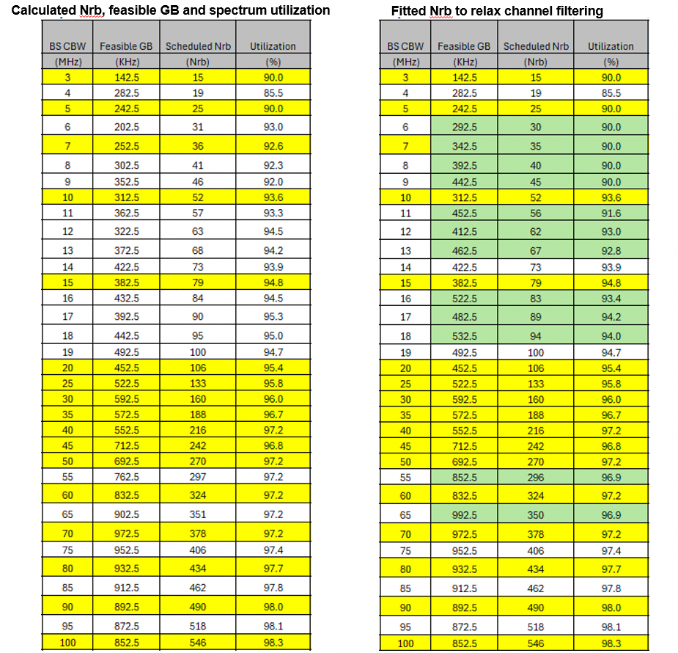
    - NRB based on designing the minimum guard-band as close as possible to 1RB but higher and keep the NRB difference between 5G and 6G NRB to an even value (Skyworks)
    - Example comparison of candidate RB and SU using the k’/k-based candidate range (15kHz SCS) (Samsung)
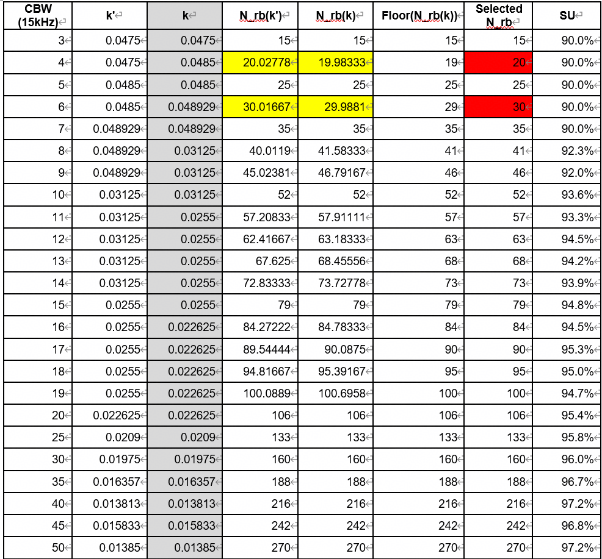
    - RAN4 consider value less than or equal to the possible maximum NRB in Table 14 as 6G NRB starting point. (LGE)
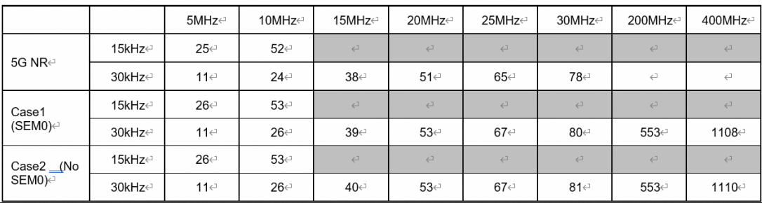
    - For existing CBWs and frequency bands, reuse the current 5G NR spectrum utilization for 6GR (Huawei).
    - Taking following RB/SU as starting point for evaluation to check the possibility of increasing SU compared to existing NR SU. (Xiaomi)
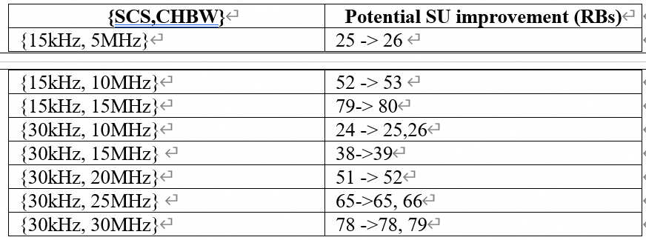
    - If the minimum guardband proposal is agreed for 6GR, increase the maximum number of RBs for 45 MHz from 119 to 120 and the and the maximum number of RBs for 50 MHz from 133 to 134. (TMO)
    - Besides the prioritized CBW and SCS combination as approved in last meeting, further enhancement can be achieved for following CBW and SCS combinations with candidate enhanced value. (CMCC)
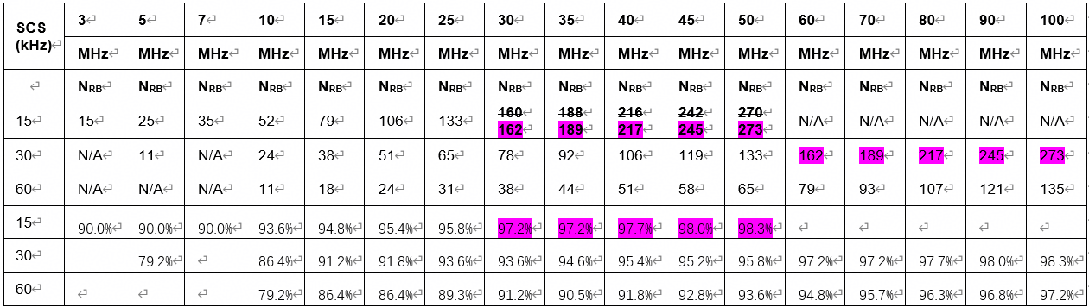
    - Agree on the following initial spectrum utilization parameters for 6G (Ericsson)
  - CBW>100MHz
    - For a 30 kHz subcarrier spacing at around 7 GHz, a 200 MHz CBW has no less than 546 RBs, and a 400 MHz CBW has no less than 1092 RBs. (Huawei)
    - The SU for 400MHz should not be smaller than 98.3%. (ZTE)
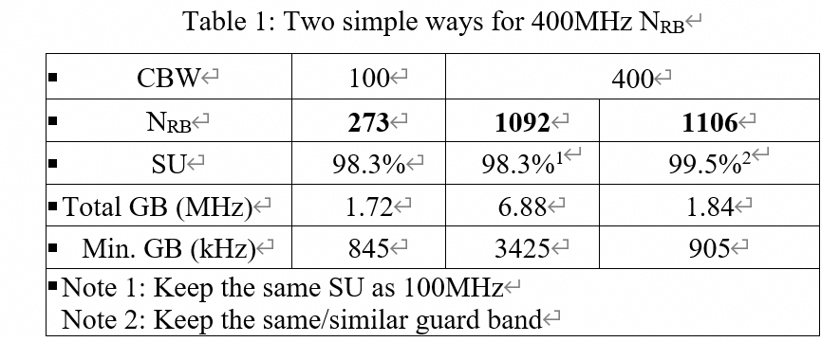
    - On new CHBW/SCS combinations, we propose following SU for 200 MHz and 400 MHz as starting points (xiaomi)
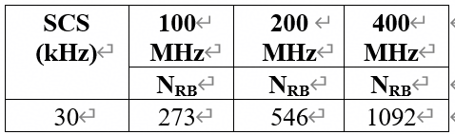
    - For PC3, the maximum RB number of 200MHz to meet the ACLR/SEM is 552, i.e.,99.36% SU, For PC2, to meet the ACLR requirement, the SU is reduced from 99.36% to 93.24% (518 RB). (vivo)

- Recommended WF
  - Further evaluate with consideration of issue 2-5-1 to issue 2-5-7

Issue 2-5-9: Other aspect
- Proposals
  - RAN4 to discuss how to mitigate UE testing increase when number of channel bandwidths in 6GR will be larger compared to 5G. (Nokia)
  - RAN4 should discuss if an indicator should be broadcast in 6G to indicate if the 5G or 6G minimum guardbands are used in the cell. (T-Mobile)
- Recommended WF
  - FFS the proposals once there is a clear view of targeted SU based on further evaluations

Sub-topic 2-6: Irregular channel bandwidth
Sub-topic description
The main observations and proposals are based on the inputs for this meeting.
- Main observations
  - Current demand for irregular CBWs is primarily concentrated between 5 MHz and 15 MHz (specifically 6, 7, 11, 12, and 13 MHz). There is little to no demand currently observed for irregular bandwidths above 15 MHz or very high aggregated bandwidths (e.g., >100 MHz).
  - Defining independent RF requirements for every possible irregular CBW would significantly increase specification complexity and test burden. Supporting flexible CBWs also introduces challenges for UE digital and analog filter design to ensure compatibility with emission and blocking requirements.
  - Reusing the next larger regular CBW framework reduces RAN4 workload and testing. However, it may lead to potential non-compliance with emission regulations and receiver blocking degradation due to interference close to the irregular channel edge.
  - Network-side solutions like overlapping CA or overlapping CBWs are considered UE transparent and could simplify the UE implementation, though they may require additional signaling or L1/L2 handling.
  - Using interpolation or scalable formulas for spectrum utilization and N_{RB} determination provides a continuous and scalable framework but may cause ambiguity in baseband filter design.
  - For very small bandwidths (e.g., 6/7 MHz), there are concerns regarding SSB/CORESET 0 bandwidth exceeding the channel size, which may necessitate specific RAN1 designs.
- Main proposals
  - Framework
    - Baseline: Establish a clear distinction between Regular (explicitly specified) and Irregular (implicitly specified via generic rules) CBWs.
    - Solutions:
      - Introduce a single, universal solution for all irregular CBWs in 6G Day-1 to avoid repetitive standardization efforts.
        - E.g., prioritize network-based solutions like overlapping carriers to handle irregular spectrum without increasing UE complexity.
    - Step sizes: 1 MHz step below 10 or 15 MHz, 5 MHz step up to 50 MHz, and larger steps (20-40 MHz) for bandwidths above 100 MHz.
  - RF requirements
    - Use the next larger regular CBW as the reference for RF conformance testing and generic RF requirements to avoid new test cases.
    - Deriving effective bandwidth based on the maximum active RB span to interpret RF implementation impact more accurately than nominal CBW.
    - Consider applying Tx requirements based on the next larger CBW and Rx requirements based on the next smaller CBW to reflect different limiting mechanisms.
    - Use interpolation formulas (e.g., floor functions based on next small/large regular CBWs) to determine the number of RBs for any irregular width.
- Recommended WF
  - Reach consensus on definition of irregular CBW
    - E.g., irregular CBW refers to bandwidths not explicitly listed in the regular set (e.g., smaller granularity, non-5MHz based, between 5–15 MHz).
  - Collect views and requests from operators on the potential irregular CBWs as inputs for the solution study
    - If few irregular CBWs are foreseen for 6G, to check whether standardization of these CBWs like 6MHz and 7MHz for 5G NR could be considered for 6G
  - Prioritize the study of 6 MHz and 7 MHz as dedicated cases or within the first 6G release.
  - To manage standardization and testing complexity, prioritize solutions that reuse existing RF requirements (such as the next larger CBW approach) or utilize UE-transparent solutions like overlapping channels from the network perspective.
  - Study possibility of generic interpolation formula and scalable guard band definitions to create a future-proof specification that does not require new entries for every unique operator request.
  - Collect inputs from operators on potential step sizes, particular for those larger than 100MHz CBW

Topic #3: Others

Companies’ contributions summary
TDoc | Title | Source
R4-2605902 | View on 6GR: number of Tx/Rx | Xiaomi
R4-2606313 | Discussion on 6GR UE Tx&Rx number | ZTE Corporation, Sanechips
R4-2606702 | 6G phase noise model | OPPO
R4-2607049 | 6G Intra-band contiguous CA simplification | Skyworks Solutions Inc.
R4-2607132 | Discussion on 6G phase noise model | Google Korea LLC
R4-2605765 | Discussion on LS reply on phase noise model for 6GR study | Huawei, HiSilicon

Open issues summary
Before Meeting, moderators shall summarize list of open issues, candidate options and possible WF (if applicable) based on companies’ contributions.

Observations and Proposals/Options

Sub-topic 3-1: UE antenna number
Sub-topic description
The main proposals are based on the inputs for this meeting.
- Main proposals
  - Proposal 1: Number of Tx/Rx antennas needs to discriminate with following factors:
    - DL and UL shall be considered separately
    - Applicable sub-frequency range
    - Applicable device assumption on form factor limitation e.g. IoT, MBB, and FWA
  - Proposal 2: For IoT device, consider 1T1R as baseline and 1T2R as optional in FR1 including around 7GHz.
  - Proposal 3: For MBB UE, number of Tx/Rx can be further decided by per sub-frequency rang basis
  - Proposal 4: Dynamic UE capability for number of Tx/Rx antennas can be considered under different states (foldable UE) and different operating modes e.g. or high performance mode/power saving mode.
  - Proposal 5. To consider higher Tx/Rx antenna number in order to achieve the targeted spectrum efficiency in IMT-2020.
  - Proposal 6: A normal 6G UE (handheld UE) should have higher capabilities than 5G handheld UE
  - Proposal 7. To consider 4Tx/8Rx for 6GR handheld UE and 8Tx/8Rx even 8Tx/16Rx for 6GR FWA UE on around 7GHz spectrum.
- Recommended WF
  - Check views for above proposals.

Sub-topic 3-2: Intra-band contiguous CA simplification
Sub-topic description
- Observation
  - Intra-band contiguous ULCA has many disadvantages compared to single carrier UL operation: in the uplink, it comes with complex MPR requirements and high MPR allowance, hereby impacting the uplink link-budget. MPR equations still require further work to fix the reported inconsistent requirements [1] for which RAN4 decided to postpone fixing these issues to a later stage, 6GR being perhaps a better timeframe. For FDD bands, the downlink link-budget may also be severely impacted due to high MSD.
- Proposals
  - Proposal 1: For 6GR, consider restricting IBC-ULCA for configurations where the ULCA aggregated BW cannot be supported by a single carrier CBW. This means that if we assume that 6GR will support single carrier 200MHz UL CBW, then the 6GR UE RF requirements for IBC-ULCA should be introduced only for aggregated CBW greater than 200MHz.
  - Proposal 2: In 6GR and to address issues reported in [1], revisit the IBC-ULCA equations that define the MPR for non-contiguous outer 1/outer 2 RB allocations. As an alternative solution, RAN4 may also be considered to no longer support non-contiguous RB allocations within an intra-band contiguous ULCA configuration.
- Recommended WF
  - Check whether requirements for intra-band contiguous UL CA can be specified only for aggregated CBW > 200MHz
  - Revisit the intra-band contiguous UL CA equations that define the MPR for non-contiguous outer 1/outer 2 RB allocations
    - Companies are encouraged to check the issues identified in R4-2602132 for 5G

Annex: Companies’ contribution proposals

Waveform (inlcuding PA model)

8.2.2.1 Low PAPR
- Proposals from Apple R4-2605298
Proposal 1: Study UL π/2-BPSK DFT-s-OFDM with GMSK approximation filters to reach near constant envelope waveform.
Observation 1: GMSK shows clear power gain over π/2-BPSK + FDSS or the baseline π/2-BPSK, especially in the case of ACLR of 37dB.
Proposal 2: In the evaluation, it is to be further discussed which ACLR requirement to use depending on the amount of power boosting rendered by the low PAPR waveform.

- Proposals from Skyworks R4-2605499
Proposal on power gain:
- Power gain is not meant to be introduced as a new requirement, but is used here as long as a 0dB MPR waveform is not defined
- Power gain is defined as the increase in power compared to fully allocated DFT-s-OFDM QPSK.
  - If 0dB MPR is defined for fully allocated DFT-s-OFDM QPSK then power increase capability is the power boosting range
- Based on DFT-s-OFDM Pi/2 BPSK with FDSS+SE (GMSK Approximation Filter: BT = 0.18, 2-pulse, spectrum extension bandwidth: 10%):
  - Power gain is larger than 3dB for low PAPR waveforms and thus power boosting range may overlap with a higher power class (assuming 3dB step)
  - Power gain may be up to 5dB depending on in-band requirements like IBE and EVM and depending on whether transparent or non-transparent mode is used for low PAPR waveforms with FDSS w/wo spectrum extension/truncation.
- Power gain is applicable to a number of low PAPR waveforms and “regular” CP-OFDM and DFT-s-OFDM waveforms with a continuum of values depending on:
  - Modulation order w/wo low PAPR techniques (at least from Pi/2 BPSK to 16QAM)
  - Allocation size and position (inner half and inner third)
  - When OOB/IB requirements are relaxed
  - When BW extension applies.

Proposal for MPR and power boosting framework:
- Power class nominal maximum output power and its tolerances is defined based on 0dB MPR for fully allocated DFT-s-OFDM QPSK waveform at a 31dB ACLR target for PC3, PC2 and PC1.5 and IQ impairments of at least 31dB down to 256QAM.
- Specific MPR values will be derived for CP-OFDM QPSK to 1024QAM and DFT-s-OFDM 16QAM to 256QAM and [1024QAM] without sub-dividing for allocation types.
- Power class and associated power boosting framework should enable the UE to boost any low order modulation CP-OFDM and DFT-s-OFDM waveform up to QPSK except fully allocated QPSK for a 31dB ACLR target
- When ACLR is relaxed to 27dB or below or other relaxations are enabled (SEM, BW extension…), boosting of fully allocated DFT-s-OFDM QPSK waveform is enabled
- Power boosting range is at least 3dB and up to [5dB] and should be enabled regardless of an overlap with another power class.
  - The upper limit is FFS pending decision on 6G low PAPR waveform(s) and whether transparent or non-transparent operation will be specified.
- To meet regulation requirement the BS can signal that boosting is not allowed or limited by PEmax.
- To claim boosting on the enabled waveforms, the UE must deliver a power > nominal maximum output power plus the upper tolerance (usually +2dB) for Pi/2 BPSK waveform w/wo shaping including 6G low PAPR waveform(s)
  - Note that other waveforms like inner 3rd, low PAPR versions of QPSK and 16QAM may be boosted too.
- FFS how UE power boosting capability is defined:
  - No signalling, UE does what it can, but BS is not aware while BS can limit via PEmax.
  - Simple signalling saying UE can boost the enabled waveforms without a value
  - Simple signalling saying UE can boost the enabled waveforms up to a signalled value.

- Proposals from Nokia R4-2605515
- Proposal 1: Frequency Domain Spectrum shaping (FDSS) and FDSS with spectrum extension (FDSS-SE) are supported in 6G Radio.
Proposal 2: Transparent filtering approach (receiver does not need to be aware of the used filter parameters) is assumed for FDSS and FDSS-SE in 6G Radio.

- Proposals from Samsung R4-2605666
Scope
Observation 1: For RAN4 low PAPR waveform evaluation, the main focus is the RF compliant Tx power impact of candidate waveforms, rather than SNR gain.
Proposal 1: RAN4 should evaluate low PAPR waveform candidates by focusing on the maximum achievable PA output power under applicable RF requirement constraints.
Evaluation
Observation 2: The PA model is calibrated with a PC3 QPSK reference condition, while the maximum PA output power is evaluated for π/2-BPSK transmission under the applicable RAN4 RF requirements.
Observation 3: FDSS-SE with an HSP filter can satisfy the relevant in-band emission and EVM equalizer spectrum flatness requirements under the calibrated PA condition.
Observation 4: FDSS-SE with an HSP filter can provide approximately 1.2–2.5 dB PA output power gain over baseline DFT-s-OFDM for π/2-BPSK transmission while satisfying RAN4 RF requirements.
Observation 5: The PA output power gain is more visible for outer RB allocation, where ACLR is the dominant limiting requirement.
Proposal 2: RAN4 should further consider FDSS-SE as a candidate low PAPR waveform, since it can provide RF-compliant PA output power gain compared to baseline DFT-s-OFDM.
Observation 6: FDSS-SE and FDSS-ST can be regarded as complementary FDSS configurations, and their Tx power impacts can be evaluated under the same RAN4 RF requirement framework.
Proposal 3: RAN4 should continue RF impact evaluation for FDSS-based candidate waveforms, including FDSS-SE and FDSS-ST, subject to the RAN1 waveform conclusion.
Potential impact
Observation 7: FDSS-based low PAPR transmission may have RAN4 specification impact on MPR/A-MPR treatment, power boosting related handling, RF test configurations, and UE capability.
Observation 8: The direct impact of spec-non-transparent FDSS is mainly on the receiver side demodulation assumption, while RAN4 RF requirements should be evaluated based on the specified or configured FDSS transmission mode.
Proposal 4: RAN4 should study possible specification impacts of FDSS-based low PAPR transmission, including MPR/A-MPR treatment, power boosting related handling, RF test configurations, and UE capability.

- Proposals from LGE R4-2605700
Proposal 1: RAN4 focus low PAPR evaluation on FDSS, FDSS-SE, and FDSS-ST to align with RAN1.
Proposal 2: Consider observation 1 and 2 for low PAPA waveform.
Proposal 3: Consider transparent scheme for low PAPA waveform.
Proposal 4: Further discuss FDSS-related confinement scheme.

Observation 1: Tx power gain for FDSS, FDSS-SE, and FDSS-ST is observed as follows,
- For Inner RB allocation,
  - Pi/2 BPSK, QPSK, and 16QAM
    - Almost no gain
- For Outer RB allocation,
  - Pi/2 BPSK
    - FDSS: ~0.7 dB
    - FDSS-SE: ~1.1 dB
    - FDSS-ST: ~0.4 dB
  - QPSK
    - FDSS: ~0.5dB
    - FDSS-SE: ~0.5dB
  - 16QAM
    - Almost no gain
- For Edge RB allocation,
  - Pi/2 BPSK
    - FDSS: No gain
    - FDSS-SE: ~0.3 dB
    - FDSS-ST: ~0.7 dB
  - QPSK
    - FDSS: No gain
    - FDSS-SE: No gain
  - 16QAM
    - FDSS: ~1.0 dB
    - FDSS-SE: ~1.3 dB
Observation 2: There is no significant difference of Tx power gain between FDSS, FDSS-SE, and FDSS-ST, e.g. < 0.5 dB

- Proposals from Huawei R4-2605711
Observation 1: I/Q-offset DFT-s-OFDM can be implemented using either a frequency-domain approach (offset-QAM with FDSS-SE) or a time-domain approach with Pre-DFT Offset QAM or Pre-DFT pi/2 PAM modulation. Compared to the time-domain implementation, the frequency-domain approach requires only a half-size DFT and can reuse NR QAM.
Observation 2: I/Q offset DFT-s-OFDM can produce the same signal as the pi/2-BPSK with ST, thus achieving same net gain performance.
Observation 3:
- As one variant of spectral extension, I/Q offset DFT-s-OFDM needs extra 6M real additions and $4M$real multiplication per OFDM symbol, compared with FDSS-SE
- Pi/2-BPSK with ST needs extra $3M\log_{2}M+6M$ real additions and $2M\log_{2}M+4M$real multiplication per OFDM symbol, compared with FDSS-SE
Observation 4: Tx power gain is contingent upon several key factors, including RB allocation, SE factor ($α$), PA model, and FDSS filter.
Observation 5: FDSS for QPSK can provide gains in outer RB allocations over baseline Rel-15 QPSK
Observation 6: Offset QPSK (FDSS-SE for QPSK) shows substantial Tx power gain over baseline Rel-15 QPSK. For example, under PA model 3 and with medium-to-large RB size (e.g., 128), the Tx power gain can exceed 3dB and 2.5 dB for outer and inner RB allocations, respectively
Observation 7: offset QPSK always provides higher Tx power gain than FDSS
Observation 8: When considering low SE factors (e.g, α≤1/4), FDSS-SE for QPSK and offset QPSK deliver similar power gains. And offset QPSK performs better when α exceeds 1/4.
Observation 9: For a given low-PAPR scheme, the power gain results obtained under the two PC3 PA models (i.e., memory-less PA model 1 and memory PA model 2) are comparable, indicating that memory effects do not translate into larger power gains. Furthermore, the power gain is typically higher under PA Model 3 compared to the other two PA models. Regarding the impact of RB allocation, the gain is lower under inner RB allocation than outer allocation.
Observation 10: Offset QPSK shows substantial net gain over Rel-15 QPSK. For example, considering a medium to large RB number (e.g. 128), low MCSs (e.g., MCS index ≤3) and PA model 3, the gains for offset QPSK exceed 3dB and 2 dB for outer RB and inner RB allocations, respectively
Observation 11: For offset 16QAM, with medium-to-large RB size (e.g., 128), the Tx power gain can exceed 2.5dB and 2 dB for outer and inner RB allocations, respectively.
Observation 12: With PA model 3, I/Q offset DFT-s-OFDM applied to 16QAM with CR 340/1024 can achieve a net gain up to 1.5dB.
Observation 13: AI/ML-based PAPR reduction can achieve additional Tx power gain and net gain on top of offset-QPSK at different RB size under outer RB allocation.
Proposal 1: The Tx power gain of the three solution families captured across different settings (e.g., bandwidth allocations, SE/ST ratios/factors, and PA models) should be summarized, thus achieving an observation in RAN4 discussion.
Proposal 2: Offset-QPSK (equivalent to FDSS for π/2-BPSK with spectral truncation but requiring a smaller DFT size) should be considered for further RAN4 evaluations.
Proposal 3: Offset-16QAM (a variant of FDSS for 16QAM with spectrum extension) should be considered for further RAN4 evaluations.
Proposal 4: Support I/Q-offset DFT-s-OFDM (e.g., Offset-QPSK and Offset-16QAM) as a lower PAPR waveform candidate for further RAN4 evaluations.
Proposal 5: Supporting further enhancement on offset-QPSK (pi/2-BPSK with ST) for PUSCH coverage enhancement, e.g., AI/ML-based PAPR reduction.

- Proposals from CATT R4-2605801
Proposal 1: for the three solution families of low PAPR, PC2 and PC1.5 should be prioritized for the evaluation of Tx power impacts in order to meet the UL coverage KPI in 6G TDD bands. After the evaluation of PC2 and PC1.5, RAN4 can study the other power classes, e.g. PC3 or other power classes higher than PC1.5.
Proposal 2: for FDSS with spectrum truncation, only pi/2 BPSK is applicable.
Proposal 3: for FDSS (transparent or non-transparent) and FDSS with spectrum extension, pi/2 BPSK, QPSK and 16QAM are applicable.
Observation 1: the following power boosting room of Pcmax, L can be observed for different modulation and different power classes.
Waveform | Modulation | PC3 | PC2 | PC1.5
DFT-s-OFDM with three low PAPR solution families | Pi/2 BPSK | 0dB room | 0dB room | 2dB room
DFT-s-OFDM with three low PAPR solution families | QPSK | 1dB room | 1dB room | 2dB room
DFT-s-OFDM with three low PAPR solution families | 16QAM | 2dB room | 2dB room | 3dBm room
Proposal 4: For the Tx power impacts to meet RF requirements, RAN4 can discuss the Tx power gain of Pcmax, H separately, which can be decoupled with Pcmax, L.

- Proposals from vivo R4-2605956
Observation 1: CFR is typically implemented in UEs to reduce the PAPR of uplink signals, thereby enabling lower PA power back-off.
Proposal 1: For net gain simulation in 6GR, CFR should be used for baseline reference.
Observation 2: CFR-SE can be analogized to FDSS-SE with a truncated rectangle FDSS pattern, the key difference between them is that distorted signals (due to clipping) placed within the CFR-SE extended bandwidth but repetitive signals placed within the FDSS-SE expanded bandwidth.
Observation 3: CFR-SE can achieve better net gain when the SE part is shared among UEs.
Observation 4: CFR without extension and FDSS without extension show best net gain in most cases.
Observation 5: {pi/2-BPSK and CFR-SE with Factor=0.25} show best in lowest spectral efficiency. If the SE is shared among UE, the gain can be up to 0.7dB.
Observation 6: {pi/2-BPSK and FDSS-ST with Factor=0.2} show best only in case of spectral efficiency=0.6. Compared with the benchmark (transparent CFR scheme), the gain is approximately 0.1dB in outer RB cases, while 0.27dB in inner RB cases.
Proposal 2: For the 6G phase, consider to support CFR‑SE scheme with lower implementation complexity and higher spectrum utilization efficiency.

- Proposals from CMCC R4-2606003
Proposal 1: RAN4 should discuss whether the measurement range for Spectrum Flatness and IBE needs to be restricted only to the information-bearing RBs, excluding the spectral extension regions.

- Proposals from ZTE R4-2606081
Observations:
Observation 1: RAN1 didn’t converge candidate waveforms in last meeting.
Observation 2: For π/2-BPSK, the I-modulation scheme achieves a maximum 3.0dB Tx power gain and approximately 2.6dB Net gain compared to baseline π/2-BPSK for edge or outer PRB allocations.
Observation 3: For QPSK, the I-modulation scheme achieves a maximum 2.9dB Tx power gain and 2.5dB Net gain relative to baseline QPSK for outer PRB allocations.
Observation 4: For 16QAM, the I-modulation scheme achieves a maximum 1.6dB Tx power gain and approximately 0.6 ~ 0.8dB Net gain relative to baseline 16QAM for outer PRB allocations.
Observation 5: For π/2-BPSK, FDSS-TR can achieve 2.96dB Tx power gain and 2.57dB Net gain with 1/8 reserve ratio and transparent filter.
Observation 6: For QPSK, FDSS-TR can achieve 2.21dB Tx power gain and 1.94dB Net gain with 1/8 reserve ratio, and can achieve 1.5dB Tx power gain and 1.4dB Net gain with 1/16 reserve ratio without transparent filter.
Observation 7: FDSS-TR can achieve considerable Tx power gain with negligible impact on BLER for π/2-BPSK, QPSK and 16QAM with flexible filter enable/disable.
Proposals:
Proposal 1: The FDSS with I-modulation based operation in frequency domain for π/2-BPSK/QPSK/16QAM should be considered to reduce PAPR for DFT-s-OFDM.
Proposal 2: The FDSS with TR operation in frequency domain for π/2-BPSK/QPSK/16QAM should be considered to reduce PAPR for DFT-s-OFDM.

- Proposals from Ericsson R4-2606863
Observation 1: Since this is a relative comparison, it is acceptable to us to use 5G NR assumptions and requirements in this 6G study.
Observation 2: FDSS allows to apply power boosting for inner RB allocations only with QPSK modulation and over wider range of RB allocations with pi/2-BPSK modulation. FDSS-SE allows power boosting for all RB allocations.
Observation 3: With QPSK modulation and inner PRB allocations, FDSS and FDSS-SE are not significantly advantageous (with gains around 0.5 dB for larger RB allocations) compared to baseline scheme without any spectral shaping with QPSK modulation.
Observation 4: With QPSK modulation and outer RB allocations, benefits of FDSS-SE over FDSS decrease with increasing code rate.
Observation 5: With Pi/2-BPSK modulation and inner RB allocations, FDSS provide gains up to 0.6 dB compared to baseline scheme while FDSS-SE is not beneficial when RB size is within 128.
Observation 6: With Pi/2-BPSK modulation and outer RB allocations, FDSS-SE and FDSS provide gains up to 0.8 dB compared to baseline scheme while FDSS is still advantageous compared to FDSS-SE when RB size is within 128.
Observation 7: With Pi/2-BPSK modulation, additional net gain due to non-transparent FDSS compared to that of transparent FDSS is marginal, up to 0.12 dB, which is varying subject to MCS and RB size.
Observation 8: The FDSS techniques may improve Tx power gain relative to the reference up to 2dB for the same allocations.
Observation 9: The variation of Tx relative power gain based on which PA model is selected may vary up to 3dB for the same allocation.
Based on the discussion in the previous sections we propose the following:
Proposal 1: RAN4 should also consider the Net Gain metric to get more insight of the improvement of FDSS techniques.
Proposal 2: RAN4 should study how to accommodate boosting above output power of a certain UE Power Class.

- Proposals from MediaTek R4-2606931
Observation 1: Promising gains can be observed from Offset-QAM modulated DFT-S-OFDM as an FDSS technique to improve coverage at low spectral efficiency levels.
Observation 2: Promising gains can be observed from Offset-QAM modulated DFT-S-OFDM with truncation as an FDSS technique to improve throughput vs coverage at QPSK level spectral efficiency levels.
Observation 3: From the results in Table 1, the following can be observed for a device based on PC2 fulfilling all Tx requirements:
- For full allocation (270 RBs at RB0):
  - O-QAM modulated DFT-s-OFDM (1 bit/symbol (BPSK)) provides 1.7dB power boost vs DFT-s-OFDM with pi/2 BSPK.
  - O-QAM modulated DFT-S-OFDM with maximum truncation (2 bit/symbol (QPSK)) provides 0.3dB power boost vs DFT-s-OFDM with QPSK.
- For inner RB allocation (90 RBs at RB90):
  - O-QAM modulated DFT-S-OFDM (1 bit/symbol (BPSK)) provides 1dB power boost vs DFT-s-OFDM with pi/2 BSPK.
  - O-QAM modulated DFT-S-OFDM with maximum truncation (2 bit/symbol (QPSK)) provides 0.3dB power boost vs DFT-s-OFDM with legacy QSPK.
- For partial 1RB allocation at channel edge (RB0):
  - O-QAM modulated DFT-S-OFDM (1 bit/symbol (BPSK)) provides 0.4dB power boost vs DFT-s-OFDM with pi/2 BSPK.
  - O-QAM modulated DFT-S-OFDM with maximum truncation (2 bit/symbol (QPSK)) provides 0.3dB power boost vs DFT-s-OFDM with QSPK.
Observation 4: For reduced levels of O-QAM spectrum truncation (and lower spectral efficiency for the radio link), the Tx power gains would tend towards the values shown for the “BPSK equivalent” OQAM, due to an increased level of shaping.
Proposal 1: Provide the results /analysis in Table 1 for the candidate “FDSS” / “FDSS with spectrum truncation” techniques: Offset-QAM modulated DFT-S-OFDM without/with spectrum truncation to RAN WG1 to allow them to take them into account in their net gain analysis.
Observation 5: If 6GR spectral shaping is considered, network non-transparent waveform approaches may provide an opportunity to revisit how this is verified. Those detailed discussions can take place once the waveform decision is made.

- Proposals from Xiaomi R4-2606962
Observation 1: In single UE setup, a given filter type may have advantage in PAPR while have disadvantage in link level performance. Apart from net gain, implementation burden of a given filter needs to be considered for both transmit signal generation and receiver side filter aware enhanced interpolation CE.
Observation 2: In single UE setup, with Kaiser filter, compared with spectrum discarding operation, spectrum folding operation leads to some performance gain for link level performance and contributes to net gain directly even with a moderate FDSS ratio value.
Observation 3: In multi UE setup with Kaiser filter and spectrum folding receiver, compared with filter agnostic CE spectrum discarding operation, filter aware enhanced interpolation CE leads to visible link level performance gain (up to 1dB) which contributes to net gain directly even with a moderate FDSS ratio at the cost of additional receiver complexity with interpolation based CE and spectrum folding operation.

- Proposals from OPPO R4-2606980
Observation 1: RAN1 currently has 11 classes of non-AI based and one AI-based waveform. For each class of waveform there are different proposals.
Observation 2: The evaluation should be based on enough understanding of the filter coefficients and extension scheme so that companies can process the waveform correctly
Observation 3: Some waveforms are transparent to spec and can be prioritized.
Observation 4: RAN4 MPR simulation should not align with RAN1 of limitation of RF requirements and bandwidth/RB allocations.
Proposal 1: RAN4 to evaluate the waveform Net Gain with its own MPR simulation procedure together consider the spec impact and complexity.

- Proposals from Qualcomm R4-2607053
Observation 1: DFT-S-OFDM with Pi/2-BPSK and FDSS offers significant potential for power boosting beyond MPR0 power levels. Power boost of ~ 2 dB appears feasible from emissions compliance perspective.
Proposal 1: DFT-S-OFDM waveforms with Pi/2-BPSK and frequency-domain truncation are confirmed as a viable candidate for the 6G study.

8.2.1.2 PA model
- Proposals from Sony R4-2605606
Observation 1: For waveform evaluation, it is more important to examine a relative result between different waveforms rather than absolute results of each waveform which leave some space for simplify the PA model itself.
Observation 2: Memory depth = 3 is sufficient for modelling PA behaviour with 100 Mhz or 200 Mhz CBW, for waveform evaluation purpose.
Observation 3: a too long memory depth may overfit the results, which limit the applicability of the model to other waveforms and create unphysical model of the PA
Observation 4: It is feasible to use a PA model obtained with a bandwidth wider than the simulated one but not the other way around.
Observation 5: It is necessary to ensure the obtained model based on one waveform is also valid for other waveforms, due to the potential different PAPR impact.
Observation 6: It is neccesery to ensure the obtained model under a given IBO can also be valid for other IBO values.
Observation 7: The peak input valid for the model should never be exceeded as they are based on polynomials and extrapolation can give unphysical results.
Observation 8: Simple DPD schemes, e.g., LUT based DPD, are popularly adopted in handheld devices.
Observation 9: DPD can improve the in-band linearity and out of band emission, while LUT DPD with limited number of entries may increase the out of band emission especially in ACLR2 region.
Observation 10: the effect of DPD can be included in PA modelling as an additional calibration point.
Observation 11: DPD may become necessary for determining features require extraordinary PA linearity in 6GR, e.g., high order modulations.
Proposal 1: RAN4 to study the possibility of defining two calibration point for 6GR PA modelling, one with DPD and one without DPD.

- Proposals from CATT R4-2605802
Proposal 1: RAN4 to use the two GMP PA models, i.e., one for PC3, the other for PC2, for further assessment on 6GR waveforms at around 7GHz.
Observation 1: As we are approaching the interim millstone, perhaps it is not good to send another LS to further clarify the highlighted sentence above.
Proposal 2: If RAN4 agree to capture the “General Guidance on PA model usage and selection” into TR 38.760-4, further clarification on this sentence may be required during TP drafting.

- Proposals from vivo R4-2605957
- The effective bandwidth of the PA model with memory effect should be greater than or equal to the bandwidth of the signal; otherwise, the model may not accurately simulate the nonlinear distortion of the signal caused by the PA.
- Models trained with narrowband data demonstrate poor upward compatibility, leading to relatively lower PSD accuracy when applied to wideband signals. Moreover, the greater the discrepancy between the PA model's bandwidth and the actual signal bandwidth, the poorer the fitting performance becomes.
- When a 100M input signal is fed into a 20M memory-based PA model, significant fluctuations appear within the band of the fitted curve, and ACLR also deteriorates noticeably.
- Whether the 100 MHz PA model can be applied to a 200 MHz signal requires further discussion.
- The calibration point setting for the PA model should take the non DPD scheme as the baseline. DPD can serve as an optional feature for the online calibration if needed.
- Control the number of calibration points for the PA model to ensure consistency in MPR requirement evaluation.
- It is recommended that calibration point in the LS [R4-2602306] be retained for bandwidths of 100 MHz, while the NR calibration point be adopted for bandwidths below 100 MHz.
- There is no need to correct the Vmax multiplier parameter in the LS, but whether further clarification of the normalization procedure is needed can be discussed.

- Proposals from vivo, SmarterMicro R4-2605958
TP for 6G SI TR: 6G memory-based PA model and related study
In the RAN4#118bis meeting, the TP for 38.760-4 about PA modelling has been endorsed. And this TP focuses on modelling study and tries to provide some observations regarding the PA’s applicable bandwidth and the impact of non-linearity and memory depth parameters.

- Proposals from CMCC R4-2606004
Observation 1: As shown in the AM-AM characteristics, although both models share the similar mean gain, the "clouding" (dispersion of points) is significantly different. Model H shows a wider "hysteresis loop," indicating stronger dependency on previous signal states. Under high-PAPR signals, Model H will experience more spectral regrowth than Model V, even if their static compression points are identical.
Observation 2: compared with 100MHz ACLR, there are 2.3dB discrepancy at 200MHz which proves that a single-point calibration at 100 MHz is not enough for wideband 6G evaluations.
Proposal 1: single-point PA calibration is insufficient to characterize memory effects for 6G wideband evaluations.
Proposal 2: RAN4 is suggested to consider the necessary of multi-point calibration framework. Following two-point calibration can be used for information.
- Calibration Point A (Static Baseline): Performed with a narrow-band or low-PAPR signal (e.g., 100 MHz) to align the fundamental non-linear coefficients and static gain compression.
- Calibration Point B (Dynamic/Memory Baseline): Performed with a wide-band or high-PAPR signal (e.g., 200MHz with 64QAM/256QAM) to align the memory depth and coefficients.

- Proposals from ZTE R4-2606082
Proposal 1: The PA calibration conditions in endorsed TP R4-2604719 where 100MHz CBW and full RB allocation should be used to derive 100MHz PA models.
Proposal 2: 200MHz PA models should use 200MHz CBW and full RB allocation as calibration condition, and the TP needs to be undated.

- Proposals from ZTE R4-2606083
Draft TP to TR38.760-4 to update the PA model calibration
In this contribution, we would like to update the PA calibration conditions on top of the endorsed draft TP in last meeting [1] based on our discussion paper [2]. We added a table to declare the calibration conditions of the 200MHz PA models in the TP.

- Proposals from OPPO R4-2606701
Observation 1: The reason why there is only 0.5dB MPR difference b/w GMP model and non-memory PA is because memory impact to ACLR was removed by normal RAN4 calibration process.
- Both memory PA and non-memory PA were calibrated according to same ACLR calibration point. It makes the highest emission in adjacent channels b/w these two PAs are same. Finally, MPR is similar.
Observation 2: Different normalization approaches have been used in companies’ PA model fitting process. And it doesn’t show much difference in MPR results.
Proposal 1: It depends on companies’ own choice on whether GMP model or non-memory PA model to be used in requirement definition, and also the normalization approaches as long as it is clearly stated and well used.

Channel bandwidth

8.2.2.1 Max CBW
- Proposals from Apple R4-2605300
Observation 1: It appears that for two RF chains implementation, no guard band between the two 200MHz segments is needed.
Proposal 1: RAN4 confirms that for two RF chains implementation, no guard band between the two 200MHz segments is needed.
Observation 2: From existing definitions of UE channel bandwidth and carrier in current LTE and NR specification, it is unclear that a single RF chain is assumed to support a UE CBW.
Proposal 2: As a baseline, RAN4 assumes that a single set of UE RF requirements can be defined for both single RF chain and two RF chains implementations.
Proposal 3: To facilitate UE RF configuration, it is agreed to inform UE of the boundary between two RF chains for CBWs that are greater than 200MHz from RAN4 perspective.
Proposal 4: More discussion is needed on MIMO layers for UEs which uses two RF chains implementation, including aspects such as CBW and MIMO layers adaptation and UE capability design.
Observation 3: It is beneficial to support UEs in RRC_IDLE or RRC_CONNECTED mode using either the lower 200MHz or upper 200MHz bandwidth in UL for load balancing.
Proposal 5: Regarding UL frequency allocation/alignment, both single LO and separate LOs for UL and DL should be considered.

- Proposals from Spreadtrum R4-2605392
Proposal 1: It is necessary to define RF boundary to avoid SSB, PRG/REG spanning across any applicable boundary. E.g., we can define the RF boundary as 200MHz in figure1 when the DL CBW is between 200MHz and 400MHz if we assume the capability of one single RF chain is 200MHz.
Proposal 2: Zero guard band for 2 RF chains architecture can be considered as the baseline.
Proposal 3: It is enough to define a single set of UE RF requirements for both single and two RF chain based architectures.
Proposal 4: Different UE capabilities for potential different device types can be postponed to discuss.
Proposal 5: RAN4 can assume that the DL MIMO layer is agnostic to different UE architectures for UE capability for 200MHz or less CBW/BWP.
Proposal 6: For TDD bands (sub-6GHz), max CBW of TDD bands can be 100MHz in 6GR. For FR2-1, max CBW can be 400MHz in 6GR.
Proposal 7: For 400MHz and 300MHz of DL CBW, FFT size can be 16k or 2*8k.
Proposal 8: For 200MHz of DL CBW, FFT size can be 8k, which is aligned to UL CBW.

- Proposals from Nokia R4-2605516
Proposal 1: Adopt the following Maximum UE channel bandwidths for 6G:
- For FDD: 100MHz (in UL & DL)
- For Sub-6GHz TDD: 200MHz (in UL & DL). Based on potential operator needs in the future (if more than 200MHz contiguous spectrum available for certain bands), this could be easily extended up to 400MHz in DL using the Around 7GHz solution.
- For Around 15GHz: 400MHz in DL and 200MHz in UL (as for Around 7GHz) if 30kHz SCS is selected. 400MHz (in UL & DL) if 120kHz SCS is selected
- For FR2-1: 800MHz (in UL & DL)
Observation 1: From network perspective, the min. supported UE RF & BB channel bandwidth for DL should be 20MHz to enable load balancing and efficient network operation.
- Note: Therefore, Alt. 1 or Alt. 3 with no DL BB reduction / 20MHz BB should be applied.
Observation 2: From network perspective, the min. supported UE RF bandwidth for UL should be 20MHz to enable load balancing and efficient network operation. A reduction of the UE BB BW can be considered if the location of the UL transmission can be dynamically changed within the 20MHz RF BW.
- Note 1: For FDD, Alt. 1 or Alt. 3 with an UL BB reduction to e.g. 5MHz enabling SAW-less filter operation can be considered
- Note 2: For TDD, if Alt. 3 with a dynamic UL BB allocation of up to 10MHz cannot be supported (e.g. by SAW-less filter designs) then Alt. 1 should be selected
Proposal 2: The decision on the min. max. UE channel bandwidths needs to balance the network efficiency and UE device complexity into account. A different alternative may need to be selected for 15kHz FDD and 30kHz TDD e.g. on the max. UL BB bandwidth supported by SAW-less filter UE designs.
Proposal 3: RAN1 to restrict the applicability of the lowest device types having limited RF &/ BB capabilities (up 20 MHz) to low / coverage bands and to consider limiting the operation of the lowest device types to FDD (using 15kHz SCS). Details are FFS.
Observation 3: Options 1 and 2 are consistent with the 1RF and 2RF chain configurations endorsed in the RAN #111 agreement.
Observation 4: Options 3–5 are not compatible with the RAN #111 agreement, as these options do not support a single scheduled TB that spans the entire CBW.
Proposal 4: For 400 MHz UE CBW scenario in DL, consider a transparent PDSCH processing with one TB spanning across up to 400 MHz CBW independently if the UE has a single RF chain (of Option 1) or two RF chains (of Option 2).
Proposal 5: Support Option A as the only frequency‑domain resource‑mapping option for bandwidths exceeding 200 MHz.
Proposal 6: Do not introduce a separate CB-to-CB mapping principle for >200 MHz scenario.
Proposal 7: The RF chain boundary for UEs with 2 RF chains is configured by aNB and indicated using SIB1 for network carrier bandwidths larger than 200MHz. The RF chain boundary is located at the RB boundary.
Proposal 8: Investigate whether a single RF boundary located in the middle of the DL channel bandwidth per cell is sufficient, or if there is a need for multiple alternative implementations and corresponding RF boundary points.
Observation 5: There are multiple signals that the aNB needs to consider with respect to the RF chain boundary. Therefore, it is important that the base station can determine the exact boundary location.
Proposal 9: The aNB shall configure DL channels and signals in an RF chain boundary–aware manner, and UEs with two RF chains shall follow the indicated RF chain boundary.
Observation 7: RF chain boundary is needed—it is located at the RB boundary at the position configured by the aNB.
Proposal 11: The 2RF case does not include a guard band between the RF chains, in order to achieve a similar resource grid in the 1RF and 2RF cases.
Proposal 12: UEs supporting CBW>200 MHz should support at least 4 DL MIMO layers with a single set of requirements
- the requirements are agnostic to different UE architectures, i.e. single and 2 RF chains
- the requirements are agnostic to UE CBW configuration, i.e. UE CBW ≤ 200 MHz and UE CBW > 200 MHz

- Proposals from MediaTek R4-2605531
Observation 1: From either BS or UE perspective, allowing the flexibility of deciding the boundary between two RF chains on one side will increase the implementation complexity on the other side.
Proposal 1: 3GPP should strive to define a single and clear rule on the boundary between two RF chains in spec for all CBWs larger than 200MHz and within 400MHz.
Observation 2: On the boundary between two RF chains, RAN1 should be the main WG making such a decision.
Proposal 2: Inform RAN1 that UE with 2-RF implementation may observe a discontinuous phase between the 2 RF chains.
Proposal 3: Inform RAN1 that the guard band between two RF chains can be zero for any BS CBW larger than 200MHz and within 400MHz
Observation 3: It is easy and necessary for network to avoid allocating SSB spanning across the boundary of 2 RF chain.
Proposal 4: Postpone discussions on number of MIMO layers and number of Rx after the device type definition is clear.
Proposal 5: For UE receiving BS CBW >200MHz, RAN4 assumes separate LOs for DL and UL as the baseline, regardless of single or two RF-chain implementations.

- Proposals from Sony R4-2605605
Observation 1: the two RF chain with zero GB are likely to perform worse than single RF chain due to the coupling between the two RF chains, although the single RF chain REFSENS may be higher for 200 MHz than 400 MHz.
Observation 2: A UE may implement with n RF chains with up to 200 MHz CBW, may support up to n layers MIMO with 200 MHz CBW and only n/2-layer MIMO with 400 MHz CBW, assuming
Observation 3: The phase difference between the two RF chains and how to sound the channel of the 400 MHz with the practical RF chain and antenna implementations needs to be studied.
Proposal 1: RAN4 considers both single and two RF chain architecture during the study phase and investigates the performance difference, while deferring the discussion on how to define the minimum requirement into normative phase.
Proposal 2: RAN4 study the possibility to allow different max MIMO layers for CBW up to 200 MHz and CBW above 200 MHz.
Proposal 3: RAN4 to study whether the out-of-band emission for the 200 MHz UL CBW shall start from the boundary of 200 MHz or the boundary of 400 MHz, when the maximum DL BW is 400 MHz.

- Proposals from Samsung R4-2605667
General principle
Observation 1: RAN4 aims to define a single set of UE RF requirements for both one-RF-chain and two-RF-chain implementations, while some implementation-dependent aspects may still need clarification for requirement applicability and testability.
Proposal 1: RAN4 should continue the max CBW discussion by identifying requirement applicability and testability aspects under both one-RF-chain and two-RF-chain implementations, without defining separate architecture-specific RF requirement sets at this stage.
Boundary and guard margin
Observation 2: For two-RF-chain DL 400 MHz reception, a boundary reference between two 200 MHz portions may be useful for interpreting RF requirement applicability and test assumptions.
Observation 3: A non-zero guard band should not be assumed as mandatory at this stage, while zero guard band can be considered as an initial baseline unless a clear boundary-related RF impact is identified.
Proposal 2: RAN4 should further discuss whether a boundary reference is needed for two-RF-chain DL 400 MHz reception from the viewpoint of RF requirement applicability and testability, while keeping zero guard band as an initial baseline assumption.
Power and phase continuity
Observation 4: Power and phase continuity across two 200 MHz portions may become relevant if the RAN1 design assumes tightly coupled full band reception over DL 400 MHz.
Proposal 3: RAN4 should study power and phase continuity across the boundary only as a conditional issue depending on the adopted RAN1 design and the assumed receiver processing model.
DL MIMO layer capability
Observation 5: DL MIMO layer capability for more than 200 MHz CBW/BWP should be agnostic to one-RF-chain and two-RF-chain architectures for the same UE capability class.
Observation 6: Different DL MIMO layer capabilities may still be considered for different device types or UE capability classes, but this should not be treated as an architecture-specific rule for two-RF-chain DL 400 MHz reception.
Proposal 4: RAN4 should maintain the architecture-agnostic assumption for DL MIMO layer capability for UEs supporting more than 200 MHz CBW/BWP, while discussing any exception only in the context of device type or UE capability class.
RRM measurements
Observation 7: For DL 400 MHz operation, the existing measurement framework should be reused as much as possible, while the need for subband related measurement assumptions may depend on receiver implementation and RAN1 design.
Proposal 5: RAN4 should study whether any measurement quantity, bandwidth assumption, or reporting granularity needs clarification for DL 400 MHz operation, especially when a two-RF-chain implementation introduces subband-oriented reception or boundary-related assumptions.

- Proposals from LGE R4-2605701
Proposal 1: RAN4 does not specify the boundary between two RF chains from RAN4 perspective.
Proposal 2: RAN4 consider Zero GB for two RF chain as baseline.
Proposal 3: RAN4 consider the overlapped equal separation as baseline for two RF chains when 200MHz < DL CBW ≤ 400MHz.
Proposal 4: RAN4 consider CBW step for DL CBW definition as follows.
- 10MHz between 100MHz and 200MHz
- 50MHz between 200MHz and 400MHz
- Proposal 5: RAN4 consider the exiting SRS carrier switching requirement for UE supporting DL 400MHz and one RF chain for UL 200MHz to switch between data transmission and sounding transmission.

- Proposals from Huawei R4-2605712
Observation 1: The maximum FFT size for NR is explicitly reflected only in the Tx EVM window length
Observation 2: The maximum FFT size is determined by the maximum CBW for the corresponding SCS.
Observation 3: Experience with NR implementation indicates there is no limitation on using separate FFTs to realize a large CBW.
Proposal 1: If FFT size needs to be reflected in the specification, similar to NR, a 16k FFT size could be considered for the BS spec regarding DL Tx EVM window length, while an 8k FFT size is considered for the UE Tx EVM window length to map with DL 400MHz and UL 200MHz maximum CBW, respectively.
Proposal 2: To avoid impact of phase discontinuity occurring at the boundary of separate frequency parts covered by different UE RF chains, a boundary of frequency part is needed for SSB/sub-band/PRG/REG as a reference.
Proposal 3: Discuss the applicable OOB emission boundary for the asymmetric case with 200MHz CBW for UL while 400MHz for DL

- Proposals from CATT R4-2605803
Proposal 2: RAN4 can consider the following two alternatives for Max. CBW in FR2-1:
Alt.1: make a decision by RAN4#119 meeting.
Option 1: 400MHz.
Option 2: 800MHz.
Alt.2: it’s recommended to postpone the decision on this issue in or after June RAN plenary meeting.
Observation 2: UE could receive some RBs in both DL two RF chains from UE implementation perspective for the CBWs smaller than 400MHz, e.g. 300MHz or 350MHz.
Proposal 3: there is no need to specify RF boundary between two DL RF chains if no issue is identified for such UE implementation shown below.
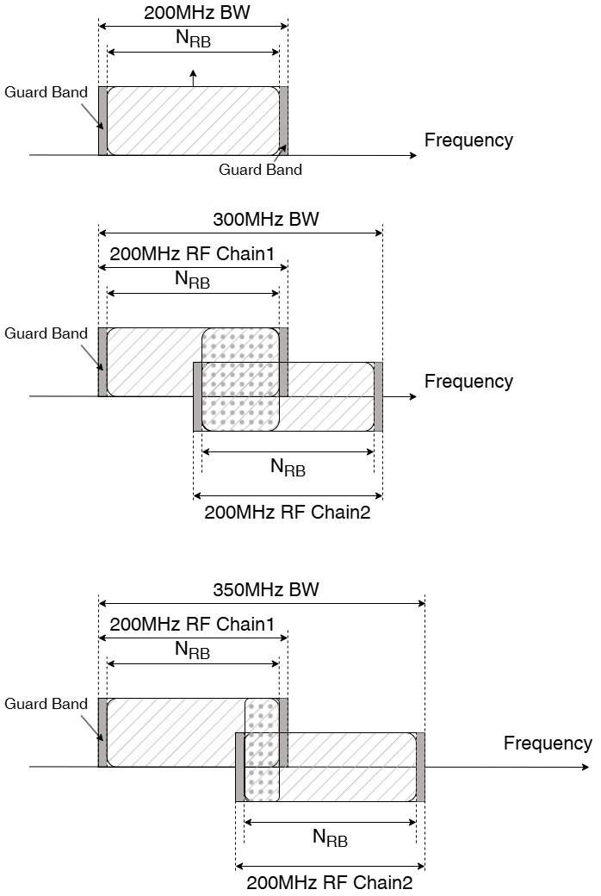

- Proposals from Tejas R4-2605827
Observation 1: A common UE RF requirement framework is preferred for both single RF chain and two RF chain implementations supporting 400 MHz DL maximum channel bandwidth, so that requirements remain implementation independent as far as possible.
Observation 2: For two RF chain implementations, the boundary between RF chains may introduce effects such as phase discontinuity, magnitude mismatch, timing misalignment, and possible degradation around the stitching point. The need to specify the RF chain boundary and the use of zero GB as the baseline remain for further study.
Proposal 1: Support a single set of UE RF requirements for maximum CBW, applicable to both single RF chain and two RF chain implementations.
Proposal 2: Further study boundary aspects for two RF chain implementations, including possible impacts on RF requirements, demodulation performance, RRM measurements, and resource allocation. If no clear performance degradation is shown, zero GB may be considered as the baseline for two RF chain architectures.

- Proposals from Xiaomi R4-2605895
Observation 2: RAN-P agreed on around 7GHz, max BW in DL is 400MHz, and UL is 200MHz as single carrier maximum BW.
- DL 400MHz single carrier BW allow both single RF chain and multiple RF chain implemenattion.
Proposal 2: In initial stage, RAN4 focus on channel bandwidth definition aspects for max BW including RF boudary defintion, inner GB, asymetric bandwdith.
- The detailed RF requirements and BB requirements impact can be further discussed in RF, RRM and demod thread separatly once sufficient progress reached in system thread and RAN1 design (RRM and demod impact).
Issue 1: RF requirement impact
Observation 3: Mutiple RF chain provide better Rx RF performance than single RF chain considering separte RF chain on each 200MHz RF bandwidth part with reduced ADC Quadratuer Error, better adjacent interference rejection performance and dynamic range performance.
Issue 2:Whether needs to specify RF boudary location /and inner GB
Proposal 4: Detailed resource mapping and scheduling belongs to RAN1 design; whether needs such RF boudary and scheduling restriction shall be decided by RAN4 consideirng UE implementation restriction with multi-RF chains.
Proposal 5: Due to phase discontinuty and unperfertime time algnment issue across two RF chain, SSB, PRG/REG spanning across boundary shall be avoided.
Observation 4：The location of two RF bandwidth part including RF boudary from UE perspective needs to be aligned between UE and network side with following reason:
- Network needs to know the location to avoid SSB, PRG/REG spanning across boundary
- UE needs to know the RF bandwidth part location to adjust LO and RF chain; also combine two bandwidth part in BB
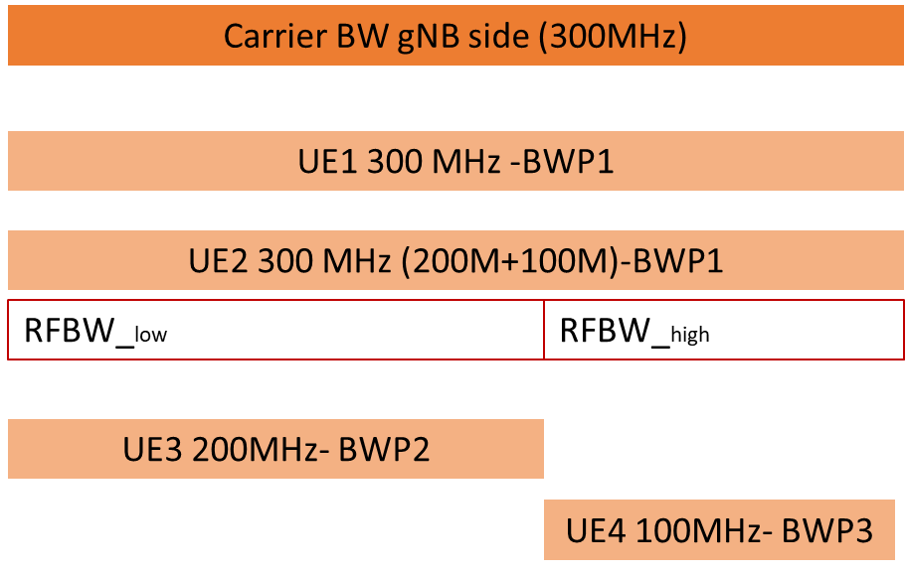
P6: For UE supporting larger than 200MHz CHBW with 2 RF chains, The boundary of 2 RF chains and location of RF chain shall be defined from system perspective, assuming single RF chain capability is 200MHz e.g. via network implict or implicit indication to UE.
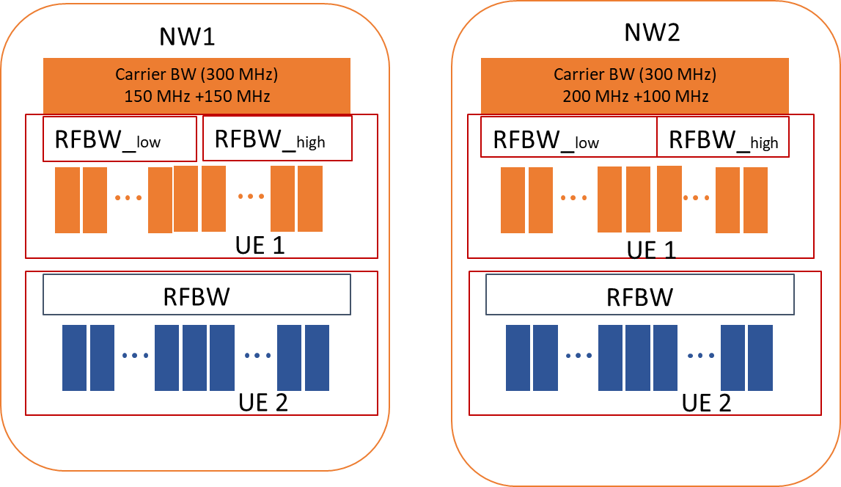
Wether needs to specify inner-guard-band across RF boudary between 2 RF chains and transmission bandwidth definition (N_{RB})
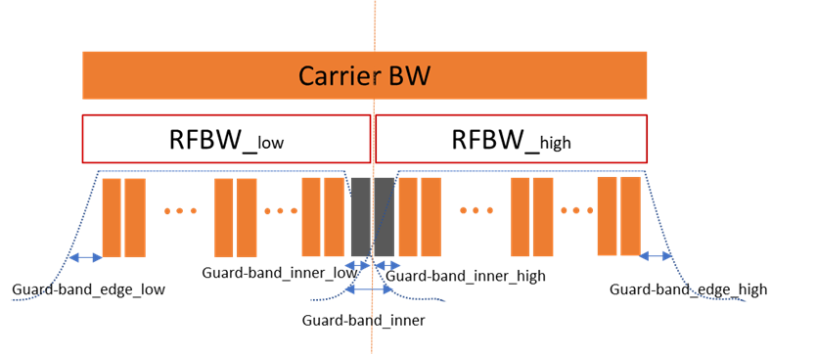
Observation 5: Due to phase discontinuty and unaligned time between two RF chains, it will introduce inter-sub-carrier interference close to RF boundary.
Observation 6: Separate RF chain and BB filtering can be helpful to reduce channel edge guard-band.
Observation 7: By shifting part of channel edge guar-band to inner GB, UE still can maintian same SU or higher SU with reserved inner GB compared to single RF chain option
200MHz | 400MHz (single RF chain) | 400MHz (single RF chain)
GB on channel edge 1.72MHz  546 PRB (98% SU) | GB on channel edge 3.44MHz  1092 PRB (98% SU) | GB on channle edge ~1.72MHz  Inner GB ~ 1.72MHz  548 PRB-~5PRB (innerGB)-548 PRB  - Avaliable PRB:1096

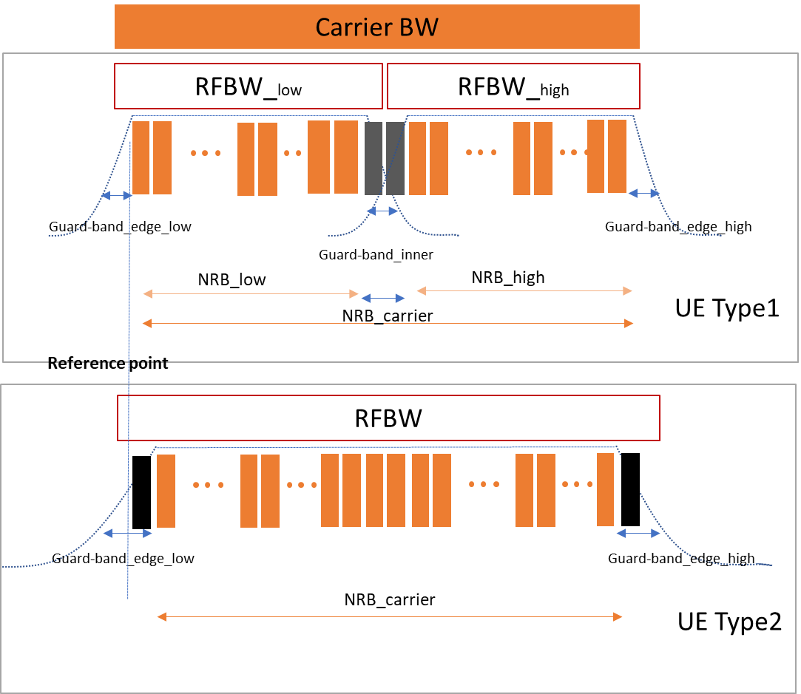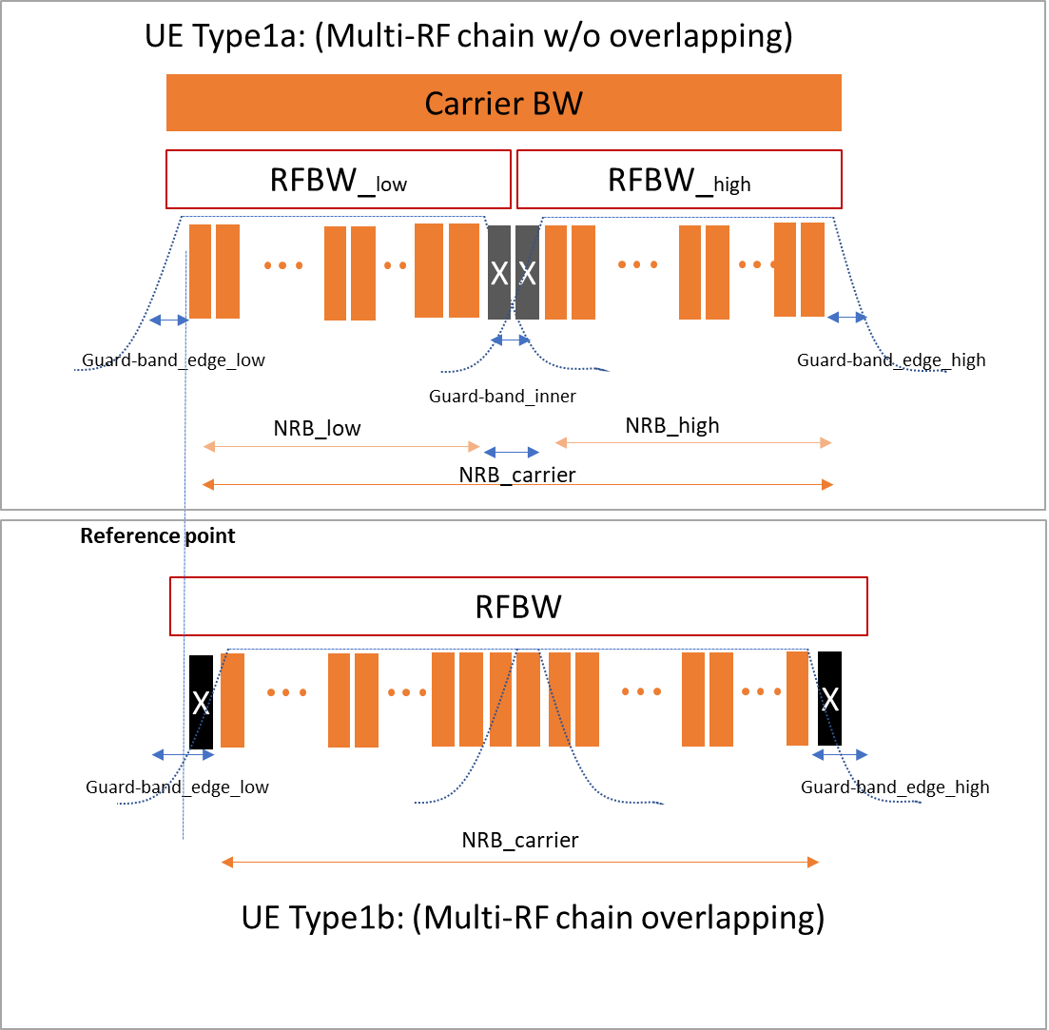
P7: Introduce UE capability for UE with multi-RF chain whether inner GB neeeded or not.
Issue 3: Asymetric bandwidth consideration
Observation 8: Addtional RF returning time including LO returning time is required for DL-UL transition if UL bandwidth centre frequency is not aligned with DL RF chains centre frequency.
- Pending on UE implemenattion, the addtional RF returning time is aroud 70 ~210 us.
Proposal 8: RAN4 further study how to take addtional RF returning time into account for DL-UL swicthing under asymetric bandwith configuration for DL BW >200MHz.
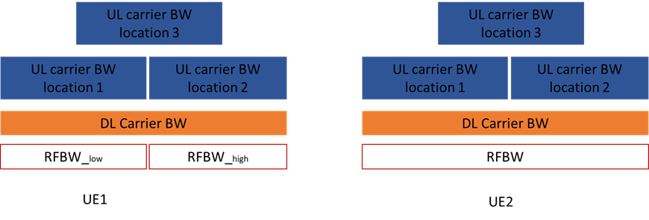
Issue 4: SRS swicthing across different DL bandwidth part
Proposal 9: RAN4 shall specify SRS switching time and corresponding time mask under asymmetric BW scenario for DL BW >200 MHz.
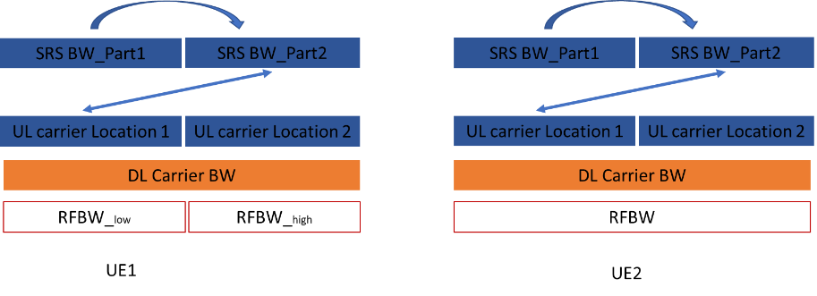
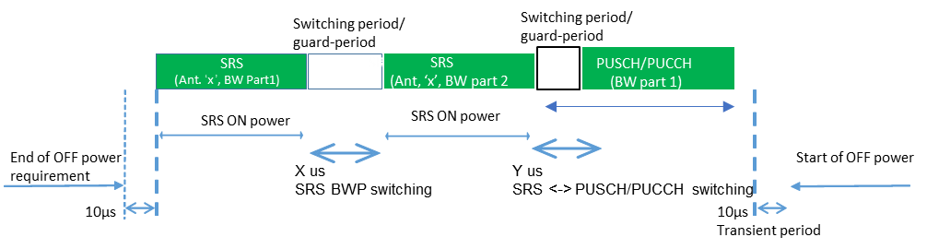
DL MIMO layer capability
Observation 9: MIMO Layer capability have dependency on channel bandwidth and number of RF chains, antennas and BB processing capability.
Proposal 10: On mandatory Rx antennas (MIMO layers), define single value without dependency on CHBW and single or multi-RF chains.
- For Optional supported Rx antennas (MIMO layers) larger than mandatory value, allow UE to report capability with discrimation with maximum bandwidth limitation

- Proposals from vivo R4-2605949
Observation 1: From RF perspective, for 2 RF chains implementation, zero guard band can be achieved with partial frequency overlapping of two RF chains, which can eliminate the impact of non-linearity at the edges of the analog filters.
Observation 2: From RF perspective, for 2 RF chains implementation, RF impairment (e.g., delay mismatch, phase offset between two RF chains) can be collaborated by UE implementations by partial frequency overlapping of two RF chains.
Proposal 1: For UE supporting CBW of 400MHz in DL with two RF chains implementation, consecutive spectrum utilization is assumed without guard band.
Observation 3: The potential boundary between 2 RF chains comes from baseband processing instead of RF part.
Observation 4: Whether PDSCH/PDCCH or certain RS has any limitation on boundary between two RF chains is up to RAN1 decision.
Observation 5: Regarding whether 6G SSB can cross the boundary between two RF chains:
- SSB is Cell specific RS which cannot be adjusted per UE’s boundary
- The BW of the SSB is small which can be handled by partial frequency overlapping
- SSB is not likely to be placed in the middle of the DL 400MHz CBW as there are UEs which is incapable of 400MHz operation.
Proposal 2: From RAN4 perspective, there is no need to define the boundary between two RF chains.
Proposal 3: For UE supporting DL 400MHz operation with one RF implementation, RAN4 to study following UL architectures with potential RF requirements impacts.
- Architecture 1: UL transmission with up to 200MHz BW can be scheduled within any place within 400M CBW without LO retuning.
  - UL baseband and transceiver support 400MHz capability, e.g., DAC, LPF, and only partial UL RF capability is restricted to 200MHz, e.g., ETPA
- Architecture 2: UL transmission with up to 200MHz BW can be scheduled within any place within 400M CBW with LO retuning.
  - Both UL baseband and RF are restricted to 200MHz.
Observation 6: For UE with shared LO (i.e., 2 LOs are required in total) between UL and DL, additional switching delay caused by LO tuning is not acceptable which will have inevitable system impact for each DL-UL and UL-DL transition. Instead, it is preferred that the UL is placed that the centre of UL is aligned with the LO of one of DL RF chain.
Proposal 4: For UE supporting DL 400MHz CBW operation with two RF implementation, RAN4 to study following UL architectures with potential RF requirements impacts.
- Architecture 1: For UE with shared LO (i.e., 2 LOs are required in total) between UL and DL, the centre of UL 200MHz has to be aligned with the LO of one of DL RF chain.
- Architecture 2: For UE with separate LO for UL (i.e., 3 LOs are required in total), the centre of UL 200MHz can be placed independently from DL LO.
Observation 7: If zero guard bound is assumed and the boundary is unnecessary, the design is common for DL 400MHz CBW and other CBW larger than 200MHz.
Proposal 5: For UE supporting CBW of 400MHz in DL operation no matter one RF implementation or two RF implementation, it shall also support CBW values between 200 and 400MHz in DL operation if corresponding CBW is introduced.
Observation 8: If BWP still exists in 6G, BWP switching delay maybe different for two RF chains implementation as RF chain activation or deactivation delay maybe considered.
Proposal 6: RAN4 to discuss the impact on BWP switching delay for two RF chains implementation if BWP is supported in 6G.
Observation 9: For NR re-farming band, the spectrum allocation is already stable.
Proposal 7: Apart from ~7GHz, for NR re-farming bands, whether to define maximum CBW larger than that in NR should be evaluated and justified based on operator’s inputs.

- Proposals from CMCC R4-2606005
Observation 1: following list candidate 2*200MHz RF chain architectures for further information.
- Case 1: split RF chain after LNA, A higher-performance LNA is required compared to Case 2 to accommodate the increased PAPR at the LNA input and prevent potential linearity degradation.
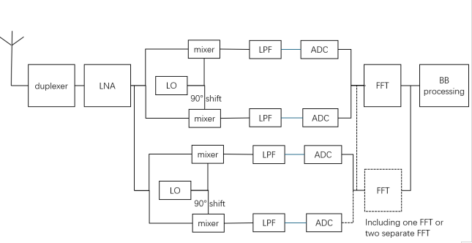
- Case 2: split RF chain after duplexer/switching, i.e. before LNA, which will introduce extra IL, impact NF and degrade REFSENSE.
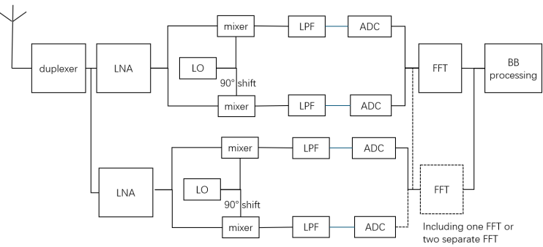
Proposal 1: the typical two RF chain architecture assumes splitting RF chain after duplexer/switching, i.e. before LNA.
Proposal 2: Consider unified UE implementation and avoiding market fragmentation, it is better to assume the same UE implementation for different system bandwidth.

- Proposals from ZTE R4-2606307
Guard band and RF requirements with different implementations:
Proposal 1. Zero GB for 2 RF chains architecture should be considered as the baseline.
Proposal 2. A single set of UE RF requirements should be defined for both single and two RF chain based architectures.
Observation 1. The RF boundary shall restrict the resource configuration mapping (e.g. to avoid SSB, PRG/REG spanning across any applicable boundary of RF chains.
Proposal 3. The RF chain boundary for UEs with 2 RF chains should be indicated by NW.
Proposal 4. The UE channel bandwidth definition should be revised to include two RF chains implementation in the downlink.

- Proposals from Qualcomm R4-2606810
Observation 1: UE RF Front-end architecture choice poses no challenge to UL 200MHz CBW support. Therefore, no special considerations are required
Proposal 1: UE RF Front-end implementation can vary across designs. There is no known impact from RF Front-end architecture to Asymmetric DL/UL design and core requirements
Observation 2: UE Transceiver can support UL 400MHz CBW. This will help enable efficient UL switching between configured 200MHz CBW within the DL 400MHz CBW that will also help SRS implementation
Proposal 2: The core specifications for UL 200MHz CBW should be designed considering the entire system BW (e.g. DL 400MHz) and UE transceivers capable of wider BWs (same as the system BW)

- Proposals from OPPO R4-2606981
Observation 1: In NR intra-band contiguous CA, the inner guard band can be scheduled by network from 0 up to the minimum guard band that fulfils the nominal channel spacing.
Observation 2: If non-zero inner guard band is used, the SU for 2*200MHz will be smaller than 400MHz.
Observation 3: Overlapping filter implementation can solve the zero inner guard band request.
Observation 4: The overlapping part of filter is transparent to base station and no information is needed to be reported
Observation 5: The RBs of two RF chains can keep perpendicular and the interference can be omitted.
Observation 6: UE can use its own design of filter to receive the two 200MHz without network scheduling.
Observation 7: Current UE can support different LO for UL and DL.
Observation 8: The typical different UL and DL LO implementation can support DL 400MHz and UL 200MHz.
Observation 9: 2*200MHz DL RX might need 3 LOs for 400MHz DL and 200MHz UL with flexible allocation.
Proposal 1: Zero guard band is proposed to achieve high enough SU for 2*200MHz compared to 400MHz.
Proposal 2: The UE RF chain implementation as well as the filter and RF boundary should be transparent to network.
Proposal 3: It is proposed to only allocate the 200MHz as lower or upper part of the 400MHz for reduce implementation complexity and network scheduling.
Proposal 4: Only up to two LOs to implement the DL 400MHz and UL 200MHz.
Proposal 5: To study the SRS switching requirement with the scenario that switch to out of the UL bandwidth.

- Proposals from Google R4-2607131
Proposal 1: Considering that the zero GB may increase more UE implementation burden due to natural phase mismatches and filter limitations in the two RF chains architecture, it is suggested to resolve this issue by introducing the RF boundary reporting mechanism and the network can perform DL scheduling restrictions to avoid allocating resources across the UE-reported boundary.
Proposal 2: Considering that unrestricted UL bandwidth placement within the DL >200MHz to 400MHz span in TDD bands may increase UE power consumption and hardware cost, it is suggested that the UL bandwidth placement should be restricted by aligning the UL center frequency with one of the DL RF chains.

8.2.2.1 Min CBW
- Proposals from Spreadtrum R4-2605392
Proposal 9: Some bands, like TDD bands n51 and n54, they just have 5MHz spectrum allocation, need to be considered additionally in the WI stage.

- Proposals from Nokia R4-2605516
Observation 6: The smaller the UE CBW, the greater the need for synchronization maintenance and measurements, which increases system complexity.
Proposal 10: All UEs support a minimum channel bandwidth (CBW) of 200 MHz for both downlink (DL) and uplink (UL) for the Around 7GHz frequency range.

- Proposals from LGE R4-2605701
Proposal 6: RAN4 consider larger minimum CBW, e.g., 20MHz for ~7GHz band in 6G.

- Proposals from Huawei R4-2605712
Proposal 4: No need to consider the applicability of 3MHz for NTN bands which is above 3GHz with 15kHz SCS for the moment, unless there is clear request from operators.
Proposal 5: No further discussion regarding min CBW is needed from spectrum perspective. Band specific min CBW can be further discussed in WI stage.

- Proposals from CATT R4-2605803
Observation 1: 20MHz Min. CBW for band n104 was specified since the smallest Max. CBW of RedCap UE is 20MHz in NR.
Proposal 1: If companies wanted to specify the Min. CBW, e.g. 40MHz or 50MHz for ~7GHz band including n104, one alternative is to decouple the discussion between BS Min. CBW for ~7GHz band and UE Min. CBW for ~7GHz band.

- Proposals from vivo R4-2605949
Proposal 8: RAN4 shall inform RAN1 the minimum CBW for initial access from RAN4 perspective as:
- 5/10/50 MHz for 15/30/120 kHz SCS
- Larger min CBW for initial access for bands with larger spectrum e.g., ~7 GHz may be considered based on further operator’s input.
Proposal 9: For the applicability of 3MHz for NTN bands above 3GHz, the targeting NTN bands above 3GHz and the necessity for 3MHz operation should be justified.

- Proposals from CMCC R4-2606005
Observation 2: larger minimum CBW for around 7GHz could be based on future operators’ spectrum holding.

- Proposals from ZTE R4-2606307
Observation 2. RAN4 mainly focus on the minimum channel bandwidth for spectrum specific, while RAN1 mainly focus on the minimum channel bandwidth for initial access.
Proposal 4: For around 7GHz including refarmed n104 band with 30kHz SCS, it is proposed to adopt larger than 10MHz minimum channel bandwidth, e.g. 20MHz.

- Proposals from Rakuten R4-2606666
Proposal 1: RAN4 should agree that, for operator requested bands, 3 MHz shall be specified as the mandatory minimum channel bandwidth for 15 kHz SCS on a band specific basis.

- Proposals from OPPO R4-2606981
Proposal 6: To further study the per band minCBW consider both operator request and SSB and sync raster design.

8.2.2.2 Numerology
- Proposals from Spreadtrum R4-2605393
Proposal 1: SCS of SSB can be 120 kHz in FR2-1 for 6GR.

- Proposals from Nokia R4-2605517
In this paper we note that the only 6GR scenario having subcarrier spacing still open is around 15 GHz but discussion on this frequency range is on hold in RAN4. Content of 15 GHz in this paper is just for information as there is parallel RAN1 discussions on this.

- Proposals from Samsung R4-2605668
Observation 1: The same-SCS principle is a reasonable baseline for FR1 and other already aligned operating ranges.
Observation 2: In FR2-1, SSB needs higher robustness than data/control channels because it is detected before reliable frequency and timing tracking is available.
Observation 3: The use of 240 kHz SCS for SSB and 120 kHz SCS for data/control channels in FR2-1 reflects different requirements before and after synchronization.
Observation 4: Maintaining 240 kHz SCS for SSB in FR2-1 can reuse a commercially verified synchronization baseline and avoid unnecessary redesign and validation burden.
Observation 5: For MRSS in FR2-1, alignment with the existing 240 kHz SSB-based synchronization structure can help avoid unnecessary resource reservation and PRB alignment constraints.
Observation 6: For FR2-1, forcing 120 kHz SCS for SSB may reduce initial access robustness and may not reduce practical UE complexity.
Proposal 1: For 6GR FR2-1, the SCS of synchronization signal should be 240 kHz, while the SCS of data/control channels can be 120 kHz.

- Proposals from LGE R4-2605702
Proposal 1: RAN4 consider SSB 120kHz for FR2-1.

- Proposals from Huawei R4-2605713
Proposal: Consider same SCS between 6GR Sync signals and other channels/signals (except PRACH) in FR2-1, i.e., 120kHz in FR2-1.

- Proposals from CATT R4-2605804
Proposal 1: RAN4 can consider the following two alternatives for Numerology of SSB in FR2-1:
Alt.1: make a decision by RAN4#119 meeting.
Option 1: 120kHz SSB (Pros: the numerology is aligned with the other physical channels).
Option 2: 240kHz SSB (Pros: Some vendors have implemented 240kHz SSB in 5G. More slot occasions can be used for different beam indexes during initial access phase).
Alt.2: it’s recommended to postpone the decision on this issue in or after June RAN plenary meeting.
Proposal 2: to further confirm that only 15kHz SCS is applicable to FR1 SDL bands (e.g. s29/s67/s75/s76).

- Proposals from Xiaomi R4-2605894
Observation 1: Multiple numerologies in same bands/sub-frequency range will bring unnecessary complexity to both gNB and UE with market fragmentation, and mixed numerologies on same carrier/bands will further increase 6GR system scheduling complexity and bring gNB/UE implementation challenge.
Observation 2: Following pain points observed for NR SSB numerology (initial cell search)
- Multiple default SSB numerologies on some bands increase UE initial cell complexity
- Mixed numerologies between SSB and data/control channel in FDM bring UE implementation complexity, and simultaneous reception belongs to UE capability which bring interruption in data channel when performing SSB measurement
Proposal 2: Deprioritize the discussion on 10GHz for system parameter including numerology.
Proposal 3: For FR2-1 SSB numerology, limit with single choice either 120kHz or 240kHz as per band basis

- Proposals from CMCC R4-2606006
Proposal 1: For 6G FR2-1 frequency range, only 120 kHz SCS is suggested for SSB.

- Proposals from ZTE R4-2606308
Observation: There are pros and cons for SSB SCS is changed from 240k to 120kHz for FR2-1.
Proposal: It is proposed to evaluate the impacts if same different SCS for SSB and data/control within the same bands for FR2-1.

- Proposals from OPPO R4-2606982
Observation 1: From evolution perspective, the economic way of FR2 is not to change too much.
Observation 2: Current 240kHz SSB and 120kHz Data has shown no problem in the field
Observation 3: The SCS for RACH in NR is not a single value; it is determined by the operating frequency range and the configured PRACH preamble format.
Proposal 1: To further study the benefit of same SCS for SSB and DATA for FR2.
Proposal 2: Close coordinate with RAN1 on RACH design and its corresponding SCS.

8.2.2.3 Asymmetric CBW
- Proposals from Nokia R4-2605518
Proposal 1: If UE needs to transmit an UL signal (e.g., SRS) outside its currently configured UL CBW, it should perform UL CBW switching beforehand. Both semi-static and dynamic UL CBW switching scenarios need to be considered.
Proposal 2: Operating according to asymmetric DL/UL CBW (such as 400MHz DL / 200 MHz UL) requires separate oscillators for DL and UL.
Proposal 3: For asymmetric DL/UL CBW scenario, support flexible placement of UL CBW within DL CBW
Proposal 4: In asymmetric DL/UL CBW, UE RF requirements should be defined not only according to UL CBW configuration, but also according to both DL CBW and UL CBW.

- Proposals from Interdigital R4-2605572
Observation 1: RAN1 has agreed to support a maximum CBW of 400 MHz at the BS.
Observation 2: Support for 400 MHz DL bandwidth is subject to UE capabilities.
Observation 3: The maximum UL CBW of 200 MHz for data and SRS is subject to further study.
Observation 4: A 400 MHz DL CBW combined with a 200 MHz UL CBW leads to an asymmetric TDD configuration in the 7 GHz band.
Observation 5: For contiguous spectrum between 200 MHz and 400 MHz, the UEs supporting 200 MHz maximum CBW require intra-band CA configuration.
Proposal 1: Support flexible DL/UL asymmetric TDD channel arrangements.
Observation 6: The UE requires RRC configuration of resources associated with transmissions beyond the initial 200MHz.
Observation 7: One option is a single 400 MHz DL channel with two 200 MHz UL BWPs, with only one UL BWP active at a time. Or more than two UL BWPs with only one active at a time.
Observation 8: Another option is an SCMC configuration with one 400 MHz DL carrier and two 200 MHz UL carriers (only one active at a time).
Proposal 2: Support one of the following options for the asymmetric TDD case:
- Option 1: A single 400 MHz DL channel with two 200 MHz UL BWPs, with only one UL BWP active at a time. Or a single 400 MHz DL channel with more than two UL BWPs, with only one UL BWP active at a time.
- Option 2: An SCMC configuration with:
  - One 400 MHz DL carrier;
  - Two 200 MHz UL carriers, with only one active at a time.
Observation 9: UL switching in a single-LO RF architecture introduces interruptions when sounding a 400 MHz channel with a 200 MHz UL CBW.
Observation 10: Two decoupled DL/UL LOs combined with two RF chains may reduce the need for measurement gaps in certain RRM scenarios.
Observation 11: Two UL RF chains enable non-contiguous UL transmissions (e.g., intra-band non-contiguous CA with two PAs).
Observation 12: With two PAs, switching from CA to UL MIMO on a single CC may be feasible, enabling additional scheduling flexibility.
Proposal 4: Support two UL RF chains for UL transmissions beyond the 200 MHz maximum CBW as a UE capability.
Proposal 5: No guard band is required at the boundary between two RF chains, each covering 200MHz.

- Proposals from Samsung R4-2605669
General view
Observation 1: Asymmetric CBW can provide a useful mechanism to support wider DL operation without imposing the same maximum bandwidth requirement on UL.
Proposal 1: RAN4 should study asymmetric DL/UL CBW as a general 6GR framework, not limited to the DL 400 MHz and UL 200 MHz case, while considering duplex-mode and band-specific applicability.
UL bandwidth placement
Observation 2: Considering all possible UL bandwidth placements within a wider DL bandwidth may unnecessarily increase RAN4 requirement and test complexity.
Observation 3: Representative UL placement cases, such as lower-edge, upper-edge, and center-aligned placement, may be sufficient for initial RAN4 evaluation without restricting actual UE operation.
Proposal 2: For initial RAN4 evaluation of asymmetric CBW, representative UL bandwidth placement cases may be considered first, while the need for actual UL placement restrictions should be determined only after technical impact is identified.
DL/UL LO architecture and RF retuning
Observation 4: The need for additional DL-UL RF retuning or transient time in asymmetric CBW operation depends on UE RF architecture and should not be assumed by default.
Proposal 3: RAN4 should first clarify whether representative asymmetric CBW configurations introduce any additional DL-UL RF retuning or transient requirement before defining configuration restrictions or capability-dependent timing assumptions.
Sounding over DL bandwidth
Observation 5: Sounding over different parts of the DL bandwidth may be a relevant dependency for asymmetric CBW, but detailed RAN4 treatment depends on the RAN1 design of the SRS/sounding mechanism.
Proposal 4: RAN4 should consider SRS/sounding-related RF requirement impact for asymmetric CBW in the UE RF thread after the corresponding RAN1 design assumptions are clarified.

- Proposals from LGE R4-2605703
Proposal 1: RAN4 consider no restriction on UL bandwidth placement within DL 400MHz.
Proposal 2: RAN4 consider RF requirement related to RF retuning of DL-UL and UL-DL switching for asymmetric UL/DL CBW.
Proposal 3: RAN4 study DL power saving for two RF chains of DL 400MHz.

- Proposals from CATT R4-2605805
Duplex mode | Band number | Reason
FDD bands | n66 (e.g., UL 10M, DL 40M) | DL frequency range is larger than UL frequency range  (Operator Spectrum Situation)
FDD bands | n24 (UL 10M, DL 5M) | UL frequency range is larger than DL frequency range  (Operator Spectrum Situation)
FDD bands | n5, n8, n25, n26, n70, n71, n105 | Larger UL CBW will cause serious sensitivity degradation
FDD bands | n28 (UL 3M, DL 5M) | Operator Spectrum Situation
FDD bands derived from SUL + SDL | n91, n92, n93, n94, n109 | UL and DL frequency ranges are asymmetric due to the bands derived from one SUL band + one SDL band.
TDD band | n50 | UL 80MHz BW exceed 4% relative channel bandwidth for TDD band.
Observation 1: all the asymmetric cases in NR are summarized above.
Proposal 1: for 6G SI, the following cases can be studied for the asymmetric CBW topic.
- 6G new case: TDD bands with DL CBWs larger than 400MHz and 200MHz UL CBW.
- Legacy 5G FDD cases.

Proposal 4: for TDD asymmetric UL/DLCBW, there is no need to consider the potential RF retuning for DL-UL switching no matter the UL centre frequency in TDD bands is not same as the DL centre frequency, as UE implement DL LO and UL LO in TDD bands separately.

- Proposals from MediaTek R4-2605852
Observation 1: Today 5G NR UEs are implemented with separate LO architecture between uplink and downlink carriers for TDD bands while FDD bands are by default implemented with separate LO architecture
Observation 2: To have better flexibility on supporting new 6G potential features and MRSS to include 5G NR CA/ENDC capabilities, separate LO architecture between UL and DL carriers will be considered
Proposal 1: Separate LO architecture between uplink and downlink carriers is assumed for 6G eMBB UE RF assumption
Proposal 2: TDD bands can apply symmetric/asymmetric CBW in uplink and downlink in 6G day one
Proposal 3: FDD bands shall apply legacy scheme e.g., fixed Tx-Rx frequency separation and symmetric CBW for uplink and downlink, when specifying minimum requirements at least REFSENS for TN bands.
- FFS on whether the LO retuning scheme has any impact on the minimum requirements (the details of minimum requirements will be discussed in General UE RF)
Proposal 4: Asymmetric CBW in FDD band and non-fixed duplex spacing can be considered where beneficial, without necessarily needing to specify corresponding single carrier REFSENS.

- Proposals from Xiaomi R4-2605904
Proposal 1: Maintain same princple as NR, introducing asymetric channel bandwidth combination for FDD bands in case by case manner with corresponding signaling.
Propsoal 2: Maintain same princple as NR, introducing asymetric channel bandwidth combination for TDD bands
- Alt 1: Maintain same restriction as NR; DL/UL centre frequency shall be aligned
- Alt2: Introduing UE capability for DL/UL centre frequency not aligned with different DL-UL trasient time
- { 13us, 140us}

- Proposals from vivo R4-2605950
Observation 1: Following principles should be adopted in 6G asymmetric CBW if defined:
- The narrower carrier shall be confined within the frequency range of the wider channel bandwidth.
- For FDD band, the maximum deviation to the Tx-Rx carrier centre frequency separation is defined as ΔFTX-RX = | (BWDL – BWUL)/2 |
- For TDD band, one PRB is dropped when of the uplink or downlink RB number is odd while the other is even
Observation 2: Whether to remove the restriction on centre frequency alignment between DL and UL depends on the conclusion in 6G UE RF discussion about LO position.
Proposal 1: If asymmetric CBW is defined in 6G, following principles shall be adopted:
- The narrower carrier shall be confined within the frequency range of the wider channel bandwidth.
- For FDD band, the maximum deviation to the Tx-Rx carrier centre frequency separation is defined as ΔFTX-RX = | (BWDL – BWUL)/2 |
- For TDD band, one PRB is dropped when of the uplink or downlink RB number is odd while the other is even
Proposal 2: Whether to remove the restriction on centre frequency alignment between DL and UL depends on the conclusion in 6G UE RF discussion about LO position.
Proposal 3: In addition to 400MHz DL/200MHz UL, RAN4 to discuss the targeting band for asymmetric operations based on operators’ inputs on spectrum availability.

- Proposals from ZTE R4-2606309
Observation 1: In NR asymmetric channel bandwidth operation, There is no restriction for the narrower carrier location in the range of the wider channel bandwidth frequency range.
Observation 2: The asymmetric channel bandwidth feature should be supported for both FDD band and TDD band in 6GR, also it depends on UE capability, which band can support this feature relays on operator’s demands.
Proposal 1: No restriction on UL bandwidth placement within DL 400 MHz.
Proposal 2: No RF retuning for DL-UL switching in the asymmetric channel bandwidth operation.

- Proposals from Spreadtrum R4-2606400
Proposal 1: No any restriction on UL bandwidth placement within DL 400 MHz
Proposal 2: Decouple the LO architecture assumptions for DL and UL.
Observation1: If we reuse the LOs for DL and UL, there is a need for RF-retuning for DL-UL switching. We need to define the switching time, such as 140us for DL-UL switching, which will decrease the throughput and may impact the TDD frame structure.

- Proposals from Qualcomm R4-2606811
Observation 1: UE UL transmission bandwidth within the DL CBW should be flexible to allow for both NW and UE side optimizations
Proposal 1: UE UL transmission bandwidth within a wider system bandwidth (e.g. 400MHz) should be flexible
Observation 2: There is potential to reduce MPR with defining emissions specification offsets based on DL CBW or BS CBW for asymmetric DL/UL
Proposal 2: Use DL CBW for UE UL emissions offset specifications
Observation 3: There is potential to improve spectral utilization for cases where UL CBW is smaller than DL CBW and allocated away from DL channel edge. This is achieved by defining guard band relative to DL CBW
Proposal 3: Consider different spectral utilizations for different UL configurations depending on their relative positions to the edge of the system bandwidth
Observation 4: SRS BWP of 200MHz could be defined to cover sounding the DL 400MHz
Proposal 4: SRS switching will be needed to support sounding 400MHz DL for asymmetric DL/UL
Observation 5: RAN4 needs guidance from RAN1 on SRS sounding framework for asymmetric DL/UL. RAN4 should study UE UL interruption time and agree on a number that works across UE designs to reduce implementation complexity and overhead
Proposal 5: RAN4 should study the interruption time for SRS in case of asymmetric DL/UL and attempt to optimize it to improve system performance by agreeing to a single number instead of multiple UE capabilities

- Proposals from OPPO R4-2606990
Observation 1: In 5G, asymmetric channel bandwidth has already been supported with signaling.
Observation 2: The ΔFTX-RX = (BWDL – BWUL)/2) has been defined to limit the separation difference introduced by asymmetric channel bandwidth.
Proposal 1: All bands can apply symmetric/asymmetric CBW in downlink and uplink in 6G day one with the limitation of maximum of deviation to the TX-RX carrier center frequency separation as ΔFTX-RX = (BWDL – BWUL)/2).=

8.2.2.4 Spectrum utilization
- Proposals from Nokia R4-2605519
Proposal 1: To enhance spectrum utilization, we suggest determining usable RBs and feasible guard bands through a generic, equation-based method derived from established regular bandwidth-to-guard band relations from 5G.
Observation 1: The proposed equation-based method is step-size (channel bandwidth) and SCS agnostic.
Observation 2: To avoid introducing more stringent RF requirement, the existing guard bands for defined channel bandwidths of 5G NR would remain unchanged. Our proposed formula-based approach will accordingly be applied only to the new channel bandwidths that are not already defined in 5G NR.
Observation 3: To ensure that the new CBWs do not complicate channel filtering, one approach is to select GBs that are no smaller than those defined for the larger regular CBW, achieved by reducing the number of resource blocks by one RB.
Proposal 2: Using the proposed equations in Table 3, the maximum number of resource blocks (Max_Nrb) and the feasible guard band (GB) can be calculated based on the established relationship between bandwidth and guard band from the existing 5G NR specifications, denoted as “k”. The only required input parameters are the irregular CBW and the SCS.
Proposal 3: RAN4 to discuss how to mitigate UE testing increase when number of channel bandwidths in 6GR will be larger compared to 5G.

- Proposals from Skyworks R4-2605570
Proposal on increased SU enabling flexible and irregular channel bandwidths:
- 6G SU is increased compared to 5G by designing NRB such that the minimum guard-band is the closest and higher value to 1RB bandwidth of the considered SCS.
- This design is applicable to any CBW and thus enables the support of flexible and irregular CBW.
  - However, to limit the flexibility it is proposed that the flexible CBW granularity is increased in 1/2/5/10/20MHz steps with increased CBW. The switching points for the step change can be further discussed based on the irregular CBW needs by operators.
  - For 15kHz SCS 3MHz to 100MHz can be supported with 4K FFT and 100MHz to 200MHz for 16k FFT (most likely for BS)
  - For 30kHz SCS 5MHz to 200MHz can be supported with 4K FFT and 200MHz to 400MHz for 16k FFT (most likely for BS)
- For verification of the UE UL and DL requirements it is sufficient to check the cases with the lowest minimum guard bands: 180kHz for 15kHz SCS and 360kHz for 30kHz SCS. 3MHz is a specific case.

Proposal: The proposed flexible CBW and SU design approach is applicable to asymmetric UL/DL CBW to fully optimize the use of the UL and DL spectrum.
Proposal on SEM0 failures when increasing SU: RAN4 studies the appropriate measures to avoid having SU dictated by edge allocations. The following aspects can be studied:
- Tightening the windowing filter for the low order modulations where the transient EVM impact is small
- Relaxing the SEM0 requirement either with a larger MBW or a relaxed level or both. For 6G this is not an issue as in most cases, the 6G adjacent channel can be SCS aligned or have a larger guard-bands if used by LTE or NR.
- Having a specific MPR for edge allocations
- Any combination of the above.
- Other approaches are not precluded.

- Proposals from Samsung R4-2605670
Observation 1: An equation-based method can be useful in the SI phase to derive candidate maximum RB allocation and guard band values for larger, new, or flexible channel bandwidths.
Proposal 1: The final maximum RB allocation and minimum guard band should be determined based on evaluation with applicable baseline RF requirements, including SEM, ACLR, EVM, ACS and blocking.
Proposal 2: If k is used as the guard band ratio to be maintained, the inequality direction should be consistent with the derived maximum RB expression.
Proposal 3: For a new channel bandwidth, both the next smaller and next larger established channel bandwidths should be considered when deriving candidate RB allocation and guard band values.
Proposal 4: A candidate RB value derived by equation should also be checked against the monotonic guard band relationship under study in RAN4.
Proposal 5: For MRSS scenarios, even number RB addition should be considered as one criterion when deriving candidate maximum RB allocation values.

- Proposals from LGE R4-2605704
Proposal 1: Study 6G SU considering SEM, and EVM RF requirements.
Proposal 2: For SU analysis, RAN4 should study how to define SEM requirement for 1st MHz outside the channel, being compliant with the regulation but also considering the characteristics of the adjacent system and protection that is necessary, as this likely has direct impact onto needed guard bands.
Observation 1: With the existing SEM requirement @ Δf_{OOB} =0~1MHz, SU is larger than 5G for CBW = 5/10MHz @ SCS 15kHz and CBW = 10~30 MHz @ SCS 30kHz in case of 5G SU < 95%.
Observation 2: Without SEM requirement @ Δf_{OOB} =0~1MHz, SU is larger than or equal to that for SEM requirement @ Δf_{OOB} =0~1MHz.
Proposal 3: RAN4 consider value less than or equal to the possible maximum N_{RB} in Table 14 as 6G N_{RB} starting point.
Table 14: summary of possible maximum N_{RB}
 |  | 5MHz | 10MHz | 15MHz | 20MHz | 25MHz | 30MHz | 200MHz | 400MHz
5G NR | 15kHz | 25 | 52
5G NR | 30kHz | 11 | 24 | 38 | 51 | 65 | 78
Case1 (SEM0) | 15kHz | 26 | 53
Case1 (SEM0) | 30kHz | 11 | 26 | 39 | 53 | 67 | 80 | 553 | 1108
Case2 (No SEM0) | 15kHz | 26 | 53
Case2 (No SEM0) | 30kHz | 11 | 26 | 40 | 53 | 67 | 81 | 553 | 1110

- Proposals from Huawei R4-2605714
Observation 1: For the SU below 95% cases, adding two RBs symmetrically on both sides of the carrier results in an extremely small guardband. This would be very challenging to implement without relaxing RF requirements or introducing new spectral confinement techniques.
Observation 2: Adding RBs to legacy CBWs may cause RBG misalignment, which would complicate schedule flexibility or increase signaling overhead.
Proposal 1: Considering applying a monotonic relationship with guard band sizes and channel bandwidth sizes only to newly defined 6GR CBWs.
Proposal 2: For existing CBWs and frequency bands, reuse the current 5G NR spectrum utilization for 6GR.
Proposal 3: For a 30 kHz subcarrier spacing at around 7 GHz, a 200 MHz CBW has no less than 546 RBs, and a 400 MHz CBW has no less than 1092 RBs.

- Proposals from CATT R4-2605806
Proposal 1: for Channel Bandwidth Sets for spectrum utilization evaluation, RAN4 need to the discuss the following issues.
Issue one: for 15kHz SCS, what is the channel bandwidth granularity for e.g. 5MHz ~ 20MHz?
Option 1: 1MHz granularity.
Option 2: 5MHz granularity.
Other options.
Issue two: for 15kHz SCS, what are the channel bandwidth granularity and range? (50MHz ~ 100MHz for 15kHz SCS)
Option 1: for 15kHz, 50~100MHz with 10MHz granularity.
Option 2: for 15kHz, 50~80MHz with 10MHz granularity.
Option 3: initially, RAN4 just assume that 50MHz is the Max. CBW for 15kHz SCS.
Other options.
Issue three: for 30kHz SCS, what is the channel bandwidth granularity between 100MHz and 400MHz.
TBD

Proposal 2: RAN4 to consider the following mainly factors when evaluating the spectrum utilization.
P2-1: the narrowest available guard band for each sub carrier spacing
NOTE: A UE’s spectral confinement ability is determined by it especially for edge RB allocation.
P2-2: the Max. SU which determine the design complexity of analog filters including Anti-alias filter and Reconstruction filter.
P2-3: Δω (Transition Band) in digital domain, which determine the design complexity of digital filters.

Proposal 3: Study how to establish a monotonic relationship where guard band sizes increase (or at least do not decrease) as channel bandwidth increases.
NOTE: Don’t reduce the transmission bandwidth configuration for the existing NR channel bandwidth.

- Proposals from MediaTek R4-2605857
Observation 1: According to the agreed WF, CBWs of 5~15MHz for 15KHz SCS,10~35MHz for 30KHz SCS and 200/400MHz are prioritized for SU evaluation
Observation 2: Spectrum utilization studies for UE Tx only cover up to 200MHz, whereas for 400MHz the spectrum utilization is applicable for DL only
On evaluation assumptions aspect:
Proposal 1: For spectrum utilization study, the impairment assumptions for 5G NR are re-used with improved IQ image rejection ratio. This also aligns the assumptions for requirements evaluation:
- Carrier leakage: -28dB
- IQ image: -34dB
- CIM3: -60dB
- CIM5: -70dB
Proposal 2: Proper PA models from each company can be used for SU evaluation. We propose a fixed-biased PA model without integrated DPD.
MRSS consideration aspect:
Proposal 3: Considering MRSS scenario, for the same channel bandwidth across 5G and 6G, if improving spectrum utilization is feasible, the added number of resource blocks need to be an even number to maintain PRB alignment between NR and 6G
Proposal 4: RAN4 Study on spectrum utilization improvement needs to wait for RAN1 progress on new waveform.

- Proposals from Xiaomi R4-2605897
Proposal 1: For existing combinations {CHBW, SCS}, taking existing SU from NR as baseline unless strong motivation well justified for the evaluation and improvement. And considering following case on evaluation work
- FR1 FDD 15kHz: 5MHz CHBW, 10MHz, 15MHz
- FR1 TDD 30kHz: 10MHz, 15MHz, 20 MHz, 25 MHz and 30 MHz
- FR2-1 TDD 120kHz: 50 MHz
Proposal 2: RAN4 shall maintain the monotonic relationship between CHBW and SU e.g. The spectrum utilization should keep monotone increasing trend for all channel bandwidths.
Proposal 3: Taking following RB/SU as starting point for evaluation to check the possibility of increasing SU compared to existing NR SU.
{SCS,CHBW} | Potential SU improvement (RBs)
{15kHz, 5MHz} | 25 -> 26
{15kHz, 10MHz} | 52 -> 53
{15kHz, 15MHz} | 79-> 80
{30kHz, 10MHz} | 24 -> 25,26
{30kHz, 15MHz} | 38->39
{30kHz, 20MHz} | 51 -> 52
{30kHz, 25MHz} | 65->65, 66
{30kHz, 30MHz} | 78 ->78, 79

Proposal 5: RAN4 shall decide SU in later stage after relevant 6G RF requirements are stable enough
Proposal 6: New channel bandwidth which is not existed in NR i.e., >50MHz Channel bandwidth for 15kHz, and >100MHz CHBW over than 30kHz SCS shall be prioritized over than existing channel bandwidth.
Proposal 7: On new CHBW/SCS combinations, we propose following SU for 200 MHz and 400 MHz as starting points
SCS (kHz) | 100  MHz | 200  MHz | 400  MHz
 | N_{RB} | N_{RB} | N_{RB}
30 | 273 | 546 | 1092

Observation 1: With NR experience, it’s hard to align spectrum confinement technology assumption which have several factors needs to be considered and trade-off between each other including Tx/Rx RF requirement impact, implementation complexity and ISI robustness.
Proposal 8: RAN4 shall specify single SU as per {channel bandwidth, SCS} combination with agonistic to spectrum refinement technology implementation.
Proposal 9: On evaluation, RAN4 can take windowing (WOLA) with 2% ~5% length

- Proposals from vivo R4-2605943
Observation 1: For PC3, the maximum RB number of 200MHz to meet the ACLR/SEM is 552, i.e.,99.36% SU

Observation 2: For PC2, to meet the ACLR requirement, the SU is reduced from 99.36% to 93.24%.

Proposal 1: RAN4 to clarify which power class is used for SU evaluation for 200MHz

Observation 3: The narrowband blocking determines the SU from Rx requirement side in NR, but the interference from narrowband system, e.g., GSM may not need to be considered in ~7GHz

Proposal 2: RAN4 to discussed whether narrowband blocking still served as the worst case for SU evaluation from Rx requirement side.

- Proposals from CMCC R4-2606007
Proposal 1: it’s challenging to define one unified BS PA model, infra-vendors can provide analysis based on their PA models. It’s FFS whether such PA models should be provided as simulation assumptions with final simulation results or not.
Proposal 2: it’s suggested to allow two sets of SU, Y% and X %, Y>X. 3GPP RAN4 requirements are based on X% and RAN1/2 spec can support Y%. this is especially beneficial for IoT devices which can’t support better spectrum confinement technique.
Proposal 3: Besides the prioritized CBW and SCS combination as approved in last meeting, further enhancement can be achieved for following CBW and SCS combinations with candidate enhanced value.
SCS (kHz) | 3 | 5 | 7 | 10 | 15 | 20 | 25 | 30 | 35 | 40 | 45 | 50 | 60 | 70 | 80 | 90 | 100
SCS (kHz) | MHz | MHz | MHz | MHz | MHz | MHz | MHz | MHz | MHz | MHz | MHz | MHz | MHz | MHz | MHz | MHz | MHz
 | N_{RB} | N_{RB} | N_{RB} | N_{RB} | N_{RB} | N_{RB} | N_{RB} | N_{RB} | N_{RB} | N_{RB} | N_{RB} | N_{RB} | N_{RB} | N_{RB} | N_{RB} | N_{RB} | N_{RB}
15 | 15 | 25 | 35 | 52 | 79 | 106 | 133 | 160  162 | 188  189 | 216  217 | 242  245 | 270  273 | N/A | N/A | N/A | N/A | N/A
30 | N/A | 11 | N/A | 24 | 38 | 51 | 65 | 78 | 92 | 106 | 119 | 133 | 162 | 189 | 217 | 245 | 273
60 | N/A | N/A | N/A | 11 | 18 | 24 | 31 | 38 | 44 | 51 | 58 | 65 | 79 | 93 | 107 | 121 | 135
15 | 90.0% | 90.0% | 90.0% | 93.6% | 94.8% | 95.4% | 95.8% | 97.2% | 97.2% | 97.7% | 98.0% | 98.3%
30 |  | 79.2% |  | 86.4% | 91.2% | 91.8% | 93.6% | 93.6% | 94.6% | 95.4% | 95.2% | 95.8% | 97.2% | 97.2% | 97.7% | 98.0% | 98.3%
60 |  |  |  | 79.2% | 86.4% | 86.4% | 89.3% | 91.2% | 90.5% | 91.8% | 92.8% | 93.6% | 94.8% | 95.7% | 96.3% | 96.8% | 97.2%
Proposal 4: it’s suggested to only focus on 6G single RAT rather than MRSS for SU enhancement analysis.

- Proposals from ZTE R4-2606310
Observation 1: PA models and PA calibration may be different for CBW ≥100 MHz and CBW <100 MHz.
Observation 2: It seems there is no room to improve the SU with existing 5G assumptions.
Proposal 1: For the existing channel bandwidths, the spectrum utilization for 6GR shall not be smaller than the 5G NR.
Observation 3: There are no consensus on spectral confinement technical, RF impairments and RF requirements in waveform study and 6GR UE RF requirements discussion respectively.
Proposal 2. Both UE and BS RF requirements should be taken into account for 6GR SU evaluation.
Proposal 3: It would be a bit early to carry out the SU evaluation.
Proposal 4: The SU for 400MHz should not be smaller than 98.3%.
Proposal 5: It is premature to consider equation-based method, and it shall be verified by simulation to meet the RF requirements.
Observation 4: It may cause the SU of some certain CBWs in 6GR are less than the SU in NR, if keeping a monotonic relationship where guard band sizes increase (or at least do not decrease) as channel bandwidth increases for all channel bandwidths.
Proposal 6: If keeping monotone increasing for the guard band, it should make sure the SU in 6GR is not smaller than NR for the same channel CBW.

- Proposals from Ericsson R4-2606356
Observation1: The relationship between spectral utilization and spectrum efficiency is not linear.
Proposal1: Within the scope of the 6G spectrum utilization study, RAN4 shall only evaluate the addition of an even number of resource blocks (RBs) to the NR maximum transmission bandwidth to enable efficient MRSS scheduling and secure 6G initial deployment success.
Proposal2: Considering the MRSS constrain, the spectrum utilization for 5 MHz channel bandwidth and 15 kHz SCS shall not be further optimized for 6G. Its transmission bandwidth configuration shall be specified with 25 RBs.
Proposal3: Regarding 6G spectrum utilization, RAN4 may adopt an equation-based methodology, but only after checking that the resulting number of RBS is validated for every single channel bandwidths and SCS configurations covered by this approach.
Proposal4: Agree on the following initial spectrum utilization parameters for 6G:

- Proposals from OPPO R4-2606983
Observation 1: WOLA can largely help to reduce the out-of-band emission and hence for edge 1RB allocation the MPR can be highly improved.
Observation 2: Different window length leads to large different MPR.
Observation 3: In NR SU, filter agnostic way is used.
Proposal 1: It is proposed to evaluate the SEM compliance with 1RB edge allocation while for ACLR, full RB allocation is used to check the ACLR
Proposal 2: If a certain new filter technology is to be introduced in 6GR, it is proposed to carefully study the complexity, time domain influence and corresponding impact on UE performance caused by such new filter technology.
Proposal 3: To further study the EVM impact of WOLA before making decision on increasing the SU.

- Proposals from Qualcomm R4-2607054
Observation 1: A non-monotonicity in the BW vs CBW trend can be fixed in isolation without impacting smaller CBWs only if the difference in GB to the next lowest CBW is greater than half RB wide (90 kHz for 15 k SCS).
Observation 2: It is not practical to make all GBs monotonic by only adding RBs relative to 5G practice.
Observation 3: Due to non-monotonic trend in guard band size and CBW-specific A-MPR, the network does not have full freedom in choosing ‘nesting’ locations for a UE that does not support a BW as wide as the cell specific BW.
Proposal 1: For 6G, RAN4 to study if it is essential to make channel ‘nesting’ fully flexible while preserving UE emissions compliance. ‘Nesting’ refers to when a UE does not support a BW as wide as the cell specific BW, and fully flexible nesting drives the GB monotonicity requirement
Observation 4: It seems possible to increase SU of those channel BWs whose SU in 5G is significantly lower than 95% without significant MPR increase from 5G

Observation 5: SEM compliance with additional RBs in the transmission BW configuration (compared to 5G) requires enhancements to spectral confinement assumptions

Proposal 2: RAN4 studies the following specific CBW/SCS combinations for SU enhancement:
- {5, 7, 10 and 15} MHz channels for 15 kHz SCS
- {10, 15, 20, 25, 30} MHz channels for 30 kHz SCS
Observation 6: For MRSS operation in a CBW with an odd number of additional RBs in 6G compared to 5G, FDM operation between 5G and 6G UEs is not feasible.
Proposal 3: RAN4 to study the impact on MRSS operation for an odd number of additional RBs in the 6G transmission BW configuration, compared to 5G.

- Proposals from T-Mobile USA R4-2607190
Observation 1: In 5G NR, some smaller channel bandwidths have wider minimum guardbands than wider channel bandwidths have.
Observation 2: There is no technical reason why a narrower channel bandwidth would need a wider minimum guardband than a wider channel bandwidth.
Observation 3: Because some narrower channel bandwidths in 5G NR have wider minimum guardbands than wider channel bandwidths have, the BWPs of those smaller channel bandwidths cannot align on PRB0 of the wider channel bandwidth, resulting in inefficient use of spectrum.
Observation 4: By choosing minimum guardbands for 6G such that the minimum guardband for each channel bandwidth is less than or equal to the minimum guardband for each wider channel bandwidth or the same SCS, the PRBs of all BWPs can be aligned with each wider channel bandwidth.
Observation 5: The proposed minimum 6G guardbands would allow for an additional RB for 45 and 50 MHz SCS with the 30 kHz SCS.
Observation 6: It could be problematic to use smaller 6G minimum guardbands for 5G.
Observation 7: guardbands when MRSS is deployed, and use the new 6G minimum guardbands when only 6G is deployed in a given piece of spectrum.
Observation 8: If needed, an IE broadcast in a SIB could let the UE know if the 6G or 5G minimum guardbands are used for that cell.
Proposal 1: RAN4 should consider choosing minimum guardbands for 6G such that the minimum guardband for each channel bandwidth is less than or equal to the minimum guardband for each wider channel bandwidth of the same SCS.
Proposal 2: The proposed monotonic guardband relationship should be evaluated against RF requirements (SEM, ACLR, ACS, blocking) to confirm feasibility.
Proposal 3: If the minimum guardband proposal is agreed for 6GR, increase the maximum number of RBs for 45 MHz from 119 to 120 and the and the maximum number of RBs for 50 MHz from 133 to 134.
Proposal 4: RAN4 should discuss if an indicator should be broadcast in 6G to indicate if the 5G or 6G minimum guardbands are used in the cell.

8.2.2.5 Irregular CBW
- Proposals from Spreadtrum R4-2605394
Proposal 1: From UE perspective, we can define scalable channel bandwidth and scalable guard band based on existing licensed channel bandwidth for irregular channel bandwidth.
Proposal 2: UE channel filter based on next large channel bandwidth can be assumption for defining UE RF requirements.

- Proposals from Nokia R4-2605520
Observation 1: Irregular CBW SU can be defined based on formula when basis comes from NR.
Observation 2: Some transmitter requirements are already CBW dependent, but some are not impacted by CBW
Observation 3: All receiver requirements are already CBW dependent
Observation 4: Supporting mode-dependent SU (MRSS vs standalone) requires additional rules/tables, signaling/validation, and potentially additional L1/L2 handling, whereas a single SU definition that also preserves MRSS alignment is simpler to standardize and implement.
Observation 5: Using the next larger bandwidth allows all irregular CBWs to inherit existing RF test coverage, instead of creating new test cases for each bandwidth value.
Proposal 1: RAN4 confirms that from UE RF requirement point of view irregular channel bandwidth concept is feasible
Proposal 2: Channel bandwidth ranges and associated granularities as presented in Table 1 are taken as a baseline for 6GR work. Values can be further discussed in WI phase in Rel-21.

- Proposals from Samsung R4-2605671
Observation 1: Introducing a separate RF requirement interpretation for each irregular CBW value may increase specification complexity and test burden.
Observation 2: For irregular CBW, the actual active RB span and the corresponding active frequency edges are more directly related to RF implementation impact than the nominal CBW value alone.
Observation 3: An active RB span-based interpretation can provide a simple reference to interpret the effective active bandwidth of an irregular CBW, without introducing a fully separate RF requirement framework for each irregular CBW.
Proposal 1: RAN4 should consider an active RB span-based interpretation for irregular CBWs, where the effective active bandwidth is derived from the maximum active RB span and the corresponding lower and upper active frequency edges.
Observation 4: The spectrum utilization discussion already includes the study of equation-based methods and scalable guard band definitions for new CBWs.
Observation 5: Reusing the same max RB or guard band derivation for irregular CBW can avoid a separate RB table and can keep irregular CBW aligned with the spectrum utilization framework.
Proposal 2: RAN4 should study whether the maximum active RB span for irregular CBWs can be derived by reusing the equation-based method or scalable guard band definition studied under the spectrum utilization topic.
Observation 6: Defining independent RF test cases for every irregular CBW may significantly increase test burden.
Observation 7: The active RB span-based interpretation can be used only for effective bandwidth and edge interpretation, while conformance testing can reuse the next larger regular CBW framework.
Proposal 3: For irregular CBWs, RAN4 should consider using the next larger regular CBW as the reference framework for RF conformance testing, instead of defining independent test cases for each irregular CBW value.
Observation 8: The combination of active RB span-based interpretation and next larger regular CBW testing can provide a balance between technical relevance, specification scalability, and testability.
Proposal 4: RAN4 should study a combined approach where the active RB span is used for irregular CBW interpretation and the next larger regular CBW is used for RF conformance testing.
Proposal 5: RAN4 should continue the irregular CBW study with the objective of avoiding new RF requirement entries and test cases for every unique operator request, while keeping a deterministic and scalable interpretation rule for irregular CBWs.

- Proposals from LGE R4-2605705
Proposal 1: RAN4 introduce a single, universal solution covering all possible irregular CBWs in 6G Day-1.
Proposal 2: RAN4 consider N_{RB} formulation for irregular CBW as below
- $N_{RB}_K= floor\left(N_{RB}_X∗\left(\frac{B}{A+B}\right)+ N_{RB}_Y∗\left(\frac{A}{A+B}\right)\right)$ , (N_{RB} for irregular CBW K MHz)
Here,
- N_{RB}_X : N_{RB} for CBW X MHz (next small regular CBW)
- N_{RB}_Y : N_{RB} for CBW Y MHz (next large regular CBW)
- A = K – X [MHz]
- B = Y – K [MHz]
Proposal 3: Reuse the existing guard band formulation.

- Proposals from Huawei R4-2605715
Observation 1: Generic approaches to handle irregular channel bandwidth may help to reduce the number of regular channel bandwidths be supported for 6G UE.
Observation 2: for the case there is no additional spectrum emission required or it is only required at one CBW edge, the larger CBW scheme can still applied to UL, i.e. larger CBW scheme can apply to both DL and UL for most of scenarios.
Observation 3: for the case where the throughput of a single UE is not a core concern, UE CBWs from network perspective is a simple and efficient solution.
Proposal 1: it is proposed to reuse existing NR channel bandwidth set for 6G FDD in sub 2GHz as starting point.

- Proposals from CATT R4-2605807
Observation 1: Interpolation-based NRB determination provides a continuous and scalable approach to spectrum utilization.
Observation 2: Applying Tx and Rx requirements asymmetrically reflects their different limiting mechanisms (emission vs interference)
Proposal 1: RAN4 to consider a generic approach that avoids the need for repetitive standardization efforts to introduce new channel bandwidths individually.
Proposal 2: RAN4 to maximize the use of existing works to support irregular channel bandwidth from Day 1, for example by applying interpolation methods for spectrum utilization, using Tx requirements associated with the next larger channel bandwidth, and Rx requirements associated with the next smaller channel bandwidth.
Proposal 3: RAN4 to further discuss the concepts between “irregular channel bandwidth” and “regular channel bandwidth” considering the following two alternatives.
- Alt 1: The channel bandwidth term only includes regular channel bandwidths and irregular channel bandwidths in 6GR.
For example:
In NR, all the channel bandwidths specified in TS 38.101-1 and TS 38.104 are defined as regular channel bandwidths, e.g. 3MHz, 5MHz, 6MHz, 7MHz, 35MHz, 100MHz, etc.
In NR, other channel bandwidths which are not specified in the latest TS 38.101-1 and TS 38.104 are considered as irregular channel bandwidths, e.g. 11MHz, 33MHz, 9MHz, etc.
- Alt 2: The channel bandwidth term includes regular channel bandwidths, irregular channel bandwidths and unspecified channel bandwidths in 6GR.
For example: (The CBW granularity of regular channel bandwidths is larger than irregular channel bandwidths)
“Regular Channel Bandwidths”: Regular Channel Bandwidths with larger CBW granularity and BW-specific RF requirements will be explicitly specified in the RF specs as what we did in LTE and NR.
“Irregular Channel Bandwidths”: Irregular Channel Bandwidths with smaller CBW granularity and BW-specific RF requirements will be implicitly specified in the RF specs based on a generic approach.
“Unspecified Channel Bandwidths”: the other channel bandwidths which are not specified in the RF specs.

- Proposals from MediaTek R4-2605856
On irregular channel bandwidth aspect:
Observation 1: We see demand for 6, 7, 11, 12, 13 MHz as CBWs, based on the R18 study. We have not seen demand for such irregular bandwidths > 15 MHz.
Observation 2: On approach 3 and 4, combined UE CBW (one cell) and overlapping CBW from UE perspective (two cell), both have similar flexibility, scalability on handling irregular CBW. And there may be some constraint on the SSB location when irregular CBW is less than 10MHz.
Observation 3: If considering approach 3 or 4, using two RF-path+two-LO to receive the small BW (i.e. to form a bandwidth less than 15MHz), UE may lose the chance to receive another larger BW carrier. This would lower the overall UE throughput under the network.
Proposal 1: Agree that Irregular CBW is confined to bandwidths between 5MHz and 15MHz and in 1MHz granularity. For any new specific CBW need other than the supported CBWs in first 6G release, to manage standardization and testing complexity, prioritize solutions that reuse existing RF requirements (such as the next larger CBW approach) or utilize UE-transparent solutions like overlapping channels from the network perspective
Proposal 2: For the UE supporting 6G and MRSS to enable operate in 5G NR, it can be less impact to specify 6, 7MHz in 6G for corresponding bands
On larger channel bandwidth aspect:
Observation 4: The aggregated BW goes higher, it may not be very beneficial to have finer BW granularity for CBWs above 100MHz
Proposal 3: For CBW in 100~200MHz, 20MHz CBW granularity can be considered as starting point. For 200~400MHz, 40MHz granularity can be considered as starting point
Proposal 4: Encourage operators to provide needed irregular BWs to optimize UE design

- Proposals from Xiaomi R4-2605896
Observation 1: One of pain points in NR, 3GPP develop several new channel bandwidths in later release which bring UE implementation complexity and NBC issue.
Observation 2: With enhanced channel raster adopted in Rel-18 i.e., 10kHz channel raster, NR already resolve the demand on supporting 10MHz above irregular BW by network scheduling and implementation e.g. Overlapping CA /Overlapping CHBW from network perspective.
Observation 3: The restriction of 6MHz, 7MHz BW in NR was SSB/Coreset BW exceeding overlapping region between 2 normal carriers.
Observation 4: For 6GR, it’s FFS whether dedicated 6MHz, 7MHz CHBW needed or not which is pending RAN1 design on common channel BW if 3MHz Sync/Control channel supporting then no needs to support 6MHz/7MHz CHBW.
Observation 5: CHBW is key parameter for filter deign (including analogue filter and digital filter). Especially for digital filter design, there is high dependency on CHBW to ensure compatibility with corresponding 3GPP RAN4 emission requirements and blocking requirements especially for small BWs.
Observation 6: Supporting flexible BW or any new CHBE will bring UE implementation complexity.
Observation 7: Next wider CHBW solution is not workable based on NR study due to following reason:
- Potential uncompliant with regulation e.g., emission requirements
- Receiver blocking performance degradation with interference close to irregular BW channel edge and within next wider CHBW.
Proposal 1: RAN4 shall careful exam channel bandwidth sets to balance UE design/test complexity and flexibility to fully usage operators’ spectrum
- RAN4 requirements and system parameter design are developed based on Channel bandwidths
- Granularity of CHBW sets need to be carefully considered e.g. separate step-size in different BW range
Proposal 2: RAN4 needs to collect operators’ request on irregular BW request first.
- Taking existing collected irregular BW request from TR 38.844 as starting point including 6MHz, 7MHz, 11MHz, 12MHz and 13MHz
Proposal 3: Study potential solution to support irregular spectrum with following direction:
- Overlapping CA /Overlapping CHBW from network perspective
- Channel raster/sync raster and channel mapping rule design to be compatible with flexible BW

- Proposals from vivo R4-2605944
Observation 1: There are very few requests of irregular CBW during whole NR and only 6/7MHz are standardized.
Proposal 1: Only consider UE transparent solution to support irregular CBW, e.g., overlapping UE CBW.
Observation 2: The regulation related requirement, e.g., A-MPR, is hard to be described as scalable way.
Observation 3: Formular based CBW would cause ambiguity in baseband filter design.
Observation 4: If only regular CBW is verified to reduce the test burden when the irregular CBW is introduced, this solution is same as next larger CBW.
Proposal 2: Do not consider saleable CBW in 6G unless significant benefit is justified.
Proposal 3：RAN4 to discuss whether single cell multi-carrier can be a candidate solution for irregular CBW in 6G.

- Proposals from CMCC R4-2606008
Observation 1: RAN4 could consider irregular CBW in the first version with following options:
  - Option 1: in the first version only define RF requirements for all CBWs that has been defined for NR or proposed by operators and consider other CBW in future release
- Option 2: based on the two promising methods as concluded from NR study phase
  - Overlapping channels from network perspective
  - The next larger CBW
- Option 3: specify the minimum RF requirements for typical CBW (e.g. min or max CBW) as baseline and add scaling factor on top of the baseline for other CBWs.
  - exception is allowed for certain RF requirements when it’s hard to simplify requirements by scaling factor for different CBW.
- Option 4: consider the possibility of defining all/part of RF requirements based on actual configured/activated bandwidth i.e. BWP-like basis rather than CBW basis.

Observation 2: following list the pros and cons analysis for all options
Options as listed in above observation | pros | cons
Option 1: define native CBW | Applicable if number of new irregular CBW are less | In future, defining RF requirements for each CBW value is time wasting if much new CBW values are proposed
Option 2: R18 method:  - overlapping channels from network perspective;  - The next larger CBW | Significantly reduce RAN4 workload  Some additional capability is required
Option 3: scaling factor on top of baseline CBW | Significantly reduce RAN4 workload. | Currently, some exception requirements don’t support the scaling method, e.g. REFSENSE and UL configured RB which are under discussion.
Option 4: BWP-like basis for RF requirements definition | BWP-like basis would help to reduce MPR to enhance UL coverage. | If the BWP is much flexible, the RF requirements may be still much complex and complicated. RAN4 needs to further study the method to reduce workload introduced by much flexible BWP.

- Proposals from ZTE R4-2606113
Proposal 1: We propose to define the regular CBW as follows: multiples of 5MHz for CBW below 50MHz, multiples of 10MHz for 50~100MHz CBW, multiples of 20MHz for 100~200MHz CBW, and multiples of 50MHz for 200-400 CBW. Any bandwidth outside this scope is regarded as irregular channel bandwidth except 3MHz.
Observation 1: The advantages and disadvantages of the aforementioned solutions are summarized in Table 1.
Proposal 2: In 6GR, if the demand for irregular CBW is limited, it is proposed to standardize the irregular channel width as other regular bandwidth in the specification, and the RF requirements could be defined based on the scalable manner.
Propose 3: If next larger CBW is used in UE receiver side, UE shall provide sufficient emission attenuation within the blanked PRB.
Propose 4: If overlapping CA from the network scheme is adopted, it needs to confirm UE can access normally to the network with overlapping CA.
Observation 2: Defining RF requirements based on the actual activated bandwidth (BWP-like) or using scalable formulas are implemented via additional dedicated digital filter.
Observation 3: Defining RF requirements based on the actual activated bandwidth may also mandates that UE support fats LO switching capability.
Observation 4: Defining RF requirements based on the actual activated bandwidth (BWP-like) or using scalable formulas need to further review MPR and A-MPR evaluation workload.
Proposal 5: Comparing with defining RF requirements based on the actual activated bandwidth, we prefer to use scalable formulas way to define requirements for irregular CBW.

- Proposals from Qualcomm R4-2606548
Observation 1: Irregular bandwidth classification in 6G should remain consistent with NR (≤15 MHz with 1MHz granularity). For larger bandwidths (>15MHz, multiples of 5) it should be evaluated separately whether a new channel BW should be introduced.
Proposal 1: 6MHz and 7MHz Channel Bandwidths to be carried over to 6G.
Observation 2: From the network perspective, overlapping channels provide a simple solution that enables full utilization of the operator’s licensed spectrum while supporting any UE.
Proposal 2: Adopt overlapping channels from the network perspective as the baseline method for supporting irregular channel bandwidths in 6G.
Observation 3: Defining 6 MHz and 7 MHz channel bandwidths eliminates the additional overhead associated with overlapping channels from the network perspective.

- Proposals from OPPO R4-2606984
Observation 1: Physical layer cares more about RB numbers while RF cares more about the spectrum allocation and guard band correspondingly.
Observation 2: If choose the nearest small regular CBW, then the additional spectrum is wasted. If choose the nearest large regular CBW, then the filter design does not match the bandwidth which will suffer interference.
Observation 3: If BS support irregular CBW while UE support regular CBW, the component carrier RB level alignment, channel raster SCS level alignment and large enough overlapping part to put SSB and Correset0 are hard to guarantee.
Observation 4: For small irregular CBW, it is difficult to put two SSB non-overlapping with the BS CA method.
Observation 5: Current methods have already been implemented by BS with RAN2 new signaling design.
Observation 6: If the irregular CBW is larger than 10MHz, it seems current solution as overlapping CA is OK.
Observation 7: With the 1MHz step for 5 to 10MHz, the flexible CBW can apply between 10, 15 and 20MHz to fulfil operator request with 1MHz granularity to limit the regular bandwidth numbers.
Proposal 1: Still define similar regular CBW as NR with below granularity.
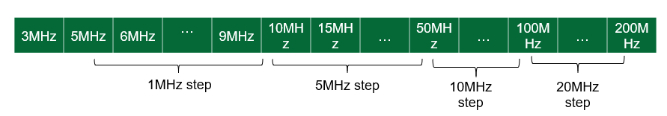
Proposal 2: The irregular CBW is defined as different number of MHz as the defined regular CBW.
Proposal 3: It is proposed to apply the flexible CBW with 1MHz granularity between 10, 15 and 20MHz.
Proposal 4: To further study the two methods as nearest SU method and scaling SU method and their impacts to SU.
Proposal 5: To reduce test burden, specific regular channel bandwidth will be defined and the test only apply to regular channel bandwidth.

Others

8.2.6 UE Tx/Rx number
- Proposals from Xiaomi R4-2605902
Proposal 1: Number of Tx/Rx antennas needs to discriminate with following factors:
- DL and UL shall be considered separately
- Applicable sub-frequency range
- Applicable device assumption on form factor limitation e.g. IoT, MBB, and FWA
Proposal 2: For IoT device, consider 1T1R as baseline and 1T2R as optional in FR1 including around 7GHz.
Proposal 3: For MBB UE, number of Tx/Rx can be further decided by per sub-frequency rang basis
Parameter | <2GHz  FDD bands | 2GHz ~5GHz  TDD bands | ~ 7GHz  (6.425~7.125GHz;7.125 GHz – 8.4 GHz)
MIMO Tx & Rx | 1Tx/2Rx | 1Tx/4Rx as baseline  2Tx, 6Rx as optional | 2Tx/4Rx as baseline  3Tx/4Tx, 6Rx as optional  8Rx pending on feasibility study
Proposal 4: Dynamic UE capability for number of Tx/Rx antennas can be considered under different states (foldable UE) and different operating modes e.g. or high performance mode/power saving mode.

- Proposals from ZTE R4-2606313
Observation. At least MBB, FWA, and Massive IoT services are expected to be supported in 6GR.
Proposal 1. To consider higher Tx/Rx antenna number in order to achieve the targeted spectrum efficiency in IMT-2020.
Proposal 2: A normal 6G UE (handheld UE) should have higher capabilities than 5G handheld UE
Proposal 3. To consider 4Tx/8Rx for 6GR handheld UE and 8Tx/8Rx even 8Tx/16Rx for 6GR FWA UE on around 7GHz spectrum.

8.2.6 Intra-band contiguous CA simplification
- Proposals from Skyworks R4-2607049
Observation 1: Intra-band contiguous ULCA has many disadvantages compared to single carrier UL operation: in the uplink, it comes with complex MPR requirements and high MPR allowance, hereby impacting the uplink link-budget. MPR equations still require further work to fix the reported inconsistent requirements [1] for which RAN4 decided to postpone fixing these issues to a later stage, 6GR being perhaps a better timeframe. For FDD bands, the downlink link-budget may also be severely impacted due to high MSD.
Proposal 1: For 6GR, consider restricting IBC-ULCA for configurations where the ULCA aggregated BW cannot be supported by a single carrier CBW. This means that if we assume that 6GR will support single carrier 200MHz UL CBW, then the 6GR UE RF requirements for IBC-ULCA should be introduced only for aggregated CBW greater than 200MHz.
Proposal 2: In 6GR and to address issues reported in [1], revisit the IBC-ULCA equations that define the MPR for non-contiguous outer 1/outer 2 RB allocations. As an alternative solution, RAN4 may also be considered to no longer support non-contiguous RB allocations within an intra-band contiguous ULCA configuration.

