3GPP TSG-RAN WG4 Meeting #116 R4-2512135

Bengaluru, India, Aug 25th – 29th, 2025

**Agenda item:** 7.23.1

**Source:** Moderator (Ericsson)

**Title:** Ad-hoc minutes for Netw_Energy_NR_enh

**Document for:** Approval

# Topic #1: SSB adaptation (AI 7.27.3.3)

### Issue 1-1-1: Applicable scenario for SSB adaption

*Background:*

|  |
| --- |
| TS 38.321  1> if the SCell is deactivated:  2> not transmit SRS on the SCell;  2> not report CSI for the SCell;  2> not transmit on UL-SCH on the SCell;  2> not transmit on RACH on the SCell;  2> not monitor the PDCCH on the SCell;  2> not monitor the PDCCH for the SCell;  2> not transmit PUCCH on the SCell. |

Tentative Agreement (to be confirmed by Thursday):

RAN4 not to define requirement for DCI based SSB adaption for deactivated SCell measurement and SCell activation.

* Note: this RAN4 agreement does not intend to impact the discussion and decision in other WGs.

**Discussion**

# Topic #2: On-demand SSB(OD-SSB) (AI 7.27.3.1)

### Issue 1-5-1: Requirement for Alt scenario 3 (OD-SSB and AO-SSB are within different frequencies)

* Background
  + In RAN1 #120 meeting, RAN1 agreed to introduce the scenario 3(OD-SSB and AO-SSB are within different frequencies).

|  |
| --- |
| RAN1 #120 Agreement  Regarding the relation in terms of frequency location (i.e., center frequency) between the always-on SSB and on-demand SSB,   * Alt 1: If always-on SSB is CD-SSB on a synchronization raster, the frequency location of on-demand SSB is different from the frequency location of always-on SSB.   + On-demand SSB is not on sync raster   + AO-SSB and OD-SSB are located in the same BWP   + FFS: Additional conditions   + Subject to separate UE capability   + Note: UE is not required to measure both AO-SSB and OD-SSB |

* + In RAN2 #130 meeting, RAN2 made the following agreements.

|  |
| --- |
| RAN2 confirms the working consumption that when AO-SSB and OD-SSB have different center frequency, introduce a new servingCellMO in ServingCellConfig to indicate MO of OD-SSB, as agreement.  When OD-SSB is activated, UE uses servingCellMO-OD to measure serving cell; when OD-SSB is deactivated, UE uses servingCellMO-AO (i.e., legacy servingCellMO) to measure serving cell. |

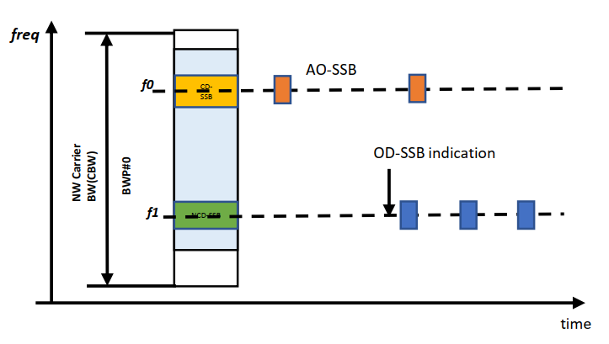

* Tentative agreement
  + RAN4 NOT to define the requirements when OD-SSB and AO-SSB are within different frequencies.
    - Issue 1-5-1(Requirement for Alt scenario 3), Issue 1-5-2(Neighbour cell measurement for scenario 3), Issue 1-5-3(Serving cell measurement for scenario 3), Issue 1-5-4(SCell activation for scenario 3), Issue 1-5-5(Measurement reporting for scenario 3), Issue 1-5-6(AO-SSB and OD-SSB CA combination) are closed

**Discussion**

### Issue 1-2-1: OD-SSB based L3 measurement when SCell is activated(scenario 3B)

* Background
  + In RAN2 #130 meeting, an LS has sent to RAN4 as follow.

|  |
| --- |
| For the case where AO-SSB and OD-SSB have the same center frequency, RAN2 had made the following agreement:   1. The UE applies the OD-SSB specific SMTC when the OD-SSB is activated and **SCell is activated**. This decision does not impact RAN4 discussion whether both OD-SSB and AO-SSB can be measured. |

* **Tentative agreement**

For SCell measurement, UE shall follow the OD-SSB specific SMTC when OD-SSB is activated; For neighbor cell measurement, UE follows legacy SMTC regardless of status of OD-SSB.

**Discussion**

### Issue 1-1-4: Requirement for RAN1 Alt Time-C2

* Proposals
  + Option 1: CATT, China Telecom, CMCC, Ericsson, Nokia, ZTE, Huawei, Samsung
    - RAN4 to define the requirement based on the OD-SSB periodicity.
  + Option 1a: CATT, Nokia, Ericsson
    - No scheduling restriction is expected for AO-SSB when OD-SSB is activated.
  + Option 1b: Nokia
    - L1 measurement requirement is based on OD-SSB and DRX cycle if OD-SSB is activated, otherwise based on AO-SSB and DRX cycle.
  + Option 1c (Qualcomm)
    - RAN4 to define the delay requirement only based on the OD-SSB periodicity only if the periodicity of AO-SSB and OD-SSB are same
  + Option 2: LG
    - RAN4 to define the L3 and L1 measurement requirement only based on the OD-SSB periodicity only if the periodicity of AO-SSB and OD-SSB are same.
      * For L3 measurement requirement, RAN4 to take into account only OD-SSB
      * For L1 measurement requirement, RAN4 to take into account union of AO-SSB and OD-SSB
  + Option 3: OPPO
    - RAN4 to define the requirement following legacy AO-SSB within SMTC.
* Recommended WF
  + Moderator suggests the group to check whether the following proposal can be agreed.
    - RAN4 to define the requirement for Alt Time-C2 only based on the OD-SSB periodicity.
      * It applies to both deactivated SCell L3 measurement and **L1 measurement**.
      * No scheduling restriction is expected for AO-SSB in Alt Time-C2.

**Discussion**

### Issue 1-4-3: Additional Processing time for joint OD-SSB and SCell activation

* Background

In RAN4 #114bis meeting, RAN4 achieved agreements as follow.

|  |
| --- |
| **Agreement**  UE applies the additional processing timing only in deactivated SCell measurement.   * Note: The additional UE processing timing **is not applied to SCell activation procedure**.   The additional processing timing is T_processing, the value of T_processing:   * Introduce different values with UE capability: [2 or 3]ms and 5ms. |

* Proposal
  + Option 1: Qualcomm, LGE, Apple
    - A UE capability for OD-SSB processing should be introduced with the same values as for MAC CE based OD-SSB activation for the deactivated SCell.
      * The candidate values can be 0ms, 2 ms and 5ms.
      * Concern: HW, Nokia, ZTE, Samsung, E///
* Tentative Agreement:
  + No consensus to introduce a UE capability for OD-SSB processing with the same values as for MAC CE based OD-SSB activation for the deactivated SCell.

**Discussion**