# Observations:

**Table 1 Clarification of Simulation Cases**

|  |  |  |  |  |
| --- | --- | --- | --- | --- |
|  | Training dataset | Model input for Inference | Ground-truth for training | Ground-truth for inference |
| Case 1 | No error | No error | No error | No error |
| Case 2a | No error | With error | No error | No error |
| Case 2b | No error | With error | No error | With error |
| Case 3 | With error | With error | With error | With error |

## Observations based on the average results submitted by each company

### For Case 1

For beam prediction accuracy, when X is greater than or equal to 2 (with X>0) or K is greater than or equal to 2, the beam prediction accuracy exceeds 90%.

Fig 1

### For Case 3 (Take Case 3 as an example to illustrate the impact of errors)

After considering the errors, the beam prediction accuracy can reach over 90% only when X is at least greater than or equal to 3 (with X>2) or K is greater than or equal to 2. When considering K=3 and X=3, the accuracy is 92.4%.

Fig 2

## Observations of the alignment of results across companies.

### For beam prediction accuracy

Considering both RF error and BB error as an example, the following charts are plotted for Case 3, respectively.

Fig 3-1

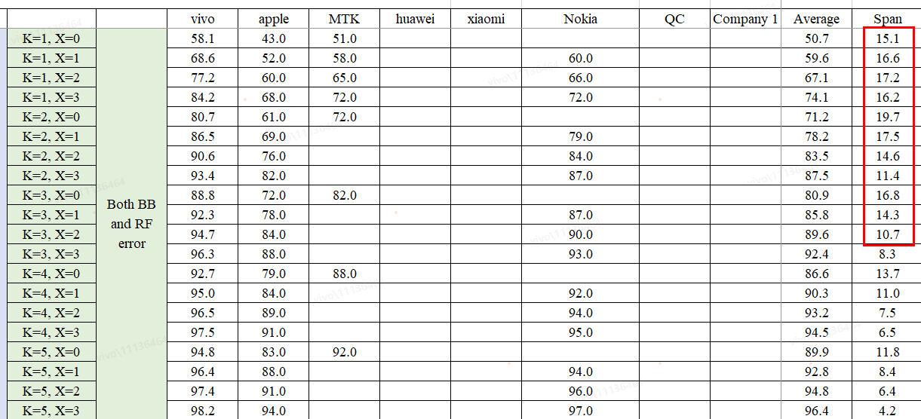

Fig 3-2

Observations on the alignment of results from each company based on the above findings include:

#### Observation 1: Regarding beam prediction accuracy, the span calculated from the results submitted by companies in Case 3 shows that the differences among the results submitted by the three companies are large (over 10%).

### For RSRP accuracy

Considering both RF error and BB error as examples, the following charts are plotted for Case 3.

Fig 4

The observations regarding the alignment of results among the companies based on the above findings are as follows:

#### Observation 2: For RSRP accuracy, the results from different companies in the three cases show the alignment, with the variance reaching up to 2.2 dB (in Case 3).

### For dataset

The figure below shows the beam prediction simulation results that MTK submit in this meeting, where:

* "Source from ‘MTK 1’" means using the dataset from MTK.
* "Source from ‘MTK 2-1’" means using the reference dataset provided by vivo (with equal size to MTK’s).
* "Source from ‘MTK 2-2’" means using the reference dataset provided by vivo (full size).

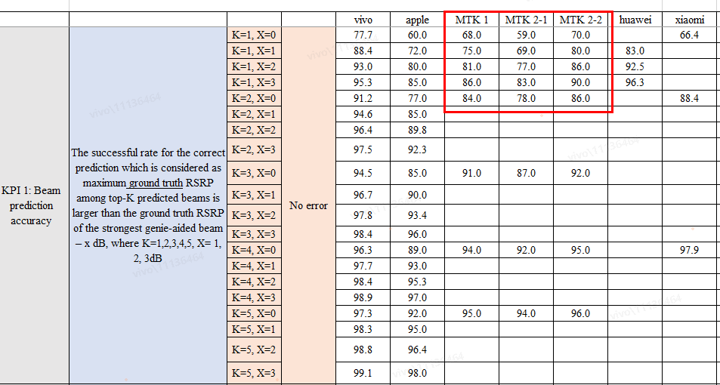

Fig 5

#### Observation 3: Different datasets lead to variations in prediction performance.

# How to proceed with defining metrics based on Simulation results

* Option 1: Continue aligning on the following aspects
  + Prediction model
    - Companies clarify the model they used (or whether they applied the reference model provided in the simulation assumptions) when submitting results in the next meeting.
  + Dataset
    - Companies should perform simulations based on the reference dataset and submit results in the next meeting.
    - Alternatively, agree on dataset-related parameter settings (e.g., dataset size) in this meeting, and companies should submit results based on the aligned dataset parameters in the next meeting.
* Option 2: In the next meeting, decide the value of metric based on the simulation results submitted by companies.
  + The source for the metric value can be determined by directly taking the average of the results from companies and applying certain criteria to exclude results with excessively large deviations
* Option 3: other parameters or assumptions to be clarified/modified