3GPP TSG-RAN4 Meeting #116 R4-2511574

Bangalore, India 25th – 29th August, 2025

Source: Qualcomm Incorporated
Title: AI-ML BM: Performance Requirements and Simulation Results
Agenda item: 7.17.6
Document for: Discussion

Introduction
This paper presents simulation results for AI/ML based beam management. The simulation assumptions were agreed during the last couple of meetings [1][4].

Simulation Setting for Performance Requirements
RAN4 has, so far, focused on dense urban macro channel to simulate and investigate the performance of spatial only beam prediction. System level channel is more realistic for field deployment.
On the other hand, RAN4 has not calibrated system level channel for FR2 OTA testing. RAN4 has calibrated Umi CDL-C channel for FR2 MIMO OTA testing and captured it in Table D.1-1 of 38.151.
RAN4 has already agreed to focus on CDL based channel model as a starting point for testing of BM-case 1.
Issue 4-2: Channel model
Agreement:
Use CDL-based channel model as starting point

Hence, RAN4 should define performance requirement based on the worst-case performance of dense urban macro and CDL/simplified CDL channels. This will allow RAN4 requirement to be realistic and achievable in a test chamber.
Observation 1: RAN4 is currently focusing on system level channel, e.g., dense urban macro, to simulate and investigate the performance of spatial only beam prediction.
Observation 2: AI-ML beam prediction requirement defined based on system level channel is more realistic for field deployment.
Observation 3: RAN4 has not calibrated system level channel for FR2 OTA testing. RAN4 has calibrated UMi CDL-C channel for FR2 MIMO OTA testing and captured it in Table D.1-1 of 38.151.
Observation 4: RAN4 has already agreed to focus on CDL based channel model as a starting point for testing.
Proposal 1: RAN4 agrees CDL-based channel model to test AI-ML BM performance.
Proposal 2: Accuracy of AI-ML BM-case 1 is defined based on the worst-case performance of two test dataset where datasets come from following two scenarios:
- Dense urban macro
  - Note: This is currently under consideration and captured in the recently agreed simulation assumption of R4-2508081
- CDL-based channel model (details are TBD)
  - Note: The UMi CDL-C channel of Table D.1-1 of 38.151 can be used as a starting point (shown in Table 1)

Table 1: Channel model parameters for UMi CDL-C at 28 GHz
Cluster # | Absolute Delay [ns] | Power in [dB] | AOD in [°] | AOA in [°] | ZOD in [°] | ZOA in [°]
1 | 0 | -4.4215 | -30.4353 | -134.4434 | 98.9242 | 83.3318
2 | 12.594 | -1.25 | -20.9269 | 129.1633 | 99.1915 | 72.5229
3 | 13.314 | -3.4684 | -20.9269 | 129.1633 | 99.1915 | 72.5229
4 | 13.974 | -5.2294 | -20.9269 | 129.1633 | 99.1915 | 72.5229
5 | 13.056 | -2.5215 | -28.0782 | -152.8206 | 99.5732 | 71.1282
6 | 38.196 | 0 | -11.6982 | 164.1145 | 99.306 | 74.7544
7 | 38.688 | -2.2185 | -11.6982 | 164.1145 | 99.306 | 74.7544
8 | 39.36 | -3.9794 | -11.6982 | 164.1145 | 99.306 | 74.7544
9 | 39.504 | -7.4215 | 17.3861 | 84.3647 | 100.4513 | 69.2454
10 | 47.61 | -7.1215 | -37.5865 | 92.0623 | 98.5616 | 66.7349
11 | 49.278 | -10.7215 | 20.2226 | -97.7585 | 100.6231 | 72.0348
12 | 56.016 | -11.1215 | -50.6106 | 78.4702 | 98.218 | 64.4337
13 | 73.71 | -5.1215 | -33.911 | 93.1719 | 100.165 | 85.4238
14 | 78.498 | -6.8215 | -37.5066 | -112.0441 | 100.2604 | 64.1548
15 | 130.224 | -8.7215 | -43.1797 | 102.4645 | 98.1225 | 64.7824
16 | 162.63 | -13.2215 | 29.2116 | 67.2359 | 100.2604 | 92.467
17 | 255.534 | -13.9215 | 27.8133 | 34.5731 | 98.4852 | 65.6889
18 | 276.018 | -13.9215 | 23.6584 | 48.5813 | 98.1416 | 68.7572
19 | 329.412 | -15.8215 | -52.5282 | 36.4455 | 97.9698 | 59.1339
20 | 336.462 | -17.1215 | 25.0168 | 52.6729 | 100.7376 | 65.3402
21 | 378.39 | -16.0215 | 25.4562 | 49.8296 | 98.1225 | 58.4365
22 | 398.244 | -15.7215 | 30.7697 | 46.4316 | 98.1034 | 65.2705
23 | 422.562 | -21.6215 | 35.9234 | 30.759 | 100.4513 | 62.6903
24 | 519.138 | -22.8215 | -61.2775 | 69.2469 | 100.9476 | 61.993
Per-Cluster Parameters
Parameter | CASD in [°] | CASA in [°] | CZSD in [°] | CZSA in [°] | XPR in [dB]
Value | 0.799 | 10.4021 | 0.5726 | 4.8814 | 7

RAN4 has not yet discussed RX beamforming assumptions for the simulations. UE and chip vendors need to pass RAN4/RAN5 conformance tests with their individual RX beamforming codebook. Hence, RAN4 spec should give UE vendor the flexibility to use their individual RX beamforming codebook while reporting simulation results. The specific RX beamforming codebook should be transparent in the simulation assumptions.
Proposal 3: RAN4 allows each company the flexibility to use individual RX beamforming codebook while reporting simulation results.

Simulation Results and Error Modeling

Simulation Framework

RAN4 agreed to the following simulation framework during a previous meeting [5].
The following cases are treated as the candidate Options:
- Case 1: No error will be considered in training dataset, model input during inference and ground-truth.
- Case 2:
  - Case 2a No error will be considered in training dataset and ground-truth. Error will be considered in model input during inference
  - Case 2b No error will be considered in training dataset and ground truth for training. Error will be considered in model input during inference and ground-truth for inference
- Case 3: Error will be considered in training dataset, model input during inference and ground-truth.

The goal of this simulation framework is to investigate the impact of measurement error on beam prediction metrics. The consideration of measurement error can appear in three forms.
- Case 1:
  - Training data: No error
  - Testing data: Includes measurement errors
  - Ground truth for training and testing: No error
- Case 2:
  - Training data: Includes measurement error
  - Testing data: Includes measurement error
  - Ground truth for training and testing: No error
- Case 3:
  - Training data: Includes measurement error
  - Testing data: Includes measurement error
  - Ground truth for training and testing: Includes measurement error
If testing data includes measurement error, UE should train its model based on a dataset that includes measurement error, too. Hence, RAN4 should investigate training with measurement error, too.
In a real FR2 AI-ML BM test, ground truth will be decided based on UE’s report. RAN4 already agreed to this concept in the context of ground truth for predicted RSRP in [5]

- Agreement
- The ground truth for the predicted RSRP is the ideal measurement of RSRP on the predicted Tx beam
  - In RAN4, the ground truth is the approximate as the reported RSRP measurement under the certain SNR on the predicted Tx beam
    - FFS on SNR level to ensure that SNR is high enough for sufficient accuracy of reported RSRP
    - FFS on impact of multiple-AoA test setup
    - FFS on the channel condition
    - FFS on whether the ground truth will be changing or not
  - Other solutions are not precluded

Baseband error will decrease at high SNR. However, RF error may not decrease at high SNR because UE’s Rx AGC settings might be calibrated for a particular SNR value.
Observation 5: Baseband error will reduce at high SNR.
Observation 6: RF error may not decrease at high SNR because UE’s Rx AGC settings might be calibrated for a particular SNR value.
Since ground truth will be based on UE’s report and UE’s reported RSRP will always include RF error that may not decrease with SNR, it would make sense to investigate where the ground truth during training and testing include measurement error. That means, RAN4 should investigate realistic performance based on case 3 of last meeting where training and testing dataset, along with ground truth during training and testing include measurement error.
Observation 7: Ground truth will be based on UE’s report and UE’s reported RSRP will include RF error that may not decrease with SNR.
Proposal 4:
- RAN4 defines performance based on case 3 of last meeting where measurement error will be considered in training dataset, model input during inference and ground-truth during training and testing.

Baseband Error Modelling
RAN4 focused on following two different options to investigate the impact of baseband error distribution on AI-ML beam prediction accuracy.

Option 1: Apply error distribution from the post beamforming SNR of the strongest Tx-Rx beam pair to all Tx-Rx beam pair’s measurements in the SLS

Option 2: Generate error distribution separately for each individual Tx-Rx beam pair’s SNRs and apply to the corresponding Tx-Rx beam pair measurement in the SLS

We use option 2 in this contribution, i.e., we generate baseband error distribution separately for each individual TX-RX beam pair’s SNRs, model these distributions as Gaussian distributions and then apply the distributions to the corresponding Tx-Rx beam pair measurement in the SLS.
Just for illustration purposes, we show the distribution of baseband error at -3 dB with AWGN and TDL-C in Figure [2] and [3] respectively.

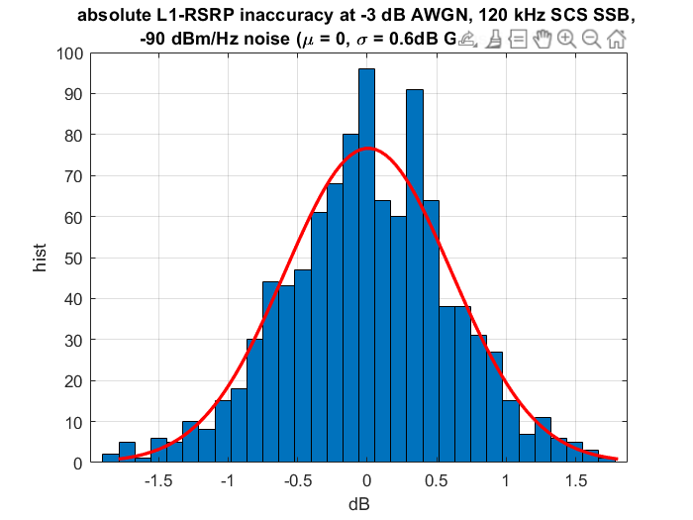
Figure 2: Baseband absolute error distribution of SSB L1-RSRP at AWGN (-3 dB SNR, curve fitted with zero mean normal distribution and sigma = 0.6 dB)

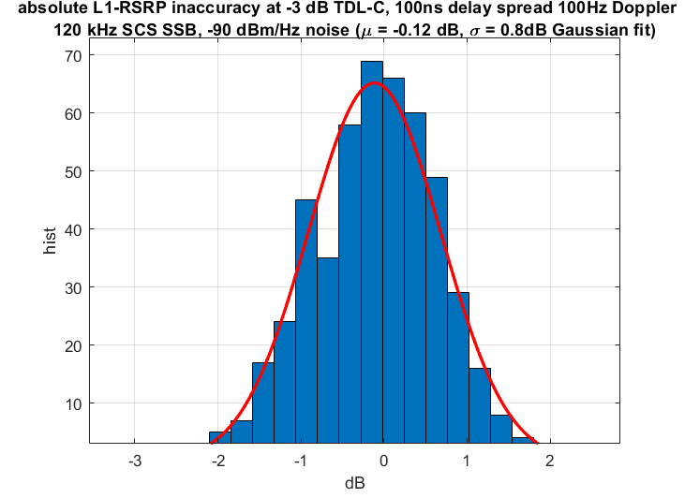
Figure 3: Baseband absolute error distribution of SSB L1-RSRP (TDL-C, -3 dB SNR, curve fitted with normal distribution and mean = -0.12 dB and sigma = 0.85 dB)

Observation 8: Baseband error at different SNRs can be modelled with Gaussian distribution. For example, at -3 dB SNR, the distribution of absolute baseband measurement error can be fitted with following Gaussian distributions:
- AWGN: Gaussian with zero mean and sigma = 0.6 dB
- TDL-C: Gaussian with mean = -0.12 dB and sigma = 0.85 dB

RF Error Modeling

RAN4 made the following agreement regarding RF error modelling. This shows that the assumed RF error for each TX beam would be independent.
The impact of RF errors should be considered. Following assumptions can be used to generate RF errors.
- Truncated Gaussian distribution under ±4.5 dB RF error (${μ=0, σ}^{2}$=4.5) is used
Each TX beam are Independent

RAN4 is assuming the following for UE antenna port assumptions:
Antenna setup and port layouts at UE: (1, 4, 2, 1, 2, 1, 1), 2 panels (left, right)

It is not clear how companies are applying RF error to received signal at two ports for each UE. This can be done in three different ways:
- RF error model-1: First, add RF error to received signal of each RX port. Thereafter, combine the received signal of two RX ports later.
  - RF error is independent across two RX ports.
- RF error model-2: First, add RF error to received signal of each RX port. Thereafter, combine the received signal of two RX ports later.
  - RF error is same across two RX ports.
- RF error model-3: Combine the received signal of two RX ports. Thereafter, add RF error to the received signal.
Results with measurement error will vary depending on the assumed RF error model. We show results with RF error model-1 and RF error model-2 in our contribution.
Observation 9: RAN4 aligns the RF error modelling assumptions among following three options:
- RF error model-1: First, add RF error to received signal of each RX port. Thereafter, combine the received signal of two RX ports later.
  - RF error is independent across two RX ports.
- RF error model-2: First, add RF error to received signal of each RX port. Thereafter, combine the received signal of two RX ports later.
  - RF error is same across two RX ports.
- RF error model-3: Combine the received signal of two RX ports. Thereafter, add RF error to the received signal.

2.4.3 Simulation Results

2.4.3.1 Simulation Assumptions

Table 2 displays the simulation parameters that we used in this study.

Table 2: Baseline System Level Simulation assumptions for AI/ML in “spatial only” beam prediction evaluations
Parameter | Value
Frequency Range | FR2 @ 30 GHz; SCS: 120 kHz
Deployment | 200m ISD, 2-tier model with wrap-around (7 sites, 3 sectors/cells per site)
Channel model | UMa with distance-dependent LoS probability function defined in Table 7.4.2-1 in TR 38.901.
System BW | 80MHz
UE Speed | 3km/h
UE distribution | 100% outdoor
Transmission Power | Maximum Power and Maximum EIRP for base station and UE as given by corresponding scenario in 38.802 (Table A.2.1-1 and Table A.2.1-2)
BS Antenna Configuration | Antenna setup and port layouts at gNB: (4, 8, 2, 1, 1, 1, 1), (dV, dH) = (0.5, 0.5) λ  Number of BS beams: 32
BS Antenna radiation pattern | TR 38.802 Table A.2.1-6, Table A.2.1-7
UE Antenna Configuration | Antenna setup and port layouts at UE: (1, 4, 2, 1, 2, 1, 1), 2 panels (left, right)  Number of UE beams: 4 downlink Rx beams per UE panel at UE side.
UE Antenna radiation pattern | TR 38.802 Table A.2.1-8, Table A.2.1-10
Inter-panel calibration for UE | Ideal
BS Tx Power | 40 dBm
Maximum UE Tx Power | 23 dBm
BS receiver Noise Figure | 7 dB
UE receiver Noise Figure | 10 dB
Inter site distance | 200 m
BS Antenna height | 25 m
UE Antenna height | 1.5 m
Car penetration Loss | 38.901, sec 7.4.3.2: μ = 9 dB, σp = 5 dB
Scenario | Dense Urban (macro-layer only, TR 38.913)
AoDs of Set A and Set B (°) | - Set A:  - 4 elevation DFT beams: [106.25, 118.75, 131.25, 143.75]  - 8 azimuth DFT beams: [-52.5, -37.5, -22.5, -7.5, 7.5, 22.5, 37.5, 52.5]  - Set B [(azimuth, elevation)]:  [(-52.5, 143.75), (-37.5, 131.25), (-22.5, 118.75), (-7.5, 106.25), (7.5, 143.75), (22.5, 131.25), (37.5, 118.75), (52.5, 106.25)
Beam pattern legend for Set A and Set B | 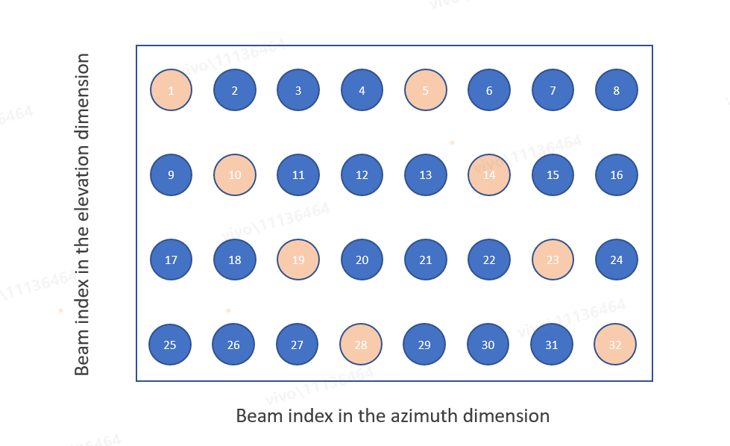
Baseline for performance evaluation | Select the best beam within Set A of beams based on the measurement of all RS resources or all possible beams of beam Set A (exhaustive beam sweeping)

2.4.3.2 Definition

Table 3 shows the definition of different metrics for which we generated results in this contribution.
Table 3: Definitions of Metrics for AI-ML based Beam Prediction
Metric | Definition
L1-RSRP absolute accuracy | 90%-tile L1-RSRP difference between the predicted L1-RSRP of the Top-1 predicted beam and the ground truth L1-RSRP of the same beam.
Worst case L1-RSRP absolute accuracy among top-K predicted beams | 90%-ile of the worst case L1-RSRP difference between the predicted L1-RSRP of the top-K predicted beams and the ground truth L1-RSRP of the same beams.  This gets calculated in following steps:  - In one sample of inference reporting, assume I = arg max_{k \in K} (predicted RSRP of beam k – ground truth of beam k)  - Store (predicted RSRP of beam I – ground truth of beam I) for this sample of inference  - Report 90%-ile distribution of above metric
Relative L1-RSRP of beam owning the 2nd largest predicted reported value | 90%-ile of following metric:  (predicted L1-RSRP of beam index i - predicted L1-RSRP of beam index n) - (ground truth of L1-RSRP of beam index i - ground truth of L1-RSRP of beam index n), [where the beam index n owns the largest reported value].
Top K/1 without margin | The percentage of the time when the Top-1 strongest beam (ground truth based) is one of the Top-K predicted beams
Top 1/K without margin | The percentage of the time when the Top-1 predicted beam is one of the Top-K strongest beams (ground truth based)
Top K/N (m) without margin | The percentage of the time when the Top-K predicted beams contain m of the top-N strongest beams (ground truth based)
Top 1/1 with margin of X dB | The successful rate for the correct prediction which is considered as maximum ideal RSRP among top-1 predicted beams is larger than the ideal RSRP of the strongest genie-aided beam – x dB

2.4.4.3. Results
Observation 10: Table 4 contains the results in “narrow” to “narrow” beam prediction scenario.
Table 4: Results of AI-ML based “spatial only” beam prediction (“narrow” to “narrow” scenario)
Metrics |  | Training and testing without measurement error | Training and testing dataset, along with ground truth for training and testing, with measurement error  (RF error model-1) | Training and testing dataset, along with ground truth for training and testing, with measurement error  (RF error model-2)
L1-RSRP absolute accuracy (dB) |  | +- 3.72 | +- 4.6 | +- 5.7
Top K/1 without margin (%) | K = 1 | 78.25 | 71.3 | 63.79
 | K = 3 | 95.6 | 93.6 | 90.65
 | K = 5 | 98 | 97 | 95.68
Top 1/1 with margin of X dB (%) | X = 1 | 87.45 | 80.53 | 72.44
 | X = 3 | 94.93 | 91.43 | 85.1
 | X = 5 | 96.94 | 95.39 | 91.85

Conclusions

Observation 1: RAN4 is currently focusing on system level channel, e.g., dense urban macro, to simulate and investigate the performance of spatial only beam prediction.
Observation 2: AI-ML beam prediction requirement defined based on system level channel is more realistic for field deployment.
Observation 3: RAN4 has not calibrated system level channel for FR2 OTA testing. RAN4 has calibrated UMi CDL-C channel for FR2 MIMO OTA testing and captured it in Table D.1-1 of 38.151.
Observation 4: RAN4 has already agreed to focus on CDL based channel model as a starting point for testing.
Observation 5: Baseband error will reduce at high SNR.
Observation 6: RF error may not decrease at high SNR because UE’s Rx AGC settings might be calibrated for a particular SNR value.
Observation 7: Ground truth will be based on UE’s report and UE’s reported RSRP will include RF error that may not decrease with SNR.
Observation 8: Baseband error at different SNRs can be modelled with Gaussian distribution. For example, at -3 dB SNR, the distribution of absolute baseband measurement error can be fitted with following Gaussian distributions:
- AWGN: Gaussian with zero mean and sigma = 0.6 dB
- TDL-C: Gaussian with mean = -0.12 dB and sigma = 0.85 dB

Observation 9: RAN4 aligns the RF error modelling assumptions among following three options:
- RF error model-1: First, add RF error to received signal of each RX port. Thereafter, combine the received signal of two RX ports later.
  - RF error is independent across two RX ports.
- RF error model-2: First, add RF error to received signal of each RX port. Thereafter, combine the received signal of two RX ports later.
  - RF error is same across two RX ports.
- RF error model-3: Combine the received signal of two RX ports. Thereafter, add RF error to the received signal.

Table 2: Definitions of Metrics for AI-ML based Beam Prediction
Metric | Definition
L1-RSRP absolute accuracy | 90%-tile L1-RSRP difference between the predicted L1-RSRP of the Top-1 predicted beam and the ground truth L1-RSRP of the same beam.
Worst case L1-RSRP absolute accuracy among top-K predicted beams | 90%-ile of the worst case L1-RSRP difference between the predicted L1-RSRP of the top-K predicted beams and the ground truth L1-RSRP of the same beams.  This gets calculated in following steps:  - In one sample of inference reporting, assume I = arg max_{k \in K} (predicted RSRP of beam k – ground truth of beam k)  - Store (predicted RSRP of beam I – ground truth of beam I) for this sample of inference  - Report 90%-ile distribution of above metric
Relative L1-RSRP of beam owning the 2nd largest predicted reported value | 90%-ile of following metric:  (predicted L1-RSRP of beam index i - predicted L1-RSRP of beam index n) - (ground truth of L1-RSRP of beam index i - ground truth of L1-RSRP of beam index n), [where the beam index n owns the largest reported value].
Top K/1 without margin | The percentage of the time when the Top-1 strongest beam (ground truth based) is one of the Top-K predicted beams
Top 1/K without margin | The percentage of the time when the Top-1 predicted beam is one of the Top-K strongest beams (ground truth based)
Top K/N (m) without margin | The percentage of the time when the Top-K predicted beams contain m of the top-N strongest beams (ground truth based)
Top 1/1 with margin of X dB | The successful rate for the correct prediction which is considered as maximum ideal RSRP among top-1 predicted beams is larger than the ideal RSRP of the strongest genie-aided beam – x dB

Observation 10: Table 4 contains the results in “narrow” to “narrow” beam prediction scenario.
Table 4: Results of AI-ML based “spatial only” beam prediction (“narrow” to “narrow” scenario)
Metrics |  | Training and testing without measurement error | Training and testing dataset, along with ground truth for training and testing, with measurement error  (RF error model-1) | Training and testing dataset, along with ground truth for training and testing, with measurement error  (RF error model-2)
L1-RSRP absolute accuracy (dB) |  | +- 3.72 | +- 4.6 | +- 5.7
Top K/1 without margin (%) | K = 1 | 78.25 | 71.3 | 63.79
 | K = 3 | 95.6 | 93.6 | 90.65
 | K = 5 | 98 | 97 | 95.68
Top 1/1 with margin of X dB (%) | X = 1 | 87.45 | 80.53 | 72.44
 | X = 3 | 94.93 | 91.43 | 85.1
 | X = 5 | 96.94 | 95.39 | 91.85

Proposal 1: RAN4 agrees CDL-based channel model to test AI-ML BM performance.
Proposal 2: Accuracy of AI-ML BM-case 1 is defined based on the worst-case performance in following two scenarios:
- Dense urban macro
  - Note: This is currently under consideration and captured in the recently agreed simulation assumption of R4-2508081
- CDL-based channel model (details are TBD)
  - Note: The UMi CDL-C channel of Table D.1-1 of 38.151 can be used as a starting point (shown in Table 1)

Table 1: Channel model parameters for UMi CDL-C at 28 GHz
Cluster # | Absolute Delay [ns] | Power in [dB] | AOD in [°] | AOA in [°] | ZOD in [°] | ZOA in [°]
1 | 0 | -4.4215 | -30.4353 | -134.4434 | 98.9242 | 83.3318
2 | 12.594 | -1.25 | -20.9269 | 129.1633 | 99.1915 | 72.5229
3 | 13.314 | -3.4684 | -20.9269 | 129.1633 | 99.1915 | 72.5229
4 | 13.974 | -5.2294 | -20.9269 | 129.1633 | 99.1915 | 72.5229
5 | 13.056 | -2.5215 | -28.0782 | -152.8206 | 99.5732 | 71.1282
6 | 38.196 | 0 | -11.6982 | 164.1145 | 99.306 | 74.7544
7 | 38.688 | -2.2185 | -11.6982 | 164.1145 | 99.306 | 74.7544
8 | 39.36 | -3.9794 | -11.6982 | 164.1145 | 99.306 | 74.7544
9 | 39.504 | -7.4215 | 17.3861 | 84.3647 | 100.4513 | 69.2454
10 | 47.61 | -7.1215 | -37.5865 | 92.0623 | 98.5616 | 66.7349
11 | 49.278 | -10.7215 | 20.2226 | -97.7585 | 100.6231 | 72.0348
12 | 56.016 | -11.1215 | -50.6106 | 78.4702 | 98.218 | 64.4337
13 | 73.71 | -5.1215 | -33.911 | 93.1719 | 100.165 | 85.4238
14 | 78.498 | -6.8215 | -37.5066 | -112.0441 | 100.2604 | 64.1548
15 | 130.224 | -8.7215 | -43.1797 | 102.4645 | 98.1225 | 64.7824
16 | 162.63 | -13.2215 | 29.2116 | 67.2359 | 100.2604 | 92.467
17 | 255.534 | -13.9215 | 27.8133 | 34.5731 | 98.4852 | 65.6889
18 | 276.018 | -13.9215 | 23.6584 | 48.5813 | 98.1416 | 68.7572
19 | 329.412 | -15.8215 | -52.5282 | 36.4455 | 97.9698 | 59.1339
20 | 336.462 | -17.1215 | 25.0168 | 52.6729 | 100.7376 | 65.3402
21 | 378.39 | -16.0215 | 25.4562 | 49.8296 | 98.1225 | 58.4365
22 | 398.244 | -15.7215 | 30.7697 | 46.4316 | 98.1034 | 65.2705
23 | 422.562 | -21.6215 | 35.9234 | 30.759 | 100.4513 | 62.6903
24 | 519.138 | -22.8215 | -61.2775 | 69.2469 | 100.9476 | 61.993
Per-Cluster Parameters
Parameter | CASD in [°] | CASA in [°] | CZSD in [°] | CZSA in [°] | XPR in [dB]
Value | 0.799 | 10.4021 | 0.5726 | 4.8814 | 7

Proposal 3: RAN4 allows each company the flexibility to use individual RX beamforming codebook while reporting simulation results.
Proposal 4:
- RAN4 defines performance based on case 3 of last meeting where measurement error will be considered in training dataset, model input during inference and ground-truth during training and testing.

References
- R4-2420480, Updated Simulation Assumptions for Beam Prediction, RAN4 #113.
[2] R4-2502856, “WF on the requirements for AI/ML air interface”, 3GPP TSG-RAN WG4 Meeting#114
[3] R4-2505105, “WF on requirements for AI/ML air interface normative work”, 3GPP TSG-RAN WG4 Meeting#114bis
[4] R4-2505152, “Updated simulation assumptions for AI/ML BM”, 3GPP TSG-RAN WG4 Meeting#114bis
[5] R4-2502856, “WF on the requirements for AI/ML air interface”, 3GPP TSG-RAN WG4 Meeting#114

