Hello all,

This is an invitation to RAN4#117 Webinar sessions on 17– 21 November 2025. This invitation covers three sessions in 3 separate rooms: Main (Yang Session), RRM_Demod_OTA (Shan Session), RF,NTN,A-IOT (Gene Session).

GoToWebinar (GTW) conference calls will be set in each session. And 2-way remote participants can be supported.

Please remember that consistent registration format is important for session chairing and hence use the following format when you register: BriefCompanyName - Firstname, Lastname. An example is shown below

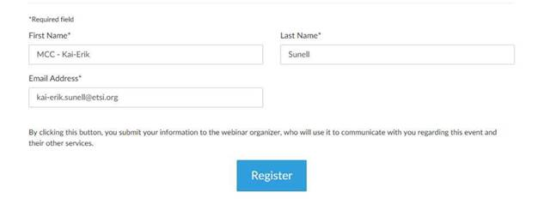
where BriefCompanyName is ‘MCC’, Firstname is ‘Kai-Erik’ and Lastname is ‘Sunell’.

Your email address for Webinar registration needs to be the same as for your 3GPP meeting registration.

Registration links are found below and they are session specific. You may register to all sessions, e.g. if you plan to switch between sessions or if you are able to listen to all sessions at the same time. Once you have registered for a session your registration is valid for the whole week.

The starting time for all sessions on 17 Nov is 09:00 local time 19:30 local time (GMT-6)

The starting time for all sessions on 18-20 Nov is 08:30 local time 19:30 local time (GMT-6)

The starting time for all sessions on 21 Nov is 08:00 local time 17:00 local time (GMT-6)

RAN4#117 Main Webinar Session (17 - 21 Nov)
Mon, Nov 17, 2025 9:00 AM - 7:30 PM CST

RAN4#117 Main Webinar Session (17 - 21 Nov)
Join us for a webinar beginning on Nov 17, 2025 at 9:00 AM CST.
Register now!

After registering, you will receive a confirmation email containing information about joining the webinar.
View System Requirements

RAN4#117 RRM_Demod_OTA (Shan Session) Webinar Session (17- 21 Nov)
Mon, Nov 17, 2025 9:00 AM - 7:30 PM CST

RAN4#117 RRM_Demod_OTA (Shan Session) Webinar Session (17- 21 Nov)
Join us for a webinar beginning on Nov 17, 2025 at 9:00 AM CST.
Register now!

After registering, you will receive a confirmation email containing information about joining the webinar.
View System Requirements

RAN4#117 RF,NTN,A-IOT (Gene Session) (17 - 21 Nov)
Mon, Nov 17, 2025 9:00 AM - 7:30 PM CST

RAN4#117 RF,NTN,A-IOT (Gene Session) (17 - 21 Nov)
Join us for a webinar beginning on Nov 17, 2025 at 9:00 AM CST.
Register now!

After registering, you will receive a confirmation email containing information about joining the webinar.
View System Requirements

Instructions on how to join the Webinars will be sent automatically every day.

Regards,
Jin Lian

