3GPP TSG-RAN4 Meeting #116-bis R4-251xxxx (Rev of R4-2514329)

Prague, Czechia, 13rd - 17th October, 2025
CR-Form-v12.3
CHANGE REQUEST
 | 38.870 | CR | Draft | rev | - | Current version: | 19.2.0
For HELP on using this form: comprehensive instructions can be found at
http://www.3gpp.org/Change-Requests.

Proposed change affects: | UICC apps |  | ME | X | Radio Access Network |  | Core Network

Title: | Introduction of Near Horizon Metrics
Source to WG: | Keysight Technologies UK Ltd
Source to TSG: | R4
Work item code: | TRP_TRS_MIMO_OTA_Ph3-Core |  |  |  |  |  | Date: |  |  | 2025-09-10
Category: | B |  |  |  |  |  | Release: |  |  | Rel-19
 | Use one of the following categories:  F (correction)  A (mirror corresponding to a change in an earlier release)  B (addition of feature),  C (functional modification of feature)  D (editorial modification)  Detailed explanations of the above categories can  be found in 3GPP TR 21.900. |  |  |  |  |  |  |  | Use one of the following releases:  Rel-8 (Release 8)  Rel-9 (Release 9)  Rel-10 (Release 10)  Rel-11 (Release 11)  …  Rel-17 (Release 17)  Rel-18 (Release 18)  Rel-19 (Release 19)  Rel-20 (Release 20)
Reason for change: |  | In RAN4#116 WF, R4-2512693, it was agreed to add Near Horizon metrics into the TR as they could be considered in the future for XR device testing
Summary of change: |  | Add NH metrics in Clause 5.3.2
Consequences if not approved: |  | Near Horizon metrics are not defined otherwise and cannot be considered in future
Clauses affected: |  | 5.3.1.1, 5.3.2
 |  | Y | N
Other specs |  |  | X | Other core specifications |  |  |  | TS/TR ... CR ...
affected: |  |  | X | Test specifications |  |  |  | TS/TR ... CR ...
(show related CRs) |  |  | X | O&M Specifications |  |  |  | TS/TR ... CR ...
Other comments: |  | Near Horizon metrics discussion paper in RAN4#116: R4-2509919
This CR's revision history: |  | v1: typos/clarifications

<<< Skip Unchanged Sections >>>
<<< START OF CHANGES >>>

5.3 Definition of the Partial Radiated Metrics (PRP/PRS)

5.3.1 Definition of the Partial Radiated Metrics (PRP/PRS) for AC

5.3.1.1 Applicability of metrics

The PRP/PRS metrics for partial surface integrated quantities are defined in Clauses 5.3.1.2 through 5.3.1.7, with the applicability provided in Table 5.3.1.1-1 below.
Table 5.3.1.1-1: Applicability of PRP/PRS metrics
Clause | TX/RX | PRP/PRS definition | Applicability
5.3.1.2 | TX | $${UPRP}_{±30}≅\frac{1}{2}\left(a_{2}cut_{TX,2}+\sum_{i=0}^{1}{cut_{TX,i}}\right)$$ | FFS
5.3.1.3 | TX | $${UPRP}_{±60}≅\frac{1}{2}\left(a_{4}cut_{TX,4}+\sum_{i=0}^{3}{cut_{TX,i}}\right)$$ | Applicable to NTN scenario 2
5.3.1.4 | TX | $$UHPRP≅\frac{1}{2}\left(a_{6}cut_{TX,6}+\sum_{i=0}^{5}{cut_{TX,i}}\right)$$ | Applicable to NTN scenario 2
5.3.1.5 | RX | $${UPRS}_{±30}=2\left(\frac{1}{cut_{RX,0}+b_{1}cut_{RX,1}}\right)$$ | FFS
5.3.1.6 | RX | $${UPRS}_{±60}=2\left(\frac{1}{cut_{RX,0}+cut_{RX,1}+b_{2}cut_{RX,2}}\right)$$ | Applicable to NTN scenario 2
5.3.1.7 | RX | $$UHPRS=2\left(\frac{1}{cut_{RX,0}+cut_{RX,1}+cut_{RX,2}+b_{3}cut_{RX,3}}\right)$$ | Applicable to NTN scenario 2
where
$$cut_{TX,i}=\frac{1}{M}\sum_{j=0}^{M-1}{\left[EiRP_{θ}\left(θ_{i},ϕ_{j}\right)+EiRP_{ϕ}\left(θ_{i},ϕ_{j}\right)\right]}⋅W\left(θ_{i}\right)$$
$cut_{RX,i}=\frac{1}{M}\sum_{j=0}^{M-1}{\left[\frac{1}{EIS_{θ}(θ_{i},ϕ_{j})}+\frac{1}{EIS_{ϕ}(θ_{i},ϕ_{j})}\right]}⋅W(θ_{i})$and $W\left(θ_{i}\right)$ are the quadrature weights of either the Clenshaw-Curtis (CC) weights or the traditional sin(θ) weights, and
$$a_{k}=\frac{1-\cos\left(k*15°\right)-\sum_{i=0}^{k-1}{W(θ_{i})}}{W(θ_{k})}$$
and
$$b_{k}=\frac{1-\cos\left(k*30°\right)-\sum_{i=0}^{k-1}{W\left(θ_{i}\right)}}{W\left(θ_{k}\right)}$$
are the coefficients for the partial segments.

5.3.1.2 Upper Partial Radiated Power Integrated over ±30° Sector (UPRP_{±30})
The UPRP_{±30} metric is defined as the power radiated with EIRP integrated for the partial surface from θ=0° to θ=30° in the upper hemisphere. This metric with the partial surface visualized in Figure 5.3.1.2-1 can be expressed mathematically as
$${UPRP}_{±30}≅\frac{1}{2}\left(a_{2}cut_{TX,2}+\sum_{i=0}^{1}{cut_{TX,i}}\right)$$
with
$$a_{2}=\frac{1-\cos\left(30°\right)-\sum_{i=0}^{1}{W(θ_{i})}}{W(θ_{2})}≈\left\{\begin{aligned}0.5059, &\text{sin}\text{(}\text{q}\text{)}\text{ quadrature} \\ 0.4632, &\text{Clenshaw-Curtis quadrature}\end{aligned}\right.$$
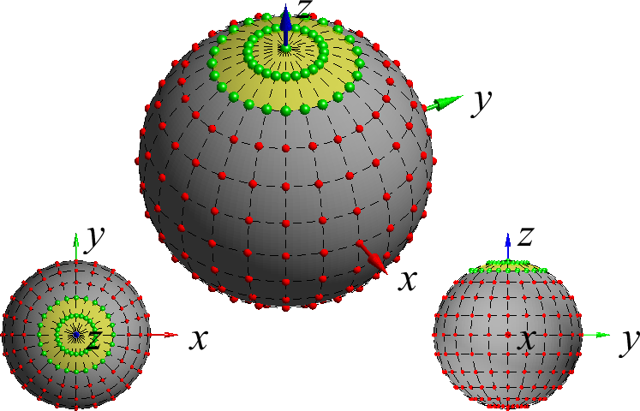
Figure 5.3.1.2-1: Visualization of partial surface with ±30° angular width for classical TRP grid.

5.3.1.3 Upper Partial Radiated Power Integrated over ±60° Sector (UPRP_{±60})
The UPRP_{±60} metric is defined as the power radiated with EIRP for the partial surface integrated from θ=0° to θ=60° in the upper hemisphere. This metric with the partial surface visualized in Figure 5.3.1.3-1 can be expressed mathematically as
$${UPRP}_{±60}≅\frac{1}{2}\left(a_{4}cut_{TX,4}+\sum_{i=0}^{3}{cut_{TX,i}}\right)$$
with
$$a_{4}=\frac{1-\cos\left(60°\right)-\sum_{i=0}^{3}{W(θ_{i})}}{W(θ_{4})}≈\left\{\begin{aligned}0.5126, &\text{sin}\text{(}\text{q}\text{)}\text{ quadrature} \\ 0.4875, &\text{Clenshaw-Curtis quadrature}\end{aligned}\right.$$
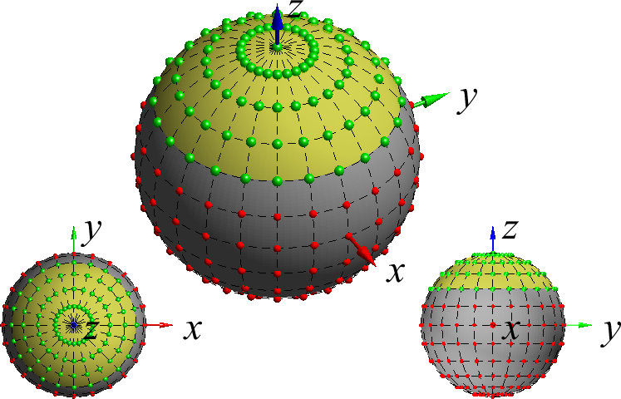
Figure 5.3.1.3-1: Visualization of partial surface with ±60° angular width for classical TRP grid.

5.3.1.4 Upper Hemisphere Partial Radiated Power (UHRPP)
The UHPRP metric, which could also be referred to as UPRP_{±90}, is defined as the radiated power for the partial surface in the upper hemisphere. This metric with the partial surface visualized in Figure 5.3.1.4-1 can be expressed mathematically as
$$UHPRP≅\frac{1}{2}\left(a_{6}cut_{TX,6}+\sum_{i=0}^{5}{cut_{TX,i}}\right)\text{where }$$
$$cut_{TX,i}=\frac{1}{M}\sum_{j=0}^{M-1}{\left[EiRP_{θ}\left(θ_{i},ϕ_{j}\right)+EiRP_{ϕ}\left(θ_{i},ϕ_{j}\right)\right]}⋅W\left(θ_{i}\right)$$
with
$$a_{6}=\frac{1-\cos\left(90°\right)-\sum_{i=0}^{5}{W(θ_{i})}}{W(θ_{6})}≈\left\{\begin{aligned}0.5128, &\text{sin}\text{(}\text{q}\text{)}\text{ quadrature} \\ 0.5000, &\text{Clenshaw-Curtis quadrature}\end{aligned}\right.$$
for both Clenshaw-Curtis or sin(θ) quadratures whose weights are expressed using $W\left(θ_{i}\right)$, defined in Clause 5.1.1.2.
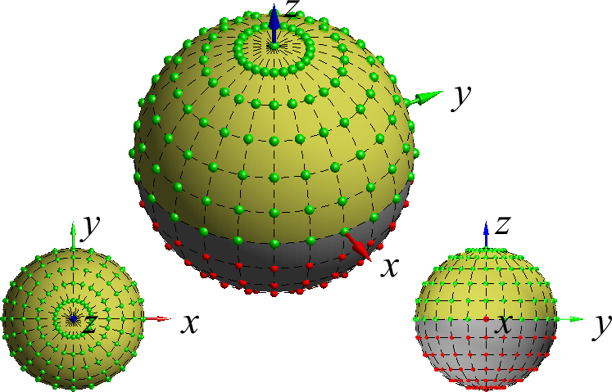
Figure 5.3.1.4-1: Visualization of upper hemisphere partial surface with ±90° angular width for classical TRP grids.

5.3.1.5 Upper Partial Radiated Sensitivity Integrated over ±30° Sector (UPRS_{±30})
The UPRS_{±30} metric is defined as the sensitivity with EIS integrated for the partial surface from θ=0° to θ=30° in the upper hemisphere. This metric with the partial surface visualized in Figure 5.3.1.5-1 can be expressed mathematically as
$${UPRS}_{±30}=2\left(\frac{1}{cut_{RX,0}+b_{1}cut_{RX,1}}\right)$$
with
$$b_{1}=\frac{1-\cos\left(60°\right)-\sum_{i=0}^{0}{W(θ_{i})}}{W(θ_{1})}≈\left\{\begin{aligned}0.5117, &\text{sin}\text{(}\text{q}\text{)}\text{ quadrature} \\ 0.4150, &\text{CC quadrature}\end{aligned}\right.$$
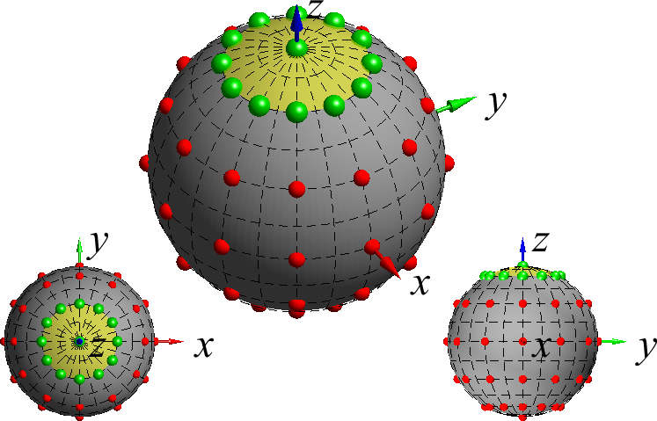
Figure 5.3.1.5-1: Visualization of partial surface with ±30° angular width for classical TRS grid.

5.3.1.6 Upper Partial Radiated Sensitivity Integrated over ±60° Sector (UPRS_{±60})
The UPRS_{±60} metric is defined as the sensitivity with EIS for the partial surface integrated from θ=0° to θ=60° in the upper hemisphere. This metric with the partial surface visualized in Figure 5.3.1.6-1 can be expressed mathematically as
$${UPRS}_{±60}=2\left(\frac{1}{cut_{RX,0}+cut_{RX,1}+b_{2}cut_{RX,2}}\right)$$
with
$$b_{2}=\frac{1-\cos\left(60°\right)-\sum_{i=0}^{1}{W(θ_{i})}}{W(θ_{2})}≈\left\{\begin{aligned}0.5253, &\text{sin}\text{(}\text{q}\text{)}\text{ quadrature} \\ 0.4757, &\text{CC quadrature}\end{aligned}\right.$$
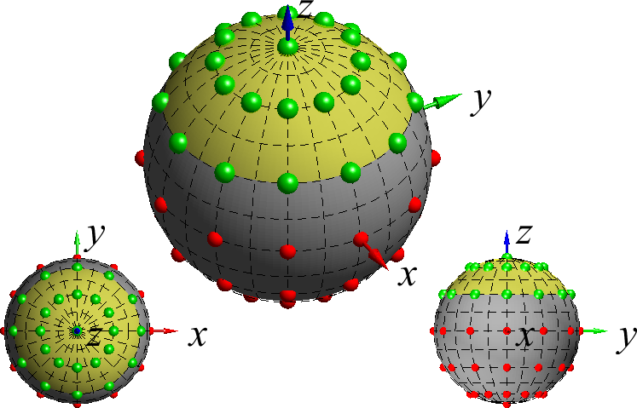
Figure 5.3.1.6-1: Visualization of partial surface with ±60° angular width for classical TRS grid.

5.3.1.7 Upper Hemisphere Partial Radiated Sensitivity (UHRPS)
The UHPRS metric, which could also be referred to as UPRS_{±90}, is defined as radiated sensitivity for the partial surface in the upper hemisphere. This metric with the partial surface visualized in Figure 5.3.1.7-1 can be expressed mathematically as
$$UHPRS=2\left(\frac{1}{cut_{RX,0}+cut_{RX,1}+cut_{RX,2}+b_{3}cut_{RX,3}}\right)\text{where }$$
$$cut_{RX,i}=\frac{1}{M}\sum_{j=0}^{M-1}{\left[\frac{1}{EIS_{θ}(θ_{i},ϕ_{j})}+\frac{1}{EIS_{ϕ}(θ_{i},ϕ_{j})}\right]}⋅W(θ_{i})$$
with
$$b_{3}=\frac{1-\cos\left(90°\right)-\sum_{i=0}^{2}{W(θ_{i})}}{W(θ_{3})}≈\left\{\begin{aligned}0.5438, &\text{sin}\text{(}\text{q}\text{)}\text{ quadrature} \\ 0.5000, &\text{CC quadrature}\end{aligned}\right.$$
for both Clenshaw-Curtis or sin(θ) quadratures whose weights are expressed using $W\left(θ_{i}\right)$, defined in Clause 5.1.1.2.
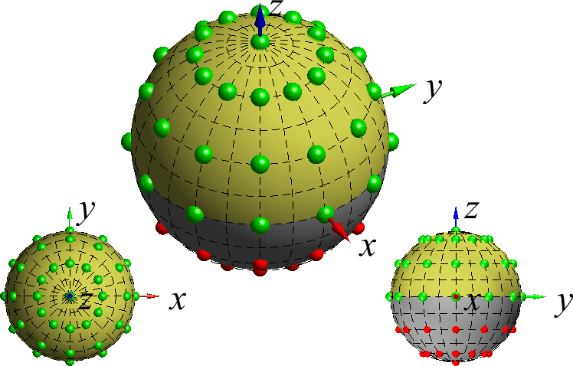
Figure 5.3.1.7-1: Visualization of upper hemisphere partial surface with ±90° angular width for classical TRS grids.

5.3.2 Definition of the Near Horizon Partial Radiated Metrics (NHPRP/NHPRS) for AC

5.3.2.1 Applicability of metrics
The NHPRP/NHPRS metrics for partial surface integrated quantities are defined in Clauses 5.3.2.2 through 5.3.2.5, with the applicability provided in Table 5.3.2.1-1 below.
Table 5.3.1.2-1: Applicability of NHPRP/NHPRS metrics
Clause | TX/RX | NHPRP/NHPRS definition | Applicability
5.3.2.2 | TX | NHPRP±30≅12a4(cutTX,4+cutTX,8)+i=57cutTX,i | FFS
5.3.2.3 | TX | NHPRP±45≅12a3(cutTX,3+cutTX,9)+i=48cutTX,i | FFS
5.3.1.4 | RX | NHPRS±30≅21cutRX,3+b2,30(cutRX,2+cutRX,4) | FFS
5.3.1.5 | RX | NHPRS±45≅21cutRX,3+b2,45(cutRX,2+cutRX,4) | FFS
where
cutTX,i=1Mj=0M-1EiRPθθi,ϕj+EiRPϕθi,ϕj⋅Wθi
cutRX,i=1Mj=0M-11EISθθi,ϕj+1EISϕθi,ϕj⋅Wθi
and Wθi are the quadrature weights of either the Clenshaw-Curtis (CC) weights or the traditional sin(θ) weights, and
ak=cos90°-k*15°-0.5*W90°-i=k+15WθiWθk
and
b2,width=cos90°-width-0.5*W(90°)W(60°)
i.e.,
b2,45=cos45°-0.5*W(90°)W(60°)
b2,30=cos60°-0.5*W(90°)W(60°)
are the coefficients for the partial segments.

5.3.2.2 Near Horizon Partial Radiated Power Integrated over ±30° Sector (NHPRP_{±30})
The NHPRP_{±30} metric is defined as the power radiated with EIRP integrated for the partial surface from θ=60° to θ=120° symmetrical to the horizon at θ=90°. This metric with the partial surface visualized in Figure 5.3.2.2-1 can be expressed mathematically as
NHPRP±30≅12a4cutTX,4+cutTX,8+i=57cutTX,i
with
a4=cos30°-0.5*W90°-i=k+15WθiW(θk)≈0.5126, &sin(q) quadrature0.5125, &Clenshaw-Curtis quadrature
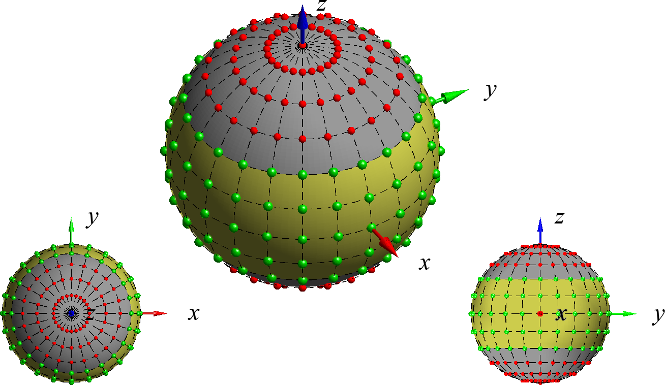
Figure 5.3.2.2-1: Visualization of near horizon partial surface with ±30° angular width for classical TRP grid.

5.3.2.3 Near Horizon Partial Radiated Power Integrated over ±45° Sector (NHPRP_{±45})
The NHPRP_{±45} metric is defined as the power radiated with EIRP for the partial surface integrated from θ=45° to θ=135° symmetrical to the horizon at θ=90°. This metric with the partial surface visualized in Figure 5.3.2.3-1 can be expressed mathematically as
NHPRP±45≅12a3(cutTX,3+cutTX,9)+i=48cutTX,i
with
a3=cos45°-0.5*W90°-i=k+15WθiW(θk)≈0.5218, &sin(q) quadrature0.5221, &Clenshaw-Curtis quadrature
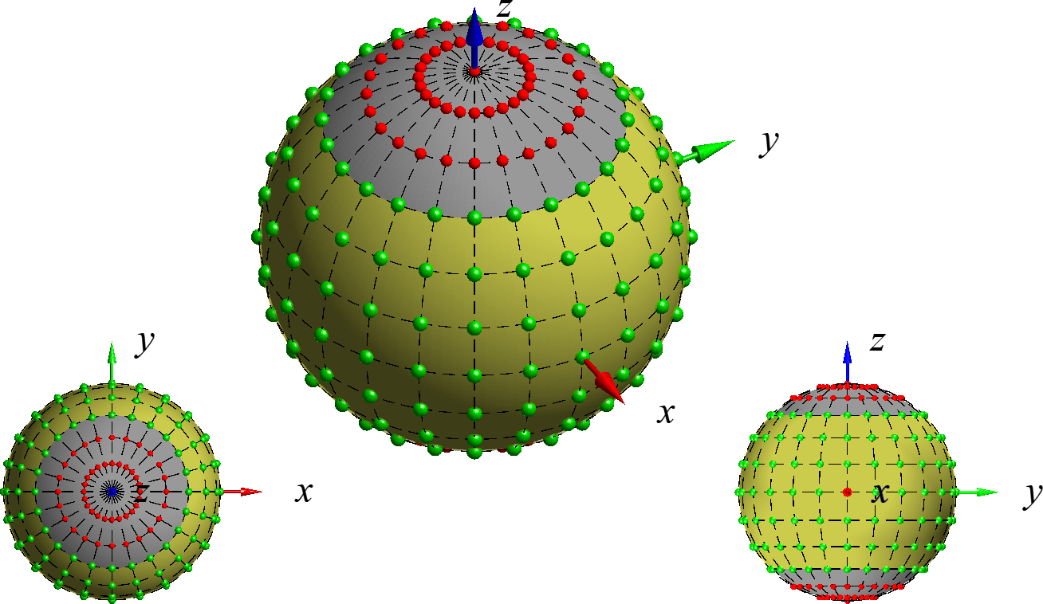
Figure 5.3.2.3-1: Visualization of near horizon partial surface with ±45° angular width for classical TRP grid.

5.3.2.4 Near Horizon Radiated Sensitivity Integrated over ±30° Sector (NHPRS_{±30})
The NHPRS_{±30} metric is defined as the sensitivity with EIS integrated for the partial surface from θ=60° to θ=120° symmetrical to the horizon at θ=90°. This metric with the partial surface visualized in Figure 5.3.2.4-1 can be expressed mathematically as
NHPRS±30≅21cutRX,3+b2,30cutRX,2+cutRX,4
with
b2,30=cos60°-0.5*W(90°)W(60°) ≈0.5253, &sin(q) quadrature0.5243, &CC quadrature
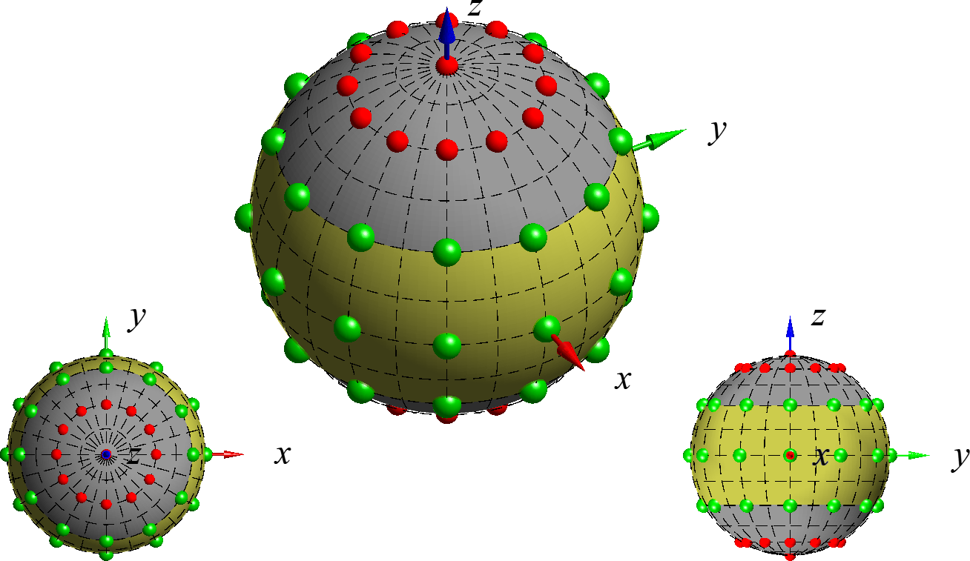
Figure 5.3.2.4-1: Visualization of near horizon partial surface with ±30° angular width for classical TRS grid.

5.3.2.5 Near Horizon Radiated Sensitivity Integrated over ±45° Sector (NHPRS_{±45})
The NHPRS_{±45} metric is defined as the sensitivity with EIS integrated for the partial surface from θ=45° to θ=135° symmetrical to the horizon at θ=90°. This metric with the partial surface visualized in Figure 5.3.2.5-1 can be expressed mathematically as
NHPRS±45≅21cutRX,3+b2,45cutRX,2+cutRX,4
with
b2,45=cos45°-0.5*W(90°)W(60°) ≈0.9820, &sin(q) quadrature0.9774, &CC quadrature
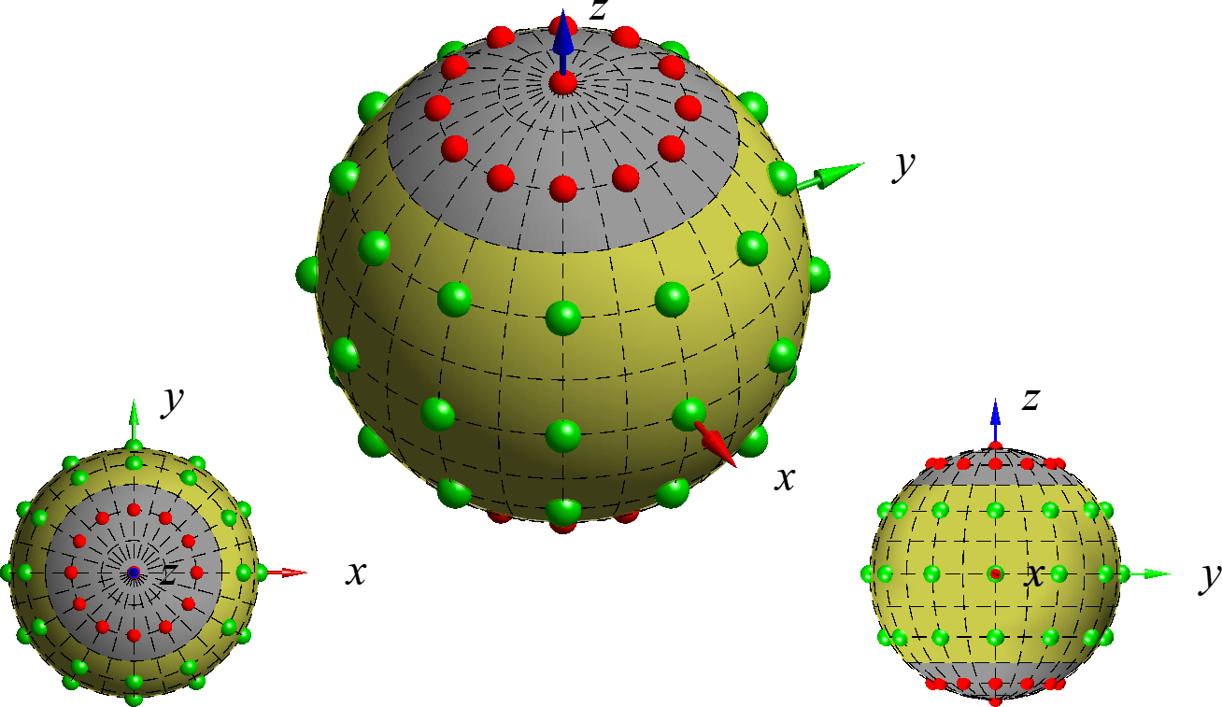
Figure 5.3.2.5-1: Visualization of near horizon partial surface with ±45° angular width for classical TRS grid.
<<< END OF CHANGES >>>

