3GPP TSG-RAN WG4 Meeting #116bis DRAFT R4-2514595
Prague, Czech Republic, 13th – 18th October, 2025

Source: Nokia
Title: WF for the Band Combination Database
Document for: Approval
- Introduction
At RAN#102 it was highlighted that there is a need for a new tool/methodology for handling the specification of CA combinations in RAN4. It is widely recognised that tens of thousands of band combinations cannot be specified efficiently using tables in DOCX files. As a result, RAN initiated a RAN task to work on a solution with ETSI.
A solution was identified together with ETSI IT and work on enabling this is now ongoing.
Status updates on the work have previously been presented with the latest in R4-2514216.
- WF
  - Content of database
RAN4 have discussed whether also ENDC/NEDC combinations on top of the initially agreed NRCA combinations. It was agreed to do this and more precisely the following is to be added to the database.
< Agreement >:
- RAN4 agrees the database shall include the information now provided by:
  - TS 38.101-1
    - Table 5.5A.1-1, Table 5.5A.2-1, Table 5.5A.2-2, Table 5.5A.3.1-1, Table 5.5A.3.2-1, Table 5.5A.3.3-1, Table 5.5A.3.4-1, Table 5.5A.3.5-1, Table 5.5B-1, Table 5.5B-2, Table 5.5B-3, Table 5.5B-4, Table 5.5C-1, Table 5.5C-2, Table 5.5C-3, Table 5.5C-4, Table 5.5C-5.
  - TS 38.101-2
    - Table 5.5A.1-1, Table 5.5A.2-1, Table 5.5A.2-2, Table 5.5A.3-1.
  - TS 38.101-3
    - Table 5.5A.1.1-1, Table 5.5A.1.2-1, Table 5.5A.1.3-1, Table 5.5A.1.4-1, Table 5.5B.2-1, Table 5.5B.2a-1, Table 5.5B.3-1, Table 5.5B.3-2, Table 5.5B.4.1-1, Table 5.5B.4.2-1, Table 5.5B.4.3-1, Table 5.5B.4.4-1, Table 5.5B.4.5-1, Table 5.5B.4a.1-1, Table 5.5B.4a.2-1, Table 5.5B.4a.3-1, Table 5.5B.4a.4-1, Table 5.5B.5.1-1, Table 5.5B.5.2-1, Table 5.5B.5.3-1, Table 5.5B.5.4-1, Table 5.5B.5a.1-1, Table 5.5B.5a.2-1, Table 5.5B.5a.3-1, Table 5.5B.5a.4-1, Table 5.5B.6.2-1, Table 5.5B.6.3-1, Table 5.5B.6.4-1, Table 5.5B.6.5-1, Table 5.5B.6a.2-1, Table 5.5B.6a.3-1, Table 5.5B.6a.4-1, Table 5.5B.6a.5-1, Table 5.5B.7-1, Table 5.5B.7-2, Table 5.5B.7-3, Table 5.5B.7-4

  - Structure of database
RAN4 have discussed how to best structure the data within the database to ensure it can be properly version controlled to align to releases of specification etc.
< Agreement >:
- RAN4 agrees to use the following separation as a starting point
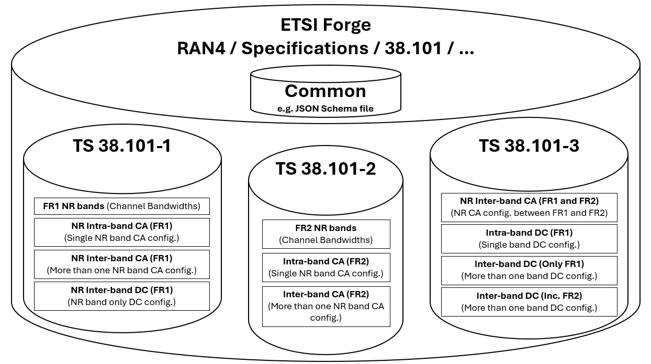

  - Working procedure
RAN4 have discussed how to ensure alignment to 3GPP working methos as given by TS 21.900 when using a database. Especially the points shown in excerpt below:

4.6.3 Contents of Change Requests
Although the CR form shall indicate the details of change, each CR shall have attached the clauses of the specification that are affected by the CR, using the latest version of the major version...
[…]
If the CR proposes changes to stage 3 specification files which are normatively documented in the 3GPP Forge repository according to clause 5C, then the proposed modifications shall be documented in the 3GPP Forge repository. In this case the cover page of the CR form shall contain a reference to a Forge Merge-Request clearly listing the proposed modifications in the "Other comments:" field, and excerpts of all affected stage 3 specification files clearly showing the proposed changes shall be appended to the cover page of the CR form.
…

5C Normative availability and distribution of stage 3 specification files
In this option, the normative code parts of the stage 3 specification shall be normatively stored in the 3GPP Forge repository.
The TS document specifying the stage 3 definition shall indicate that the 3GPP Forge repository is normative for the corresponding stage 3 specification files and:
- The TS document shall contain a link to a 3GPP Forge repository tag that implicitly includes the versioning information about the TS, e.g. https://forge.3gpp.org/rep/sa5/MnS/-/tree/Tag_Rel18_SA100;
- The TS document shall contain the directory path where the files are stored, e.g. "yang-models";
- The TS document shall contain the name of the files specified by this TS;
- The TS document shall not contain a copy of the stage 3 specification files.
Before making available any new version of a TS specifying stage 3 files, the responsible MCC officer shall download the specification files from 3GPP Forge and store them in the zip file containing the new version of the TS document. This zip file shall be published in the usual places.

< Agreement >:
- RAN4 will incorporate the specified 3GPP working methods of TS 21.900 to the handling of JSON files within the database in the 3GPP Forge repository.
  - Visualization of specific release/version
RAN4 have discussed whether they saw benefit in being able to visualize specific releases/versions of the database within the ETSI provided WebApp.
< Agreement >:
- RAN4 will encourage ETSI IT to implement a feature to view a specific release/version of the database aligned to the specification.
  - Timeline
RAN4 have discussed when a transition from MS Word table representation of band combinations to the ETSI provided database can be done. Previously RAN4 has agreed this to be in Rel-20. This meeting it was noted that since the Rel-19 baskets is extended until the end of the year the transition is then expected during 2026.
< WF >:
- Since RAN4 intends to transition to fully use the database and remove the current DOCX table-based representation of supported band combinations in Rel-20 considerations is needed on how to facilitate the CRs needed to make the specification changes.
Since the database need to be aligned to the DOCX based specification and RAN4 needs to start providing updates to it via new or revised JSON files. It is suggested to use the last version of the Rel-19 specification, expected in Dec. 2025 as baseline for the alignment. This means from this point, i.e. in Rel-20 new or revised JSON files has to be provided to keep alignment.
< Agreement >:
- RAN4 shall consider mandating JSON files to be provided for new or modified band combinations in Rel-20

  - Additional information in JSON files
RAN4 have discussed whether it would be beneficial to add additional information into the JSON files as e.g. WI-code or Tdoc number used for when it is agreed. Also, whether or not to adopt the pre-fix, i.e. CA or DC, in front of filename and BcID within the JSON file.
< Agreement >:
- RAN4 will work with ETSI IT on how to introduce additional “change history” information within the JSON file as well as addition of pre-fix, i.e. CA or DC.

  - Track-Change feature for JSON files
RAN4 have discussed how to best enable visualization of changes made to JSON files.
< WF >:
- RAN4 will further discuss whether companies are to provide “diff files” with the modified JSON files or a tool can be provided by ETSI to high-light changes compared to the current version within in the database.

- Previous WFs for reference
R4-2420341, WF on next step for CA framework database
R4-2502976, WF on next step for CA framework database
R4-2508014, WF for the ETSI band combination database
R4-2511804, WF for the ETSI band combination database

