3GPP TSG-RAN WG2 Meeting #131 DRAFT R2-2506332
Bengaluru, India, 25 – 29 August 2025

Agenda item: 8.7.4
Source: Nokia, Nokia Shanghai Bell
Title: [AT131][503][XR] Cover remaining PDCP/RLC issues for DSR (Nokia)
WID/SID: NR_XR_Ph3-Core - Release 19
Document for: Discussion and Decision

1 Introduction
This document is the report of the following email discussion:
- [AT131][503][XR] Cover remaining PDCP/RLC issues for DSR (Nokia)
Scope: Cover remaining PDCP/RLC issues, including PDCP-1, RLC-13 and new issue from R2-2506331
Intended outcome: Report with proposals
Deadline: Report ready for Thursday CB session

2 RLC-13
Agreements:
- PDCP should indicate to RLC what needs to be included in the data volume calculation in RLC for each threshold
- We can remove definition of delay reporting and non-delay reporting data from RLC

Issue Description: Remaining question is whether the PDCP 1) indicates total volume to be considered as delay-reporting RLC data volume for each threshold, or 2) indicates which PDCP PDU is considered for the delay-reporting RLC data volume for each threshold. Rapporteur understands this could be left to the PDCP specification rapporteur, but it would be good to briefly check the companies view to make his life easier.
Question 1: How to specify in TS 38.323 that PDCP should indicate to RLC what needs to be included in the data volume calculation in RLC for each threshold?
- Option 1. For each threshold, the PDCP indicates total volume to be considered as delay-reporting RLC data volume
- Option 2. For each threshold, the PDCP indicates which PDCP Data PDU is to be considered as delay-reporting RLC data
Summary 1: TBD.
Proposal 1 [RLC-13]: TBD.

3 New issue from R2-2506331
Issue description: One issue from R2-2506331 is incorrect calculation of delay-reporting PDCP data volume, which arises because the procedural text in S5.15 specifies that the calculation of delay-reporting data volume is performed in two iterations, and the definition in S3.1 excludes any PDCP SDU from being identified as a non-delay-reporting PDCP SDU in the second iteration once it has been identified as a delay-reporting PDCP SDU for any threshold in the first iteration.
The current procedural text in clause 5.15:
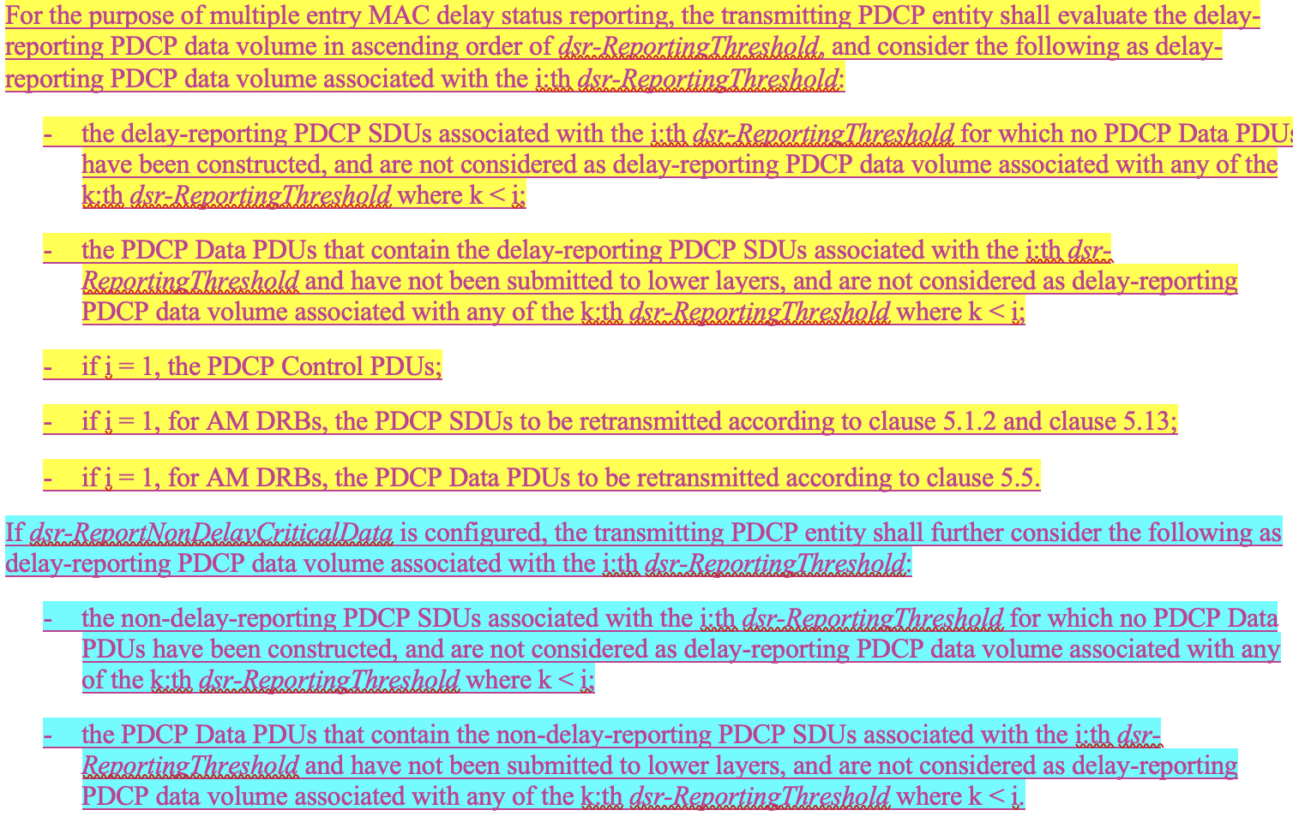
The current definition in clause 3.1:
Non-delay-reporting PDCP SDU: a non-delay-reporting PDCP SDU associated with the i:th dsr-ReportingThreshold is a PDCP SDU that will be transmitted prior to any of the delay-reporting PDCP SDUs associated with the i:th dsr-ReportingThreshold and that is not a delay-reporting PDCP SDU.

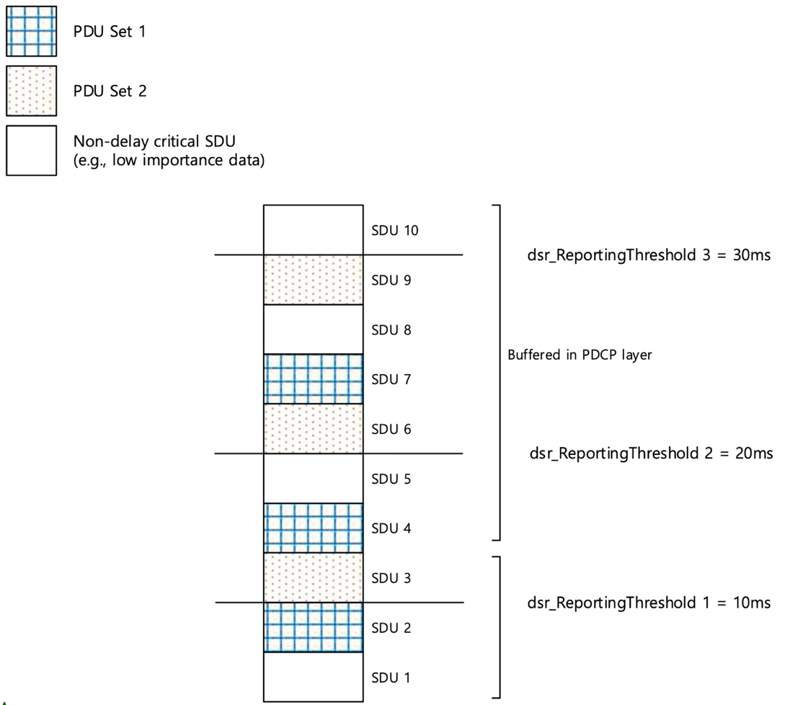
Figure 1. Example case for discussion
Question 2: Do companies agree to the corrections to PDCP and the text proposal (in Annex) from R2-2506331?
- Correct the definition in subclause 3.1 that a PDCP SDU can be identified as a non-delay-reporting PDCP SDU associated with the i:th dsr-ReportingThreshold unless it is identified as a delay-reporting-PDCP SDU associated with the i:th dsr-ReportingThreshold.
- Correct the procedural text in subclause 5.15 so that the data volume for each threshold is calculated by considering both delay-reporting PDCP SDUs and non-delay-reporting PDCP SDUs before moving on to the next threshold in ascending order.
Summary 2: TBD.
Proposal 2 [NewIssue]: TBD.

4 PDCP-1 (Editorial)
Issue description: Whether the text in clause 5.15 “and are not considered as delay-reporting PDCP data volume associated with any of the k:th dsr-ReportingThreshold where k < i” needs to be moved to the definition section in clause 3.1 for both delay-reporting PDCP SDU and non-delay-reporting PDCP SDU.
The current definition in clause 3.1:
Delay-reporting PDCP SDU: if pdu-SetDiscard is not configured, a delay-reporting PDCP SDU associated with the i:th dsr-ReportingThreshold is a PDCP SDU for which the remaining time till discardTimer expiry is less than the i:th dsr-ReportingThreshold and larger than or equal to the i-1:th dsr-ReportingThreshold (if i>1) or larger than zero (if i=1). If pdu-SetDiscard is configured, a delay-reporting PDCP SDU associated with the i:th dsr-ReportingThreshold is a PDCP SDU belonging to a PDU Set of which the PDU Set remaining time is less than the i:th dsr-ReportingThreshold and larger than or equal to the i-1:th dsr-ReportingThreshold (if i>1) or larger than zero (if i=1).
Non-delay-reporting PDCP SDU: a non-delay-reporting PDCP SDU associated with the i:th dsr-ReportingThreshold is a PDCP SDU that will be transmitted prior to any of the delay-reporting PDCP SDUs associated with the i:th dsr-ReportingThreshold and that is not a delay-reporting PDCP SDU.
Two options on the table (planned to be discussed by the session chair):
- Option 1: P5 from R2-2505372 (ZTE)
The text “and are not considered as delay-reporting PDCP data volume associated with any of the k:th dsr-ReportingThreshold where k < i” should be moved to the definition section for both delay-reporting PDCP SDU and non-delay-reporting PDCP SDU.
- Option 2: P6 from R2-2505458 (LGE)
Keep the current definition of delay-reporting PDCP SDU and non-delay-reporting PDCP SDU.
Question 3: Which option do companies agree?
Summary 3: TBD.
Proposal 3 [PDCP-1]: TBD.

5 Conclusion
Proposal 1 [RLC-13]: TBD.
Proposal 2 [NewIssue]: TBD.
Proposal 3 [PDCP-1]: TBD.

Annex: Text proposal based on PDCP running CR (R2-2505438)

3.1 Definitions
<… omitted unimpacted part …>
Non-delay-reporting PDCP SDU: a non-delay-reporting PDCP SDU associated with the i:th dsr-ReportingThreshold is a PDCP SDU that will be transmitted prior to any of the delay-reporting PDCP SDUs associated with the i:th dsr-ReportingThreshold and that is not a delay-reporting PDCP SDU associated with the i:th drx-ReportingThreshold.

5.15 Data volume calculation for delay status reporting
<… omitted unimpacted part …>
For the purpose of multiple entry MAC delay status reporting, the transmitting PDCP entity shall evaluate the delay-reporting PDCP data volume in ascending order of dsr-ReportingThreshold, and consider the following as delay-reporting PDCP data volume associated with the i:th dsr-ReportingThreshold:
- the delay-reporting PDCP SDUs associated with the i:th dsr-ReportingThreshold for which no PDCP Data PDUs have been constructed, and are not considered as delay-reporting PDCP data volume associated with any of the k:th dsr-ReportingThreshold where k < i;
- the PDCP Data PDUs that contain the delay-reporting PDCP SDUs associated with the i:th dsr-ReportingThreshold and have not been submitted to lower layers, and are not considered as delay-reporting PDCP data volume associated with any of the k:th dsr-ReportingThreshold where k < i;
- if dsr-ReportNonDelayCriticalData is configured:
- the non-delay-reporting PDCP SDUs associated with the i:th dsr-ReportingThreshold for which no PDCP Data PDUs have been constructed, and are not considered as delay-reporting PDCP data volume associated with any of the k:th dsr-ReportingThreshold where k < i;
- the PDCP Data PDUs that contain the non-delay-reporting PDCP SDUs associated with the i:th dsr-ReportingThreshold and have not been submitted to lower layers, and are not considered as delay-reporting PDCP data volume associated with any of the k:th dsr-ReportingThreshold where k < i;
- if i = 1, the PDCP Control PDUs;
- if i = 1, for AM DRBs, the PDCP SDUs to be retransmitted according to clause 5.1.2 and clause 5.13;
- if i = 1, for AM DRBs, the PDCP Data PDUs to be retransmitted according to clause 5.5.

