3GPP TSG-RAN2 Meeting # 131 R2-250

Bengaluru, India, 25 – 29 August, 2025

Agenda Item: 7.0.2.21
Source: Huawei, HiSilicon (Rapporteur)
Title: Summary for [AT131][401][POS] CRs on PosSIB segments in dedicated signalling (Huawei)
Document for: Discussion and Decision

1 Introduction
During the discussion in RAN2#131, we have discussed on the issues proposed by R2-2505324 on how to deliver multiple segments of the same posSIB via dedicated signalling. It was concluded that we examine the CR by the following email discussion
- [AT131][401][POS] CRs on posSIB segments in dedicated signalling (Huawei)
Scope: Check and update the CRs in R2-2505324 / R2-2505325 / R2-2505640, including confirming if there is a restriction in the spec today. Intention is to allow multiple segments of a posSIB when sent by dedicated signalling, without changing the broadcast behaviour or the non-positioning SIBs.
Intended outcome: Agreeable CRs in R2-2506301 / R2-2506302 / R2-2506303
Deadline: Wednesday 2025-08-27 1900 IST
This paper summarizes the email discussion.

2. Discussion

Question: Any comment on the CRs?
Company | Comments
vivo | I agree with the intention to allow multiple segments of a posSIB when sent by dedicated signalling.  However, I think the current spec has no restriction on the intention.  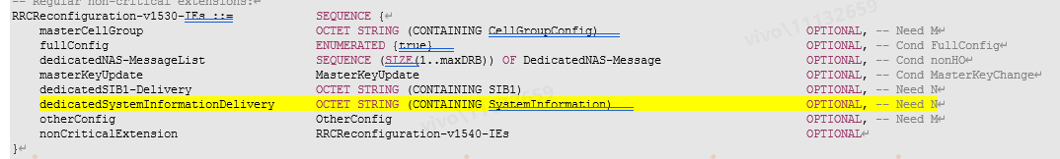  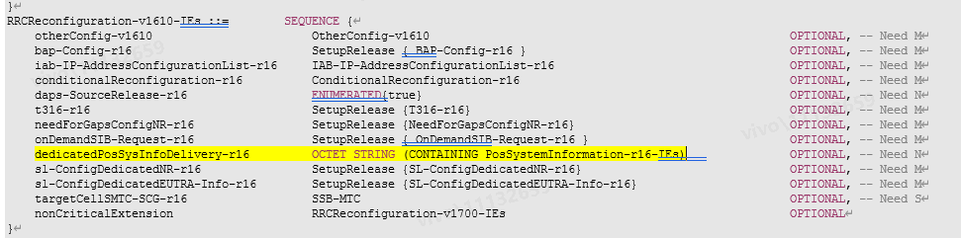
The current spec is copied as above, it can be observed that the normal SIB and posSIB are carried in different container. For the normal SIB, it is carried in SI message, while for posSIB, it is carried in PosSystemInformation-r16-IEs.
And the current spec only have restriction on the SI message container, i.e., Each SIB and posSIB is contained at most once in an SI message.
Therefore, we think no restriction on the list in PosSystemInformation-r16-IEs, that is, multiple posSIB with the same type can be contained in the PosSystemInformation-r16-IEs when it is sent via dedicated signaling.
ZTE | We share the same view with vivo.  If gNB transmit SI message which contains PosSystemInformation-r16-IEs (via broadcast signaling), the restriction in 5.2.1 (each posSIB segment is contained at once in a SI message) should be followed; if gNB only transmit PosSystemInformation-r16-IEs (via dedicated signaling), the restriction in 5.2.1 does not apply.  So, if the PosSystemInformation-r16-IEs is sent in dedicated signalling, according to current spec, gNB is already possible to set the multiple segments of one posSIB type in one PosSystemInformation-r16-IEs:  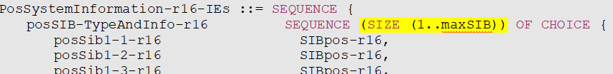  Of course, if the PosSystemInformation-r16-IEs is contained in SI message sent by broadcast signalling, the above gNB behaviour is not allowed according to 5.2.1.  So it is just a clarification to the current spec. Nothing is wrong in current spec. if companies still have concern on the understanding, instead of this NBC change, we suggest to make the following agreement in chair notes to clarify:  When gNB sends PosSystemInformation-r16-IEs to UE in dedicated RRC signalling, the PosSystemInformation-r16-IEs may contain multiple segments of a posSIB.

3. Conclusion
TBD

