3GPP TSG-RAN WG2#131 R2-25XXXXX
Bengaluru, India, 25 Aug - 29 Aug, 2025

Agenda Item: 8.19.1
Source: Huawei, HiSilicon
Title: Report of [AT131][011][TEI19] Early CSI (Huawei)
Document for: Discussion and decision

1 Introduction
This document is the report of the following discussion:
- Prepare offline a RAN2 CR (how it would like). Wait for some RAN1/RAN4 progress on LTM related issues and identify whether we can assume that those solutions can be used.
- Prepare an LS to RAN1 and cc RAN4 to indicate intention on RAN2 solution, provide the RAN2 CR (how it would look like). Provide the identified impacts to RAN1 and ask if this is ok.

- [AT131][011][TEI19] Early CSI (Huawei)
Intended outcome: LS, RAN2 CR
Deadline: Thursday

Based on the comments from received online, the description related to CSI reporting was removed from the field description in the RRC CR. We also share the progress from RAN1 and RAN4 and provide our view.

Please provide your comments by 09:00 on Thursday to allow time to update the CR and the draft LS before deadline.

2 RAN1’s progress
Of all the agreements made by RAN1, only the following agreement is relevant for L3 handover.
Agreement
- Adapt LTM-CSI-ReportConfig to include cqi-Table for CQI reporting

And per band capability was agreed which has been captured in session chair note as follows:
https://www.3gpp.org/ftp/Meetings_3GPP_SYNC/RAN1/Inbox/Ralf_notes/Session_Notes_AI_9-6_v01.docx
63. NR_Mob_Ph4 | 63-6 | Intra-frequency CSI-RS and CSI-IM measurement and CSI reporting for cell indicated in CSC MAC CE after reception of LTM CSC MAC CE based on periodic CSI-RS resource | 1. Support of CSI-RS and CSI-IM measurement and CSI reporting after reception of LTM CSC MAC CE based on periodic CSI-RS(s) of cell indicated in CSC MAC CE  [2. Maximum number of the RRC configured candidate cells]  3. Maximum number of CSI-RS resources for CMR associated with CSI report configuration for a candidate cell  4. Max number of CSI-RS ports of CSI-RS resource(s) associated with a CSI report configuration for CSI reporting for a candidate cell  5. Maximum number of Tx ports in one NZP CSI-RS resource  6. Max rank for CSI reporting for a candidate cell  7. Maximum number of CSI-IM resources for interference measurement associated with CSI report configuration for a candidate cell | FFS | Yes | No | Intra-frequency periodic CSI-RS and CSI-IM measurement and CSI reporting for cell indicated in CSC MAC CE after reception of LTM CSC MAC CE is not supported | FFS  Per Band | n/a | n/a | n/a | Component 2 candidate values: {1,2,3,4,5,6,7,8}  Component 3 candidate values: {1,2,3,4,5,6,7,8}  Component 4 candidate values: {1,2,4,8,12,16,24,32,48,64,128}  Component 5 candidate values: {1, 2, 4, 8, 12, 16, 24, 32}  Component 6 candidate values: FFS {1,2,3,4,5,6,7,8}  Component 7 candidate values: {1,2,3,4,5,6,7,8} | Optional with capability signaling

We updated the RRC CR to include this for L3 handover.

3 RAN4’s progress
The following is the agreement from RAN4:
Agreement:
- No consensus on defining new RAN4 requirements for early CSI acquisition.
  - Clarification on the applicability of the existing requirement is not precluded if consensus on the exact clarification can be reached.

There was no consensus on defining new RAN4 requirements.

4 RAN2 CRs

In addition to capturing the latest RAN1’s agreement, we removed the description related to CSI reporting from the field description of the RRC CR as suggested by Ericsson during online.
Please don’t change the CR text or insert comments to the CR file. Please use the table below for comments and wording suggestions for clarity of the CR tdoc.

CR to 38.331:
Company | Section and detailed comments | Rapporteur’s response
MediaTek | RAN1 has not yet finalized (FFS) the granularity of this feature (FG63-6) for LTM. We suggest informing RAN1 and let RAN1 to decide the granularity of this feature in L3 HO—or, at least, setting the granularity per band to align with LTM basic capability.  Moreover, LTM early CSI have separate sub-features (e.g., intra/inter-freq, the support or not for SP-CSI-RS). We should let RAN1 to also decide whether the same sub-features are introduced(copied) for L3 HO, or to reuse the LTM sub-features. | According RAN1’s latest progress, the granularity is per band. But we wait with updating the UE capabilities part as RAN1 will send the UE feature list after the meeting.  All FGes in RAN1 are only for intra-freq.  Supporting SP-CSI-RS is subject to UE’s capability was agreed in RAN1-120b shown below. We consider only the baseline (i.e., periodic case), not semi-persistent for L3 HO.  “For candidate cell CSI acquisition  - In addition to periodic CSI-RS resource, semi-persistent CSI-RS resource is supported  - Support of semi-persistent CSI-RS resource is subject to separate UE capability.”

Samsung | We think this is determined by RAN1. We are not sure the per UE capability is enough for this feature. The capabilities for early CSI acquisition for LTM is not determined yet (i.e. FFS and per BC is considered now).  We think the per UE capability is not good granularity. At least per band or per BC (between source and target) should be considered. | We wait with updating capabilities as explained above.
Nokia | Nokia mentioned that RAN1 also agree to introduce a new RRC IE for LTM code book configuration. | We checked the agreement and incorporated the code book configuration.

CR to 38.306:
Company | Section and detailed comments | Rapporteur’s response
MediaTek | Same comment as above. | As above
Samsung | Same comment as above | As above

5 draft LS to RAN1
A draft LS is provided in the same folder. Please provide your comments.
Company | Section and detailed comments | Rapporteur’s response
MediaTek | We believe there will be more RAN1 spec impact than those two TPs. We should also ask RAN1 to check and review all potentially impacted specs and update them as needed.  Please see the suggested words as below:  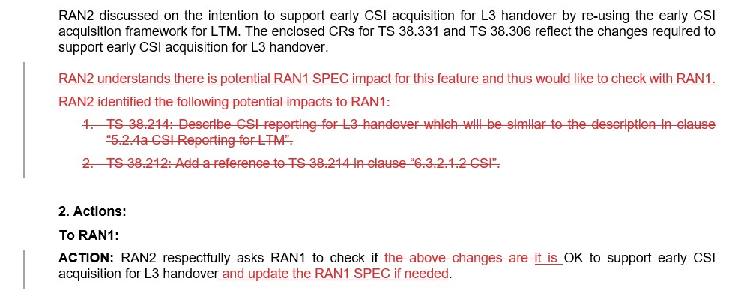 | As we already identified potential impacts to RAN1, we think it’s good to convey them to RAN1.  We modified the ACTION as suggested.
Samsung | From RRC signaling perspective, we think there are no big issues to support it.  We think it is better to provide the differences compared with the early CSI acquisition for LTM or legacy HO.  - For L3 HO early CSI acquisition always done after RRCReconfiguration decoding (processing delay should be considered).  - From the target cell perspective, target cell needs to activate these CSI resources after sending the HandoverCommand message to source cell because the target cell has no idea when HO is triggered by source cell. This is the new NW operation compared to legacy HO. | We reuse the CSI-RS for traditional CSI report as explained in DP R2-2505598, so the CSI-RS activation will follow that in legacy. Our understanding is that even in legacy HO, target cell activates the CSI resources after sending HO command.
Nokia | Rapporteur recording the comments from Nokia here:  - We should enclose the CRs only if they are agreed in RAN2, while we understood from some of the comments shared by the companies that they are not sure if we can decide how capabilities are defined without RAN1 inputs.  - Modify “RAN2 identified the following potential impacts to RAN1” to “RAN2 identified at least the following potential impacts to RAN1” as likely RAN can/will add more  - We believe there should be also an action to RAN4 to ask them to define corresponding requirements (or check if there are any existing requirements that apply). | For 1, we wait with updating capabilities as explained above  For 2, we modified as suggested.  For 3, no new requirement identified by RAN4 for early CSI report as we enclosed in response above.

