RAN1#122 Online Session Schedule
Zinnia
Pre-function Area
Convention Hall

 | Monday |  |  | Tuesday |  |  |  | Wednesday |  |  | Thursday |  |  | Friday
08:30  ~  10:30  (120 min) | RAN1#122 commences at 09:00 on Monday  Agenda items 1, 2, 3, 4, 5  Detailed discussion on SA4 LS for R20 IoT-NTN and AI 8.14 |  |  | R20 6GR (120)  Channel coding | R19 CRs (120)  XR (30)  MIMO (30)  NES (60) |  | R19UE features (120)  - Duplex (60)  - LP-WUS (60) | R20 6GR (120)  Energy | R19 CRs  MIMO (60)  R20  MIMO (60) | R19UE features (120)  - AIML (60)  - NTN (60) | R20 6GR Channel coding  Modulation |  |  | R20 6GR  AI/ML
Morning coffee break: 10:30 ~ 11:00
11:00  ~  13:00  (120 min) | R20 6GR (120)  AI/ML |  |  | R20 6GR (120)  Modulation | R19 UE features (120)  - AIML (40)  - MCE/LBCA (45)  - XR (15)  - Mobility (20) |  | R19 CRs (600)  A-IoT (60)  R20 A-IoT (60) | R20 6GR (120)  Evaluations | R19UE features (120)  - MIMO (60)  - NES (30)  - Broadcast (15)  - TEI19 (15) | R20 ISAC (60)  R20 A-IoT (60)
Lunch break: 13:00 ~ 14:30
14:30  ~  16:30  (120 min) | R20 6GR (120)  Overall | R19  MIMO (60)  R20  MIMO (60) | R20 A-IoT (60)  R20 ISAC(60) | R19 CRs (120)  8.3 (60)  8.6 (60) | R20  NR-NTN (60)  R19 CRs (60)  AI/ML (60) |  | R20 ISAC (60)  R19 CRs  NR/IoT-NTN (60) | R20 6GR (120)  Waveform  Frame structure | R19 CRs AI/ML (60)  R20  NR-NTN (60) | R19 CRs (60)  NR/IoT-NTN  5G broadcast  R19 CRs (60)  A-IoT (30)  ISAC (30) |  |  |  | Any other open issues  . Session reports  . etc  RAN1#116 expected to close at 17:00
Afternoon coffee break: 16:30 ~ 17:00
17:00  ~  19:30  (150 min) | 6GR (150)  Waveform  Frame structure | R19 CRs (90)  AI/ML (90)  R20 AI/ML (60) | R19 CRs(90)  ISAC (30)  A-IoT (30)  5G Broadcast(30)  R20 A-IoT (60) | R19 CRs (90)  8.8 (10)  8.9 (40)  8.12 (40)  8.6 (60) |  | R20 AI/ML (150) | R20 A-IoT (150) | R19 CRs (150)  8.3 (30)  8.9 (30)  8.12 (30) | R20 AI/ML (90) | R20 A-IoT (90)
All sessions end at 19:45 – no exceptions
RAN1#122 Offline Session Schedule
Poinsettia 1 & 2
Heliconia 1 & 2
 | Monday |  | Tuesday |  | Wednesday |  | Thursday |  | Friday
08:30  ~  10:30  (120 min) |  |  | David  R20 A-IoT(120) | Sorour  R19 CRs  AI/ML (120) | Sorour  R20 NTN (60)  R19 CRs  AI/ML (60) | David  R20 ISAC (40)  R20 A-IoT (80)
Morning coffee break: 10:30 ~ 11:00
11:00  ~  13:00  (120 min) |  |  | David  R20 ISAC (40)  Sorour  R20 AI/ML (80) | Xiaodong  R19 CRs  8.9 (60)  8.6 (60) | Sorour  R20  AI/ML (120) | David  R19 CRs (120)  A-IoT(60)  NR/IoT-NTN(60)
Lunch break: 13:00 ~ 14:30
14:30  ~  16:30  (120 min) | David  R19 CRs  ISAC (30)  NR/IoT-NTN(30)  A-IoT (60) | Sorour  R19 CRs  AI/ML (60)  NES (60) | David  R20 A-IoT (120) | Sorour  R19 CRs  MIMO (60)  R20 MIMO(60) | Xiaodong  R19 CRs  8.3 (40)  8.9 (40)  8.12 (40) | David  R20 A-IoT (60)  Xiaodong  Modulation (60) |  |  | To be assigned by Sorour  To be assigned by David
Afternoon coffee break: 16:30 ~ 17:00
17:00  ~  19:30  (150 min) | Xiaodong  R19 CRs  8.3 (60)  8.6 (60)  8.12 (30) | Sorour  R20 MIMO (90)  R19 CRs  MIMO (60) | Xiaodong  Waveform (90)  Frame structure (60) | Xiaodong  R20 6GR (60)  Evaluations  Sorour  R20 NR-NTN (90) | Xiaodong  Channel coding (90) | Xiaodong  Waveform (90)
All sessions end at 19:45 – no exceptions

RAN1#122 Detailed Schedule for RAN1 Main Session

 | Monday | Tuesday | Wednesday | Thursday | Friday
08:30  ~  10:30  (120 min) | Agenda items 1, 2, 3, 4, 5  Detailed discussion on SA4 LS for R20 IoT-NTN and AI 8.14 | R20 6GR (120)  Channel coding | R20 6GR (120)  Energy
Morning coffee break: 10:30 ~ 11:00
11:00  ~  13:00  (120 min) | R20 6G (120)  AI/ML | R20 6GR (120)  Modulation | R20 6GR (120)  Evaluations
Lunch break: 13:00 ~ 14:30
14:30  ~  16:30  (120 min) | R20 6GR (120)  Overall | R19 CRs (60)  AI 8.6  AI 5 (30)  LS for IoT-NTN (ULBC) (60)  AI 8.14 (30) | R20 6GR (120)  Waveform  Frame structure
Afternoon coffee break: 16:30 ~ 17:00
17:00  ~  19:30  (150 min) | 6GR (150)  Waveform  Frame structure | R19 CRs (90)  AI 8.3 (30)  AI 8.9 (30)  AI 8.12 (30)  AI 8.6 (60) | R19 CRs (150)  AI 8.3 (30)  AI 8.9 (30)  AI 8.12 (30)
All sessions end at 19:45 – no exceptions

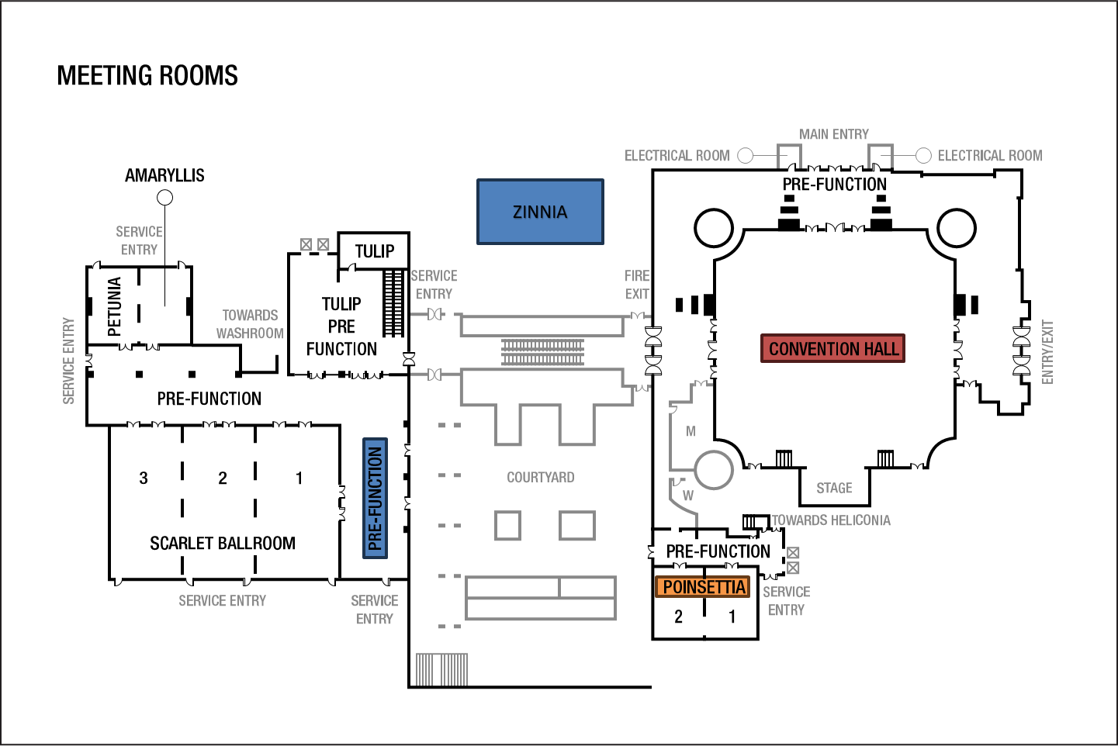
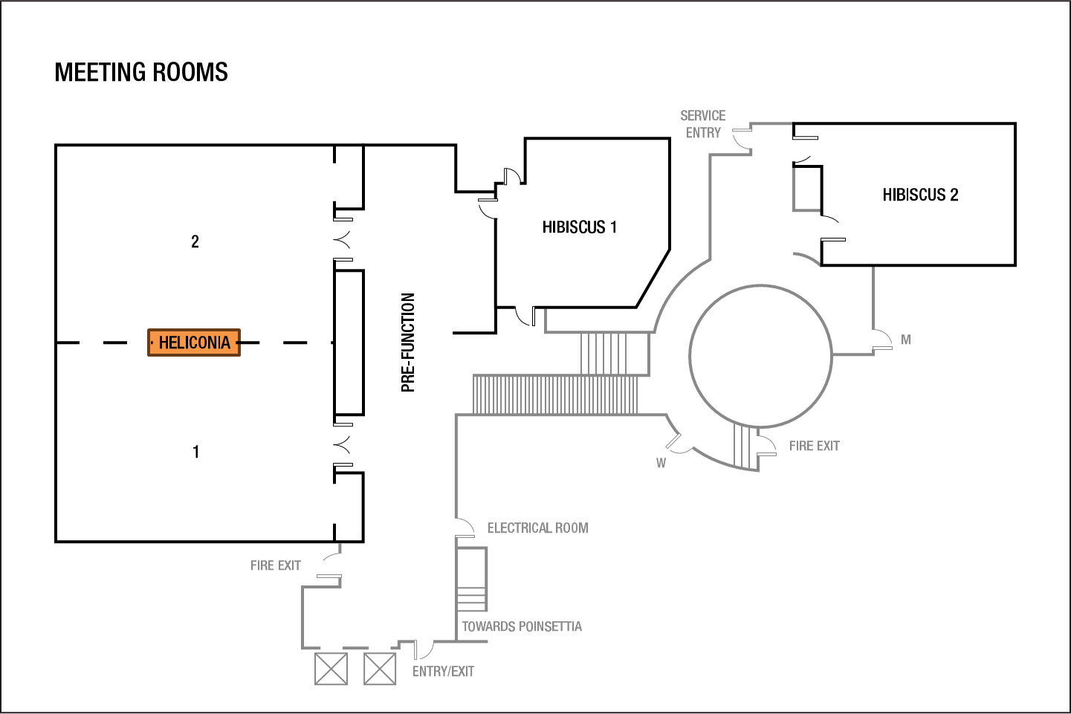
RAN1 Meeting Rooms:

