**.RAN1#122b Online Session Schedule**

**E1**

**D11+D12**

**B1+B2**

|  |  |  |  |  |  |  |  |  |  |  |  |  |  |  |  |
| --- | --- | --- | --- | --- | --- | --- | --- | --- | --- | --- | --- | --- | --- | --- | --- |
|  | **Monday** | | | **Tuesday** | | | **Wednesday** | | | **Thursday** | | | **Friday** | | |
| **08:30**  **~**  **10:30**  **(120 min)** | **RAN1#122b commences at 09:00 on Monday**  Agenda items 1, 2, 3, 4, 5  R20 IoT-NTN (30)  Maintenance  . 8.8 other (7-24GHz, TEI leftover)  . 8.3 SBFD | | | R20 6GR  Frame structure (30)  Waveform (40)  Modulation (50) | AI 8 (120)  AI 8 (120)  AI/ML (60)  NES (30)  MIMO (30) | R19UE features (120)  MCE(30)  NTN(50)  AI/ML(40) | R20 6GR  AI/ML (40)  Channel Coding (80) | R20  NR-NTN (60)  AI 8 (60) | R19UE features (120)  MCE(40)  MIMO(40)  LTE Broadcast(10)  AI/ML(30 | R20 6GR    Channel coding&  Energy (120) | AI 8 (60)  AI 7 (60) | R19UE features (60)  MCE (60)  R20 Coverage (60) | R20 6GR  energy (40)  Evaluation (80) | R20 AI/ML (60)  AI 6&7 (60) | R20 A-IoT (120) |
| **Morning coffee break: 10:30 ~ 11:00** | | | | | | | | | | | | | | | |
| **11:00**  **~**  **13:00**  **(120 min)** | AI 8 (120)  . 8.3 SBFD  . 8.6 LP-WUS  . 8.8 other (LTM, MC&LB-CA) | | | R20 6GR  AI/ML (40)  Channel coding (80) | R19 UE features (120)  Mobility/R19 TEI (45)  AI/ML(75) | R20 A-IoT (60)  AI 8 (60) | R20 6GR  AI/ML (50)  Waveform (40)  Frame structure (30) | R19UE features (120)  Duplex （50）  LP-WUS（30）  NTN(40) | AI 8 (60)  R19 NTN（40）  R19 A-IoT （20）  R20 A-IoT (60) | R20 6GR AI/ML (40)  Frame structure (80) | R19 UE features (120)  NR-NTN (60)  Duplex(15)  MIMO (45) | R20 A-IoT (120) | R20 6GR Sweep | | |
| **Lunch break: 13:00 ~ 14:30** | | | | | | | | | | | | | | | |
| **14:30**  **~**  **16:30**  **(120 min)** | R20 6GR  Overall (60)  Evaluations (60) | AI 8 (120) | R20 Coverage (60)  AI 8 (60) | R20 6GR  AI/ML (60)  Overall (60) | R20  MIMO (60)  R20  NR-NTN (60) | ISAC (60)  R20  A-IoT (60) | R20 6GR  Modulation  (40)  R20 6GR  Energy (800) | R20  MIMO (60)  R20  NR-NTN (60) | R20 ISAC (60) | AI 8 (120)  NTN LS  LTM, MC&LB-CA (30)  SBFD (30)  LP-WUS(50) | R20  MIMO (60)  R20  NR-NTN (60) | AI 8 (60)  8.7.1, 8.7.2  R20 ISAC (60) | Any other open issues . Session reports . etc  **RAN1#122b expected to close at 17:00** | | |
| **Afternoon coffee break: 16:30 ~ 17:00** | | | | | | | | | | | | |
| **17:00**  **~**  **19:30**  **(150 min)** | R20 6GR (150)  Modulation (60)  Frame structure (40)  Waveform(50) | R20 AI/ML (45)  AI 6, 7 (45)  R20  MIMO (60) | R20 ISAC(60)  R20 A-IoT (90) | R20 6GR  Energy (100)  Evaluations (50) | AI 6, 7 (50)  R20 AI/ML (100) | R20 A-IoT (90)  AI 8 (60) | R20 6GR  Evaluations (40)  Overall (50) | R20 AI/ML (900) | R20 A-IoT (90) | R20 6GR  Energy (60)  Waveform (90) | R20 AI/ML (90)  AI 8 (60) | R20 A-IoT (150) |
| **All sessions end at 19:45 – no exceptions** | | | | | | | | | | | | | | | |

**RAN1#122 Offline Session Schedule**

**B3**

**E2**

|  |  |  |  |  |  |  |  |  |  |  |
| --- | --- | --- | --- | --- | --- | --- | --- | --- | --- | --- |
|  | **Monday** | | **Tuesday** | | **Wednesday** | | **Thursday** | | **Friday** | |
| **08:30**  **~**  **10:30**  **(120 min)** |  | | Xiaodong  R20 6GR  Modulation (40)  Channele coding (80) | David  R20 A-IoT (60)  AI 8 (60) | Xiaodong  R20 6GR  Evaluation (45)  AI/ML (40)  Modulation (35) | David  R20 A-IoT (80)  R20 ISAC (40) | Xiaodong  R20 6GR  Frame structure (75)  AI/ML (45) | David(120)  R20 A-IoT (60)  AI 8 (60)  NTN |  |  |
| **Morning coffee break: 10:30 ~ 11:00** | | | | | | | | | | |
| **11:00**  **~**  **13:00**  **(120 min)** |  | | Xiaodong (60)  AI 8 (60)  R20 IoT-NTN (15)  SBFD (25)  LTM (20)  David (60)  R20 A-IoT (60) | Sorour  R20  MIMO (60)  R20  AI 8 (60) | Xiaodong  R20 5GR  Energy (80)  Overall (40) | Sorour(80)  R20  MIMO (40)  R20  NR-NTN (40)  David(40)  R20 Coverage (40) | Xiaodong  R20 5GR  Energy (80)  Waveform (40) | Sorour  R20  MIMO (60)  R20  NR-NTN (60) |  |  |
| **Lunch break: 13:00 ~ 14:30** | | | | | | | | | | |
| **14:30**  **~**  **16:30**  **(120 min)** | Xiaodong  R20 6GR  Waveform (40)  Modulation (40)  AI/ML (40) | Sorour  R20 AI/ML (60)  David  R20 A-IoT (60) | Xiaodong  R20 6GR  Energy (120) | Sorour  NR-NTN (60)  R20 AI/ML (60) | Sorour  R20 AI/ML (60)  AI 8 (60) | David(80)  R20 A-IoT (80)  Sorour (40)  AI 8 (40) | Sorour  R20 AI/ML (120) | David  R20 ISAC (40)  R20 A-IoT (80) | To be assigned by Sorour  To be assigned by David | |
| **Afternoon coffee break: 16:30 ~ 17:00** | | | | | | | | |
| **17:00**  **~**  **19:30**  **(150 min)** | Xiaodong  R20 6GR  Frame structure (40)  Overall (40)  Evaluatoin (30)  AI/ML (40) | Sorour (110)  R20 MIMO (50)  AI 8 (60)  R19 MIMIO(30)  R19 AI/ML(30)  David (40)  R20 ISAC (40) | Xiaodong  R20 6GR  AI/ML (50)  Channele coding (100) | Xiaodong (60)  Waveform (60)  David (90)  R20 Coverage (50)  R20  ISAC (40) | Xiaodong (90)  Channel coding (90) | Xiaodong (90)  AI 8 (40)  . LP-WUS (40)  Energy (50) | Xiaodong (150)  Evaluation (150) | Xiaodong (150)  Overall (60)  Frame structure (40)  Energy (50) |
| **All sessions end at 19:45 – no exceptions** | | | | | | | | | | |

**RAN1#122b Detailed Schedule for RAN1 Main Session**

|  |  |  |  |  |  |
| --- | --- | --- | --- | --- | --- |
|  | **Monday** | **Tuesday** | **Wednesday** | **Thursday** | **Friday** |
| **08:30**  **~**  **10:30**  **(120 min)** | Agenda item 1, 2, 3, 4, 5  R20 IoT-NTN (30)  Maintenance  . 8.8 other (7-24GHz, TEI leftover)  . 8.3 SBFD | R20 6GR  Frame structure (30)  Waveform (40)  Modulation (50) | R20 6GR  AI/ML (40)  Channel Coding (80) | R20 6GR    Channel coding & Energy (120) |  |
| **Morning coffee break: 10:30 ~ 11:00** | | | | | |
| **11:00**  **~**  **13:00**  **(120 min)** | Maintenance AI 8.3 (45), 8.6 (45)  Maintenance AI 8.8 Others (30)  . LTM  . MC&LB-CA | R20 6GR  AI/ML (40)  Channel coding (80) | R20 6GR  AI/ML (50)  Waveform (40)  Frame structure (30) | R20 6GR AI/ML (40)  Frame structure (80) |  |
| **Lunch break: 13:00 ~ 14:30** | | | | | |
| **14:30**  **~**  **16:30**  **(120 min)** | R20 6GR  Overall (60)  Evaluations (60) | R20 6GR    AI/ML (60)  Overall (60) | R20 6GR  Modulation  (40)  R20 6GR  Energy (80) | AI 8 (120)  NTN LS  LTM, MC&LB-CA (30)  SBFD( 30)  LP-WUS(50) |  |
| **Afternoon coffee break: 16:30 ~ 17:00** | | | | |
| **17:00**  **~**  **19:30**  **(150 min)** | R20 6GR (150)  Modulation (60)  Frame structure (30)  Waveform (60) | R20 6GR  Energy (100)  Evaluations (50) | R20 6GR  Evaluations (40)  Overall (50) | R20 6GR  Energy (60)  Waveform (90) |
| **All sessions end at 19:45 – no exceptions** | | | | | |

**RAN1#122bis Election Schedule**

**RAN1 election for a second vice-chair position will be held on Tuesday.**

|  |  |
| --- | --- |
|  | **Tuesday** |
| **Online session**  08:30 ~ 10:30 (120 min) | **Election for a second Vice Chair position**   * First round of voting from **08:00** until 10:30 |
| **Morning coffee break**  10:30 ~ 11:00 | **Election for a second Vice Chair position**   * First round voting results announcement at 10:50 (in main session room) |
| **Online session**  11:00 ~ 13:00 (120 min) | **Election for a second Vice Chair position**   * Candidates consider whether or not to have second round of voting |
| **Lunch break**  13:00 ~ 14:30 | **Election for a second Vice Chair position**   * Announcement on whether there will be a second round of voting at 13:00 (in main session room and via MCC email) |
| **Online session**  14:30 ~ 16:30 (120 min) | **Election for a second Vice Chair position**   * Second round of voting from **14:00** until 16:30 |
| **Afternoon coffee break**  16:30 ~ 17:00 | **Election for a second Vice Chair position**   * Second round voting results announcement at 16:50 (in main session room) |

**RAN1 Meeting Rooms: RAN1_Main, RAN1_Off2**

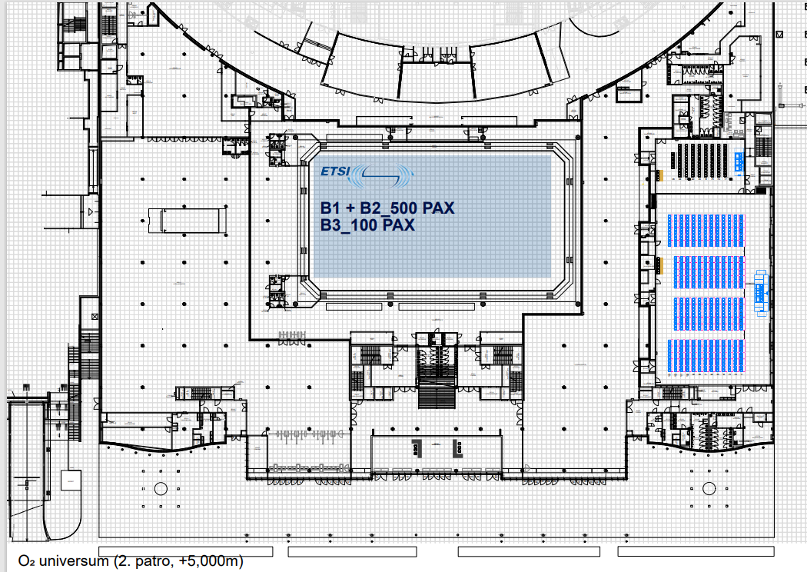

**RAN1 Meeting Rooms: RAN1_Brk1 & RAN1_Brk2, RAN1_Off1**

