3GPP TSG-SA WG6 Meeting #60 S6-241226
Changsha, P. R. China, 15th – 19th April 2024 (revision of S6-24xxxx)

Title: LS on Clarification related to MC gateway UE requirements
Response to:
Release: Rel-19
Work Item: FRMCS_Ph5

Source: 3GPP TSG SA WG6
To: 3GPP TSG SA WG1
Cc:

Contact person: Cuili Ge – gecuili@huawei.com

Send any reply LS to: 3GPP Liaisons Coordinator, mailto:3GPPLiaison@etsi.org

Attachments:

1 Overall description
SA6 is working on the MC gateway UE features, SA6 would like to ask SA1 to clarify the following scenario:
When an MCX user uses multiple devices simultaneously e.g., two devices as shown in the figure below, whether it allows:
- Two devices simultaneously connect to the same gateway UE for the same MC service, i.e., MCPTT call #1 and MCPTT call #2 in the figure?
- Two devices simultaneously connect to different gateway UEs for the same MC service, i.e., MCPTT call #1 and MCPTT call #3 in the figure?
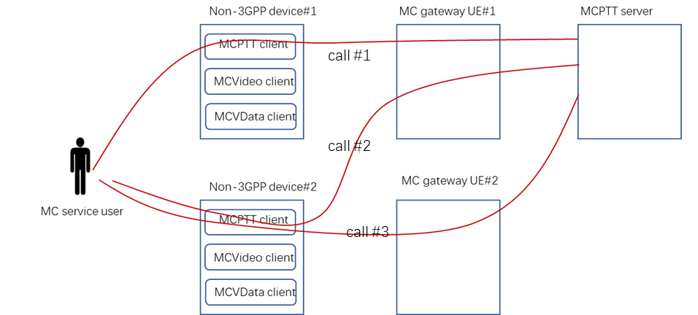

2 Actions
To SA1
ACTION: SA6 kindly asks SA1 to answer the above questions and update the SA1 specifications respectively, if necessary.

3 Dates of next TSG SA WG 6 meetings
SA6#61 20th May – 24th May 2024 Jeju, Korea

