3GPP TSG-SA WG6 Meeting #60 S6-241500
Changsha, China 15th – 19th April 2024 (revision of S6-241121)

Source: China Mobile
Title: Sol for KI#1 & KI#2: multi-modal flows alignment and monitoring
Spec: 3GPP TR 23.700-23
Agenda item: 8.5
Document for: Approval
Contact: Shaowen Zheng, zhengshaowen@chinamobile.com

1. Introduction
This paper proposes solution for KI#1 & KI#2 by proposing multi-modal flows alignment and monitoring.
2. Reason for Change
As discussed in KI#1, according to clause 6.43 of TS 22.261 [2], synchronization between different media components is crucial for immersive multi-modal VR applications. In other words, the delay difference among the associated flows should be small. Otherwise, the arrived flows need to wait for other associated flows that do not arrived yet.
Also in KI #2, “Whether and how to support the E2E multi-modal communication flows between application clients and application servers within the application enablement layer?” are proposed to be studied.
This solution aims to monitor and alleviate the delay difference to support the E2E multi-modal communication flows by proposing multi-modal flows alignment and monitoring.
3. Conclusions
<Conclusion part (optional)>
4. Proposal
It is proposed to agree the following changes to 3GPP TR 23.700-23.

* * * First Change * * * *

5.X Multi-modal flows alignment and monitoring requirements

5.X.1 Description
This subclause specifies the requirements for multi-modal flows alignment and monitoring service.

5.X.2 Requirements
[AR-5.x.2-a] The XRApp shall provide a mechanism to enable multi-modal flows alignment by the authorized VAL server.
[AR-5.x.2-b] The XRApp shall provide a mechanism to enable multi-modal flows alignment monitoring by the authorized users or VAL server.

* * * Next Change * * * *

7.1 Mapping of solutions to key issues
Table 7.1-1 Mapping of solutions to key issues
 | KI #1 | KI #2 | KI #3 | KI #4
Sol #X | X | X
Sol #2

7.x Solution #x: Multi-modal flows alignment and monitoring

7.x.1 Architecture Impacts
This solution requires a mechanism for data storage to cache the traffic flows.

x.2 Solution description

7.x.2.1 General
Synchronization between different multi-modal XR application components is crucial. In other words, the delay difference among the associated flows should be small. Otherwise, the arrived flows need to wait for other associated flows that do not arrived yet.
To avoid the downlink traffic flow delay difference introduced from (R)AN and Internet, the SEALDD/XRApp client could do the multi-modal traffic flow alignment, by steering associated multi-modal traffic flows to be transferred to application client at specific time.
As shown in figure 7.x.2.1-1, flow#1 and flow#2 are associated flows. They are sent out from VAL server at the same time, while flow#1 arrives at SEALDD/XRApp client earlier than flow#2 due to different routing path. To align those associated flows, the SEALDD/XRApp client holds and buffers the flow#1 for a while. Until all the associated flows arrived(i.e., flow#2), the SEALDD/XRApp client sends out those associated flows to application client at the same time.
Editor’s note: Whether the implementation entity is XRApp or SELADD depends on the the Application enablement architecture.
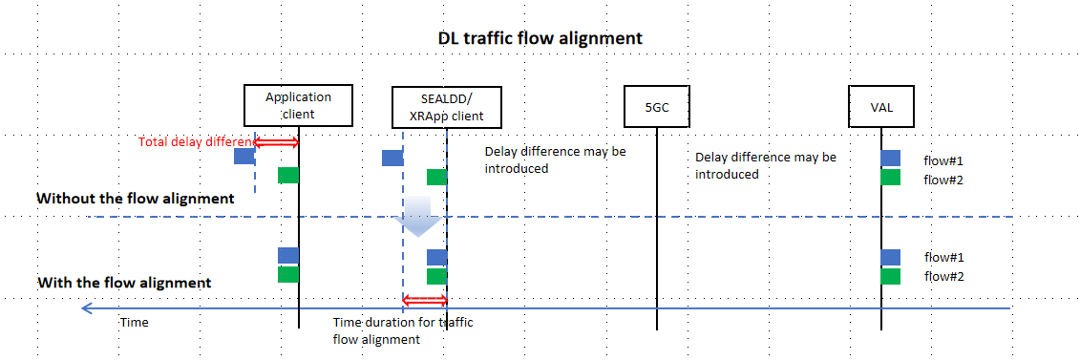
Figure 7.x.2.1-1: DL traffic flow alignment

7.x.2.2 Procedure of flow alignment
Figure 7.x.2.2-1illustrates the procedures of multi-modal flows alignment.
Precondition:
SEALDD/XRApp client
5GC
SEALDD/XRApp server
1. multi-modal flows coordination request
VAL server
5. flows coordination
4. multi-modal flows coordination response
connection established
2. multi-modal flows coordination request
3. multi-modal flows coordination response
Application client
- The VAL server can discover and select the XRApp server by CAPIF functions.
- The connection has been established among the UE, XRApp server and VAL server.

Figure 7.x.2.2-1: multi-modal flows alignment

- VAL server sends the multi-modal flows alignment request with VAL ID, UE ID(s), flows description (e.g., Multi-modal Service ID, packet flows filter description, etc.), flows transmission requirement, flows alignment assistance information. Flows transmission requirement including the delay requirement. Flows alignment assistance information may includes the timestamp, number of associated flows, maximum acceptable duration for traffic flow alignment. Maximum acceptable time duration for traffic flow alignment is used to limit the maximum waiting time for the associated flow.
- Upon receiving the request, the SEALDD/XRApp server performs an authorization check. If authorization is successful, the SEALDD/XRApp server sends the multi-modal flows alignment request to the SEALDD/XRApp client identified by the UE ID(s), along with the information received in step1.
If the maximum acceptable duration for traffic flow alignment is not provided, then the XRApp server would determine the maximum acceptable duration for traffic flow alignment based on flows transmission requirement. The server may translate the flows description into SEALDD flow ID.
- The SEALDD/XRApp client sends the multi-modal flows alignment response to the SEALDD/XRApp server.
- The SEALDD/XRApp server sends the multi-modal flows alignment response to the VAL server indicating the result of multi-modal flows alignment.
- When the traffic flow arrived, the SEALDD/XRApp client initiate the multi-modal flows alignment based on the received information. The flows needs to be aligned is detected by the VAL ID, flows description. If number of associated flows are provided, the number of associated flows are used to determine whether all the associated flows arrived. If the timestamp is provided, the flow that are sent at specific time will be aligned. After all associated flows arrived, the SEALDD/XRApp client sends the flows to the application client. If the maximum acceptable time duration is provided, once the maximum acceptable time is reached, the SEALDD/XRApp client will no longer waits for the associated flows even if the associated flow is not arrived yet.

NOTE: Step3 and step5 can be executed in parallel.

7.x.2.3 Procedure of flow alignment monitoring
Figure 7.x.2.3-1illustrates the procedure of multi-modal flows alignment monitoring.
Precondition:
- The multi-modal flows alignment has been requested and triggered.
SEALDD/XRApp client
5GC
SEALDD/XRApp server
1. multi-modal flows coordination monitoring request
VAL server
5. flows coordination monitoring
7. multi-modal flows coordination monitoring notification
multi-modal flows alignment
2. multi-modal flows coordination monitoring request
4. multi-modal flows coordination monitoring response
6. multi-modal flows coordination monitoring notification
3. multi-modal flows coordination monitoring response

Figure 7.x.2.3-1: traffic flow alignment monitoring
- VAL server sends the multi-modal flows alignment monitoring request. VAL ID, UE ID, flows description, monitoring period are provided in the request.
- Upon receiving the request, the SEALDD/XRApp server performs an authorization check. If authorization is successful, the SEALDD/XRApp server sends the multi-modal flows alignment monitoring request to the SEALDD/XRApp client.
- The SEALDD/XRApp client sends the multi-modal flows alignment monitoring response to the SEALDD/XRApp server.
- 4. The SEALDD/XRApp server sends the multi-modal flows alignment monitoring response to the VAL server, indicating whether the multi-modal flows alignment monitoring request is successful.
- 5. The XRApp client calculates the end-to-end delay difference based on the arrival time and timestamp among the flows.
- Editor’s note: The detail of the end-to-end delay difference calculation is FFS.
6-7.XRApp client sends the multi-modal flows alignment monitoring result to the XRApp server, then to the VAL server.

* * * Next Change * * * *
<Proposed change in revision marks>

